APRICOT
A Pilot Randomised Study to Compare Combination Antibiotic Therapy (Ciprofloxacin, Doxycycline and Hydroxychloroquine) with Standard Therapy (Budesonide) in the Treatment of Active Crohn's Disease

CLINICAL TRIAL REPORT

________________________________

Chief Investigator: Professor Christopher Probert
Sponsor: • The Royal Liverpool & Broadgreen
University Hospitals NHS Trust
• University of Liverpool
EudraCT Number: 2008-001137-99
ClinicalTrials.gov Identifier: NCT01783106

CONFIDENTIAL
Version: 1
Date: 27 April 2020

Please also refer to ICH E 3 ‘guidelines for structure and content of a clinical study report’ along with using the LCTU clinical trial template below.

1. TITLE PAGE:

- Study title: A Pilot Randomised Study to Compare Combination Antibiotic Therapy (Ciprofloxacin, Doxycycline and Hydroxychloroquine) with Standard Therapy (Budesonide) in the Treatment of Active Crohn's Disease
- Name of test drug/Investigational Medicinal Products (IMPs)
Ciprofloxacin, Doxycycline and Hydroxychloroquine, and Budesonide
- Indication Studied: Crohn’s disease
- A brief (1-2 sentences) description of the trial giving the design: cross-over, open-label, randomised study in patients with active Crohn’s disease
- Name of sponsor(s) : The Royal Liverpool & Broadgreen University Hospitals NHS Trust & University of Liverpool

- Protocol identification (Version and date at time of end of study): v12, 31 May 2016
- Study initiation date (or date first patient enrolled) : 25 November 2013
- Study completion date (or date last patient completed) (or date of early study termination, if applicable) : 30 May 2019
- Name and affiliation of the Chief Investigator: Prof Chris Probert, Institute of Translational Medicine, University of Liverpool
- Date of the report. 27 April 2020

2. SYNOPSIS/ABSTRACT
This section should contain a brief summary or abstract that summaries the study. The synopsis should include numerical data to illustrate results, not just text or p-values.

Abstract
Background
The role of E.coli in Crohn’s disease pathogenesis is uncertain. This Phase 2a study aimed to assess efficacy and safety of an antibiotic/hydroxychloroquine combination effective against E.coli inside macrophages.
Methods
Adults with active disease (CDAI>220 plus CRP≥5mg/l and/or faecal calprotectin >250ug/g) were randomised to receive (open label) oral budesonide (Entocort CR 9mg/day 8 weeks, 6mg/day 2 weeks, 3mg/day 2 weeks) or oral ciprofloxacin 500mg bd, doxycycline 100mg bd, hydroxychloroquine 200mg tds for 4 weeks, followed by doxycycline 100mg bd and hydroxychloroquine 200mg tds for 20 weeks. Use of anti-TNF in the previous 3 months was excluded. Primary endpoints were remission (CDAI</=150) at 10 weeks, remission maintained to 24 weeks, and remission maintained to 52 weeks. Patients not responding (CDAI fall by >70) by 10 weeks were invited to cross-over onto the alternative therapy.
Results
Fifty-nine patients were recruited across 8 sites. Including cross-over, 39 patients received antibiotics/hydroxychloroquine and 39 received budesonide. At 10 weeks, 24 weeks, 52 weeks, on intention to treat analysis including crossover 7/39, 6/39, 3/39 patients were in remission on antibiotics/hydroxychloroquine compared with 10/39, 1/39, 1/39 on budesonide (not significant). Withdrawals by 10 weeks due to adverse events were seen in 15 AB/HCQ and 6 budesonide. Nine of 24 patients receiving antibiotics/hydroxychloroquine per protocol were in remission by 24 weeks and 4/23 at 52 weeks. No correlation was seen between response to antibiotics/hydroxychloroquine and ASCA/OmpC antibody status or disease location.
Conclusion
Long-term remission with antibiotics/hydroxychloroquine is encouraging and justifies a phase 3 study.

Registered at ClinicalTrials.gov NCT01783106

3. STUDY OBJECTIVES

Primary Objective

To compare the efficacy of a combination of antibiotics (Ciprofloxacin and Doxycycline together with Hydroxychloroquine) with standard therapy (oral Budesonide) in the Treatment of Active Crohn’s Disease.

Secondary objectives

Will include assessment of tolerability and treatment-related side effects, partial response.

4. STUDY DESIGN and DESCRIPTION
- Study design
- This was an open-label investigator-led randomised controlled trial involving two arms with 1:1 randomisation in adults with moderate to severe Crohn’s disease. The aim of the trial was to provide an unbiased estimate of the remission rate for the antibiotic/hydroxychloroquine combination to inform the design of a potential subsequent phase 3 trial. Patients were recruited from 8 Hospitals in England between 2013 and 2018. The study protocol was approved by the North West-Liverpool East Research Ethics Committee of the NHS Health Research Authority and was co-sponsored by the University of Liverpool and the Royal Liverpool and Broadgreen Hospitals University Trust. It was adopted onto the National Institute for Health Research portfolio of supported clinical research studies. An independent Data Monitoring Committee monitored the trial at approximately 6month intervals. All patients gave informed written consent.
- Participants
- Eligible patients were aged 18 or over with moderate-to severe active Crohn’s disease (CDAI>220-450) involving small intestine, colon, or both, with serum C reactive protein (CRP) >5mg/l and / or faecal calprotectin >250 microgram/gram. Patients receiving azathioprine or mercaptopurine had to have had a stable dose for at least 3 months. Patients receiving anti-TNF therapy, other biologics, or methotrexate within the previous 3 months were excluded. Concurrent use of systemic corticosteroids in excess of oral prednisolone 5mgs/day or budesonide 3mg/day was also excluded as were patients receiving any antibiotic within the previous 4 weeks. Patients receiving mesalazine must have been receiving a stable dose for at least one month.
- Randomisation and stratification
- Patients were randomised centrally 1:1 to either a combination of antibiotics and hydroxychloroquine or to budesonide (Entocort CR©). Patients were stratified prior to randomisation into one of four groups according to isolated colonic Crohn’s disease versus small intestine + colon and according to immunosuppression (azathioprine or mercaptopurine) or no immunosuppression.
- Interventions and crossover
- Patients randomised to antibiotics and hydroxychloroquine received oral ciprofloxacin 500mg bd plus doxycycline 100mg bd plus hydroxychloroquine 200mg tds before meals for 4 weeks followed by a further 20 weeks continued therapy with doxycycline 100mg bd and hydroxychloroquine 200mg tds. Patients randomised to budesonide received oral budesonide (Entocort CR©) 9mg per day taken in the morning for 8 weeks followed by 6mg per day for 2 weeks as per Rutgeerts et al ²¹ followed by 3 mg per day for a further 2 weeks as this is now standard steroid tailing practice. Patients who failed to respond (CDAI fall by >70) by 10 weeks were offered the opportunity to crossover onto the alternative treatment (Figure 1).
- Outcomes
- The primary endpoint was remission defined as CDAI <150 without addition of any other medication or treatment for the Crohn’s disease and assessed at three time points: 10 weeks; remission at 10 weeks that was maintained through to 24 weeks; remission at 10 weeks that was maintained through to 52 weeks. These time points were chosen as follows: 10 weeks to conform to the comparator budesonide trial data,²¹ 24 weeks to correspond with the end of the antibiotic/hydroxychloroquine therapy period, 52 weeks to determine whether any therapeutic effect might persist after cessation. Secondary endpoints included remission defined as CDAI <150 at 4 weeks, remission or response (CDAI fall by >70 points) at 10 weeks, patient global assessment of symptom severity by IBD10 (10 cm visual analogue score)²² at 4,10,24,52 weeks, faecal calprotectin (assayed using whichever assay was in routine use at the recruiting site) 10,24,52 weeks. Adverse events were assessed at each visit.

- Power calculation and early closure
- Budesonide was predicted to have a 53% remission rate (95% CI 43%, 64%) at 10 weeks.²¹ It was estimated that a sample size of 50 in each group, 100 total, would have 80% power at 5% significance level to detect a difference between the predicted 53% remission rate for budesonide and a remission rate of 80% in the antibiotic/hydroxychloroquine group. Recruitment commenced late 2013 and initially progressed reasonably but below target: 9 in first year, 12 in second year, 17 in third year and then, even after increasing the number of sites, remained below target at 9 in fourth year, 12 in fifth year. On discussion with co-investigators it was clear that this was related to the greatly increased availability of biologics for this group of patients that had occurred during the course of the trial. With 59 patients recruited, amounting to 78 treatment courses with crossover, and following two no-cost study extensions over the five-year recruitment period the independent Data Monitoring Committee agreed that we had useful data to address the primary aims of the trial and that it was appropriate to close the trial at that point.
- Serology
- Serum samples were obtained on recruitment, blind labelled, and tested for antibodies against relevant bacterial components: OmpC (outer membrane porin C of E. coli and other Gram negative bacteria), FlaX, Fla2 , CBir1 (all flagellar antigens present in Clostridiales) and for anti-Saccharomyces cerevisiae antibodies (ASCA) by quantitative ELISA performed by Prometheus® Laboratories Inc., San Diego as part of the Prometheus IBD sgi Diagnostic® Cat.#1800 and with reference to their pre-established normal ranges.
- Statistical analysis
- The primary analysis of the categorical outcomes of remission at 10 weeks and maintenance of remission at 24 weeks and 52 weeks (separately assessed) was by Fisher's exact test. This was also performed with crossover data included. A pre-planned subgroup analysis was performed to assess the possibility that serology, particularly anti-Saccharomyces cerevisiae antibody (ASCA) status might predict response to antibiotics/hydroxychloroquine. To account for the multiple testing implied in these secondary analyses, significance was set at P-values of 0.02 (Fisher's test including crossover) and 0.01 for the other tests, implying an overall type I error risk of approximately 0.05 (Bonferroni calculations). Secondary outcomes were analysed by Fisher’s exact test for categorical outcomes, and by Wilcoxon Rank Sign test for numerical values (patient global index [IBD10] and faecal calprotectin).
- Ethics approval
- The trial protocol was approved by the North West-Liverpool East Research Ethics Committee of the NHS Health Research Authority on February 6th, 2012 08/H1002/71.

5. STUDY RESULTS
Results
Eighty-three patients were screened and 61 randomised of whom 59 took the study medication and were eligible for participation (Supplementary Figure 1). Patients had been stratified prior to randomisation for isolated colonic disease (L2) and for thiopurine use and there were no differences at baseline between the two treatment groups in terms of demographics or disease activity (Table 1).
Response to therapy
Initial therapy
Response to the initial therapy course was not significantly different between antibiotics/hydroxychloroquine and budesonide at any of the three primary outcome timepoints: 10 weeks, 24 weeks and 52 weeks (Table 2). There was a non-significant tendency towards a higher remission rate with budesonide at 10 weeks (8/32 versus 2/27 on intention to treat (ITT) analysis (P=0.092), but by 24 weeks only one budesonide-treated patient remained in remission. Only patients who were in remission at 10 weeks were eligible for the primary analyses of maintenance in remission at 24 and 52 weeks. However, a post-hoc analysis that includes 3 patients who responded (CDAI fall by >70 but still >150) by 10 weeks and had gone into remission by 24 weeks on continued therapy showed a trend towards benefit with antibiotics/hydroxychloroquine, particularly when assessed per protocol (5/17 in remission at 24 weeks versus 1/26 for budesonide; P=0.028 [not reaching predetermined significance threshold of 0.01]. Only one patient in each treatment group remained in remission through to 12 months – plus one additional patient receiving antibiotics/hydroxychloroquine who had been a responder at 10 weeks.

Initial therapy and crossover combined
Including crossover, there were 39 treatment courses in each group. Intention to treat analysis showed no significant differences in the primary endpoint data at any of the three time points, 10, 24, and 52 weeks (Table 3, Figure 2). Again though, there was a trend towards a more sustained therapeutic effect in response to the antibiotic/hydroxychloroquine combination with 6 of 39 patients maintaining remission through to 24 weeks compared with only one of 39 receiving budesonide (P=0.11).

When analysed according to patients who had received medication per protocol, and including (post hoc) the three 10 week responders who were in remission by 24 weeks, 9 of 24 patients receiving antibiotics/hydroxychloroquine were in remission at 24 weeks compared with 1 of 32 receiving budesonide (P=0.001). By 52 weeks only one patient of 31 who had received budesonide per protocol remained in remission. Of those 23 patients who received antibiotics/hydroxychloroquine per protocol three were maintained in remission plus one additional patient who had responded (CDAI fall >70 but still >150) by 10 weeks plus an additional patient who was in clinical remission through to 51 weeks but then unfortunately developed a urinary tract infection requiring antibiotics.

Impact of phenotype and serology
A sub-group analysis of patients with isolated colonic Crohn’s disease (L2) showed similar results to the group as a whole and there was no signal that these patients responded better or worse to the antibiotic/hydroxychloroquine combination (Supplementary Table 1). For example, including crossover and on a per protocol analysis, 2 of 8 patients with isolated colonic disease receiving antibiotics/hydroxychloroquine were in remission at 24 weeks compared with 4 of 16 of the remainder (P=1.0).

Out of the 59 patients recruited of whom 50 had serum samples available for testing, 21 were positive for ASCA, 6 were positive for OmpC, and 26 were positive for either ASCA or OmpC. Patients who were positive for ASCA serology showed a similar response to the antibiotic/hydroxychloroquine combination to those who were ASCA negative (Supplementary Table 2). For example, on intention to treat analysis at 24 weeks 2 of 11 ASCA positive patients had continued in remission compared with 4 of 21 ASCA negative. Similarly 3 of 15 patients positive for ASCA and/or OmpC were in remission at 24 weeks on antibiotics/hydroxychloroquine compared with 3 of 17 ASCA/OmpC negative patients. FlaX serology, positive in 17 of 59 patients, Fla2 serology, positive in 19 of 59 patients, and CBir serology, positive in 8 of 59, also had no significant association with response to antibiotics/hydroxychloroquine.

In a further attempt to identify a phenotype linked with response to antibiotics /hydroxychloroquine we looked specifically at the profile of the 9 patients who were in remission at 24 weeks on antibiotics/hydroxychloroquine (including the 3 patients who had shown a response rather than full remission at 10 weeks). Again this showed no obvious profile that might be used to predict response (Table 4).

Secondary endpoints
Rates of remission at 4 weeks and the combination of remission or response at 10 weeks were very similar in both treatment groups, both on initial therapy (Table 2) and including patients who crossed over (Table 3).
Patient global index of severity (IBD10) correlated well with CDAI (r=-0.745; P<0.0001 based on all 219 data sets from the 59 patients) with a cut off of IBD10 >8 equivalent to CDAI 150 (remission) as previously reported²² (Supplementary Figure 2). Patients treated with antibiotics/hydroxychloroquine showed similar improvement to those treated with budesonide. IBD10 improved from week 0 median (IQR) 3.3 (2.1-4.9) to week 10 5.9 (4.2-8.1) with antibiotics/hydroxychloroquine (P=0.001) and from week 0 median (IQR) 4.1 (2.2-5.3) to week 10 6.35 (2.7-9.1) with budesonide (P=0.006) (Supplementary Figure 3). These data are based on the patients continuing in the trial at each endpoint so are per protocol. Again there was some evidence of better response at 24 weeks in those treated with antibiotics/hydroxychloroquine median (IQR) 8.75 (6.75-9.3) compared with budesonide median 6 (3.3-6.5) but numbers for analysis at this endpoint were small (n=12 for antibiotics/hydroxychloroquine; n=6 for budesonide).

Faecal calprotectin correlated less closely with CDAI (r=0.331; P<0.0001 based on 136 datasets from all 59 patients) (Supplementary Figure 4). Improvements in both treatment groups were similar but quite modest – falling from median (IQR) 497 (265-726) ug/g at week 0 to 331.5 (89-600)ug/g at week 10 with antibiotics/hydroxychloroquine (P=0.03) and from 573.5 (307-924)ug/g at week 0 to 454 (167-634)ug/g at week 10 with budesonide (P=0.15) (Supplementary Figure 5).

6. SAFETY EVALUATION
Include a brief summary of adverse events, deaths, SAEs and Significant Safety events
Adverse events
There were 100 adverse events reported in 34 of 39 (87%) of patients receiving antibiotics and hydroxychloroquine and 55 adverse events reported in 31 of 39 (79%) of patients receiving budesonide (Table 5). Withdrawals by 10 weeks due to adverse events were seen in 15 receiving antibiotics and hydroxychloroquine and 6 budesonide. Nausea with/without vomiting was common in patients receiving antibiotics and hydroxychloroquine affecting 24 of 39 (62%) but was usually transient and only led to discontinuation of therapy in two. Other adverse events that were commoner in patients receiving antibiotics and hydroxychloroquine included photosensitivity or rash in 11 of 39 (28%) even though all patients were advised of the risk and warned to use strong sunblock and minimise exposure. This led to discontinuation of therapy in 3 patients. Tendopathy or arthralgia affected 7 of 39 (18%) and the tendopathy led to discontinuation in two but then resolved without tendon rupture. Six patients (15%) receiving antibiotics and hydroxychloroquine developed candidiasis of whom two received topical therapy but none received systemic anti-fungals. Five patients receiving antibiotics and hydroxychloroquine suffered severe adverse events of which two were drug-related (vomiting and photosensitivity) and three unrelated – a fall in an elderly patient complicated by rhabdomyolysis, perianal abscess, and non-fatal pulmonary embolism. There was one severe adverse event (incisional hernia) in a patient receiving budesonide.

Legends to Figures
Figure 1. Study design.
Figure 2. Remission rates at 10, 24, 52 weeks, including crossover data: (a) Intention to treat data; (b) Per protocol data.

Supplementary Figures:
Figure 1. Consort flow diagram.
Figure 2. Correlation between CDAI and patient global index (IBD10) - 219 datasets from the 59 patients.
Figure 3. Patient global index (IBD10) scores including crossover (per protocol). P values for 0 vs 10 weeks by Wilcoxon Signed Rank test on paired samples.
Figure 4. Correlation between CDAI and faecal calprotectin (136 datasets from 59 patients)
Figure 5. Faecal calprotectin levels including crossover (per protocol). P values for 0 vs 10 weeks by Wilcoxon Signed Rank test on paired samples.

1.

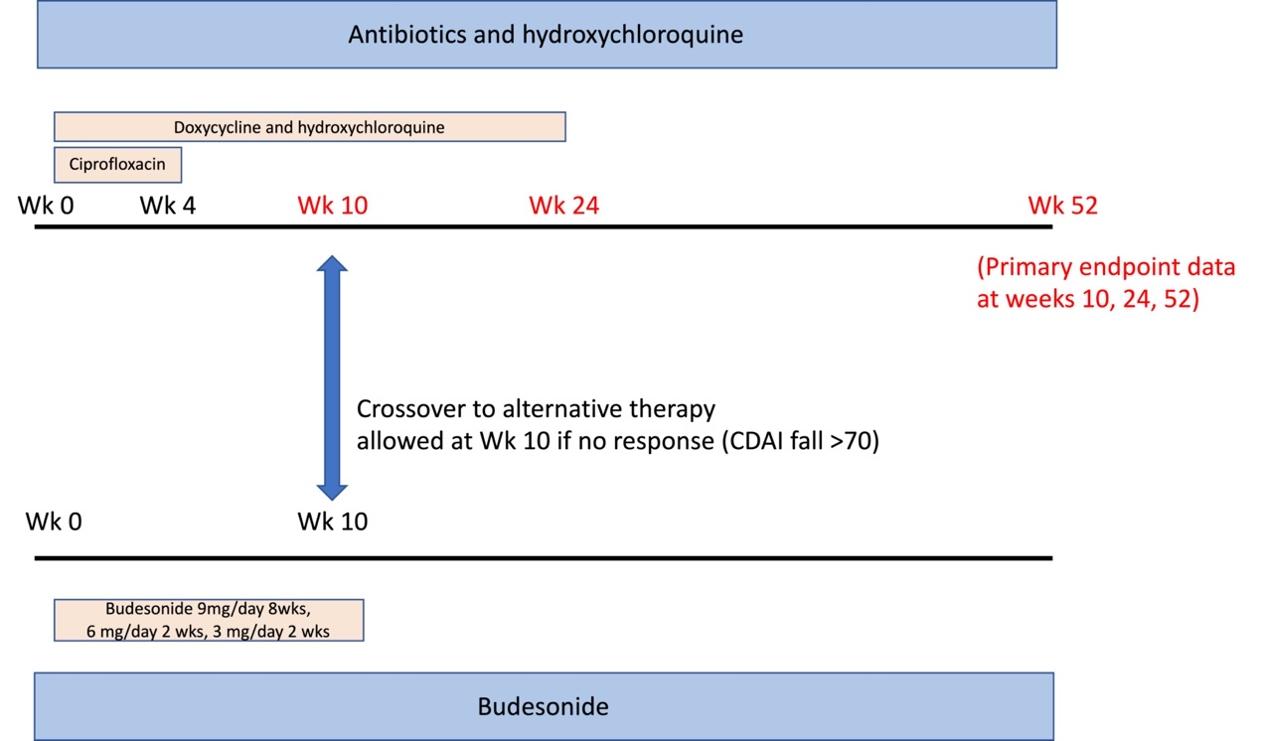

Figure 2.a 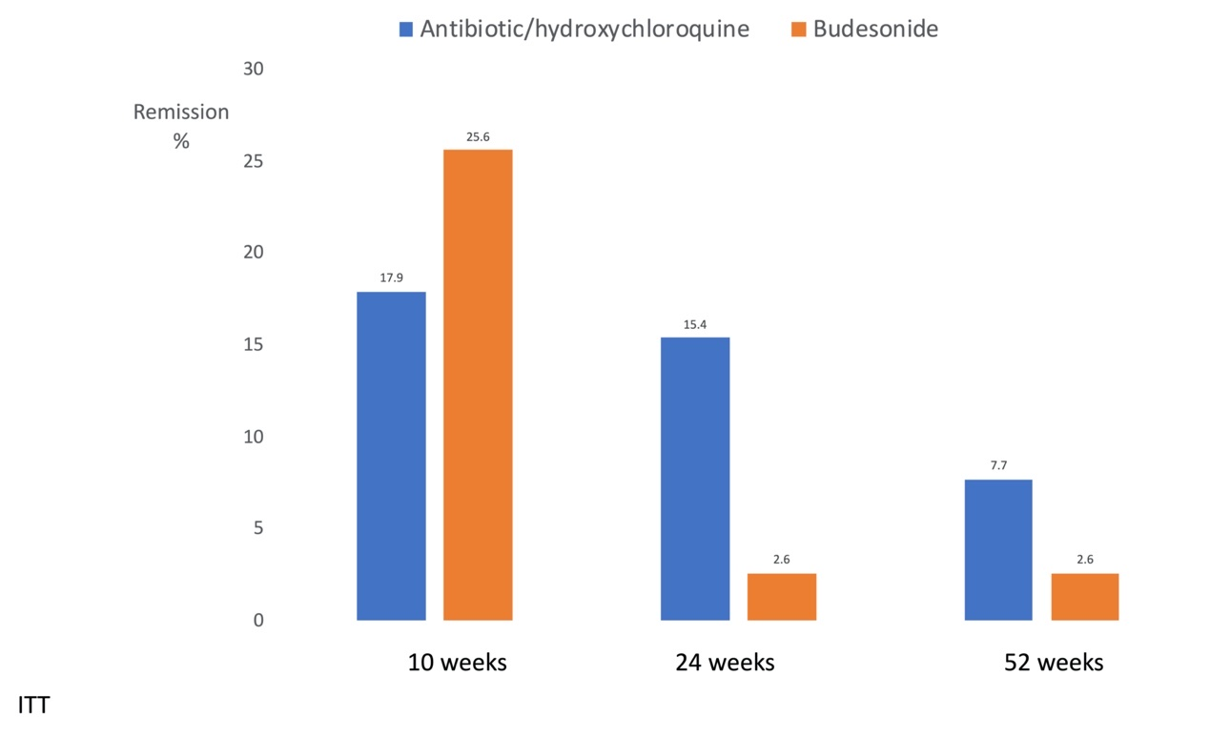

Figure 2B.
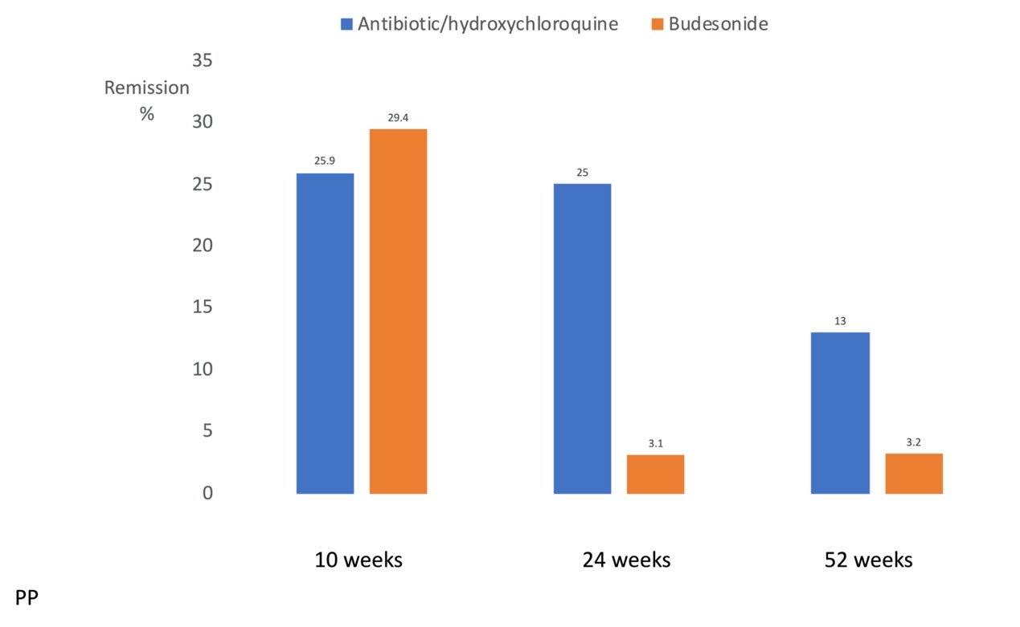

Suppl Fig 1.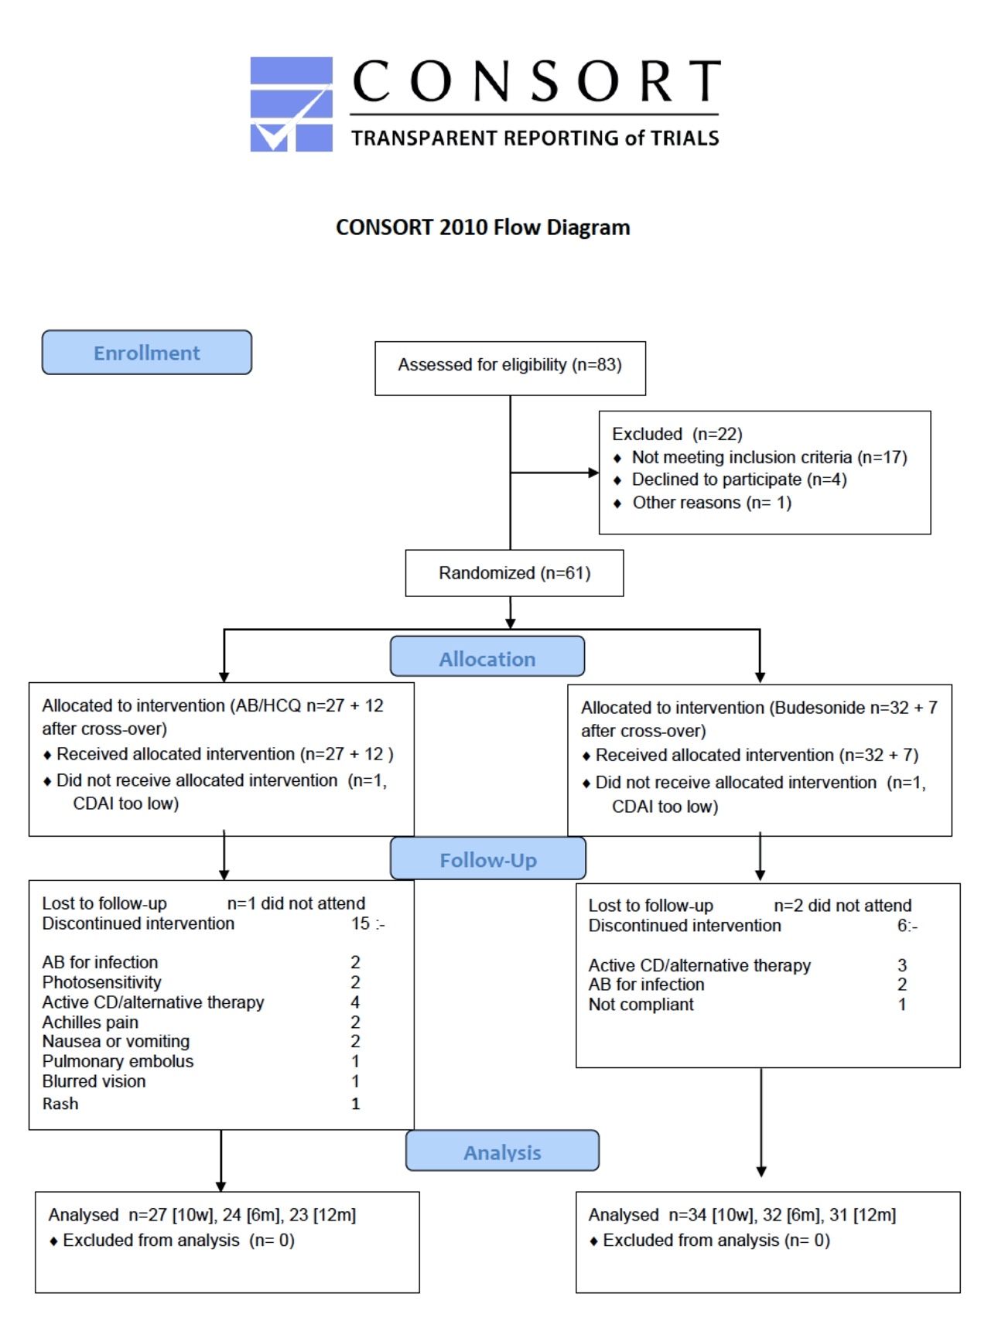

Suppl Fig 2:

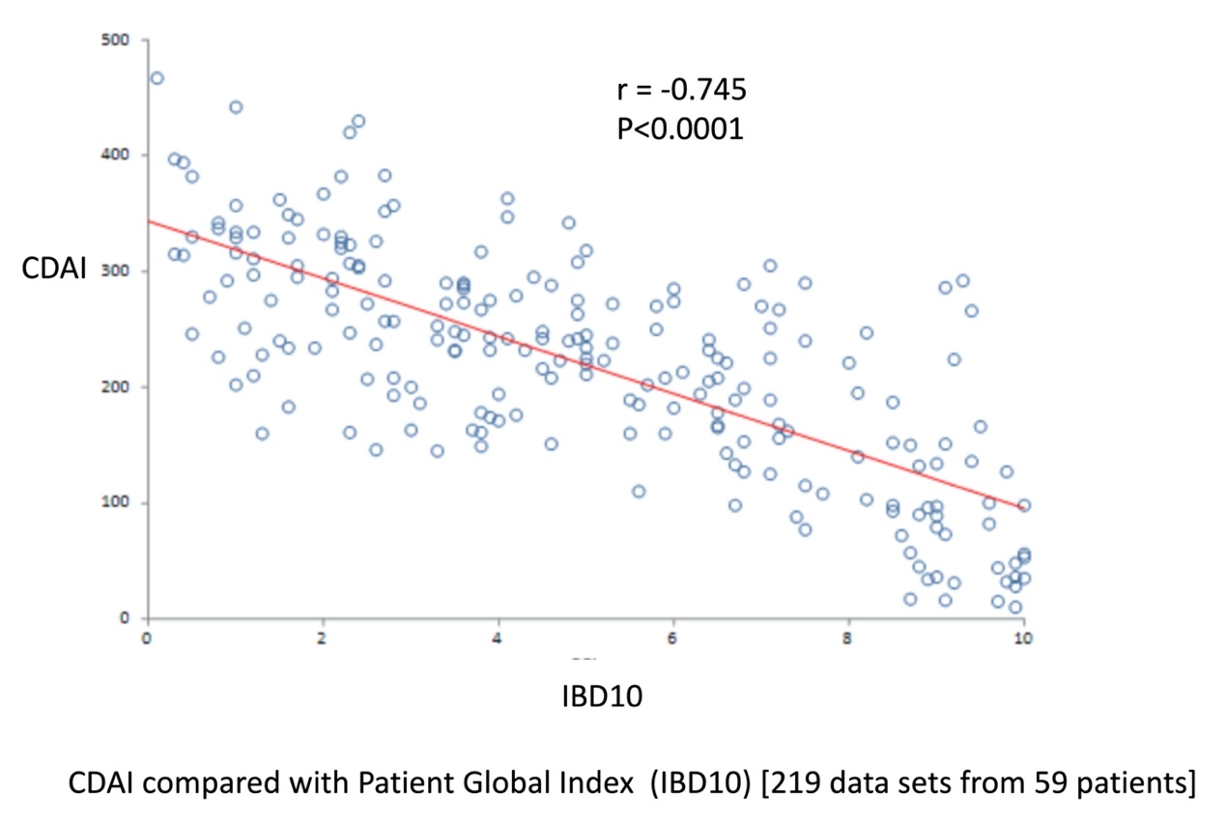

Suppl Fig 3.

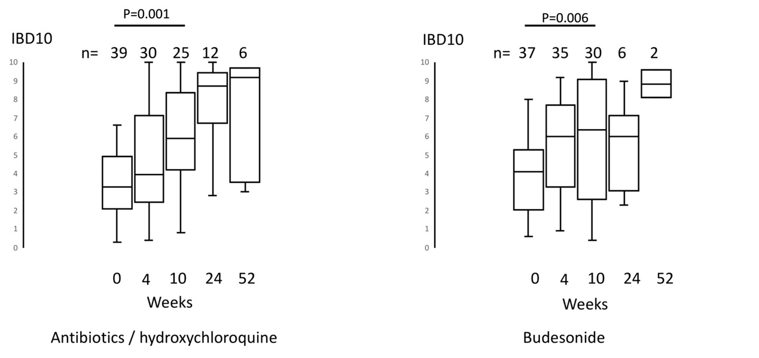

Suppl Fig 4

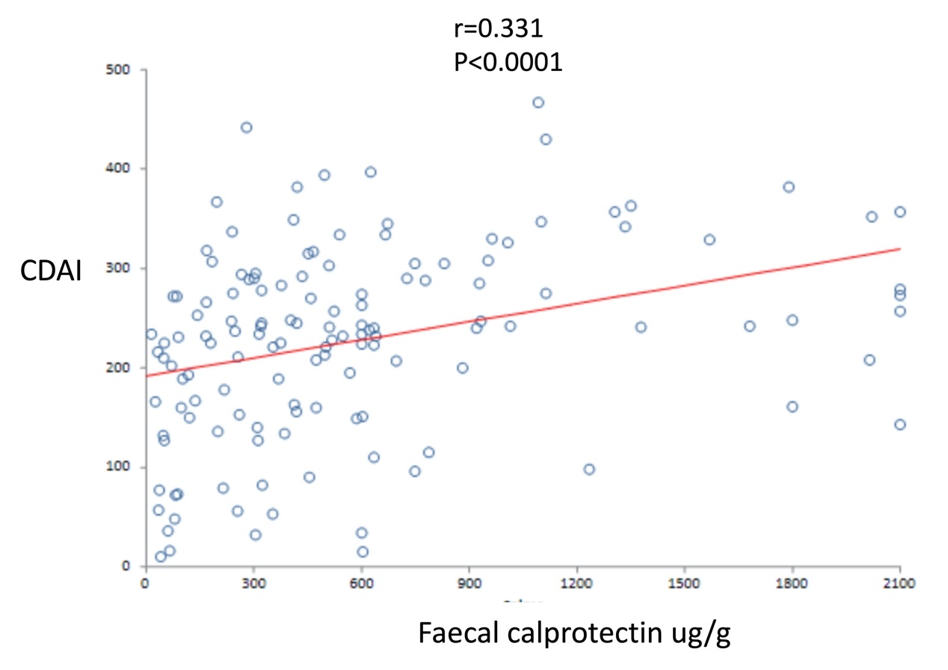
Suppl Fig 5.
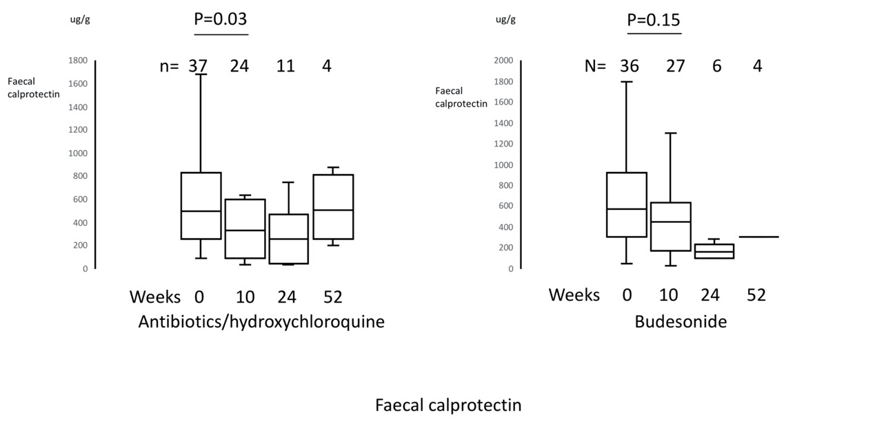

Tables:
Table 1 Demographic data
Baseline: | Antibiotic / hydroxychloroquine |  |  | Budesonide |  |  | P value  (Total AB/HCQ  vs Total budesonide)
 | Initial | Cross-over | Total | Initial | Cross-over | Total
 | n=27 | n=12 | n=39 | n=32 | n=7 | n=39
Male | 18 (66.6%) | 9 (75.0%) | 27 (69.2%) | 18 (56.3%) | 4 (57.1%) | 22 (56.4%) | 0.35
Age (years) | 44.9+/-17.7 | 44.2 +/- 24.2 | 44.7 +/- 19.6 | 43.3 +/- 18.4 | 46.0 +/- 16.5 | 43.8 +/- 17.9 | 0.84
Duration (years)(median[IQR]) | 6 (1-11) | 4 (1.5-7.5) | 5 (1-10) | 3.5 (1.5-12) | 10 (2-19) | 5 (2-13) | 0.64
Age of onset: (Montreal classification)
A1 (</=16) | 2 (7.4%) | 1 (8.3%) | 3 (3.3%) | 3 (9.4%) | 0 | 3 (7.8%) | 1.0
A2 (17-40) | 15 (55.6%) | 5 (41.7%) | 20 (51.3%) | 15 (46.9%) | 4 (57.1%) | 19 (48.7%) | 1.0
A3 (>40) | 10 (37.0%) | 6 (50.0%) | 16 (15.4%) | 14 (43.8%) | 3 (42.9%) | 17 (43.6%) | 1.0
Location: (Montreal classification)
L1 | 8 (29.6%) | 2 (16.7%) | 10 (25.6%) | 8 (25.0%) | 3 (42.9%) | 11 (28.2%) | 1.0
L2 (stratified before randomisation) | 8 (29.6%) | 3 (25.0%) | 11 (28.2%) | 11 (34.4%) | 1 (14.3%) | 12 (30.8%) | 1.0
L3 | 11 (40.7%) | 7 (58.3%) | 18 (46.2%) | 13 (40.6%) | 3 (42.9%) | 16 (41.0%) | 0.82
L2/L3 (colonic involvement) | 19 (70.4%) | 10 (83.3%) | 29 (74.4%) | 24 (75.0%) | 4 (57.1%) | 28 (71.8%) | 1.00
L4 (proximal small bowel disease) | 1 (3.7%) | 0 | 1 (2.6%) | 0 | 1 (14.3%) | 1 (2.6%) | 1.00
Perianal disease | 4 (14.8%) | 1 (8.3%) | 5 (12.8%) | 3 (9.4%) | 2 (28.6%) | 5 (12.8%) | 1.00
Type:
B1 | 23 (85.2%) | 9 (75.0%) | 32 (82.1%) | 26 (81.3%) | 5 (71.4%) | 31 (79.5%) | 1.00
B2 (stricturing) | 4 (14.8%) | 2 (16.7%) | 6 (15.4%) | 4 (12.5%) | 2 (28.6%) | 6 (15.4%) | 1.00
B3 (penetrating) | 0 | 1 (8.3%) | 1 (2.6%) | 2 (6.3%) | 0 | 2 (5.1%) | 1.00
Baseline CRP (mg/l, normal <3)(median [IQR]) | 9 (5-26) | 5.5 (5-11.5) | 9 (5-20) | 8 (5-22)  (n=31) | 9 (5-13) | 8.5 (5-19)  (n=38) | 0.83
Baseline calprotectin (ug/g, normal <100)(median [IQR]) | 487.5 (265-726)  (n=26) | 497 (255-952)  (n=11) | 497 (265-726)  (n=37) | 627.5 (404-963)  (n=30) | 209 (70-286)  (n=6) | 573.5 (307-924) | 0.66
Current smoker | 6 (22.2%) | 0 | 6 (15.4%) | 2 (6.3%) | 0 | 2 (5.1%) | 0.26
Current thiopurine (stratified before randomisation) | 6 (22.2%) | 4 (33.3%) | 10 (25.6%) | 7 (21.9%) | 3 (42.9%) | 10 (25.6%) | 1.00

Table 2 Response to initial therapy course (Primary endpoint data in bold)
Intention to treat analysis:
 | Remission 10w | Remission maintained to 24 weeks | Remission maintained to 52 weeks | Rem. &/or response 10w | Remission  4wk
AB/HCQ | 2/27 | 2/27  (plus 3 10wk responders in remission @24 weeks) | 1/27  (plus 1 10wk responder in remission at 52 weeks) | 9/27 | 4/27
Budesonide | 8/32 | 1/32 | 1/32 | 11/32 | 8/32
Per protocol analysis:

 | Remission 10w | Remission maintained to 24 weeks | Remission maintained to 52 weeks | Rem. &/or response 10w | Remission  4wk
AB/HCQ | 2/20 | 2/17  (plus 3 10wk responders in remission @24 weeks) | 1/17  (plus 1 10wk responder in remission at 52 weeks) | 9/20 | 4/21
Budesonide | 8/28 | 1/26 | 1/25 | 11/28 | 8/30

Table 3 Response to therapy including crossover (Primary endpoint data in bold)
Intention to treat analysis:
 | Remission 10w | Remission maintained to  24 weeks | Remission maintained to  52 weeks | Rem. &/or response 10w | Remission  4wk
AB/HCQ | 7/39 | 6/39  (plus 3 10wk responders in rem @ 24 weeks) | 3/39  (plus 1 10wk responder in rem @ 52 weeks; plus 1 clin rem but withdrawn UTI) | 15/39 | 8/39
Budesonide | 10/39 | 1/39 | 1/39 | 13/39 | 9/39

Per protocol analysis:
 | Remission 10w | Remission maintained to  24 weeks | Remission maintained to  52 weeks | Rem. &/or response 10w | Remission  4wk
AB/HCQ | 7/27 | 6/24  (plus 3 10wk responders in rem @ 24 weeks)  P=0.035 (0.01 needed for significance) | 3/23  (plus 1 10wk responder in rem @ 52 weeks; plus 1 clin rem but withdrawn UTI) | 15/27 | 8/30
Budesonide | 10/34 | 1/32 | 1/31 | 13/34 | 9/37

Table 4. Phenotypic and serological features of the 9 patients who achieved remission at 24 weeks on antibiotics/hydroxychloroquine.

Sex | Age | Duration (y) | Montreal | Colon (L2/L3) | Antibiotic/HCQ  initial/crossover | Thiopurine | Smoker  Y(current)  N (former/never) | CRP  At week 0 | ASCA | OmpC | FlaX | CBir | Fla2
M | 21 | 10 | A1L1B1 | N | Initial | N | N | 8 | N | N | N | N | N
F | 30 | 1 | A2L3B1 | Y | Initial | Y | Y | 74 | N | N | Y | N | Y
M | 54 | 6 | A2L3B1 | Y | Initial | N | Y | 9 | N | N | N | N | N
M | 59 | 0.5 | A3L1B1 | N | Initial | N | N | 9 | N | N | Y | N | N
F | 37 | 1 | A2L3B1 | Y | Initial | N | Y | 7 | N | N | N | N | N
M | 89 | 5 | A3L2B1 | Y | Crossover | Y | N | 30 | N | Y | N | N | Y
M | 47 | 5 | A3L1B2P | N | Crossover | Y | N | 6 | Y | N | N | N | N
M | 29 | 16 | A1L3B1 | Y | Crossover | N | N | 5 | Y | N | N | Y | N
M | 27 | 1 | A2L2B1 | Y | Crossover | N | N | 5 | N | N | N | N | N

Table 5. Adverse events (AEs)
 |  |  |  |  | Budesonide | Antibiotics/HCQ
 |  |  |  |  | n=39 | n=39
Subjects with any AEs |  |  |  |  | 31 | 34
Intensity of worst AE
Mild |  |  |  |  | 12 | 8
Moderate |  |  |  |  | 18 | 19
Severe |  |  |  |  | 1 | 5
Subjects with AEs leading to discontinuation |  |  |  |  | 2 | 11
Adverse events by system
Total |  |  |  |  | 55 | 100
Gastrointestinal
 | Nausea +/-vomiting |  |  |  | 6 | 24
 | Diarrhoea (worsened) |  |  |  | 7 | 9
 | Reflux/heartburn |  |  |  | 1 | 4
 | Anorexia |  |  |  | 0 | 2
 | Abdominal pain (worsening) |  |  |  | 3 | 2
 | Proctalgia |  |  |  | 1 | 2
 | Tenesmus (worsened) |  |  |  | 2 | 1
 | Rectal bleeding |  |  |  | 2 | 0
General disorders
 | Mouth ulcers |  |  |  | 3 | 1
 | Fatigue |  |  |  | 2 | 1
 | Hair loss |  |  |  | 1 | 1
Infections and infestations
 | Respiratory |  |  |  | 7 | 4
 | UTI |  |  |  | 0 | 2
 | Candidiasis |  |  |  | 0 | 6
Nervous system disorders
 | Sleep disturbance |  |  |  | 6 | 8
 | Headache |  |  |  | 4 | 5
 | Mood disturbance |  |  |  | 5 | 3
 | Dizziness |  |  |  | 1 | 1
 | Panic |  |  |  | 1 | 1
Skin and subcutaneous disorders
 | Photosensitivity |  |  |  | 0 | 8
 | Rash |  |  |  | 0 | 3
 | Acne |  |  |  | 1 | 1
 | Eczema (worsening) |  |  |  | 1 | 1
Respiratory, thoracic, and mediastinal disorders
 | Pulmonary embolism |  |  |  | 0 | 1
 | Dyspnoea |  |  |  | 0 | 1
Musculoskeletal disorders
 | Tendopathy |  |  |  | 0 | 2
 | Cramp |  |  |  | 1 | 1
 | Arthralgia |  |  |  | 0 | 5

. DISCUSSION and CONCLUSION
Discussion
In this open-label study we found no significant difference in remission or response rates at 10, 24, or 52 weeks between the antibiotic/hydroxychloroquine combination and a standard 12 week course of budesonide. The study was not powered for non-inferiority. Although remission rates at 10 weeks were (non-significantly) lower for the antibiotic/hydroxychloroquine combination on first treatment course, when crossover data were included similar results were seen with both treatments for remission and response at 10 weeks. The 24 week data also showed no significant difference between the two treatment groups when assessed on intention to treat and using pre-defined thresholds for statistical significance. However, when all patients who were still continuing per protocol were considered, the results were encouraging for the antibiotic/hydroxychloroquine combination with 9 of 24 in remission at 24 weeks. Sustained remission to 24 weeks proved very uncommon (1 of 39 on intention to treat, 1 of 32 per protocol) amongst budesonide-treated patients – who had of course tailed off their therapy by 12 weeks. This might sound “unfair” given that the doxycycline and hydroxychloroquine were continued through to 24 weeks but is justified by the evidence that the efficacy of budesonide is only sustained for around three months, with longer maintenance proving no more effective than placebo.²³ We had hoped that an effective antibiotic/hydroxychloroquine combination might achieve longer remission after cessation of therapy – a more permanent “cure” seemed unlikely given the probability that bacterial invasion would recur. The 52 week data showed a modest signal to support prolonged efficacy, with 4 of 23 in remission at that time point on per protocol analysis, plus one additional patient who had been in clinical remission up till week 51 but then required antibiotics for a urinary tract infection.

Secondary endpoint data included patient global assessment according to the IBD10 scale and faecal calprotectin. The patient global assessment (IBD10) correlated very well with CDAI scores, with further confirmation that an IBD10 score of 8 is equivalent to a CDAI of 150,²² and consequently showed treatment responses comparable to the primary outcome data, with improvements by 10 weeks that were similar for both treatment groups. There was a much weaker correlation between faecal calprotectin and CDAI as reported previously ²⁴ and improvements seen in both treatment arms were modest. Faecal calprotectin has been reported to correlate better with mucosal healing²⁵ and the 9 patients who were in remission at 24 weeks had a median faecal calprotectin of 254 (range 34 to 1234) with 4 of 9 below 70ug/g, one of the lower proposed cut-off values for indicating likely endoscopic remission.²⁵

The antibiotic/hydroxychloroquine combination was selected on the basis of its efficacy against E. coli replicating within macrophages within the laboratory. It is difficult to know what proportion of patients with Crohn’s disease might have E. coli replicating within their tissue macrophages. Prevalence of mucosal E. coli in Crohn’s disease has been reported to range from 21 to 63% of cases.¹ The antibiotic/hydroxychloroquine combination would of course also be effective against other organisms, perhaps most likely other Gram negative bacteria, that could invade the gut and replicate within macrophages.

We had hypothesised that the serological testing might identify patients more likely to be affected by E. coli and thus predict response to antibiotics/hydroxychloroquine. OmpC is an outer membrane porin protein found in Gram negative organisms including E. coli but in this study only 6 of 50 patients with available sera tested positive for OmpC antibody. Anti-Saccharomyces cerevisiae (baker’s yeast) antibody (ASCA) is the best established antibody associated with Crohn’s disease. Its origin is unclear as baker’s yeast is not the only source of its antigen, an oligomannan with a specific mannose alpha 1,3 mannose alpha 1,2 mannose terminal sequence.^{26,27} Other possible microbial sources include Candida albicans and mycobacteria including Mycobacterium avium subspecies paratuberculosis.^{28,29} There is however an intriguing possibility that a key source could be the mannan that acts as the receptor for Gram negative bacterial fimH on glycoprotein 2 (GP2) on microfold (M) cells.³⁰ M cells are present in the dome epithelium that overlies the Peyer’s patches and lymphoid follicles that are the main sites for bacterial invasion and are also thought to be the sites of the initial lesions in Crohn’s disease. There is considerable overlap between ASCA and anti-GP2 serology in Crohn’s disease sera.³¹ Moreover, although the mannan on GP2 has yet to be characterised, the bladder equivalent of GP2 is uroplakin and its mannan receptor for fimH expressed by uropathogenic E. coli has been shown to be oligomannose-3 which also contains the same terminal mannose alpha 1,3 mannose sequence as the ACA epitope.³² It therefore seemed plausible that ASCA positivity might identify Crohn’s disease patients with E. coli invasion. However, in this study there was no correlation between ASCA, either separately, or combined with ompC positivity, and response to the antibiotic/hydroxychloroquine combination.

There is a good case for considering isolated colonic Crohn’s disease as a separate condition from Crohn’s disease affecting the small intestine. ^{33,34} There has also been a suggestion that isolated colonic Crohn’s disease might respond better to antibiotics.³³ In this study we therefore stratified for isolated colonic disease but analysis showed no significant difference in the response to antibiotics/hydroxychloroquine compared with Crohn’s disease at other sites. Careful analysis of the nine patients who were in remission at 24 weeks on the antibiotic/hydroxychloroquine combination again failed to show association with phenotype or serotype. It is possible that a more specific bacterial DNA-based technique is needed, possibly based on detection of circulating Gram negative bacterial DNA which has been shown to predict relapse.³⁵

Side effects were an issue with the ciprofloxacin, doxycycline, hydroxychloroquine combination, particularly in the first month when patients were taking all three drugs. Nausea or vomiting affected 24 of 39 (62%) but was usually transient and only resulted in treatment cessation in two patients. All three drugs are photosensitisers and all patients were warned to minimise direct sunlight exposure and use high strength sun block. Despite this, photosensitivity and/or skin rash affected 11 patients and three had to withdraw from the trial because of this. Ciprofloxacin is known to be associated with risk of tendon rupture and two patients withdrew because of Achilles tendon pain. Hydroxychloroquine is associated with risk of retinopathy but this is related to cumulative dosage, usually over years of therapy. All patients were screened prior to trial entry for any history of visual impairment not corrected by wearing glasses and by testing of visual acuity which was repeated at 10 weeks or early withdrawal. No patient failed screening on these grounds. One patient was withdrawn because of transient blurred vision three weeks after cross-over from budesonide to antibiotics/hydroxychloroquine but this was thought unlikely to be related to the hydroxychloroquine. Six patients developed candidiasis but none stopped trial medication because of this.

We believe that the signals of efficacy seen with the antibiotic/hydroxychloroquine combination, particularly the longer-term remissions, justify further study. It is unfortunate that neither phenotypic information or serology seem to identify patients likely to respond. It is possible that a DNA-based approach probing for E. coli or other Gram negative organisms on faecal or peripheral blood samples might better identify patients likely to respond. Alternatives deserving further study include serological testing for serum anti-E. coli /salivary CEACAM6 index ³⁶ and quantification of faecal IgA-coated E. coli.³⁷

The choice of antibiotics is also an issue. Ciprofloxacin was selected mainly because it showed the greatest in vitro potency against E. coli replicating within macrophages.¹¹ It does however seem to have added considerably to the side-effects sustained within the first month of therapy, particularly nausea, photosensitivity and tendon pain. A future trial might perhaps be confined to long term therapy just with the doxycycline hydroxychloroquine combination. This has proved a successful strategy in both Whipple’s disease¹⁹ and Q fever.¹⁸ The use of only a single antibiotic would of course increase risk of resistance and addition of nitrofurantoin, an antibiotic that has good efficacy against E. coli and a low risk of resistance ³⁸ might also be considered.

Conclusion
Further study of long term doxycycline plus hydroxychloroquine as an adjunct to biologic therapy in Crohn’s disease is merited.

End of Study Clinical Trial Report Approval

This confirms approval of the End of Study Clinical Trial Report for the <<TRIAL NAME>> trial
- A Pilot Randomised Study to Compare Combination Antibiotic Therapy (Ciprofloxacin, Doxycycline and Hydroxychloroquine) with Standard Therapy (Budesonide) in the Treatment of Active Crohn's Disease

Trial Co-ordinator


Name: …………Kate Martin……………………………………………………………………….

Signature:………………………………………………………………………………….

Date: 27/APR /2020

Trial Statistician

Name: ……Dr Graham Horgan…………………………………………………………………………….
Signature: ………………………………………………………………………………….

Date: __27 __/__ 4__ _ /__2020_ __

Chief Investigator

Name: ………Prof C Probert
Signature: … 

Date: 28 / APR / 2020

