Title of Study: Intravenous induction therapy followed by oral therapy vs. oral therapy alone: Randomized study on the treatment of Whipple's disease.
Name or abbreviated title of the trial:
MWD08
EudraCT-Number:
2008-003951-54
Sponsor’s protocol code number:
MWD08
Chief Investigators
Prof. Dr. Dr. Thomas Schneider
Medizinische Klinik I, Infektiologie
Charité – Campus Benjamin Franklin
Hindenburgdamm 30, 12203 Berlin
Tel.: 030 /8445-2286
Fax: 030 /8445-4481
E-Mail: thomas.schneider@charite.de

Co-sponsor Representative
n.A.

Trial Manager
Nadine Sommer
Medizinische Klinik I, Infektiologie
Charité – Campus Benjamin Franklin
Hindenburgdamm 30, 12203 Berlin
Tel.: 030 / 450 614353
Fax: 030 / 450 514945
E-Mail: nadine.sommer@charite.de

Dr. Verena Moos
Medizinische Klinik I, Infektiologie
Charité – Campus Benjamin Franklin
Hindenburgdamm 30, 12203 Berlin
Tel.: 030 / 450 514383
Fax: 030 / 450 7514383
E-Mail: Verena.Moos@charite.de

Trial Statistician
Andrea Stroux
Institut für Medizinische Informatik, Biometrie und Epidemiologie
Bereich Biometrie und Klinische Epidemiologie
Hindenburgdamm 30
D- 12200 Berlin
Tel.: 030 /450 662146
andrea.stroux@charite.de
Participating Sites: n.A; study was monocentric

Publication (reference):
Oral treatment of Whipple’s disease: a randomized controlled trial; Verena Moos, Justina Krüger, Kristina Allers, Annette Moter, Judith Kikhney, Anja A. Kühl, Christoph Loddenkemper, Andrea Stroux, Katina Schinnerling, and Thomas Schneider, submitted

Studied period (years):  07.05.2010 - 05.11.2020 | Phase of development:  Phase II
Introduction
Whipple's disease is a fatal infection with Tropheryma (T.) whipplei if left untreated. The efficacy of antibiotics in the treatment of Whipple's disease has only been demonstrated in case series (1) and in a study that has only been published as an abstract (2).
The current treatment of Whipple's disease is therefore empirical, without an evidence-based foundation such as randomised controlled trials. The latter is a systematic problem due to the rarity of the disease. The rarity of the disease is also the reason why the drugs ceftriaxone, hydroxychloroquine, trimethoprim and sulfamethoxazole have not yet been approved.
Because the pathogen often penetrates the cerebrospinal fluid (3), an induction phase with an antibiotic with good cerebrospinal fluid penetration, usually ceftriaxone, for 2 weeks, followed by maintenance therapy with oral Cotrim for 1 year, is currently recommended in Germany (1, 4). The efficacy of this treatment has been demonstrated in the only randomised clinical trial conducted to date in Whipple's disease (2).
In France, however, the initial intravenous therapy, which is usually administered in hospital, is dispensed with and oral therapy is usually started from the outset on an outpatient basis.
If T. whipplei DNA is not detected in the cerebrospinal fluid, a combination of doxycycline and hydroxychloroquine is used, and if T. whipplei DNA is detected in the cerebrospinal fluid, Cotrim therapy is added (5, 6). There are in vitro data on the efficacy of the latter therapy against T. whipplei (7, 8) and C. burnetii (9) and clinical experience in the treatment of chronic Q fever infections (mostly endocarditis) (10) and M. Whipple (5).

To date, there have been no comparative studies of these two treatment regimens. It is obvious that a purely oral therapy would have some advantages for the patient. Firstly, there would be no need for venous access, which is always associated with a risk of nosocomial infection (11, 12). Secondly, there would be no need for hospitalisation, which significantly limits the patient's radius of action and is associated with higher costs than outpatient therapy.

A possible advantage of initial intravenous induction therapy with ceftriaxone is the good penetration of the antibiotic into the CNS. The planned cerebrospinal fluid studies are therefore of great importance.

Objectives
The aim of this study is to demonstrate non-inferiority of the oral-only compared to the intravenous/oral regime. If this proves to be the case, future patients with this disease may be spared intravenous therapy and the associated hospital stays, doctor visits and additional health risks.

Primary Endpoint:
The main target criterion is complete clinical remission without recurrence during the observation period (Figure 1).

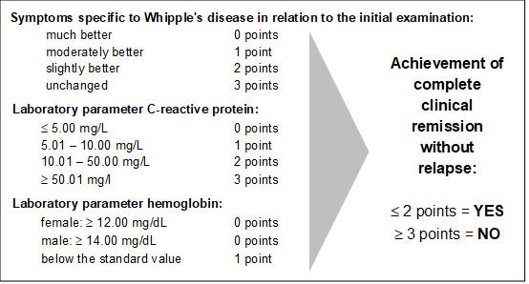

Figure 1: Composite score for evaluation of complete clinical remission at 24 months

Secondary Endpoints:
Histological remission and elimination of the bacterium from the duodenum and the cerebrospinal fluid measured by T. whipplei-specific PCR are defined as secondary target criteria.

Methodology:

Prospective monocentric, randomized controlled clinical trial with parallel comparison of two groups (phase II/III clinical trial)

The study was conducted monocentrically at the Charité, Campus Benjamin Franklin in Berlin/Germany.
With an incidence of 1: 1-2,000,000/per year and the study experience to date, we expected the inclusion of approximately 7 patients per year. We were aiming for a number of 30 patients in each group. We therefore assumed a total study duration of approx. 10 years.

(Recruitment phase with 7 patients/year: 9 years, so with 1 year of treatment and 1 year of follow-up, this resulted in a total duration of approx. 11 years)

Start of recruitment: 01.01.2010
Assumed end of recruitment: 01.01.2020
Assumed end of the study: 01.01.2022

Adaptive 1:1 randomization of the 60 patients included in the study to the two treatment groups was performed using a centralized method involving the drawing of envelopes in three blocks of 20 patients each to enable interim evaluations at visit 3 after inclusion of 20 and 40 patients. However, ten patients who were already on ceftriaxone therapy at inclusion were automatically assigned to group A. The study was open label due to the various modes of antibiotic applications.

Histology
Paraffin-embedded duodenal biopsies were histopathologically assessed by the reference pathologist C. Loddenkemper at inclusion to confirm diagnosis and at follow-ups to evaluate histological remission. Histology was also applied to all other, available tissue samples (eg, lymph node, skin, bone marrow). PAS-positive macrophages were classified as subtypes 1 to 4 according to von Herbay. (14) T. whipplei-specific IHC was applied whenever possible.

PCR
T. whipplei-specific PCR was performed from fresh duodenum, CSF, stool, and urine, in some cases from lymph node, synovial fluid, lung, bone marrow, vitreous punctate, pericard, and ascites as previously described.(15) Paraffin-embedded specimen were re-embedded in methacrylate before sectioning and DNA-extraction. T. whipplei specific real-time PCR of the rpoB gene was used as first line PCR. Every positive sample was confirmed by partial 16S rRNA gene PCR followed by sequencing.(15)

Number of patients (planned and analyzed):
To be allocated to trial: n = 60
To be analyzed: at least n = 60 (Test substence n= 60 ; Placebo n= 0)

Diagnosis and main criteria for inclusion/exclusion:
Inclusion criteria:
- Age > 18 years
- Written consent (according to AMG §40 (1) 3b)
- Negative pregnancy test
- Patients with systemic chronic infection with T. whipplei: Whipple-typical macrophages were detected in the small intestine biopsy or extraintestinally, which can be visualized in the periodic acid-Schiff (PAS) staining, or positive PCR results for T. whipplei with sequencing from cerebrospinal fluid or alternative available tissue (from the reference laboratory of the study)

Exclusion criteria:
- Pregnancy and lactation; lack of safe contraceptive measures
- All contraindications to test medication (including excipients of the dosage form). A known allergic reaction to one of the substances to be used is not initially a criterion for exclusion. Substitute preparations are provided for these cases
- Lack of willingness to store and pass on pseudonymized disease data in the context of the clinical trial
- Participation in a clinical trial within the last 30 days before the start of this trial, as well as simultaneous participation in other clinical trials or research projects
- Placement in an institution by court or official order
- Antibiotic therapy that has already lasted longer than one month
- Previous and unsuccessful antibiotic therapy for Whipple's disease
- Recurrence of Whipple's disease after previous antibiotic therapy
- Manifest severe tumor disease
- HIV infection
- Lack of willingness to cooperate
- History of hypersensitivity to the ingredients of the test substances/medicines or chemically related substances
- Persons who are in a dependent / employment relationship with the sponsor or investigator

Randomized IMP treatment was:

Arm 1: Group A)
14 days Ceftriaxone 2g intravenously once daily,
then 12 months trimethoprim 160mg and sulfamethoxazole 800mg (cotrimoxazole forte) twice daily orally

Arm 2: Group B)
12 months Doxycycline 2x100mg daily + Hydroxychloroquine 2x200mg daily
(in case of cerebral involvement additionally trimethoprim 160mg and sulfamethoxazole 800mg (cotrimoxazole forte) 5x daily until PCR negative, thereafter 2x daily)

Test product, dose and mode of administration, batch number:
Oral Doxycycline 2x100mg daily + Oral Hydroxychloroquine 2x200mg daily
(in case of cerebral involvement additionally oral trimethoprim 160mg and sulfamethoxazole 800mg (cotrimoxazole forte) 5x daily until PCR negative, thereafter 2x daily)
Batch number was not applicable since the duration of the trial was too long.

Duration of treatment:
12 months

Reference therapy, dose and mode of administration, batch number:
14 days Ceftriaxone 2g intravenously once daily,
then 12 months trimethoprim 160mg and sulfamethoxazole 800mg (cotrimoxazole forte) twice daily orally.
Batch number was not applicable since the duration of the trial was too long.

Efficacy and Safety Variables

The schedule of the trial was:
- Screening, information, consent with Esophagogastroduodenoscopy (EGD) (with biopsies for PCR and histology), cerebrospinal fluid (CSF) puncture (laboratory parameter and PCR), analysis of blood laboratory parameters and physical examination
- Randomization to arm a) or b) and start of treatment
- Visit I (optional); 14 days after initiation of treatment with analysis of blood laboratory parameters and physical examination
- Visit II, III and IV, 3 months (analysis of blood laboratory parameters and physical examination), 6 months (EGD, CSF puncture, analysis of blood laboratory parameters and physical examination) and 12 months (EGD, analysis of blood laboratory parameters and physical examination) after initiation of treatment
- follow-up (final visit) 12-15 months after the end of treatment (EGD, CSF puncture, analysis of blood laboratory parameters and physical examination)

Efficacy Evalution
- Data Sets Analysed
All patient included were analysed in Intention to treat Analysis and in per-protocol analysis 25 patients for Arm A and 27 patients for Arm B were included (Figure 2)

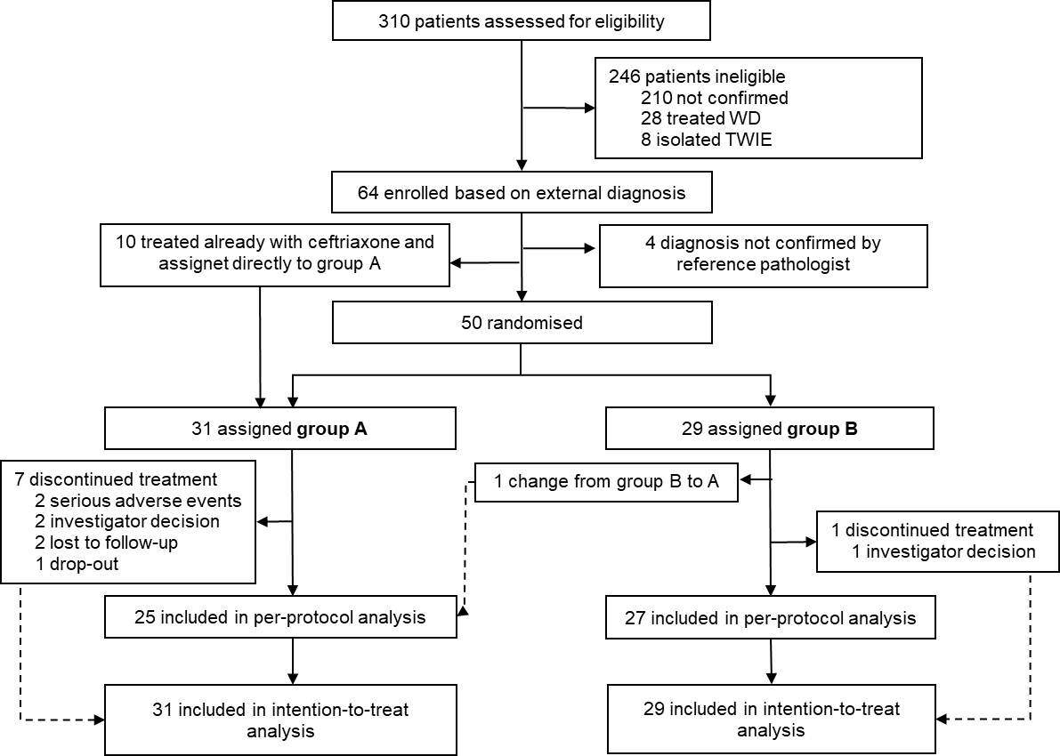

Figure 2: Recruitment of 60 study participants from 310 screened patients from 2010-2018. WD: Whipple’s disease, TWIE: T. whipplei-induced infective endocarditis

-Demographic / Baseline Characteristics

 | Intraveneous (Group A)  (n=31) | Oral (Group B)  (n=29)
Sex
Male | 18 (58%) | 18 (62%)
Female | 13 (42%) | 11 (38%)
Age at first manifestation (years) | 47 (37–57) | 53 (45–60)
Age at diagnosis of WD (years) | 55 (49–64) | 62 (56–68)
Time from first manifestation  to diagnosis (years) | 8 (3–11) | 5 (3–10)
Height (cm) | 169 (165–178) | 171 (164–173)
Weight (kg) | 62 (51–68) | 65 (58–78)
Body-mass index (kg/m²) | 20·5 (17·9–24·1) | 22·6 (20·5–25·5)
Previous use of immunosuppressants | 19 (61%) | 16 (55%)
General condition
Good  Slightly reduced  Reduced  Seriously reduced | 3 (10%)  6 (19%)  15 (48%)  7 (23%) | 4 (14%)  3 (10%)  19 (66%)  3 (10%)
Erythrocyte sedimentation rate (mm/h) | 62·5 (23–79)ª | 34·5 (22–52)ª
Hemoglobin level (g/dL) | 10·8 (9·8–12·4) | 11·7 (11–12·9)
White blood cell count (/nL) | 10·9 (8·4–14·4) | 11·6 (9·3–15·7)
Neutrophils (%) | 83 (75–86)^{c} | 84 (77–88)^{d}
Lymphocytes (%) | 11 (7–17)^{c} | 9 (6–16)^{d}
C-reactive protein level (mg/L) | 76 (39–118) | 72 (33–98)
Data are n (%), or median (IQR). There were no significant differences between the two groups, except for the body-mass index (p=0·036). ªn=22; ^{b}n=30; ^{c}n=25; ^{d}n=23.

Table 1: Patient’s characteristics and laboratory values at baseline

 | Intravenous  (Group A)  (n=31) | Oral  (Group B)  (n=29)
Joint manifestations
Arthritis | 24 (77%) | 26 (90%)
Arthralgia | 30 (97%) | 27 (93%)
Joint swelling | 25 (81%) | 24 (83%)
Tendon-muscle pain | 19/30 (63%) | 19/28 (68%)
Gastrointestinal manifestations
Malabsorption | 30 (97%) | 26 (90%)
Weight loss | 25 (81%) | 22 (76%)
Lost weight (kg) | 12 (8·5–15) | 10 (6–15)
Period of weight loss (months) | 6 (3–7·5) | 6 (3–12)
Diarrhea | 19 (61%) | 15 (52%)
Abdominal pain | 14 (45%) | 11/28 (39%)
Meteorism | 8 (26%) | 11 (38%)
Nausea | 10 (32%) | 5 (17%)
Emesis | 4 (13%) | 3 (10%)
Loss of appetite | 12/30 (40%) | 8/28 (29%)
Neurological symptoms | 11 (37%) | 7 (25%)
Depressed mood | 7/11 (64%) | 3/7 (43%)
Visual disturbances | 6/11 (55%) | 5/7 (71%)
Balance disorders | 5/11 (45%) | 1/7 (14%)
Concentration disorder | 5/11 (45%) | 2/7 (29%)
Headache | 5/11 (45%) | 2/7 (29%)
Memory disorders | 4/11 (36%) | 2/7 (29%)
Dizziness | 3/11 (27%) | 2/7 (29%)
Sleep disorders | 3/11 (27%) | 3/7 (43%)
Ataxia | 2/11 (18%) | 0/7 (0%)
Myclonia | 1/11 (9%) | 0/7 (0%)
Further symptoms
Performance reduction | 30 (97%) | 26 (90%)
Lymphadenopathy | 15 (48%) | 14 (48%)
Fever | 15 (48%) | 8 (28%)
Night sweats | 15 (48%) | 12 (41%)
Peripheral edema | 11 (35%) | 10 (34%)
Endocardial/pericardial involvementª | 6 (19%) | 2 (7%)
Pleural effusion | 8 (26%) | 5 (17%)
Ascites | 4 (13%) | 4 (14%)
Polyneuropathy | 3 (10%) | 5 (17%)
Data are n (%), median (IQR), or n/N (%). There were no significant differences between the two groups.ªEndocarditis, pericarditis and/or pericardial effusion.

Table 2: Clinical symptoms of the patients at baseline

Safety and security
Patients are asked about adverse events and intolerances at each study visit. All incidents are documented in the CRF.

In individual cases if the following clinical symptoms persist 4 weeks after the start of therapy:
- More than 4-5 mushy bowel movements per day
- Persistent weight loss
- CRP values of more than 10mg/l
- if hypersensitivity to all of the possible study medication occurs
- if a life-threatening serious adverse event probably associated with the medication occurs.

The entire study is discontinued if:
- The planned interim analysis of the study data following inclusion of 20 and 40 patients, respectively, shows that one of the trial medications is inferior
- the risk-benefit ratio for the patients changes significantly
- the head of the clinical trial deems it necessary to discontinue the study for safety reasons
- the use of the study medication is no longer justifiable
- the study proves to be unfeasible

Statistical methods:

Estimation of case numbers
Based on previous clinical and epidemiological data and considering an inclusion rate of seven patients per year, the number of cases was calculated to 30 patients per group based on a power of 80% with a significance level of α=5% to prove non-inferiority.

Analysis of data:
Binary variables are compared by chi²-test, metric variables are described using median and interquartile range, tested for normal distribution, and are compared using the t-test for unpaired samples or using the Mann-Whitney U-test. All tests are performed two-sided.
A non-inferiority margin of -18 percentage-points was based on the case number estimate and the results of the previous study. The risk difference between the two groups regarding the primary endpoint is determined by subtracting the success rates of group A from group B and is calculated based on the Newcombe method with 95% confidence interval (CI). In order to adjust for possible confounders or to identify possible predictors, a binomial logistic regression with forward/backward selection is performed as the measurement level of the dependent target variable is binary. The model coefficients, odds ratios and 95% CI are calculated. Probabilities of recurrence-free survival are presented in Kaplan-Meier curves and tested for significance using the logrank test, hazard ratio was calculated with Mantel Haenszel. Missing values are imputed using the last-observation-carried-forward method, and p values <0.05 are considered significant.

Summary - Conclusions
Efficacy Results:
During a mean observation period of 25 ± 1.8 and 26 ± 4.7 months in group A and B, respectively, in ITT analysis, 25 of the 31 patients (80.6 %) from group A and 28 of 29 patients (96.6%) from group B achieved complete clinical remission (Figure 3), which was 6.7 times more likely in group B compared to group A (OR 6.72; 95% CI 0.759–59.722).

In the PP analysis, 21 of the 25 patients (84.0%) from group A and 26 of the 27 patients (96.3%) from group B achieved complete clinical remission (Figure 3) and the odds ratio of 4.95 (95% CI 0.541–47.721) also shows that cure was more likely in group B.

The non-inferiority margin was predefined as -18 percentage points. Using the Newcombe method, non-inferiority of group B compared to group A was confirmed. In both, the ITT and PP analyses, the lower bound of the one-sided 95% CI for the risk difference between the groups was -1.2 and -5.2, respectively, (Figure 3) and thus, the primary endpoint of our study demonstrated that a sole oral treatment (group B) is non-inferior compared to the combination of intravenous and oral treatment (group A).
During follow-up, none of the participants developed recurrence of WD, but two of the patients treated in group A died from nosocomial pneumogenic sepsis and subsequent septic shock following MRSA infection and recurrent pneumonia with MRSA infection and subsequent cardiogenic shock, respectively (details see supplemental).
In a logistic regression analysis, none of the potential confounders such as age at diagnosis, BMI, time between initial manifestation and diagnosis, and assignment to the study arm, were found to have a significant impact on the endpoint. A backward selection showed that the treatment group was the only remaining influencing variable for the ITT analysis (p=0.087), while the PP analysis was not influenced by it (details in supplementary Table 2 and 3).

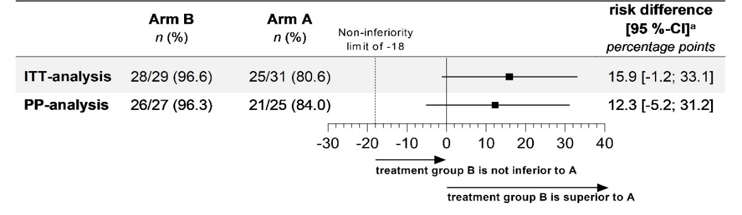
Figure 3: Composite outcome of complete clinical remission at 24 months. Point estimates and two-sided 95% confidence intervals are shown for the treatment effect, defined as the risk difference for complete remission between groups in the intention-to-treat (ITT) and per protocol (PP) analysis. The non-inferiority margin for doxycycline and hydroxychloroquine as compared with the combination of ceftriaxone and TMP-SMX was −18 percentage points. For ITT and PP analysis, the lower end of the two-sided 95% confidence interval of the risk difference in the composite of complete remission at 24 months was at -1.2 and -5.2 percentage points, respectively, which met the pre-specified alpha level. Categorical data presented as number n (%); ITT analysis = intention-to-treat; PP = per protocol; CI = confidence interval; a two-sided CI for group comparison was calculated using the Newcombe method.

Safety Results:
There was no difference between both groups regarding occurrence of SAEs (p=0.244): Overall, 49 SAEs in 13 of the 31 patients (41.9%) of group A and 12 SAEs in 8 of the 29 patients in group B (27.6%) were recorded (Table 3, for details see supplemental and supplemental Table 4). Two deaths due to septic and cardiogenic shock, respectively, of multimorbid patients included into group A occurred 11 and 15 months after start of treatment and were probably not related to the treatment but a consequence of nosocomial MRSA infection. A C. difficile infection under treatment with ceftriaxone in group A, and in group B a severe allergic reaction that resulted in change to group A and one episode of nausea/vomiting and dizziness (all category 3) were probably treatment-associated, but for 52 SAEs of category 3 and 3 life-threatening events of category 4 a connection with the treatment seems unlikely.
An immune reconstitution inflammatory syndrome (IRIS) was diagnosed in 7 patients from group A and 2 from group B. Prior to the study, 88.9% of the 9 affected patients received immunosuppressive treatment, which was slowly phased out after the start of treatment for WD but still increased the risk of developing IRIS significantly (p=0.044; OR=7.111; 95% CI 0.828–61.069).

 | Intraveneous (Group A) | Oral (Group B)
Serious adverse events
Total | 49 in 13 patients | 12 in 8 patients
Death from any cause | 2ª/31 (6%) | 0/29 (0%)
Fever | 13/31 (42%) | 0/29 (0%)
Immune reconstitution inflammatory syndrome | 11/31 (36%) | 2/29 (7%)
Pneumonia | 4/31 (13%) | 0/29 (0%)
Shock/ cardiovascular arrest | 4/31 (13%) | 0/29 (0%)
Hypertensive crisis | 1/31 (3%) | 0/29 (0%)
Malignant disease | 1/31 (3%) | 1/29 (3%)
Clostridioides-difficile-infection | 1^{b}/31 (3%) | 0/29 (0%)
Ischemic stroke | 1/31 (3%) | 0/29 (0%)
Allergic reaction | 0/31 (0%) | 1^{c}/29 (3%)
Further events | 11/31 (36%) | 8/29 (28%)
Study discontinuations
Total | 7 of 31 patients (23%) | 1 of 29 patients (3%)
Drop-out | 1/31 (3%) | 0/29 (0%)
Investigator-caused discontinuation
Malignant disease | 1/31 (3%) | 1/29 (3%)
Pregnancy | 1/31 (3%) | 0/29 (0%)
Lost to follow-up | 2/31 (6%) | 0/29 (0%)
Death | 2ª /31 (6%) | 0/29 (0%)
Data are n/N (%). ª as the final consequence of nosocomial MRSA infection; ^{b} In temporal relation to ceftriaxone administration; ^{c} With doxycycline and hydroxychloroquine intake, resulting in a change to group A.
Table 3: Serious adverse events and study discontinuations in both groups
Conclusion:
Sole oral treatment of WD is non-inferior to sequential intravenous/oral treatment and safe. Oral treatment facilitates patient management and may reduce hospital-acquired complications and costs.
Date of the report: 19.07.2024

