Title of Study:
A comparative efficacy and safety of cetylpyridinium chloride 1 mg/benzydamine hydrochloride 3 mg fixed combination lozenges in subjects with sore throat associated with upper respiratory tract infections

Responsible investigator:
Dr. Sergey A. Karpischenko

Study sites:
RUSSIAN FEDERATION
1. State Educational Institution of Higher Professional Institution "St. Petersburg State Medical University n.a. I.P. Pavlov" of Roszdrav
Responsible investigator:
Prof. Sergey Anatolievich Karpischenko

2. State Educational Institution of Higher Professional Institution "St. Petersburg State Medical Academy n.a. I.I. Mechnikov" of Roszdrav
Responsible investigator:
Prof. Alexander Nikolaevich Paschinin

3. St. Petersburg State Healthcare Institution "City Hospital of St. George"
Responsible investigator:
Dr. Veronika Borisovna Popova

SLOVENIJA
4. Chair of family medicine, Faculty of Medicine, University of Ljubljana
Responsible investigator:
Doc.dr. Mateja Bulc, MD, PhD

Studied Period :  First subject in (enrolled):  26.4.2011  Last subject out (completed) :  15.6.2011 | Phase of development: III
Objectives:
- To assess the parameters of the treatment effect of the test investigational medicinal product (TIMP) and the reference investigational medicinal product (RIMP) in comparison with placebo
- To assess the safety profile of TIMP in comparison with RIMP and placebo
- To evaluate the adequacy of efficacy and safety variables for the application in further studies with TIMP

Methodology/Study Design:
A randomised, partially blind, placebo-controlled parallel study. A single dose, single visit of investigational medicinal product was applied and clinical assessment made within 3 hours after the drug administration. The assessment followed the schedule of the assessment intervals 3 minutes at the beginning followed by 15 minutes till the completion. The efficacy and safety during the active period was assessed at 5 visits.
Number of patients:
Planned: 60
Analysed (per-protocol analysis): 60
Altogether sixty subjects were enrolled in the study: 20 of these subjects were randomized to receive reference drug, other 20 were randomized to receive test drug and 20 to receive placebo. All enrolled subjects successfully completed the study.
Diagnosis and main criteria for inclusion:
Sore throat associated to upper respiratory tract infections (URTI)
Inclusion criteria:
- Subjects with a sore throat associated with URTI
- Both sexes, age range 18-65 years
- Written informed consent
- Onset of sore throat ≤ 6 days
- ≥ 3 points on the 10 point Tonsillopharyngitis assessment (TPA) score
- Moderate to severe sore throat pain defined as a score ≥ 60 mm on the 100 mm Sore Throat Pain Intensity Scale (STPIS)
- The ability to read and understand how to use Visual assessment scales

Reference investigational medicinal product: GOLA ACTION orosoluble tablets, 3mg/1mg
Randomisation group: B
Dose and mode of administration: a single dose of one orosoluble tablet (benzydamine hydrochloride 3 mg / cetylpyridinium chloride 1 mg
Batch number: 10002
Test investigational medicinal product: SEPTOLETE TOTAL lozenges, 3mg/ 1 mg
Randomisation group: C
Dose and mode of administration: a single dose of one orosoluble tablet (benzydamine hydrochloride 3 mg / cetylpyridinium chloride 1 mg
Batch number: L59136
Placebo
Randomisation group: A
Dose and mode of administration: a single dose of one placebo lozenge
Batch number: SDS2010
Duration of treatment :
A single dose of TIMP, RIMP or placebo was administered and followed-up for 3 hours.

Efficacy criteria for evaluation:
Primary endpoint:
- Total pain relief (TOTPAR_{3-180min}) assessed over the time period of 3 to 180 minutes after the IMP application.

Secondary endpoints:

- Percent of maximal Total pain relief (%max TOTPAR _{3-180min}),
- Percent of responders (% RESP),
- Sore throat Pain relief (STPAR),
- Time to sore throat pain relief (TSTPAR),
- Sore throat pain intensity differences (STPID_{3-180min})
- Sore throat pain intensity (STPI)
- Swollen throat differences (STD_{15-180min})
- Swollen throat (ST)
- Difficulty in swallowing differences (DSD_{15-180min})
- Difficulty in swallowing (DS)

Criteria for safety evaluation:
- Overall incidence of adverse reactions (drug-related adverse events)
- Incidence of adverse reactions stratified by specific type of adverse reaction
- A number/percent of subjects unable to finish the clinical assessment due to clinically significant adverse reaction

Statistical methods:
PRIMARY EFFICACY VARIABLE
The superiority of TIMP AND RIMP over placebo and the extent of the TIMP efficacy with respect to RIMP were tested.
TOTPAR_{3-180min} score, which was calculated as Area under curve (AUC) is based on an analysis of covariance (ANCOVA) model with center and treatment as factors, and baseline pain intensity score as covariate; pairwise treatment comparisons will be estimated by differences in least square means with their corresponding 95% confidence interval.
The primary efficacy hypothesis test was performed using a 5% overall significance level.

SECONDARY EFFICACY VARIABLES
For secondary efficacy variables, %maxTOTPAR_{3-180min}, STPID_{3-180min}, STD_{15-180min}, and DSD_{15-180min}, the similar ANOVA or ANCOVA models as for the primary variable was used.
Secondary efficacy variables STPAR, STPI, ST and DS, were analysed using a Mixed Model Analysis for repeated measurements. Fixed factors in the model were treatment groups (TIMP, RIMP and placebo) and the assessments times.
TSTPAR was analyzed using survival analysis methods.
% RESP was analyzed by means of a Fisher’s exact test.
For the secondary endpoints, hypothesis tests were performed individually at the 5% significance level.

Summary statistics consists of sample size, frequencies and corresponding percentages for categorical variables. For continuous variables, descriptive statistics (number of available observations, mean, median, standard deviation, minimum and maximum are tabulated.
Baseline characteristics are summarized by treatment group using appropriate descriptive statistics.

Statistical analysis was performed on the locked data files using appropriate software (SPSS version 17.0).

Summary of results and conclusions:

EFFICACY RESULTS:
Primary efficacy variable (TOTPAR_{3-180min})
Point estimates for placebo, TIMP and RIMP were 328.6, 504.5 and 575, 5, respectively.
Statistically significant greater pain relief has been demonstrated of both TIMP and RIMP in comparison with placebo. Point estimate of the difference between TIMP and placebo were 175.92 (p = 0,034) while the difference between RIMP and placebo was 246, 905 (p= 0,004). There was no significant difference between the two active treatments.

Figure 1: Box plot presentation for TOTPAR3-180min by therapy

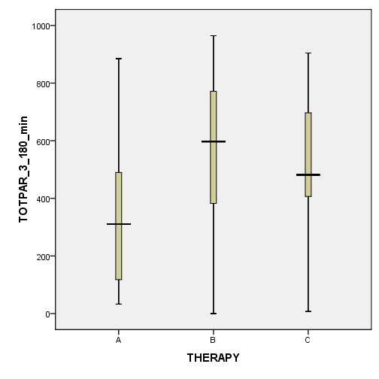
Note: Box-plot presentations display median values, quartiles and min/max values

Secondary efficacy variables

- %max TOTPAR _{3-180min})
Similarly to primary efficacy variable, the %max TOTPAR _{3-180min} has shown that both TIMP and RIMP were significantly more effective in relieving sore throat. Point estimates for placebo, TIMP and RIMP were 31.82 %, 48, 43 % and 53, 48 %, respectively. The difference between TIMP and placebo was 16, 6 % (p = 0,034) while the difference between RIMP and placebo was 21, 6 % (p= 0,006). There was no significant difference between the two active treatments.

- % RESP
The definition of a responder to therapy has been set to 33% of % max TOTPAR, i.e. 33 % pain relief with respect to maximal possible pain relief at all measurement points. In placebo group 40 % of subjects responded to the therapy, in TIMP group 80% and in RIMP group 85%. The differences between placebo and both active treatments were significant. There was no significant difference between the two active treatments.

Figure 2: Distribution of the secondary efficacy variable %RESP
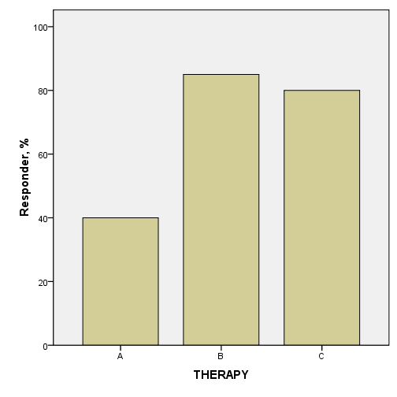
- STPAR
The point estimates for mean pain relief score over 3- 180 minutes according to direct pain relief scale measurements for placebo, TIMP and RIMP were 2,01 points, 2,81 points and 2, 92 points , respectively. The difference between placebo and RIMP was 0.909 (p=0.032) and between the placebo and TIMP 0.79 (p=0.059). The latter difference was of borderline significance. There was no significant difference between the two active treatments.

Figure 3: STPAR scores over the therapy assessment interval of 3-180 minutes
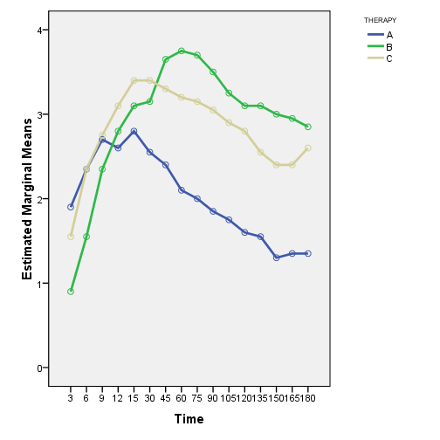
- TSTPAR
The TSTPAR was defined as the time of the onset of relief of at least 1 point on the STPAR scale with at least 3-point score at each of the following two measurements.
Point estimates of TSTPAR for placebo, TIMP and RIMP were 58, 9 min, 29, 10 min and 36, 45 min, respectively. TIMP and RIMP tended to have considerably faster onset of action, yet the differences were not statistically significant.

- STPID_{3-180min}
The variable denotes the difference in pain intensity score over the 0 to 3 hour interval with respect to baseline values. The variable is calculated as AUC.
Significantly greater difference in pain intensity was shown between both active treatments and placebo with no significant difference between the two active treatments.

- STPI
The variable denotes the mean pain intensity score (mm) over the interval of 3 - 180 minutes assessed by the visual analogue pain intensity scale. The point estimates for STPI for placebo, TIMP and RIMP were 54, 59 mm, 41, 92 mm and 40, 24 mm, respectively.
The difference between placebo and RIMP was 14, 35 mm (p=0.03) and between the placebo and TIMP 12, 67 mm (p=0.055). The latter difference was of borderline significance. There was no significant difference between the two active treatments.

Figure 4: STPI mean values over the therapy assessment interval of 3-180 minutes
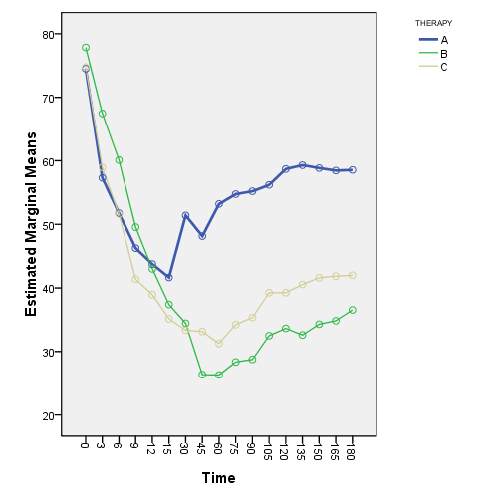

- STD_{15-180min}
The variable denotes the difference in swollen throat score over the 0 to 3 hour interval with respect to baseline values. The variable is calculated as AUC.
The point estimates tended to show greater difference in swollen throat symptom intensity in active treatment groups compared to placebo, yet these differences didn't reach statistical significance. There was no significant difference between the two active treatments.

- ST
The variable denotes the mean swollen throat score (mm) over the interval of 15 - 180 minutes assessed by the visual analogue swollen throat scale. The point estimates for ST for placebo, TIMP and RIMP were 26, 77 mm, 21, 44 mm and 28, 46 mm, respectively.
The difference between placebo and RIMP was 1,696 mm in favour of placebo and between the placebo and TIMP 5,331 mm in favour of TIMP. These differences were not statistically significant. There was no significant difference between the two active treatments.

- DSD_{15-180min}
The variable denotes the difference in difficulty swallowing score over the 0 to 3 -hour interval with respect to baseline values. The variable is calculated as AUC.
The point estimates tend to show greater difference in difficulty swallowing symptom intensity in active treatment groups compared to placebo, yet these differences didn't reach statistical significance. There was no significant difference between the two active treatments.

- DS
The variable denotes the mean difficulty swallowing score ( mm) over the interval of 15 - 180 minutes assessed by the visual analogue difficulty swallowing scale. The point estimates for ST for placebo, TIMP and RIMP were 46, 35 mm, 37, 79 mm and 33, 62 mm, respectively.
The difference between placebo and RIMP was 12,727 mm in favour of RIMP and between the placebo and TIMP 8,558 mm in favour of TIMP. These differences were not statistically significant. There was no significant difference between the two active treatments.

SAFETY RESULTS:
All three therapies were equally well tolerated. There were no adverse events reported during the course of the treatment follow-up.

Conclusions:
The study demonstrated superiority of both TIMP and RIMP over the placebo treatment in all the key endpoints of sore throat pain, sore throat pain relief and percent of responders to therapy.
Time to affect onset was shorter in both active treatments compared to placebo, but the difference was not statistically significant. The time to onset of TIMP was around 5 minutes shorter compared to RIMP but it was not statistically significant.
In some secondary endpoints which are related to other symptoms such as the feeling of swollen throat or difficulty of swallowing, there was a trend towards better effect of active treatments but it does not reach statistical significance, presumably due to high data variability and the fact that study has been statistically designed with respect to primary endpoint statistical features.
As for the comparison between the TIMP and RIMP there was a consistent trend of a slightly greater effect of RIMP in almost all the endpoints, however we did not find any significant differences in any of endpoints between the two active therapies.
There were no adverse events identified during the assessment follow-up period in this study.
IN conclusion, superiority of both TIMP and RIMP over placebo in the key variables of sore throat pain and the absence of significant differences between the two active treatments indicate that RIMP and TIMP are effective in the treatment of sore throat pain and that they have similar therapeutic efficacy and safety profile.

