Supplementary data for “Early detection of diabetic kidney disease by urinary proteomics and subsequent intervention with spironolactone to delay progression: A prospective observational study with embedded randomised placebo-controlled trial“

Page 2 Acknowledgements
Page 5 Urinary proteomics method
Page 6 Statistical analysis method and detailed randomisation process supplement
Page 8 Supplementary figure S1 Receiver operating characteristics curve of progression to microalbuminuria for known risk markers for diabetic nephropathy
Page 9 Supplementary figure S2. Glycemic control (A) and systolic blood pressure (B) during the study period in the entire observational cohort by high-risk and low risk.
Page 10 Supplementary figure S3.Change in eGFR over time according to A) high-risk or low-risk CKD score, B) Spironolactone and placebo.
Page 11 Supplementary figure S4. Glycemic control (A) and systolic blood pressure (B) during the study period in the intervention cohort by treatment.
Page 12 Supplementary figure S5. Development of CKD stage 3 during the study period in the intervention cohort by treatment.
Page 13 Supplementary figure S6. Progression to renal endpoints according to CKD273 status and intervention during follow-up
Page 14 Supplementary Table S1 Baseline medication by CKD273 subgroup and treatment
Page 15 Supplementary Table S2 Baseline characteristics by CKD273 subgroup
Page 16 Supplementary Table S3 Number of included participants at each study centre, by CKD273 subgroup
Page 17 Supplementary Table S4: Adverse events in intention to treat population divided by treatment allocation
Page18 Supplementary Table S5: Serious adverse events in intention to treat population divided by treatment allocation
Page 19 Supplementary Table S6: Number of participants started on an antihypertensive or glucose lowering drug during follow-up in observational study population cohort divided by CKD273 status
Page 20 Supplementary Table S7: Number of participants started on an antihypertensive or glucose lowering drug during follow-up in the intension to treat population divided by treatment allocation
Page 21 Supplementary Table S8: Ethics committee registration numbers and voluntary harmonisation number (VHP)

Acknowledgements:
PRIORITY investigators:
Study Coordination
Rikke Stefansen
Maria Athena Campbell
Morten Lindhardt
Nete Tofte

Executive Steering Group
Peter Rossing
Harald Mischak
Christian Delles
Heiko von der Leyen

Study Monitoring and data handling (Hannover Clinical Trial Center)
Heiko von der Leyen (PI)
Silke Zimmermann
Brit Rädisch
Anika Hävemeier
Annette Busmann
Ulrike Wittkop
Barbara Neuhaus
Heidrun Wölk
Regina Ax-Smolarski
Veit Zieglschmid
Eva Bollweber

Proteomic analysis (Mosaiques)
Harald Mischak (PI)
Petra Zürbig
Justyna Siwy
Annika Durban
Julia Raad
Marco Schiemann
Michael Prigge

Statistical analyses
Morten Lindhardt
Tine Willum Hansen

Robertson Centre for Biostatistics (IWRS)
Robbie Wilson
Sharon Kean

NHS Greater Glasgow and Clyde Pharmacy
Elizabeth Douglas
Pamela Surtees

Investigators
(organised per site)
Steno Diabetes Center Copenhagen:
Peter Rossing (PI)
Morten Lindhardt (SI)
Nete Tofte (SI)
Marie Frimodt-Møller (SI)
Viktor Rotbain Curovic (SI)
Ninna Hahn Tougaard (SI)
Mie Klessen Eickhoff (SI)
Sascha Pilemann-Lyberg (SI)
Signe Abitz Winther (SI)
Signe Rosenlund (SI)
Tine Willum Hansen(SI)
Bernt Johan von Scholten (SI)
Christian Stevns Hansen (SI)
Emilie Hein Zobel (SI)
Jens Christian Laursen (SI)
Simone Theilade (SI)
Lone Jelstrup
Tina Ragnholm Juhl
Dorthe Riis
Jessie Hermann
Anne Lundgaard
Maja Lis Halkjær
Lene Aabo
Therese Frost Lerche
Maria Lajer

University Medical Center Groningen
Gerjan Navis (PI)
Stephan J.L. Bakker (SI)
Gozewijn Dirk Laverman (SI)
Christina Gant (SI)
Stanley Yeung
Ilse Hagedoorn

NHS Greater Glasgow and Clyde Clinical Research Facility
Joanne Flynn

University of Glasgow
Christian Delles (PI)
Gemma Currie (SI)
John Petrie
Katriona Brooksbank
Joe Galloway

Istituto di Ricerche Farmacologiche Mario Negri
Piero Luigi Ruggenenti (PI)
Matias Trillini (SI)
Aneliya Parvanova (SI)
Maria Carolina Aparicio (SI)
Ilian Petrov Iliev (SI)
Francesco Nones
Francesca Lo Bue
Daniela Melacini
Daniela Cugini
Silvia Prandini
Verusca Lecchi
Svitlana Yakymchuk
Giulia Gherardi
Alessandro Villa
Davide Villa
Flavio Gaspari
Antonio Nicola Cannata
Silvia Ferrari
Nadia Stucchi

Charles University Prague
Ivan Rychlik (PI)
Lidmila Francova (SI)
Šárka Albrechtová

National and Kapodistrian University of Athens
Marina Noutsou (PI)
Elina Eldeik
Renata Amanaki
Institute for Clinical and Experimental Medicine Prague
Peter Girman (PI)
Tereza Havrdova (SI)
Instituto de Investigacion Sanitaria de la Fundacion Jiménez Díaz
Alberto Ortiz (PI)
Beatriz Fernandez-Fernandez (SI)
Maria Ángeles Gonzalo (SI)
Jinny Sanchez-Rodriguez (SI)
Clotilde Vázquez (SI)
Ana Belen Sanz (SI)
Maria Dolores Sanchez-Niño (SI)
Adrian Mario Ramos (SI)
Hospital St. Georg, Leipzig
Joachim Beige (PI)
Ingo Dimos
Ulrike Schmidt
University Clinic of Endocrinology, Skopje
Goce Spasovski (PI)
Katarina Adamova (SI)
Tatjana Gjorgovski
Gjulsen Selim
Slavica Subevska Stratrova
Olivera Stojceva-Taneva
Bethesda Diabetes Research Center
Adriaan Kooy (PI)
Petra Schutten-Westerneng
Anneke Kleine
Brenda Wierbos
Frank Huvers
Ghent University Hospital
Marijn Speeckaert (PI)
Bruno Lapauw (SI)
Elsie de Man
Isabelle Dewettinck
Kelly Rokegem
Sabien Inion
University Hospital Tübingen
Andreas Birkenfeld (PI)
Kristin Kreutzmann (SI)
VUMC Amsterdam
Joline W.J. Beulens (PI)
Femke Rutters (SI)
Caroline Boukens-de Graaf
Ferrina Clerc-de Jong
Jannet Entius
Marian Nannings
Suzy van Steenderen
Diabetologen Hessen
Rüdiger Göke (PI)
Friedhelm Petry (PI)
Ceyda Kilic

Data Safety Monitoring Committee
Prof. Carl Erik Mogensen, Univ of Aarhus, Denmark
Prof. Hiddo Lambers Heerspink (statistician), University Medical Center Groningen, The Netherlands

Expert External Advisory Board
Antonia Vlahou, Biomedical Research Foundation, Academy of Athens, Athens
Hans-Henrik Parving, Univ of Copenhagen Denmark
Raymond Vanholder, Univ of Ghent, Belgium
Roland Schmieder, Univ of Erlangen Germany
Prof Joachim Jankowski, Univ of Aachen, Germany

Pharmacovigilance
Prof Christoph Schröder, University of Hannover
Dr Ruxandra Sabau, University of Hannover

Urinary proteomics method:

The present study applied a new test for prediction of diabetic kidney disease based on urinary proteomics in a prospective way. Whereas microalbuminuria is thought to reflect the presence of glomerular filtration barrier damage with increased leak of albumin into the urine, we propose that the urinary proteomic-based classifier (CKD273) reflects altered composition of mesangial extracellular matrix components, which occur before any structural damage to the filtration barrier has developed. The CKD273 classifier score is calculated from the relative abundance of 273 urinary peptides and determined by a proteomics method. High-risk was defined as CKD273 classifier score >0·154. At the screening visit a random spot urine sample was collected and shipped to the central laboratory at Mosaiques Diagnostics for analysis.
For urinary proteomics a urine sample of 1 mL was prepared for capillary electrophoresis mass spectrometric (CE-MS) analysis. The urinary proteomic analysis and data processing of the CE-MS analysis results in individual data sets containing information on generally 1200–2000 peptides per sample. Data sets were accepted only if prespecified quality control criteria were met. All detected polypeptides were deposited, matched and annotated in a Microsoft Structured Query Language database. The final result was a peak list, characterising each protein and peptide by its molecular mass (Da), and normalised CE migration time (min). Migration time and ion signal intensity (amplitude) were normalised using internal polypeptide standards that include 28 collagen fragments that are generally found in urine, and that do not appear to be significantly associated with disease.
The CKD273 classifier is a Support Vector Machine (SVM)-based classification model that was developed for discrimination between patients with chronic kidney disease (CKD) and controls. Classification is performed by determining the Euclidian distance (defined as the SVM classification score) of the 273-dimensional vector to a 272-dimensional maximal margin hyperplane. In previous studies, a CKD273 threshold of 0·343 was found to discriminate between patients with and without diabetic kidney disease. To accommodate the early detection of CKD, the cut-off for use in the PRIORITY trial was lowered from 0·343 to 0·154. This decision was based on a post hoc analysis of 737 normoalbuminuric type 2 diabetic patients from the DIRECT-2 study, where this cut-off was associated with increased risk of progression to microalbuminuria independent of eGFR and UACR, and was present in 20% of the participants. Scoring above this threshold indicates high risk of development of CKD in diabetes.
Thus, for the current study participants were divided into high-risk or low-risk for progression to CKD based on the CKD273 risk score from the analysis of the predefined renal risk profile based on 273 peptides (CKD273) in a random urine sample from the screening visit.
(for references see main document)

Randomisation
The randomisation process was run by the Robertson Centre for Biostatistics using a custom Microsoft .NET Windows service application running as a front-end to Microsoft SQL Server. Randomisations were ‘requested’ via emails sent to a dedicated monitoring email account located within the Robertson Centre. Unique email randomisation requests were parsed by the application and a SQL Server stored procedure was executed using the parameters contained in each email received. The stored procedure code contained checks to prevent invalid randomisation requests being processed e.g. repeat randomisation requests for the same Patient ID. Randomisation was completed using sequential allocation from a randomisation list stratified by Site ID and whether or not the patient is treated with RAS blocking agents at the time of entry (Yes / No). Allocation to either of the two treatment arms is randomly assigned across the strata groups to ensure a 1:1 ratio. The randomisation list assigned treatments in a 1:1 ratio, within randomised permuted blocks of random lengths (4 and 6) and was generated from an S-Plus program written and checked by independent statisticians at the Robertson Centre.
Statistical analysis
The study data were handled by Hannover Clinical Trial Center (HCTC) using a Marvin database for the case record form and lab data. Data were annually sent for analysis by the data monitoring committee (DMC) independently of the steering group. The DMC charter had specified to consider stopping the study in the case of excess mortality or SAEs: a) More than 7 deaths in one of the treatment group occurs, and the ratio between the two treatment groups exceed 1·50 or b) More than 14 SAEs occurred in one treatment group and the ratio between the two treatment groups exceeds 1·50 (see DMC charter provided as supplementary material). At end of study the database was locked after cleaning of the data by HCTC. Final dataset was sent to the study statistician for analysis.
Sample size for the primary objective of association between CKD273 status (high/low risk) and development of persistent microalbuminuria was smaller than for the secondary objective the effect of spironolactone vs. placebo in CKD273 high risk participants so in order to address the second objective more patients than needed for objective one was included. High-risk subjects were expected to comprise 15 % of the screened and included participants. The anticipated proportion of events for low risk was 8·5% and for high risk 40% if randomised to placebo, and reduced with 40% to 24% in high risk individuals randomised to spironolactone (or a mean of 36% for high risk patients with 1:1 placebo:spironolactone) for the expected duration of the study (mean 2.5 years). Using the samples size formula for two proportions test (α = 0·05, β = 0·99), 333 participants were needed for the primary objective. For the secondary objective (α = 0·05, β = 0·80), randomized (1:1), 129 high risk subjects in each arm of the intervention group would provide sufficient power. Expecting 10% drop out based on previous studies and planning to randomise 300 high risk participants, it required 2000 subjects in total to be included in the observation cohort to accomplish this. The sample size was reduced by an amendment after a revised sample size calculation based on a review of the treatment effect of mineralocorticoid receptor antagonists¹³. Follow up time was also modified with the amendment. Initially it was planned to follow all for three years, which was changed to ending follow up at September 30, 2018 for all, resulting in up to 4·5 years follow up with a median of 2·5 years (see details of amendments in supplementary material including the study protocol). Continuous variables are reported as means with standard deviation (SD) for normally distributed data or median with interquartile range (IQR) for skewed data and are compared between groups using an unpaired t-test where skewed data are log transformed before comparison between groups. A chi-square test is used for comparison of categorical data, using exact Poisson two-sided tests of difference in rates (central method) for CI when events where “0” in a group.. In the observation cohort for the primary objective, including all participants with valid proteomic score and data at baseline visit, a comparison between progression to persistent microalbuminuria in the high- and low-risk stratum was conducted using an unadjusted Cox-regression model with Chi-square test. In addition, adjustment for age, sex, Hba1c, systolic blood pressure, retinopathy, eGFR and UACR at baseline was performed. For the secondary objective (effect of spironolactone in high-risk subjects), a comparison between spironolactone and placebo treatment was performed in the intention to treat cohort with a Cox-regression model including data on the primary outcome. The patients assessed in the analysis was the intention to treat cohort comprised all participants with a valid proteomic score with a high-risk pattern who were provided with study medication. The relative integrated discrimination improvement (rIDI) was calculated for all above described Cox-regression models with a significant hazard ratio for treatment allocation in the unadjusted model for each endpoint. For the secondary endpoint of progression to eGFR less than 60 ml/min/1.73m², participants with an eGFR less than 60 ml/min/1.73m² at baseline were excluded from the analysis. To evaluate changes in UACR and eGFR over time a linear mixed model was applied and for UACR with adjustment for UACR at baseline followed by truncation to weeks in the study period. For the intention to treat cohort serious adverse events and adverse events to be presented by organ system as number of events, and events of special interest (hyperkalaemia, gynecomastia, drop in renal function 30% or 40% from baseline to be presented and compared between groups in intention to treat cohort using chi-square test. The intention to treat cohort had all received study medication, and no patient randomised to placebo was treated with spironolactone open label after randomisation, and thus the intention to treat cohort active group represents all treated with spironolactone in the intervention study. In figures error bars indicate standard error of mean. A two-tailed P value of <0·05 was considered significant. SAS Enterprise Guide version 7·1 (7.100.1.2711) (64-bit) by SAS Institute, Inc., Cary, NC, USA was used for statistical analysis.

Supplementary Figure 1 Receiver operating characteristics curve of progression to microalbuminuria for known risk markers for diabetic nephropathy.
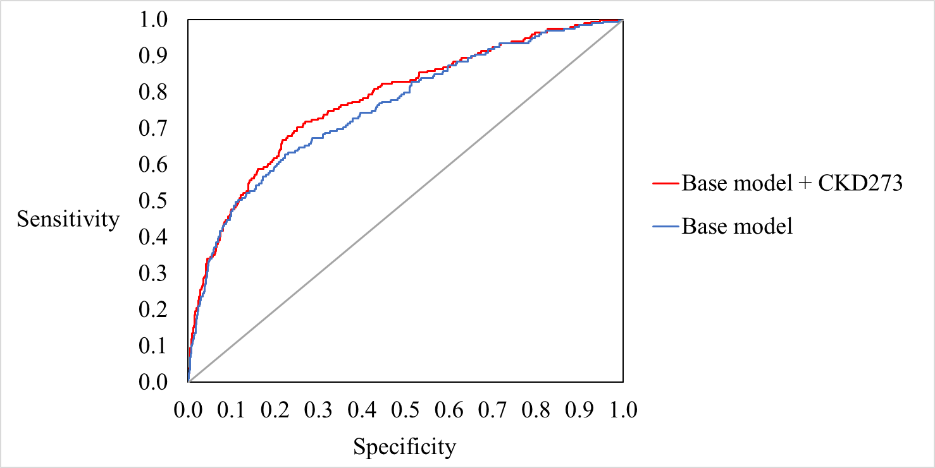

The base logistic model including clinical characteristics had an of AUC of 0·76 (95 % CI 0·72 to 0·80) (Base model: baseline age, sex, HbA_{1c}, systolic blood pressure, retinopathy, eGFR and UACR). AUC increased 0·022 (95% CI, 0·0070 to 0·037) to 0·78 (95 % CI 0·75 to 0·82) when CKD273 was added to the base-model, p = 0.0040. The sensitivity of the test was 30·5 % and specificity 90·2 % with a positive predictive value of 28·2 %.
Adding CKD273 to the Cox-model together with significant clinical variables (age, sex, HbA_{1c}, systolic blood pressure, retinopathy, UACR and eGFR) strengthened the association: beta integrated discrimination improvement (IDI) was 0·10 and relative IDI was 0·10 (P=0·0009).

Supplementary figure S2. Glycemic control (A) and systolic blood pressure (B) during the study period in the observational study population divided by high-risk and low-risk based on CKD273.
A:
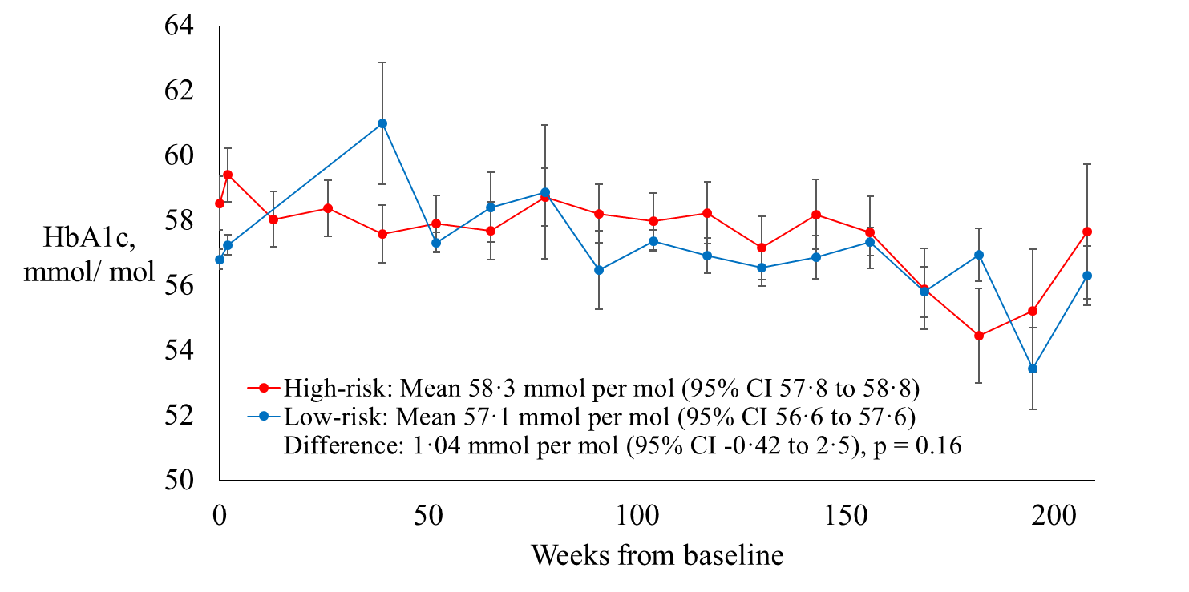

No. of Participants
High-risk | 216 |  | 189 |  | 177 | 73 |  | 15
Low-risk | 1559 |  | 1496 |  | 1381 | 491 |  | 77

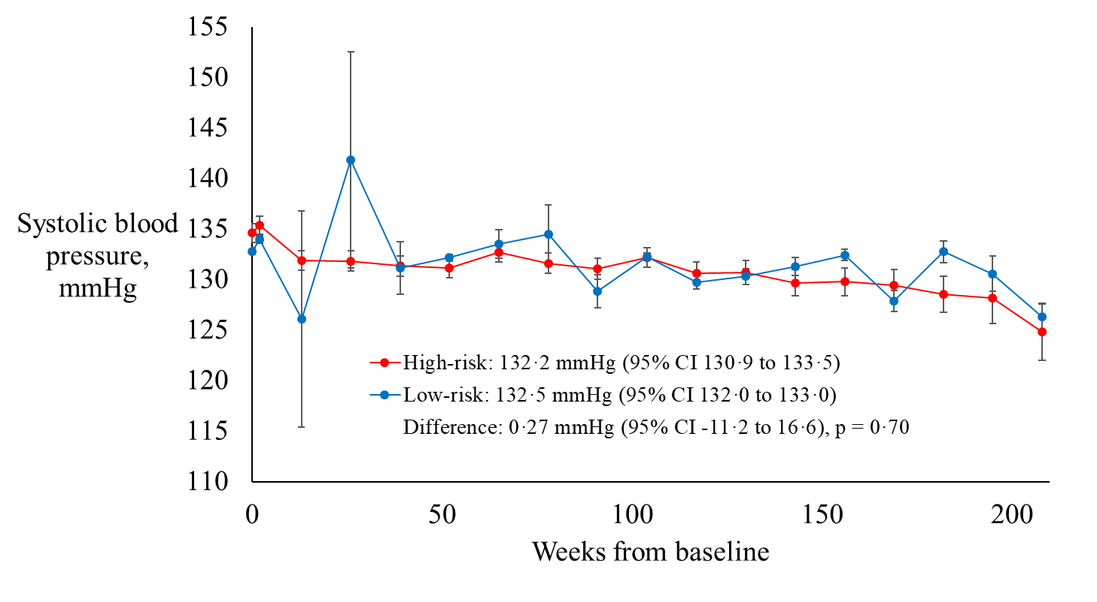
B:

No. of Participants
High-risk | 216 |  | 189 |  |  | 177 | 73 |  | 15
Low-risk | 1559 |  | 1496 |  |  | 1381 | 491 |  | 77

Supplementary figure S3.Change in eGFR over time according to A) Observational study population divided by high-risk or low-risk based on CKD273 score, B) Intention to treat population divided by Spironolactone or placebo allocation.
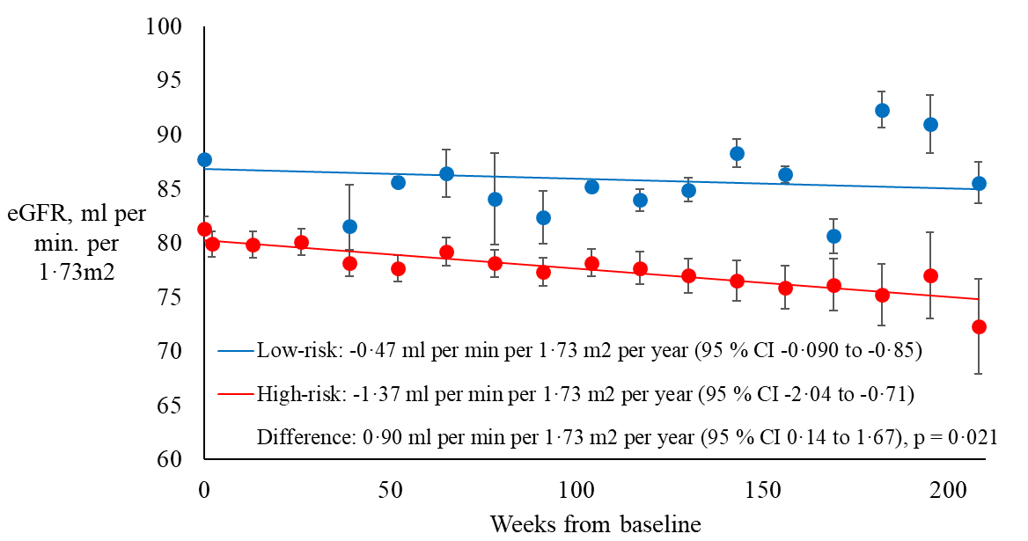
A:

No. of participants
Low-risk | 1559 |  | 1496 |  | 1381 | 491 |  | 77
High-risk | 216 |  | 189 |  | 177 | 73 |  | 15

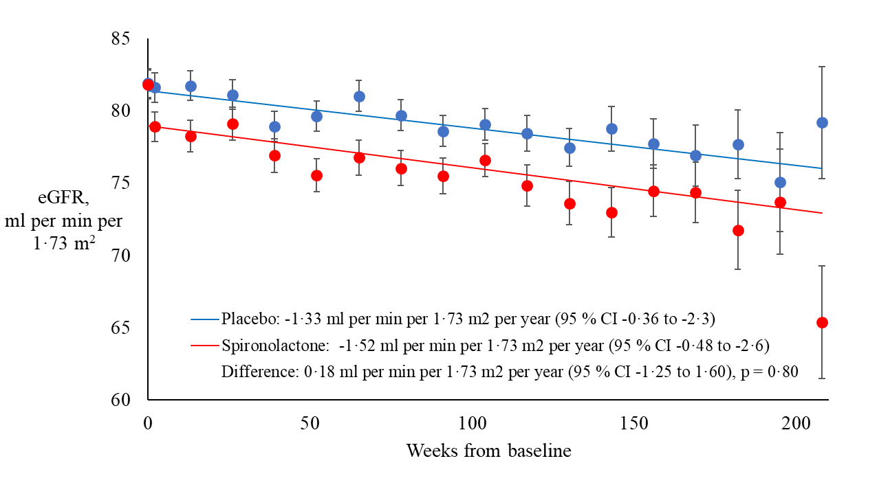
B:

No. of participants
Placebo | 107 |  | 98 |  | 92 | 37 |  | 8
Spironolactone | 102 |  | 86 |  | 81 | 35 |  | 7

Supplementary figure S4. Glycemic control (A) and systolic blood pressure (B) during the study period in the intention to treat population divided by spironolactone or placebo allocation.
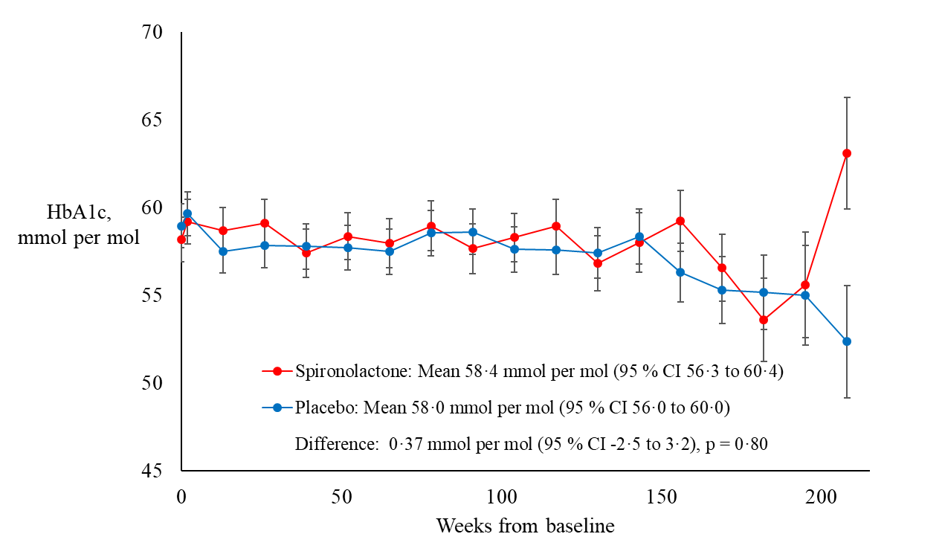
A:

No. of participants
Spironolactone | 102 |  | 86 |  |  | 81 | 35 |  | 7
Placebo | 107 |  | 98 |  |  | 92 | 37 |  | 8
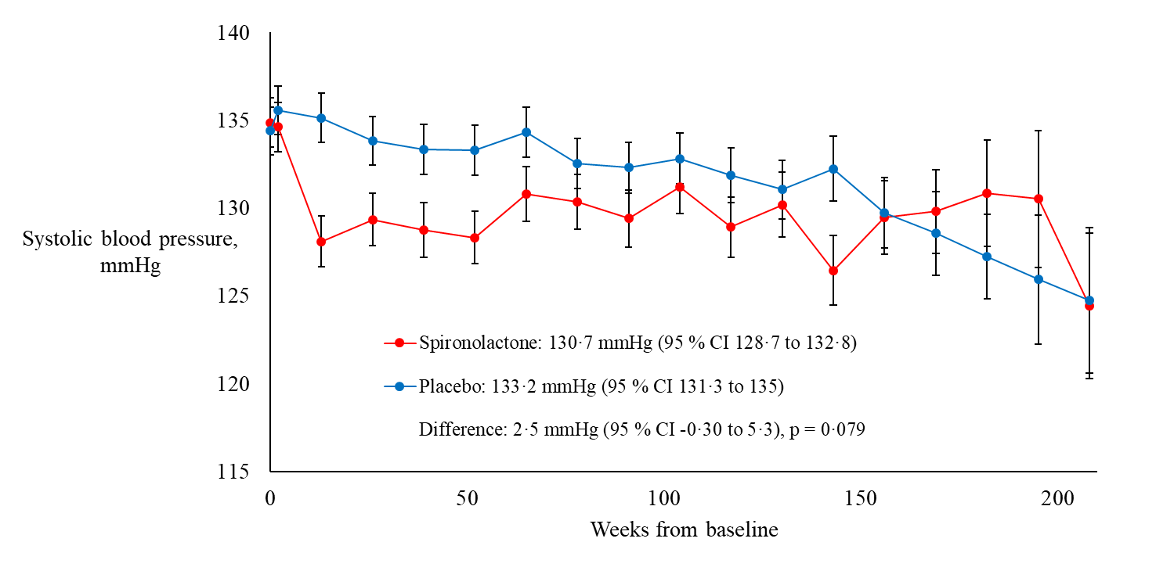
B:

No. of participants
Spironolactone | 102 | 86 |  | 81 |  | 35 | 7
Placebo | 107 | 98 |  | 92 |  | 37 | 8

Supplementary figure S5: Development of CKD3 in intention to treat population in participants with baseline eGFR above 60 ml per min per 1·73 m²
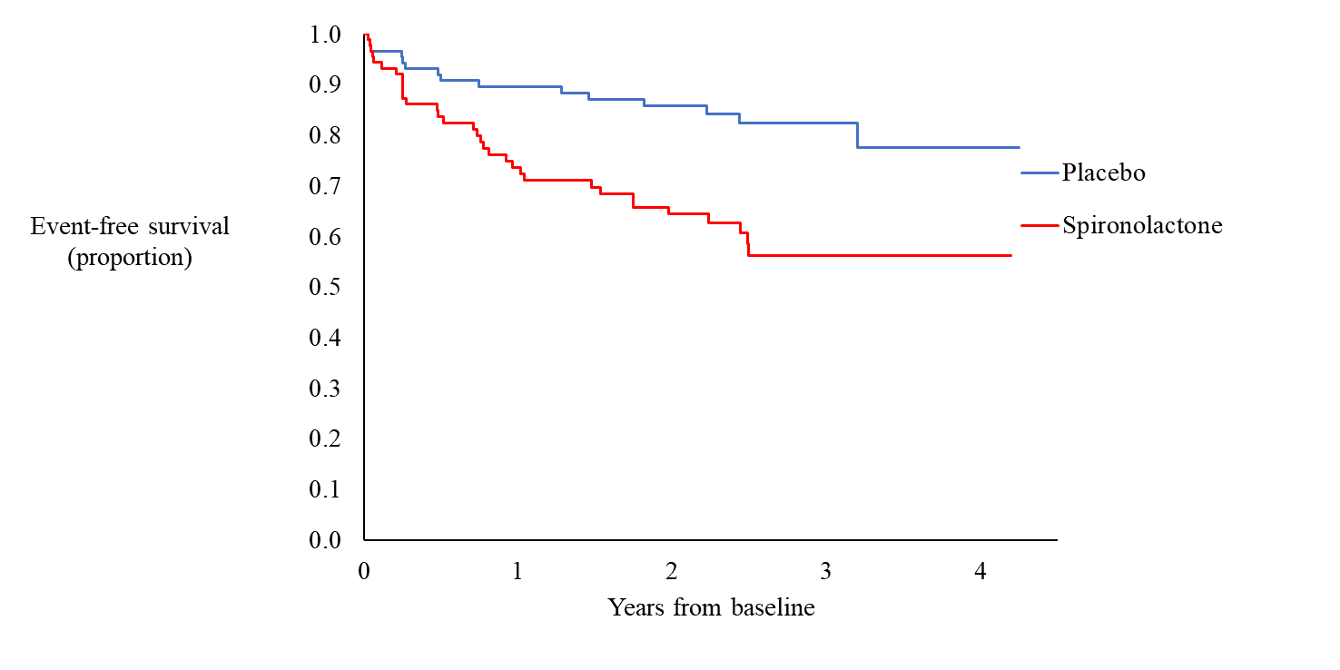

Hazard ratio 2·62 (95 % CI 1·42 to 4·82) , P = 0·002

No. of Participants
Placebo | 90 |  | 82 |  |  | 66 |  | 25 |  | 3
Spironolactone | 92 |  | 79 |  |  | 69 |  | 28 |  | 7

Supplementary figure S6:Progression to confirmed microalbuminuria according to CKD273 status and intervention allocation in observational study population
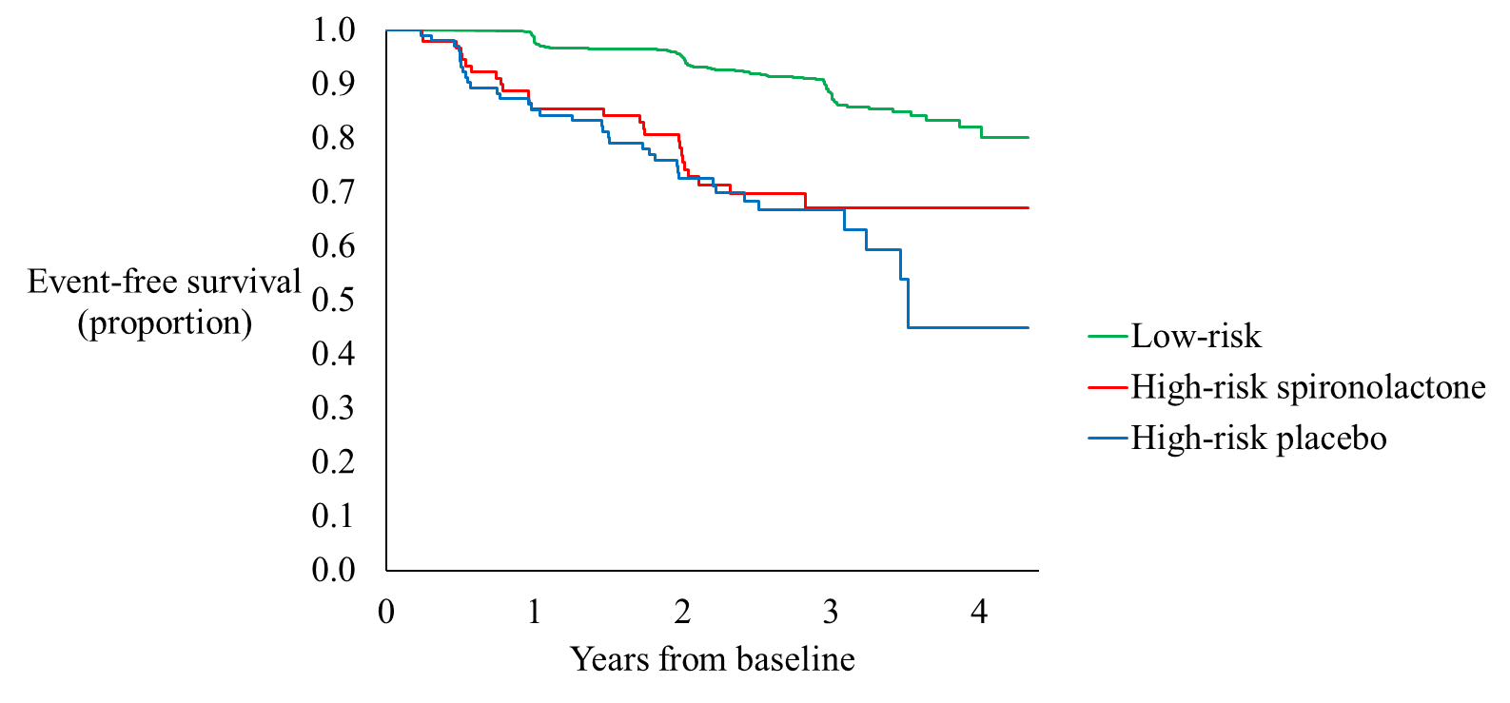

HR for Low-risk vs. High-risk placebo:
4·23 (95 % CI 2·92 to 6·12), p < 0·0001

HR for Low-risk vs. High-risk spironolactone:
3·55, (95 % CI 2·33 to 5·39), p < 0·0001

No. of Participants
High-risk spironolactone |  | 102 | 98 |  | 79 | 33 | 6
High-risk placebo* |  | 114 | 91 |  | 77 | 30 | 7
Low-risk |  | 1559 | 1482 |  | 1200 | 394 | 47

*Including seven participants with a high-risk CKD273 pattern, who didn’t receive any study medication

Supplementary Table S1 Baseline medication in observational study population divided by CKD273 status and treatment allocation
Medication | Low-riskª  n = 1559 | High-risk^{b}  Spironolactone  n = 102 | High-risk^{b}  Placebo  n = 107
Insulin of any kind | 462 (31) | 37 (36) | 35 (33)
Biguanides | 1168 (78) | 91 (89) | 88 (82)
Sulphonylureas | 353 (24) | 32 (31) | 30 (28)
GLP-1 analogues | 239 (16) | 10 (10) | 25 (23)
SGLT-2 inhibitors | 102 (7) | 6 (6) | 13 (12)
DDP4 inhibitors | 209 (14) | 20 (20) | 17 (16)
Glitazones | 53 (4) | 2 (2) | 7 (7)
ACE inhibitors | 469 (31) | 72 (71) | 71 (66)
ARB | 487 (33) | 21 (21) | 23 (22)
Alpha-blockers | 62 (4) | 6 (6) | 8 (7)
Beta-blockers | 386 (26) | 38 (37) | 35 (33)
Calcium channel blockers | 332 (22) | 19 (19) | 37 (35)
Loop diuretics | 62 (4) | 5 (5) | 7 (7)
Thiazides | 390 (26) | 43 (42) | 45 (42)
Statins | 995 (67) | 70 (69) | 74 (69)
Fibrates | 69 (5) | 3 (3) | 12 (11)
Aspirin | 464 (31) | 50 (49) | 50 (47)
Other anti-platelet agents^{c} | 106 (7) | 9 (9) | 15 (14)

N (%, rounded) GLP-1 denotes glucagon-like peptide-1, SGLT-2 sodium-glucose cotransporter-2, DDP-4 dipeptidyl peptidase-4, ACE angiotensin-converting-enzyme and ARB angiotensin-II-receptor blockers. ªCKD273-classifier below or equal to the cut-off of 0·154. ^{b}CKD273-classifier above the cut-point of 0·154. ^{c}Other anti-platelet agents include Warfarin, Non-vitamin K-antagonistic oral anticoagulants (NOAC) and Clopidogrel.

Supplementary Table S2 Baseline characteristics in observational study population divided by CKD273 status
 | Low-risk  n = 1559 | High-risk  n = 216ª | P-value  (high vs. low)
Sex, men | 955 (61) | 149 (69) | 0·03
Age, years | 61 (9) | 63 (6) | <0·01
Known diabetes duration, years | 11 (8) | 14 (8) | <0·01
Body mass index, kg/ m² | 30 (5) | 31 (5) | 0·25
Systolic blood pressure, mmHg | 133 (12) | 135 (12) | 0·03
Diastolic blood pressure, mmHg | 78 (9) | 79 (9) | 0·52
eGFR, ml per minute per 1·73 m² | 88 (15) | 81 (17) | <0·01
UACR, mg/g | 5 (3–8) | 7 (4–12) | <0·01
Potassium, mmol/ L | 4·2 (0·4) | 4·2 (0·4) | 0·07
Sodium, mmol/ L | 140 (3) | 140 (3) | 0·97
HbA_{1c}, mmol/ mol | 57 (12) | 59 (13) | 0·05
HbA_{1c}, % | 7·3 (1·1) | 7·5 (1·2) | 0·05
Total cholesterol, mmol/ L | 4·4 (1·0) | 4·4 (1·1) | 0·94
HDL cholesterol, mmol/ L | 1·2 (0·3) | 1·2 (0·3) | 0·56
LDL cholesterol, mmol/ L | 2·4 (0·9) | 2·4 (1·0) | 0·77
Triglycerides, mmol/ L | 1·6 (1·1-2·3) | 1·7 (1·2–2·6) | 0·11
CKD273 | -0·4 (0·3) | 0·3 (0·2) | -
Smoking status | Current: 223 (14)  Never: 861 (55)  Former: 468 (30)  Unknown: 6 (< 1) | Current: 20 (9)  Never: 117 (54)  Former: 79 (37)  Unknown: 0 | 0·20
ACEi/ARB | 952 (61) | 190 (88) | <0·01
Follow-up time, years | 2·5 (2·0-3·0) | 2·5 (2·0-3·1) | <0·01

a:Observational high risk group was 216 participants of whom 209 were included in the randomised trial (intention to treat cohort).
Mean (SD) or median (IQR) for continuous variables, n (%, rounded) for categorical variables. Low-risk: CKD273-classifier below or equal to the cut-point of 0·154. High-risk: CKD273-classifier above the cut-point of 0·154. eGFR denotes estimated glomerular filtration rate, UACR Urine Albumin-to-Creatinine Ratio, ACEi angiotensin-converting-enzyme inhibitors and ARB angiotensin-II-receptor blockers.

Supplementary Table S3 Number of included participants at each study centre in the observational study population divided, by CKD273 status

Study centre | Total, n | Low-risk | High-risk
Hoogeveen, Netherlands | 24 | 23 (95·8) | 1 (4·2)
Prague, Czech Republic | 81 | 76 (93·8) | 5 (6·2)
Prague, Czech Republic | 51 | 38 (74·5) | 13 (25·5)
Marburg, Germany | 60 | 58 (96·7) | 2 (3·3)
Madrid, Spain | 13 | 13 (100) | 0 (0)
Ghent, Belgium | 31 | 28 (90·3) | 3 (9·7)
Dresden, Germany | 17 | 17 (100) | 0 (0)
Glasgow, United Kingdom | 219 | 189 (86·3) | 30 (13·7)
Groningen, Netherlands | 132 | 120 (90·9) | 12 (9·1)
Athens, Greece | 84 | 79 (94·0) | 5 (6·0)
Bergamo, Italy | 282 | 241 (85·5) | 41 (14·5)
Skopje, Macedonia | 175 | 155 (88·6) | 20 (11·4)
Leipzig, Germany | 52 | 38 (73·1) | 14 (26·9)
Gentofte, Denmark | 436 | 372 (85·3) | 64 (14·7)
Hoorn, Netherlands | 118 | 6 (5·1) | 112 (94·9)
N (%, rounded). Low-risk: CKD273-classifier below or equal to the cut-point of 0·154. High-risk: CKD273-classifier above the cut-point of 0·154.

Supplementary Table S4: Adverse events in intention to treat population divided by treatment allocation and organ system
Adverse events | High-risk^{b}  Spironolactone  n = 102 | High-risk^{b}  Placebo  n = 107
Blood and lymphatic system disorders | 7 | 2
Cardiac disorders | 10 | 7
Congenital, familial and genetic disorders | 1 | 0
Ear and labyrinth disorders | 2 | 2
Endocrine disorders | 3 | 2
Eye disorders | 11 | 18
Gastrointestinal disorders | 26 | 18
General disorders and administration site conditions | 8 | 14
Hepatobiliary disorders | 5 | 2
Immune system disorders | 1 | 1
Infections and infestations | 49 | 70
Injury, poisoning and procedural complications | 13 | 17
Investigations | 29 | 13
Metabolism and nutrition disorders | 44 | 24
Musculoskeletal and connective tissue disorders | 18 | 33
Neoplasms benign, malignant and unspecified (incl. cysts and polyps) | 6 | 6
Nervous system disorders | 18 | 27
Psychiatric disorders | 2 | 5
Renal and urinary disorders | 5 | 17
Reproductive system and breast disorders | 11 | 7
Respiratory, thoracic and mediastinal disorders | 13 | 6
Skin and subcutaneous tissue disorders | 12 | 15
Social circumstances | 0 | 1
Surgical and medical procedures | 7 | 8
Vascular disorders | 11 | 6
Total | 312 | 321

Supplementary Table S5: Serious adverse events in intention to treat population divided by treatment allocation and organ system
Serious adverse events | High-risk^{b}  Spironolactone  n = 102 | High-risk^{b}  Placebo  n = 107
Cardiac disorders | 6 | 4
Eye disorders | 1 | 0
Gastrointestinal disorders | 0 | 1
Hepatobiliary disorders | 1 | 0
Infections and infestations | 3 | 4
Injury, poisoning and procedural complications | 3 | 4
Metabolism and nutrition disorders | 0 | 1
Musculoskeletal and connective tissue disorders | 0 | 4
Neoplasms benign, malignant and unspecified (incl. cysts and polyps) | 1 | 2
Nervous System disorders | 0 | 5
Renal and urinary disorders | 1 | 5
Respiratory, thoracic and mediastinal disorders | 1 | 2
Skin and subcutaneous tissue disorders | 1 | 0
Surgical and medical procedures | 4 | 2
Total | 22 | 34

Supplementary Table S6: Number of participants started on an antihypertensive or glucose lowering drug during follow-up in observational study population divided by CKD273 status
 | Low-risk (n=1559) | High-risk (n=216) | p-value
Metformin | 147 (9.4) | 20 (9.3) | 0.93
Sulfonylurea | 98 (6.3) | 9 (4.2) | 0.22
Glitazone | 8 (0.51) | 4 (1.9) | 0.024
Insulin | 236 (15.1) | 40 (18.5) | 0.20
Glp1-ra | 91 (5.8) | 21 (9.7) | 0.028
DPP4i | 81 (5.2) | 11 (5.1) | 0.95
SGLT2i | 198 (12.7) | 39 (18.1) | 0.030
Aspirine | 45 (2.9) | 10 (4.6) | 0.17
Statin | 156 (10.0) | 22 (10.2) | 0.93
Alpha blocker | 13 (0.83) | 4 (1.9) | 0.15
Beta blocker | 101 (6.5) | 23 (10.6) | 0.024
Calcium Channel blocker | 88 (5.6) | 25 (11.6) | 0.0008
ACEinhibitor | 86 (5.5) | 17 (7.9) | 0.17
ARB | 94 (6.0) | 17 (7.9) | 0.30
Thiazide diruretic | 63 (4.04) | 32 (14.8) | <0.0001
Loop-diuretic | 36 (2.3) | 14 (6.5) | 0.0005

N (%, rounded).
Supplementary table S7: Number of participants started on an antihypertensive or glucose lowering drug during follow-up in the intension to treat population divided by treatment allocation
 | Placebo (n=107) | Spironolactone (n=102) | p-value
Metformin | 11 (10) | 8 (7.8) | 0.54
SU | 4 (3.7) | 4 (3.9) | 0.95
Glitazone | 3 (2.8) | 1 (1.0) | 0.34
Insuline | 21 (20) | 18 (18) | 0.71
Glp1-ra | 10 (9.4) | 11 (11) | 0.73
DPP4i | 4 (3.7) | 6 (5.9) | 0.47
SGLT2i | 19 (18) | 18 (18) | 0.98
Aspirine | 6 (5.6) | 3 (2.9) | 0.34
Statin | 11 (10) | 10 (9.8) | 0.91
Alpha blocker | 2 (1.9) | 2 (2.0) | 0.96
Beta blocker | 14 (13) | 9 (8.8) | 0.33
Calcium channel blocker | 11 (10) | 13 (13) | 0.58
ACEi | 7 (6.5) | 9 (8.8) | 0.54
ARB | 11 (10) | 5 (4.9 | 0.14
Thiazide | 15 (14) | 16 (16) | 0.74
Loop-diuretisk | 7 (6.5) | 6 (5.8) | 0.84
N (%, rounded).

Supplementary table S8: Ethics committee registration numbers and voluntary harmonisation number (VHP)
Country | Ethics Committee | ID No.
Danmark | Region Hovedstaden Regionsgården Kongens | Projekt-ID H-3-2013-141
Germany | Sächsische Landesärztekammer | EK-AMG-MCF-6/13-2
Belgium | Commissie voor Medische Ethiek Universitair Ziekenhuis | 2015/0331
Czech Republic | Ethics Committee of the Institute for Clinical and Experimental Medicine and Thomayer Hospital | 212/2014
 | Ethics Committee of the University Hospital Kralovske Vinohrady | KH/13/0/2014
Spain | CEIC Fundación Jiménez Díaz | EC 42-13/IIS-FJD
Greece | EAAHNIKH AHMOKPATIA  YIIOYPTEIO YTEIA∑ (NEC)  EAAHNIKH AHMOKPATIA 1n Y.H.E. ATTIKHE rEN. NOI/MEIO A0HNAI «inflOKPATElO» (HEC) | 13/14  52/3-4-2014
Italy | Comitato Etico della Provincia di Bergamo | 138/13
Macedonia |  | 15-9322-13/2
Netherland | Medisch Ethische Toetsingscommissie, Universitair Medish Centrum Groningen | M14.156887
United Kingdom | West of Scotland REC 1  R&D Management Office  Western Infirmary  Tennent Institute R&D | 13/WS/0284  GN12DI096

National competent authority
VHP-No.: | VHP342 (VHP201371)

