A Phase IIa Exploratory Study of OCZ103-OS in Combination with Platinum-Gemcitabine based Doublet First Line Therapy in Stage IV Non-Small Cell Lung Cancer (NSCLC) Patients

Introduction
Lung cancer is the leading cause of smoking-related mortality throughout the world.(1) In Canada, an estimated 26,100 cases were diagnosed in 2014, representing 13.6% of cancer cases. Moreover, lung cancer is responsible for more deaths than those due to breast, colorectal and prostate cancer combined with 20,500 deaths in Canada in 2014 representing 26.8% of cancer mortalities.(2)
Non-small cell lung cancer (NSCLC) accounts for approximately 85% of lung cancer cases.(3, 4) Half of NSCLC patients present with metastatic disease at diagnosis (5, 6) when potentially curative therapy, such as surgical resection, is rarely an appropriate therapeutic option (7, 8). The current standard of care (SOC) among stage IV NSCLC patients is chemotherapy (7, 8) though the selection of first-line chemotherapy drugs depends on patients’ performance status (PS). American and Canadian metastatic NSCLC therapy guidelines recommend the administration of platinum-based doublet combination therapy for patients with a PS of 0 or 1 and single-agent chemotherapy for patients with a PS of 2.(9, 10) Despite the availability of novel agents in recent years, chemotherapy offers limited effectiveness in NSCLC treatment. Although various combinations of cytotoxic drugs can produce response rates of 20-40%, the survival time of most patients with stage IV NSCLC is less than 12 months (9, 11) and the five-year survival rate remains low at 1% (12). Therefore, there is a need to expand the current armamentarium of chemotherapy drugs to potentially improve patient response and survival among stage IV NSCLC populations.
Resistance of tumour cells to alkylating agents, for instance cisplatin, is believed to occur, at least in part, through rapid DNA repair mechanisms provided by enzymes such as endo-exonucleases (EEs).(13-15) The incorporation of OCZ103-OS, also known as pentamidine, a dicationic diarylfuran, in combination with platinum-gemcitabine doublet therapy may be beneficial in this treatment setting by providing the inhibitory effects of DNA repair of the former with the alkylating effects of the latter. As genomic instability and an accelerated growth rate are common properties of neoplastic cells, pentamidine may be utilized in the treatment of various cancers. Indeed, positive results in preclinical studies evaluating the efficacy of pentamidine in the treatment of metastatic colorectal cancer and pancreatic cancer (13, 16, 17) support the integration of OCZ103-OS in stage IV NSCLC chemotherapy regimens.
The aim of the present study was to assess the safety and obtain preliminary evidence of the clinical efficacy of OCZ103-OS used in combination with platinum-gemcitabine based doublet first-line therapy in adult patients with stage IV NSCLC.

Methods

Study Design
This was an open-label, multi-center, single-arm Phase IIa study at 4 recruiting sites in Poland. The trial is registered with ClinicalTrials.gov (Identifier NCT01844791).
The study was approved by the independent ethics committee at the Regional Chamber of Physicians in Łódź, Poland. The organization and functioning of the study complied with Good Clinical Practices and applicable laws. Written consent was required in order to be included in the study.

Patient Population
Patients were enrolled between October 2012 and February 2013.
Patients were eligible for study entry if they presented with histologically or cytologically confirmed stage IV NSCLC or with a prior diagnosis of stage IIIa or IIIb who had progressed to stage IV, and were eligible to receive platinum-gemcitabine based doublet therapy. Furthermore, patients were required to be aged between 18 and 75 years of age; have a life expectancy, in the opinion of the investigator, of more than 3 months; have an ECOG performance status of 0 or 1; have one or more tumor lesions measurable by the Response Evaluation Criteria in Solid Tumors (RECIST) version 1.1 on computed tomography (CT) or magnetic resonance imaging (MRI); and have had palliative radiotherapy completed at least 2 weeks prior to study entry (concomitant palliative radiotherapy to an existing bone lesion for pain control was allowed). Patients who had received previous radiotherapy as definitive therapy for locally advanced NSCLC were also eligible as long as the selected measurable lesions were outside the original radiation therapy port unless there had been demonstrated progression in the lesion. Radiotherapy must have been completed at least 4 weeks prior to study entry.
Patients who fulfilled any of the following exclusion criteria were not eligible for study entry: any prior systemic therapy for recurrent or metastatic NSCLC, except prior neoadjuvant or adjuvant systemic chemotherapy for NSCLC if administered at least 6 months prior to enrolment; low systolic blood pressure (< 100 mmHg); uncontrolled diabetes; severe renal impairment; chronic pancreatitis; history of clinically significant hypoglycaemia; abnormal baseline hematology, liver and kidney function as determined by various laboratory assessments; oxygen treatment dependence; active infections requiring antibiotic treatment; a surgical procedure within 28 days of protocol therapy; active alcohol or drug abuse; known or suspected allergy to any agent given in the trial; any comorbid condition rendering the subject at high risk of treatment complication or reducing the probability of assessing clinical effect, as per the judgment of the investigator; other malignancies within the last 5 years with the exception of basal cell carcinoma of the skin; and inability to comply with the study protocol. Patients with any of the following conditions were further excluded from study enrolment: ongoing cardiac dysrhythmias with a National Cancer Institute Common Terminology Criteria for Adverse Events (NCI CTCAE) grade of at least 2; atrial fibrillation of any grade; QTc interval higher than 450 milliseconds (ms) for males or 470 ms for females or uncontrolled intercurrent illness such as angina; severe coronary disease; ventricular arrhythmias; bradycardia below 50 beats per minute; or a history of additional risk factors for ‘Torsades de Pointe’ such as heart failure, hypokalemia or family history of long QT syndrome.

Study Treatment and Administration
During the first treatment cycle which lasted 24 days, OCZ103-OS was administered through intravenous (IV) infusion at a dosage of 7 mg/kg over four hours on days 1, 2 and 3 before platinum and gemcitabine combined treatment which was administered on day 4. On day 11, OCZ103-OS was administered prior to gemcitabine. In all subsequent cycles, each lasting 22 days, OCZ103-OS was administered intravenously at a dosage of 7 mg/kg over four hours preceding gemcitabine infusion on days 1 and 9 of the cycle. A maximum of 6 cycles were permitted per patient.
The SOC therapy included platinum-gemcitabine doublet chemotherapy consisting of the combination of either cisplatin or carboplatin and gemcitabine. Gemcitabine was infused over 30 minutes at a dosage of 1000 mg/m², if combined with carboplatin, or 1250 mg/m², if combined with cisplatin, prior to the platinum drugs. Cisplatin was administered at a dosage of 75 mg/m² on day 4 of the first cycle or day 2 of subsequent cycles. The dosage of carboplatin was determined by the area under the concentration versus time curve of 5 or 6 mg/mL/min on day 4 of the first cycle or day 2 of subsequent cycles. Gemcitabine was re-administered on day 11 of the first cycle or day 9 of subsequent cycles at the same dose as the first cycle following OCZ103-OS infusion.
The dose of OCZ103-OS may have been reduced to 5 mg/kg if severe enough adverse reactions as per pre-established safety criteria occurred following the administration of 7 mg/kg of the drug. The SOC chemotherapy drug dosages remained unchanged if this study drug dose reduction was implemented.
As per recent ASCO guidelines (18), SOC platinum doublet therapy was to be discontinued following 4 cycles in the absence of response or at a maximum of 6 cycles with or without a response. However, OCZ103-OS therapy was further pursued as maintenance monotherapy as an IV infusion at a dosage of 7 mg/kg on the first and ninth days of a 21-day cycle.

Study Assessments and Outcome Measures
The primary endpoint evaluated was response to treatment as determined by the overall response rate (ORR) (CR or PR). Secondary endpoints included the duration of response (DR), progression-free survival (PFS), overall survival (OS) and time to progression (TTP).
The determination of anti-tumour efficacy was based on objective tumour assessments made according to the RECIST system (version 1.1) of uni-dimensional evaluation. Baseline imaging assessments were done during the screening period and included CT scans of the chest, abdomen and pelvis. Post-baseline tumour assessments were performed at day 48 ± 4 days or within 4 days prior to initiation of the following cycle. Tumour assessments were further conducted at every cycle thereafter (i.e. cycle 2, 4, 6, etc.) until permanent discontinuation or end of study (EOS) which occurred when radiological progressive disease (PD) had been documented or the patient began a subsequent anti-cancer therapy of a different composition. In case of tumour response (PR or CR), confirmatory imaging studies were to be performed no less than 3 weeks after initial documentation of response.
Safety and tolerability were assessed with the evaluation of physical exams, electrocardiograms, laboratory tests and the occurrence of AEs. Hepatic and renal function were closely monitored, as well as hematopoietic function. Adverse events were reported and described according to CTCAE 4.03 terminology, and mapped to the Medical Dictionary for Regulatory Activities (MedDRA) version 13.1.
The pharmacokinetic analysis of OCZ103-OC required the collection of several blood samples during or following each IV infusion. During the first cycle, blood was withdrawn on day 1 immediately before the infusion, 1.5 and 4 hours following the beginning of the drug administration (during the infusion) and 10 minutes, 30 minutes, 3.5 and 20 hours following the end of the infusion. On day 11 as well as during cycles 2 to 6, blood samples were obtained immediately before and at the end of the infusion period.

Statistical Analyses
All efficacy and safety analyses were performed on the Intent-to-Treat (ITT) population including all patients who received at least one dose of study treatment.
Descriptive statistics were used for patient demographics, baseline characteristics, treatment administration and compliance, safety parameters and pharmacokinetic variables. Kaplan-Meier survival analysis and life tables were used to estimate the six-month OR rate and associated 95% confidence intervals (CIs) as well as TTP, PFS, OS and DR rates. DR was calculated for the subgroup of patients with objective disease response. Patients lost to follow-up or deceased prior to six months of treatment were censored. An exploratory subgroup analysis was performed based on the median H-score of EE status and the impact of EE expression on mean time to OR, OS and PFS was assessed with Cox’s proportional hazards model. Adverse events were tabulated with reported incidences.
SAS® (version 9.2) was used to conduct all statistical analyses.

Results

Patient Population
Table 1 shows the baseline characteristics of the study sample including sociodemographics and disease characteristics. Thirty-two (32) patients were screened for study eligibility of which 26 (81.3%) were eligible and were administered at least one dose of study treatment, thus comprising the ITT population. The majority of patients were male (n = 17; 65.4%) and all were Caucasian (n = 26; 100.0%). Mean (SD) age was 63.2 (6.5) years. In regard to baseline histology/cytology status, 12 patients had adenocarcinoma while 9 (34.6%) patients had squamous cell carcinoma.

Treatment Exposure
Patients received between one and 9 cycles of chemotherapy during the study of which 5 and 4 were induction and maintenance cycles, respectively. The mean (SD) number of cycles was 3.0 (2.0) during the study of which 3.0 (2.0) cycles were during the treatment period and 0.4 (1.0) cycles were during the maintenance period, respectively. All patients received at least 90% of the planned dose of study medications.
Figure 1 presents the pharmacokinetics of OCZ103-OS at cycle 1. Pentamidine concentrations rapidly increased to 1187.1 and 644.4 ng/mL at 1.5 and 4 hours following the beginning of infusion, respectively. Drug concentrations drastically decreased to 287.0, 178.8, 98.8 and 34.8 ng/mL 10 minutes, 30 minutes, 3.5 hours and 20 hours following the end of the administration, respectively. Following the end of administration, drug blood concentrations gradually decreased, reaching 34.8 ng/mL 20 hours post end of infusion.

Efficacy
Table 2 and Figure 2 summarize the efficacy outcomes during treatment with OCZ 103-OS. Overall, 10 (38.5%) patients achieved objective response with a mean (SE) duration of response of 3.5 (0.4) months. Twelve (46.2%) patients experienced PD or death after a mean (SE) time of 4.1 (0.5) months. Eight (30.8%) patients experienced progressive disease during the study following a mean (SE) TTP of 4.7 (0.4) months. Moreover, 21 (80.8%) patients died after a mean (SE) of 11.4 (1.7) months. The one-year survival rate was 40.3% (95% CI: 21.5, 58.4).
Overall, comparable efficacy was observed based on EE expression in terms of ORR, PFS, and TTP. However, one-year survival was considerably higher among patients with high EE expression (45.0% vs. 22.2%).

Safety
All patients in the study reported at least one AE. Three-hundred twenty-seven (327) AEs were reported of which 33 (10.0%) were classified as SAEs and 151 (46.2%) had reasonable relatedness to the study treatment. The preponderance (n = 157; 48.0%) of AEs were grade 1 while 117 (35.8%), 42 (12.8%) and 11 (3.4%) were grade 2, 3 and 4, respectively. The majority of AEs (n = 246; 75.2%) required no intervention.
The most frequent adverse events (any grade experienced by > 10% of patients) are described in Table 3. AEs experienced by more than 30% of patients were increase of blood creatinine (n = 13; 50.0%), anaemia (n = 14; 53.9%), neutropenia (n = 11; 42.3%), nausea (n = 9; 34.6%), thrombocytopenia (n = 8; 30.8%) and increase of blood urea (n = 13; 30.8%).

Discussion
This phase IIA study aimed to assess the efficacy and safety of IV pentamidine in 26 patients with stage IV NSCLC in combination with platinum-gemcitabine doublet therapy as first-line therapy. Generally, pentamidine combination therapy showed increased efficacy when compared to traditional first-line stage IV NSCLC doublet chemotherapy regimens as reported in the literature. Following a mean (SD) of 3.0 (2.0) and 0.4 (1.0) cycles during the treatment period and maintenance period, respectively, the ORR and time to OR were 38.5% following a mean (SE) of 3.4 (0.4) months, respectively.
These results were improved compared to those reported in the study by Scagliotti et al. including gemcitabine and cisplatin; paclitaxel and carboplatin; as well as vinorelbine and cisplatin, for which, 30%, 32% and 30% of patients achieved ORR during the study after a median time of 9.4, 8.7 and 8.2 months, respectively.(19) The present study results further surpassed the ORR reported by Schiller and colleagues for patients receiving cisplatin and paclitaxel (21%); cisplatin and gemcitabine (22%); cisplatin and docetaxel (17%); and carboplatin and paclitaxel (19%) (20) as well as that reported by Fossela et al. where patients were administered docetaxel and cisplatin (31.6%); docetaxel and carboplatin (23.9%); and vinorelbine and cisplatin (24.5%) (21). Moreover, the mean OS duration of 11.4 months surpassed all reported overall survivals by the above-stated trials with median (95% CI) durations varying between 7.8 (7.0, 8.9) and 11.3 (10.1, 12.4) months though the latter results can be considered comparable to our study results.(19-21) The rates of progressive disease and of one-year survival were in line with previous study findings of first-line SOC chemotherapy regimens.(19-21) Furthermore, the efficacy following administration of pentamidine combined with gemcitabine and platinum chemotherapy was greater than that of doublet gemcitabine and platinum chemotherapy alone reported by Schiller et al. where ORR and PD rates of 22% and 40%, respectively, were reported.(20) Of note, although all patients in the present study had stage IV NSCLC, a minority of patients in the Schiller, Scagliotti and Fossella et al. trials had stage III NSCLC which reduces the comparability of the results between studies.
The overall AE profile was in line with the safety profile of SOC chemotherapy regimens of previous studies. The most frequently reported AEs included neutropenia, thrombocytopenia, anemia and nausea.(19-21)
The subgroup analysis identified endo-exonuclease expression as a potential predictor of treatment response with patients in the high EE expression group showing a one-year survival rate that was double than that in the low EE expression group (45.0% vs. 22.2%). These findings support the hypothesis of EE overexpression in neoplastic cells (13, 14) and therefore suggest that treatment with OCZ103-OS may be a preferred treatment option in this patient subgroup.
The main limitation of the current study is the single-cohort nature of the patient population limiting the comparability of pentamidine with traditional chemotherapy regimens or placebo and the study’s low sample size. However, the aim of this study was to obtain preliminary evidence of the safety and efficacy of OCZ103-OS in combination with gemcitabine and platinum chemotherapy and not to compare its effects with other treatments.
Overall, this study has shown that pentamidine combined with traditional doublet chemotherapy in the treatment of stage IV NSCLC may be a viable option for the treatment of NSCLC, particularly among patients with high EE expression, and warrants further investigation in larger trials.

Tables

Table 1. Summary of Baseline Characteristics
Variable | All Subjects (N = 26)
Demographics
Gender, n (%)
Male | 17 (65.4%)
Female | 9 (34.6%)
Age, years, mean (SD) | 63.2 (6.5)
Race, n (%)
Caucasian | 26 (100.0%)
Disease Characteristics
Histology/ Cytology at Initial Disease Diagnosis
Adenocarcinoma (bronchioalveolar carcinoma) | 1 (3.8%)
Adenocarcinoma (not otherwise specified) | 11 (42.3%)
Squamous cell carcinoma | 9 (34.6%)
Unknown | 5 (19.2%)
UICC and/or AJCC Stage at Initial Disease Diagnosis, n (%)
Ib (T2, N0, M0) | 1 (3.8%)
IIIb (T3, N0-1, M0) | 1 (3.8%)
IV (Any M1) | 24 (92.3%)
Cancer Staging at Study Screening, n (%)
IV | 26 (100.0%)
AJCC, American Joint Committee on Cancer; SD, standard deviation; UICC, Union for International Cancer Control.

Figure 1. Pentamidine Concentration in Plasma PK Samples – Cycle 1

Table 2. Efficacy Outcomes* for All Subjects and Based on Endo-Exonucleatic Status.
Variable | Low EE Status (N = 9)¹ | High EE Status (N = 8)¹ | p-value | All Subjects (N = 26)
Objective response rate, n (%) | 4 (44.4%) | 3 (37.5%) | 0.661 | 10 (38.5%)
Time to objective response, months, mean (SE) | 3.3 (0.7) | 2.3 (0.5) | 0.661 | 3.4 (0.4)
Progressive disease rate, n (%) | 5 (55.6%) | 3 (37.5%) | 0.893 | 8 (30.8%)
Time to progression, months, mean (SE) | 4.3 (0.7) | 4.2 (0.9) | 0.893 | 4.7 (0.4)
Progression-free survival, months, mean (SE) | 3.8 (0.8) | 3.3 (0.9) | 0.821 | 4.1 (0.5)
Overall survival, months, mean (SE) | 10.3 (2.7) | 10.8 (3.8) | 0.815 | 11.4 (1.7)
One-year survival, % (95% CI) | 22.2% (3.37, 51.31) | 45.0% (10.76, 75.13) |  | 40.3% (21.5, 58.4)
* Based on Kaplan-Meier survival analysis.
¹ Nine patients had missing information on EE levels.
CI, confidence interval; EE, endo-exonuclease; PD, progressive disease; SE, standard error.

Figure 2. 1A Time to Objective Response. 1B Progression Free Survival. 1C Overall Survival. 1D Time to Progression
A
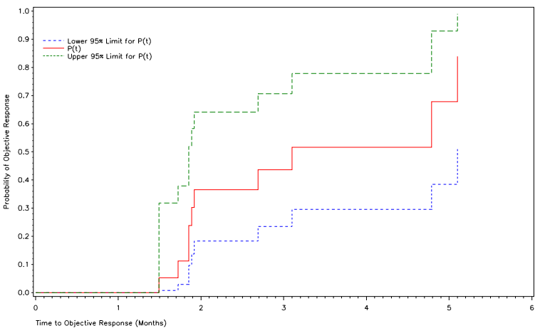
B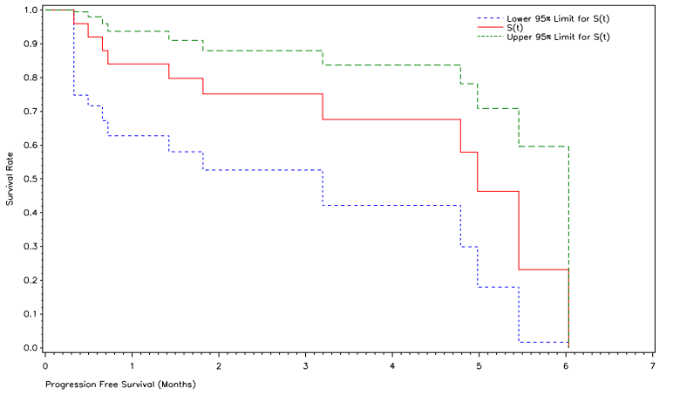

C
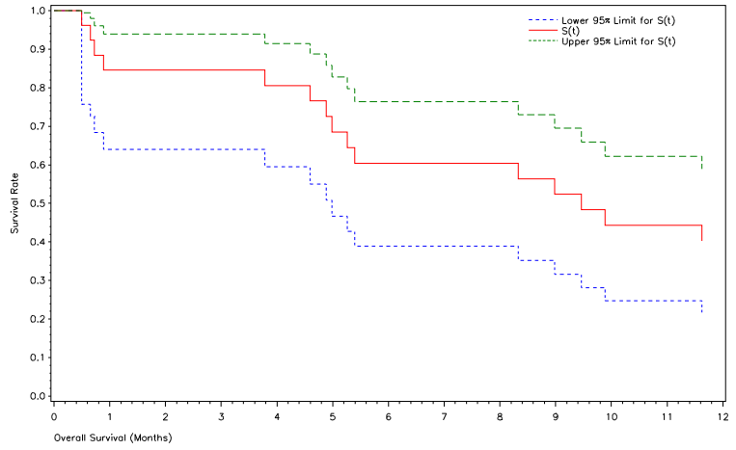
D
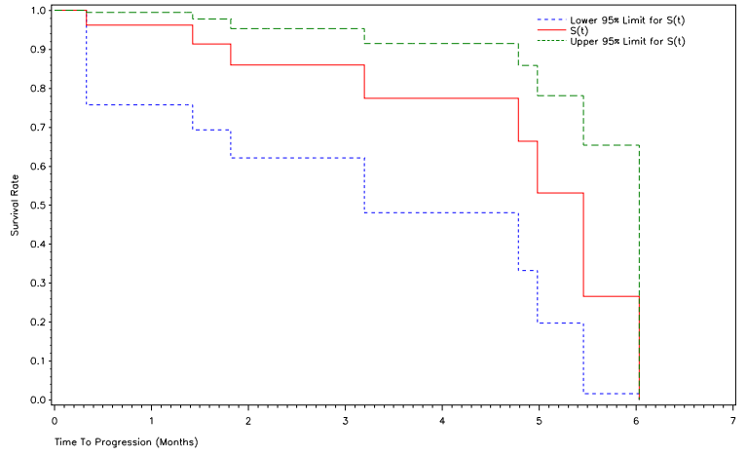

Table 3. Incidence of Most Frequent (> 10% of Patients) Adverse Events by Preferred Term (PT) – ITT Population
PT | Events |  | Patients  (ITT population = 26)
PT | N of events | % of events | N of patients¹ | % of patients¹
All events | 327 | 100.0 | 26 | 100.0
Anaemia | 42 | 12.8 | 14 | 53.9
Leukopenia | 11 | 3.4 | 7 | 26.9
Neutropenia | 24 | 7.3 | 11 | 42.3
Thrombocytopenia | 15 | 4.6 | 8 | 30.8
Abdominal pain | 4 | 1.2 | 4 | 15.4
Nausea | 17 | 5.2 | 9 | 34.6
Vomiting | 7 | 2.4 | 5 | 19.2
Asthenia | 5 | 1.5 | 5 | 19.2
Fatigue | 13 | 4.0 | 6 | 23.1
Aspartate aminotransferase increased | 5 | 1.5 | 4 | 15.4
Blood creatinine increased | 29 | 8.9 | 13 | 50.0
Blood urea increased | 12 | 3.7 | 8 | 30.8
Blood uric acid increased | 3 | 0.9 | 3 | 11.5
Lipase increased | 6 | 1.8 | 4 | 15.4
Platelet count decreased | 5 | 1.5 | 4 | 15.4
Decreased appetite | 5 | 1.5 | 5 | 19.2
Hyperglycaemia | 15 | 4.6 | 7 | 26.9
Hypoglycaemia | 5 | 1.5 | 3 | 11.5
Hypomagnesaemia | 6 | 1.8 | 3 | 11.5
Cough | 4 | 1.2 | 3 | 11.5
Dyspnoea | 7 | 2.4 | 7 | 26.9
¹ Patients who experienced more than one event were only counted once per Preferred Term.

References
Reference List

1. Fenelon A, Preston SH. Estimating smoking-attributable mortality in the United States. Demography. 2012;49(3):797-818.
2. Canadian Cancer Society, Statistics Canada, Public Health Agency of Canada, Provincial/ Territorial Cancer Registries. Canadian Cancer Statistics 2014. Special topic: Skin cancers. May 2014.
3. Ramalingam S, Belani C. Systemic chemotherapy for advanced non-small cell lung cancer: recent advances and future directions. The oncologist. 2008;13 Suppl 1:5-13.
4. Riessk J. Shifting paradigms in non-small cell lung cancer: an evolving therapeutic landscape. The American journal of managed care. 2013;19(19 Suppl):s390-7.
5. Cersosimo RJ. Lung cancer: a review. American journal of health-system pharmacy : AJHP : official journal of the American Society of Health-System Pharmacists. 2002;59(7):611-42.
6. Molina JR, Yang P, Cassivi SD, Schild SE, Adjei AA. Non-small cell lung cancer: epidemiology, risk factors, treatment, and survivorship. Mayo Clinic proceedings. 2008;83(5):584-94.
7. Quint LE. Lung cancer: assessing resectability. Cancer imaging : the official publication of the International Cancer Imaging Society. 2004;4(1):15-8.
8. Socinski MA, Evans T, Gettinger S, Hensing TA, Sequist LV, Ireland B, et al. Treatment of stage IV non-small cell lung cancer: Diagnosis and management of lung cancer, 3rd ed: American College of Chest Physicians evidence-based clinical practice guidelines. Chest. 2013;143(5 Suppl):e341S-68S.
9. Azzoli CG, Baker S, Jr., Temin S, Pao W, Aliff T, Brahmer J, et al. American Society of Clinical Oncology Clinical Practice Guideline update on chemotherapy for stage IV non-small-cell lung cancer. Journal of clinical oncology : official journal of the American Society of Clinical Oncology. 2009;27(36):6251-66.
10. Goffin J, Lacchetti C, Ellis PM, Ung YC, Evans WK. First-line systemic chemotherapy in the treatment of advanced non-small cell lung cancer: a systematic review. Journal of thoracic oncology : official publication of the International Association for the Study of Lung Cancer. 2010;5(2):260-74.
11. Ginsberg RJ, Vokes EE, Raben A. Non-small cell lung cancer, in Cancer: Principles and Practice of Oncology, V.T.J. DeVita, Hellman S., Rosenberg S.A., Editory 1997, Lippincott-Raven: Philadelphia, PA p. 858-911.
12. Society. AC. Lung cancer (non small cell). http://www.cancer.org/acs/groups/cid/documents/webcontent/003115-pdf.pdf; Access date: December 28, 2015. 2014.
13. Chow TY, Alaoui-Jamali MA, Yeh C, Yuen L, Griller D. The DNA double-stranded break repair protein endo-exonuclease as a therapeutic target for cancer. Molecular cancer therapeutics. 2004;3(8):911-9.
14. Chow TY, Choudhury SA. DNA repair protein: endo-exonuclease as a new frontier in cancer therapy. Future oncology (London, England). 2005;1(2):265-71.
15. Esteller M, Garcia-Foncillas J, Andion E, Goodman SN, Hidalgo OF, Vanaclocha V, et al. Inactivation of the DNA-repair gene MGMT and the clinical response of gliomas to alkylating agents. The New England journal of medicine. 2000;343(19):1350-4.
16. A Safety Study of OCZ103-OS in Patients with Metastatic Colorectal Cancer Undergoing Standard Chemotherapy as Second-Line and/or Third-Line Treatmnet. clinicaltrials.gov Identifier: NCT00809796.
17. A Safety Study of Pentamidine (OCZ103-OS) in Patients with Pancreatic Cancer Undergoing Standard Therapy. clinicaltrials.gov Identifier: NCT00810953.
18. Azzoli CG, Temin S, Aliff T, Baker S, Jr., Brahmer J, Johnson DH, et al. 2011 Focused Update of 2009 American Society of Clinical Oncology Clinical Practice Guideline Update on Chemotherapy for Stage IV Non-Small-Cell Lung Cancer. Journal of clinical oncology : official journal of the American Society of Clinical Oncology. 2011;29(28):3825-31.
19. Scagliotti GV, De Marinis F, Rinaldi M, Crino L, Gridelli C, Ricci S, et al. Phase III randomized trial comparing three platinum-based doublets in advanced non-small-cell lung cancer. Journal of clinical oncology : official journal of the American Society of Clinical Oncology. 2002;20(21):4285-91.
20. Schiller JH, Harrington D, Belani CP, Langer C, Sandler A, Krook J, et al. Comparison of four chemotherapy regimens for advanced non-small-cell lung cancer. The New England journal of medicine. 2002;346(2):92-8.
21. Fossella F, Pereira JR, von Pawel J, Pluzanska A, Gorbounova V, Kaukel E, et al. Randomized, multinational, phase III study of docetaxel plus platinum combinations versus vinorelbine plus cisplatin for advanced non-small-cell lung cancer: the TAX 326 study group. Journal of clinical oncology : official journal of the American Society of Clinical Oncology. 2003;21(16):3016-24.

