Clinical Study Summary: MD2012/01XP

Study Title: | A Phase II, randomised, single centre, open-label, two-arm study to determine the safety and efficacy of buprenorphine oral lyophilisate (Xprenor®) in comparison with buprenorphine sublingual tablets (Subutex®) in opioid-dependent patients
Study Number: | MD2012/01XP
EudraCT Number: | 2012-003560-49
Study Phase: | II
Study Design: | Randomised, single centre, open-label, two-arm study
Product Name: | Xprenor® (buprenorphine oral lyophilisate)
Formulation: | Xprenor® 2 mg and 8 mg oral tablets
Indication: | Opioid substitution therapy
Study Initiated (first subject enrolled): | 14 February 2013
Study Completed (last subject completed): | 22 December 2013
Sponsor: | Macarthys Laboratories Limited (trading as Martindale Pharma®), Building A2, Wooburn Green, Buckinghamshire, HP10 0DF, UK  Telephone: 01628 551 933
Final Date: | Final V 1.00, 09 April 2014

Results
Fifty-five subjects were screened, of whom 17 subjects (30.9%) did not meet inclusion/exclusion criteria (Fig. 1). Two randomised subjects did not receive study treatment (one withdrawing consent, one lost contact). A total of 36 subjects received treatment and comprised the study population; 23 randomised to Xprenor®, 13 to Subutex®. Two subjects (one in each group) were regular benzodiazepine users.

Fig. 1. Flow diagram of the study. * % Screened, ** % of subjects administered specific study drug.
PK = Pharmacokinetic study population; DNA: Did Not Attend.

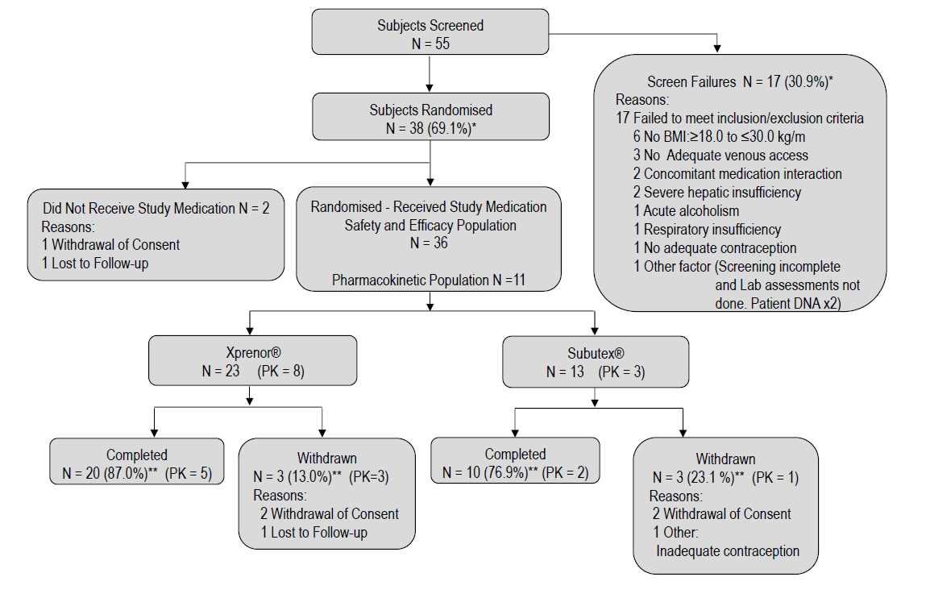
Eleven subjects also participated in the PK study (8 Xprenor®; 3 Subutex®). Two PK subjects (one per group) withdrew during the extension period, and cannulae blockage spoilt PK on a further 2 subjects (Xprenor®) at final (extension) assessment.

Demographics and Drug Use Histories
Subject demographic characteristics are summarised in Table 1. The study samples were typical of people presenting for treatment of opiate dependence, although slightly older (mean ± SD 42 ± 8.6, range 23–58 years), mostly white Caucasian (64%) and with a higher proportion male (86%). The age of first opiate use was 25 ± 8.8 (range 11–42 years); the duration of heroin/opiate use prior to the study was 17 ± 11 (range 3–47 years); 50% (18) had ever injected (3 currently; fuller detail in Table 1).
Table 1. Characteristics of the 2 randomised groups (Xprenor® versus Subutex®; total population in right-hand column)
 | Lyophilised oral buprenorphine (Xprenor®; n = 23), mean (SD), median (range) | Sublingual buprenorphine (Subutex®; n = 13), mean (SD), median (range) | Total study population (n = 36), mean (SD), median (range)
Age, years (at entry to trial) | 42.0 (8.0) | 42.0 (10.0) | 42.0 (8.6)
 | 43 (26-58) | 45 (23-53) | 44.5 (23-58)
Age, years of first opiate use | 25.4 (8.7) | 25.7 (9.4) | 25.5 (8.8)
 | 22 (11-41) | 23.0 (14-42) | 22.5 (11-42)
Number of years of opiate use | 16.6 (11.3) | 16.3 (10.3) | 16.5 (10.8)
 | 15 (2-47) | 13 (3-14) | 14 (2-47)
Gender
Male | 20 | 11 | 31
Females | 3 | 2 | 5
Ethnicity
Caucasian | 15 | 8 | 23
Asian | 0 | 1 | 1
“Other” of which | 7 | 4 | 11
“Black British” | 2 | 4 | 6
“African/Caribbean” | 1 | 0 | 1
“African/British” | 1 | 0 | 1
“Mixed black/white” | 1 | 0 | 1
“British Caribbean” | 1 | 0 | 1
No ethnicity given | 1 | 0 | 1
OST at time of entering trial
None | 2 | 0 | 2
Buprenorphine | 15 | 10 | 25
Methadone | 6 | 3 | 9
Using illicit opiates pre-trial
Yes | 13 | 10 | 23
No | 9 | 3 | 12
Not known | 1 | 0 | 1
Injecting history
Never | 12 | 6 | 18
Past | 10 | 5 | 15
Current | 0 | 2 | 2
Unknown/refused | 1 | 0 | 1
Hep C status
Positive | 3 | 6 | 9
Negative | 16 | 7 | 23
Cleared | 4 | 0 | 4

Retention and Attrition through Titration and Maintenance Periods
Retention across the 28-day study was 87% (20/23) in Xprenor® and 77% (10/13) in Subutex® (difference not statistically significant).

Retention during the first 14 days (when subjects were randomised to medication) was 96% for Xprenor® versus 85% for Subutex® at end of titration, and 91 and 85%, respectively, at the end of the maintenance period (differences were not statistically significant).

Intensity of Withdrawal Symptoms, Craving, and Adequacy of “Hold”
For both medications, moderately high levels of withdrawal severity on day 1 were evident (OOWS and SOWS), then reducing rapidly to low levels within a couple of days, remaining low throughout the remainder of the study period. No significant between-group differences were detected.

The Titration Period
Daily doses were individually tailored to clinical response. For Xprenor® subjects ( n = 22/23 successfully titrated), the mean ± SD maintenance daily dose was 10.8 ± 4.9 mg with 3 (14%) on ≤ 4 mg, 6 (27%) on 6–8 mg, 9 (41%) on 10–14 mg, 3 (14%) on 16 mg and 1 (5%) on 20 mg. For Subutex® subjects (n = 11/13 successfully titrated), the mean maintenance daily dose was 9.6 ± 4.3 mg, with 1 subject (9%) on 4 mg, 7 (64%) on 6–8 mg and 3 (27%) on 16 mg.
For both groups, the titration period proceeded smoothly with 18 Xprenor® subjects (81.8%) and 10 Subutex® subjects (90.9%) reaching their maintenance daily dose by day 3.

The Maintenance Period
There were no statistically significant differences between Xprenor® and Subutex® in within-subject changes of either SOWS or OOWS scores from baseline (titration day 7) to either maintenance day 2 or 7, nor with adequacy of “hold,” intensity of withdrawal, or intensity of craving.

Crossover: Dose Changes Required on Switch from Xprenor® to Subutex®
No dose adjustment was deemed clinically indicated for any of the 20 subjects on Xprenor® who switched from Xprenor® to Subutex® at day 15 (same prescribed dose), and there were no significant differences in subjective and objective scores.

Respiratory Safety and Respiratory Function
There was no statistically significant difference in respiratory depression between Xprenor® and Subutex® when comparing subject differences from baseline (up to last valid titration oximeter record) to Maintenance days 2 and 7 for the number of SpO₂ <90% events lasting ≥ 1 min or for the cumulative duration of SpO₂ <90% in either the 0–30 or 0–120 min post-dose period.
There was also no statistically significant difference in respiratory depression between Xprenor® and Subutex® as determined by the difference in the mean number of SpO₂ <90% events lasting ≥ 1 min in the 0–30 min post-dose period at either maintenance days 2 or 7 (p = 0.20 and p = 0.19, respectively) from baseline.
Similarly, there was no statistically significant difference between Xprenor® and Subutex® in the mean difference in total duration of SpO₂ <90% (p = 0.87 and p = 0.61, respectively) during this period. Mean ± SD durations of SpO₂ <90% in the 0–30 min post-dose period on maintenance days 2 and 7 were 6.1 ± 11.95 and 7.1 ± 13.47 seconds in the Xprenor® group compared to 177.0 ± 544.00 and 14.0 ± 31.25 seconds in the Subutex® group, respectively.
The same conclusions applied to the 0–120 min post-dose period assessments, where no statistically significant differences between Xprenor® and Subutex® were observed for the mean difference in the number of SpO₂ <90% events lasting ≥ 1 min at either Maintenance days 2 or 7 (p = 0.18 and p = 0.19, respectively) and the mean difference in the total duration of SpO₂ <90% (p = 0.81 and p = 0.29, respectively). Mean ± SD durations of SpO₂ <90% in the 0–120 min post-dose period on maintenance days 2 and 7 were 68.0 ± 92.37 and 61.1 ± 88.94 seconds in the Xprenor® group compared to 499.3 ± 959.26 seconds and 226.0 ± 281.46 seconds in the Subutex® group.
There were no statistically significant differences between Xprenor® and Subutex® for either the mean respiration rate or mean categorical SpO₂ during the 0–60 min post-dose periods across assessment sessions. Numerical values are summarised in Table 2.

Table 2. Assessments of respiratory function with continuous oximetry – Xprenor® vs. Subutex®
 | Cumulative total SpO₂ <90% 0-30 min post-dose, mean (SD) |  | Incidence of SpO₂ <90% for ≥1 min, 0-30 min post-dose, mean (SD) |  | Cumulative total SpO₂ <90% 0-120 min post-dose, mean (SD) |  | Incidence of SpO₂ <90% for ≥1 min, 0-120 min post-dose, mean (SD)
 | Xprenor® | Subutex® | Xprenor® | Subutex® | Xprenor® | Subutex® | Xprenor® | Subutex®
Titration day 1 | 8.1 (16.69) | 158.3 (510.09) | 0 (0) | 0.3 (1.15) | 68.1 (88.40) | 207.5 (123.74) | 0 (0) | 0.5 (0.71)
Titration day 1.1 | 22.9 (42.37) | 157.8 (402.49) | 0.1 (0.27) | 0.7 (2.00) | 67.3 (65.91) | 958.0 (1969.18) | 0.2 (0.38) | 3.8 (8.5)
Maintenance day 2 | 6.1 (11.95) | 177.0 (544.00) | 0 (0) | 0.1 (0.32) | 68.0 (92.37) | 499.3 (959.26) | 0.2 (0.49) | 0.9 (1.46)
Maintenance day 7 | 7.1 (13.47) | 14.0 (31.25) | 0 (0) | 0 (0) | 61.1 (88.94) | 226.0 (281.46) | 0 (0.5) | 0 (1.27)

Adverse Events
There were no deaths and no serious adverse events (SAE).
No adverse event (AE) was scored “severe.” No treatment-emergent AEs (TEAEs) resulted in withdrawal. However, a greater proportion of Xprenor® subjects experienced at least one AE and similarly for TEAE (73.9 and 69.6%, respectively) compared to the Subutex® group (30.8 and 15.4%, respectively). These mostly scored “mild,” with similar proportions of “moderate” AEs in both treatment groups (Xprenor® = 17.4%, Subutex® = 23.1%). Moderate TEAEs reported by ≥ 2 subjects included vomiting, arthralgia, hyperhidrosis, and nausea. However, more Xprenor® subjects reported a greater number of “mild” TEAEs (48 TEAEs in 17 subjects, 73.9%) versus Subutex® subjects (9 TEAEs in 4 subjects, 30.8%). All of these “mild” TEAEs were self-limiting.
The most frequently reported TEAE was headache in the Xprenor® group (4 subjects, 17.4%). There were 3 events of oral hypoaesthesia from 2 Xprenor® subjects at 5 and 10 min post-administration; these resolved within 20 min, 20–25 min, and “within an hour.” One subject also experienced an intermittent itchy feeling at the back of the throat (pruritus). All these events were considered mild but possibly related to study medication.

Laboratory Test Results, Physical Examination, and ECG Recordings
No clinically significant differences were observed between groups, with findings consistent with expectations for this patient population. A majority of subjects in both treatment groups had at least one positive report from drug testing for cocaine (Xprenor® = 52.2%, Subutex® = 76.9%) during titration and/or maintenance.

Disintegration and Solubility of the Xprenor® and Subutex® Tablets
At dosing occasions, a record was made of both time to disintegration (i.e., tablet could no longer be removed intact) and time to complete disintegration (see Fig. 2). Over all periods, 96.3% of Xprenor® administrations achieved partial disintegration on the tongue in ≤ 15 vs. 71.8% with Subutex® (p < 0.001). At 2 min, Xprenor® had completely dissolved in 58.0% of administrations versus 5.1% (Subutex®; p < 0.0001). The median time for tablets to completely disintegrate was 2.0 min for Xprenor® versus 10 min for Subutex® (p < 0.0001).
All assessments of buccal mucosa during administration were reported as normal.

Fig. 2. Time to complete disintegration of tablets (Xprenor® vs. Subutex®).
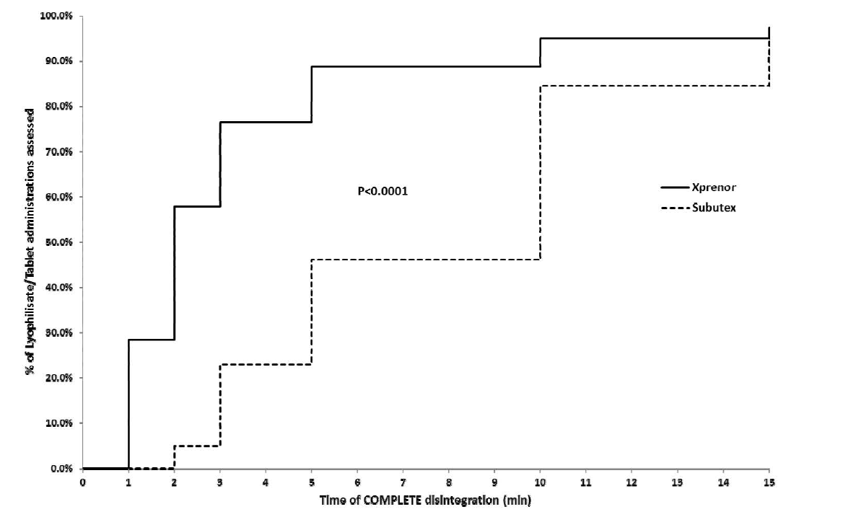

PKs (from Volunteer Subsample) – Buprenorphine and nor-Buprenorphine
Blood samples that could be analysed for PK were available from 11 subjects (8 Xprenor® and 3 Subutex®), yielding 21 sessions over days 2 and 7 of the maintenance period (15 Xprenor® and 6 Subutex®).
Since subjects were on individualised maintenance doses, we examined PK curves for a dose-adjusted 4 mg dose. Samples were collected on days 2 and 7 of the maintenance period (Fig. 3). In summary, these dose-normalised data find comparability in norbuprenorphine PK profiles between Xprenor® and Subutex® despite apparent increased bioavailability for Xprenor® for buprenorphine concentrations.
Of particular PK interest were the 5 subjects for whom PK data were available following administration of both Xprenor® and Subutex®. These subjects received the same dose of Xprenor® on maintenance day 7 as Subutex® at extension end (all had received repeat dosing for 13–15 days) and provide within subject relative bioavailability. For these subjects, Xprenor® demonstrated a higher mean (SD) buprenorphine bioavailability (C_{max}: 185.8 ± 88.2% and AUC0–3 h: 169.8 ± 62.0%) relative to Subutex®. However, for norbuprenorphine the mean (SD) bioavailability was comparable (C_{max}: 109.6 ± 42.2% and AUC0–3 h: 105.0 ± 39.4%) relative to Subutex®.

Fig. 3. Mean ± SD blood concentration-time profiles for (a) buprenorphine and (b) nor-buprenorphine (both figures dose-normalised to 4 mg dose to allow analysis of patients on different personal maintenance doses).
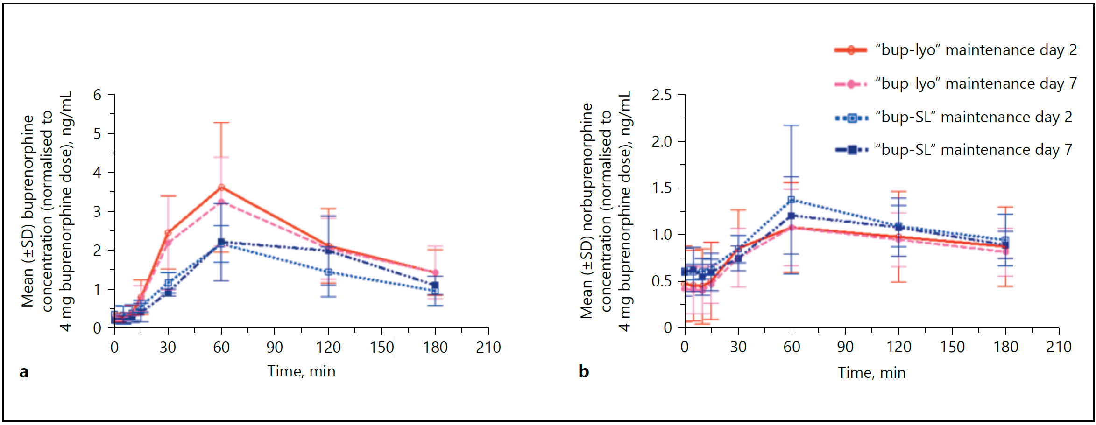
Xprenor® maintenance day 2
Xprenor® maintenance day 7
Subutex® maintenance day 2
Subutex® maintenance day 7

