Minocycline in mild Alzheimer’s disease (MADE): a randomised controlled, double-blind trial

Key words

MeSH terms: Humans; Minocycline; Dizziness; Activities of Daily Living; Intention to Treat Analysis; Amyloidogenic Proteins; Alzheimer Disease; Vertigo; Amyloidosis; Models, Animal; Outcome Assessment (Health Care); Mental Status and Dementia Tests; Cognition

Authors
Robert Howard¹*, Olga Zubko², Rosie Bradley³, Emma Harper⁴, Linda Kelly⁴, Lynn Pank⁴, John O’Brien⁵, Chris Fox⁶, Naji Tabet⁷, Gill Livingston¹, Peter Bentham⁸, Rupert McShane⁹, Alistair Burns¹⁰, Craig Ritchie¹¹, Suzanne Reeves¹, Simon Lovestone¹², Clive Ballard¹³, Wendy Noble¹⁴, Ramin Nilforooshan¹⁵, Gordon Wilcock⁴, Richard Gray⁴

¹ Division of Psychiatry, University College London, London, UK;
² Department of Old Age Psychiatry, King’s College London, London, UK;
³ Medical Research Council Population Health Research Unit, University of Oxford, Oxford, UK;
⁴ Nuffield Department of Population Health, University of Oxford, Oxford, UK;
⁵ Department of Psychiatry, University of Cambridge, Cambridge, UK;
⁶ Norwich Medical School, University of East Anglia;
⁷ Department of Old Age Psychiatry, University of Sussex, Brighton, UK;
⁸ Birmingham and Solihull Mental Health NHS Foundation Trust;
⁹ Department of Psychiatry, University of Oxford, Oxford, UK;
¹⁰ Department of old Age Psychiatry, University of Manchester, UK;
¹¹ Centre for Clinical Brain Sciences, University of Edinburgh, UK;
¹² Department of Psychiatry, University of Oxford, Oxford, UK;
¹³ Medical School, University of Exeter, UK;
¹⁴ Department of Basic and Clinical Neuroscience, King’s College London
¹⁵ Surrey and Borders Partnership NHS FT

*Corresponding Author

Professor Robert Howard, Division of Psychiatry, University College London, 6th Floor Maple House, 149 Tottenham Court Road, London W1T 7NF; robert.howard@ucl.ac.uk

ABSTRACT

Background

Minocycline is anti-inflammatory and protects against the toxic effects of β-amyloid in vitro and in animal models of Alzheimer’s disease (AD). No clinical trials in patients with AD looking at the efficacy and tolerability of minocycline have been carried.

Objectives

We investigated whether minocycline was superior to placebo in slowing down the rate of decline in cognitive and functional ability over 2 years. The safety and tolerability of minocycline was also assessed.

Design
Phase II, 3-arm, randomised, double blind, multi-centre trial with a semi-factorial design. Participants continued on trial treatment for up to 24months.

Setting
Patients were identified from memory services, both within the 32 participating NHS Trusts, and within the network of memory services supported by DeNDRoN.

Participants
Patients with sMMSE scores > 23 points and with AD assessed by the NIA/AA criteria were identified from memory services.

Intervention

Patients with mild AD were randomly allocated 1:1:1 to receive one of three treatment arm: arm1 - minocycline 400mg/day, arm 2- 200mg/day, or arm3- placebo, and continued treatment for 24 months. Participants, investigators and outcome assessors were blind to treatment allocation.

Main outcome measures

Primary outcome measures were decline in standardised Mini-Mental State Examination (sMMSE) score and Bristol Activities of Daily Living Scale (BADLS) of combined minocycline group vs placebo, analysed by intention-to-treat repeated measures regression.

Results

Between May 23, 2014 and April 14, 2016, 554 participants were randomised. Of the 544 eligible participants, mean age was 74.3 years, and average sMMSE score 26.4. Significantly fewer participants completed 400mg minocycline treatment [29% (53/184)] than 200mg [62% (112/181)], or placebo [64% (114/179), p<0.0001, mainly because of gastrointestinal symptoms (p=0.0008), dermatological side-effects (p=0.02), and dizziness (p=0.01). Assessment rates were also lower in the 400mg treatment arm: 68% (119 of 174 expected) for sMMSE at 24-months compared to 82% (144/176) for 200mg, and 84% (140/167) for placebo. Decline in sMMSE scores over the 24-month study period in the combined minocycline groups was similar to that in the placebo group 4.1 vs 4.3 point reduction (p=0.9), as was the decline in the 400mg and 200mg groups: 3.3 vs 4.7 points (p=0.08). Likewise, worsening of BADLS scores over 24 months was similar in all groups: 5.7, 6.6 and 6.2 in the 400mg, 200mg and placebo groups, respectively: p=0.57 for minocycline vs placebo, and p=0.77 for 400mg vs 200mg minocycline. Results were similar in different patient subgroups, and in sensitivity analyses adjusting for missing data.

Limitations

Compliance was worse than expected and differential follow-up rates were observed with fewer assessments obtained for the 400mg group than 200mg and placebo arms.

Conclusions

Minocycline does not delay the progress of cognitive or functional impairment in people with mild AD over a 2-year period. Minocycline at a dose of 400mg is poorly tolerated in this population.

Future work

MADE provides a framework for a streamlined trial design which can be usefully applied to test other disease-modifying therapies.

Study registration

EudtaCT2013-000397-30; ISRCTN16105064

Funding details

Funded by Medical Research Council and National Institute of Health Research (EME 11/47/01).

TABLE OF CONTENTS

Key words 1
Authors 1
*Corresponding Author 1
Word count: 2
ABSTRACT 2
Background 2
Objectives 2
Design 2
Setting 2
Participants 2
Intervention 2
Main outcome measures 3
Results 3
Limitations 3
Conclusions 3
Future work 3
Study registration 4
Funding details 4
TABLE OF CONTENTS 4
List of Tables 6
List of Figures 6
ALPHABETICAL LIST OF ABBREVIATIONS 6
PLAIN ENGLISH SUMMARY 8
SCIENTIFIC SUMMARY 9
Background 9
Objectives 10
Methods 10
Results 11
Conclusions 11
Future work 11
Study registration 11
Funding details 11
Literature search 12
INTRODUCTION 12
METHODS 14
Objectives 14
Trial Design 14
Ethical Approval and Research Governance 15
Outcomes 15
Participants 16
Recruitment procedure 17
Screening 17
Trial treatment 17
Treatment preparation 18
Packaging and Labelling 18
Storage and dispensing 18
Unblinding 19
Concomitant Medication 19
Side effects 20
Treatment Compliance 20
Drug accountability 20
Assessments 20
Safety and tolerability 22
Randomisation and blinding 22
Ethical considerations 23
Statistical considerations 24
RESULTS 25
DISCUSSION 32
ACKNOWLEDGEMENTS 35
Contributors 35
MADE Trialist Group 36
Participating centres and MADE Collaborative Group members 36
Declaration of interests 39
Acknowledgements 39
Publications 40
REFERENCES 40
APPENDIX 1 46
REC amendments 46
Literature Search 46
sMMSE outcome measure response sheet 47
BADLs outcome measure responses sheet 49
Sample participant responses: BADLS responses for a 12 months follow-up 51
APPENDIX 2 53
Table 1 - Follow-up rate for SMMSE and BADLS by treatment group and follow-up period 53
Table 2 – Skin toxicity incidence and severity by treatment arm 54
Table 3 – Causes of death 54
Figure 2. Change in (A) MMSE and (B) BADLS from baseline to month 24 using imputation method (2) to estimate scores for patients with no follow-up past baseline 56
Figure 3 – Subgroup analyses of change in sMMSE over 24 months for minocycline (any dose) versus placebo by baseline characteristics 57
Figure 4: Probability of A) Survival, (B) remaining community resident and (C) being alive and community-resident by treatment allocation: Kaplan-Meier survival plots 58

List of Tables

Table 1: Study time-event chart……………………………………………………………………………………………………………………………..22
Table 2. Baseline characteristics by treatment allocation for the 544 eligible patients………………………………………….26
Table 3. (A) Reasons for stopping treatment, and (B) Serious Adverse Events by treatment
allocation………………………………………………………………………………………………………………………………………………………………….29

List of Figures
Figure 1: Flow chart…………………………………………………………………………………………………………………………………………………27
Figure 2. Proportion taking trial treatment over time: Kaplan-Meier plot……………………………………………………………….28
Figure 3. Change in (A, B) sMMSE and (C, D) BADLs from baseline to month 24. (A, C) From data collected, (B, D) using imputation method 1 to estimate scores for patients with no follow up past baseline ……………………………..….30

ALPHABETICAL LIST OF ABBREVIATIONS

Aβ - β-amyloid
AD – Alzheimer’s disease
AE – Adverse Event
ALS – Amyotrophic Lateral Sclerosis
AR – Adverse Reaction
BADLS – Bristol Activities of Daily Living Scale
BIN1 - bridging integrator 1
CD33 - myeloid specific sialic acid binding receptor
CI – Chief Investigator
CR1- complement receptor 1
CRA - Clinical Research Associate
CRF – Case Report Form
CTSU - Clinical Trial Service Unit
DeNDRoN – Dementia and Neurodegenerative Diseases Research Network.
DSUR - Development Safety Update Report
DMEC – Data Monitoring and Ethics Committee
EME - Efficacy and Mechanism Evaluation Programme
GCP – Good Clinical Practice
HTA - Health Technology Assessment
IMP - Investigational Medicinal Product
KCL – Kings College London
KHP-CTO – Kings Health Partners Clinical Trials Office
LSC – Local Study Coordinator
MADE - Minocycline in Alzheimer’s Disease Efficacy trial
MHRA – Medicines and Healthcare Products Regulatory Agency
MHRN – Mental Health Research Network
MMSE – Mini-Mental State Examination
MR – Modified Release
NIA/AA – National Institute on Aging / Alzheimer’s Association
NRES – National Research Ethics Service
NSAIDs - Non-steroidal anti-inflammatory drugs
PI- Principal Investigator
R & D – Research and Development
REC - Research Ethics Committee
RW – Research Worker
SAE – Serious Adverse Event
SAR – Serious Adverse Reaction
SUSAR – Suspected Unexpected Serious Adverse Reaction
SLE – Systemic Lupus Erythematosus
sMMSE – Standardized Mini-Mental State Examination
SOP – Standard Operating Procedures
SSA – Site Specific Assessment
TM – Trial Manager
TMG – Trial Management Group
TREM2 - triggering receptor expressed on myeloid cell 2
TSC – Trial Steering Committee
UAR – Unexpected Adverse Reaction

PLAIN ENGLISH SUMMARY

Alzheimer's disease affects about 700,000 people in the UK and, although we have drug treatments that can modestly improve some of the symptoms, we do not yet have any treatments that slow down or arrest the progression of dementia.

Minocycline is an antibiotic that, in addition to its antibacterial action, has been shown to protect brain cells in a number of experimental and animal models of Alzheimer's disease and other neurological diseases. Minocycline is cheap and well tolerated. If it could be shown to significantly slow down the course of Alzheimer's disease, minocycline could quickly be made available to large numbers of sufferers worldwide. Although it is probably one of the best current candidates for Alzheimer's disease modification, the evidence from animal and other experimental models of dementia can only suggest that minocycline has the potential to help sufferers.

We conducted a clinical trial to determine definitively whether or not minocycline is effective in slowing decline in Alzheimer's disease and whether a high dose of the drug is more effective than a lower dose that is commonly used in the long term treatment of acne. We investigated the effects of long term treatment with two doses of minocycline on decline in cognitive function and ability to carry out essential functions involved in activities of daily living.

Unfortunately, we found that Minocycline treatment did not have any measurable effect in slowing down the progression of Alzheimer’s disease. Participants who took Minocycline showed exactly the same worsening of their cognitive functioning and activities of daily living as those who were allocated to placebo treatment over the 2 years of the trial. The trial also established that minocycline at the high dose is poorly tolerated in patients with AD whilst the low dose of minocycline is well tolerated with participants allocated this treatment being no more likely to withdraw from trial medication than those taking placebo.
The limitations of the study include low compliance rates with few patients in the high dose arm completing two years of treatment, and only moderate compliance in the low dose and placebo arms. It was also difficult to obtain outcome assessments which resulted in unequal numbers of completed assessments between the three arms, which could have biased our results. Having said that, the additional analyses investigating potential bias have shown the same pattern of results, which suggests that the results are in fact quite robust.
Although disappointing, these results are important because they will guide further research into the search for a treatment. There is currently much interest in treating inflammatory changes in the brain in Alzheimer’s disease. As Minocycline is a potent anti-inflammatory drug, the results of MADE will show researchers which pathways they should focus on.

SCIENTIFIC SUMMARY

Background

Alzheimer’s disease (AD) is a major public health issue with approximately 700,000 people in the UK suffering from dementia of whom some 400,000 have Alzheimer’s disease. The imperative to discover and develop treatments that can stop or at least delay disease progression is clear. None of the drug treatments licensed for AD have been shown to affect progression of the illness and, despite a better understanding of the pathogenesis of AD, clinical trials of potentially disease modifying treatments so far undertaken have had disappointing results.

There is a substantial body of evidence to indicate that minocycline may be neuroprotective in neurodegenerative diseases such as AD. Although the primary neuroprotective target of minocycline in the central nervous system is not known, the principal effects of minocycline include: inhibition of microglial activation, attenuation of apoptosis and suppression of the production of reactive oxygen species. Minocycline is arguably the most promising off-patent candidate for AD modification that is not currently in trials and it is cheap and well tolerated.

Objectives

MADE is a multi-centre, randomised, controlled trial in very mild AD, which primarily aimed to determine whether minocycline is superior to placebo in affecting the disease course, over a 2-year period, as measured by reduced rate of decline in cognition (Standardised Mini-Mental State Examination (sMMSE)) and function (Bristol Activities of Daily Living Scale (BADLS). We also compared the safety and tolerability of minocycline at doses of 200mg and 400mg per day.

Methods

MADE was a phase II, 3-arm, randomised, double blind, multi-centre trial with a semi-factorial design. Patients with very mild AD (sMMSE > 23 points) and assessed by the NIA/AA criteria were identified from memory services, both within the 32 participating NHS Trusts, and within the network of memory services supported by DeNDRoN.

Inclusion criteria were (i) Diagnosis of NINCDS-ADRDA possible or probable AD, (ii) Standardised Mini-Mental State Examination score >23, (iii) Consent to participate or agreeing to participate if capacity to give informed consent lost, (iv) Renal and hepatic function within normal limits, (v) If taking AD medication (memantine or cholinesterase inhibitor) on stable dose for at least 8 weeks. Exclusion criteria were (i) Known allergy to tetracycline antibiotics, (ii) Serious or unstable medical condition that would represent contraindication to taking trial medication.

Following informed consent and completion of baseline assessment, participants were randomly allocated 1:1:1 to receive one of three treatment arm: arm1 - minocycline 400mg/day, arm 2- 200mg/day, or arm3- placebo, and continued treatment for 24 months. Participants, investigators and outcome assessors were blind to treatment allocation.

Primary outcome measures were decline in standardised Mini-Mental State Examination (sMMSE) score and Bristol Activities of Daily Living Scale (BADLS) of combined minocycline group vs placebo, analysed by intention-to-treat repeated measures regression. The secondary research objectives were to establish (i) safety and tolerability of minocycline at doses of 200mg/day and 400mg/day in patients with mild AD, (ii) whether 400mg/day offers superior neuroprotection to 200mg/day, and (iii) estimate the magnitude of effect sizes on cognitive and functional decline associated with any statistically significant positive treatment effects that will inform the design and powering of a future phase III trial of definitive clinical effectiveness within the NHS.

Results

Between May 23, 2014 and April 14, 2016, 554 participants from 32 UK memory clinics were randomised. Of the 544 eligible participants, mean age was 74.3 years, and average sMMSE score 26.4. Significantly fewer participants completed 400mg minocycline treatment [29% (53/184)] than 200mg [62% (112/181)], or placebo [64% (114/179), p<0.0001, mainly because of gastrointestinal symptoms (p=0.0008), dermatological side-effects (p=0.02), and dizziness (p=0.01). Assessment rates were also lower in the 400mg treatment arm: 68% (119 of 174 expected) for sMMSE at 24-months compared to 82% (144/176) for 200mg, and 84% (140/167) for placebo. Decline in sMMSE scores over the 24-month study period in the combined minocycline groups was similar to that in the placebo group 4.1 vs 4.3 point reduction (p=0.9), as was the decline in the 400mg and 200mg groups: 3.3 vs 4.7 points (p=0.08). Likewise, worsening of BADLS scores over 24 months was similar in all groups: 5.7, 6.6 and 6.2 in the 400mg, 200mg and placebo groups, respectively: p=0.57 for minocycline vs placebo, and p=0.77 for 400mg vs 200mg minocycline. Results were similar in different patient subgroups, and in sensitivity analyses adjusting for missing data.

Conclusions

The MADE trial has shown that, in patients with mild AD, 24 months minocycline treatment at the doses tested does not delay the progress of cognitive or functional impairment, as measured by the well validated and widely used sMMSE and BADLS clinical rating scales. The trial has also established that minocycline at a dose of 400mg is poorly tolerated in this population with fewer than a third of participants completing 24 months of treatment. By contrast, 200mg per day is well tolerated, with participants allocated this treatment being no more likely to withdraw from trial medication than those taking placebo.

Future work

MADE provides a framework for a streamlined trial design which can be usefully applied to test other disease-modifying therapies.

Study registration

EudtaCT2013-000397-30; ISRCTN16105064

Funding details

Funded by Medical Research Council and National Institute of Health Research (EME 11/47/01).

Literature search

Full details of the literature search conducted can be found in Appendix 1.

INTRODUCTION

Alzheimer’s disease (AD) is a progressive neurodegenerative disorder that currently affects 50 million people worldwide,¹ with projected numbers reaching 135.5 million by 2050 and associated costs, just for the United States, at $1.2 trillion.² At the Dementia Summit in 2013, the G8 health ministers committed to identifying a cure or a disease-modifying therapy for dementia by 2025,² but no treatments have so far been shown to delay the progression of cognitive and functional disability that characterises AD. Failure of treatment approaches directed at preventing the associated build-up of β-amyloid (Aβ) or tau protein deposits has stimulated investigation of alternative treatment approaches, including targeting inflammation in the brain.
The risk of developing AD is associated with immune-related and inflammatory genes, including myeloid specific sialic acid binding receptor (CD33), triggering receptor expressed on myeloid cell 2 (TREM2), complement receptor 1 (CR1) and bridging integrator 1 (BIN1).³ Microglial activation is increased in AD.⁴ Aβ is a pro-inflammatory agent in AD⁵ and several microglial surface receptors are also Aβ receptors.⁶ In the early stages of AD, microglia clear Aβ by phagocytosis and produce Aβ degrading enzymes.⁷ However, as AD pathology progresses, accumulation of Aβ stimulates the microglial production of pro-inflammatory agents which drive further neurodegeneration.⁷
Two independent systematic reviews of mechanisms, tolerability, brain penetration, epidemiology and early phase trial efficacy data on several classes of repositioned drugs have identified minocycline among the most promising of these agents to progress to clinical trials in patients with AD.^{8,9} Minocycline is an anti-inflammatory tetracycline that crosses the blood-brain barrier and inhibits the pro-inflammatory functions of microglia and there is a substantial body of evidence to indicate that minocycline may be neuroprotective in neurodegenerative diseases. Although the primary neuroprotective target of minocycline in the central nervous system is not known, the principal effects of minocycline include inhibition of microglial activation, attenuation of apoptosis and suppression of the production of reactive oxygen species.¹⁰ In vitro, minocycline protects against Aβ induced cell death and prevents fibrillisation of Aβ.¹¹ In transgenic mice, minocycline prevents Aβ deposition and neuronal death,¹² reduces tau phosphorylation and insoluble tau aggregates,¹³ down-regulates inducible nitric oxide synthetase, cyclooxygenase-2 and beta-amyloid precursor protein cleaving enzyme-1,¹⁴ and protects hippocampal neurogenesis in the presence of Aβ.¹⁵ Minocycline reduces interleukin and Tumour Necrosis Factor-alpha levels in mice,¹⁶ and neuronal death and learning deficits in rats, following Aβ administration.¹⁷ In stroke patients, open-label treatment with 200mg/day of minocycline for 5 days after infarct has been reported to improve functional outcome¹⁸. In animal models of Parkinson’s disease, studies have reported both reduced microglial activation and neuronal death^{19,20} and reduced microglial activation and worsened neuronal death.^{21,22} Pilot clinical trials in Parkinson’s disease at a dose of 200mg/day over 18 months have shown no effect on symptoms and no significant increase in adverse events.²³
Minocycline treatment in the superoxide dismutase1 transgenic mouse model for amyotrophic lateral sclerosis (ALS) delayed the onset of neurodegeneration and muscle strength decline.²⁴ A completed phase III trial in ALS, however, reported worse outcomes with minocycline in terms of faster decline in forced vital capacity and manual muscle strength.²⁵
Suggested explanations for this are that the dose of up to 400mg/day used may have contributed to fatigue in a highly susceptible population, and that increased glutamate receptor 1 phosphorylation may have promoted glutamate toxicity to motor neurons.²⁶ In AD, both in vitro and in vivo studies have reported reduced microglial activation, attenuated neuronal death, astrogliosis and improved behavioural performance. 27, 11, 29, 30, 12, 31, 17, 32, 13 There have, however, been no published clinical trials to date in AD patients and none are currently registered as recruiting.
The minimum daily dose of minocycline that offers neuroprotection in the human has not been established. A dose of 200mg/day is generally very well tolerated in the long-term treatment of acne³³ and has been shown to be neuroprotective in acute stroke¹⁸, spinal cord injury³⁴ and multiple sclerosis.³⁵ However, 200mg/day of minocycline, although well tolerated, did not improve outcomes in trials in Parkinson’s disease²³ or Huntington’s disease.³⁶ Some authors have argued that one reason for the failure of some trials may be that such doses are too low to be neuroprotective, pointing out that the typical effective dose in animal studies would be equivalent to 3 to 7g/day in humans.¹⁰ It would not be feasible or ethical to subject AD participants to such very high doses of minocycline, but MADE includes a comparison of 400mg/day vs 200mg/day to investigate the tolerability of 400mg/day and whether the higher dose confers increased efficacy.
AD is a major public health issue and the imperative to discover and develop treatments that can stop or at least delay disease progression is clear. Symptomatic AD treatments in the form of cholinesterase inhibitors and memantine have been the mainstay of current treatment for more than 10 years, but do not slow progression of the disease. With a more detailed understanding of the basic biology of the AD process, a wide range of cellular and animal model systems have been developed within which several candidate disease-modifying treatments appear promising, though no such agent has performed successfully in phase III trials.^{38,39} Unfortunately, the development of treatments for AD is a complex and difficult process. Slowness of the neurodegenerative process and the substantial difficulties involved in demonstrating that this has been changed by treatment are major contributors to this problem. Minocycline is arguably the most promising off-patent candidate for AD modification that is not currently in trials and is cheap and well tolerated. The time is now absolutely right for an adequately powered clinical trial, conducted for a sufficiently long period to demonstrate efficacy on simple cognitive and functional outcomes. The results, even if clearly negative, will move the field on to a significant degree.
Based on this wealth of preclinical research suggesting neuroprotection, we investigated whether minocycline slows decline in cognitive and functional ability in people with mild AD over a 2-year treatment period. The safety and tolerability of minocycline was also compared at doses of 200mg and 400mg per day.

METHODS

Objectives

MADE is a multi-centre randomised controlled trial with the following objectives.
The primary objective is to determine whether minocycline is superior to placebo in slowing the disease course of early AD, over a 2-year period, measured by reduced rate of decline in cognition (as measured by the sMMSE) and function (as measured by BADLS).

The secondary objectives of MADE are to i) compare the safety and tolerability of minocycline at doses of 400mg/day and 200mg/day; ii) determine whether 400mg/day offer superior neuroprotection to 200mg/day; iii) investigate associated risks of side-effects and serious adverse events and iv) estimate the magnitude of any statistically significant positive treatment effects on cognitive and functional decline and thereby inform the design and powering of a future phase III trial of definitive clinical effectiveness within the NHS.

Trial Design

MADE is a multi-centre, randomised, double-blind trial for patients with very mild AD. It has a semi-factorial design where participants were allocated to one of three treatment arms: Arm 1- Minocycline 400mg/day; Arm 2- Minocycline 200mg/day; Arm 3- Placebo. Trial treatment continued for up-to a period of two years.
A summary of all changes to the protocol including amendments to the inclusion/exclusion criteria and safety monitoring protocol are presented in the Appendix 1.

Ethical Approval and Research Governance
MADE was conducted in accordance with the International Conference on Harmonization Good Clinical Practice guidelines and the Declaration of Helsinki. The study protocol, patient and caregiver information sheets and informed consent forms were approved by East of England/Essex Research Ethics Committee (13/EE/0063) and the Medicines and Healthcare Products Regulatory Agency (14523/0246/001-0005). Ethical approval for the trial was given by the NRES Committee East of England on May 1st 2013 (reference number 13/EE/0063). Local Research Ethics Committee (LREC) approval and the appropriate site-specific assessments were obtained from each of the 32 the participating NHS trusts (see Acknowledgements section for full list of participating trusts). The trial was registered with the International Standard Randomised Controlled Trial Register (ISRCTN) under the reference number 16105064. The trial conduct was overseen by independent Data Monitoring and Trial Steering Committees. The protocol is included in the supplementary appendix.

Outcomes

sMMSE
The first primary outcome measure is the standardised Mini-Mental State Examination (sMMSE) ^{40,41}, a widely used clinician-rated instrument for assessing cognition. Scores range from 0 to 30 with higher scores indicating better cognitive function.

The original Mini-Mental State (MMSE) was designed as a brief test to detect organic brain disease and quantify the degree of cognitive impairment. It is still probably the most widely used cognitive test in the world⁴² and has good psychometric properties⁴³. The sMMSE was developed to provide raters with explicit guidelines for administration and scoring with the aim of improving reliability of the instrument. The sMMSE differs from the MMSE in four main areas: serial sevens are omitted, the order of the time orientation questions is changed, for all questions a response time limit imposed and for each item unambiguous scoring rules are given. The sMMSE score is considered to be of clinical relevance with the minimum clinically important difference estimated to be 1.4 points⁴⁴. The sMMSE has been shown to be sensitive to the effects of anti-dementia drug treatment in previous AD clinical trials^{45,46,47}.

BADLS
The second outcome measure is the Bristol Activities of Daily Living Scale (BADLS) ⁴⁸ used to assess functional ability (activities of daily living). Scores range from 0 to 60 with higher scores indicating greater impairment.

The BADLS was specifically designed for use with dementia patients living in the community and participating in clinical trials. The BADLS is sensitive to change, correlates well with economic outcomes and despite being a carer rated instrument appears to have good test-retest reliability. The levels of disability between which the scale aims to discriminate were also carer generated giving some perspective on the value of change with the minimum clinically important difference estimated to be 3.5 points⁴⁴. The BADLS has also been shown to be sensitive to change across a wide range of functional disability in previous AD clinical trials^{45, 51}.
Data was collected on the sMMSE at Screening, 6, 12, 18 and 24 months, and for the BADLS at Baseline, 6, 12, 18 and 24 months.

Participants
Patients were identified from NHS Memory Services at 32 university and general mental health trusts in England and Scotland. Inclusion and exclusion criteria used to select patients are listed below:
Inclusion criteria:
* Diagnosis of possible or probable AD by NIA/AA criteria⁵⁰
* sMMSE score >23 with no upper limit.
* Giving informed consent to participate
* Aged 50+
* Participants must have a potential informant who will assist in the administration of the BADLS

Exclusion criteria:
* Known allergy to tetracycline antibiotics
* Female of childbearing potential. Patients must be surgically sterile (hysterectomy, bilateral salpingectomy / oophorectomy) for at least 6 months minimum or have undergone bilateral tubal occlusion / ligation at least 6 months prior or have been post-menopausal for at least 1 year
* Uncontrolled serious concomitant illness
* Known chronic kidney disease stages 3b-5
* Moderate liver disease (based on the Child-Pugh for Classification of Severity of Liver Disease)
* Abnormal serum chemistry laboratory value at Screening deemed to be clinically relevant by the investigator.
* Withholds consent for the study team to inform his/her GP
* Systemic Lupus Erythematosus (SLE).
* Participation in another Clinical Trial of an Investigational Medicinal Product (IMP) in the previous 28 days.

Recruitment procedure
Patients with very mild (defined as sMMSE > 23 points) AD (by NIA/AA criteria⁵⁰ were identified from memory services, both within the participating NHS Trusts (see below for a comprehensive list of all participating NHS sites), where the Principal Investigators practiced and within the network of memory services supported by DeNDRoN. Potentially eligible patients were approached by a clinician who knew them and were provided with an opportunity to hear more about research. The JDR recruitment tool was also used. Those interested met with a member of the research team who provided further information about the study. Potentially interested individuals were given an opportunity to review the information, ask questions over the telephone and make a date for the interview. Written informed consent was obtained prior to commencing the screening assessment for the trial and after they have received the information sheet.

Screening

The diagnosis and provisional eligibility for the study was first confirmed using the inclusion/exclusion criteria listed above. The sMMSE was performed and this score was also used as the baseline value. Blood was taken for analysis of full blood count and biochemical profile. The screening blood results and concomitant medicines were reviewed and recorded to confirm eligibility before randomisation.

Trial treatment

Trial treatment consisted of oral minocycline modified release capsules or identically appearing placebo packed into treatment cartons sufficient for 13 weeks’ treatment (with a small overage). The dosing regimens for the 3 treatment arms were:

Arm 1 - Minocycline (400mg) - two 100mg MR capsules of minocycline in the morning and two 100mg MR capsules in the evening.
Arm 2 - Minocycline (200mg) – one 100mg MR capsule of minocycline plus one minocycline placebo capsule in a morning and one 100mg MR capsule of minocycline plus one minocycline placebo capsule in an evening.
Arm 3 - Placebo minocycline – two minocycline placebo capsules in the morning and two placebo minocycline capsules in the evening.
Treatment packs were supplied on a 3-monthly basis for a total treatment duration of 24 months. Participants, their carers, prescribing clinicians, outcome assessors, and all MADE trial staff (except statisticians) were masked to group assignment.

Treatment preparation
MODEPHARMA was responsible for arranging the IMPs’ manufacture as well as project management and assistance relating to the IMP for the trial including preparation of the IMPD. The actual manufacturing of placebo, all IMP packaging and labelling, and final QP release of the IMPs was undertaken by Piramal Healthcare UK Ltd (Licence Number 29595).
Acnamino MR 100mg capsules were used as the active treatment. These were procured and supplied to Piramal Healthcare for IMP packaging by MODEPHARMA. Acnamino MR 100mg capsules are hard gelatin capsules each containing one pink film-coated tablet and one peach enteric-coated tablet. Each capsule contained 100mg of the active substance minocycline as minocycline hydrochloride. Placebo tablet intermediates were made using similar tablet tooling and film coating colour to the tablets in the active Acnamino™ MR 100mg capsule. The blinding of the placebo product was achieved by using the same capsule size and similar gelatin capsule body and cap colours as the Acnamino™ MR 100mg capsule. Placebo blister strips and patient treatment packs matched those of the active substance, and were labelled in the same way.

Packaging and Labelling

Both active and placebo IMP were packaged under QP control by Piramal Healthcare UK Ltd. Capsules were packed in blister strips of 27 capsules with a colour-coded Annex 13 compliant label. 7 blister strips (189 capsules) were placed in a carton, each with its own individual randomisation number (or treatment pack number) and colour-coded Annex 13 compliant label. Patients were given 2 cartons, each containing 7 blister strips, at randomisation and every 3 months subsequently. This made up a 3-month (13 weeks) supply. Patients were directed to take 1 capsule from one carton and 1 capsule from the other carton every morning and every evening. As the capsules and blisters looked the same, for patients’ ease, the labels used on the first and second cartons (and blisters) had two different colours

Storage and dispensing

Batches of treatment packs were distributed to participating trial pharmacies by Polarspeed. Drug supplies were kept in a secure, limited access storage area, in their original packaging and under the authorised storage conditions for the Acnamino 100mg MR capsules which were specified as “Store in the original package”. Trial participants were advised to store medication at ambient temperature, and out of the reach of children. All unused medication was destroyed by the site pharmacy. Receipt, usage and destruction was monitored and documented throughout the trial on the respective forms. Account was given for discrepancies.

Unblinding

Investigators and patients remained blinded to the treatment allocation throughout the trial. Unblinding was not normally necessary as serious side-effects were dealt with on the assumption that the patient was on active minocycline treatment. Study medication was omitted rather than unblinded. If considered urgently necessary for patient management, a 24hr unblinding service was available (see protocol for further details).

Concomitant Medication

Patients could be randomised into the MADE study whilst taking a cholinesterase inhibitor or memantine. Cholinesterase inhibitors and memantine could also be commenced or discontinued during the course of the study at the discretion of the responsible consultant.
Other concomitant medications which may interact with minocycline (listed in the Summary of the Product Characteristics (SmPc) for minocycline and summarised below) were recorded at each visit and the prescriber informed:
- ACE Inhibitors - absorption of minocycline decreased by quinapril tablets
- Antacids, adsorbants and vitamin/mineral supplements - absorption of minocycline is impaired by the concomitant administration of antacids, iron, calcium, aluminium, magnesium and zinc salts (interactions with specified salts, antacids and kaolin) unless taken 3 hours apart. Dosages should be maximally separated
- Antibacterials - minocycline should not be used with penicillins as minocycline can decrease its effectiveness.
- Anticoagulants - tetracyclines depress plasma prothrombin activity and reduced dosages of concomitant anticoagulants may be necessary
- Diuretics – may aggravate nephrotoxicity by volume depletion.
- Ergotamine and ergometrine – increased risk of ergotism.
- Retinoids - Administration of isotretinoin should be avoided shortly before, during and shortly after minocycline therapy as the combined administration of the two drugs increases the risk of benign intracranial hypertension.
- Ulcer healing drugs – absorption of minocycline is decreased by sucralfate and bismuth salts.

Side effects

If side effects were reported their significance was discussed with the study doctor. Depending on severity, participants were asked to continue with the study drug if possible and a review by the study doctor arranged in 2 weeks. If at the time of the review the side effects were severe enough to warrant withdrawal from the study, participants were advised to omit the morning dose and a further review arranged in 2 weeks. If side effects persisted, participants were advised to take a temporary (eg 2-week) break from IMP treatment and were reminded to re-start once the symptoms resolved. If side-effects persisted, participants were advised to stop taking the study drug.

Treatment Compliance

Treatment compliance was monitored by capsule count at the 6, 12, 18 and 24 month visits and monitored over the phone at week 2, and then at months 3, 9, 15 and 21. Participants were asked to bring any unused study medication at each follow-up visit and at the end of the trial. Unused study medication was obtained from the carer at these assessments. The local Principal Investigator (PI) or research worker kept a log of study medication returns, return date and amount of study medication returned and enter the information on the Case Report Form (CRF). Once returned medication has been logged, it was destroyed by the local pharmacy. Carers were also questioned regarding study drug compliance at all interim assessments. The study specific prescriptions were maintained in the pharmacy file for audit purposes.

Drug accountability

The study drug was dispensed by the local site pharmacy and full accountability of dispensing by pharmacy and of returns (at each face to face visit) was undertaken by the PI or one of the research team. Pharmacy departments at each site maintained a study medication dispensing log, including date dispensed, batch number, expiry date, and number of capsules dispensed. In addition the unique code numbers assigned to the treatment pack and trial patients was recorded. The study specific prescriptions were maintained in the pharmacy file for audit purposes. Once the unused or partially used drug supplies were verified they were destroyed by the local pharmacy.

Assessments
Screening and Randomisation were performed prior to the assessments described below.
Baseline: the baseline assessment took place within 28 days of screening. The BADLS was then administered to complete the primary outcome assessments. Three months study drug was supplied via the trial pharmacy.
2-week assessment: a telephone assessment of safety, tolerability, compliance and concomitant medicines was made.
3, 9, 15 and 21 month assessments: an assessment of safety, tolerability, compliance and concomitant medicines was made. Blood was taken for analysis at the clinic or patient’s home. Three months study drug was supplied via the trial pharmacy.
6, 12 and 18 month assessments: compliance and safety was assessed and concomitant medicines recorded. Primary outcomes were administered and blood was be taken for analysis at the clinic or patient’s home. Three months’ study drug was supplied via the trial pharmacy.
24 month assessment: primary outcomes were administered. Compliance and safety were assessed and concomitant medicines recorded. See Table 1 below for further details on the administration of the study assessments.
Table 1: Study time-event chart
 | Screen |  | Base | 2/52 | 3/12 | 6/12 | 9/12 | 12/12 | 15/12 | 18/12 | 21/12 | 24/12
Diagnosis | *
Inclusion | *
Exclusion | *
Con-meds | * |  |  | * | * | * | * | * | * | * | * | *
Consent | *
Random |  | *
SMMSE | * |  |  |  |  | * |  | * |  | * |  | *
BADLS |  |  | * |  |  | * |  | * |  | * |  | *
Dispense |  |  | * |  | * | * | * | * | * | * | *
Compliance |  |  |  | * | * | * | * | * | * | * | * | *
Safety γ |  |  |  | * | * | * | * | * | * | * | * | *
FBC/Bio | * |  |  |  | * | * | * | * | * | * | *
Assessments marked with large bold stars represent visits, whilst those marked with small stars could be conducted over the telephone. All visits have a permissible window of +- 7 days (telephone calls) and +- 14 days for face to face visits

Safety and tolerability

Our secondary objectives focused on the safety and tolerability of the treatment and therefore data on safety parameters including: blood monitoring of haematological, renal and hepatic function as well as documentation of skin reactions, gastrointestinal and neurological symptoms and concurrent infections (bacterial enteritis, clostridium difficile and orogenital candidiasis) were also assessed and recorded every 3 months. To monitor renal function, MDRD formula was used to calculate the eGFR at baseline and changes in creatinine levels were used to monitor renal function post baseline. In particular, the following guidelines were used:
Any patient with a follow up creatinine of ≥25% and <50% higher than their baseline value can remain on treatment but will have a repeat blood sample in 2-3 weeks. If creatinine remains the same or higher then a further check will be required. Any patient with a follow-up creatinine of ≥50% higher than baseline can remain on treatment but will have a repeat blood sample within 10 days. If creatinine remains the same or higher then study treatment will be stopped (unless an obvious alternative cause is identified eg, NSAID use, other illness).

Randomisation and blinding
Once informed consent had been given, and baseline assessments completed, we randomly allocated participants, using a centralised randomisation service, to one of three groups: minocycline 400mg; minocycline 200mg; or placebo. Treatment packs were allocated centrally by the MADE study office. The minimised randomisation procedure aimed to balance treatment allocation overall, and by four stratification variables: centre, duration of symptoms prior to randomisation (<6 months, ≥6 months), baseline sMMSE score (24-26, 27-30), and age (<65, 65-74, ≥75 years). Participants were enrolled by their clinicians, or appropriately trained clinical study officers, or research nurses. These staff also administered the outcome assessments. Patients, caregivers, clinicians, outcome assessors and investigators were blinded to treatment allocation.
The person randomising completed the MADE randomisation form and had to answer a set of pre-specified questions over the telephone. Alternatively, completed randomisation forms were faxed - or scanned and e-mailed - to the MADE randomisation service who provided a call back service with a treatment allocation. After all the necessary details have been provided, a MADE patient trial number was assigned and two treatment pack numbers were allocated. Allocated treatment packs of minocycline 400mg/day, 200mg/day or matching placebo, were dispensed to patients via a local pharmacy and/or researcher.

Ethical considerations

Any neuroprotective benefit from minocycline is likely to outweigh the risks. Minocycline is routinely used at doses of 200mg per day in the long-term treatment of acne and is considered safe in this indication³². Rare side effects include acute renal failure, irreversible skin pigmentation, and very rarely systemic lupus erythematosus (SLE).
We have applied for multi-centre research ethics approval and local research governance approval for the studies. The study personnel, the co-investigators and collaborators as the management group and independent Trial Steering Committee (TSC) ensured that the study was conducted within appropriate NHS and professional ethical guidelines. Information was kept strictly confidential and held in accordance with the Data Protection Act (1998). Data is held on a secure database on a password-protected university computer. Access to data is restricted to the research team.
Participation in MADE carried only a 1 in 3 risk of randomisation to placebo and patients did not have to forgo treatment with a cholinesterase inhibitor or memantine if their responsible clinician considered that they would benefit from such treatment.
Potentially eligible patients were approached by a clinician, who knows them, and given the opportunity to hear more about research activities. The study was also advertised directly to patients via posters, leaflets etc. Those individuals who were interested in learning more about research were referred to a member of the research team who provided an information sheet with full study details including possible benefits and risks. They were offered the opportunity to ask questions and discuss any queries with the carer/relative/doctor and make a date for the eligibility interview. Interested patients were sent the information sheet with the invite to screening and written informed consent obtained prior to commencing the screening assessment.
All researchers were trained in gaining informed consent through the Dementia and Neurodegenerative Diseases Research Network (DeNDRoN) or Mental Health Research Network (MHRN) training course. National Research Ethics Service (NRES) Guidance on the content and format of patient information and consent documentation was followed. Consumer representatives were involved to ensure that these documents and all other written trial materials were fit for purpose. Information about the study was mailed to potential participants and their caregivers.
The main potential ethical issue in dementia trials is that the disease may interfere with an individual’s ability to give informed consent. Because we are studying people with mild dementia, most of the participants had capacity to give informed consent for their involvement. Consequently, fully informed, written, consent was obtained from patients entering the MADE study. However as patients remained in the study for up to two years it was likely that some may lose capacity over this period. Patients were therefore also asked what they would want to happen in the event of them losing capacity during the course of the study. They were given the option of either withdrawing at this point or a decision being made on their behalf by their Personal Legal Representative in line with The Medicines for Human Use (Clinical Trials) Regulations 2004. This person was usually the patient’s main carer, who would have the best knowledge of the individual’s attitudes and stated preference to research and consequently best placed to judge whether they would have wished to continue if they had capacity. In this situation the patient’s agreement to participate was still obtained to their best level of understanding and they did not remain in the study if they refused or showed significant distress.

Statistical considerations
We aimed to randomise 560 participants in a semi-factorial (2x1) design 1:1:1 between minocycline (400mg or 200mg), and placebo. Based on previous studies, we estimated that 24-month assessments would be available on at least 80% of surviving participants (i.e. approximately 390) which would provide 90% power at p<0.05 to detect a small to moderate (0.35 standard deviation) effect size for minocycline (any dose) compared to placebo on the primary outcome measures. With outcome assessments on 130 patients allocated minocycline 400mg and 130 allocated minocycline 200mg, we would have 80% power at p<0.05 to detect a 0.35 SD treatment effect of 400mg compared to 200mg at 24 months.
Only participants who received at least one capsule of study treatment were to be included in the analyses of primary and secondary outcomes. The primary analyses of the effect of minocycline on rate of decline of sMMSE and BADLS, and subgroup analyses, used repeated measures regression methods, adjusted for baseline scores. These analyses use all available assessment data to maximise statistical power to detect any differences between treatments, and to minimise the impact of missing outcome data. For both primary outcomes, the difference in the rate of decline between minocycline (any dose) and placebo, and between patients allocated 400mg and 200mg of minocycline, was compared using a time-by-treatment interaction test, with time modelled as a continuous variable. Comparisons of time on trial medication over the 24-month follow-up period split by treatment arms are displayed in Kaplan-Meier curves, with statistical significance determined by log-rank tests. Participants who died were censored at the last assessment time point before death. Reasons for stopping trial medication and adverse events are tabulated by treatment arm. We used SAS software (version 9.3) for all statistical analyses. The independent data monitoring and ethics committee reviewed the unblinded accumulating data and the safety of patients in the study at approximately yearly intervals.
Comment on primary/secondary analyses
Missing data
Interim analyses

RESULTS

Between May 23, 2014 and April 14, 2016, 554 participants were entered from 32 National Health Service memory services in England and Scotland. Ten patients did not start trial medication and, as prespecified in the protocol, were excluded from all analyses (figure 1); one participant had been allocated to 400mg minocycline, four to 200mg, and five to placebo. Baseline characteristics of the 544 eligible participants were well balanced across the three treatment groups (table 2).

Table 2. Baseline characteristics by treatment allocation for the 544 eligible patients
 |  | 400mg  N=184 | 200mg  N=181 | Placebo  N=179
Age | <65 | 22 (12%) | 22 (12%) | 21 (12%)
 | 65-74 | 68 (37%) | 66 (36%) | 66 (37%)
 | 75+ | 94 (51%) | 93 (51%) | 92 (51%)
Age | Mean (SD) | 74.3 (8.0) | 74.1 (8.4) | 74.6 (8.1)
Gender | Male | 104 (57%) | 100 (55%) | 99 (55%)
 | Female | 80 (43%) | 81 (45%) | 80 (45%)
Home circumstance | Living with spouse/partner/relative | 153 (83%) | 153 (85%) | 149 (83%)
 | Alone | 31 (17%) | 28 (15%) | 29 (16%)
Duration of symptoms | <6 months | 20 (11%) | 20 (11%) | 20 (11%)
 | >=6 months | 164 (89%) | 161 (89%) | 159 (89%)
Duration of symptoms | Mean (SD) | 23.5 (18.3) | 23.1 (17.8) | 24.2 (18.0)
sMMSE score | 24-26 | 100 (54%) | 97 (54%) | 96 (54%)
 | 27-30 | 84 (46%) | 84 (46%) | 83 (46%)
sMMSE score | Mean (SD) | 26.4 (1.9) | 26.5 (1.9) | 26.4 (1.8)
Data are n (%) unless otherwise stated. sMMSE=standardised Mini Mental State Examination

Mean age was 74.3 years, 57% (303/544) were male, and 84% (455/544) living with a spouse, partner or relative. Average duration of symptoms was 24 months and average sMMSE score at baseline was 26.4.
sMMSE assessments were obtained for 542 (99.6%) of the 544 participants at baseline, 498 (92%) of 544 at 6 months, 453 (84%) of 537 at 12 months, 420 (80%) of 528 at 18 months, and 403 (78%) of 517 at 24 months (appendix 2 table 1). There were somewhat fewer BADLS than sMMSE assessments as BADLS assessments are not valid for participants in residential care.

Figure 1: Flow chart
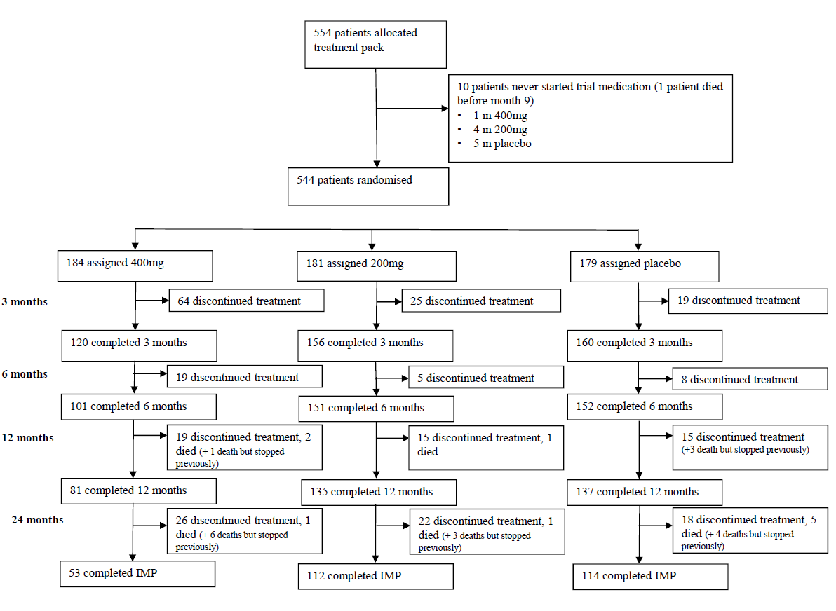

Figure 2. Proportion taking trial treatment over time: Kaplan-Meier plot
Minocycline at a daily dose of 400mg was poorly tolerated with just 29% (53/184) of those allocated 400mg completing 2 years of treatment, significantly fewer than in the 200mg [62% (112/181)], or placebo arms [64% (114/179), p<0.0001, figures 1 & 2]. By contrast, 200mg was well tolerated with similar discontinuation rates with 200mg and placebo (p=0.56). When reasons for stopping trial treatment were compared (table 3A), more participants allocated to minocycline than to placebo stopped because of gastrointestinal symptoms (p=0.0008), dermatological side-effects (p=0.02), and dizziness (p=0.01).
As a consequence of the higher treatment withdrawal rate, fewer assessments were obtained for the 400mg treatment arm than for the 200mg and placebo arms (appendix 2 table 1). For sMMSE at 24-months we received 68% (119 of the 174 expected) for the 400mg, 82% (144/176) for the 200mg, and 84% (140/167) for the placebo group. Return rates for BADLS assessments were similarly lower for the 400mg arm, than 200mg and placebo arms (appendix 2 table 1).
Change from baseline in sMMSE scores over time, with standard error bars, is shown in figure 3A. There was an average 4.1 point reduction in the combined minocycline groups compared to a 4.3 point reduction in the placebo group over the 24-month study period (p=0.90). The reduction in sMMSE score in the 400mg group over 24 months was somewhat less than that in the 200mg group (3.3 vs 4.7 points) but this difference was not significant (p=0.08).
Likewise, the worsening of BADLS scores over 24 months was similar in all groups: 5.7, 6.6 and 6.2 in the 400mg, 200mg and placebo groups, respectively, with no significant differences between participants allocated minocycline compared to the placebo group (p=0.57), or between those allocated 400mg and those allocated 200mg minocycline (p=0.77, figure 3C).
Table 3. (A) Reasons for stopping treatment, and (B) Serious Adverse Events by
treatment allocation

- Reasons for stopping | 400mg (n=184) | 200mg (n=181) | Placebo (n=179) | Total | Minocycline vs placebo p-value
GI symptoms | 42 | 15 | 10 | 67 | 0.0008
Dizziness | 14 | 3 | 1 | 18 | 0.01
Dermatological symptoms | 10 | 5 | 1 | 16 | 0.02
Haematological | 5 | 3 | 1 | 9 | 0.16
Impaired renal function | 2 | 5 | 4 | 11 | 0.81
Infection | 1 | 2 | 2 | 5 | 0.74
Shortness of breath | 6 | 0 | 0 | 6 | 0.08
Worsening dementia | 1 | 3 | 3 | 7 | 0.57
Depression or anxiety | 4 | 2 | 2 | 8 | 0.63
Joint or muscle pain | 2 | 0 | 2 | 4 | 0.47
Concomitant disease/illness | 9 | 6 | 7 | 22 | 0.91
General deterioration in physical health | 2 | 0 | 2 | 4 | 0.47
Unknown | 1 | 0 | 0 | 1 | 0.48
Unspecified side effect | 5 | 2 | 7 | 14 | 0.17
Patient or carer choice | 23 | 21 | 18 | 62 | 0.49
Total | 127 | 67 | 60 | 254 | 0.00002
- Serious adverse events | Counts of SAEs reported
SAE class | 400mg (n=184) | 200mg (n=181) | Placebo (n=179) | Total | Minocycline vs placebo p-value
Gastrointestinal | 3 | 8 | 10 | 21
Respiratory | 8 | 8 | 10 | 26
Mechanical injury | 6 | 11 | 13 | 30
Endocrine and metabolic | 2 | 1 | 9 | 12
Cancer | 12 | 3 | 11 | 26
Haematological/thrombosis | 3 | 1 | 2 | 6
Dermatological | 0 | 1 | 0 | 1
Neuropsychiatric | 10 | 13 | 16 | 39
Cardio-circulatory | 14 | 9 | 11 | 34
Renal | 3 | 2 | 2 | 7
Infection | 10 | 1 | 19 | 30
Other | 7 | 11 | 2 | 20
Total | 78 | 69 | 105 | 252
Differences were compared by χ² test with associated p values (two sided)

To assess how the higher number of missing outcome assessments in the 400mg treatment arm than in the 200mg or placebo arms (appendix 2 table 1) might have affected outcome comparisons, we ran various sensitivity analyses to investigate potential bias from non-random drop-out. In particular, there were 41 participants who had a baseline sMMSE but no further assessments, so did not contribute any information to the primary analysis (appendix 2 figure 1). Those who discontinue treatment in AD trials are often atypical, usually having worse cognitive and functional ability than those who continue.²⁰ This is evident from the scores of the 41 participants with a 6-month sMMSE, but no later assessments.
Figure 3. Change in (A, B) sMMSE and (C, D) BADLs from baseline to month 24. (A, C) From data collected, (B, D) using imputation method 1 to estimate scores for patients with no follow up past baseline Graph shows change in mean sMMSE and BADLs scores with standard errors; baseline scores* are set to zero; p -values are from tests for time by treatment interaction from repeated measures analyses.
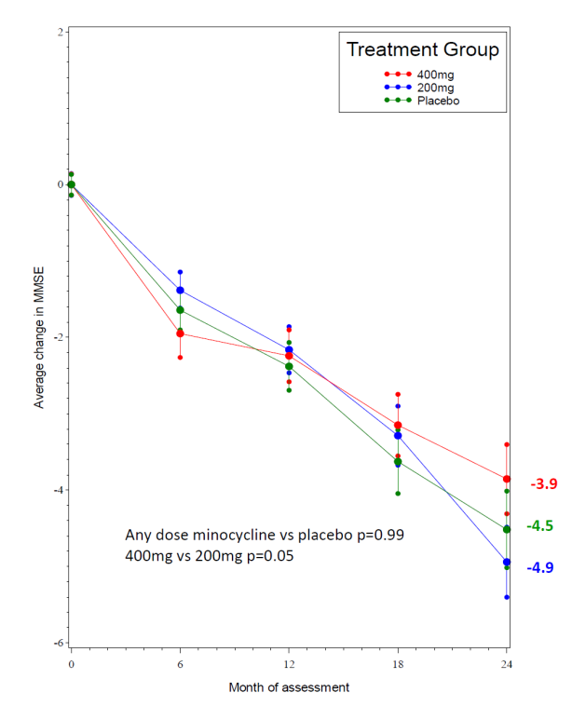
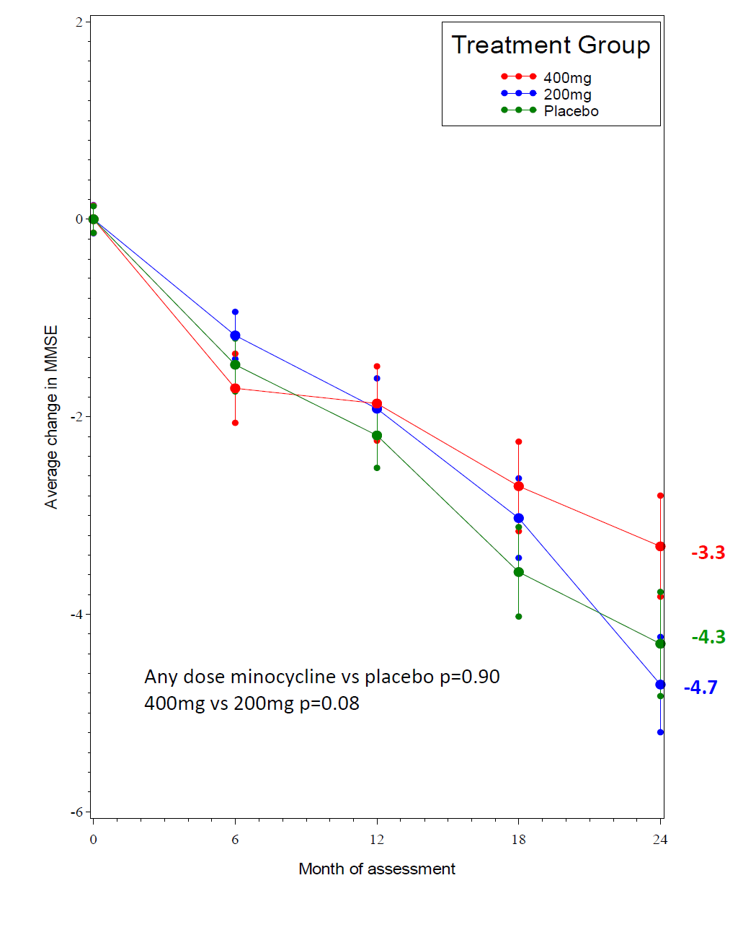
(3A) Change in sMMSE from baseline to month 24, using data collected (3B) Change in sMMSE from baseline to month 24, using imputation

*Baseline scores: 400mg 26.3, 200mg 26.5, placebo 26.4
(3C) Change in BADLs from baseline to month 24, using data collected (3D) Change in BADLs from baseline to month 24, using imputation
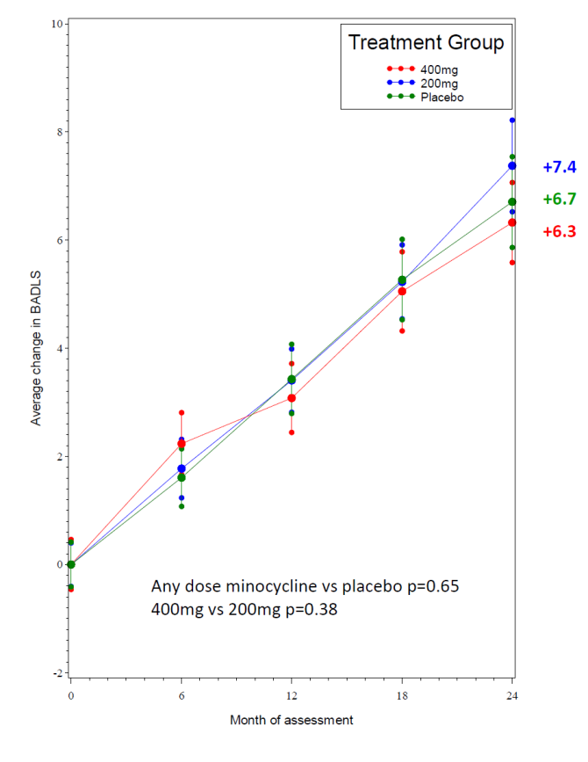
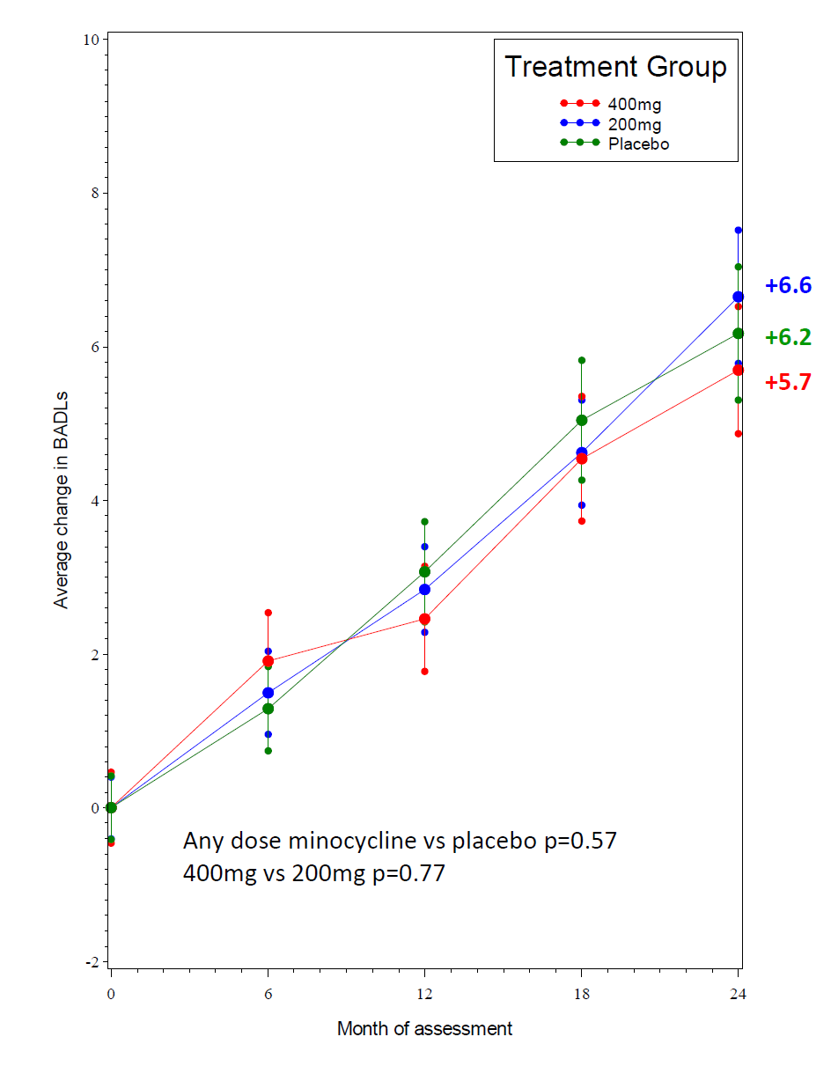

*Baseline scores: 400mg 5.6, 200mg 4.9, placebo 5.5

The average decline in sMMSE from baseline to 6 months in this subset was 3.9 points, a three times higher rate of decline than the 1.3 points average decline among the 498 patients who had a 6-month sMMSE assessment and went on to complete later assessments. It seems likely, therefore, that those patients without any post-baseline assessments, who do not contribute to the estimate of the rate of decline, also had worse than average decline in cognitive and functional ability.
To estimate what impact the missing outcome data from the 41 participants with no post-baseline assessments might have had on the trial results, our sensitivity analyses made two different assumptions: (1) we assumed that, for the first 6 months they declined at a rate of 3.9 points (as did those who had a 6-month sMMSE, but no further assessments), and then declined at the average rate of 1.1 points every 6 months for the rest of the trial. Method (2) assumed that patients with no post-baseline assessments declined at the average rate of those with assessments, i.e. 1.3 sMMSE points for the first 6 months, and 1.1 points every 6 months subsequently. The results from imputation method (1) are shown in figure 3B, and from imputation method (2) in appendix 2 figure 2A. Results are not qualitatively different from those of the primary analyses. The only borderline significant (p=0.06) differences seen in these sensitivity analyses were between 400mg and 200mg minocycline. However, with 400mg a little better and 200mg a little worse than placebo, and no difference between any dose of minocycline and placebo, this is likely a chance finding.
As return rates for BADLs were also lower for the 400mg arm, than 200mg and placebo, we ran similar sensitivity analyses. There were 39 participants with no BADLS assessment post baseline who did not contribute to the primary analysis. Imputation method (1) assumed that their BADLS score worsened (i.e. increased) by 3.7 points over the first 6 months, and then by 1.9 points every 6 months for the rest of the trial. Method (2) assumed that their BADLS score worsened by 1.5 over the first 6 months, and then by 1.9 points subsequently. As BADLS is only valid for community-resident patients, scores for those who went into residential care were only imputed up until the last time point before moving into care. Results for imputation method (1) are shown in figure 3D, and for imputation method (2) in appendix 2 figure 2B. Again, results were not qualitatively different to those from the primary analyses of BADLS.
To investigate whether the efficacy of minocycline varied by baseline characteristics, we did subgroup analyses of change in sMMSE over 24 months for minocycline (any dose) versus placebo by duration of symptoms, baseline sMMSE, age and gender (appendix 2 figure 3). There was no indications of any benefit from minocycline in those with shorter or longer duration of symptoms, lower or higher baseline sMMSE, or in men or women. There was a borderline significant (p=0.04) trend towards greater efficacy in younger than older patients but this unanticipated finding could be a chance occurrence given the number of subgroup investigations.
In total, there were 252 reported serious adverse events (SAEs), with the most common categories being neuropsychiatric and cardio-circulatory. The number of SAEs was somewhat higher in the placebo arm than the 400mg and 200mg minocycline arms (table 3B). Given that gastrointestinal symptoms were the main reason for stopping trial treatment, it is reassuring that the numbers of gastrointestinal serious adverse events in the minocycline arms were low, and no higher than in the placebo group. Similarly, though more skin related toxicities, particularly pigmentation, were reported with minocycline than placebo [36% (130/365) vs 21% (38/179), p=0.0007], few stopped trial treatment because of such toxicities (table 3A), and only six skin toxicities were considered severe (3 allocated any dose minocycline and 3 placebo: appendix 2 table 2). There were no differences in numbers stopping treatment because of impaired renal function, which had been a prior concern, nor in numbers of renal SAEs. Twenty-eight patients died during the study, 10 allocated 400mg minocycline, 6 200mg, and 12 placebo (appendix 2 table 3 & figure 4A). Fifteen of these 28 patients had stopped trial treatment prior to dying. One additional patient died without starting trial treatment. Rates of care home admission were low in this mild AD population with no difference in numbers between trial groups (appendix 2 figure 4b & 4C).

DISCUSSION

The MADE trial has shown that, in patients with mild AD, 24 months minocycline treatment at the doses tested does not delay the progress of cognitive or functional impairment, as measured by the well validated and widely used sMMSE and BADLS clinical rating scales. The trial has also established that minocycline at a dose of 400mg is poorly tolerated in this population with fewer than a third of participants completing 24 months of treatment. By contrast, 200mg per day is well tolerated, with participants allocated this treatment being no more likely to withdraw from trial medication than those taking placebo.
The failure of minocycline to slow the progression of cognitive and functional decline in mild AD is disappointing given the evidence suggesting that neuroinflammation is instrumental in AD progression,⁷ minocycline’s established anti-inflammatory and neuroprotective effects, and the positive data from several experimental animal models of AD.¹¹⁻¹⁷ Non-steroidal anti-inflammatory drugs (NSAIDs) have similarly failed to slow disease progression in clinical trials,⁵² despite long-term use being associated with a lower risk of developing AD in observational studies,⁵³ and promising data from transgenic animal models.⁵⁴ Our findings also parallel those of clinical trials of minocycline in other neurodegenerative disorders where, despite preclinical research suggesting neuroprotection, minocycline worsened outcomes in amyotrophic lateral sclerosis,²⁵ had no effect in Huntington’s disease,⁵⁵ multiple system atrophy,⁵⁶ negative symptoms of schizophrenia⁵⁷ and only short-term benefits in multiple sclerosis.⁵⁸
We consider that there could be three broad potential explanations for the negative results of our trial. First, although there is good evidence for neuroinflammation in AD,⁷ this may be more as a reaction to pathology rather than an important driver of progressive neurodegeneration, particularly in patients who are still at the mild stage of dementia. Second, even if neurodegeneration is accelerated by neuroinflammation, minocycline at the doses administered in MADE may not have had sufficient activity against these processes to show efficacy. Animal studies, from which much of the evidence for minocycline’s activity as an anti-inflammatory and anti-AD agent has come, have generally used much higher doses of minocycline than used in MADE (typically equivalent to 3-7g per day in the human),⁵⁹ and so it could be that trial participants were not exposed to a sufficiently high dose for efficacy. However, if doses of 200-400mg per day are insufficient for neuroprotection, the difficulties with tolerability experienced by participants allocated 400mg of minocycline indicate that use of higher doses in this patient population is not feasible.
Minocycline is potentially neuroprotective through several anti-inflammatory processes (suppression of microglial proliferation and activation, reduced release of interleukins 1β and 6 and of tumour necrosis factor-α, decreased chemokine expression and decreased activity of metalloproteases), as well as anti-apoptotic and anti-oxidant effects^{.11-17} A study of 15 patients with traumatic brain injury found reduced microglial activation, as visualised with ¹¹C-PBR28 PET,⁶⁰ following twelve weeks of treatment with 200mg minocycline per day, indicating that the dose ranges used in MADE can have a measurable effect on anti-inflammatory targets. The relationship between minocycline sensitive microglial activation and neurodegeneration may, however, be complicated. Minocycline treatment in the traumatic brain injury study⁶⁰ was also associated with increased plasma levels of neurofilament light, considered a marker of neurodegeneration. The faster progression seen with minocycline in amyotrophic lateral sclerosis²⁵ also suggests that some activated microglia might have a reparative function so that their inhibition could accelerate neurodegeneration. Our results do not suggest that reduced microglial activation with minocycline worsens neurodegeneration in Alzheimer’s disease.
A third plausible explanation for the negative results of MADE could be that minocycline did have some efficacy against progression of AD, but treatment effects were too small to be detectable in the trial. It is difficult to discount this possibility. MADE was, however, powered to detect minimal clinically important differences between minocycline and placebo, so smaller differences might not be considered of clinical relevance.
Our pragmatic trial had a number of strengths. It was based within a broad network of academic and NHS memory services and the wide eligibility criteria facilitated the recruitment of participants who were representative of patients with very mild Alzheimer’s disease diagnosed within the NHS. Outcome measures were limited in number, practical and easy to administer reliably by trial staff, and chosen because any differences between minocycline and placebo treatment would have unambiguous clinical relevance. The trial recruited to target, was sufficiently large to detect a clinically meaningful treatment effect and the trial arms were well matched on potentially important variables at baseline. This streamlined trial design could usefully be applied to test other putative disease-modifying therapies.
Potential limitations of the study include that biomarkers were not used to confirm AD diagnosis, since these are not routinely available within the NHS. Nonetheless, no diagnoses were revised during the study and rates of decline were as expected in a mild AD population. Compliance was also problematic with few patients in the 400mg arm completing two years of treatment, and only moderate compliance in the 200mg and placebo arms. A recommendation to take trial medication once rather than twice daily in the event of perceived side-effects helped improve compliance but was only introduced late in the trial when the problem with 400mg compliance was identified.
Although the trial protocol specified that outcome assessments should be obtained irrespective of treatment compliance, this could not always be achieved despite the vigorous efforts of the trial team. Consequently, differential follow-up rates could have biased our results. However, despite the large number of treatment withdrawals in the 400mg arm and consequent loss to follow-up of some participants, results were essentially unchanged in sensitivity analyses investigating potential bias from missing data. Thus, our conclusion that two years of minocycline treatment for patients with mild AD does not result in any clinically meaningful difference in the rate of decline of cognitive and functional ability is disappointing but robust.

ACKNOWLEDGEMENTS

Contributors

Robert Howard, Richard Gray, John O’Brien, Peter Bentham, Simon Lovestone, Alistair Burns and Suzanne Reeves designed the trial. Olga Zubko, Emma Harper, Linda Kelly, Rebecca Gathercole, Lynn Pank, Robert Howard, and Richard Gray ran the trial. Keith Anderson designed and programmed the study database. Rosie Bradley and Richard Gray analysed the data. Robert Howard, Peter Bentham, Nicholas Woodthorpe, John O'Brien, Ajay Macharouthu, Anilkumar Pillai, Gill Livingston, Vandana Mate, Demi Onalaja, Simon Thacker, Richard Brown, Anna Green, Santanu Chakrabarti, Latha Velayudhan, Abdul Patel, Ban Al-Kaissy, Iracema Leroi, Judy Rubinsztein, Vandana Menon, Paul Koranteng, Robert Barber, Rob Jones, Sujata Das, Rohan Van Der Putt, Ejaz Nazir, Jeremy Darryl Isaacs, Ramin Nilforooshan, Paul Loughlin, Naji Tabet, Divya Tiwari, Vanessa Raymont, Tarun Kuruvilla, Rosalind Ward, Marisa Wray, Wendy Neil, Robert Lawrence, Farhad Huwez, Bryan Corridan, Tarik Qassem and Aparna Prasanna, recruited participants. Robert Howard, Olga Zubko, Rosie Bradley and Richard Gray wrote the initial paper draft. All authors contributed to writing the paper and assume responsibility for the accuracy and completeness of the data and for the overall content and integrity of the paper.

MADE Trialist Group
Writing committee: Robert Howard (University College London, London, UK); Olga Zubko (King’s College London [KCL] London, UK); Rosie Bradley (Medical Research Council Population Health Research Unit [MRC PHRU], University of Oxford, Oxford, UK); Emma Harper (NDPH, University of Oxford, Oxford, UK); Linda Kelly (NDPH, University of Oxford, Oxford, UK); Lynn Pank (NDPH, University of Oxford, Oxford, UK); John O’Brien (University of Cambridge, Cambridge, UK); Chris Fox (University of East Anglia); Naji Tabet (University of Sussex, Brighton, UK); Gill Livingston (University College London); Peter Bentham (Birmingham and Solihull Mental Health NHS Foundation Trust); Rupert McShane (University of Oxford, Oxford, UK); Alistair Burns (University of Manchester, UK); Craig Ritchie (University of Edinburgh, UK); Suzanne Reeves (University College London, London, UK); Simon Lovestone (University of Oxford, Oxford, UK); Clive Ballard (University of Exeter, UK); Wendy Noble (King’s College London, London, UK); Ramin Nilforooshan (Surrey and Borders Partnership NHS FT) Gordon Wilcock (Nuffield Department of Clinical Neurosciences [NDCN], University of Oxford); Richard Gray (Nuffield Department of Population Health [NDPH], University of Oxford).
Data monitoring committee: Peter Crome (Chair), Jeremy Brown, Sarah Walker.
Trial Steering Committee: Gordon Wilcock (Chair), Peter Dyte, Declan McLoughlin, Rosie Bradley, Richard Gray, Robert Howard.
Trial management: Olga Zubko, Rebecca Gathercole (King’s College, University of London); Emma Harper, Lynn Pank, Linda Kelly, Natalie Lam and Keith Anderson (NDPH, University of Oxford).
Trial monitoring: King’s Health Partner’s Clinical Trials Office (London UK).
Pharmacist: Nigel Barnes.

Participating centres and MADE Collaborative Group members

(*indicates PI at that centre)
Avon and Wiltshire Mental Health Partnership NHS Trust (number of patients 20): Rosalind Ward*, Hayley Dash, Jo Morris, Catherine Sheppard, Nathan Maynard, Shan Williams, Aiste Baltramaityte. Ayrshire and Arran NHS Trust (4): Ajay Macharouthu*, Mark Wilson, Jacqui Kerr, Scott Prentice, Colin Grant, Elma Norwood, Alistair Rennie, Karen Greig, Lynne McNeil. Berkshire Healthcare NHS Foundation Trust (26): Nicholas Woodthorpe*, Lynn Rigby. Birmingham and Solihull Mental Health NHS Foundation Trust (31): Peter Bentham*, Jane Dyer, Di Baines, Abdul Patel*, Jan Wright, Akram Ali, Nigel Barnes. Black Country Partnership NHS Foundation Trust (3): Tarik Qassem*, Aparna Prasanna*, Joanne Sawyer, Neeti Gupta, Laura Lord, Aparna Prasanna, Amy Shipman, Darren Weaver, Gurj Bhella, Danielle Cornford, Susan Horton, Tim Kingscote-Davies, Amanda Nicklin, Carolyn Ogden, Sukvinder Sandhar. Bradford District Care Trust (10): Anilkumar Pillai*, Deepa George, Alison Barraclough, John Hiley, Sarah Poll, Jyoti Rana, Gregor Russell, Angus Sturrock, Sade Abiola, Jaspreet Sohal, Edward Sykes. Cambridgeshire and Peterborough NHS Foundation Trust (23): John O'Brien*, Siobhan Rust, Julie Philps, Annabel Price, Ben Underwood, Steven Albery, Lorraine Carter, Rachel Carter, Lauren Dawson, Bernice Gregory, George Griffiths, Christopher Jenkins, Clare Mundell, Christine Rowe, Sara Williamson. Camden and Islington NHS Foundation Trust (16): Gill Livingston*, Mary-Jo Doyle, Yvonne Foreshaw, Kate O'Connor, Baindu Saffa, Selina Paul, Poureya Aghakhani, Camila Becker, Silvia Ceci, Rebecca Chennells, Adam Heffer, Priyal Shah, Simon Wan. Cornwall Partnership Foundation Trust (15): Vandana Mate*, Sharon Hudson, Suzanne Dean, Jackie Kerr, Joanna Ledger, Sadir Altaan, Emma O'Shaughnessy, Linda Allsop, Carolyn Brodie, Kimberley Moore, Johanna Skewes. Coventry and Warwickshire Partnership NHS Trust (16): Demi Onalaja*, Emily Benson, Wendy Roughan, David Tait. Cumbria Partnership NHS Foundation Trust (15): Marisa Wray*, Leon Jonker, Yumna Masood, Naomi Pierce, Fiona Proudfoot, Darren Reynolds, Gillian Webster, Joanne Rafferty. Derbyshire Healthcare NHS Foundation Trust (23): Simon Thacker*, Smita Saxena, John Sykes, Gemma Harrison, Audrey Williamson, Caroline Cheetham, Graham Spencer, Victoria Baron, Susan Chapman, Russell Cooper, Megan Harman, Sandra Kimberlin, Sarah Wymer. Gloucestershire 2gether NHS Foundation Trust (11): Tarun Kuruvilla*, Ellen Tait, Lisa Moore, Genevieve Riley, Samantha Holt, Rui Zheng, Philip Barber, Bethan Cartwright, Chris Harding, Jenny Romer, Suzanna Stithou, Marelle Harvey. Kent and Medway NHS and Social Care Partnership Trust (8): Richard Brown*, Amy Hammond, Richard Brown, Alison Welfare-Wilson, Nina Cotter, Vilma Gilis, Sam Manktelow, Agostina Secchi. Leeds and York Partnership NHS Foundation Trust (20): Anna Green*, Lisa Hackney, Wendy Neil*, Aishia Perkis, Damian Reynolds, Jenny Sweetman, Danielle Varley, Francesca Williams, Amanda Taffinder, Michael Dixon, David Braun, Lucy Allender. Leicestershire Partnership NHS Trust (17): Sarah Baillon, Latha Velayudhan*, Santanu Chakrabarti*, Nizam Khodabux, Sarah Thomason, Howard Fairey, Tom Pringle, Robyn McAskill, Lynne Hartwell. Lincolnshire Partnership NHS Foundation Trust (6): Ban Al-Kaissy*, Diane Brennan, Lizwi Nyathi, Bharti Pathak, Vijayendra Waykar, Kerry Evans, Dimple Oza, Aliya Turk, Richard Anand, Joan Spencer. Manchester Mental Health and Social Care Trust (23): Iracema Leroi*, Lewis Harpin, Alistair Burns, Christopher Broughton, Hannah Goldup, Sharon Hall, Lewis Harpin, Adam Kennedy, Sally-Anne Heasman, Javier Torres Martin, Stephanie Pacey, Andrew Peers, Jane Smithies, Maxine Syme, Michelle Thorpe. Norfolk and Suffolk NHS Foundation Trust (15): Judy Rubinsztein*, Vandana Menon*, Kim Clipsham, Chris Fox, Zoe Inman, Louise McCarthy, Juniper West, Silvan Aidasani, Bonnie Teague, James Curtis, Valerie Dixon, Susan Durrell, Dennis Liew, Alex McFarlane, Winnie Ng. Northamptonshire Healthcare NHS Foundation Trust (15): Paul Koranteng*, Kim Burke, Tim Crisp, Abby Lovesy, Gayle Borley, Tim Crisp, Helen Reboul, Sarah Vogel, Jemma Gambrill, Navdeep Kanwar, Rose Menzel, Russell Parsons. Northumberland Tyne and Wear NHS Foundation Trust (22): Robert Barber*, Victoria Hetherington, Jill Davison, Nichola Duffelen, Caroline Gerrard, Matthew Haggerty. Nottinghamshire Healthcare NHS Trust (21): Rob Jones*, Sujata Das*, David Trevor, Craig Beecroft, Kehinde Junaid, David Kelly, John Lawton, Effie Pitsillides. Oxford Health NHS Foundation Trust (26): Rohan Van Der Putt*, Jenny McCleery*, Deborah Cooper, Jemima Hume, Justine Adams, Hazel Eaton, Rupert McShane, Claire Merritt, Christine Parker, Gordon Wilcock, Marilyn Arnold, Ioana Fodor, Orla Macdonald, David Sharma. Royal Bournemouth and Christchurch Hospitals NHS Foundation Trust (2): Divya Tiwari*, Jo Bell, Chantel Cox, Owen David, Emma Gunter, Gail Hann, Becky Jupp, Catherine Ovington, James Page, Andrew Williams, Rachel Bower, Alison Hogan, Sam Lloyd. Southend University Hospital NHS Foundation Trust (5): Farhad Huwez*, John Whitear*, Paula Harman, Amirrah Ropun, Laura Wilson. South London and Maudsley NHS Foundation Trust (54): Robert Howard*, Olga Zubko, Leeza Almedom, Lauren Armstrong, Ana Bajo, Rebecca Brendell, Jack Cahill, Hannah Grocott, Siobhan Hurley, James Rackie, Arann Rowe, Clive Ballard, Jenny Bousfield, Elizabeth Highton-Williamson, Zainab Al Noor, Suzanne Reeves, Melody Smith, Ola Dada, Martin Heasman, Glynis Ivin, Ian Osborne, Sophie Ward, Michael Welds. South Staffordshire and Shropshire Healthcare NHS Foundation Trust (33): Ejaz Nazir*, Paula Dolby, Lucy Hamilton, Yvette Lycett, Andy Taylor, Ayesha Bangash, Liz Glaves, Sarah Johnson, Susan Lavender, Prince Nwaubani, Richard Heys, Felicity Massey, Ruth Mills, Allison Newman, Sacheev Patel, Lindsay Rose, Carla Silva, Mark Stallard, Tamir Latif, Farzad Khalkhali, Sudhakar Anumanchi, Eva Kabir, Adnan Sharaf, Sajeev Kshemendran, Rashi Negi. South West London and St George's Mental Health NHS Trust (9): Robert Lawrence*, Enitan Eboda, Ashes Howson, Robert Lawrence, Mustabshira Qayyum, Philip Woodgate, Laura Dalrymple, Jess Lee, Felicity Mayer, Carl Holvey, Aiste Navickaite. St George's University Hospitals NHS Foundation Trust (20): Jeremy Isaacs*, Tabindah Khan, Jake Cinco, Chukwuka Orefo, Sally Goff, Servious Dube, Peter Garrard, Kirsty McMillan, Emma Saunders, Jennifer Tulloch, Nia Al-Samarrai, Alice Dainty, Geoffrey Howell. Surrey and Borders Partnership NHS Foundation Trust (30): Ramin Nilforooshan*, Ruth Charig, Jane Gregg, Caroline Khurana, Helen Adams, Jack Holland, Brian Parsons, Emily Williams, Samantha Francis, Richard Johnson, Fiona Lockwood, Ailsa McKay, Jane Wenham. Sussex Partnership NHS Foundation Trust (12): Naji Tabet*, Samuel Holden, Gail Chandler, Andrew Risbridger, Gail Chandler, Gus Fernandez. West London Mental Health NHS Trust (3): Sarah Gregory, Merrie Manalo, Vanessa Raymont*, Bryan Corridan*, Craig Ritchie*, Tahira Arshad, Sharon Linsell, Laura McKee.

# Rob Jones and Selina Paul died unexpectedly during the course of MADE.

Declaration of interests

Acknowledgements

The trial was supported by a grant from the Efficacy Mechanisms and Evaluation Board funded by National Institute of Health Research and the Medical Research Council following external peer and Board review. MODEPHARMA Limited (Beckenham, UK) manufactured the IMP and placebo which was distributed to participating cites by POLARspeed (Bedfordshire, UK).

Publications
Include publication

REFERENCES

- Alzheimer’s Disease International. World Alzheimer Report 2015: The Global Impact of Dementia (Alzheimer’s Disease International, 2015).
- Vrandenburg G. A pivotal moment in Alzheimer’s disease and dementia: how global unity of purpose and action can beat the disease by 2025. Expert Rev Neurother 2015; 15:73-82.
- Karch CM, Goate AM. Alzheimer’s disease risk genes and mechanisms of disease pathogenesis. Biol Psychiatry 2015; 77:43-51.
- Edison P, Donat CK, Sastre M. In vivo imaging of glial activation in Alzheimer’s disease. Fron Neurol 2018; 9 625. Doi: 10.3389/fneur.2018.00625.
- VanItallie TB. Alzheimer’s disease: Innate immunity gone awry? Metab Clin Exp 2017; 69S:S41-S49.
- Yu Y, Ye RD. Microglial Abeta receptors in Alzheimer’s disease. Cell Mol Neurobiol 2015; 35:71-83.
- Heneka MT, Carson MJ, El Khoury J, Landreth GE, Brosseron F, Feinstein DL, et al. Neuroinflammation in Alzheimer’s disease. Lancet Neurol 2015; 14:388-405.
- Corbett A, Pickett J, Burns A, Corcoran J, Dunnett SB, Edison P, Hagan JJ, Holmes C, Jones E, Katona K, Kearns I, Kehoe P, Mudher A, Passmore A, Shepherd N, Walsh F, Ballard C. Drug repositioning for Alzheimer’s disease. Nature Reviews Drug Discovery 2012; 11:833-846.
- Appleby BS, Cummings JL. Discovering new treatments for Alzheimer’s disease by repurposing approved medications. Current Topics in Medical Chemistry 2013; 13:2306-27.
- Plane JM, Shen Y, Pleasure DE, Deng W (2010) Prospects for minocycline neuroprotection. Archives of Neurology 67 1442-1448.
- Familian A, Boshuizen RS, Eikelenboom P, Veerhuis R. Inhibitory effect of minocycline on amyloid beta fibril formation and human microglial activation. Glia 2006; 53:233-240.
- Seabrook TJ, Jiang L, Maier M, Lemere CA. Minocycline affects microglia activation, Abeta deposition and behaviour in APP-tg mice. Glia 2006; 53:776-782.
- Noble W, Garwood C, Stephenson J, Kinsey AM, Hanger DP, Anderton BH. Minocycline reduces the development of abnormal tau species in models of Alzheimer’s disease. FASEB Journal 2009; 23:739-50.
- Ferretti MT, Allard S, Partridge V, Ducatenzeiler A, Cuello AC. Minocycline corrects early, pre-plaque neuroinflammation and inhibits BACE-1 in a transgenic model of Alzheimer’s disease-like amyloid pathology. Journal of Neuroinflammation 2012; 9:62.
- Biscaro B, Lindvall O, Tesco G, Ekdahl CT, Nitsch RM. Inhibition of microglial activation protects hippocampal neurogenesis and improves cognitive deficits in a transgenic mouse model for Alzheimer’s disease. Neurodegenerative Dis 2012; 9:187-98.
- Garcez ML, Mina F, Bellettini-Santos T, Carneiro FG, Luz AP, Schiavo GL, Andrighetti MS, Scheid MG, Bolfe RP, Budni J. Minocycline reverses inflammatory parameters in the brain structures and serum and reverses memory impairment caused by the administration of amyloid β (1-42) in mice. Progress in Neuropsychopharmacology and Biological Psychiatry 2017; 77: 25-31.
- Choi Y, Kim HS, Shin KY, Kim EM, Kim M, Kim HS, Park CH, Jeong YH, Yoo J, Le JP, Chang KA, Kim S, Suh YH. Minocycline attenuates neuronal cell death and improves cognitive impairment in Alzheimer’s disease models. Neuropsychopharmacology 2007; 32:2393-404.
- Lampl Y, Boaz M, Gilad R, et al (2007) Minocycline treatment in acute stroke: an open-label, evaluator-blinded study. Neurology 69 1404-1410.
- Du Y, Ma Z, Lin S, et al (2001) Minocycline prevents nigrostriatal dopaminergic neurodegeneration in the MPTP model of Parkinson’s disease. Proceedings of the National Academy of Sciences USA 98 14669-14674.
- Radad K, Moldzio R, Rausch WD (2010) Minocycline prevents dopaminergic neurons against long-term rotenone toxicity. Canadian Journal of Neurological Science 37 81-85.
- Diquet E, Fernagut PO, Wei X, et al (2004). Deleterious effects of minocycline in animal models of Parkinson’s disease and Huntington’s disease. European Journal of Neuroscience 19, 3266-3276.
- Yang L, Sugama S, Chirichigno JW, et al (2003) Minocycline enhances MPTP toxicity to dopaminaregic neurons. Journal of Neuroscience Research 74 278-285.
- NINDS NET-PD Investigators (2008) A pilot clinical trial of creatine and minocycline in early Parkinson disease: 18-month results. Clinical Neuropharmacology 31 141-150.
- Zhu S, Stavrovoskaya IG, Drozda M, et al (2002) Minocycline inhibits cytochrome c release and delays progression of amyotrophic lateral sclerosis in mice. Nature 417 74-78.
- Gordon PH, Moore DH, Miller RG, et al for Western ALS Study Group (2007) Efficacy of minocycline in patients with amyotrophic lateral sclerosis: a phase III randomised trial. Lancet Neurology 6 1045-1053.
- Huntington Study Group (2004) Minocycline safety and tolerability in Huntington disease.Neurology 63 547-549.
- Hunter CL, Quintero EM, Gilstrap L, Bhat NR, Grandhelm AC (2004) Minocycline protects basal forebrain cholinergic neurons from mu p75-saporin immunotoxic lesioning. European Journal of Neuroscience 19 3305-3316.
- Familian A, Boschuizen RS, Eikelenboom P, Veerhuis R (2006) Inhibitory effect of minocycline on amyloid beta fibril formation and human microglial activation. Glia 53 233-240.
- Familian A, Eikelenboom P, Veerhuis R (2007) Minocycline does not affect amyloid beta phagocytosis by human microglial cells. Neuroscience Letters 416 87-91.
- Cuello AC, Ferretti MT, Leon WC, et al (2010) Early stage inflammation and experimental therapy in transgenic models of the Alzheimer-like amyloid pathology. Neurodegenerative Disorders 7 96-98.
- Ryu JK, McLarnon JG (2006) Minocycline or iNOS inhibition block 3-nitrotyrosine increases and blood-brain barrier leakiness in amyloid beta-peptide-injected rat hippocampus.Experimental Neurology 198 552-557.
- Parachikova A, Visilevko V, Cribbs DH, Laferla FM, Green KN (2010) Reductions inamyloid-beta-derived neuroinflammation with minocycline restore cognition but do not significantly affect tau hyperphosphorylation. Journal of Alzheimer’s Disease 21 527-542.
- Goulden V (1996) Safety of long-term high dose minocycline in the treatment of acne. British Journal of Dermatology 134 693-695.
- Casha S, Zygun D, McGowan D, et al (2009) Neuroprotection with minocycline after spinal cord injury: results of a double blind, randomized, controlled pilot study. Neurosurgery 65 410- 411.
- Metz LM, Li D, Traboulsee A, et al for GA/minocycline study investigators (2009). Glatiramer acetate in combination with minocycline in patients with relapsing-remitting multiple sclerosis: results of a Canadian, multicenter, double-blind, placebo-controlled trial. Multiple Sclerosis 15 1183-1194.
- Bonelli RM, Hodl AK, Hofman P, Kapfhammer HP (2004) Neuroprotection in Huntington’s disease: a 2-year study on minocycline. International Clinical Psychopharmacology 19 337-342.
- Plane JM, Shen Y, Pleasure DE, Deng W (2010) Prospects for minocycline neuroprotection. Archives of Neurology 67 1442-1448.
- Green RC, Schneider LS, Amato DA, Beelen AP, Wilcock G, Swabb EA, Zavitz KH (2009) Effect of Tarenflurbil on cognitive decline and activities of daily living in patients with mild Alzheimer’s disease. A randomised controlled trial. JAMA 302 2557-2564.
- Aisen PS, Gauthier S, Ferris SH, et al (2011) Tramiprosate in mild-to-moderate Alzheimer’s disease – arandomised double-blind placebo controlled multicentre study (the Alphase Study). Archives of Medical Science 7 102-111.
- Molloy DW et al (1991). Reliability of the standardized Mini-Mental State Examination compared with the traditional Mini-Mental State Examination. American Journal of Psychiatry, 148, 102-105.
- Molloy DW, Standish TI (1997) A guide to the Standardised Mini-Mental State Examination. International Psychogeriatrics 9 Supplement 1 87-94.
- Folstein MF et al (1975). Mini-Mental state: a practical method for grading the cognitive state of patients for the clinician. Journal of Psychiatric Research, 12, 189-98.
- Tombaugh TN and McIntyre NJ (1992). The Mini-Mental State Examination: a comprehensive review. Journal of the American Geriatric Society, 40, 922-935.
- Howard R, Phillips P, Johnson T, et al (2010) Determining the minimum clinically important differences for outcomes in the DOMINO trial. International Journal of Geriatric Psychiatry 26, 812-817.
- AD2000 Collaborative Group (2004). Long-term donepezil treatment in 565 patients with Alzheimer’s disease (AD2000): randomised double blind trial. Lancet, 363, 2105-2115.
- Feldman H et al (2001). A 24-week randomized double blind study of donepezil in moderate to severe Alzheimer’s disease. Neurology, 57, 613-620.
- Howard RJ et al (2007). Donepezil for the treatment of agitation in Alzheimer’s disease. N Eng J Med 357, 1382-1392.
- Bucks RS, Ashworth DL, Wilcock GK, Siegfried K. Assessment of activities of daily living in dementia: development of the Bristol Activities of Daily Living Scale. Age and Ageing 1996; 25:113-20.
- Howard RJ et al 2012. Donepezil and memantine for moderate-to-severe Alzheimer's disease. N Engl J Med. 366: 893-903.
- McKhann GM, Knopman DS, Chertkow H, et al. The diagnosis of dementia due to Alzheimer’s disease: recommendations from the National Institute on Aging-Alzheimer’s Association workgroups on diagnostic guidelines for Alzheimer’s disease. Alzheimer’s Dementia 2011; 7:263-9.
- Lavori PW. Clinical trials in psychiatry: should protocol deviation censor patient data? Neuropsychopharmacology 1992; 6: 39-48; discussion 49-63
- Miguel-Alvarez M, Santos-Lozano A, Sanchis-Gomar F, Finza-Luces C, Pareja-Galeano H, Garatachea N, et al. Non-steroidal anti-inflammatory drugs as a treatment for Alzheimer’s disease: a systematic review and meta-analysis of treatment effects. Drugs Aging 2015; 32:139-147.
- Breitner JC, Gau BA, Welsh KA, Plassman BL, McDonald WM, Helms MJ, et al. Inverse association of anti-inflammatory treatments and Alzheimer’s disease: initial results of a co-twin control study. Neurology 1994; 44:227-232.
- McGeer PL, McGeer EG. NSAIDs and Alzheimer’s disease: Epidemiological, animal models and clinical studies. Neurobiol Aging 2007; 28:639-647.
- Huntington Study Group DOMINO Investigators. A futility study of minocycline in Huntington’s disease. Movement Disorders 2010; 25:2219-24.
- Dodel R, Spottke A, Gerhard A, Reuss A, Reinecker S, et al. Minocycline 1-year therapy in multiple system atrophy: effect on clinical symptoms and [(11)C](R)-PK11195 PET (MEMSA trial). Movement Disorders 2010; 25:97-107.
- Deakin B, Suckling J, Barnes TRE, Byrne K, Chaudhry IB, Dazzan P, et al. The benefit of minocycline on negative symptoms of schizophrenia in patients with recent-onset psychosis (BeneMin): a randomised, double-blind, placebo-controlled trial. Lancet Psychiatry 2018; 5:885-894
- Metz LM, Li DKB, Traboulsee AL, Duquette P, Eliasziw M, et al. Trial of minocycline in a clinically isolated syndrome of multiple sclerosis. New England Journal of Medicine 2017; 376:2122-33.
- Plane JM, Shen Y, Pleasure DE, Deng W. Prospects for minocycline neuroprotection. Arch Neurol 2010; 67:1442-1448.
- Scott G, Zetterberg H, Jolly A, Cole JH, De Simoni S, Jenkins PO, et al. Minocycline reduces chronic microglial activation after brain trauma but increases neurodegeneration. Brain 2018; 141:459-471.

APPENDIX 1

REC amendments

Summary of changes to the original MADE protocol that have been approved by the REC and MHRA (where relevant)
Change to protocol | Date
Increased leeway window for final assessments from +/- 14 days to +/-30 days | 22.03.18
Guidance on restarting IMP added with participants able to re-start IMP at any time after break | 29.07.16
End of study participant letter added | 29.07.16
End of study GP letter added | 29.07.16
Increase recruitment from 480 to 560 participants by March 2016 | 30.10.15
Adding JDR as additional recruitment tool | 21.01.15
Inclusion criterion Severe liver disease’ modified to ‘’Moderate liver disease’ | 04.02.15
Added a trial leaflet | 03.09.14
Added a trial recruitment advertisement poster | 03.09.14
Added a GP letter of invitation | 03.09.14
Add inclusion criterion: Participants must have a potential informant to assist with administration of the BADLS | 09.01.14
Exclusion criterion ‘Patients with creatinine clearance < 50mL/min at Screening, according to the Cockroft and Gault equation must be excluded’ | 07.08.14
Exclusion criterion ‘Known chronic kidney disease stages 3-5’ has been amended to ‘Known chronic kidney disease stages 3b-5’ | 07.08.14
Guidance for renal functioning monitoring updated | 09.01.14
Further guidance for monitoring side effects and loss to follow-up added | 09.01.14
Additional exclusion criterion added: uncontrolled serious concomitant illness | 09.01.14
Removed from exclusion criteria: pregnancy and lactation; diagnosis of MCI; lacks capacity to give informed consent; severe liver disease | 09.01.14
Broaden recruitment strategy by allowing members of the research team to get patient consent after patients have been initially approached by the study Doctor | 14.10.13
Guidance on reporting SAEs/SUSARs added | 28.08.13
Changed frequency of Safety checks from every 6 to every 3 months | 28.08.13
Broaden recruitment strategy by advertising the study and allowing potentially interested individuals to contact the research team directly | 28.08.13
Added age range (50+) to inclusion criterion | 28.08.13

Literature Search

The following search terms were used in March 2018 to perform the search:
minocycline AND (AD OR alzheimer OR MCI OR "mild cognitive impairment" OR dementia)
The table below summarises the number or articles identified by each engine and the url below provides a link to the prospero record for the search.
Search engine | Number of articles identified
Pubmed | 1549
Cochrane | 19
Web of Science | 121
Ovid (inc embase, psycharticle and psychinfo) | 1471

https://www.crd.york.ac.uk/prospero/display_record.php?RecordID=90377

sMMSE outcome measure response sheet
 | QUESTION | TIME ALLOWED | SCORE
1 | What year is this? | 10 seconds
 | Which season is this? | 10 seconds
 | What month is this? | 10 seconds
 | What is today’s date? | 10 seconds
 | What day of the week is this? | 10 seconds
2 | What country are we in? | 10 seconds
 | What province are we in? | 10 seconds
 | What city/town are we in? | 10 seconds
 | IN HOME – What is the street address of this house?  IN FACILITY – What is the name of this building? | 10 seconds
 | IN HOME – What room are we in?  IN FACILITY – What floor are we on? | 10 seconds
3 | SAY: I am going to name three objects. When I am finished, I want you to repeat them. Remember what they are because I am going to ask you to name them again in a few minutes. Say the following words slowly at 1‐second intervals ‐ ball/ car/ man | 20 seconds
4 | Spell the word WORLD. Now spell it backwards. | 30 seconds
5 | Now what were the three objects I asked you to remember? | 10 seconds
6 | SHOW wristwatch. ASK: What is this called? | 10 seconds
7 | SHOW pencil. ASK: What is this called? | 10 seconds
8 | SAY: I would like you to repeat this phrase after me: No ifs, ands or buts. | 10 seconds
9 | SAY: Read the words on the page and then do what it says. Then hand the person the sheet with CLOSE YOUR EYES on it. If the subject reads and does not close their eyes, repeat up to three times. Score only if subject closes eyes | 10 seconds
10 | HAND the person a pencil and paper. SAY: Write any complete sentence on that piece of paper. (Note: The sentence must make sense. Ignore spelling errors) | 30 seconds
11 | PLACE design, eraser and pencil in front of the person. SAY: Copy this design please.  Allow multiple tries. Wait until person is finished and hands it back. Score only for correctly copied diagram with a 4‐sided figure between two 5‐sided figures. | 1 minute
12 | ASK the person if he is right or left‐handed. Take a piece of paper and hold it up in front of the person. SAY: Take this paper in your right/left hand (whichever is non‐dominant), fold the paper in half once with both hands and put the paper down on the floor . Score 1 point for each instruction executed correctly:  - Takes paper correctly in hand  - Folds it in half  - Puts it on the floor | 30 seconds
TOTAL TEST SCORE |  | /30

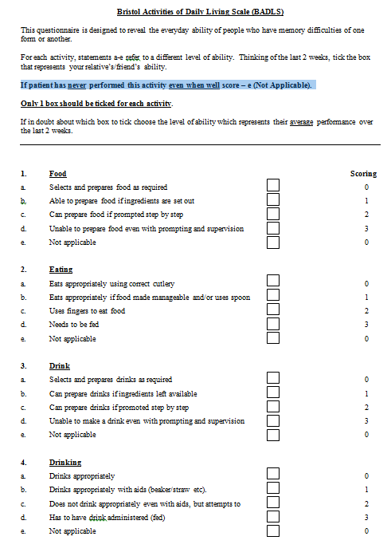
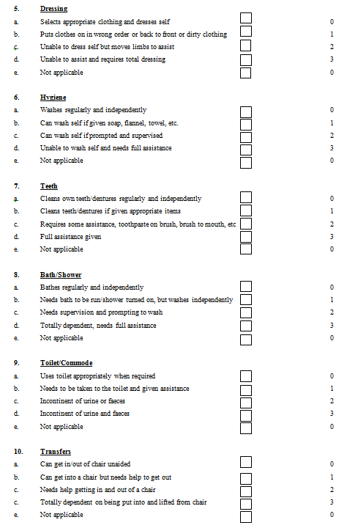
BADLs outcome measure responses sheet

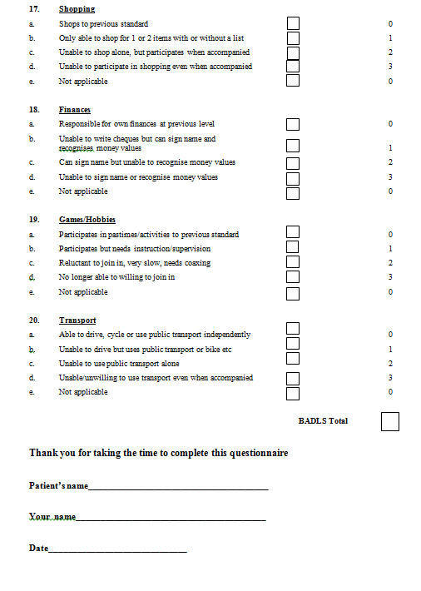
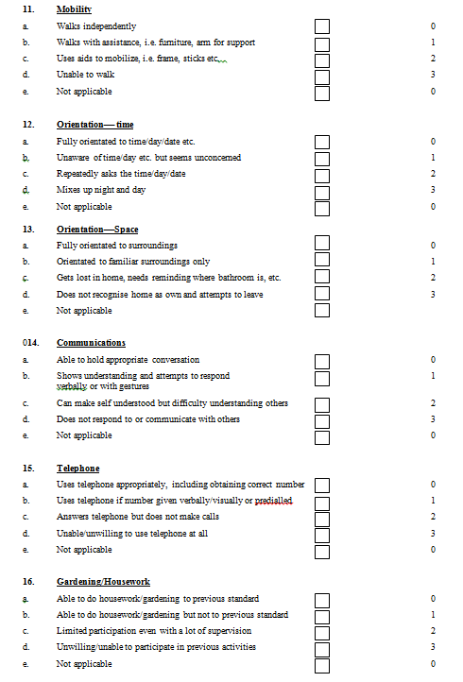

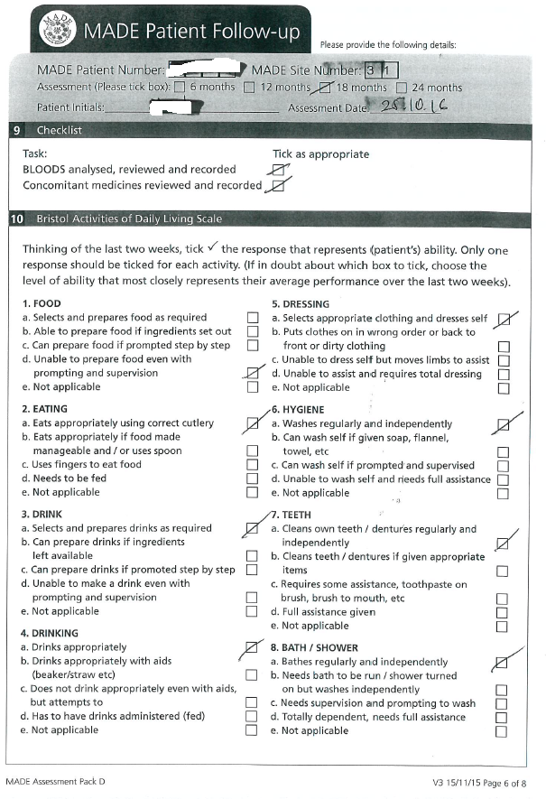
Sample participant responses: BADLS responses for a 12 months follow-up
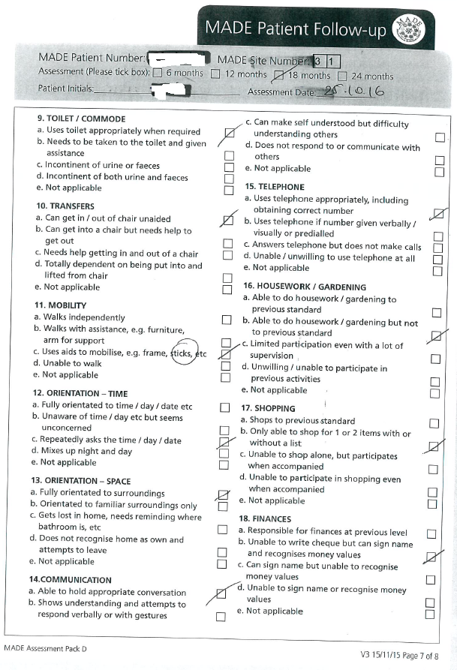

Sample participant responses: sMMSE responses for a 12 months follow-up


APPENDIX 2

Table 1 - Follow-up rate for SMMSE and BADLS by treatment group and follow-up period

 |  | sMMSE |  |  |  | BADLS
 |  | Received | Expected* | % |  | Received | Expected** | %
Screening | 400mg | 183 | 184 | 99.5  100  99.4  99.6 |  | 183 | 184 | 99.5  100  99.4  99.6
Screening | 200mg | 181 | 181 | 99.5  100  99.4  99.6 |  | 181 | 181 | 99.5  100  99.4  99.6
Screening | Placebo | 178 | 179 | 99.5  100  99.4  99.6 |  | 177 | 178 | 99.5  100  99.4  99.6
Screening | Total | 542 | 544 | 99.5  100  99.4  99.6 |  | 541 | 543 | 99.5  100  99.4  99.6
6 Month | 400mg | 159 | 184 | 86  95  93  92 |  | 159 | 184 | 86  95  93  91
6 Month | 200mg | 172 | 181 | 86  95  93  92 |  | 172 | 181 | 86  95  93  91
6 Month | Placebo | 167 | 179 | 86  95  93  92 |  | 164 | 176 | 86  95  93  91
6 Month | Total | 498 | 544 | 86  95  93  92 |  | 495 | 541 | 86  95  93  91
12 Month | 400mg | 139 | 181 | 77  88  89  84 |  | 140 | 180 | 78  88  91  85
12 Month | 200mg | 158 | 180 | 77  88  89  84 |  | 157 | 178 | 78  88  91  85
12 Month | Placebo | 156 | 176 | 77  88  89  84 |  | 155 | 171 | 78  88  91  85
12 Month | Total | 453 | 537 | 77  88  89  84 |  | 452 | 529 | 78  88  91  85
18 Month | 400mg | 127 | 179 | 71  82  85  80 |  | 128 | 178 | 72  86  89  82
18 Month | 200mg | 146 | 177 | 71  82  85  80 |  | 146 | 169 | 72  86  89  82
18 Month | Placebo | 147 | 172 | 71  82  85  80 |  | 148 | 167 | 72  86  89  82
18 Month | Total | 420 | 528 | 71  82  85  80 |  | 422 | 514 | 72  86  89  82
24 Month | 400mg | 119 | 174 | 68  82  84  78 |  | 118 | 170 | 69  85  89  81
24 Month | 200mg | 144 | 176 | 68  82  84  78 |  | 142 | 167 | 69  85  89  81
24 Month | Placebo | 140 | 167 | 68  82  84  78 |  | 137 | 154 | 69  85  89  81
24 Month | Total | 403 | 517 | 68  82  84  78 |  | 397 | 491 | 69  85  89  81

* Expected numbers of sMMSE assessments exclude those who withdrew prior to starting treatment – i.e., those not effectively randomised – and those who died prior to the assessment
** Expected numbers of BADLS* assessments also exclude those who were admitted to care

Table 2 – Skin toxicity incidence and severity by treatment arm
Treatment arm | Toxicity rating | No. patients
400mg | Mild  Moderate  Severe | 33  27  1
400mg | Sub-total | 61
200mg | Mild  Moderate  Severe | 38  29  2
200mg | Sub-total | 69
Placebo | Mild  Moderate  Severe | 22  13  3
Placebo | Sub-total | 38

Table 3 – Causes of death
Treatment | Cause of death | Weeks until death | Stopped treatment ≥28 days previously?
Infection
Placebo | Infection | 64 | Yes, 17 weeks
Placebo | Pneumonia | 36 | No
Placebo | Pneumonia and pulmonary oedema | 28 | Yes, 23 weeks
Placebo | Pneumonia | 66 | No
Placebo | Chest infection | 83 | No
200mg | Pneumonia | 56 | No
400mg | Pneumonia | 86 | Yes, 2 weeks
Neuropsychiatric
Placebo | Dementia | 95 | No
Placebo | Alzheimer’s/Lewy Body Dementia | 92 | Yes, 87 weeks
400mg | Progression of Alzheimer’s | 58 | Yes, 7 weeks
Cardiovascular
Placebo | Myocardial infarction | 102 | No
Placebo | Myocardial infarction | 72 | No
Placebo | Heart attack | 64 | No
200mg | Cardiac event | 50 | No
200mg | Heart attack | 58 | Yes, 51 weeks
400mg | Heart attack | 37 | No
400mg | Heart failure | 100 | Yes, 88 weeks
400mg | Heart attack | 91 | No
Cerebrovascular
200mg | Unknown (stroke on 21/03/17) | 103 | Yes, 84 weeks
400mg | CVA | 42 | Yes, 3 weeks
400mg | Stroke | 36 | No
Renal failure
Placebo | Chronic renal failure | 32 | Yes, 12 weeks
400mg | Lung and kidney failure | 103 | Yes, 1 week
Other cause
Placebo | Complications after bowel surgery | 89 | Yes, 44 weeks
200mg | General health decline | 56 | Yes, 29 weeks
200mg | Large abdominal tumour causing kidney failure | 28 | Never started
400mg | COPD | 57 | Yes, 11 weeks
Unknown
400mg | Unknown | 77 | Yes, 17 weeks

Figure 1. Flow chart: follow up completeness over time
Colour coding to show assessments split by treatment: red is 400mg, blue is 200mg and green is placebo.
Screening
6 months
12 months
18 months
24 months
453 had MMSE at 12 months: 139, 158, 156
(453 had assessment + 48 + 41 + 2 without)
420 had MMSE at 18 months: 127, 146, 147
(420 had assessment + 40 + 41 + 41 + 2 without)

40 patients missing 18m assessment
  - 7 just missing 18m
  - 3 missing 12m & 18 m
  - 30 no more follow up – 7 died before reaching 18m & 1 died after 18m: 11, 11, 8
554 patients allocated treatment pack
10 patients never started trial medication
(1 patient died before month 9)
544 patients randomised

2 patients no more follow up: 1, 1
498 had MMSE at 6 months: 159, 172, 167
(498 had assessment + 44 + 2 without)

44 patients missing 6m assessment
  - 1 just missing 6m
  - 2 missing 6m & 24m
  - 41 no more follow up – 2 died after 6m: 22, 9, 10
542 had MMSE screening: 183, 181, 178
(542 had assessment + 2 without)

48 patients missing 12m assessment
  - 2 just missing 12m
  - 3 missing 12m & 18m
  - 2 missing 12m & 24m
  - 41 no more follow up – 4 died before reaching 12m & 4 died after 12m: 21, 11, 9
403 had MMSE at 24 months: 119, 144, 140
(403 had assessment + 27 + 30 + 41 + 41 + 2 without)
27 patients missing 24m assessment
  - 15 just missing 24m: 5, 5, 5
  - 2 missing 6m & 24m: 1, 1
  - 2 missing 12 & 24m: 2
  - 8 died before 24m

Figure 2. Change in (A) MMSE and (B) BADLS from baseline to month 24 using imputation method (2) to estimate scores for patients with no follow-up past baseline. Graph shows change in mean MMSE scores with standard errors. Baseline scores* are set to zero. p-values are from tests for time-by-treatment interaction from repeated measures analysis.
+7.2
+6.6
+6.0
Any dose minocycline vs placebo p=0.66
400mg vs 200mg p=0.39
Any dose minocycline vs placebo p=0.99
400mg vs 200mg p=0.06
-3.5
-4.4
-4.8

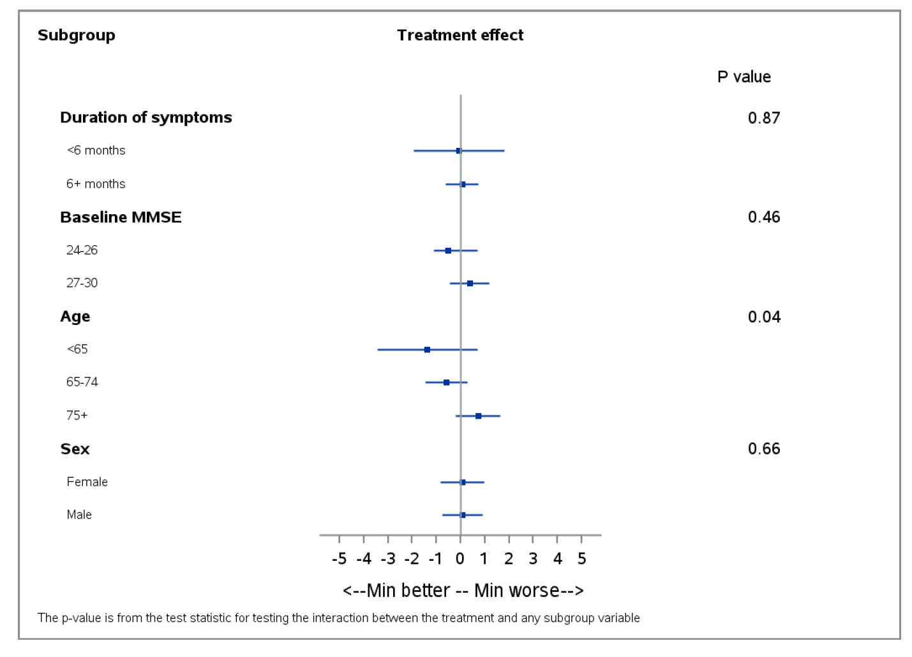
Figure 3 – Subgroup analyses of change in sMMSE over 24 months for minocycline (any dose) versus placebo by baseline characteristics: duration of symptoms, baseline sMMSE, age and gender. Results are derived from a repeated measures model, with p-values from tests for interaction between treatment and the selected subgroup.

Figure 4: Probability of A) Survival, (B) remaining community resident and (C) being alive and community-resident by treatment allocation: Kaplan-Meier survival plots
Any dose minocycline vs placebo: 16/365 vs 12/179 (p=0.25)
400mg vs 200mg: 10/184 vs 6/181 (p=0.32)

Any dose minocycline vs placebo: 13/365 vs 13/179 (p=0.06)
400mg vs 200mg: 4/184 vs 9/181 (p=0.15)

Any dose minocycline vs placebo: 25/365 vs 21/179 (p=0.05)
400mg vs 200mg: 13/184 vs 12/181 (p=0.87)

