The HALT-LTBI study: Phase IV, multi-site, unblinded, randomised trial of prophylactic daily rifampicin/isoniazid vs. weekly rifapentine/isoniazid for latent tuberculosis infection (LTBI)

REC Reference 13/LO/1666
EudraCT Number 2013-000750-21

Start date 10/10/2014 – End Date: 30/06/2017

Chief Investigator: Professor Ibrahim Abubakar

End of Study Summary for MHRA
August 2018

EXECUTIVE summary

Study aims

The trial aimed to assess the feasibility of undertaking a trial to investigate whether a 12 dose rifapentine based treatment improved treatment completion for latent tuberculosis compared to the UK standard of care of a daily dose rifampicin and isoniazid regimen with both regimen given over 3 months.

Background

Despite the availability of effective treatment for drug susceptible Mycobacterium tuberculosis, TB continues to cause significant morbidity and mortality worldwide. In the UK, there has been a resurgence of TB over the last three decades with stabilisation of the rates of disease in the last five years at a level higher than most Western European countries. Elimination requires a focus on sterilising the pool of latently infected individuals from which future TB cases would be generated. A randomised pilot trial was designed to assess the safety and feasibility of treating adults between 16 and 65 years of age for LTBI in the UK context, with a relevant comparator regimen and a standardised treatment process and support in both arms without DOT.

Methods

Phase IV, unblinded, randomised, multi-site UK trial. Individuals who present with LTBI at TB clinics, who meet the eligibility criteria and agree to preventative therapy and to give their written consent to take part will participate in the trial. Recruited individuals were randomised to receive either a daily combination of rifampicin/isoniazid (‘standard’ practice) for 90 days (three months) versus a weekly combination of rifapentine/isoniazid (‘experimental’ practice), for 12 weeks. Safety and feasibility was assessed with 52 patients. Multivariable logistic regression of the likelihood of completion of treatment and presence of adverse effects was undertaken.

Results

HALT: LTBI successfully led to the recruitment of 52 participants to explore the feasibility of a full trial. Factors to improve study enrolment were identified including appropriate inclusion criteria. There was no difference in the adverse effect profile between the two arms. Economic modelling suggests that the 12 dose rifapentine based regimen may be cost-effective if it achieves the same level of effectiveness as observed in this pilot study.

Conclusions and further research

HALT: LTBI: We have demonstrated the feasibility of undertaking a randomised controlled trial of the novel rifapentine and isoniazid weekly regimen, approaches to enhance recruitment and with the potential to roll this out into a full trial. Economic evaluation suggests that this approach could be cost-effective.

PARTICIPANT FLOW

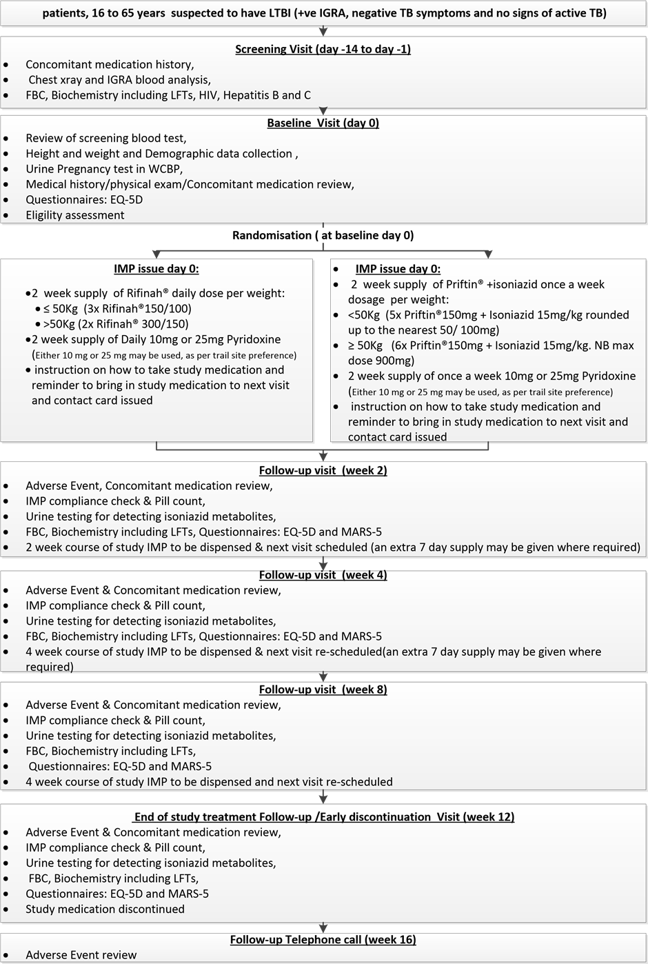

BACKGROUND

Despite the availability of effective treatment for drug susceptible Mycobacterium tuberculosis, TB continues to cause significant morbidity and mortality worldwide. A major obstacle to the control of TB is poor adherence to treatment due to lengthy and complicated regimens for active TB (usually 6-9 months) and LTBI (3-6 months). The use of directly observed therapy (DOT: which means that a health care worker watches the patient swallow each dose of treatment) can improve patient adherence in both active and latent tuberculosis and reduce the emergence of resistant microorganisms in active TB, but is logistically difficult and expensive to implement.

National Institute for Health and Care Excellence (NICE) guidelines at the time of this study, which form the basis of TB management in the UK, did not recommend LTBI treatment in people over 35 years of age due to the increased risk of adverse events with age, particularly hepatotoxicity except where in the opinion of the caring physician a special exception can be made. However, the pool of latently infected individuals from which future TB cases would be generated, includes adults aged over 35 years. US, Dutch and Spanish guidelines recommend LTBI treatment with careful monitoring for individuals at risk of developing TB, irrespective of age. A recent paper by Sterling et al. described a 12-dose regimen of rifapentine/isoniazid with a low rate of drug-related hepatotoxicity (0.4%) in a group of 3,986 LTBI patients with a median age of 36 years (IQR 25-47).¹⁴ This regimen was shown to be non-inferior in a RCT (nearly double the efficacy of standard nine month treatment), but adherence could not be evaluated, as patients placed on the rifapentine/isoniazid arm had treatment under direct observation but the control arm did not.

In the UK, there has been a resurgence of TB over the last three decades with stabilisation of the rates of disease in the last five years at a level higher than most Western European countries. Due to epidemiologic changes in the UK TB patients’ profile, the risk of developing active disease may have risen in the last decade (3). Elimination requires a focus on sterilising the pool of latently infected individuals from which future TB cases would be generated. Improving prophylactic treatment and it’s compliance in patients with LTBI may help to reduce the rate of future TB cases amongst this cohort. Far from being non-discriminatory, TB disproportionately affects specific groups such as migrants from high-TB burden countries and homeless people, with a geographical burden focussed in urban centres. As the majority of TB in migrants to the UK arises through the reactivation of infections acquired overseas and develop in the first few years post-entry, screening for clinically asymptomatic LTBI in this population is an essential element of any TB elimination strategy. The development of novel treatment strategies with more potent antimycobacterial activity could lead to shorter and simpler regimens that are easier for patients to adhere to and have a similar or reduced frequency of side effects. This is especially valuable for individuals with LTBI, who are healthy, and thus at a high risk of discontinuing preventive treatment early. These issues become more severe in hard-to-reach populations. Nevertheless, better adherence will improve control in all groups targeted for LTBI treatment.

Building on the work of Sterling et al., a new trial was felt to be required for the following reasons:

- In the trial by Sterling et al, the arms differed both by treatment allocation and by treatment support. Those in receipt of the weekly 12 dose regimen had DOT for each dose taken, whereas those allocated to nine months of daily isoniazid took their tablets without such support. It is therefore difficult to assess whether the difference in treatment completion was as a result of differences in treatment allocation or in treatment support.
- The comparator regimen in the Sterling et al. trial was nine months of daily isoniazid. The standard of care in the UK for people is usually three months of daily rifampicin/isoniazid or six months of isoniazid. There are good reasons to expect better rates of completion with the shorter 12 dose regimen of rifapentine/isoniazid and thus a head to head trial is needed against a three month daily dose rifampicin/isoniazid regimen.
- Treatment completion is likely to be affected by context. A UK-based trial assessing rates of treatment completion using this new 12 dose regimen would be helpful in informing UK recommendations for the treatment of LTBI.
- Cost-effectiveness of both strategies in terms of direct costs: at the moment, rifapentine costs are high. Only by demonstrating the superiority of the interventional arm (rifapentine/isoniazid) compared to the standard one in terms of adherence and efficacy, would this new strategy be implemented in the UK.

A randomised pilot trial was therefore designed to assess the safety and feasibility of treating adults between 16 and 65 years of age for LTBI in the UK context, with a relevant comparator regimen and a standardised treatment process and support in both arms without DOT. The trial aimed to assess differences in levels of adverse events and treatment completion between two different treatments of approximately equal duration: the standard of care in the UK, consisting of daily rifampicin/isoniazid for three months versus a three month regimen consisting of weekly rifapentine/isoniazid.

Aims and Objectives

The aim of this study was to assess the safety and feasibility of treating adults between 16 and 65 years of age for LTBI in the UK context.

PRIMARY OBJECTIVES
- To check safety of conducting a full RCT.
- To assess the feasibility of trial i.e. whether it would be possible to conduct a larger trial on completion rates of two different LTBI treatment regimens (daily rifampicin/isoniazid vs. weekly rifapentine/isoniazid).

SECONDARY OBJECTIVES
- To assess treatment completion (using the MARS-5 scale).
- To assess frequency of adverse events (AE) when individuals are treated for LTBI.
- To build an integrated transmission-dynamic and health economic model to assess the cost-effectiveness of the interventions, as well as cost per quality adjusted life year.

Methods

Trial design

Phase IV, unblinded, randomised, multi-site UK trial. Individuals who present with LTBI at TB clinics, who meet the eligibility criteria and agree to preventative therapy and to give their written consent to take part will participate in the trial.

Inclusion criteria
- Adults between 16 and 65 years
- Diagnosed with LTBI
- Individuals accepted receiving preventive treatment and gave their informed consent.

Exclusion criteria
- Pregnant and breast-feeding women
- Weight under 45kg
- HIV infected
- Individuals unable to receive study drugs because of allergy, liver disease or any medical condition contraindicating the use of a rifamycin or isoniazid or need for concomitant medications which cannot be safely taken together
- Individuals unable to give informed consent or whose lifestyles would usually lead to the need of DOT

Randomisation

Randomisation to the intervention or standard of care arms was undertaken centrally using Sealed Envelope’s Simple Randomisation Service. There was no stratification. The ratio of individuals in the intervention to normal care arm was 1:1.

Intervention and Standard of Care

Recruited individuals were randomised to receive either a daily combination of rifampicin/isoniazid (‘standard’ practice) for 90 days (three months) versus a weekly combination of rifapentine/isoniazid (‘experimental’ practice), for 12 weeks. Both arms were performed without Directly Observed Therapy (DOT).

Sample size

52 participants were recruited for this pilot study to assess the feasibility of conducting a fully powered trial in the future. This is consistent with recommendations for the number of participants required for pilot/feasibility studies.

Primary outcome

The primary outcome was treatment completion assessed using self-report, pill counts, and urine tests for isoniazid metabolites.

Secondary outcomes

Secondary outcomes included: (1) treatment completion measured using the MARS-5 tool; (2) frequency of AE, which was assessed by a standardised interview procedure and blood tests, including liver function tests (LFT) at baseline and at each visit, utilising a validated grading procedure; (3) cost per QALY, using EQ-5D test at baseline and at each visit.

Statistical analysis

Safety and feasibility was assessed with 52 patients. Multivariable logistic regression of the likelihood of completion of treatment and presence of adverse effects was undertaken. Likert scale-derived data from MARS-5 on treatment completion was analysed.

Health economics analysis

We considered screening for LTBI of recent immigrants in England, Wales and Northern Ireland (EWNI). Firstly, individuals passed through a probabilistic decision tree representing the screening and treatment pathway. All individuals remaining with LTBI (i.e. excluding those cured by treatment) were then simulated in a competing risks-type multistate model to time of event for all-cause mortality, leaving EWNI or progression to active TB. Experimental and standard LTBI treatment regimens were directly compared within a cost-effectiveness sensitivity analysis.

The following complies with the Consolidated Health Economic Evaluation Reporting Standards (CHEERS) checklist.⁴⁶ All analysis was carried-out in the statistical software programme R 3.3.3.

Data

The main data source has been used in a previous study and is described in full there.^{47;48} In brief, the data consisted of a linked dataset of PHE’s Enhanced TB Surveillance system (ETS) and pre-entry screening data for 15 countries with high incidence of active TB who intended to stay for 6 months or longer, aged 11 years or older and who tested negative for active TB before entry. Data were obtained for those screened before entry to the UK between 1st January 2006 and 31st December 2012. For a single year of entry cohort we used 2009 because this had the best trade-off of sample size and follow up duration.

Model parameterisation

Baseline model parameter values, uncertainties and references are given in Tables 15 and 16.

Table 15: Epidemiological parameters
Parameter | Value (uncertainty) | Source/Reference
Time to all-cause death | Imputed sample | ⁴⁸
Active TB progression rate from LTBI | Observed data,  Imputed sample | ^{48;49}
Time to exit country | Imputed sample | ⁴⁸
Number of arrivals | Observed data | ⁴⁸
Average number of secondary active TB cases per primary case arising in the cohort | Pert(min=0.1, mode=0.2, max=0.3) | ⁵⁰

Probabilities
Prevalence of LTBI (per 100,000) | 0-50: 0.03  50-150: 0.13  150-250: 0.2  250-350: 0.3  >350: 0.3 | ⁵¹
Agree to LTBI screening | 0.325 | ⁵²
IGRA (QFT-IT) sensitivity | 0.84  Uniform(0.81, 0.87) | ⁵³
IGRA (QFT-IT) specificity | 0.99 (0.98-1.00) | ⁵³
Initiation rate for LTBI treatment | 0.97 | ⁵⁴
Probability of hepatotoxic adverse reaction to isoniazid | 0.00245 Uniform(0.0008, 0.00687) | ⁵⁵
Probability of non-hepatic minor adverse events | 0.143 | ⁵⁵
Active TB case fatality rate | 15-44: 0.0018 Beta(1,564)  45-64: 0.0476 Beta(125,2500) >64: 0.1755 Beta(413,1940) | ⁵⁶

Table 16: Economic parameters
Parameter | Value | Source/Reference
Discount rate | 3.5% p.a. | ⁵⁷

Costs (£)
LTBI test: QFT-GIT | 48.73 | ⁵⁸
Active TB test: QFT-GIT | 48.73 | ⁵⁸
Adverse events due to LTBI treatment: Hepatotoxicity | 587  Gamma(6.679, 87.889) | ⁵⁰
Adverse events due to LTBI treatment: Nausea/vomiting | 63 | ⁵⁰
Managing an active TB case | 5,329  Gamma(8.333, 639.435) | ⁵⁰
Culture | 22.29  Gamma(100, 0.22) | ⁵⁹
X-ray | 35  Uniform(23, 43) | ⁶⁰
Smear microscopy | 7  Gamma(106, 0.07) | ⁶⁰
Liver Function Test | 2.69 | ⁶¹
Hepatitis B surface Ag and  hepatitis C | 25.42 | ⁶¹
HIV ELISA antibody test | 8  Uniform(3,12) | ⁶²
First visit: respiratory medicine, multi-professional | 241  Gamma(53.3, 4.52) | ⁶³
Initial consultation with doctor | 126 | ⁵⁰
Nurse follow up | 64 | ⁵⁰

Health impact
QALY losses due to LTBI treatment: Hepatotoxicity | 0.00033  Gamma(65.753, 7x10-5) | ⁵⁰
QALY losses due to LTBI treatment: Nausea/vomiting | 0.0046  Gamma(109.67, 3x10-6) | ⁵⁰
Active TB utility loss | 0.067 (0.038) | ⁵⁹

The effect on health was measured in utilities and associated QALY loss. The cost-effectiveness willingness-to-pay threshold (WTP) was assumed to be either £20,000 or £30,000 per QALY, in line with common practice. The active TB case fatality rate (CFR) assumed that all deaths due to active TB occur within 12 months of progression.⁵⁶ We assumed that patients not completing treatment dropped out on average after six weeks. The analysis uses the NHS perspective and the time horizon was the lifetime of the patient cohort, but cost savings from averted cases of active TB were only accrued for individuals who remained in EWNI. All costs were inflated to 2016 equivalent prices, if necessary, and cost and QALYs were discounted in to the future at 3.5% p. a.

The modelled screening age range was from 18 to 45 years old. Immigrants from relevant countries are eligible to be screened up to five years after entry to EWNI, and the model allows for competing events (e.g. leaving EWNI or progression to active TB) occurring prior to screening. Onwards transmission is accounted for in the model as the average number of secondary active TB cases due to each primary case. The utility detriment was assumed to be the same between treatments. The lower limit for LTBI treatment staff costs was used, assuming an efficient use of resources. That is, an initial doctor consultation and one month follow up with a nurse: £126 + £64 = £190.

Using Table 17, from the HALT: LTBI study protocol, the total cost of three months of standard treatment was 90 × (£0.9 + £0.039) = £84.51. The total cost of 12 weeks of experimental treatment was 12 × (£6.18 + £0.43 + £4.64) = £135.

Table 17: LTBI treatment drugs, doses and costs

*⁶⁴ †Inflated from 2013 to 2017 and converted from dollars to pounds at 1 to 0.77⁶⁵.

Drug Name | Cost per tablet (£) | Tablets per dose | Total cost per dose (£)
Rifinah©300/150 (rifampicin/isoniazid) | 0.45 (£25.22/56)* | 2 | 0.9
Pyridoxine 10 mg | 0.039 (£3.90/100)* | 1 | 0.039
Priftin® 150 mg (rifapentine) | 0.77 ($32/32=£24.74/32)† | 6 | 4.64
Isoniazid 100mg | 0.69 (£19.24/28)* | 9 | 6.18
Pyridoxine 10 mg | 0.43 (£12.95/30)* | 1 | 0.43

Estimating time taken to progress to active TB

Active TB progression is a competing risk with all-cause death and is left-censored in the data when an individual leaves EWNI. The time of death and EWNI exit is also unobserved.

The (unobserved) times for leaving EWNI and all-cause death were imputed in Aldridge et al.⁴⁷ for the defined cohort. We randomly sampled LTBI status for those individuals that did not have observed active TB progression in accordance with their risk of infection due to country of origin.⁵¹ In order to sample progression times, we extrapolated the annual probability of progression to active TB curves into the future using generalised linear regression on cumulative incidence values in literature.⁴⁹ We were also interested in active TB progression after leaving EWNI. In order to do this, we fit a competing-risks model to the imputed data using the empirical transition matrix (also called Aalen-Johansson) to the complete data set (2006-12) using the R package etm.⁶⁶

LTBI screening decision tree model

The LTBI screening pathway was modelled as a probabilistic decision tree (Figure 8).

Figure 8: LTBI screening decision tree schematic

The decision between whether to potentially screen all new EWNI entrants represented on the left-hand side. Individuals terminate in this model in either an LTBI or Not LTBI state, indicated on the right-hand side. The individuals remaining with LTBI are passed to the competing-risks population level model.
Are some people who test positive not offered treatment?

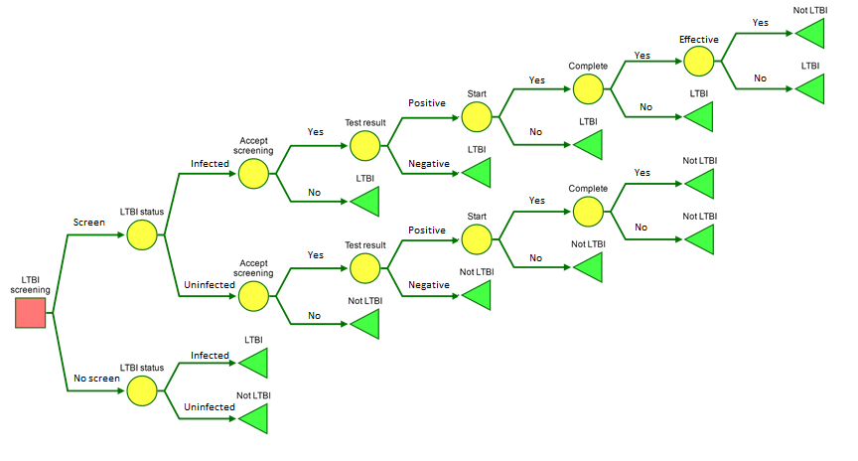
“Disease-free” should be “Uninfected”, since the vast majority of people with LTBI remain disease-free for life

The probability of being screened encompasses the probability of being offered screening (e.g. via primary care) and of accepting the offer. The number of simulations was N = 1000 which captured both the individual level variation and the uncertainty in the costs and utilities. The outcome of the decision tree model was a distribution of individuals between the LTBI and non-LTBI states. These are then passed to the ‘right hand’ model, the competing-risks population model.

Competing-risks multi-state population model

Figure 9 gives the multi-state model for the subpopulation of individuals with LTBI who can either progress to active TB, die of active TB, die of another cause, or leave EWNI. Individuals who leave EWNI are still considered in the model.

Figure 9: A discrete state diagram of the Population Model

The cohort of individuals initially enters the LTBI state (source). The dashed lines indicate possible transitions when including individuals who have already exited EWNI. This is the case when calculating the QALYs. Death from active TB and from other causes (and exit EWNI for cost calculation) are sink states (bold).

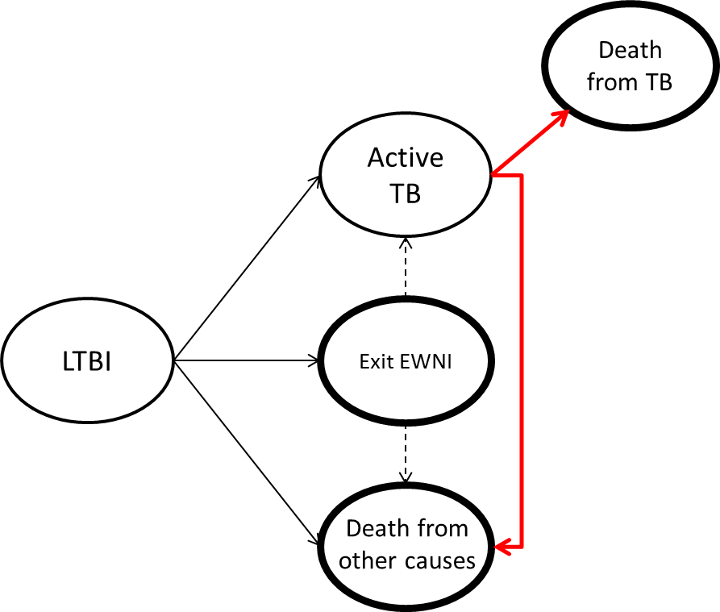

Cost-effectiveness analysis

The cost-effectiveness of each scenario was determined using the incremental cost-effectiveness ratio (ICER). The experimental and standard regimens were directly compared. Denoting $w$ and $d$ as the weekly (experimental) and daily (standard) regimen respectively, and $e$ and $c$ are the expected QALY gain and expected cost incurred respectively, then

$$ICER=\frac{c_{}^{w}{- c}_{}^{d}}{e_{}^{w}{- e}_{}^{d}}$$

The standard regimen is the status-quo control group in this case.

Approvals

The study was registered as ISRCTN04379941. It was reviewed and ethically approved by the Brent NHS Research Ethics Committee (REC approval: 13/LO/1666) and the Medicines and Healthcare products Regulatory Agency (MHRA).

Results

Statistical analysis

Recruitment

At the end of the study, after follow up was completed, data were transferred to the study statistician for analysis. Between the 31st March 2015 and the 23rd January 2017 a total of 52 eligible subjects were recruited and randomised into the study. Figure 10 shows the cumulative recruitment into the study against time of randomisation in the two centres.

Figure 10: Cumulative numbers recruited for each study centre.

The Royal Free recruited 23 subjects, randomised between the 31st March 2015 and the 23rd January 2017. Recruitment at Barts Health was more rapid, as can be seen in Figure 10, with 29 subjects recruited and randomised between the 20th November 2015 and the 9th January 2017.

Twenty two were positive using T.Spot-TB, 25 positive using QuantiFERON-GIT, one of which was also tuberculin skin test positive, and three tuberculin skin test positive. For the remaining two subjects test results were missing.

Randomisation

A total of 27 (51.9%) subjects were randomly allocated to the experimental treatment arm and 25 (48.1%) to the standard treatment arm.

As can be seen in Table 18, a larger percentage of subjects recruited at the Royal Free (65.5%) were randomly allocated to the experimental treatment arm compared to Barts Health (41.4%).

Table 18: Randomisation by centre
Randomised Group | Name of Site
Randomised Group | Barts Health | Royal Free | Total
Experimental Treatment | 12 (41.4%) | 15 (65.2%) | 27
Standard Treatment | 17 (58.6%) | 8 (34.8%) | 25
Total | 29 | 23 | 52

Comparison of experimental and standard treatment arms

We should not expect to observe any important differences between the study arms in the potential confounders due to the use of randomisation to allocate subjects. However, the study groups have been compared to ensure that, by chance, no important imbalance has occurred between study arms. The results of this comparison are shown in Table 19.

None of the potential confounders exhibited any major imbalances between the experimental and standard treatment groups.

Table 19: Comparison of intervention and normal care groups for potentially important confounding variables at baseline assessment
Variable | Experimental (n=27) | Standard (n=25)

Demographic
Male (%) | 13 (48.2%) | 13 (52.0%)

Lifestyle
Concomitant medication | 9 (33.3%) | 5 (20.0%)

Smoking
Current | 3 (11.1%) | 6 (24.0%)
Ex | 2 (7.4%) | 3 (12.0%)
Never | 22 (88.5%) | 16 (64.0%)

Haematology (median, lower and upper quartiles)
Pulse (per minute) | 77.7 (70.0,85.5) | 70 (61,82)
Systolic BP (mmHg) | 124.5 (114,138) | 110 (107,127)
Diastolic BP (mm Hg) | 79 (71,86.5) | 77 (70,80)
HB | 137 (128,145) | 137.5 (123,152)
WBC | 6.20 (5.32,8.02) | 6.43 (5.43,7.61)
Platelets | 240 (225,323) | 240 (214.5,298)
Neutrophils | 3.8 (2.1,4.5) | 3.65 (2.95,4.50)
Monocytes | 0.46 (0.39,0.60) | 0.465 (0.40,0.60)

Biochemistry (median, lower and upper quartiles)
Sodium | 141 (139,141) | 140 (139,141)
Potassium | 4.4 (4.2,4.6) | 4.35 (3.9,4.55)
Urea | 4.2 (3.2,5.1) | 4.5 (4.2,5.3)
Creatinine | 71 (68,85) | 80.5 (65,94.5)
Total bilirubin | 9 (6,12) | 10 (6,11)
ALT | 22 (15,32) | 19.5 (17,30)
AST | 20 (16,26) | 18.5 (18,24)
Alkaline phosphatase | 66 (59,74) | 66.5 (54.5,79)
Glucose | 5.0 94.5,5.7) | 5.1 (4.45,5.6)

The case report form recorded a range of physical and blood test results at baseline assessment, which were described as normal, or abnormal, and when abnormal whether this was clinically significant (CS), or not (NCS). These were all normal, or not done, apart from one subject with a NCS abnormal lung examination, and one subject with NCS abnormal lymph nodes.

One subject had CS low haemoglobin of 104 g/l. Another subject has CS high platelets per microlitre of 496. A further subject had a CS eosinophil count of 0.51 x 10⁹/L. One subject had abnormal biochemistry results with a value for alanine transaminase (ALT) of 92 international units/litre (iu/L) and aspartate transaminase (AST) of 60 iu/L.

One subject had a history of homelessness and two had a history of drug use. All virological tests were negative; one subject had an abnormal chest x-ray which was not TB. One subject had some mobility problems, five had moderate pain or discomfort and two were moderately anxious or depressed.

Primary outcome

A total of 38 of the 52 subjects completed treatment. Table 20 presents the outcomes of the study subjects in each study arm.

Table 20: Treatment completion study arm
Outcome | Experimental | Standard | Total
Completed | 21 (77.8%) | 17 (68.0%) | 38
Withdrawn | 6 (22.2%) | 8 (32.0%) | 14
Total | 27 | 25 | 52

For the experimental treatment, the exact binomial 95% CI was 57.7% to 91.4%, compared to 46.5% to 85.1% in the standard treatment arm. The difference in completion rate was 9.8%. The reason that 14 subjects that failed to complete treatment are shown in Table 21.

Table 21: Reason for failure to complete treatment by study arm
Reason for withdrawal | Experimental | Standard | Total
Investigator’s decision | 1 | 2 | 3
Participant’s decision | 4 | 1 | 5
Lost to follow up | 1 | 5 | 6
Total | 6 | 8 | 14

In the experimental arm four of the six failures to complete treatment were the participant’s decision, the reasons for these were: ‘Participant requested daily medication instead, due to nausea, itching, vomiting and some abdominal pain’, ‘stopped due to side effects, mainly itching, sweating and tingling fingers’, ‘blood sugars were too high’, and a female subject who ‘declined barrier contraception, therefore ineligible.’

In the standard treatment arm the reason the one participant that stopped treatment was ‘Patient said he did not have TB and didn't need treatment’.

For the three subjects that were withdrawn by the investigator the stated reasons were ‘LFTs >3 times ULN [upper limit of normal] if symptomatic or >5 time ULN if asymptomatic’ for one subject in the standard treatment arm, and for undocumented for the other two subjects.

The time between dosing is presented in Figure 11.

Figure 11: Time of dosing for each ‘visit’ for those completing treatment and those withdrawing by study arm

Compliance

The information collected on the Medication Adherence Rating Scale (MARS)-5 are summarised in Tables 22 to 25. MARS-5 is an assessment of adherence since last visit, using five dimensions; ‘I alter the dose’, ‘I forget to use it’, ‘I stop taking it for a while’, ‘I decide to miss out on a dose’, and ‘I take less than instructed’, using a five-point Likert scale of ‘always’, ‘often’, ‘sometimes’, ‘rarely’, and ‘never’ scored 1 to 5, respectively. An overall score of 20 points or higher is considered to be high adherence.

Table 22: MARS-5 adherence rating at week 2 visit by study arm
MARS-5 rating | Study arm
 | Experimental | Standard | Total
19 | 0 | 1 | 1
24 | 1 | 3 | 4
25 | 23 | 19 | 42
Total | 24 | 23 | 47

Table 23: MARS-5 adherence rating at week 4 visit by study arm
MARS-5 rating | Study arm
 | Experimental | Standard | Total
19 | 1 | 0 | 1
23 | 1 | 0 | 1
24 | 0 | 1 | 1
25 | 22 | 19 | 41
Total | 24 | 20 | 44

Table 24: MARS-5 adherence rating at week 8 visit by study arm
MARS-5 rating | Study arm
 | Experimental | Standard | Total
24 | 2 | 5 | 7
25 | 19 | 16 | 35
Total | 21 | 21 | 42

Table 25: MARS-5 adherence rating at week 12 visit by study arm
MARS-5 rating | Study arm
 | Experimental | Standard | Total
22 | 1 | 0 | 1
23 | 0 | 1 | 1
24 | 1 | 3 | 4
25 | 19 | 16 | 34
Total | 21 | 19 | 40

There are two MARS-5 ratings of 19, i.e. below the score considered to represent high compliance, one in the standard treatment arm at week 2, and one in the experimental treatment arm at week 4.

A self-assessment of the number of doses missed since the last visit was also recorded on the CRF. These are tabulated in Table 26.

Table 26: Self-reported numbers of doses missed since last visit by study arm
Doses missed | Randomised Group
Doses missed | Experimental | Standard | Total

week 2
0 | 24 | 21 | 45
1 | 1 | 3 | 4

week 4
0 | 22 | 21 | 43
1 | 2 | 2 | 4

week 8
0 | 22 | 16 | 38
1 | 0 | 5 | 5

week 12
0 | 23 | 18 | 41
1 | 0 | 4 | 4

At most, one dose was reported as being missed, with a slightly higher proportion of those in the standard treatment arm reporting having missed a dose.

Haematology and biochemistry

Tables 27 to 31 provide the haematological and biochemical tests performed on subjects throughout the study, with a consideration as to whether these are outside of the normal range. A small number of subjects were observed to fall outside of the normal range for these parameters. Of note are those with raised ALT and AST during the study. There were seven subjects- three in the experimental treatment arm and four in the standard treatment arm- that had CS ALT results during the trial.

In the experimental treatment arm, one subject had raised ALT values throughout the trial; the other two had raised ALTs at one and two measurement points. In the standard treatment arm, two subjects had raised ALTs at two measurement points, the other two having raised ALTs at just one point. These subjects had similar results for ASTs. In the experimental treatment arm the three subjects had raised ASTs at just one occasion (week 8). In the standard treatment arm only two of the subjects had raised ASTs, both at two measurement points during the trial.

Table 27: Results out of normal range at week 2
Parameter | Result
Parameter | Normal | Clinically significant
Haemoglobin | 28 | 0
White Blood Cells | 25 | 2
Platelets | 27 | 0
Haematocrit | 26 | 1
Neutrophils | 25 | 2
Lymphocytes | 25 | 2
Monocytes | 27 | 0
Eosinophils | 27 | 0
Sodium | 27 | 0
Potassium | 25 | 0
Urea | 23 | 0
Creatinine | 24 | 2
Total bilirubin | 26 | 0
ALT | 24 | 2
AST | 22 | 0
Alkaline phosphatase | 26 | 0
Glucose | 22 | 0

Table 28: Results out of normal range at week 4 by study arm
Parameter | Result
Parameter | Normal | Clinically significant
Haemoglobin | 27 | 0
White Blood Cells | 25 | 1
Platelets | 25 | 1
Haematocrit | 26 | 0
Neutrophils | 22 | 4
Lymphocytes | 26 | 0
Monocytes | 26 | 0
Eosinophils | 26 | 0
Sodium | 26 | 0
Potassium | 22 | 0
Urea | 22 | 0
Creatinine | 26 | 0
Total bilirubin | 26 | 0
ALT | 22 | 4
AST | 20 | 1
Alkaline phosphatase | 26 | 0
Glucose | 22 | 0

Table 29: Results out of normal range at week 8 by study arm
Parameter | Result
Parameter | Normal | Clinically significant
Haemoglobin | 22 | 0
White Blood Cells | 22 | 0
Platelets | 21 | 1
Haematocrit | 22 | 0
Neutrophils | 20 | 2
Lymphocytes | 22 | 0
Monocytes | 22 | 0
Eosinophils | 22 | 0
Sodium | 22 | 0
Potassium | 22 | 0
Urea | 19 | 0
Creatinine | 22 | 0
Total bilirubin | 22 | 0
ALT | 17 | 5
AST | 13 | 5
Alkaline phosphatase | 22 | 0
Glucose | 17 | 0

Table 30: Results out of normal range at week 12 by study arm
Parameter | Result
Parameter | Normal | Clinically significant
Haemoglobin | 22 | 1
White Blood Cells | 22 | 1
Platelets | 21 | 2
Haematocrit | 22 | 1
Neutrophils | 21 | 2
Lymphocytes | 23 | 0
Monocytes | 23 | 0
Eosinophils | 23 | 0
Sodium | 22 | 0
Potassium | 22 | 0
Urea | 20 | 0
Creatinine | 22 | 0
Total bilirubin | 22 | 0
ALT | 19 | 2
AST | 18 | 1
Alkaline phosphatase | 22 | 0
Glucose | 22 | 0

Adverse events

There were no serious AEs reported during the trial in either study arm.

A total of 26 trial subjects reported having AEs during the trial; these are summarised in Table 31. Of these, 15 (55.6%) were in the experimental treatment arm, and 11 (44.0%) in the standard treatment arm.

Table 31: Number and percentage of subjects experiencing at least one adverse event by study arm
Experienced an adverse event | Randomised Group
Experienced an adverse event | Experimental | Standard | Total
No | 12 | 14 | 26
Yes | 15 (55.6%) | 11 (44.0%) | 26
Total | 27 | 25 | 52

Of the 38 subjects that completed the trial, 20 (52.6%) reported at least one AE, compared to 6 (42.9%) of the 14 that withdrew from the trial.

There were a total of 122 AEs reported during the trial. The relationship to the study drugs were considered probably for 25 (20.5%), possibly for 53 (43.4%), unlikely for 35 (28.7%), and not related for 7 (5.7%) of events. Of the two AEs that were not attributed a relationship, in one subject the description ‘felt dizzy after taking rifampicin and isoniazid. Felt better after pyridoxine’, and for the other ‘developed cold and headache. Paracetamol 2x4 times given, [patient] feels better’.

Sixteen (13.2%) of the AEs were considered to be of moderate severity, and 105 of mild severity. For one severity was not recorded.

The 25 AEs that were probably the result of the study drugs occurred in nine subjects and are described in Table 32.

Table 32: Number and percentage of subject experiencing at least one adverse event probably due to the study treatment, by study arm
Experienced an adverse event | Randomised Group
Experienced an adverse event | Experimental | Standard | Total
No | 23 | 20 | 43
Yes | 4 (14.8%) | 5 (20.0%) | 9
Total | 27 | 25 | 52

Again, there appears to be no strong link between such AEs and trial completion, with six (15.8%) of those completing, and three (21.4%) of those withdrawn, reporting AEs probably due to the study treatment.

There were a total of 20 recorded AEs in five subjects which were reported as not resolved. All but one of these subjects completed the trial. These are recorded in Table 33. In this table the AEs are grouped by subject and delineated by horizontal lines within the table.

Table 33: Description of the adverse events recorded as not resolved
Arm | Status | Description
Standard | Completed | Rash (acne) on chest persists but some improvement
Experimental | Completed | Neutrophil count low 1.54
Standard | Completed | ALT remains raised
Standard | Completed | Continued low neutrophil count
Standard | Completed | Continuing low neutrophil count but higher than before 1.37
Standard | Completed | Continuing low neutrophil count 0.88
Standard | Completed | Low neutrophil count dropped since 26/05/2015 0.88
Standard | Completed | Low neutrophil count 0.79
Standard | Completed | AST raised to 87
Standard | Completed | continuing low neutrophil count 0.79
Standard | Completed | Continued low neutrophil count but raised since 24/06/2015 1.59
Standard | Completed | White cell count low 3.05
Standard | Completed | ALT raised to 167
Standard | Completed | AST remains raised but lower than 24/07/2015 43
Standard | Completed | Low neutrophil count 0.98
Standard | Completed | Low neutrophil count 1.25
Standard | Completed | Low neutrophil count 1.41
Standard | Completed | Low neutrophil count 1.37
Experimental | Withdrawn | Blood sugar remains high
Experimental | Withdrawn | Raised high blood sugars

Health economics analysis

Data from the statistical analysis were used to calculate the counts and probabilities for adherence for the two study arms (Table 34). Crucially, 17/25 individuals completed the standard regimen and 19 received at least 90% of doses, versus 21/27 for both measures in the experimental arm.

Table 34: Counts and probabilities of adherence for standard and experimental drug regimens

Binomial 95% confidence intervals are shown in square parentheses using $p±1.96\sqrt{p\left(1-p\right)/n}$.
Metric | Standard | Experimental
Number allocated to group | 25 | 27
Number completed the trial | 17 (0.68) [0.50, 0.86] | 21 (0.78) [0.62, 0.93]
Number received at least 90% of prescribed doses | 19 (0.76) [0.59, 0.93] | 21 (0.78) [0.62, 0.93]

Costs and QALYs were calculated. In our analysis, the scenario using the weekly regimen has the largest net cost (Table 35). However, the intervention was relatively more beneficial to health than the standard regimen, with a larger QALY gain. Whether the weekly regimen scenario would be considered cost-effective depends on the value of a QALY, represented by the WTP threshold. The weekly regimen would be considered more cost-effective than the standard regimen for a WTP of £30,000/QALY but not for a WTP of £20,000/QALY (Figures 12 and 13). We note, however, that that there is a large range of uncertainty in estimated incremental costs and QALYs.

Table 35: Cost-effectiveness analysis results of comparing weekly and standard LTBI treatment regimens in the LTBI screening programme
Scenario | Cost  (£) | Total QALY gain | Compared with weekly
Scenario | Cost  (£) | Total QALY gain | Incremental cost (£) | Incremental QALYs | ICER (£/QALY)
Standard regimen | 33.05 | 8.65x10⁻⁴ | - | - | -
Weekly regimen | 36.31 | 9.94 x10⁻⁴ | 3.26 | 1.29 x10⁻⁴ | 25,184.27

Figure 12: Cost-effectiveness plane for a LTBI screening programme, comparing current practice of a standard regimen with a weekly regimen.

The points show incremental costs and incremental QALYs from individual model realisations. The larger red point shows the overall mean value. Diagonal lines show the cost-effectiveness thresholds if a QALY is valued at £30,000 (thin line) or £20,000 (bold line).

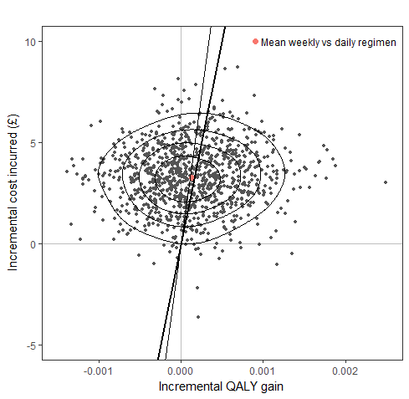

Figure 13: Cost-effectiveness acceptability curve for a LTBI screening programme, comparing current practice of a standard regimen with a weekly regimen.

Vertical lines show the cost-effectiveness thresholds if a QALY is valued at £30,000 (thin line) or £20,000 (bold line). The horizontal dashed line indicates no preference between regimens.

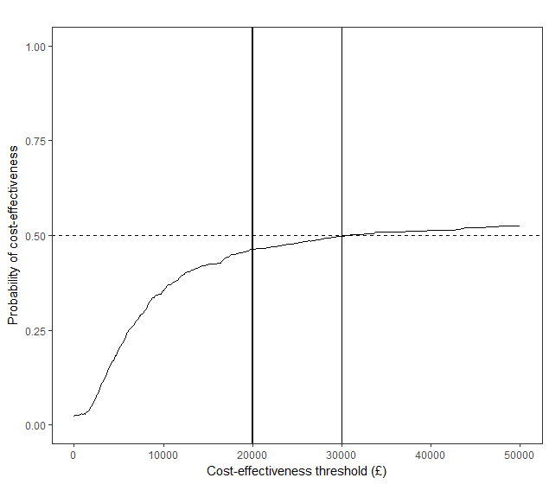

Discussion

Summary of findings

After recruiting 52 participants we can conclude that it is feasible to undertake a fully powered trial to assess whether adherence can be enhanced by using a 12 dose weekly rifapentine regimen versus a UK standard of care. There were no major differences in AEs between the two arms of the trial

Based on the observed levels of adherence, economic modelling suggests that if a fully powered trial were undertaken to detect a similar effect, this intervention will be cost-effective.

Strengths and limitations

This is the first UK based adherence studies assessing whether the weekly 12 dose rifapentine regimen will improve adherence. The small pilot size of the trial means that we were unable to assess the efficacy of the experimental weekly regimen. Nevertheless, we have demonstrated the feasibility of undertaking a full trial, which will form the basis of funding application. The study has identified the challenges of recruiting participants in one centre, while in the second centre it was relatively easy to recruit participants. We have also identified the list of inclusion and exclusion criteria that will support the design of the future trial, and ensure that the results are relevant to the NHS patients.

Comparison with other studies

There are no UK studies to compare to and, internationally, in countries with similar health systems to the UK, there is also paucity of data. Research from the US and other countries suggest that the new regimen is associated with good adherence (Study 33a).

Relevance to policy

Future research should evaluate the effectiveness of the 12 dose weekly rifapentine based regimen compared to daily rifampicin and INH for three months. Such research should consider including adherence support measures such as electronic reminders, dossett boxes and other patient support mechanisms. Importantly, the cost of the weekly regimen in the UK is not known, and the estimated drug cost used in this analysis was 59% more than the drug cost of the standard regimen; a lower cost would make the regimen more likely to be considered cost-effective. It is also possible that the requirement for weekly rather than daily dosing might increase the willingness of patients to accept LTBI screening and/or accept treatment after testing positive for LTBI. Both effects would contribute to increasing the effectiveness and cost-effectiveness of the LTBI screening programme. In addition, the pill burden for the weekly regimen is high, and any future change in formulation that decreases the number of pills will increase the ease with which patients can adhere this regimen.

The national LTBI screening programme should evaluate whether additional simpler regimen may be useful within the migrant screening programme currently being implemented by PHE.

Conclusion

Our work demonstrates the feasibility of running a full RCT in the UK of a novel regimen for the treatment of LTBI that is likely to prove cost-effective.

Monitoring

Data Monitoring Committee and Trial Steering Committee

Purpose of the Data Monitoring Committee

At the commencement of the HALT study both a Data Monitoring Committee (DMC) and Trial Steering Committee (TSC) were formed. The DMC’s role was to safeguard the interests of trial participants, assess the safety and efficacy of the interventions during and for a defined period after the end of the trial, and also to monitor the overall conduct of the trial. It reviewed the results of the interim analysis and reported on them to the TSC. The DMC could not make decisions about the trial, but rather could make recommendations to the TSC. The DMC was independent of, but reported to, the TSC. The DMC operated to a set of Terms of Reference.

Membership of the Data Monitoring Committee

Dr. Mark Kroese, PHG Foundation Chair

Dr. Cono Ariti, London School of Hygiene and Tropical Medicine Statistician

Dr. David Adeboyeku, Central Middlesex Hospital Clinician

Dr André Charlett, National Infection Service, Public Health England Statistician

Meetings of the Data Monitoring Committee

The DMC met four times during the study- in January 2014, February 2015, January 2016, and July 2017.

At the DMC initiation meeting in January 2014 key discussion topics included the protocol for HALT: LTBI, including the requirement for an analysis plan to be written and agreed

At the second meeting in February 2015 the progress of the HALT LTBI study was reviewed. A revised protocol was approved, including expanding recruitment to the Barts Health Trust and the inclusion of individuals with LTBI detected through occupational health screening as well as non-migrants in the eligible trial population. Proposed changes to the analysis plan were discussed.

At the third meeting in January 2016 interim data was reviewed and progress of the HALT LTBi study. Highlighted recruitment challenges in the HALT: LTBI Study necessitated a decision. The DMC agreed to a change in the focus of the study to completing the pilot phase with a reduced target of 50 participants, which would still enable the study to achieve the outcomes and objectives outlined in the study protocol particularly the qualitative outcomes. Following the meeting, the HALT: LTBI protocol and analysis plan were reviewed with reference to the lower level of participants and the DMC confirmed that these were robust and recommended that the study continue.

At the fourth and last meeting in July 2017 the final statistical analysis and economic analysis of the HALT LTBI study was presented by the Study Statistician and reviewed by the DMC.

Purpose of the Trial Steering Committee

The TSC’s role was to independently monitor and supervise the progress of the study towards its objectives, given the reports received from the DMC. This included any decision for early cessation of the trial, based upon recruitment rates or the results of the interim analysis. The TSC operated to a set of Terms of Reference.

Membership of the Trial Steering Committee

Professor Paul Hunter, University of East Anglia Chair

Dr. Stefan Lozewicz, North Middlesex/Barts and the London Hospitals Clinician

Emma Ward/Rachel Halford, Hepatitis C Trust Lay member

Meetings of the Trial Steering Committee

The TSC met four times during the study- May 2014, April 2015, April 2016 and July 2017. The study protocol, recruitment to date and the analysis plan were discussed at the first meeting. At the second meeting recruitment was reviewed. During the third meeting progress to date the pragmatic decision to reduce the sample size of the HALT LTBI pilot study was signed off and the interim analysis was discussed.

Dissemination plans

This report and the findings of the study will be disseminated through a number of mechanisms:
- Peer reviewed publications in general medical journals and tuberculosis specialist journals.

- Presentation at International and national conferences targeting specialists who will benefit from the findings.

- Policy brief for commissioners outlining the main findings.

- Summary of the key results for lay stakeholders

▀ Report dated: 31 August 2018

References

4 Peate I. Prisoner health: HIV infection and other blood-borne viral infections. Br J Nurs 2011; 20(10): 605-6, 608, 610.

14 Sterling TR, et al. Three months of rifapentine and isoniazid for latent tuberculosis infection. N Engl J Med 2011; 365(23): 2155-66.

47 Aldridge RW, Zenner D, White PJ, Muzyamba MC, Loutet M, Dhavan P, Mosca D, Hayward AC, Abubakar I. Prevalence of and risk factors for active tuberculosis in migrants screened before entry to the UK: a population-based cross-sectional study. Lancet Infect Dis 2016; 16(8): 962-70.

48 Aldridge RW, et al. Tuberculosis in migrants moving from high-incidence to low-incidence countries: a population-based cohort study of 519 955 migrants screened before entry to England, Wales, and Northern Ireland. Lancet 2016; 388(10059): 2510-8.

49 Sutherland I, Svandova E, Radhakrishna S. The development of clinical tuberculosis following infection with tubercle bacilli. 1. A theoretical model for the development of clinical tuberculosis following infection, linking from data on the risk of tuberculous infection and the incidence of clinical tuberculosis in the Netherlands. Tubercle 1982; 63(4): 255-68.

50 White PJ, Jit M. Appendix I: Imperial College- LTBI treatment report. National Institute for Health and Care Excellence; 2015. https://www.nice.org.uk/guidance/NG33/documents/tuberculosis-update-appendix-i2.

51 Pareek M, Abubakar I, White PJ, Garnett GP, Lalvani A. Tuberculosis screening of migrants to low-burden nations: insights from evaluation of UK practice. Eur Respir J 2011; 37(5): 1175-82.

64 Joint Formulary Committee. British National Formulary (69th edition). London: BMJ Group and Pharmaceutical Press; 2015. https://bnf.nice.org.uk/.

65 DeLuca A, Frick M, Lessem E, Kanouse J, Wegener D, Mingote LR. Activism on rifapentine pricing: removing cost barriers to improve the uptake of tuberculosis research innovations. Public Health Action 2014; 4(4): 238-42.

66 Allignol A, Schumacher M, Beyersmann J. Empirical Transition Matrix of Multi-State Models?: The etm Package. The Journal of Statistical Software 2011; 38(4): 1-15.

The focus of the trial was widened to include all patients, rather than just individuals from hard-to-reach groups, as adherence levels were identified to be a challenge among all patients being treated for LTBI.

