SUMMARY

Results from:
INSPIRE-AF trial
EudraCT: 2013-000797-30

Primary investigator and sponsor:
Dragana Rujic, MD

Sponsor:
Kenneth Egstrup, MD, DMsc

Hypothesis
The present study was designed to test the hypothesis that add-on therapy with a low dose mineralocorticoid receptor antagonist, in this case spironolactone, will reduce the burden of myocardial fibrosis and structural remodeling in the left atrium and left ventricle, and improve left atrial function, as compared with conventional treatment in patients with symptomatic recurrent episodes of paroxysmal or persistent atrial fibrillation.

METHODS AND ENPOINTS

Study design and population
The present study was designed as an investigator-initiated, prospective, randomized, double-blind, placebo-controlled, single center study conducted at Odense University Hospital, Svendborg Hospital, Denmark from November 2013 through February 2017. All inpatients were recruited from the Department of Cardiology, Odense University Hospital, Svendborg, and outpatients were recruited from the Outpatients Clinic of Cardiology, Odense University Hospital, Svendborg with paroxysmal or persistent AF, defined according to European Heart Rhythm Association (EHRA), were screened for eligibility. In brief, inclusion criteria for the study were: adults (age >18 years) with symptomatic and recurrent episodes of paroxysmal or persistent AF, estimated by EHRA score ≥II, with at least one AF-episode, confirmed by 12-lead ECG or Holter monitoring (AF-episode lasting ≥ 30 seconds) within the last 12 months prior to the screening visit. Major exclusion criteria were permanent AF, previous radiofrequency ablation, Heart failure (New York Heart Association (NYHA) class > II and/or LVEF less than 40%). Ongoing therapy with class IC antiarrhythmics (flecainide, propafenone), amiodarone, dronedarone or sotalol. Or any contradictions towards MRAs i.e. chronic kidney disease (estimated glomerular filtration rate (eGFR) ≤ 45 ml/min/1.73m² (MDRD)), hyperkalemia at baseline (serum potassium >5 mmol/l), or previous allergic reactions. Full inclusion and exclusion criteria are listed in appendix I.
All subjects that fulfilled inclusion criteria and no exclusion criteria were screened with routine blood samples (serum potassium, sodium, creatinine and blood urea nitrogen (BUN), and transthoracic echocardiography (TTE). Subjects who did not meet any exclusion criteria were randomized to the intervention (spironolactone) group or the control (placebo) group. Re-screening was permitted but only on one occasion with at least 7 days apart from first screening. Randomization and any screening measurements were performed after having received the subject’s written informed consent.
Eligible randomized subjects were furthermore recruited to CMR at a target of approximately minimum of 50% of subjects from each treatment group. Entire list of inclusion and exclusion criteria for MR study is found in appendix II.

Primary endpoints
- Twelve-month changes in myocardial post-contrast T1 times in the left atrium in patients randomized to spironolactone versus placebo.
- Twelve-month changes in function of the left atrium and ventricle, assessed by peak strain and strain rate values assessed by TTE and CMR, in patients randomized to spironolactone versus placebo.

Secondary endpoints
- Volumetric measures of LA and LV
- Number of patients free from recurrence AF, total number AF recurrences, total number AF recurrences after 90 days blanking period, and total number DC cardioversions.
- Quality of life as assessed with the Short Form-12 (SF-12) questionnaire and the modified Toronto Atrial Fibrillation Severity Scale (mAFSS).
- Adverse events (AE’s) and serious adverse events (SAE’s) of special interest i.e. gynecomastia, moderate and severe hyperkalemia, and worsening renal function.

Randomization
Study subjects were randomly assigned (1:1 ratio) to receive either spironolactone 25 mg (Spirix® 25 mg) or placebo once daily, using a permuted block design with variable block size (between 1 and 4) stratified by type of AF (paroxysmal and persistent AF). The date of randomization was used as time zero (baseline) for analysis, and end of follow-up was the date of last TTE or/and CMR scan in the study. Spirix® 25 mg and placebo were both produced by Takeda Pharma A/S, Tokyo, Japan and supplied as an oral tablet.

Follow-up
Demographic, clinical and laboratory data were collected at baseline (pre-treatment), and study participants were seen routinely at 3, 6, and 12 months after randomization. Clinical data included measurements of blood pressure, height, weight, and 12-lead ECG. Office blood pressure was recorded three times after 10 minutes of supine rest, 5 minutes between each measurement, with values averaged for the analyses. Laboratory data included measurements of potassium, sodium, hematocrit, hemoglobin, creatinine, BUN, and estimated glomerular filtration rate (eGFR by the simplified Modification of Diet in Renal Disease (sMDRD) prediction equation (41)) for safety purposes, and were additionally collected at 1 week, 1, 2, and 9 months after randomization. TTE, CMR and QoL were assessed at baseline and after 12 months of treatment. All office visits, interviews, and TTE were conducted by the primary investigator DR. In addition, all CMR scans were conducted together by an experienced MR technician (>5 years) and the primary investigator DR.
All patients were in sinus rhythm at baseline and on optimal medical therapy for concomitant medical conditions such as hypertension, diabetes mellitus, thyroid diseases, and AF. Optimal therapy for AF included beta-blockers, verapamil, diltiazem, digoxin, and anticoagulant therapy, where appropriate. When randomized participants were asked to communicate any episodes of documented AF or symptoms suggestive of AF recurrence between scheduled visits. Study participants with symptoms of AF underwent 12-lead ECG by their nearest health care provider or in our outpatient clinic, and 12-lead ECG’s were collected as documentation. Only ECG documented events of AF were included as AF recurrences in the statistical analyses. Aggressive rhythm strategy was encouraged, including direct current-conversions when indicated, and treatment with an anti-arrhythmic drug (AAD) therapy, such as class IC, amiodarone or sotalol, was allowable at the discretion of the primary investigator.
Compliance to study medication was monitored by collection of excess study medicine at 3-, 6-, and 12-months visits after randomization. For each study subject, treatment compliance was estimated by calculating the ratio of effective treatment duration over expected treatment duration. Effective treatment duration was estimated by the quantity of medication received and the corresponding number of days of treatment. Overall compliance with the study drug intake was expected to be equal to or higher than 80% of the scheduled dose at the end of the treatment.

Adverse events
Reports of adverse events (AE) were collected throughout the study period, classified and graded according to seriousness, intensity, outcome, and causality with study medication. Adverse events of special interest were gynecomastia, hyperkalemia, and worsening of renal function compared to baseline. Breast tissue pain or discomfort ≥ 1 month, or visually apparent gynecomastia were regarded as a serious AE, and the subject was withdrawn from the study (42). The severity of hyperkalemia was defined according to the European Resuscitation Council guidelines into mild (5.5–5.9 mmol/L), moderate (6.0–6.4 mmol/L), and severe (>6.5 mmol/L)(43). The worsening of renal function was defined according to the Kidney Disease Improving Global Outcomes Guidelines (44,45). A relative increase in serum creatinine <25% from baseline and serum potassium <6.0 mmol/L was considered acceptable. In case of a moderate increase of serum creatinine 25–29% from baseline or moderate hyperkalemia 6.0-6.4 mmol/L, potassium supplements, concomitant treatment with ACEI/ARB, or temporarily study medication was removed. The subject was withdrawn from the study if the serum creatinine ≥30% compared to baseline, or the serum creatinine increased ≥200 micromoles/L, or in case of serious hyperkalemia (≥6.5 mmol/L).

Echocardiography
All patients underwent a standard two-dimensional TTE at baseline and after 12 months of treatment, adhering to the recommendations of the American Society of Echocardiography and the European Association of Cardiovascular Imaging (46,47), using the same Vivid 9 Digital Ultrasound System (GE Medical Systems, Chicago, Illinois, United States) equipped with a M4s Matrix array adult cardiac (2.5 MHz) transducer. All exams were performed by the primary investigator (≥4 years experience) in TTE. Three consecutive cardiac cycles in cine loop were recorded for offline analyses by the PI, using commercially available software (EchoPAC GE Healthcare, Horten, Norway).
For evaluation of global LV systolic function, EF was estimated by the Simpson biplane method from apical 4- and 2-chamber views. In study participants with sinus rhythm the diastolic function was assessed by the transmitral inflow peak early diastolic filling (E), and lateral mitral annular diastolic velocity (é) by tissue Doppler in apical 4-chamber view. The derived E/e’ was used as an index of LV filling pressure. Furthermore, late diastolic filling (A) from the mitral valve inflow, the derived E/A ratio, and deceleration time (DT) were obtained.
Strain and strain rates were derived from speckle tracking echocardiography (STE) by manual tracing of the LV myocardium in apical 4-, 2-, and long axis chamber views, dividing the myocardium into 18 segments. The software delivered global and regional strain and strain rate values. In case of poor image quality, a maximum of two consecutive segments in each view was allowed to be excluded. When feature tracking was inadequate for 3 or more segments pr. view, the scan was excluded as a total from strain and strain rate analysis. A similar approach was applied for STE analysis of LA, using average of mean global values from apical 4- and 2-chamber. Reservoir function of LA was assessed by peak atrial longitudinal strain (PALS) and systolic atrial strain rate (SR-s), conduit function was assessed by early diastolic atrial strain rate (SR-e), and contractile function was assessed by peak atrial contraction longitudinal strain (PACS) and late diastolic atrial strain rate (SR-l), respectively.
Assessment of LA size included maximum LA volume during ventricular end-systole (LAEDV) measured at the first frame after mitral valve closure, minimal LA volume during ventricular end-diastole (LAESV) measured one frame before mitral opening, and precontract LA volume (LAP) at the onset of the P wave, all measured by the biplane area-length method. The LA volume index (LAVI) was calculated as LAEDV indexed to body surface area (BSA) by DuBois formula (48). LA maximum/minimum/pre-contraction volumes were measured using the biplane area-length method from 2- and 4-chamber views. Accordingly, LA phasic volumetry was calculated with the following formula:
$$LA total emtying fraction (LATEF)=\frac{LA maximum volume-LA minimum volume}{LA maximum volume}∙100$$
$$LA passive emptying fraction (LAPEF)=\frac{LA maximum volume-LA precontraction volume}{LA maximum volume}∙100$$
$$LA active emptying fraction (LAAEF)=\frac{Volume before LA contraction-LA minimal volume}{Volume before LA contraction } ∙100$$
$$Total reservoir volume=LA maximum volume-LA minimum volume$$
$$Passive emptying volume=LA maximum volume-Volume before LA contraction$$
$$Active emptying volume=Volume before LA contraction-LA minimum volume$$

Finally, the LA sphericity index (LASI) (49) and LA expansion index (LAEI) (50) were calculated from the following formulas:
$$LASI=\frac{LAVI}{LA volume of sphere} where LA volume of sphere={\frac{4π}{3}\left(\frac{Maximum LA lenght}{2}\right)}^{3}$$
$$LAEI=\frac{LA maximum volume-LA minimum volume}{LA minimum volume}-1∙100$$

Cardiac magnetic resonance
All CMR scans were performed using the same 1.5-Tesla scanner (Avanto, Siemens Medical Systems, Erlangen, Germany) and the same 32-channel array coil. All studies were planned using scout images for localization. For evaluation of LA and LV, a transversal stack covering the whole LA volume, and a double-oblique short axis stack covering the whole LV volume, and further 2-, and 4-chamber views were acquired as steady-state free precession cine images (SSFP) during end-expiratory breath hold and retrospective ECG gating. In patients with AF, prospective ECG gating was used. Both transversal and short axis stacks were obtained as follows: 8 mm slice thickness, without gap, 25 phases corresponding to a temporal resolution of 24-48 ms, repetition time / echo time 2.8-3.2 msec/1.4-1.6 msec; flip angle 80º, field of view 240 x 300 mm, and matrix 256 x 150.
Intravenous access was gained by a 20-gauge needle in the left elbow joint for injection of the gadolinium contrast agent (GDA), Gadovist® (gadobutrol 1,0 mmol/ml, Bayer Pharma AG, Berlin, Germany) with a bolus of 0.2 mmol/kg at an injection rate of 2 ml/s, followed by a 20-30 ml saline flush. Myocardial scarring was evaluated with inversion recovery and PSIR sequences within a range of 12 to 16 minutes after the injection of a bolus of GDA. Normal myocardium was nulled at a mid-ventricular double oblique short axis image, and a stack of late gadolinium enhancement images (LGE) was acquired covering whole LV using SSFP readouts. For quantification of diffuse fibrosis, native T1 and post-contrast were obtained, using a modified Look-Locker inversion-recovery sequence (MOLLI) during single short breath holds of 3 heart beats before and 12 minutes after injection of GDA, respectively. The images were assessed in a mid-ventricular short axis view and standard 2- and 4-chamber long-axis views, using the 5(3)3 standard MOLLI protocol (Siemens, Erlangen, Germany)(51). The MR scanner provided automated in-line motion correction of MOLLI images.
All image analyses were carried out off-line in a random order by the primary investigator DR, using dedicated software CircleCVI42 (Canada). Volumes, LGE, and T1 relaxation times were obtained in all scanned study participants. Furthermore, feature tracking CMR (CMR-FT) including strain and strain rate, was obtained in the participants in sinus rhythm. LA maximum/minimum/pre-contraction volumes were measured using the biplane area-length method, excluding the atrial appendage and pulmonary veins and averaging measurements from 2- and 4-chamber views. Accordingly, LA total/passive/active emptying fractions, volumes, LA sphericity index (LASI), and LA expansion index (LAEI) were calculated following same formula and approach for transthoracic echocardiography described above.
LV myocardial and blood pool T1 relaxation times were extracted from native and post-contrast MOLLI images, where endo- and epicardial contours were manually traced in the middle of compact myocardium in a short axis view, subdivided into 10 equal segments. T1 values within the defined myocardium was quantified for each segment and averaged to a global value. Segments with suspected artifacts or LGE were excluded. In addition, an approximate 0,5 x 0,5 cm region of interest (ROI) was drawn in blood pool. For measures of T1 times a similar approach was applied for the LA. However, since the LA is a thin-walled structure, LA T1 times were obtained by placing 2 to 4 different ROI, each less than 1 x 1 mm in size, in the most visible place of myocardium in 4-chamber view, guided by correction coefficient. The ROIs with lowest T1 value and highest correction coefficient were chosen for statistical analyses. Extracellular volume fraction (ECV) was calculated from the following formula: ECV = (√T1 “myocardium post-contrast” – 1 / T1 “myocardium pre-contrast”) (1 / T1 “blood post-contrast” – 1 / T1 “blood pre-contrast”) x (1- hematocrit). ECV is given in percentage(52-54).
Feature tracking of the LV was obtained by manually contouring endo- and epicardium in all phases through the short axis stack in addition to the 2- and 4-chamber views, providing 3-dimensional values of global strain and strain rate. Meanwhile, the LA epicardium was manually delineated in the 4- and 2- chamber views when the LA was at its maximal volume, providing 2-dimensional strain and strain rates values as average of the two views.

Quality of Life
Quality of life (QoL) was assessed at baseline and at end of follow-up (after at 12 months of treatment) with the use of the Medical Outcomes Study 12-Item Short-Form Health Survey (SF-12) questionnaire and a structured interview by the Modified Toronto Atrial Fibrillation Severity Scale (mAFSS). SF-12 included a physical-component summary score and a mental-component summary score, both of which range from 0 to 100 points, with higher scores indicating greater well-being (55-58). Further, all study participants were interviewed by the primary investigator, using mAFSS to assess severity of AF symptoms, including frequency of AF recurrence, severity of symptoms, and duration, each quantity ranging from 0 to 10 point (59-61). The mAFSS scoring was used as a disease-specific questionnaire in order to quantify AF related symptoms and complement the standardized generic health-survey SF-12.

Statistical methods
The statistical software packages Stata/IC (StataCorp LP, College Station, TX, USA) and R software, https://www.R-project.org/, R Core Team (2019) were used for statistical analyses.

Summary Statistics
All variables presented were stratified by treatment group. Continuous variables were plotted as histograms, and distributions were visually inspected. Means, medians, skewness, and kurtosis were examined. Summary statistics were presented as means and standard deviations for variables with a clear or approximate Gaussian distribution or medians and interquartile ranges (IQR) (25th and 75th percentile) for variables with a clear non-Gaussian distribution. Categorical variables were presented as counts with corresponding percentages. Group-wise comparisons for continuous variables were performed using an unpaired 2-sided Student t test, one-way analysis of variance, Kruskal Wallis test and Mann-Whitney U test, as appropriate. Comparisons of distributions of categorical variables were carried out with the chi-square test.

Longitudinal analyses
Analyses for primary endpoints, including changes in volumes, strain, strain rate, T1 myocardial times, and ECV from baseline to the end of study (after 12 months of treatment) were performed by a repeated measure mixed effects linear model with maximized likelihood, including testing of interaction between treatment and change in the continuous outcomes. Moderately to severely positively skewed variables (E/A ratio, E/e’ ratio, strain rate variables) were natural logarithmically transformed before entering into the regression models. Absolute changes in outcome variables from baseline to the end of study were calculated by subtracting the baseline value from the follow-up value and expressed as means or medians change by treatment group with corresponding standard deviations, 95% confidence interval or IQR in the units of their measurements. Potential covariates entered into the mixed effects linear model were clinical and imaging parameters of known or expected relevance and selected a priori based on biological plausibility or published studies, or both, regardless of their statistical significance at univariate analysis. Covariates adjusted in the mixed models for strain and strain rate included age, LAEDV, BMI, sex, type AF, blood pressure. In the mixed models for T1 times and ECV, in addition, adjustments were made for serum creatinine, GDA dose, time for image acquisition after contrast administration, and hematocrit level.
Analyses of QoL data (paper III), including SF-12 and mAFSS questionnaires, were carried out using two-way analysis of variance (ANOVA) with change from baseline (baseline to 12 months) as the response variable, and interaction of treatment and time as the dependent variable. The F and P values of the comparison between treatment and within treatment were assessed with the Greenhouse-Geisser correction followed by Bonferroni’s post-hoc test.

Survival Analyses
Distributions of cumulative total number DC cardioversions, cumulative total number of AF recurrences, and cumulative recurrence free subjects were compared between treatments by Wilcoxon rank sum tests. In addition, time-to- first DC cardioversion, recurrence free survival probabilities over time, and recurrence free survival after 90 days blanking period were carried out using Poisson regression and binomial negative regression, when applicable. Time-to-event data were presented graphically by Kaplan Meier survival plots for each entity. We defined a blanking period of 90 days as effect of spironolactone on myocardium was expected to be time-depended. All randomized patients were included in the survival analysis. Subjects who were recurrence-free at the end of follow-up were censored at the analysis time point, and AF-free time was defined as time from randomization to date of censoring.

Statistical Significance
All analyses were performed using the intention-to-treat principle and no imputation was performed. The intention-to-treat population consisted of all randomly assigned patients in the study. A two-sided P-value < 0.05 was considered statistically significant. No adjustments for multiple comparisons were made, and all findings are to be considered hypothesis-generating.

Sample size considerations
Calculation of sample size for the study was firstly based on the primary endpoint of the effect of spironolactone on post-contrast myocardial T1 time, and secondly on left atrial and ventricle function assessed by STE and CMR-FT. At the time of writing of this protocol there were no prior prospective, randomized clinical studies that had been performed in patients with paroxysmal or persistent atrial fibrillation with normal LVEF, where the effect of spironolactone on the left atrium and ventricle using T1 mapping or STE/CMR-FT has been investigated. Therefore, the preliminary sample size determination was based on limited knowledge about the distribution of the primary outcome measures.
Sample size determination for secondary endpoints were not performed, and they are therefore to be regarded as exploratory.
Study I (the CMR study): Liu et al. demonstrated that a reasonable sample size of 27 participants in a human paired study design of two treatment arms was adequate to detect a 38% change in ECV with a power of 80%, which corresponds to about 3% increase in histological collagen tissue. In this study, statistically significant group differences in ECV were detected using a relatively small sample size of 24 healthy volunteers and 25 patients with heart failure with reduced ejection fraction (62). Based on a previous study by Dabrowski et al. (19) we anticipate a 12% effect of spironolactone in our AF population with normal LVEF, and therefore a sample size of 45 patients in each treatment arm was considered adequate to detect a significant difference between the intervention and the placebo group with a power of 80% and a two-sided significance level of 0.05, including 10% of loss-to-follow-up.
Study II (the TTE study): The sample size calculation is based on a previously published study on the effect of spironolactone in patients with diastolic dysfunction and hypertensive cardiomyopathy, where the changes in myocardial calibrated integrated backscatter (IB) have been documented. From this publication, we hypothesized that there will be a difference in IB between placebo and the intervention group of -4.5 dB (SD = 7) on 12-month spironolactone therapy. Thus, with a two-sided significance level (α) of 0.05 and power 0.8, at least 124 patients should be included in the study with 62 patients in each treatment arm. This includes 5% of loss-to-follow-up and non-compliance with study medicine.

The funding sources
This study received study medication including placebo from Takeda. Takeda had no role in study design, data collection, data analysis, data interpretation or writing of the report. The corresponding author had full access to all data in the study and had final responsibility for the decision to submit for publication.

Ethics
The study protocol was approved by The Ethics Committee of Southern Denmark (S-20120220), The Danish Health and Medicines Authority, The Danish Data Protection Agency, and conducted in accordance with the Declaration of Helsinki and all applicable amendments laid down by the World Medical Assemblies and the ICH guidelines for Good Clinical Practice. All patients provided written informed consent before participating in any study related exams. Well in advance of the written informed consent, subjects were informed verbally about the study. Written and oral information included description of study rationale, follow-up, exams carried out, potential risks and side effects.
The study is registered at ClinicalTrials.gov (NCT02764619) and European Medicines Agency, European Clinical Trials Database (EudraCT: 2013-000797-30).
The study was monitored by Good Clinical Practice Unit, Odense University Hospital, Odense, Denmark.

RESULTS

Baseline characteristics
We initially screened a total of 2200 subjects with the diagnosis AF in electronic health records of inpatients (November 2013-March 2016) and outpatients (January 2012-March 2016) in our institution, resulting in 315 individuals potentially eligible for inclusion. A total of 185 patients declined to participate, and 23 were excluded: 2 had LVEF ≤ 40%, and 21 had asymptomatic AF at inclusion. In total, 125 patients were enrolled in the TTE study: 63 patients were allocated to the spironolactone group and 62 to the placebo group (Figure 1). Furthermore 100 eligible patients from the complete study population participated in the CMR study: 48 patients from the spironolactone group and 52 from the placebo group. The baseline demographic, clinical, laboratory, and imaging characteristics of patients enrolled in the complete study and CMR study are summarized in Table 1 and Table 2. The mean age of the 125 patients was 63.9 ± 8.1 years; 64% were male; 46.4% had paroxysmal and 53.6% persistent AF; mean BMI was 28.2 kg/m²; 51.6% suffered from hypertension, while only 3.2% had diabetes mellitus or ischemic heart disease. Additionally, Table 3 summarizes the comparison of baseline characteristics for patients included vs. not included in the CMR study. Subjects not included in the CMR study tended to be older (P=0.09) with more having persistent AF than paroxysmal (P<0.001); larger LAVI (P<0.001); more often suffered from hypertension (P=0.01), and as consequence more frequent ACEI or ARB use (0.03), and higher median CHA₂DS₂-VASc score (P=0.03).

Patient compliance and protocol adherence
All planned patients were enrolled in both studies. In total 123 patients completed the study protocol: 61 patients from the spironolactone group and 62 from the placebo group (Figure 1). Compliance to study medication and adherence to the protocol were high. Effective treatment duration for all 123 patients was 354 ± 72.2 days (347.1 ± 80 days for the patients in the spironolactone group vs. 361.1 ± 63.3 for the patients in the placebo group, P=0.27). Treatment compliance to study medication were estimated at 6- and 12-months follow-up visits and were both times greater than 80% for all participants. Nine participants (7.2%) discontinued the treatment with study medication: five patients (7.9%) allocated to the spironolactone group discontinued treatment with study medication due to breast discomfort or gynecomastia, one patient with diabetes mellitus type 2 allocated to the spironolactone group died due to alcohol intoxication 6 months from time of the randomization, one patient allocated to the spironolactone group withdraw the consent, two patients allocated to the placebo group discontinued the study medication due to abdominal pain.

Adverse events
During follow-up, a total of 177 adverse events occurred during the trial in 107 patients: 9 patients in the intervention group and 10 patients in the placebo group did not experienced any adverse events (P=0.60). The majority of the adverse events were minor such as fatigue (24.0%), the composite adverse events of dizziness/bradycardia/orthostatic hypotension (29.6%), and dyspnea (16.8%) (Figure 2). The incidence of adverse events in their entirety was approximately equally distributed with a slightly fewer adverse events in the placebo group (spironolactone 53.1% vs. placebo 47.5%, P=0.30). However, there were two important exceptions where treatment arms differed significantly: dizziness/bradycardia/orthostatic hypotension was more prevalent in the spironolactone group (25.5% vs. 14.3%, P=0.01), while high blood pressure was more prevalent in the placebo group (defined as office blood pressure >140/85 mmHg, (63)) (3.2% vs. 13.1%, P=0.02) (Table 4). Serious adverse events, including new or prolonged hospitalization as reason for notification, occurred equally in the spironolactone and placebo group (P>0.99): one patient was hospitalized for pleural effusion and underwent diagnostic thoracentesis, another one for surgical intervention of a primary ovarian cancer, one for surgical intervention of a primary kidney cancer, and one for transurethral resection of the prostate. There were no cases of unexpected adverse events in either groups (Table 4).
In total 16 patients (25.4%) in the intervention group experienced adverse events attributed to spironolactone (Table 5) of which the majority were minor i.e., an increase in serum creatinine <25% from baseline. Of the more serious adverse events, gynecomastia or breast discomfort occurred in nine subjects: eight of them in the intervention group, resulting in discontinuation of study drug treatment in five patients (7.9%) vs. only one (1.6%) in the placebo group (P=0.02) (Figure 4). Apart from mild breast tissue discomfort at time 3 months in one male patient from the spironolactone group that required discontinuation of study treatment, the gynecomastia or breast discomfort usually presented in male patients from 6 months or later: four patients from the spironolactone group had mild to moderate gynecomastia at time 6 months which required withdrawal of study medication, additional three patients presented with gynecomastia 12 months after treatment.
Significant laboratory deviations were observed in 7 patients (11.1%) allocated to the spironolactone group, in whom 2 (3.2%) required withdrawal of the study medication: one due to acute worsening of renal function and hyperkalemia (≥30% increase in serum creatinine level from baseline and serum potassium 6.1 mmol/L) and one due to moderate, symptomatic hyponatremia (serum sodium level <120 mmol/L), but none in the placebo group. The incidence of mild hyperkalemia (serum potassium 5.5-5.9 mmol/L) and/or 20-25% increase in serum creatinine from baseline was significantly higher in the intervention group vs. placebo group (mild hyperkalemia, P=0.03 and mild increase in creatinine from baseline, P=0.04) (Table 5). Patients who developed hyperkalemia were older, more likely to have diabetes, had higher CHA₂DS₂VASc score, baseline serum creatinine, and were more likely to be treated with ACEI (age: 67 ± 5.5 years; 33% were diabetic; median CHA₂DS₂VASc score 2 (IQR: 2-3), baseline serum creatinine 85 ± 15 μmol/l, 83.3% in ACEI treatment at baseline). Regarding concomitant medications, the combination of ACE inhibitors and spironolactone increased the risk of hyperkalemia by 8% but was not found to be significant (P=0.09).

Changes in clinical and laboratory parameters
Systolic and diastolic blood pressures significantly reduced in the spironolactone group compared to placebo group (mean reduction in systolic blood pressure from baseline: 9.1±2.6 mmHg vs. 3.4±2.2 mmHg; P=0.02) (Figure 5 and 6). The reduction in both systolic and diastolic blood pressure was predominantly seen in the first 6 six months of treatment with the largest reduction in systolic blood pressure in spironolactone group (mean change from baseline: 11.6 mmHg; P<0.01) (Table 6). Similar results were observed for diastolic blood pressure (P<0.001 for treatment effect). There was a significant correlation between diastolic blood pressure and age (R²=0.16; P=0.02 for interaction), and serum creatinine (R²=0.20; P=0.03 for interaction).
Finally, as expected, serum creatinine and serum potassium increased significantly in the spironolactone group compared to placebo (mean increase in serum creatinine from baseline: 6.4±1.2 μmol/L vs. 3.4±1.2 μmol/L; P<0.01; and mean increase in serum potassium from baseline: 0.1±0.05 mmol/L vs. 0.05±0.005 mmol/L; P<0.001) (Figure 7 and Figure 8).

The Structure and Function of Left Atrium, assessed by CMR

Structure of Left Atrium
Of the two primary endpoints, no significant changes with spironolactone relative to placebo were found, including LA post-contrast myocardial T1 time (P=0.20) and PALS (P=0.20) (Table 7). With the respect to the first primary endpoint, LA post-contrast T1 time increased from baseline to the end-of-study, and the mean change was found significant in the intervention group, and in addition was nine fold higher than in the placebo group (mean increase in spironolactone group: 6.1 ms [95% CI: 0.2; 12.2]; P=0.004 vs. mean increase in placebo group 0.7 ms [95% CI: -4.4; 5.9]; P=0.80).
For all three volumetric phases of LA, all volumes showed a number albeit non-significant reduction in the spironolactone group whereas the same parameters showed a numerical small albeit non-significant increase in the placebo group (Table 7). Only LA maximum volume, LA precontract volume and LA precontract volume index were significantly changed after 12 months of treatment (mean change in LA precontract volume between spironolactone and placebo group 11.7 mL [95% CI: 1.4; 23.2]; P=0.02). Notably, when LA maximum volume was indexed to body surface area, the mean difference between treatment groups after 12 months was found nonsignificant.
In total 14.7% (n=14) of all scans (8 from the spironolactone group and 6 from the placebo group) were excluded from intention-to-treat analyses for LA T1 mapping due to poor image quality of MOLLI. Upon further analysis of these scans, it was found that 21.4% (n=3) of the images with poor quality were due to MRI technologist error or high BMI, however 78.6% (n=11) related to arrhythmia.

Function of Left Atrium
Treatment with spironolactone did not significantly alter the function of the volumetric phases of LA compared with placebo. However, in the placebo treatment group, PALS, LA SR-s, and LA SR-e were significantly reduced from baseline to 12 months, indicating worsening of the LA reservoir and conduit function in the placebo group. Although PALS was nearly fourteen-fold and LA SR-s almost sixteen-fold reduced compared to the changes in the spironolactone group, the mean difference between treatment arms at the end-of-study remained nonsignificant.

The Structure and Function of Left Ventricle Assessed by CMR
Treatment with spironolactone versus placebo did not significantly affect the two co-primary endpoints, myocardial T1 times and strain (Table 8). Similar to the results from LA T1 mapping, a small decrease in LV native myocardial T1 times was noted in the placebo group, while there was a small increase in the spironolactone group (mean change from baseline to 12 months for native myocardial T1 times in the placebo group: decrease 6.5 ms [95% CI: -15.1; 2.1] vs. spironolactone group: increase 4.5 ms [95% CI: -15.1; 2.1]) but did not reach statistical significance. On the contrary, LV post-contrast T1 times decreased in both treatment arms, suggesting increasing myocardial fibrosis burden over time, however the reduction of the LV post-contrast T1 times in the placebo treatment arm was nearly 30% larger than in spironolactone group (mean change from baseline to 12 months for post-contrast myocardial T1 times in placebo group: decrease 7.5 ms [95% CI: -19.2; 4.1] vs. spironolactone group: decrease 5.3 ms [-3.2; 23.9], P-value for treatment effect=0.20).
In the volumetric measurements, spironolactone treatment numerically reduced LVEVD, LVESV, and LVM, yet the spironolactone arm did not show significant favorable changes in any of the volumetric or functional measurements of the LV at 12 months of follow-up when compared to the placebo arm (Table 8). Likewise, no significant difference in strain or strain rate was observed in patients in spironolactone vs. placebo group at end of study (Table 8).

The TTE study

Left atrium
Of the two imaging endpoints, significant improvement with spironolactone relative to placebo was found for strain and strain rate measures in the reservoir phase of LA, but not for LA post-contrast myocardial T1 time (p-value for treatment effect=0.20) (Table 9). The spironolactone group showed significant improvement in the reservoir phase of LA, documented by both strain and strain rate (mean change from baseline to 12 months for PALS in the placebo group: mean decrease 3% [95% CI: -6; -0.07], P=0.05 vs. spironolactone group: mean increase 1.8% [95% CI: -1.2; 4.8], P=0.20; P for treatment effect = 0.03). Although, strain rate in the reservoir phase of LA, assessed as LA SR-s, followed a similar pattern, a major difference lied in that the mean increase in the spironolactone group from baseline to end-of-study was found significant (P for treatment effect=0.02).
Comparisons with the placebo group revealed that spironolactone did not affect any of the volumetric parameters significantly (Table 9). Although, LAmax and LAmin decreased in both treatment groups, there was an overall greater reduction in the spironolactone group relative to placebo group, but no changes in the volumetric parameters reached statistical significance. LAAEF which is a ratio between LA precontract volume and LA minimum volume, increased in both the placebo and the spironolactone group, but was found significantly more improved in the spironolactone treatment arm (P for treatment effect=0.02) (Figure 9). Likewise, LA sphericity index increased in both treatment arms, but no significant alternations were noted at the end-of-study (P=0.30) (Figure 9).

Left ventricle
Treatment with spironolactone did not significantly improve function or affect structure of LV, assessed by conventional TTE and speckle tracking (Table 10). LVESV and LVEF increased slightly in the spironolactone-treated patients, but oppositely was found reduced in the placebo-treated patients (P=0.09 and P=0.50 for treatment effect, respectively). LV GLS reduced to a higher extent in the placebo group compared the spironolactone group after 12 months of treatment (P=0.10) (Table 10). Strain rate analyses revealed a small reduction in all measurements in both treatment arms, and particularly SrL peak E and SrL peak A reduced to a higher extent in the spironolactone group compared to placebo. Although strain and strain rate measures decreased from baseline to the end-of-study in the spironolactone group, none of these changes did reach statistical significance compared with placebo.

Hemodynamics
Overall, there were no significant changes in E velocity, A velocity, E/A ratio, e’ or E/e’ between treatment groups (Table 10). There was only a significant increase in a’ in the spironolactone-treated subjects compared to placebo-treated (P=0.03).

AF recurrences
At 12-month follow-up, 67 patients (53.6%) were free from arrhythmia recurrence. At least one episode of AF was documented by 12-lead ECG in 58 (46.4%) patients during follow-up. In placebo group 34 (54.8%) were recurrence free in comparison with 33 (52.3%) in spironolactone group (P=0.50) at the end of study. Recurrence of AF rate was 32 [31%] in the placebo group and 33% in the spironolactone group (IRR=0.75; P=0.60). No patient was lost to follow-up during the study period. The Kaplan-Meier survival curves comparing cumulative time to AF recurrence probability over time across treatment groups is presented in Figure 20. Figure 21, and showed no significant difference between treatment groups, including when the first 90 days were blanked.

Figure 1. CONSORT diagram

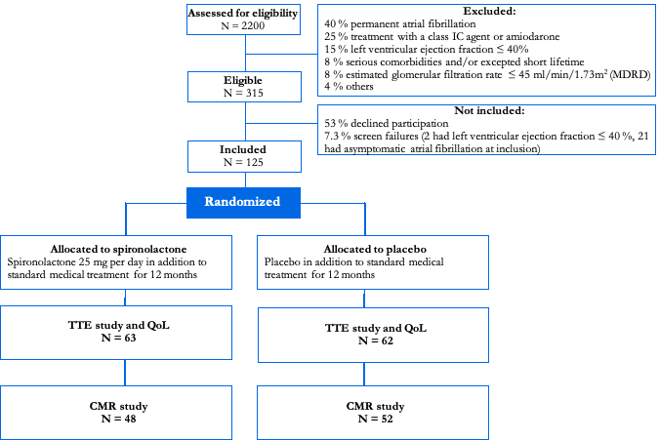

Table 1. Comparison of baseline clinical and echocardiographic characteristics of the entire study group
 | All patients  (n = 125) | Spironolactone group  (n = 63) | Placebo group  (n = 62)
Age (years) | 63.9 ± 8.1 | 63.8 ± 7.5 | 64.1 ± 8.8
Male, (%) | 64 % | 66.7 % | 61.3 %
Paroxysmal AF, (%)  Persistent AF, (%) | 46.4 %  53.6 % | 44.4 %  55.6 % | 48.4 %  51.6 %
Systolic blood pressure (mmHg) | 137.6 ± 17.7 | 136.2 ± 16.9 | 139 ± 18.4
Diastolic blood pressure (mmHg) | 82.7 ± 10 | 83.3 ± 10.2 | 82 ± 9.8
Heart rate (beats per minute) | 58.2 ± 9.6 | 57.9 ± 9.3 | 58.5 ± 10
Body mass index (kg/m²) | 28.2 ± 4.4 | 27.9 ± 4.7 | 28.5 ± 4.2
Laboratory parameters  Creatinine (μmol/L)  BUN (mg/dL)  eGFR (mL/min/1.73m²)  Potassium (mmol/L) | 73.9 ± 12.7  5.4 ± 1.2  86.1 ± 16.3  4 ± 0.3 | 74.9 ± 12.4  5.4 ± 1.1  85.4 ± 15.9  3.9 ± 0.3 | 73 ± 13.1  5.4 ± 1.2  86.9 ± 16.8  3.9 ± 0.2
Current smoker, (%)  Prior smoker, (%) | 14.4 %  57.6 % | 12.7 %  60.3 % | 16 %  54.8 %
Significant medical history  Ischemic heart disease, (%)  Sleep apnea, (%)  Diabetes mellitus, (%)  Hypertension, (%)  Stroke or TIA, (%) | 3.2 %  4 %  3.2 %  51.6 %  11.2 % | 3.2 %  4.8 %  3.2 %  54.8 %  12.7 % | 3.2 %  3.2 %  3.2%  48.4 %  9.7 %
Medications  ACEI or ARB use, (%)  Beta-blocker or non-dihydropyridin calciumantagonists use, (%)  Anticoagulants use, (%)  Antiplatelet agents use, (%)  Statin use, (%) | 32 %  80 %  66.4 %  16.8 %  30.4 % | 30.2 %  81 %  65.1 %  22.2 %  33.3 % | 33.9 %  79 %  67.7 %  11.3 %  27.4 %
CHA₂DS₂-VASc score, median (IQR)  EHRA score, median (IQR)  NYHA score, median (IQR) | 2 (1-2)  3 (2-3)  1 (1-1) | 1 (1-2)  1 (2-3)  0 (1-1) | 1 (1-2)  1 (2-3)  0 (1-1)
Echocardiographic parameters  Left ventricle  LV end-diastolic volume index (mL/m²)  LVMI (g/m²)  LVEF (%)  E velocity (cm/sec)  e’ (cm/sec)  E/e’ ratio  Left atrium  LA maximum volume area-length (mL)  LAVI (mL/m²)  LA maximum area index (cm²/m²)  LA major length (mm) | 56.9 ± 15  74.2 ± 16.2  59.6 ± 4  69.2 ± 17.1  9.3 ± 2.3  7.5 (9.2-6.2)  71.5 ± 21  34.6 ± 9.4  10.9 ± 2.1  6 ± 0.7 | 54.9 ± 12.6  76.1 ± 17.3  59.6 ± 3.8  68.3 ± 17.1  9.3 ± 2.6  7.6 (8.7-6.2)  72.6 ± 22.2  35.1 ± 9.8  11.1 ± 2.1  6 ± 0.8 | 54.3 ± 14.3  72.3 ± 14.9  59.6 ± 4.1  70.1 ± 17.2  9.3 ± 2.2  7.4 (9.7-6.1)  70.3 ± 19.8  34.1 ± 8.9  10.8 ± 2.1  6 ± 0.7
Data presented as mean ± standard deviation or N (%) [or N/total no. (%)], unless otherwise indicated. Continuous variables were compared by Students t test, and categorical variables by Pearson X². For CHA₂DS₂-VASc, EHRA, and NYHA scores, median (range) are given. Groups were compared by Wilcoxon-Mann-Whitney test. BUN indicates blood urea nitrogen; eGFR, estimated glomerular filtration rate; TIA, transient ischemic attack; ACEI, angiotensin-converting-enzyme inhibitor; ARB, angiotensin II-receptor blocker; CHA₂DS₂-VASc, congestive heart failure (or left ventricular systolic dysfunction), hypertension, age ≥ 75 years, diabetes mellitus, prior stroke or transient ischemic attack or thromboembolism, vascular disease, age 65-74, sex category; NYHA, New York Heart Association; EHRA, European Heart Rhythm Association score, LVMI, left ventricle mass index; LAVI, left atrial volume index.
Table 2. Comparison of baseline clinical and cardiac magnetic resonance parameters in the CMR study
 | All patients  (n = 100) | Spironolactone group  (n = 48) | Placebo group  (n = 52)
Age (years) | 63.4 ± 8.5 | 63.7 ± 7.8 | 63.2 ± 9.2
Male, (%) | 64 % | 68.8 % | 60 %
Paroxysmal AF, (%)  Persistent AF, (%) | 50 %  50 % | 47.9 %  52.1 % | 51.9 %  48.1 %
Systolic blood pressure (mmHg)  Diastolic blood pressure (mmHg) | 138.4 ± 18.4  83.2± 9.9 | 136.3 ± 17.3  83.5 ± 10.1 | 140.3 ± 19.3  82.9 ± 9.8
Heart rate (beats per minute) | 58.2 ± 9.6 | 58.3 ± 9.5 | 58.1 ± 9.7
Body mass index (kg/m²) | 28.3 ± 4.4 | 27.9 ± 4.7 | 28.7 ± 4.2
Laboratory parameters  Creatinine (μmol/L)  BUN (mg/dL)  eGFR (mL/min/1.73 m²)  Potassium (mmol/L) | 72.8 ± 12  5.3 ± 1.1  87.7 ± 16.2  3.9 ± 0.3 | 73.9 ± 11.9  5.3 ± 1.1  87.1 ± 15.6  4 ± 0.3 | 71.7 ± 12.1  5.3 ± 1.1  88.3 ± 16.9  3.9 ± 0.3
Significant medical history  Ischemic heart disease, (%)  Sleep apnea, (%)  Diabetes mellitus, (%)  Hypertension, (%)  Stroke or TIA, (%) | 4 %  5 %  4 %  44 %  12 % | 4.2 %  6.3 %  4.2 %  45.8 %  14.6 % | 3.9 %  3.9 %  3.9 %  42.3 %  9.6 %
Current smoker, (%)  Prior smoker, (%) | 13 %  56 % | 12.5 %  60.9 % | 13.5 %  51.9 %
Medications  ACEI or ARB use, (%)  Beta-blockers or non-dihydropyridin calciumantagonists use, (%)  Anticoagulants use, (%)  Antiplatelet agents use, (%)  Statin use, (%) | 28 %  78 %  62 %  18 %  25 % | 27.1 %  79.2 %  60.4 %  25 %  27.1 % | 28.9 %  76.9 %  63.5 %  11.5 %  23.1 %
CHA₂DS₂-VASc score, median (IQR)  EHRA score, median (IQR)  NYHA score, median (IQR) | 1 (1-2)  3 (2-3)  1 (1-1) | 1 (1-2)  1 (2-3)  0 (1-1) | 1.5 (0.5-2)  1 (2-3)  0 (1-1)
Cardiac magnetic resonance parameters  LV end-diastolic volume (mL)  LV end-diastolic volume index (mL/m²)  LVEF (%)  LV mass diastole (g)  LVMI (g/m²)  LA end-diastolic volume (mL)  LAVI (mL/m²) | 163.2 ± 96.1  71.7 ± 3.9  61.7 ± 3.9  153.3 ± 34.6  73.1 ± 13.6  121.6 ± 30  58.4 ± 13.9 | 178.6 ± 133.6  71.6 ± 13.5  61.8 ± 2.7  154.3 ± 36.4  73.8 ± 14.8  120.2± 32.6  57.5 ± 13.6 | 149.1 ± 32.2  71.8 ± 14.4  61.5 ± 4.8  152.4 ± 33.2  72.4 ± 12.5  122.8 ± 27.7  59.3 ± 14.2
Data presented as mean ± standard deviation or N (%) [or N/total no. (%)], unless otherwise indicated. Continuous variables were compared by Students t test, and categorical variables by Pearson X². For CHA₂DS₂-VASc, EHRA, and NYHA scores, median (range) are given. Groups were compared by Wilcoxon-Mann-Whitney test. Abbreviations as above.

Table 3. Comparison of baseline clinical and echocardiographic data between the entire population (n=125) and CMR population (n=100)
 | All patients  (n = 125) | CMR-population  (n = 100) | Not in CMR  (n = 25) | P-value for difference between CMR and not-CMR population
Age (years) | 63.9 ± 8.1 | 63.4 ± 8.5 | 66.2 ± 6.4 | 0.09ª
Male, (%) | 64 % | 64 % | 64 % | 0.9
Paroxysmal AF, (%)  Persistent AF, (%) | 46.4 %  53.6 % | 50 %  50 % | 32 %  68 % | <0.001ª  0.01ª
Systolic blood pressure (mmHg)  Diastolic blood pressure (mmHg) | 137.6 ± 17.7  82.7 ± 10 | 138.4 ± 18.4  83.2 ± 9.9 | 134.6 ± 14.2  80.6 ± 10.5 | 0.30^{b}  0.45^{b}
Heart rate (beats per minute) | 58.2 ± 9.6 | 58.2 ± 9.6 | 58.1 ± 10 | 0.80^{b}
Body mass index (kg/m²) | 28.2 ± 4.4 | 28.3 ± 4.4 | 27.8 ± 4.4 | 0.80^{b}
Laboratory parameters  Creatinine (μmol/L)  BUN (mg/dL)  eGFR (mL/min/1.73 m²)  Potassium (mmol/L) | 73.9 ± 12.7  5.4 ± 1.2  86.1 ± 16.3  4 ± 0.3 | 72.8 ± 12  5.3 ± 1.1  87.7 ± 16.2  3.9 ± 0.3 | 78.9 ± 14.6  5.9 ± 1.3  79.8 ± 15.3  4 ± 0.3 | 0.06^{b}  0.05^{b}  0.02^{b}  0.10^{b}
Current smoker, (%)  Prior smoker, (%) | 14.4 %  57.6 % | 13 %  56 % | 20 %  64 % | 0.04ª  0.03ª
Significant medical history  Ischemic heart disease, (%)  Sleep apnea, (%)  Diabetes mellitus, (%)  Hypertension, (%)  Stroke or TIA, (%) | 3.2 %  4 %  3.2 %  51,6 %  11.2 % | 4 %  5 %  4 %  44 %  12 % | 4 %  -  -  76 %  8 % | 0.80ª  <0.001ª  <0.001ª  0.01ª  0.10ª
Medications  ACEI or ARB use, (%)  Beta-blocker or non-dihydropyridin calciumantagonists use, (%)  Anticoagulants use, (%)  Antiplatelet agents use, (%)  Statin use, (%) | 32 %  80 %  66.4 %  16.8 %  30.4 % | 28 %  78 %  62 %  18 %  25 % | 48 %  88 %  84 %  12 %  52 % | 0.03ª  0.06ª  0.04ª  0.07ª  0.01ª
CHA₂DS₂-VASc score, median (IQR)  EHRA score, median (IQR)  NYHA score, median (IQR) | 2 (1-2)  3 (2-3)  1 (1-1) | 1 (1-2)  3 (2-3)  1 (1-1) | 2 (2-3)  3 (2-3)  1 (1-1) | 0.03^{c}  0.30^{c}  0.50^{c}
Echocardiographic parameters  Left ventricle  LV End-diastolic volume index (mL/m²)  LVMI (g/m²)  LVEF (%)  E velocity (cm/sec)  e’ (cm/sec)  E/e’ ratio  Left atrium  LA Maximum volume area-length (mL)  LAVI (mL/m²)  LA Maximum area index (cm²/m²)  LA major length (mm) | 56.9 ± 15  74.2 ± 16.2  59.6 ± 4  69.2 ± 17.1  9.3 ± 2.3  7.5 (9.2-6.2)  71.5 ± 21  34.6 ± 9.4  10.9 ± 2.1  6.0 ± 0.7 | 55.6 ± 13.3  74.6 ± 16.1  59.6 ± 4.1  69.2 ± 17.3  9.3 ± 2.4  7.3 (9.2-6.0)  69.3 ± 21  33.6 ± 9.4  10.7 ± 2  6.0 ± 0.7 | 58.8 ± 17.8  72.7 ± 16.9  59.6 ± 3.5  69 ± 16.9  9 ± 2.1  8.0 (8.6-6.8)  79.9 ± 18.7  39.0 ± 7.8  11.7 ± 2.3  6.2 ± 0.9 | 0.20^{b}  0.30^{b}  0.90^{b}  0.80^{b}  0.70^{b}  0.008^{c}  <0.001^{b}  <0.001^{b}  0.01^{b}  0.30^{b}
Data presented as mean ± standard deviation or N (%) [or N/total no. (%)], unless otherwise indicated. For CHA₂DS₂-VASc, EHRA, and NYHA scores, median (range) are given. Abbreviations as above.
ª Pearson’s X²-test
^{b} One-way ANOVA
^{c} Kruskal-Wallis test

Table 4. All registered adverse events and serious adverse events in the study.
 | All patients  N = 125 | Spironolactone  N = 63 | Placebo  N = 62 | P-value
Constitutional and neurological:  Fatigue, n (%)  Headache, n (%)  Restless legs, n (%)  Sleep disturbances, n (%) | 30 (24.0 %)  6 (4.8%)  10 (8.0 %)  9 (7.2 %) | 13 (20.6 %)  5 (8.3 %)  7 (11.1 %)  5 (7.9 %) | 17 (27.4 %)  1 (1.6 %)  3 (4.8 %)  4 (6.5 %) | 0.40  0.10  0.20  0.70
Cardiovascular:  Dizziness, bradycardia,  orthostatic hypotension, n (%)  High blood pressure, n (%)  Chest pain, n (%) | 37 (29.6 %)  14 (11.2 %)  13 (10.4 %) | 25 (39.7 %)  3 (4.7 %)  8 (12.7 %) | 12 (19.4 %)  11 (17.7 %)  5 (8 %) | 0.01*  0.02*  0.40
Pulmonary:  Dyspnea, n (%) | 21 (16.8 %) | 7 (11.1 %) | 14 (22.6 %) | 0.01*
Gastrointestinal:  Acid reflux, n (%)  Abdominal pain, nausea,  Bloating, n (%) | 14 (11.2 %)  17 (13.6 %) | 6 (9.5 %)  9 (14.3 %) | 8 (12.9 %)  8 (12.9 %) | 0.60  0.80
Hematological:  Anemia, n (%) | 6 (4.8 %) | 5 (8.3 %) | 1 (1.6 %) | 0.10
Serious adverse events, n (%) | 4 (3.2 %) | 2 (3.2 %) | 2 (3.2 %) | 0.90

Figure 2. Distribution of proportion of all adverse events by treatment group.

Table 5. Adverse events of special interest or suspected related to the treatment with spironolactone.
 | All patients  N = 125 | Spironolactone  N = 63 | Placebo  N = 62 | P-value
Gynecomastia or breast tissue discomfort, n (%) | 9 (7.2 %) | 8 (12.7 %) | 1 (1.6 %) | 0.02
Hyperkalemia 5.5-5.9 mmol/l, n (%) | 4 (3.2 %) | 4 (6.3 %) | 0 | 0.03
Hyperkalemia ≥ 6 mmol/l, n (%) | 1 (0.8 %) | 1 (1.6 %) | 0 | 0.30
Increase in creatinine from baseline 20-25 %, n (%) | 10 (8 %) | 8 (12.7 %) | 2 (3.2 %) | 0.04
Increase in creatinine from baseline ≥ 25 %, n (%) | 7 (5.6 %) | 6 (9.5 %) | 1 (1.6 %) | 0.05
Increase in creatinine from baseline ≥ 30 %, n (%) | 1 (0.8 %) | 1 (1.6 %) | 0 | 0.30
Hyponatremia ≤ 120 mmol/l, n (%) | 1 (0.8 %) | 1 (1.6 %) | 0 | 0.30
Erectile dysfunction, n (%) | 4 (3.2 %) | 1 (1.6 %) | 3 (4.8 %) | 0.30
Data are presented as the N (%). Percent values are relative to the total number of N in treatment groups. Chi-square tests were used for analyses.

Figure 3. Distribution of frequent adverse events in the study.
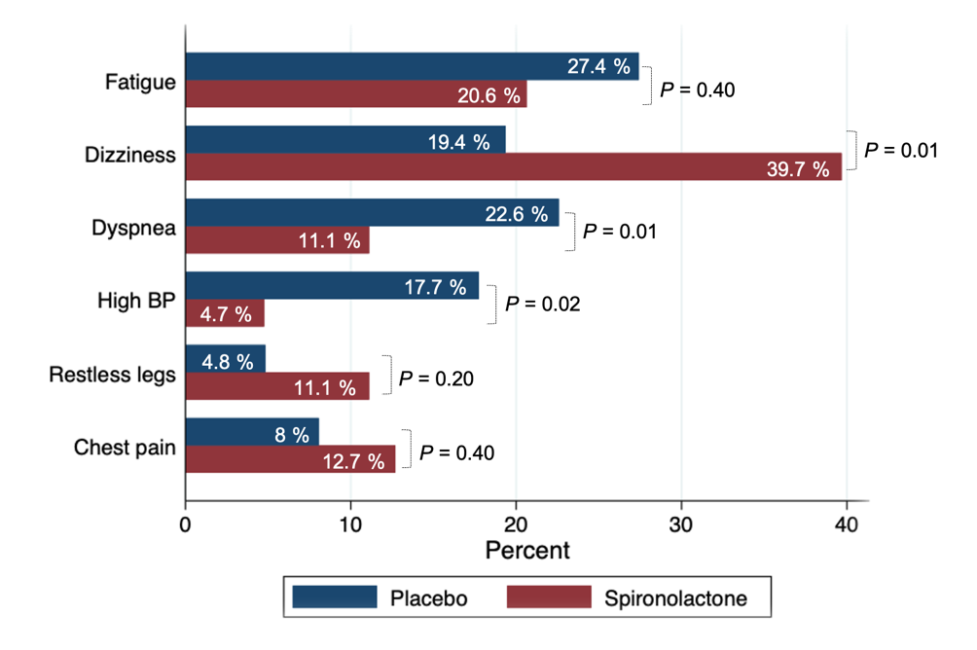

 | Spironolactone group  (n=63) |  |  |  |  | Placebo group  (n=62) |  |  |  |  | P-value  for treatment effect
 | Baseline | 6 Months | 12 Months | P, △6 Months | P, △12 Months | Baseline | 6 Months | 12 Months | P, △6 Months | P, △12 Months | P-value  for treatment effect
Clinical parameters
Systolic blood pressure (mmHg) | 136.6±17.1 | 124.5±12.2 | 128.4±17.5 | <0.01 | <0.01 | 138.3±17.4 | 135.4±15.2 | 135.1±15.1 | 0.08 | 0.30 | 0.02
Diastolic blood pressure (mmHg) | 83.7±10.5 | 78.3±3.9 | 77.5±9.3 | <0.01 | <0.01 | 81.5±9.3 | 82.5±9.7 | 79.6±10.7 | 0.50 | 0.20 | <0.01
Heart rate (beats per minute) | 57.8±9.4 | 60.2±10.3 | 59.5±9.3 | 0.04 | 0.08 | 58.8±10 | 61.5±11 | 61.1±10.7 | 0.03 | 0.30 | 0.90
Body mass index (kg/m²) | 27.9±4.7 | 28.1±4.7 | 28.1±4.7 | 0.05 | 0.10 | 28.6±4.2 | 28.6±4.4 | 28.9±4.3 | 0.07 | 0.40 | 0.30
Laboratory parameters
Haemoglobin (mmol/L) | 8.9±0.8 | 8.8±0.8 | 8.8±0.9 | 0.50 | 0.30 | 8.8±0.7 | 8.8±0.7 | 8.8±0.7 | 0.70 | 0.80 | 0.80
White blood cells (x 10⁹/L) | 7.3±1.7 | 7.1±1.7 | 6.5±1.6 | 0.04 | <0.01 | 7.4±2.2 | 7.1±2.1 | 7.4±2.4 | 0.30 | 0.70 | 0.03
Creatinine (μmol/L) | 74.9±12.6 | 80.6±15.5 | 81.5±13.9 | <0.01 | <0.01 | 73.1±13 | 74.9±13.4 | 76.4±17.1 | 0.08 | 0.04 | 0.03
BUN (mg/dL) | 25.8±11.3 | 30.9±13.5 | 29.4±14.1 | <0.01 | 0.40 | 26±12.2 | 26.1±12.2 | 27.3±12.3 | 0.90 | 0.50 | 0.10
eGFR (mL/min/1.73 m²) | 84.8±15.9 | 79.6±16.3 | 78.1±15.1 | 0.03 | 0.50 | 87.3±16.7 | 83.1±14.3 | 82.1±15.4 | 0.30 | 0.40 | 0.30
Potassium (mmol/L) | 4.2±0.3 | 4.2±0.3 | 4.1±0.3 | <0.01 | 0.10 | 3.9±0.3 | 4.2±0.3 | 4.1±0.5 | 0.20 | 0.30 | 0.01
Sodium (mmol/L) | 140.6±2.6 | 140.2±1.7 | 139.8±2.7 | 0.20 | 0.20 | 140.8±1.9 | 140.1±2.2 | 138.5±17.6 | 0.70 | 0.10 | 0.70
Magnesium (mmol/L) | 0.9±0.1 | 0.9±0.1 | 0.8±0.1 | 0.20 | <0.01 | 0.9±0.6 | 0.8±0.1 | 0.8±0.1 | <0.01 | <0.01 | 0.10
hsCRP (mg/L) | 4.5±6.9 | 3.3±3.1 | - | 0.10 | - | 5.2±6.0 | 7.1±13.9 | - | 0.90 | - | 0.30
Table 6. Comparison of clinical and laboratory parameters at baseline and follow-up at 6 and 12 months, respectively, for the entire population

Data are presented as mean ± standard deviation. The P value for treatment effect indicates the significance of interaction between treatment and time (baseline to 12 months). Abbrevations: eGFR, estimated glomerular filtration rate; BUN, blood urea nitrogen; hsCRP, high-sensitivity C-reactive protein; Pro-C6, collagen type VI formation; C4M, matrix-metalloproteinase mediated degradation of collagen type IV. Data were compared using mixed-effects linear regression models, where between subject effect is treatment and the within-subject factor is time. All models were adjusted for type AF, i.e. paroxysmal or persistent AF, age, body mass index, and change in blood pressure. In addition, mixed-effects model for serum potassium was adjusted for changes in serum creatinine.

Figure 5. Mean systolic blood pressure with 95% confidence interval at baseline and follow-up at 6 and 12 months.
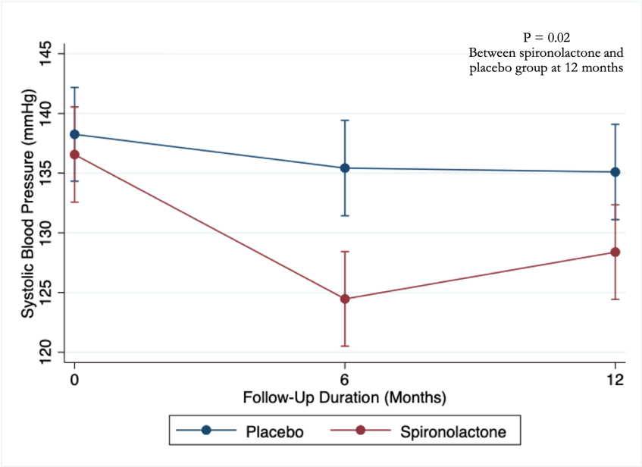

Figure 6. Mean diastolic blood pressure with 95% confidence interval at baseline and follow-up at 6 and 12 months.
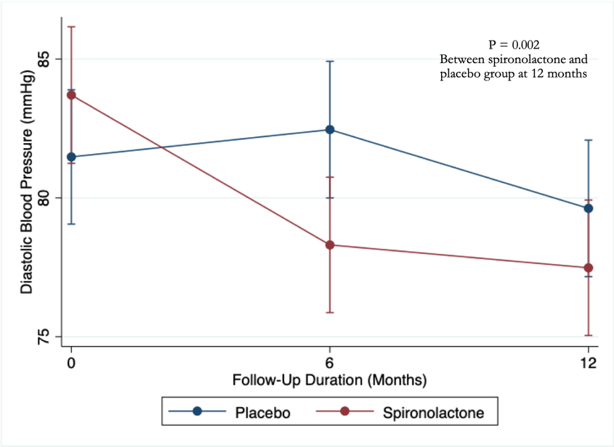

Figure 7. Mean serum potassium with 95% confidence interval at baseline and follow-up at 6 and 12 months.
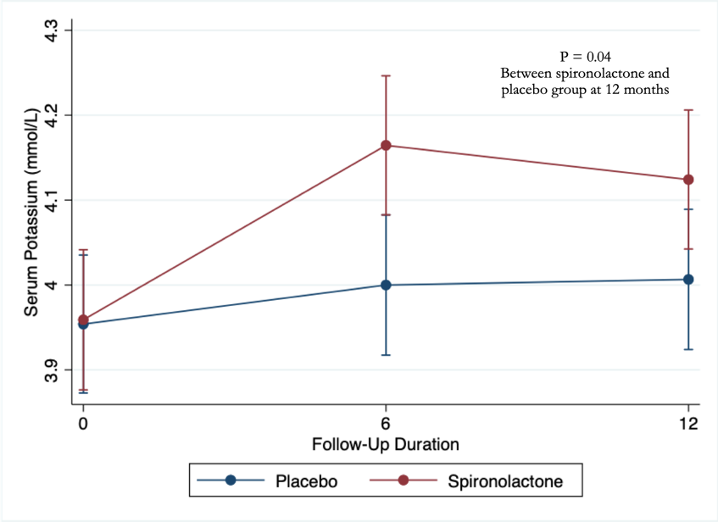

Figure 8. Mean serum creatinine with 95% confidence interval at baseline and follow-up at 6 and 12 months.
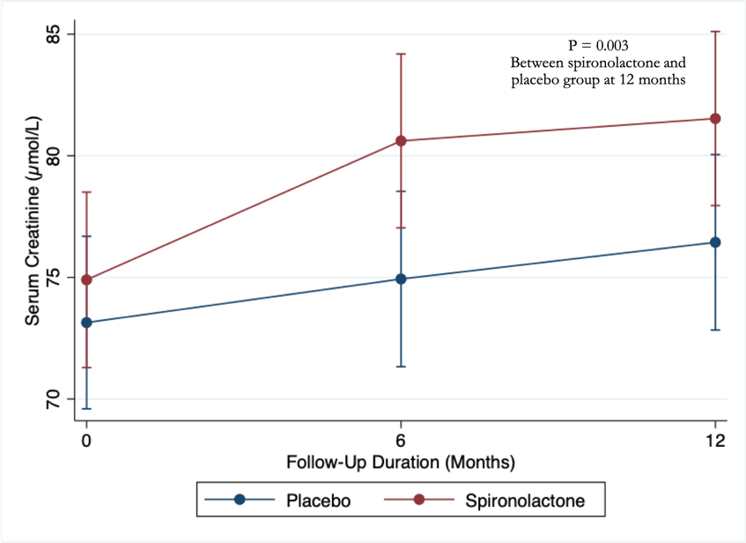

Table 7. Comparison of structure, function, fibrosis burden, and geometry of LA at baseline and end-of-study, assessed by CMR.

 | Placebo (n=52) |  |  |  | Spironolactone (n=48) |  |  |  |  |  |  |  |  | Mean difference  [95% CI] |  | P-value for treatment effect
 | Baseline | Change  [95% CI] | P-value |  |  | Baseline |  | Change  [95% CI] |  |  | P-value
LA reservoir function
LAmax (mL) | 98.8±37.4 | 5.3 [1.6; 12.5] |  | 0.10* |  | 101.8±36.2 |  |  | -3.8 [-9.21; 1.9] |  |  | 0.20* |  | 9.5 [0.4; 19.4] |  |  | 0.04*
LAVImax (mL/m²) | 47.7±16.2 | 4.7 [-1.9; 11.9] |  | 0.10* |  | 49.3±17.6 |  |  | -3.8 [-9.2; 1.8] |  |  | 0.20* |  | 8.9 [-0.11; 18.9] |  |  | 0.05*
LAmin (mL) | 57.3±34.6 | 5.5 [-2.7; 14.4] |  | 0.20* |  | 57.0±30.3 |  |  | -4.7 [-11.3; 2.3] |  |  | 0.20* |  | 10.6 [-1.8; 8.7] |  |  | 0.06*
LAVImin (mL/m²) | 27.4±15.6 | 4.9 [-3.3; 13.8] |  | 0.20* |  | 27.6±14.8 |  |  | -4.7 [-11.3; 2.3] |  |  | 0.20* |  | 10.1 [-1.1; 22.5] |  |  | 0.08*
LA reservoir volume (mL) | 41.5±14.2 | 2.5 [-1.8; 6.8] |  | 0.30 |  | 44.8±12.6 |  |  | -1.2 [-5; 2.6] |  |  | 0.50 |  | 3.7 [--2; 9.4] |  |  | 0.20
LA reservoir volume index (mL/m²) | 20.7±5 | 0.9 [-1.2; 3] |  | 0.4 |  | 21.7±6 |  |  | -0.7 [-2.6; 1.1] |  |  | 0.40 |  | 1.6 [-1.1, 4.4] |  |  | 0.30
LA TEF (%) | 46.5±18.3 | -0.2 [-2.8; 2.3] |  | 0.80 |  | 47.7±16.9 |  |  | 0.3 [-2; 2.5] |  |  | 0.70 |  | -0.5 [-3.9; 2.9] |  |  | 0.70
PALS (%) | 28.4±10.5 | -13.9 [-22.9; -3.7] |  | 0.008* |  | 25.4±14.5 |  |  | -1.9 [-15.3;11.2] |  |  | 0.80* |  | 13.8 [-3.6;34.4] |  |  | 0.20*
SR-s (s⁻¹), median (IQR) | 1.6 (2.3-1.3) | -15.4 [-26.1; -3.1] |  | 0.02* |  | 1.4 (2.1-1.0) |  |  | -2.4 [-16.1;13.6] |  |  | 0.80* |  | 15.4 [-5.6; 31.2] |  |  | 0.20*
LA conduit function
LAprec volume (mL) | 82.4±41.1 | 6.7 [-0.9; 14.8] |  | 0.09 |  | 84.4±36.1 |  |  | -4.6[-10.6; 1.8] |  |  | 0.20 |  | 11.7 [1.4; 23.2] |  |  | 0.02
LAprec volume index (mL/m²) | 39.6±18.5 | 5.9 [-1.6; 14] |  | 0.10 |  | 40.9±17.5 |  |  | -4.6 [-10.6; 1.8] |  |  | 0.20 |  | 11 [0.8; 22.3] |  |  | 0.03
LA passive volume (mL) | 17.4±22 | -2.8 [-15.6; 11.8] |  | 0.60* |  | 17.9±5.9 |  |  | -9.2 [-19.6; 2.6] |  |  | 0.10* |  | 7 [-11; 28.5] |  |  | 0.50*
LA passive volume index (mL/m²) | 9.4±7.8 | -3.5 [-16.2; 11.1] |  | 0.60* |  | 8.5±2.8 |  |  | -9.2 [-19.6; 2.5] |  |  | 0.10* |  | 6.4 [-11.6; 27.7] |  |  | 0.50*
LA PEF (%) | 17.7±18.3 | -7.8 [-18.3; 4.1] |  | 0.20* |  | 19.1±8.2 |  |  | -5.6 [-15; 4.7] |  |  | 0.30* |  | -2.3 [-16.6; 14.5] |  |  | 0.80*
LA SR-e (s⁻¹), median (IQR) | -1.8  (-1.1 to -2.3) | -0.3 [0.04; 0.5] |  | 0.04 |  | -1.4  (-1.1 to -2.0) |  |  | 0.2 [-0.1; 0.4] |  |  | 0.30 |  | -0.1 [-0.5; 0.3] |  |  | 0.50
LA active function
LA active volume (mL) | 27.4±9.1 | -1.1 [-4.5; 2.2] |  | 0.50 |  | 24.1±19.1 |  |  | 2.6 [-1.2; 6.4] |  |  | 0.20 |  | 3.7 [-1.3; 8.8] |  |  | 0.15
LA active volume index (mL/m²) | 13.3±4.2 | -0.7 [-2.4; 1.04] |  | 0.40 |  | 13.1±3.9 |  |  | 1.22 [-0.7; 3.2] |  |  | 0.20 |  | 2 [-0.7; 4.9] |  |  | 0.15
LA AEF (%) | 36.3±18.8 | -0.4 [-3.3; 2.6] |  | 0.80 |  | 40.2±33.8 |  |  | 1.2 [-2.1; 4.5] |  |  | 0.50 |  | 1.6 [-2.8; 6] |  |  | 0.50
PACS (%) | 15.9±4.6 | -12.7 [-27.3; 4.9] |  | 0.10 |  | 15.9±8.1 |  |  | 3.1 [-15.9; 26.5] |  |  | 0.80 |  | 18.1 [-10; 35.9] |  |  | 0.20
SR-l, median (IQR) | -2.3  (-1.8 to -3.1) | -13.9 [-26.0; 2.6] |  | 0.05* |  | -2.4  (-1.5 to -3.1) |  |  | -1.3 [-16.6; 16.8] |  |  | 0.80* |  | 14.6 [-8.5; 23.2] |  |  | 0.20*
LA fibrosis burden
LA Post-contrast myocardial T1 time (ms) | 500.2±90.5 | 0.7 [-4.4; 5.9] |  | 0.80* |  | 480.1±68.1 |  |  | 6.1 [0.2; 12.2] |  |  | 0.04* |  | 5.4 [-2.2; 13.5] |  |  | 0.20*
LA ECV (%) | 35.6±8.3 | -1.3 [-4.2; 1.6] |  | 0.40* |  | 36.1±8.4 |  |  | -2.2 [-5.4; 1.0] |  |  | 0.20* |  | -0.9 [-5.1; 3.3] |  |  | 0.70*
LA geometry
LA maximum length (mm) | 59.3±8.9 | -0.9 [-3.9; 2.2] |  | 0.60 |  | 61.0±6.3 |  |  | -2.4 [-5.1; 0.3] |  |  | 0.08 |  | 1.6 [-2.4; 5.6] |  |  | 0.40
LA sphericity index (%),  median (IQR) | 0.40 (0.49-0.34) | 16.6 [2.5; 3.3] |  | 0.02* |  | 0.41 (0.51-0.35) |  |  | -0.01 [-0.12; 11.0] |  |  | 0.80* |  | 17.9 [-0.006; 39.7] |  |  | 0.06*
Continuous variables are given as mean ± standard deviation (approximately normally distributed variables, i.e. LAmax, left atrial maximum volume; LAVImax, left atrial maximum volume indexed to body surface area; LAmin, left atrial minimum volume; LAVImin, left atrial minimum volume indexed to body surface area; LAprec, left atrial pre-contraction volume in mid-diastole; LAprecI, left atrial pre-contraction volume indexed to body surface area; LA TEF, left atrial total emptying fraction; LA PEF, left atrial passive emptying fraction; LA AEF, left atrial active emptying fraction; reservoir, passive, and active volume; PALS, peak atrial longitudinal strain; PACS, peak atrial contraction longitudinal strain) or median (IQR) (non-normally distributed variables, i.e. variables SR-s, systolic atrial strain rate; SR-e, early diastolic atrial strain rate; SR-l, late diastolic atrial strain rate; sphericity index).
Data were compared using mixed-effects linear regression models, where between subject effect is treatment and the within-subject factor is time. All models were adjusted for age, body mass index, and change in blood pressure. In addition, mixed-effects models for myocardial T1 times were adjusted for changes in serum creatinine (μmol/L), gadolinium contrast agent (GDA) amount (mL), time for nulling the myocardium TI time (ms), and changes in hematocrit level (%). The P value for treatment effect indicates the significance of interaction between treatment and time (baseline to 12 months).
*Natural log transformation of the variable

Table 8. Comparison of baseline and end-of-study structure, function, fibrosis burden of LV, assessed by CMR
 | Placebo (n=52) |  |  | Spironolactone (n=48) |  |  |  | Mean difference  [95% CI] |  |  | P-value  for treatment effect
 | Baseline | Change  [95% CI] | P-value | Baseline | Change  [95% CI] |  | P-value
LV Structure
LVEDV (mL) | 151.1±29.1 | -0.6 [-6.4; 5.3] | 0.80 | 151.5±27.6 | -2.9 [-9.4; 3.6] |  | 0.40 | -2.3 [-11.0; 6.3] |  | 0.60
LVEDVI (mL/m²) | 73.1±11.9 | -0.5 [-3.4; 2.4] | 0.70 | 73.8 ± 12.2 | -1.9 [-5.1; 1.3] |  | 0.20 | -1.4 [-5.7; 2.8] |  | 0.50
LVESV (mL) | 56.1±15.4 | 0.02 [-3.2; 3.2] | 0.90 | 56.9±12.4 | -0.3 [-3.8; 3.3] |  | 0.80 | -0.3 [-5.0; 4.4] |  | 0.90
LVESVI (mL/m²) | 27.1±6.6 | -0.1 [-1.6; 1.5] | 0.90 | 27.6±5.4 | -0.3 [-2.0; 1.4] |  | 0.70 | -0.2 [-2.5; 1.5] |  | 0.80
SV (mL) | 93.6±17.3 | -3.6 [-7.6; 0.5] | 0.08 | 92.2 ±19.8 | -0.04 [-4.5; 4.4] |  | 0.90 | 3.5 [-2.4; 9.4] |  | 0.20
SV index (mL/m²) | 45.2±7.3 | -1.7 [-3.6; 0.2] | 0.09 | 44.9±8.7 | -0.2 [-2.3; 1.9] |  | 0.80 | 1.5 [-1.3; 4.3] |  | 0.30
LVEF (%) | 62.1±2.8 | -0.2 [-1.5; 1.1] | 0.70 | 61.8±2.7 | 0.2 [-1.3; 1.7] |  | 0.80 | 0.4 [-1.5; 2.4] |  | 0.60
LVM (g) | 154.5±29.8 | -1.7 [-7.2; 3.8] | 0.50 | 154.3±36.4 | -4.9 [-11.1; 1.4] |  | 0.10 | -3.2 [-11.3; 5.0] |  | 0.40
LVMI (g/m²) | 74.4±10.6 | -1.0 [-3.6; 1.7] | 0.50 | 74.7±14.9 | -2.6 [-5.5; 0.4] |  | 0.09 | -1.6 [-5.5; 2.3] |  | 0.40
LV myocardial T1 times and ECV
Native T1 Time (ms) | 964.8±29.3 | -6.5 [-15.1; 2.1] | 0.10 | 962.1±31.1 | 4.6 [-6.1; 15.3] |  | 0.40 | 11.1 [-2.1; 24.3] |  | 0.10
Post-contrast T1 time (ms) | 511.6±52.5 | -7.5 [-19.2; 4.1] | 0.20 | 498.1±32.4 | 10.3 [-3.2; 23.9] |  | 0.10 | 17.9 [0.5; 35.2] |  | 0.07
ECV (%) | 27.2±2.9 | 0.2 [-0.5; 0.8] | 0.60 | 27.9±2.8 | -0.4 [-1.3; 0.4] |  | 0.30 | -0.6 [-1.7; 0.5] |  | 0.30
Peak strain values
Radial (%) | 30.9±13.1 | 1.3 [-2.5; 5.1] | 0.50 | 30.8±14.8 | 3.6 [-0.7; 7.8] |  | 0.10 | 2.3 [-3.3; 7.8] |  | 0.40
Circumferential (%) | -20.8±4.5 | 1.8 [0.5; 3.1] | 0.006 | -20.3±3.3 | 0.7 [-0.7; 2.1] |  | 0.30 | -1.1 [-2.9; 0.8] |  | 0.20
Longitudinal (%) | -20.4±2.6 | -0.3 [-1.2; 0.6] | 0.50 | -19.7±6.5 | 0.05 [-0.9; 1.03] |  | 0.80 | 0.3 [-0.9; 1.6] |  | 0.60

Continuous variables are given as mean ± standard deviation (approximately normally distributed variables i.e., LVEDV, LVEDVI, SV index, LVEF, LVM, LVMI, T1 times, ECV, radial, circumferential, and longitudinal peak strain values) or median (IQR) (non-normally distributed variables i.e., ECV). LVEDV indicates left ventricular end-diastolic volume; LVEDVI, LVEDV index to body surface area; SV, stroke volume, SV index, stroke volume index to body surface area; LVM, left ventricular mass; LVMI, LVM index to body surface area; SR, strain rate.
Data are compared using mixed-effects linear regression models, where between subject effect is treatment and the within-subject factor is time. All models were adjusted for age, sex, type AF i.e., paroxysmal or persistent AF, body mass index, change in blood pressure. In addition, mixed-effects models for myocardial T1 times were adjusted for change in serum creatinine (μmol/L), gadolinium contrast agent (GDA) amount (mL), time for nulling the myocardium TI time (ms), changes in hematocrit level (%), LVMI (g/m²), and heart rate (beats per minute). The P value for treatment effect indicates the significance of interaction between treatment and time (baseline to 12 months).

Table 9. Comparison of structure, function and geometry of LA at baseline and end-of-study, assessed by transthoracic echocardiography
 | Placebo (n=62) |  |  |  |  | Spironolactone (n=63) |  |  | Mean difference  [95% CI] |  |  | P-value for treatment effect
 | Baseline | Change  [95% CI] | P-value | Baseline | Change  [95% CI] |  |  | P-value
LA Reservoir function
LA max volume (mL) | 71.7±20.5 | -3.9 [-14.8; 8.2] | 0.50 | 73.8±25.9 | -7 [17.7; 8.1] |  |  | 0.20 | -0.03 [-18.3; 14.7] |  |  |  | 0.70
LAVImax (mL/m²) | 34.9±9.8 | -0.04 [-14.9; 8.1] | 0.50 | 35.6±11.4 | -6.9 [-17.7; 5.3] |  |  | 0.30 | -2.9 [-18.1; 15] |  |  |  | 0.70
LA minimum volume (mL) | 35.1±13.9 | -3.6 [-16.5; 11.4] | 0.60 | 37.9±17.1 | -13.3 [-25.2; 0.5] |  |  | 0.059 | -10.1 [-26.7; 10.3] |  |  |  | 0.30
LAVImin (mL/m²) | 17.1±6.8 | -3.2 [-16.7; 11.2] | 0.60 | 18.3±7.6 | -13.9 [-25.9; 9.2] |  |  | 0.049 | -10.6 [-27.2; 9.8] |  |  |  | 0.30
LA reservoir volume (mL) | 36.6±10.8 | -4.9 [-16.6; 8.3] | 0.50 | 35.9±12.1 | -2.6 [-14.7; 11.3] |  |  | 0.70 | 2.4 [-14.9; 23.2] |  |  |  | 0.80
LA reservoir index (mL/m²) | 17.7±4.8 | -5.1 [-16.6; 8] | 0.40 | 17.4±5.4 | -2.8 [-14.8; 11.1] |  |  | 0.70 | 2.5 [-14.8; 23.2] |  |  |  | 0.80
LA TEF (%) | 51.8±9.2 | -0.4 [-3.7; 3] | 0.80 | 49.7±8.7 | 3.3[-0.9; 6.8] |  |  | 0.06 | 3.7 [-1.1; 8.5] |  |  |  | 0.10
PALS (%) | 31±9.5 | -3 [-6; -0.07] | 0.0049 | 29±9.2 | 1.8 [-1.2; 4.8] |  |  | 0.20 | 4.8 [0.6; 9] |  |  |  | 0.03
LA SR-s (1/s),  median (IQR) | 1.2 (1-1.6) | -7 [-15.9; 2.8] | 0.20* | 1.1 (1-1.4) | 10.2 [-0.5; 22.1] |  |  | 0.06* | 18.6 [2.9; 36.5] |  |  |  | 0.02*
LA Conduit function
LAprec volume (mL) | 51.6±16 | -0.8 [-12.8; 12.9] | 0.90 | 52.7±22.5 | 2.7 [-9.9; 17.1] |  |  | 0.70 | 3.5 [-13.7; 24.2] |  |  |  | 0.70
LAprecI volume (mL/m²) | 25.2±7.8 | -1.2 [-13.3; 12.6] | 0.90 | 25.5±10.3 | 2.9 [-10; 17.5] |  |  | 0.70 | 4.1[-13.5; 25.1] |  |  |  | 0.70
LA passive volume (mL) | 20.1±12.7 | -2.6 [-7; 1.8] | 0.30 | 20.9±11.7 | -4.9 [-9.3; -0.4] |  |  | 0.03 | -2.3 [-8.5; 3.9] |  |  |  | 0.50
LA passive index (mL/m²) | 9.7±5.8 | -1.1 [-3.2; 0.9] | 0.30 | 10.1±5.4 | -2.2 [-4.3; -0.1] |  |  | 0.04 | -1.1 [-4; 1.8] |  |  |  | 0.50
LA PEF (%) | 27.1±12.7 | -2.5 [-7.2; 2.1] | 0.30 | 29.2±13.6 | -6.9 [-11.6; -2.1] |  |  | 0.01 | -4.4 [-11; 2.2] |  |  |  | 0.10
LA SR-e (1/s),  median (IQR) | -1.1  (-1.4 to - 0.9) | -21.9 [-31.9; -10.7] | <0.0001* | -1.1  (-1.3 to -0.9) | -2.1 [-23.1; 12.4] |  |  | 0.80* | 25.4[3.6; 51.9] |  |  |  | 0.02*
LA Active function
LA active volume, (mL) | 16.5±9.4 | 0.7 [-3.5; 4.9] | 0.70 | 15.2±10.7 | 4.9 [0.7; 9.2] |  |  | 0.02 | 4.2 [-1.7; 10] |  |  |  | 0.10
LA active index (mL/m²) | 8.1±4.5 | 0.2 [-1.9; 2.3] | 0.80 | 7.4±5 | 2.5 [0.4; 4.6] |  |  | 0.02 | 2.3 [-0.6; 5.2] |  |  |  | 0.10
LA AEF (%) | 32.5±14.4 | 4.1 [-0.6; 8.6] | 0.09 | 27.6±14.2 | 11.5 [6.7; 16.3] |  |  | <0.001 | 7.5 [1; 14.1] |  |  |  | 0.024
PACS (%) | 15.9±5.9 | -0.6 [-2.4; 1.2] | 0.50 | 13.9±5.9 | 1.8 [-0.1; 3.6] |  |  | 0.06 | 2.4 [-0.2; 4.9] |  |  |  | 0.07
LA SR-l (1/s),  median (IQR) | -1.7  (-1.3 to -1.7) | -0.12 [-0.31; 0.08] | 0.20* | -1.7  (-1.2 to -2.2) | 0.12 [0.08; 0.32] |  |  | 0.20* | 0.24 [-0.03; 0.5] |  |  |  | 0.09*
LA Geometry
LA maximum length (mm) | 60.1±7.1 | 0.2 [-0.08; 0.4] | 0.20 | 60.2±7.9 | 0.1[-0.11; 0.4] |  |  | 0.30 | -0.02 [-0.4; 0.3] |  |  |  | 0.90
LA shericity index (%),  median (IQR) | 0.37  (0.23-0.55) | 0.2 [-0.5; 0.8] | 0.10* | 0.31  (0.23-0.45) | 0.4 [0.1; 1.2] |  |  | 0.003* | 0.2 [-6.1; -0.07] |  |  |  | 0.30*

Continuous variables are given as mean ± standard deviation (approximately normally distributed variables, i.e. LAmax, left atrial maximum volume; LAVI max, left atrial maximum volume indexed to body surface area; LAmin, left atrial minimum volume; LAVImin, left atrial minimum volume ; LAprec, left atrial pre-contraction volume in mid-diastole; LAprecI, left atrial pre-contraction volume indexed to body surface area; LA TEF, left atrial total emptying fraction; LA PEF, left atrial passive emptying fraction; LA AEF, left atrial active emptying fraction; reservoir, passive, and active volume; PALS, peak atrial longitudinal strain; PACS, peak atrial contraction longitudinal strain) or median (IQR) (non-normally distributed variables, i.e. variables SR-s, systolic atrial strain rate; SR-e, early diastolic atrial strain rate; SR-l, late diastolic atrial strain rate; sphericity index).
Data are compared using mixed-effects linear regression models, where between subject effect is treatment and the within-subject factor is time. All models were adjusted for type AF, i.e. paroxysmal or persistent AF, age, body mass index, and change in blood pressure. The P value for treatment effect indicates the significance of interaction between treatment and time (baseline to 12 months).
*Natural log transformation of the variable

Table 10. Comparison of structure, function, fibrosis burden of LV at baseline and end-of-study, assessed by transthoracic echocardiography
 | Placebo (n=62) |  |  | Spironolactone (n=62) |  |  | Mean difference  [95%CI] |  | P-value for difference between treatment groups
 | Baseline | Change  [95% CI] | P-value | Baseline | Change  [95% CI] | P-value
LV Structure
LVEDV (mL) | 118.3±39.6 | -1.0 [-9.2; 7.3] | 0.80 | 117.9±34.1 | -0.6 [-9.1; 8] | 0.90 | 0.42 [-11.3;12.3] | 0.90
LVEDVI (mL/m²) | 56.916.1 | -2.5 [-6.5; 1.4] | 0.20 | 56.8±13.9 | -0.3 [-4.4; 3.8] | 0.90 | 2.3 [-3.4; 7.9] | 0.40
LVESV (mL) | 47.5±13.5 | -2.9 [-13.2; 8.7] | 0.60 | 48.3±16.5 | 11.2 [-0.9; 24.7] | 0.07 | 14.5 [-3.47; 34] | 0.09
LVESVI (mL/m²) | 22.9±5.3 | -3.2 [-13.6; 8.4] | 0.60* | 23.3±6.5 | 10.9 [-1.1; 24.4] | 0.08* | 14.6 [-2.3; 34.5] | 0.09*
LVSV (mL) | 70.3±23 | -3.5 [-12.2; 5.9] | 0.50 | 69.6±19.8 | 4.4 [-5.1; 14.9] | 0.40 | 8.3 [-5.2; 1.2] | 0.20
LVM (g) | 149.4±36.4 | -0.8 [-5.2; 6.1] | 0.70 | 149.4±32.7 | -0.4 [-5.5; 4.9] | 0.70 | -5.2 [-11.9; 2.1] | 0.20
LVMI (g/m²) | 72.3±14.9 | -0.9 [-4.2; 6.1] | 0.70 | 76.1±17.3 | -4.3 [-9.4; 1] | 0.10 | -5.2 [-11.9; 2.1] | 0.20
LV Function
LVEF (%) | 59.6±4.1 | -0.2 [-1.8; 1.4] | 0.80 | 59.6±3.8 | 0.6 [-0.9; 2.2] | 0.50 | 0.8 [-1.4; 2.9] | 0.50
GLS (%),  median (IQR) | -20.2  (-21.9 to – 16.9) | -2.1 [-3.1; -0.9] | <0.001 | -19.9  (-21.6 to -18) | -0.7 [-1.9; 0.4] | 0.20 | 1.3 [-0.3; 2.9] | 0.10
SrL peak E (s⁻¹),  median (IQR) | 1.37  (1.66-1.13) | -8.5 [-15.3; -1.1] | 0.03* | 1.42  (1.63-1.42) | -10.7 [-17.5; -3.4] | <0.01* | -2.5 [-12.56; 8.8] | 0.70*
SrL peak A (s⁻¹),  median (IQR) | 0.91  (1.12-0.78) | -0.04 [-0.12; 0.05] | 0.40 | 0.99  (1.22-0.79) | -0.15 [-0.2; -0.06] | <0.001 | -0.11 [-0.23; 0.009] | 0.07
SrL peak S (s⁻¹),  median (IQR) | -1.10  (-0.93 to -1.24) | -0.06 [-0.13; 0.02] | 0.20 | -1.11  (-0.99 to -1.25) | -0.08 [-0.2; 0.005] | 0.06 | -0.02 [-0.13; 0.08] | 0.60
Hemodynamics
E velocity (m/s) | 0.70±0.2 | -0.03 [-0.09; 0.03] | 0.30 | 0.68±0.2 | 0.02 [-0.04; 0.08] | 0.60 | 0.05 [-0.03; 1.3] | 0.30
A velocity (m/s) | 0.67±0.2 | -0.03 [-0.08; 0.02] | 0.30 | 0.64±0.2 | 0.04 [-0.02; 0.09] | 0.20 | 0.06 [-0.08; 0.1] | 0.08
E/A ratio,  median (IQR) | 0.99 (0.9–1.2) | -0.5 [-12.7; 10.1] | 0.90* | 1.0 (0.8-1.3) | -3.2 [-12.7; 7.2] | 0.50* | -2.7 [-15.6; 10.1] | 0.70*
Deceleration time (m/s) | 236.1±52.9 | -0.5 [-9.3; 9.1] | 0.90 | 236.7±71.7 | 6.6 [-2.9; 17.1] | 0.20 | 7.2 [-5.9; 22.1] | 0.10
Average e’ (cm/s) | 0.09±0.02 | -4.4 [-12.9; 5.1] | 0.30* | 0.09 ± 0.03 | -5.8 [-14.2; 3.5] | 0.20 | -1.4 [-13.5; 12.3] | 0.80
Average a’ (cm/s) | 0.08±0.02 | 0.003 [-0.005; 0.01] | 0.40 | 0.08 ± 0.03 | 0.02 [0.008; 0.02] | <0.0001 | 0.01 [0.001; 0.02] | 0.03
E/e’ ratio,  median (IQR) | 7.6 (6.2-8.7) | 1.8 [-8.4; 13] | 0.70* | 7.2 (6.3-9.4) | 6.6 [-4; 18.4] | 0.20* | 4.8 [-9.4; 21.1] | 0.50*
Data presented as mean ± standard deviation, median (IQR) or percent %, unless otherwise indicated. Data are compared using mixed-effects linear regression, where between subject effect is treatment and the within-subject factor is time. All measurements were adjusted for type AF, i.e. paroxysmal or persistent AF, age, body mass index, and change in blood pressure. LV indicates left ventricular; LVEDV, LV end-diastolic volume; LVEDVI, LVEDV index to body surface area calculated by DuBois DuBois formula; LVESVI, LV end-systolic volume index; LVMI, LV mass index; GLS, global longitudinal strain; SrL peak E, peak early diastolic longitudinal strain rate; SrL peak A, peak late diastolic longitudinal strain rate; SrL peak S, peak systolic longitudinal strain; A, late diastolic peak velocity of mitral flow; a’, peak late diastolic annular velocity; E, early diastolic peak velocity of the mitral flow; e’, peak early diastolic annular velocity. The P value for treatment effect indicates the significance of interaction between treatment and time (baseline to 12 months).
*Natural log transformation of the variable

Figure 12. Distribution of AF burden by treatment group.
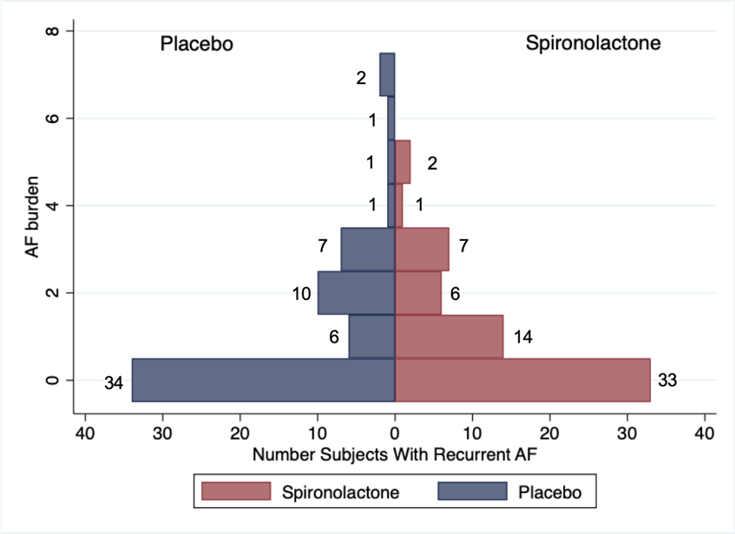
Mirror histogram showing the frequency distribution of total number AF recurrences per patient in the two comparison treatment groups (P=0.7). AF indicates atrial fibrillation. Number of recurrences per patient during follow up.

Table 11. Distribution of AF recurrences, recurrence free subjects, and rhythm control during follow up
 | Spironolactone  N = 63 | Placebo  N = 62 | P-value
Total number recurrence free subjects, n (%) | 33 (52.3%) | 34 (54.8%) | 0.50
Total number AF recurrences, n (%) | 67 (46.9%) | 76 (53.1%) | 0.70
Total number DC cardioversions, n (%) | 15 (51.7%) | 14 (48.3%) | 0.90
Total number patients developing permanent AF without possibility of cardioversion, n (%) | 3 (4.7%) | 4 (6.5%) | 0.70
Rhythm control with antiarrhythmic drugs (AAD)  Total number patients treated with AAD, n (%)  Time spent in treatment with AADs (days)  Total number RFA, n (%) | 8 (12.7%)  147  6 (9.5%) | 8 (12.9%)  158  7 (11.2%) | 0.90  0.60  0.70
Data presented as N (%) or in days. Groups were compared using Pearson’s chi-square test of association. DC indicates direct current cardioversion; AAD, antiarrhythmic drug; RFA, radiofrequency ablation.

Figure 13. Cumulative Incidence of Arrythmia Recurrence During Follow-Up: Panel A shows Total Number Atrial Fibrillation Recurrences; Panel B shows Total Number Atrial Fibrillation Recurrences After 90 Days Blanking Period; Panel C shows Total Number DC cardioversions, according to treatment assignment.

Table 12. Table of unadjusted median health-related quality of life from baseline to the end of study for the complete study population.
 | Placebo group  (n=62) |  | Spironolactone group  (n=63) |  | Mean difference between treatment groups,  [95% CI] | P-value for treatment effect
SF-12 physical component score
Baseline,  median (IQR) | 50.9  (45.7 to 56) |  | 50.2  (45.9 to 53.9)
12 Months,  median (IQR) | 52.8  (45 to 55.6) |  | 52.3  (45.2 to 55.9)
Median difference,  95% CI | 1.7  [1.6; 4.9] | P=0.30 | 2.27  [0.9; 5.5] | P=0.20 | 0.57  [-4; 5.2] | 0.80
SF-12 mental component score
Baseline,  median (IQR) | 56.5  (50.5 to 58.9) |  | 56.8  (50.1 to 60.2)
12 Months,  median (IQR) | 56.7  (49.8 to 61) |  | 57.1  (51 to 61.3)
Median difference,  95% CI | 0.49  [-3.3; -4.3] | P=0.80 | 0.52  [-3.2; -4.2] | P=0.80 | 0.03  [-5.27; -5,33] | 0.90
mAFSS Symptom Score
Baseline,  median (IQR) | 18.7  (13.9 to 27) |  | 19.4  (15 to 24.1)
12 Months,  median (IQR) | 19.1  (10.4 to 22.9) |  | 17  (10.9 to 22.8)
Median difference,  95% CI | 0.18  [-3.7; 4.1] | P=0.90 | -2.3  [-6.2; 1.5] | P=0.20 | -2.5  [-8; 3] | 0.40
mAFSS Burden Score
Baseline,  median (IQR) | 19.3  (13 to 21.8) |  | 19.5  (12.4 to 22.2)
12 Months,  median (IQR) | 18.7  (12.1 to 23) |  | 18.5  (11.5 to 22.2)
Median difference,  95% CI | -0.7  [-3.9; 2.7] | P=0.70 | -0.9  [-4.2; 2.4] | P=0.60 | -0.2  [-4.9; 4.4] | 0.90
mAFSS Total Score
Baseline,  median (IQR) | 40.4  (35.2 to 45.4) |  | 39.7  (35.4 to 43.5)
12 Months,  median (IQR) | 39.9  (29.5 to 43) |  | 38.1  (25 to 42.9)
Median difference,  95% CI | -0.5  [-8.3; 7.2] | P=0.90 | -1,5  [-9.2; 6.2] | P=0.70 | -1  [-11.9; 9.9] | 0.70
Values are median (IQR). The P value for treatment effect indicates the significance of interaction between treatment and time (baseline to 12 months).

Figure 15. Median Physical Component Score, assessed by SF-12 questionnaire at baseline and after 12 months of treatment for the complete study population
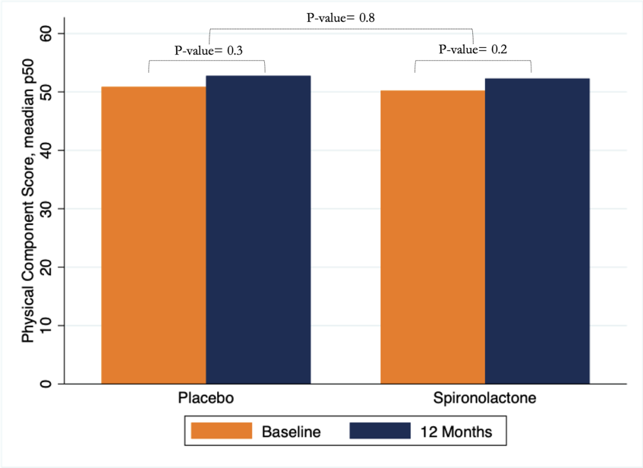

Figure 16. Median Mental Component Score, assessed by SF-12 questionnaire at baseline and after 12 months of treatment for the complete study population
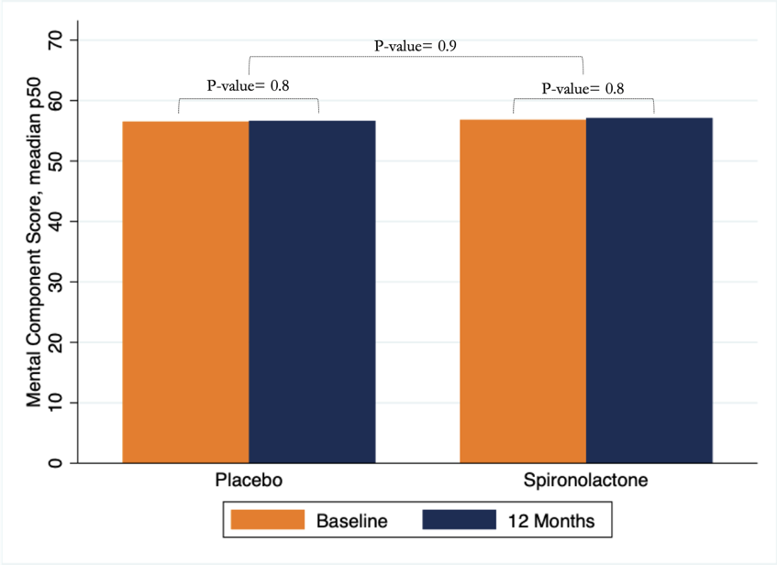

Figure 17. Median Total mAFSS Score at baseline and after 12 months of treatment for the complete study population


