Comparison of pain scores (primary outcome measure) at follow up

A. Absolute pain scores by treatment arm

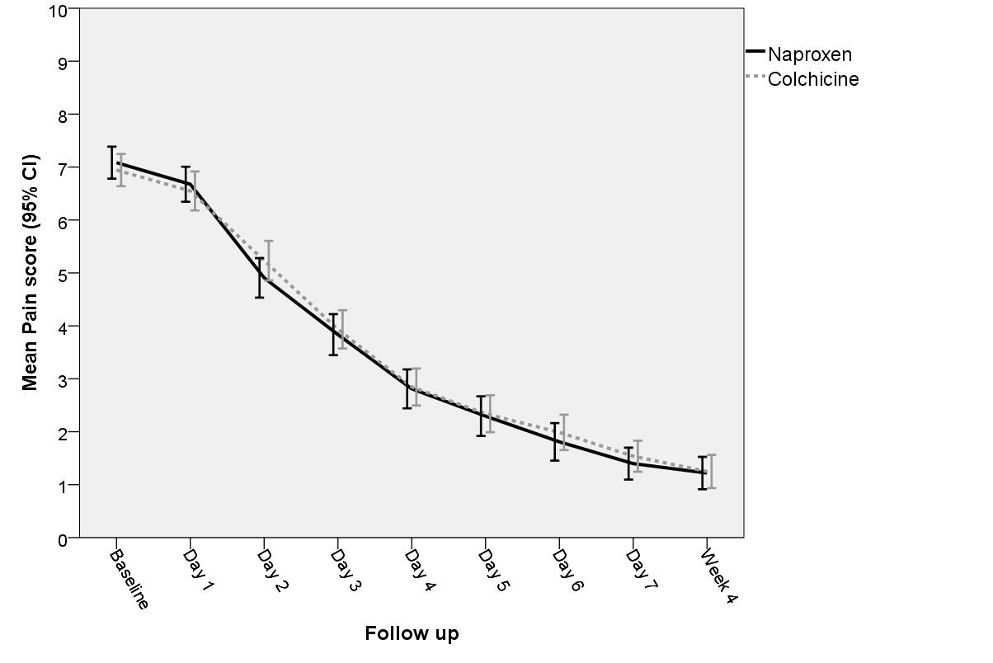

B. Change in pain scores by treatment arm

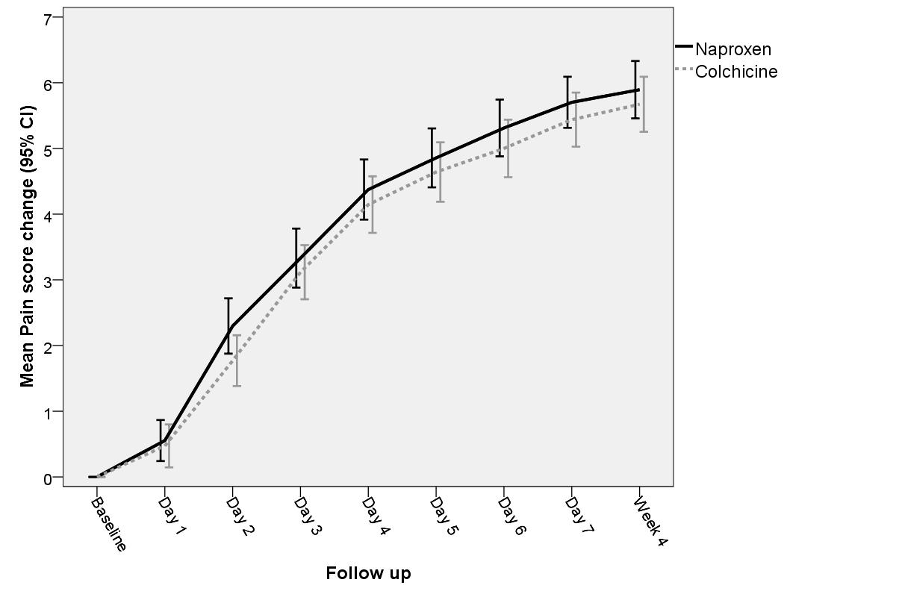

C. Between-group difference in pain-change scores (adjusted for age, gender and baseline pain score): colchicine – naproxen


