Comparison of pain scores (primary outcome measure) at follow up

A. Absolute pain scores by treatment arm

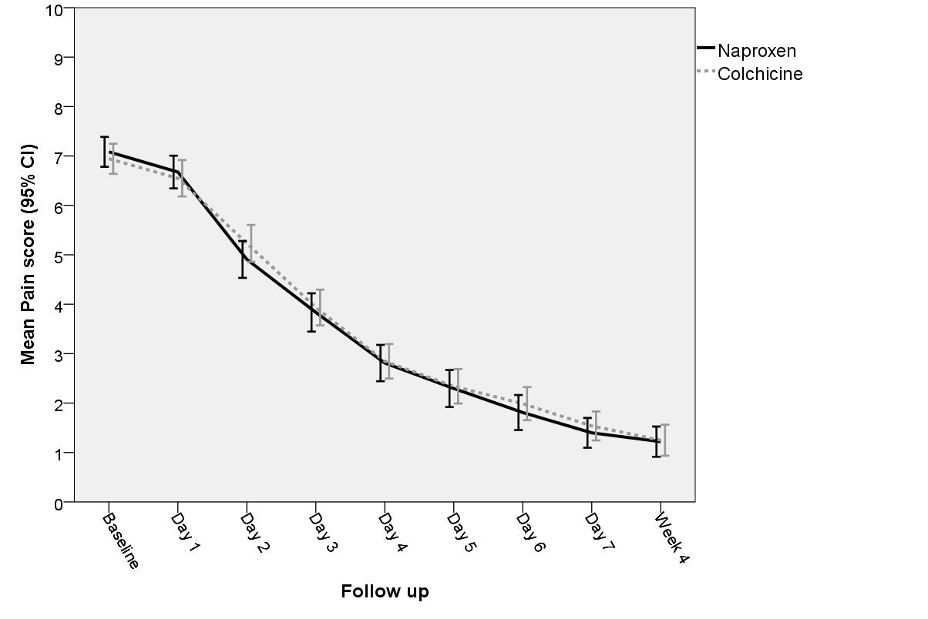

B. Change in pain scores by treatment arm



