Observed Recruitment Graph.

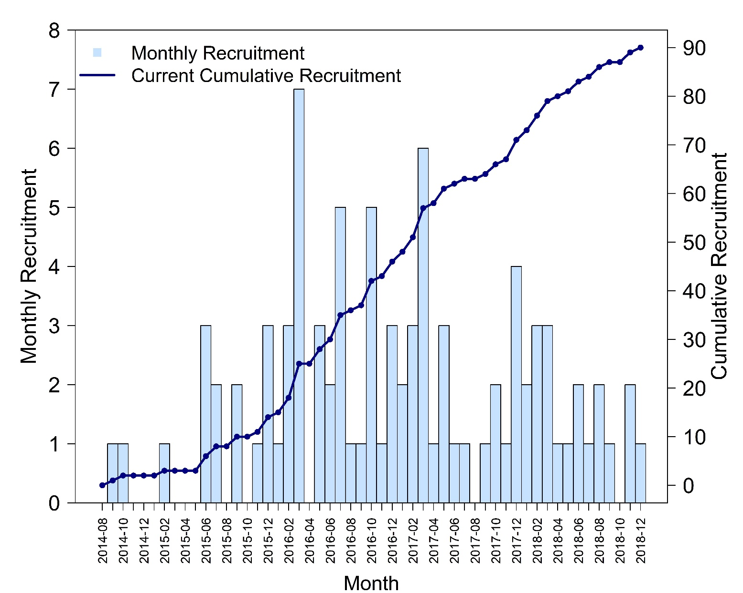

The recruitment graph does not include a planned recruitment forecast as it changed over the course of the study. Initially, the study was expected to recruit 100 patients in 24 months from 16 centres. However, this projection has been reviewed due to difficulties in site opening and randomisation of this patients’ population. Although the minimum number of patients required was 75 and this target was achieved in the first quarter of 2018, it was agreed to extend recruitment until the end of that year.

