Efficacy results
Secondary Efficacy Analysis:
- Results for BSS Score ( for efficacy second endpoint / per-protocol)

Table 01: Secondary endpoint – BSS difference day 0 and day 10 and confidence levels

Table 02: Mann-Whitney test for secondary endpoint (per protocol)

Conclusion:

The Mann-Whitney test shows a significance at level ~ .00002927237and therefore the 0- hypothesis can be rejected and it can be concluded the BSS score at day 10 for the verum is significantly lower than for the placebo.

- Results of Quality-of-Life assessment (for efficacy second endpoint)

Efficacy Results: Assessment of Quality of Life
Whereas at baseline, QoL score was comparable between the Tavipec and the Placebo group, at day 7 the mean QoL score in the Tavipec group was lower (Table 03). At baseline versus day 7, as rated on a score ranging from 0 to 10, the mean scores in the Tavipec and Placebo groups were 7.72 versus 3.22, and 7.6 versus 4.7, respectively, thus scores were significantly lower for the Tavipec group (p < 0.001).
Table 03: QoL-score at baseline and day 7
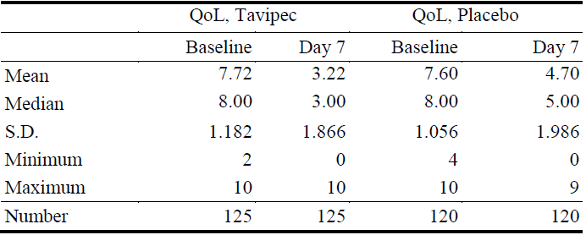
At baseline all patients from the Tavipec and baseline group (ITT), show a similarly impact by the disease: 63.2 % of Tavipec group and 62.5 % of the Placebo group were severe and 36.% and 37.5 %, respectively were moderate impacted by the disease (Table 04).

Table 04: Impact of disease on QoL at baseline, ITT
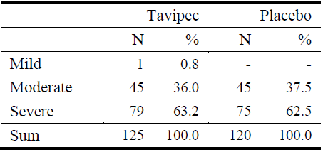
In the Tavipec group (ITT), 62.4 %. 34.4 % and 3.2 % of patients, respectively were mildly, moderately, and severely impacted (ITT), but 28.3 %. 65.8 % and 5.8 % of patients, respectively in the Placebo group (Table 05).

Table 05: Impact of disease on QoL at day 7, ITT
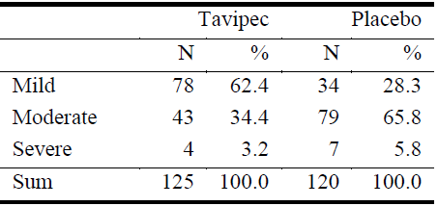

The impact of disease on QoL from patient’s view was done by evaluation of the change of QoL score from baseline to EOT. The mean QoL score dropped from 7.72 at baseline to 1.20 at EOT in the Tavipec group and from 7.60 at baseline to 3.14 at EOT in the Placebo group, corresponding to an improvement by 6.52 and 4.46 score points, respectively (Table 06).
Table 06: QoL-score at baseline and day 10, ITT
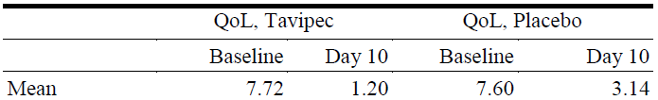
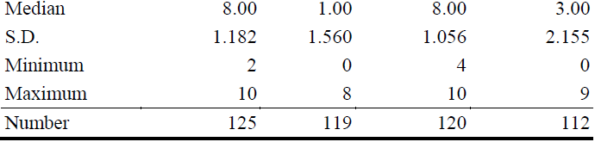

At the end of therapy (day 10), 94.1 % of evaluable Tavipec-treated patients in contrast to only 51.8 % of patients in the Placebo group reported to be mildly impacted. On the other hand, only 4.0 % of the Tavipec group reported a moderate impact, whereas 46.4 % of the Placebo group was moderately impacted by the disease at day 10 (Table 07).
Table 07: Impact of disease on QoL at day 10, ITT
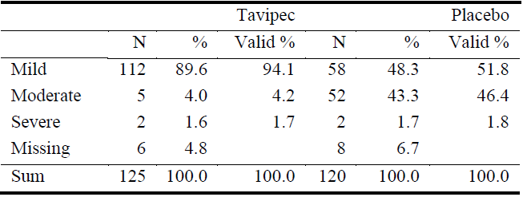

Table 08: Mean QoL score from baseline to EOT, change from baseline, ITT
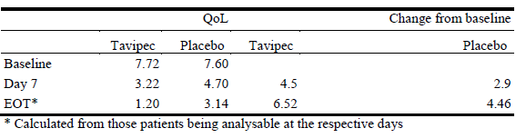

Table09: QoL score – mean change (improvement from baseline) at day 7 and day 10, ITT
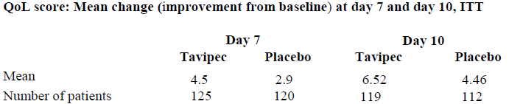

The proportion of patients reporting only a mild impact of disease on quality of life at baseline, day 7, and day 10 was 0.8 %. 62.4 %, and 94.1 %, respectively in the Tavipec group and 0 %, 28.3 % and 51.8 %, respectively in the Placebo group. This indicates a clear advantage of Tavipec over Placebo is seen (Table 10).
Table 10: Impact of disease on QoL from baseline to EOT, ITT, % mild, moderate, severe


