GRACE Clinical Study Report
Study title: | Continous treatment with bevacizumab in elderly patients with mCRC: an open label, single arm, prospective phase IV trial to evaluate outcome and safety of continuous bevacizumab treatment in combination with chemotherapy over disease progression
Name of investigational  Product: | Bevacizumab
Indication studied: | ≥ 70 year old patients with treatment naïve metastatic colorectal cancer
Name of the sponsor: | Department of Oncology, Linköping University Hospital, 581 85 Linköping, Sweden
Protocol identification: | ML29242
Phase of study: | Phase IV
Study initiation date: | 02NOV2015
Date of early study  termination: | 11DECEMBER2018
Study completion date  (last patient completed): | 11DECEMBER2018
Sponsor’s responsible  medical officer: | Gunnar Adell
Name of sponsor signatory: | Gunnar Adell
Sponsor contact person: | Pernilla Nilsson, Phone: +4610 103191, Mail: Pernilla.l.nilsson@regionostergotland.se
The study has been performed in compliance with Good Clinical Practices (GCP), including the archiving of essential documents
Date of the report: | 06DECEMBER2019

SYNOPSIS
Name of Sponsor: | Department of Oncology, Linköping University Hospital, Linköping, Sweden
Title of Study: | Continous treatment with bevacizumab in elderly patients with mCRC: an open label, single arm, prospective phase IV trial to evaluate outcome and safety of continuous bevacizumab treatment in combination with chemotherapy over disease progression
Investigators: | Gunnar Adell, Department of Oncology, Linköping, Sweden  Björn Kullinger, Department of Oncology, Karlstad, Sweden  Johan Haux, Department of Oncology, Skövde, Sweden
Study centres: | Department of Oncology, Linköping, Sweden  Department of Oncology, Karlstad, Sweden  Department of Oncology, Skövde, Sweden
Studied period (years): | Date of first enrolment: 02NOV2015  Date of last completed: 11DEC2018
Objectives: | To assess Overall survival (OS) from time of inclusion (primary)  To assess safety parameters (secondary)  To assess total treatment duration as time from start of treatment at inclusion until end of last treatment  To assess progression free survival as time from inclusion until first progression or death.  To assess patient reported outcomes including health related quality of life, as measured by EORTC QLQ-C29, across multiple lines of bevacizumab-containing regimens  To assess over all response rate (ORR)  To investigate correlation between biomarkers and outcome of continuous bevacizumab treatment by collection and analysis of tumour samples and serial blood samples (tertiary).
Methodology: | This is a prospective, open-label, multicenter, phase IV study
Number of patients: | 100 patients were planned to be enrolled, allowing a drop-out rate of 10%. Estimated accrual time of 36 months. The study was early terminated at 37 months after study initiation and after 48 patients had been included, of which 19% dropped- out. The 39 patients correctly included were assessed in the survival analysis, whereas safety was assessed in all 48 patients.
Diagnosis: | Metastatic colorectalcancer
Main criteria for inclusion: | Untreated metastatic colorectal carcinoma  Age ≥ 70 years  Measurable disease according to Response Evaluation Criteria in solid Tumors (RECIST) criteria  Eastern Cooperative Oncology Group (ECOG) performance status ≤2  Life expectancy more than 3 months but not considered optimal candidate for treatment with combination chemotherapy with oxaliplatin or irinotecan  Adequate haematological, renal and liver function as measured by:  haemoglobin >90 g/L  absolute neutrophil count ≥ 1,5 x 109/L  platelets ≥ 100 x 109/L  bilirubin ≤1.5 × ULN  ALAT≤ 2.5 × ULN (<5 × ULN if liver metastases)  creatinine ≤1.5 × ULN  PK ≤ 1.5  APTT <1.5 ULN  Urine dipstick of proteinuria <2+  Tumor tissue available for biomarker analysis  Signed written informed consent to the clinical study and translational research according to ICH/GCP and the local regulations will be obtained prior to any study specific screening procedures
Test product: | Bevacizumab, fixed dose of 2.5 mg/kg/week (either as 5 mg/kg/q2w or 7.5 mg/kg/q3w), IV
Non-investigational: | Capecitabine, 5-FU, leucovorin or Best Supportive care
Duration of treatment: | As long as the investigator perceive patient benefit from the treatment
Criteria for evaluation: | Overall survival was measured as the time from the date of enrolment to the date of death. Patients without death date were censored at the date the study was early terminated.  Safety outcomes included: ≥ Grade 3 AEs, SAEs, AEs leading to premature discontinuation of study treatment and laboratory parameters. Safety assessed from the start of 1st-line treatment was summarized overall and in the subgroup of patients who received / did not receive continuous treatment beyond first progression.
Statistical methods: | The main efficacy endpoint overall survival was estimated using the Kaplan-Meier method in the 39 subject who were correctly included. Due to early termination of the trial, secondary endpoints apart from safety were not analyzed. Safety, in terms of grade 3-4 adverse event, was assessed in all 48 patients, and will be described as type of adverse event, grades and number.
Summary – Conclusions:
Efficacy Results: | Median overall survival (95% CI) was 530 days (383 – 677) equal to 17.4 months (12.6 – 22.3).
Safety Results: | AEs ≥ grade 3, or AE criteria for SAE, were reported in 21 of 48 patients (44%). The most common AEs were infection or fever 6 (21%) followed by abdominal or back pain 5 (18%). Adverse events considered drug-related by the investigator were 12 (42%) of all events. In total, 1 (2 %) of all patients had AEs that lead to death.
Conclusion: | Due to the slow inclusion rate and the high drop-out this trial was prematurely terminated. No unexpected findings concerning overall survival or safety were evident, but the two events of bowel perforation reported confirms the necessity of close monitoring and awareness of warning symptoms in elderly mCRC patients treated with bevacizumab in addition to capecitabine.
Date of Report: | 06DECEMBER2019

SIGNATURES
PRINCIPAL OR COORDINATING
INVESTIGATOR SIGNATURE
OR SPONSOR´S RESPONSIBLE MEDICAL OFFICER

STUDY TITEL:
Continous treatment with with bevacizumab in elderly patients with mCRC: an open label, single arm, prospective phase IV trial to evaluate outcome and safety of continuous bevacizumab treatment in combination with chemotherapy over disease progression

STUDY AUTHOR (S): Gunnar Adell, Nils Elander and Pernilla Nilsson

I have read this report and confirm that to the best of my knowledge it accurately describes the conduct and results of the study
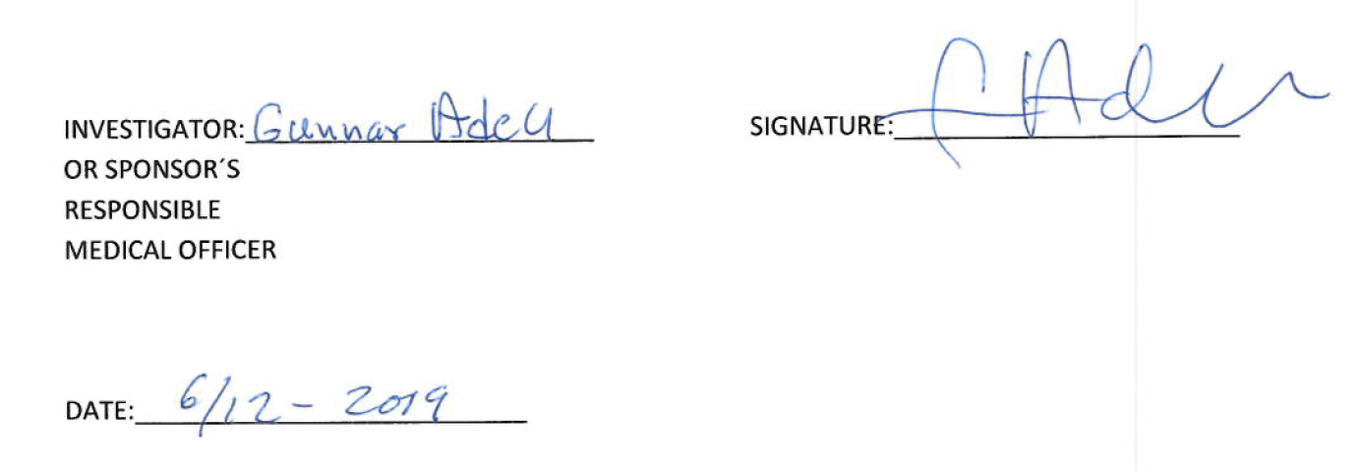
TABLE OF CONTENT FOR STUDY REPORT

1. SYNOPSIS 2
2. SIGNATURES 5
3. LIST OF ABBREVIATIONS AND DEFINITATION OF TERMS 9
4. ETHICS 10
4.1. Independent Ethics Committee (IEC) 10
4.2. Ethical Conduct of the Study 10
4.3. Patient Information and Consent 10
5. INVESTIGATORS AND STUDY ADMINISTRATIVE STRUCTURE 10
6. INTRODUCTION 11
7. STUDY OBJECTIVES 11
7.1. Primary objective 11
7.2. Secondary objectives 11
7.3. Exploratory objectives 12
8. INVESTIGATIONAL PLAN 12
8.1. Overall Study Design and Plan-Description 12
8.2. Discussion of Study Design, including the Choice of Control Groups 12
8.3. Selection of Study Population 12
8.3.1. Inclusion criteria 12
8.3.2. Exclusion criteria 13
8.3.3. Removal of patients from therapy or assessment 14
8.4. Treatments 14
8.4.1. Treatments administered 14
8.4.2. Identity of investigational product 14
8.4.3. Method of assigning patients to treatment group 14
8.4.4. Selection of doses in the study 14
8.4.5. Selection and timing of dose for each patient 15
8.4.6. Blinding 15
8.4.7. Prior and concomitant therapy 15
8.4.8. Treatment compliance 15
8.5. Efficacy and Safety Variables 15
8.5.1. Efficacy and safety measurement assessed and flow chart 15
8.5.2. Primary efficacy variable 15
8.5.3. Drug concentration measurements 15
8.6. Data Quality Assurance 15
8.7. Statistical Methods Planned in the Protocol and Determination of Sample Size 16
8.7.1. Statistical and analytical plans 16
8.7.2. Determination of sample size 16
8.8. Changes in the Conduct of the Study or Planned Analyses 16
9. STUDY PATIENTS 16
9.1. Disposition of Patients 16
9.2. Protocol Deviations 16
10. EFFICACY EVALUATION 16
10.1. Data Sets Analysed 16
10.2. Demographic and Other Baseline Characteristics 17
10.3. Efficacy Results and Tabulations of Individual Patient Data 17
10.3.1. Analysis of Efficacy 17
11. SAFETY EVALUATION 17
11.1. Extent of Exposure 17
11.2. Adverse Events (AE) 17
11.2.1. Brief summary of adverse events 17
11.2.2. Analysis of adverse events 18
11.3. Deaths, Other Serious Adverse Events and Other Significant Adverse Events 18
11.4. Clinical Laboratory Evaluation 18
11.4.1. Listing of individual laboratory measurement by patient and each abnormal laboratory value 18
11.5. Vital Signs, Physical Findings and Other Observation Related to Safety 18
11.6. Safety Conclusion 18
12. DISCUSSION AND OVERALL CONCLUSION 18
13. TABLES, FIGURES 19
14. REFERENCE LIST 19
15. APPENDICES 19
APPENDIX 1. List of applications and approval from IEC 20
APPENDIX 2. Written informed consent 21
APPENDIX 3. List and description of investigators 25
APPENDIX 4. Protocol 29
APPENDIX 5. List of protocol amendment 84
APPENDIX 6. Schedule of assessment 85
APPENDIX 7. Sample case report form 87
APPENDIX 8. Disposition of patients 91
APPENDIX 9. Adverse Event listning 92
APPENDIX 10. Protocol Deviations 93

LIST OF ABBREVIATIONS AND DEFINITATION OF TERMS

Abbreviation/Definition | Text
AE | Adverse event
ALAT | alanine aminotransferase
APTT | activated partial thromboplastin time
CHF | congestive heart failure
CRC | colorectal cancer
CRF | Case report form
CRO | Contract research organisation
ECG | Electro cardiogram
ECOG | Eastern Cooperative Oncology Group
ECRF | Electronic case report form
FU | Fluorouracil
GI | Gastro intestinal
ICH/GCP | International Conference on Harmonisation/Good Clinical Practice
IEC | Independent ethical committee
INR | International normalized ratio
LV | Leucovorin
LVFS | Läkemedelsverkets författningssamling
mCRC | Metastasised colorectal cancer
NCI CTCAE | National Cancer Institute Common Terminology Criteria for Adverse Event
ORR | Overall response rate
OS | Overall Survival
PFS | Progression free survival
PK | pyruvate kinase
PRO | Patient Reported Outcome
RECIST | Response Evaluation Criteria in solid Tumours
SAE | Serious Adverse Event
SAP | Statistical Analysis Plan
ULN | Upper limit of normal

ETHICS

Independent Ethics Committee (IEC)
The protocol, the informed consent forms and amendment for the protocol and informed consent form has been submitted by the investigator to an independent ethics committee (IEC). Approvals from the committee have been obtained before starting the study.
For a list of applications and approval from IEC see APPENDIX 1.

Ethical Conduct of the Study
The study has been performed in accordance with the ethical principles that have their origins in the Declaration of Helsinki.

Patient Information and Consent
Written informed consent was obtained from each patient participating in the study before any study specific screening procedure was performed. Informed consent was signed after adequate explanation of the aims, methods, anticipated benefits and potential hazards of the study.
Written informed consent is included in APPENDIX 2.

INVESTIGATORS AND STUDY ADMINISTRATIVE STRUCTURE
Principal Investigator: | Maria Albertsson*, Department of Oncology, Linköping University Hospital  Gunnar Adell, Department of Oncology, Linköping University Hospital
Sponsor: | Department of Oncology Linköping University Hospital, Linköping
Investigators: | Gunnar Adell, Department of Oncology, Linköping  Björn Kullinger, Department of Oncology, Karlstad  Johan Haux, Department of Oncology, Skövde, Sweden
Study centres: | Department of Oncology, Linköping, Sweden  Department of Oncology, Karlstad, Sweden  Department of Oncology, Skövde, Sweden
Study coordinator: | Maria Albertsson*, Department of Oncology, Linköping University Hospital  Gunnar Adell, Department of Oncology, Linköping University Hospital
Monitoring: | Rita Grönberg, RMG Konsultbyrå
Contract research organization: | LINK medical Research AB
*From the start of the study to 11dec2018, Maria Albertsson was Principal Investigator and study coordinator. When Albertsson terminated her employment at the department of oncology, Linköping University Hospital, Gunnar Adell took over the role as principal investigator and study coordinator for the study.
A complete list and description of investigators is included in APPENDIX 3.

INTRODUCTION
A majority of patients with metastasized CRC suffer from incurable disease, where a treatment that offers prolonged overall survival with sustained quality of life is warranted. Although approximately half of the mCRC patients are over the age of 70 at first diagnosis, the elderly population is often under-represented in clinical studies. However, recently a phase III trial in patients older than 70 years showed that the addition of bevacizumab to mono-chemotherapy is tolerable and has a beneficial effect on progression free survival and overall response rate (Cunningham 2013).
Bevacizumab is an angiogenesis inhibitor with a separate mechanism of action to chemotherapy implying that development of resistance to chemotherapy is not associated with development of resistance to anti-angiogenic treatment. In line with this, a phase III clinical trial investigating continuous treatment with bevacizumab has demonstrated an increased overall survival in patients where bevacizumab was continued after first tumor progression (Bennouna 2012).
This study aims to assess the feasibility of the new treatment modality of continuous bevacizumab treatment, approved by the European Health Authorities in 2013, in an elderly community based patient population.

STUDY OBJECTIVES

Primary objective
To assess Overall survival (OS) from time of inclusion.

Secondary objectives
To assess safety parameters in elderly patients receiving continuous bevacizumab treatment beyond progression.
To assess total treatment duration as time from start of treatment at inclusion until end of last treatment.
To assess treatment duration from first progression as time from progression until end of last treatment.
To assess progression free survival as time from inclusion until first progression or death.
To assess patient reported outcomes including health related quality of life, as measured by EORTC QLQ-C29, across multiple lines of bevacizumab-containing regimens
To assess over all response rate (ORR)

Exploratory objectives
To investigate correlation between biomarkers and outcome of continuous bevacizumab treatment by collection and analysis of tumour samples and serial blood samples.

INVESTIGATIONAL PLAN

Overall Study Design and Plan-Description
This is a prospective, open-label, multicenter, phase IV study in patients with previously untreated metastatic CRC over the age of 70 years. A total of 100 patients will be recruited. For the Protocol of the study see APPENDIX 4.
Patients included in the study will be treated with bevacizumab and capecitabine or 5-FU. Patients will remain on first line treatment until disease progression or unacceptable toxicity occurs. If toxicities due to capecitabine or 5-FU require their respective discontinuation patients will remain on bevacizumab treatment.
Assessments during the study are described in schedule of assessments, see APPENDIX 6. Tumour status will be assessed at regular time intervals according to clinical practice. After first progression is established according to RECIST 1.1 criteria, patients fit for second line treatment will remain on bevacizumab and the investigators choice of chemotherapy or best supportive care (BSC) as long as the investigator perceive a benefit with the treatment.
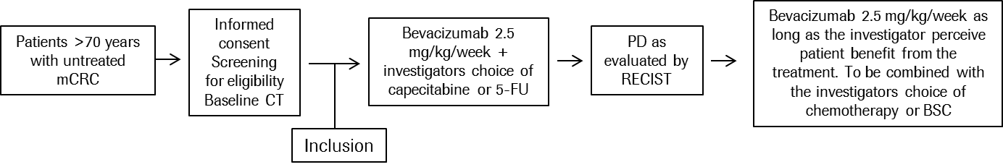
Figure 1 Study design
The list of protocol amendment is included in APPENDIX 5.
Samples of case report forms are included in APPENDIX 7.

Discussion of Study Design, including the Choice of Control Groups
This was an open label single-arm trial based on a previous phase III trial (Cunningham 2013) that provided a survival benefit of the combination of capecitabine and bevazizumab in elderly patients with metastatic colorectal cancer and not considered fit for combination chemotherapy. The present study aimed to assess the efficacy and safety of this treatment regimen in a real world set up, as well as to explore potential prognostic and treatment predictive biomarkers.

Selection of Study Population

Inclusion criteria
Patients with histological confirmed diagnosis of adenocarcinoma of the colon or rectum.
Age ≥ 70.
Measurable disease according to RECIST criteria.
ECOG/WHO performance status 0-2
Life expectancy more than 3 months but not considered optimal candidate for treatment with combination chemotherapy with oxaliplatin or irinotecan
Adequate haematological, renal and liver function;
haemoglobin >90 g/L (may be transfused to maintain or exceed this level)
absolute neutrophil count ≥ 1,5 x 10⁹/L
platelets ≥ 100 x 10⁹/L
bilirubin ≤1.5 × ULN, ALAT≤ 2.5 × ULN (<5 × ULN if liver metastases)
creatinine ≤1.5 × ULN
PK ≤ 1.5
APTT <1.5 ULN
Urine dipstick of proteinuria <2+ (patients discovered to have ≥2+ proteinuria on dipstick urinalysis at baseline, should undergo a 24-hour urine collection and must demonstrate ≤ 1 g of albumin/24 h)
Tumor tissue available for biomarker analysis.
Signed written informed consent to the clinical study and translational research according to ICH/GCP and the local regulations

Exclusion criteria
Previous treatment with chemotherapy within 6 months.
Surgical procedure or significant traumatic injury within 28 days prior to first study treatment, or anticipation of need for major surgical procedure during the course of the study.
Clinically significant (i.e. active) cardiovascular disease, for example cerebrovascular accidents ≤ 6 months prior to study enrolment, myocardial infarction ≤ 6 months prior to study enrolment, unstable angina, New York Heart Association Grade II or greater congestive heart failure (CHF), or serious cardiac arrhythmia uncontrolled by medication or potentially interfering with protocol treatment.
Other malignancy within 5 years except for carcinoma in situ of the cervix, basal or squamous cell skin cancer, localized prostate cancer or ductal carcinoma in situ treated with curative intent
Serious non-healing wound or ulcer.
Evidence of bleeding diathesis or coagulopathy.
International normalized ration (INR) > 1.5 and activated thromboplastin time (aPTT) <1.5 x ULN within 7 days prior to study enrolment for patients not receiving anti-coagulation. The use of full oral or parenteral anticoagulants is permitted as long as the INR or aPTT is within therapeutic limits according to the medical standard of the enrolling institution and the patient has been on a stable dose of anticoagulants for at least two weeks prior to the first study treatment
Uncontrolled hypertension despite pharmacological antihypertensive treatment.
Prior history of gastrointestinal perforation or abscess
Significant vascular disease (e.g. aortic aneurysm requiring surgical repair or arterial thrombosis within 6 months of start of study treatment). Any previous venous thromboembolism > NCI CTCAE Grade 3.
Ongoing treatment with aspirin (>325 mg/day) or other medications known to predispose to gastrointestinal ulceration.
Known hypersensitivity to any contents of any of the study drugs.
Any other serious or uncontrolled illness or treatment with a medicinal product that in the opinion of the investigator makes it undesirable for the patient to enter the trial.

Removal of patients from therapy or assessment
Patients have the right to withdraw from the study treatment at any time for any reason. The investigator also has the right to withdraw patients from the study treatment in the event of intercurrent illness, adverse events or patient non-compliance with study procedures. If possible, a complete final evaluation should be made at the time of the patient’s withdrawal. In the case of a patient failing to attend the clinic, the investigator or a member of the team must make efforts to determine the reason for the non-attendance.

Treatments

Treatments administered
Bevacizumab was administered at a fixed dose equivalent to 2.5 mg/kg per week; either as 7.5 mg /kg every three weeks (q3w) or 5 mg/kg every two weeks (2qw). The dose of bevacizumab could not be reduced nor escalated. In case of serious bevacizumab-related toxicity, bevacizumab treatment was temporarily or permanently suspended. Patients in which bevacizumab were interrupted for more than three cycles during treatment were not continue with further treatment within the study.
Patients enrolled in the study were treated with capecitabine or 5-FU/LV. The drug was administered twice a day. Normal dose was 800mg/m2 twice daily on days 1-14 in a three week cycle. The investigator could also chose to use a continuous metronomic capecitabine dose of 500 mg twice daily according to institutional practice.

Identity of investigational product
Bevacizumab is a concentrate that should be diluted with sodium chloride (NaCl) for intravenous infusions. Bevacizumab was administered at a fixed dose equivalent to 2.5 mg/kg per week. The patient’s body weight at screening was used to calculate the required doses. Dose adjustments for body weight changes were not required unless the patient’s body weight changes by at least 10 % from baseline.

Method of assigning patients to treatment group
All patients were provided written Informed Consent. Once the patient’s eligibility had been confirmed, the enrolment was occurring and a patient ID number were allocated to the patient via the electronic CRF (eCRF) website.

Selection of doses in the study
Bevacizumab, equivalent of 2.5 mg/kg per week (either5 mg/kg/q2w or 7.5 mg/kg/q3w) via IV infusion.

Selection and timing of dose for each patient
Bevacizumab was administered at a fixed dose equivalent to 2.5 mg/kg per week; either as 7.5 mg /kg every three weeks (q3w) or 5 mg/kg every two weeks (2qw).
Capecitabine or 5-FU/LV was administered twice a day. Normal dose was 800mg/m² twice daily on days 1-14 in a three week cycle. The drug was administered in the morning and evening, half an hour after a meal. The investigator could also chose to use a continuous metronomic capecitabine dose of 500 mg twice daily according to institutional practice.

Blinding
There was no blinding in the study.

Prior and concomitant therapy
Concomitant medications and treatments should follow standard medical oncology practice and are given at the discretion of the investigator.

Treatment compliance
Laboratory assessment and vital signs was performed before each treatment according to protocol APPENDIX 4.

Efficacy and Safety Variables

Efficacy and safety measurement assessed and flow chart
Safety was evaluated according to the protocol, see APPENDIX 4. Assessments during the study are described in schedule of assessments, see APPENDIX 6. Please see APPENDIX 9, for reporting off the registered SAEs and grade 3-4 AEs in the total population (n=48).

Primary efficacy variable
Overall survival was measured as the time from the date of enrolment to the date of death. Patients without death date were censored at the date when the trial was terminated (11dec2018). Due to the premature termination of the study, it was not considered relevant to assess secondary endpoints (apart from safety). Overall survival was analyzed in the population of 39 correctly included patients. Median overall survival days (95% CI) was 530 days (383 – 677) being equal to 17.4 months (12.6 – 22.3).

Drug concentration measurements
Not relevant. The drugs administered in this trial were established treatments already thoroughly investigated in terms of pharmacokinetics and already approved for use in routine clinical practice.

Data Quality Assurance
The study was conducted in compliance with the protocol, the ICG E6 guideline for Good Clinical Practice, the EU Clinical trial Directive (2001/20/EC) and the Swedish Medical Products Agency regulation LVFS 2011:19.
Regular monitoring of the data was performed by Rita Grönberg, RMG Konsultbyrå, via physical visits at the Departments of Oncology in Linköping, Skövde and Karlstad. Source data verification were performed to confirm that critical protocol data entered into the eCRF by authorized site personnel were accurate, complete and verifiable from source documents.

Statistical Methods Planned in the Protocol and Determination of Sample Size

Statistical and analytical plans
Per protocol a statistical analysis plan (SAP) will be created once the study is approved and the final SAP will be approved and signed prior to clean to file. SAP has not been designed.

Determination of sample size
100 patients were planned to be included in the study. With an estimated accrual time of 36 months, a follow up time of 24 months and assumptions of OS being exponentially distributed, a one-sided Brookmeyer-Crowley test, an alpha level of 10 %, a power of 80 % and a median OS of 22 months in the study patients versus 15.7 months observed in patients on chemotherapy only; sample size was calculated to 89 patients. To allow for a dropout rate of 10 %, 100 patients are planned to be enrolled. Approximately 35 % of patients was estimated to continue treatment for mCRC after progression and could be candidates for continued bevacizumab treatment (based on data from the AVEX study (Cunningham 2013)).

Changes in the Conduct of the Study or Planned Analyses
Not Applicable.

STUDY PATIENTS

Disposition of Patients
The disposition of patients, including discontinued patients, is summarized in APPENDIX 8.

Protocol Deviations
100 patients were planned to be enrolled, allowing a drop-out rate of 10%.Estimated accrual time was 36 months. The study was early terminated at 37 months after study initiation and after 48 patients had been included, of which 9 (19%) dropped- out.
A detailed description of the protocol deviations /drop-out patients is provided, see APPENDIX 10

EFFICACY EVALUATION

Data Sets Analysed
Overall survival was analysed with the Kaplan-Meier method in the 39 correctly included patients. Due to premature termination and considerably fewer patients included than expected, it was decided that PFS and other secondary outcomes, apart from safety, were not feasible to evaluate.

Demographic and Other Baseline Characteristics
In the 39 subject feasible for efficacy assessment 16 (41%) were female and 23 (59%) were male. The median (range) age was 76 (70-88) years.

Efficacy Results and Tabulations of Individual Patient Data

Analysis of Efficacy
Median overall survival (95% CI) was 530 days (383 – 677) being equal to 17.4 months (12.6 – 22.3).
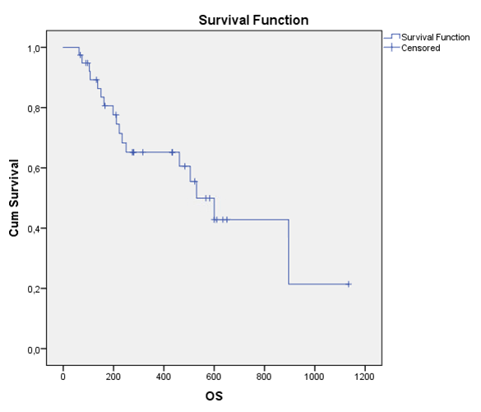
OS in days
Figure 2 Survival function
Considering the limited number of patients available for efficacy analysis (n=39), no further or comparative analyses were performed.

SAFETY EVALUATION

Extent of Exposure
All 48 patients were exposed to both study drugs (Capecitabine and Bevazizumab).

Adverse Events (AE)

Brief summary of adverse events
In the total population (n=48) criteria for AEs ≥ grade 3 or AE criteria for SAE were reported for 21 patients (44%).
The most common AEs were infection or fever (n=6, 21%) followed by abdominal or back pain (n=5, 18%). 12 (42%) of all adverse events considered drug-related by the investigator. In total, 1 (2 %) of all patients had AEs that lead to death. For a detailed description of adverse event in each individual patient see APPENDIX 9.

Analysis of adverse events
The proportions (%) between adverse event grades were as follow:
- AEs grade 4: 2 events (7%)
- AEs grade 3: 20 events (71%)
- SAE grade 2: 5 events (18%)
- SAE grade 1: 1 event (4%)
The number of patients with AE leading to permanent discontinuation of investigational drug was 9 (32%).

Deaths, Other Serious Adverse Events and Other Significant Adverse Events
All adverse events, including deaths and SAE, are included in 11.2.

Clinical Laboratory Evaluation

Listing of individual laboratory measurement by patient and each abnormal laboratory value
All participating patients underwent laboratory testing according to the study protocol. Any deviations considered SAE or AE grades 3 or 4 were recorded in the safety log and are summarized in APPENDIX 9.

Vital Signs, Physical Findings and Other Observation Related to Safety
All participating patients underwent examinations according to the study protocol. Any deviations considered SAE or AE grades 3 or 4 were recorded in the safety log and are summarized in APPENDIX 9.

Safety Conclusion
No unexpected or previously unknown side effects to the study drugs were revealed.

DISCUSSION AND OVERALL CONCLUSION
The scope of this trial was to assess the value of continuous bevacizumab in addition to capecitabine in elderly patients with mCRC. As patients above 70 have been generally underrepresented in clinical trials, but still overrepresented in real world clinical practice, the relevance of this kind of trial remains high. Unfortunately, this study had to be prematurely terminated due to slow rate of inclusion. In addition, upon monitoring 9/48 (19%) of the included subjects did not meet all inclusion/exclusion criteria. Only 39 patients were therefore available for analysis of efficacy outcome. Median overall survival of 17.4 months (12.6 – 22.3) in the cohort of 39 correctly included patients was similar to what has been previously reported. Safety was assessed in the total cohort (n=48), without any unexpected or previously unknown adverse events reported. Bowel perforation occurred in 2/48 patients (4%), which confirms previously known risks with this treatment, and underlines the need for awareness of warning symptoms and careful monitoring of patients under treatment. This might be particularly important when treating elderly and/or frail patients.

TABLES, FIGURES
Figure 1 Study design 12
Figure 2 Survival function 17

REFERENCE LIST
Cunningham et al. Bevacizumab plus capecitabine versus capecitabine alone in elderly patients with previously untreated metastatic colorectal cancer (AVEX): an open-label, randomized phase 3 trial. Lancet Oncol 2013; 11: 1077-1085
Bennouna et al. Continuation of bevacizumab after first progression in metastatic colorectal cancer (ML18147): a randomized phase 3 trial. Lancet Oncol 2013; 14: 29-37

APPENDICES

- List of applications and approval from IEC
Ethics Committee: | Regional Ethics Review Board in Linköping, Sweden (Regional etikprövningsnämnden i Linköping, Sweden). Department of Medical Research Testing(Avdelning för prövning av medicinsk forskning)
Dnr: | 2014/499-31
2014-12-11  2015-01-28 | Application for ethics review of research involving human, Containing:  Protocol version 1.0, dated 2014-12-09  Patient information and Consent version 1.0, dated 2014-08-30  SPC for Avastin (bevacizumab) dated 2014-09-25  Resource certificate and Curriculum Vitae PI Linköping  Request Completion of the application  Dnr: 2014/499-31
2015-02-24  2015-03-25 | Completion of the application, Containing:  Protocol version 2.0, dated 2015-02-09  Patient information and Consent version 2.0, dated 2015-02-10  MPA approval  Request Completion of the application  Dnr: 2014/499-31
2015-04-10  2015-04-22 | Completion of the application, Containing:  Patient information and Consent version 2.1, dated 2015-04-07  Approval  Dnr: 2014/499-31
2015-08-25  2015-10-07 | Amendment 3, Containing:  Protocol version 3.0, dated 2015-08-19  Approval  Dnr:2015/318-32
2016-02-19  2016-03-10 | Addition of participating clinic, Skövde, in the GRACE study  Containing: Resource certificate and Curriculum Vitae PI Skövde  Approval  Dnr: 2016/111-32
2016-10-11  2016-10-24 | Addition of participating clinic, Karlstad, in the GRACE study  Containing: Resource certificate and Curriculum Vitae PI Karlstad  Approval  Dnr: 2016/429-32
2017-03-27 | Information on the change of responsible PI in the GRACE study in Karlstad  Attached: Curriculum Vitae PI Karlstad
2018-12-11  2018-12-19 | Change of PI and national coordinator in Linköping and closure of the study  Containing: Curriculum Vitae PI Linköping and letter of closure of the study  Approval  Dnr: 2018/626-32

- Written informed consent

Patientinformation GRACE studien
En klinisk studie som utvärderar effekt och säkerhet av kontinuerlig behandling med Avastin före och efter återfall tillsammans med kemoterapi hos äldre patienter med tjock-och ändtarmscancer.
Du tillfrågas här om att delta i en vetenskaplig studie med läkemedlet Avastin (bevacizumab) i kombination med kemoterapi. Läs igenom följande information noggrant, diskutera den med din läkare och andra om du vill. Ditt deltagande är helt och hållet frivilligt och om du väljer att inte delta kommer du att få annan beprövad behandling för din cancersjukdom. Om du, efter att ha erhållit fullständig muntlig och skriftlig information, väljer att delta i studien ber vi dig om att signera det bifogade skriftliga samtycket.
Bakgrund och syfte:
Avastin är ett receptbelagt läkemedel som ges som dropp och verkar genom att hämma bildning av blodkärl i och omkring tumören Blodtillförsel till tumörer anses vara avgörande för dess förmåga att växa och sprida sig i kroppen. Avastin har visat sig ha en gynnsam effekt på flera olika tumörtyper och är ett godkänt läkemedel för behandling av spridd tjock- och ändtarmscancer.
Denna studie vänder sig till patienter som fyllt 70 år och som fått diagnosen spridd tjock- och ändtarmscancercancer och som ska få behandling med kemoterapi (cellgifter) för första gången. Standardbehandling för patienter äldre än 70 år med spridd tjock- och ändtarmscancer är idag framförallt kemoterapi men i vissa fall kombineras detta med ett så kallat målinriktat läkemedel som Avastin.
Syftet med denna studie är att undersöka om en kombination av sedvanlig kemoterapibehandling tillsammans med Avastin® tolereras och kan minska risken för återfall och förlänga överlevnaden. Man vill också undersöka om fortsatt behandling med Avastin efter avslutad kemoterapibehandling är gynnsam samt om man i blodprov och tumörprov från patienterna kan finna markörer som kan kopplas till behandlingseffekt av Avastin.
Denna studie drivs och genomförs av Linköpings Universitetssjukhus med ekonomiskt bistånd från läkemedelsföretaget Roche AB. Studien beräknas inkludera 100 patienter i Sverige under 36 månader.

Hur går studien till?
Efter att du givit ditt samtycke till att delta i studien, kommer du att få lämna blodprover, ta ett EKG samt genomgå datortomografi för att se om du kan gå med i studien. Om du väljer att delta och uppfyller alla kriterier för att kunna inkluderas kommer du att få behandling med Avastin i kombination med en kemoterapi, antingen Xeloda eller 5-FU beroende på vad din ansvariga läkare anser vara mest lämpligt.
Du kommer att få din behandling med Avastin genom dropp varannan eller var tredje vecka, beroende på vilken kemoterapibehandling du får. Cytostatikan Xeloda® (Capecitabine) ges i tablettform två gånger per dag, vanligen under perioder av två veckor i taget. Cytostatikan 5-FU ges som dropp i samband med Avastinbehandling
Om du väljer att medverka i studien kommer läkarundersökningar, blodprov, urinprov, röntgen- undersökningar och EKG att utföras. Det kommer också att tas forskningsprover från redan insamlade bitar av tumören för att försöka finna markörer som är kopplade till behandlingseffekt och säkerhet vid Avastinbehandling hos patienter äldre än 70 år. Du kommer även att få fylla i ett frågeformulär där du får uppskatta din livskvalitet inför varje ny behandling.
Hur följs behandlingseffekten i studien?
Var 9-12 vecka kommer behandlingens effekt på tumören att kontrolleras via datortomografiundersökning. Behandlingen i denna studie kan avslutas på förhand om den inte längre är verksam, om det uppstår allvarliga biverkningar, eller om du och din läkare anser att det är bäst för dig att avsluta studiebehandlingen.
Nyligen visades att behandling med Avastin och kemoterapi hos patienter äldre än 70 år kan förlänga tiden till sjukdomsåterfall. Att delta i denna studie kan innebära en ökad möjlighet till bättre behandlingseffekt jämfört med rutinbehandling.
Det finns en risk att du får biverkningar av Avastin och att du inte får någon nytta av behandlingen. Under studiens gång kommer din läkare kommer att noggrant övervaka din hälsostatus och om du får biverkningar kommer denne att diskutera andra rutinmässiga behandlingar med dig.
Risker och obehag
Alla läkemedel har biverkningar. De vanligaste biverkningarna beskrivs här men det är ovanligt att man drabbas av samtliga.
Avastin kan bl.a. leda till högt blodtryck, andfåddhet, äggvita i urinen och ökad risk för blodproppar. Avastin kan även verka hämmande på sårläkning efter större kirurgiska ingrepp. Avastin i kombination med kemoterapi ge en ökad benägenhet för infektioner och blödningar (särskilt näsblod).
Det finns också ovanliga biverkningar som kan bli allvarliga såsom tarmperforation (hål i tarmen), och proppbildning i en artär (blodkärl som går från hjärtat med syrerikt blod). Detta kan leda till propp i hjärnan eller hjärtinfarkt. Avastin-behandlade patienter har i vissa fall utvecklat ett sällsynt neurologiskt tillstånd med biverkningar som krampanfall, huvudvärk, förvirring eller synförändringar. Dessa symtom försvinner efter utsättande av läkemedlet.
De vanligaste biverkningarna vid cytostatikabehandling av tarmcancer är trötthet, illamående, kräkningar och symptom från mage och tarm och vissa läkemedel kan även ge nervpåverkan eller fjällande torr hud i framför allt händer och fötter.
Om du upplever något ovant och oroande symtom så är det viktigt att du underrättar din läkare omgående. Du kommer också att få information ifall några nya allvarliga biverkningar skulle visa sig på andra patienter under den pågående studien.
Du ska också tala om för din doktor om du börjar ta någon annan ny medicin. Detta inkluderar även receptfria läkemedel och naturläkemedel.
Avbrott i förtid
Om du beslutar dig för att delta så kommer du att få ta del av all viktig ny information som framkommer under studien och som kan påverka ditt tillstånd eller villighet att fortsätta delta i studien.
Om studiebehandlingen inte har avsedd effekt, biverkningarna är oacceptabla, eller om du av andra skäl vill avbryta behandlingen kommer din läkare att i samråd med dig besluta om annan behandling.
Även om du beslutar dig för att delta kan du när som helst ångra dig och avbryta ditt deltagande. Det kommer inte att påverka ditt medicinska omhändertagande.
Alternativ till deltagande i denna studie är att få behandling enligt standard på den klinik där du behandlas.
Biobank
Prov som redan insamlats från din tumör kommer att analyseras på Linköpings Universitetssjukhus samt sparas i sjukhusets biobank.
Proverna kommer att sparas så länge studien pågår och därefter kommer de att förstöras. Proverna kommer att vara kodade med ditt specifika patientnummer. Proverna kommer enbart att användas för det ändamål som du skriftligt samtyckt till. Du har full rätt enligt biobanklagen (SFS2002:297) att utan närmare förklaring begära att dina prover ska förstöras. Proverna kan bli aktuella för ännu inte planerade undersökningar om du godkänner sparande för detta. I dessa fall kommer en ny etisk prövning att göras och du kommer då att kontaktas igen med en förfrågan.

Hantering av data och sekretess
Du har rätt till full integritet och all information som insamlas i denna studie är konfidentiell enligt lag. Delar av Din patientjournal kommer att rapporteras i en elektronisk Case Report Form (eCRF) som är en del av studiedatabasen.

Under studien kommer bara dina initialer och ett särskilt studienummer att användas för att identifiera dig. Om resultaten i studien publiceras, kommer din identitet inte att framgå. Dina sjukhusjournaler är konfidentiella och arkiveras på sjukhuset under minst 15 år.
Du har rätt att en gång per år kostnadsfritt få ta del av de data som samlats in gällande dig i denna studie, ett så kallat registerutdrag.
De prover som tas i studien kommer att förvaras i en biobank på ditt sjukhus. Du har rätt att säga nej till att proverna sparas och har även rätt att senare ta tillbaka ditt samtycke om sparande av proverna. Proverna får endast användas på det sätt du gett samtycke till. För denna studie är Region Östergötland personuppgiftsansvarigt enligt PUL (Personuppgiftslagen).
Genom att skriva under detta formulär samtycker du till att dessa data kan samlas in och analyseras inom denna studie samt att representanter för Läkemedelsverket och den Regionala Etikprövningsnämnden kan komma att beredas tillgång till dina journaler. Den här studien är godkänd av den Regionala Etikprövningsnämnden i Linköping samt av Läkemedelsverket.
Hur får jag information om studiens resultat?
Studien finns upplagd på hemsidan clinicaltrials.gov och där kommer även resultatet att presenteras. Studien kommer även att publiceras i vetenskapliga tidskrifter. Du kan även kontakta koordinatorn för studien, Maria Albertsson enligt nedan.

Ansvarig läkare
Forskningshuvudman är Linköpings Universitetssjukhus, Region Östergötland.
Koordinator för studien är överläkare/professor Maria Albertsson på Onkologkliniken i Linköping, 581 91 Linköping, telefon 010-1030000(växel).

Patientsamtycke och Underskrift
Jag har fått muntlig information och tagit del av ovanstående skriftliga information. Jag förstår att jag kommer att få en kopia av detta formulär efter det att det undertecknats och daterats. Jag har haft en möjlighet att fråga min läkare om risker, fördelar och alternativa behandlingsmöjligheter. Jag förstår informationen och har fått mina frågor besvarade. Jag vet att mitt deltagande är helt frivilligt samt att jag när som helst har rätt att avbryta studien. Om jag avbryter studien kommer alla data som samlats in om mig fram till dess att få användas för forskning. Jag samtycker till att delta i denna forskningsstudie enligt vad som beskrivs ovan och ger mitt tillstånd till att information om mig och min hälsa får användas enligt beskrivningen i detta informerade samtycke. Jag samtycker till att de insamlade prover som tagits inom ramen för studien får användas i enlighet med beskrivningen i det informerade samtycket. Om jag avbryter studien i förtid godkänner jag att informationen som insamlats upp till den tidpunkten används som en del av studiedata. Jag förstår att jag kan komma att bli kontaktad i framtiden avseende godkännande för nya undersökningar av insamlade prover. Om jag väljer att inte fullfölja studien så godkänner jag att min ansvarige läkare får rätt att samla in information angående överlevnad.
Jag godkänner att representant från läkemedelskontrollmyndighet och andra kontrollinstanser får jämföra de i studien rapporterade uppgifterna med de som finns i min patientjournal under förutsättning att information som därvid blir tillgänglig inte förs vidare.
Jag ger här mitt samtycke att delta i denna studie

--------------------------------------------
Ort, datum

----------------------------------------------
Deltagares underskrift

-----------------------------------------------------------------
Namnförtydligande

ANSVARIG PRÖVARES FÖRSÄKRAN
Undertecknad har gått igenom och förklarat innebörden och syftet för patienten med att delta i studien. Patienten har haft möjlighet att ställa frågor och fått dem grundligt besvarade. Patienten har även erhållit en kopia av patientinformationen och det informerade samtycket.

----------------------------------------------
Ort, datum
------------------------------------------------------------
Prövares underskrift

-----------------------------------------------------------------
Namnförtydligande
- List and description of investigators
Principal Investigator: | Gunnar Adell, Dept of Oncology, Linköping University Hospital  Maria Albertsson*, Dept of Oncology, Linköping University Hospital (*From the start of the study to 11dec2018)
Investigators: | Gunnar Adell, Department of Oncology, Linköping  Björn Kullinger, Department of Oncology, Karlstad  Johan Haux, Department of Oncology, Skövde, Sweden
Curriculum Vitae Maria Albertsson
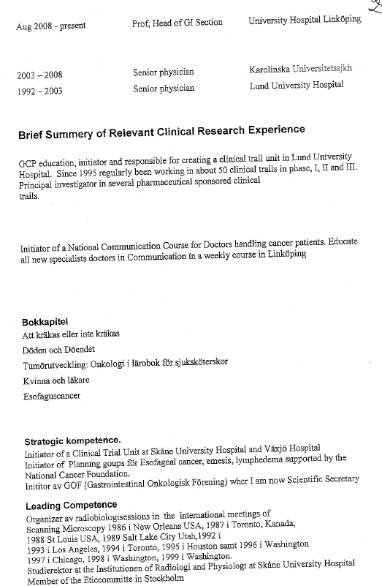


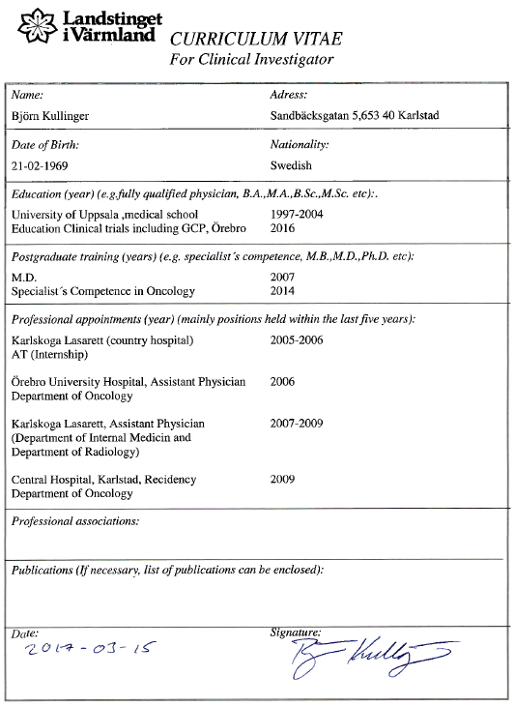
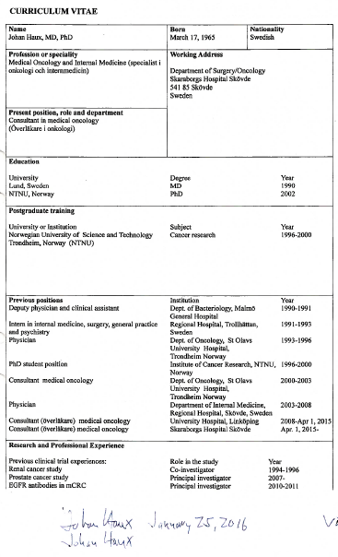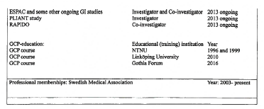

- Protocol
CLINICAL STUDY PROTOCOL

Continous treatment with with bevacizumab in elderly patients with mCRC: an open label, single arm, prospective phase IV trial to evaluate outcome and safety of continuous bevacizumab treatment in combination with chemotherapy over disease progression

Protocol ID: ML29242
Eudract no: 2014-003844-11
Version 3.0

GRACE
Geriatric patients tReated with Avastin in CRC multiple linEs

Principal Investigator: | Gunnar Adell, Department of Oncology, Linköping University Hospital
Name of Sponsor: | Department of Oncology, Linköping University Hospital, Linköping, Sweden

- SIGNATURES
The signature below constitutes the approval of the protocol and appendices and provides the necessary assurances that the study will be conducted according to all stipulations of the protocol, including statements regarding confidentiality, and according to local legal and regulatory requirements and applicable ICH guidelines.
I have thoroughly read and understood the protocol and agree to perform the clinical study according to the international good clinical practice principles and regulatory requirements for source document verification and auditing/inspection of the study.
I understand that changes to the protocol are to be made in form of amendments, which must have the prior written approval by myself and the Sponsor.
I agree to ensure that all personnel that assist me in the conduct of the trial are aware of their obligations.
I agree to report any Serious Adverse Event (SAE) as described in this CTP.

Principal Investigator:

Signature Date
Gunnar Adell
Dept of Oncology
Linköping University Hospital
581 85 Linköping, Sweden

Printed Name

Sponsor’s Representative:

Christina Johansson, Head of Clinic Date
Dept of Oncology
Linköping University Hospital
581 85 Linköping, Sweden

STUDY SYNOPSIS
TITLE | Continous treatment with bevacizumab in elderly patients with mCRC: an open label, single arm, prospective phase IV trial to evaluate outcome and safety of continuous bevacizumab treatment in combination with chemotherapy over disease progression
CLINICAL PHASE | IV
SPONSOR | Dept of Oncology, Linköping Hospital, Linköping, Sweden
PRINCIPAL INVESTIGATOR | Prof. Maria Albertsson, Dept of Oncology, Linköping University Hospital, Linköping
INDICATION | Treatment naive metastatic colorectal cancer
TRIAL DESIGN | Open-label, multicenter, prospective, phase IV study
STUDY PERIOD | Approximate time point for first patient enrolment: Q2 2014. The study is expected to enroll patients for approximately 3 years with an estimated follow up time of 2 years.
STUDY RATIONALE | A majority of patients with metastasized CRC suffer from incurable disease, where a treatment that offers prolonged overall survival with sustained quality of life is warranted. Although approximately half of the mCRC patients are over the age of 70 at first diagnosis, the elderly population is often under-represented in clinical studies. However, recently a phase III trial in patients older than 70 years showed that the addition of bevacizumab to mono-chemotherapy is tolerable and has a beneficial effect on progression free survival and overall response rate (Cunningham 2013).  Bevacizumab is an angiogenesis inhibitor with a separate mechanism of action to chemotherapy implying that development of resistance to chemotherapy is not associated with development of resistance to anti-angiogenic treatment. In line with this, a phase III clinical trial investigating continuous treatment with bevacizumab has demonstrated an increased overall survival in patients where bevacizumab was continued after first tumor progression (Bennouna 2012).  This study aims to assess the feasibility of the new treatment modality of continuous bevacizumab treatment, approved by the European Health Authorities in 2013, in an elderly community based patient population.
TARGET POPULATION | Patients ≥ 70 years old with histological confirmed diagnosis of metastatic CRC that are candidates for first-line therapy with bevacizumab and capecitabine/5-FU chemotherapy.  Main inclusion criteria:  - Untreated metastatic colorectal carcinoma  - Age ≥ 70 years  - Measurable disease according to Response Evaluation Criteria in solid Tumors (RECIST) criteria  - Eastern Cooperative Oncology Group (ECOG) performance status ≤2  - Life expectancy more than 3 months but not considered optimal candidate for treatment with combination chemotherapy with oxaliplatin or irinotecan  - Adequate haematological, renal and liver function as measured by:  - haemoglobin >90 g/L  - absolute neutrophil count ≥ 1,5 x 109/L  - platelets ≥ 100 x 109/L  - bilirubin ≤1.5 × ULN  - ALAT≤ 2.5 × ULN (<5 × ULN if liver metastases)  - creatinine ≤1.5 × ULN  - PK ≤ 1.5  - APTT <1.5 ULN  - Urine dipstick of proteinuria <2+  - Tumor tissue available for biomarker analysis.  - Signed written informed consent to the clinical study and translational research according to ICH/GCP and the local regulations will be obtained prior to any study specific screening procedures  Main exclusion criteria:  - Adjuvant therapy within 6 months  - Clinically significant (i.e. active) cardiovascular disease, e.g:  - cerebrovascular accidents ≤ 6 months prior to study enrolment  - myocardial infarction ≤ 6 months prior to study enrolment  - unstable angina  - congestive heart failure (NYHA Grade II or greater)  - serious cardiac arrhythmia uncontrolled by medication or potentially interfering with protocol treatment.  - Surgical procedure or significant traumatic injury within 28 days prior to first study treatment, or anticipation of need for major surgical procedure during the course of the study.  - Any other serious or uncontrolled illness, which, in the opinion of the investigator, makes it undesirable for the patient to enter the trial
NUMBER OF SUBJECTS | 100 patients are planned to be included in the study. With an estimated accrual time of 36 months, a follow up time of 24 months and assumptions of OS being exponentially distributed, a one-sided Brookmeyer-Crowley test, an alpha level of 10 %, a power of 80 % and a median OS of 22 months in the study patients versus 15.7 months observed in patients on chemotherapy only; sample size was calculated to 89 patients. To allow for a dropout rate of 10 %, 100 patients are planned to be enrolled. Approximately 35 % of patients are estimated to continue treatment for mCRC after progression and can thus be candidates for continued bevacizumab treatment (based on data from the AVEX study) (Cunningham 2013).
INVESTIGATIONAL  MEDICAL PRODUCT(S)  DOSE/ ROUTE/ REGIMEN | Bevacizumab: equivalent of 2.5 mg/kg per week (either 5 mg/kg/q2w or 7.5 mg/kg/q3w) via IV infusion
NON-INVESTIGATIONAL MEDICAL PRODUCT(S) | Capecitabine, 5-FU, leucovorin (LV) for mCRC
COMPARATOR “DRUG” | N.A.
ENDPOINTS:  PRIMARY  SECONDARY  EXPLORATORY | To assess Overall survival (OS) from time of enrolment  To assess safety parameters in elderly patients receiving continuous bevacizumab treatment beyond progression.  To assess total treatment duration as time from start of treatment at inclusion until end of last treatment.  To assess treatment duration from first progression as time from progression until end of last treatment.  To assess progression free survival (PFS) as time from inclusion until first progression or death.  To assess patient reported outcomes including health related quality of life, as measured by EORTC QLQ-C29, across multiple lines of bevacizumab-containing regimens  To assess overall response rate (ORR) according to the RECIST 1.1 criteria  To investigate correlation between biomarkers and outcome of continuous bevacizumab treatment by collection and analysis of tumour samples(see Appendix 4).
SAFETY ASSESSEMENTS | Patients enrolled will be evaluated clinically and with standard laboratory tests before and at regular intervals during their participation. Safety evaluations will consist of medical interviews, recording of AEs ≥ grade 3, physical examinations, blood pressure monitoring, and laboratory measurements. Patients will be evaluated for select AEs and SAEs requiring bevacizumab interruption or discontinuation at each study visit for the duration of their participation in the study. Patients discontinued from the treatment phase of the study for any reason will be evaluated at 28 (± 3) days after the decision to discontinue treatment
MANDATORY BIOMARKER SAMPLES  (MBS) | All subjects are asked to donate mandatory biomarker specimens; a formalin-fixed, paraffin-embedded tissue sample from the time of original diagnosis will be collected during the screening period. Biomarker samples will be collected to promote, facilitate and improve individualized healthcare by better understanding bevacizumab efficacy and safety in the target patient population.
STATISTICS  EVALUATION OF PRIMARY VARIABLE  EVALUATION OF SECONDARY VARIABLES  EVALUATION OF EXPLORATORY VARIABLES | Efficacy endpoints (OS, PFS) will be analyzed using the Kaplan-Meier method. Estimates of median survival and associated confidence intervals will be reported using a Brookmeyer-Crowley approach in PROC LIFETEST in SAS®. Data on demographics, treatment duration, patient reported outcomes, safety and biomarker expression will be summarized using descriptive statistics.  Overall survival will be measured as the time from the date of enrolment to the date of death. Patients without death date will be censored at the date the patient was last known to be alive  Safety outcomes will include: Grade ≥ 3 AEs, SAEs, AEs leading to premature discontinuation of study treatment and laboratory parameters. Safety assessed from the start of 1st-line treatment will be summarized overall and by the groupings of patients who receive continuous treatment beyond first progression and those who do not.  Progression-free survival (PFS) will be defined as the time from the date of enrolment until the date of documented first disease progression according to the RECIST 1.1 criteria, or death due to any cause.  Total treatment duration for bevacizumab and chemotherapy will be defined as time from the start of treatment date at enrolment until the date of the last treatment. Total exposure will be described as the total number of doses of bevacizumab and chemotherapy received.  Treatment duration for bevacizumab and chemotherapy after first progression will be defined as time from the date of documented disease progression until the date of the last treatment. Post-progression exposure will be described as the number of doses of bevacizumab and chemotherapy received after first disease progression.  Data from the HRQoL questionnaires will be summarized for all patients through the study.  Overall response rate will be evaluated as the proportion of patients with complete or partial response after start of treatment as measured by CT and assessed by RECIST 1.1 criteria.  Biomarkers will be analyzed for correlation with primary and secondary endpoints and illustrated by descriptive analysis.

SCHEDULE OF ASSESSMENTS
 | Before treatment |  | Study treatment period |  | End of treatment | Post treatment
 | Screening  (days -28 to -1) | Baseline days  (-7 to -1) | Before each treatment cycle | Every 9-12 weeks | Within 30 days after last study treatment | Every three months
Informed consent form | Xª
Demographics and medical history | X
Cancer and treatment history | X
Concurrent disease | X
ECG | X |  | As clinically indicated
Physical examination and vital signs |  | X | As clinically indicated |  | X
Blood pressure |  | X | X |  | X
ECOG performance status |  | X | X |  | X
Haematology |  | X | X |  | X
Urinalysis |  | X | X |  | X
PRO measures |  | X | X |  | X
Blood chemistry |  | X |  | X | X
Biomarker samples | X^{b}
Tumour measurement | X |  |  | X | X | X^{c}
Adverse events |  |  | Recorded throughout the study. Any SAEs or AEs of special interest should be followed until return to baseline status, stabilization or death
Survival follow up / subsequent anti-cancer therapies |  |  |  |  |  | X
a: Written informed consent must be obtained before any study specific screening procedures are performed
b: A formalin fixed, paraffin-embedded tissue sample from the time of original diagnosis will be collected
c: For patients with no progressive disease after terminating study participation, tumour assessment should be performed every 3 months until progressive disease or death
1 SIGNATURES 3
1 Background 19
1.1 Disease background 19
1.2 Anti-angiogenic treatment with bevacizumab 19
1.3 Clinical data with bevacizumab in mCRC 19
1.4 Treatment of elderly patients with mCRC 20
1.5 Treatment with bevacizumab in multiple lines 21
2 Study rationale 22
3 Objectives 23
3.1 Primary objective 23
3.2 Secondary objectives 23
3.3 Exploratory objectives 23
4 Study design 24
5 Study population 25
5.1 Patient Inclusion Criteria 25
5.2 Patient Exclusion Criteria 26
5.3 Patient enrolment 27
5.4 Withdrawal of patients 27
6 Assessments and procedures 28
6.1 Screening examination and eligibility 28
6.2 Study assessments 28
6.2.1 Tumour measurements 28
6.2.2 Other clinical assessments 28
6.2.3 Laboratory assessments 29
6.2.4 Assessment of biomarkers 29
6.3 Study procedures 30
6.3.1 Screening procedures (days -28 to -1) 30
6.3.2 Baseline procedures (days -7 to -1) 31
6.3.3 Treatment phase 31
6.3.4 Assessments at end of treatment 32
6.3.5 Follow up 32
7 Study Treatment 33
7.1 Bevacizumab 33
7.2 Chemotherapy 33
7.3 Best supportive care 34
7.4 Dose modifications 34
7.4.1 Bevacizumab 34
7.4.2 Chemotherapy 35
7.5 Formulation, Packaging, and Labelling 36
7.6 Concomitant medication and treatment 36
7.7 Surgery during the study 36
7.8 Radiation therapy during the study 36
8 Safety 37
8.1 Adverse events and laboratory abnormalities 37
8.1.1 Adverse events 37
8.1.2 Serious adverse events 37
8.1.3 Project specific adverse event definition 38
8.1.4 Laboratory test abnormalities 38
8.1.5 Follow up of adverse events 38
8.1.6 Follow up of laboratory abnormalities 39
9 Statistical considerations and analytical plan 39
9.1 Sample size calculation 39
9.2 Analysis populations 39
9.3 Replacement policy 40
9.4 Analysis plan 40
9.4.1 Primary endpoint 40
9.4.2 Secondary endpoints 40
9.4.3 Exploratory endpoints 41
9.5 Interim analysis 41
10 Data management and quality assurance 42
10.1 Data management 42
10.2 Quality control and quality assurance 42
11 Ethical considerations 43
11.1 Local Regulations/Declaration of Helsinki 43
11.2 Informed Consent 43
11.3 Independent ethics committee/Institutional review board 43
12 Data handling 44
12.1 Retention of records 44
12.2 Confidentiality of trial documents and subject records 44
13 Insurance 44
14 Publication plan 44
15 References 45
16 Appendices 48
16.1 Appendix 1 – New York Heart Association (NYHA) Functional Classification 48
16.2 Appendix 2 – Patient-reported outcome instrument 49
16.3 Appendix 3 Management of bevacizumab related toxicities 51
16.4 Appendix 4 – Handling of samples for biomarker analysis 54
16.5 Appendix 5 - ECOG performance status 55

LIST OF ABBREVIATIONS
ANC Absolute neutrophil count
AE Adverse event
ALAT alanine aminotransferase
APTT activated partial thromboplastin time
CEA Carcinoembryonic antigen
CHF congestive heart failure
CRC colorectal cancer
CRO Contract research organisation
CT Computer tomography
ECG Electro cardiogram
ECOG Eastern Cooperative Oncology Group
EDC Electronic data capture
EORTC-QLQ-C29 European Organisation for Research and Treatment for Cancer Quality of Life Questionnaire Core 30
ECRF Electronic case report form
FU Fluorouracil
GI Gastro intestinal
HRQoL Health related quality of life
ICH/GCP International Conference on Harmonisation/Good Clinical Practice
IEC Independent ethical committee
INR International normalized ratio
ITT Intention to treat
LD Longest Diameter
LV Leucovorin
LVFS Läkemedelsverkets författningssamling
MBS Mandatory biomarker samples
mCRC Metastasised colorectal cancer
NCI CTCAE National Cancer Institute Common Terminology Criteria for Adverse Events
NYHA New York Heart Association
ORR Overall response rate
OS Overall Survival
PAD Pathological anatomical diagnosis
PFS Progression free survival
PINCH Particularly interesting new cysteine-histidine rich protein
PK pyruvate kinase
PRO Patient Reported Outcome
RECIST Response Evaluation Criteria in solid Tumours
SAE Serious Adverse Event
SAP Statistical Analysis Plan
TRAIL Tumour necrosis factor related apoptosis inducing ligand
ULN Upper limit of normal
VEGF Vascular endothelial growth factor

- Background
  - Disease background
Colorectal cancer (CRC) is the third most commonly diagnosed malignancy with approximately 1.4 million cases diagnosed per year (International agency for research on cancer 2014). In Sweden 4117 men and 3723 women were diagnosed in 2012 (Socialstyrelsen 2014). Patients presenting with localized disease can often undergo surgical resection of the primary tumour and local lymph-nodes, leading to cure in about 50 % of the patients. However, approximately half of the patients will eventually develop metastatic disease and approximately 25 % of the patients present with metastases at the time of diagnosis (Van Cutsem 2010).
The most common site for metastases in CRC is the liver and treatment strategy in these patients is based on a number of variables including patient performance status, tumour size, the number of metastases and their localization. The majority of patients with metastasized CRC (mCRC) are not considered candidates for surgical metastasectomy and the treatment goals in this group mainly consist of prolonging survival and time to progression and decreasing tumour burden and tumour related symptoms. Medical treatment of these patients consists of chemotherapy in combination with biological targeted treatment.
  - Anti-angiogenic treatment with bevacizumab
Recent advances in molecular biology have resulted in an improved understanding of the tumour cell-signalling processes and intricate interplay with surrounding tissues involved in tumour growth. This has led to the development of targeted agents for the treatment of solid tumours, designed to interfere with the processes that are essential for tumour function. One successful approach involves inhibition of the vascular endothelial growth factor (VEGF). VEGF is a stimulator of new vessel proliferation and a potent survival factor for existing tumour vasculature. Without VEGF, recently formed microvasculature disintegrates and endothelial cells undergo apoptosis (Gerber 2005, Hicklin 2005, Ferrara 2004, Erber 2004).
Many approaches have been developed to inhibit the VEGF pathway. The most successful of these is the development of the monoclonal humanized antibody bevacizumab (Avastin®), which prevents tumour angiogenesis by targeting circulating VEGF, preventing it from interacting with its receptors on the surface of endothelial cells.
  - Clinical data with bevacizumab in mCRC
In 2004 a large phase III trial (AVF2107g) was published, demonstrating that bevacizumab improves the efficacy of fluoropyrimidine-based combination chemotherapy in previously untreated patients with mCRC (Hurwitz 2004). This was the first trial to show that anti-angiogenic therapy could prolong survival. 813 patients were treated with irinotecan and 5-FU/LV (IFL regimen) and randomized to receive additional bevacixumab or placebo. Median overall survival, the primary endpoint, was improved from 15.6 to 20.3 months (HR: 0.54, p<0.0001). Progression-free survival was also improved (6.2 versus 10.6 months; HR: 0.66 p<0.001), as was response rate (35 versus 45%; p=0.004). Addition of bevacizumab to chemotherapy was overall well tolerated, with grade 3 hypertension (manageable using standard oral medication) clearly more frequent in the bevacizumab arm (10.9 versus 2.3%). Gastro-intestinal (GI) perforation, arterial thromboembolism and haemorrhage were also identified as safety signals in the bevacizumab-treated patients; occurring at 1.6%, 3.3% and 3.1% respectively.
Addition of bevacizumab to 5-FU/LV or capecitabine alone or in combination with oxaliplatin has similarily demonstrated improved efficacy in the absence of unexpected toxicity (Kabbinavar 2005, Tebbutt 2010, Hochster 2008, Giantonio 2007, Saltz 2008). Furthermore, safety and efficacy data of bevacizumab in combination with various chemotherapy regimens in CRC from the observational studies BRITE (n=1968) and FirstBEAT (n=1915) confirms the data from randomized trials in broader patient populations (Kozloff 2009, van Cutsem 2009).
  - Treatment of elderly patients with mCRC
As with many cancer types, CRC is mainly a diagnosis of the elderly with epidemiological data demonstrating a majority of CRC patients being over 65 years with a median age of around 70 years at diagnosis (Köhne 2008, Pallis 2010). Despite this large and growing patient population there is an underrepresentation of elderly patients in prospective randomized phase III trials, possibly due to strict eligibility criteria regarding performance status and comorbidities.
In the treatment of elderly patients risks associated with old age need to be taken into account since these patients are more likely to present with age-related decline in organ function and comorbidities (Sehl 2005, Sawhney 2005). The use of combination chemotherapy versus mono chemotherapy has been debated in the management of elderly mCRC patients. Most reports on combination chemotherapy show clinical improvements similar to what is seen in younger patients but increased frequency of adverse events (Seymour 2011, Goldberg 2006, Feliu 2006, Twelves 2005, Folprecht 2008, Souglakos 2005). A retrospective analysis of the use of single-agent 5-FU chemotherapy in mCRC demonstrates similar benefit for older patients as what is seen among younger patients (Folprecht 2004) and our research group has recently reported that low-dose capecitabine treatment can be a favorable treatment option in elderly or frail mCRC patients (Miger 2014).
Subgroup and pooled analyses from randomized trials and data from observational studies have suggested that the survival benefits of adding bevacizumab to first line chemotherapy treatment are similar in elderly patients and the general population (Cassidy 2010, Kabbinavar 2009, Kozloff 2010, Kozloff 2011, Price 2012, Venderbosch 2012). Recently, a phase III prospective trial on addition of bevacizumab to capecitabine treatment in mCRC patients over the age of 70 was published. This study demonstrated a significant improvement in the primary endpoint progression free survival for patients who received bevacizumab and capecitabine compared to those treated with capecitabine alone (9.1 vs 5.1 months, HR 0.53, p < 0.0001). Also overall response rate was significantly improved (19% vs 10 %, p=0.04). The safety profile in total was in line with what has been reported by other studies of bevacizumab and capecitabine in mCRC (Cunningham 2013).
  - Treatment with bevacizumab in multiple lines
Preclinical studies have shown that VEGF is continually expressed during the tumour life cycle and that sustained VEGF inhibition achieves and maintains tumour regression (Mesiano 1998, Klement 2000). Use of anti-angiogenic treatment that acts on genetically stable endothelial cells should in principle induce less drug resistance compared to treatments directed at genetically unstable tumour cells (e.g. chemotherapeutic drugs). Consequently, continued antiangiogenic treatment can be clinically effective despite development of resistance to chemotherapy. In the large observational trials following the approval of bevacizumab for mCRC (BRite and ARIES), continued treatment with bevacizumab beyond first disease progression correlated with prolonged survival (Grothey 2008, Cohn 2010).
The concept of continuing bevacizumab treatment beyond progression in mCRC was prospectively tested in the TML trial (ML18147) where mCRC patients treated with combination chemotherapy and bevacizumab in first line were randomized to cross over chemotherapy with or without bevacizumab at first progression. The study met its primary endpoint and showed that patients who received continuous bevacizumab treatment over progression had a significant prolonged overall survival compared to patients who stopped bevacizumab at progression (11.2 vs 9.8 months, HR 0.81, p=0.062). The study also showed that continuous bevacizumab treatment was associated with a significantly prolonged PFS (5.7 vs 4.1 months, HR 0.68, p<0.0001) and with a safety profile consistent with previously reported data in bevacizumab naïve patients (Bennouna 2012).
- Study rationale
More than half of the patients that are diagnosed with metastatic colorectal cancer are over the age of 70 and are often not considered fit enough to tolerate a combination chemotherapy treatment. For this patient group a phase III trial recently showed that the combination of bevacizumab and mono-chemotherapy is an effective and tolerable treatment regimen (Cunningham 2013).
Bevacizumab is an angiogenesis inhibitor with a separate mechanism of action to chemotherapy implying that development of resistance to chemotherapy is not associated with development of resistance to anti-angiogenic treatment. Data to support a beneficial effect of continuous treatment with bevacizumab, despite development of chemotherapy resistance, has been demonstrated in pre-clinical and observational studies. Recently, the concept of continuous treatment was proved in a prospective phase III clinical trial demonstrating increased overall survival in patients where bevacizumab was continued after first tumor progression (Bennouna 2012).
There is a need to define effective and tolerable treatment strategies for the increasing group of elderly mCRC patients. This study aims to assess the feasibility of the new treatment modality of continuous bevacizumab treatment over progression in an elderly community based patient population.

- Objectives

  - Primary objective
To assess Overall survival (OS) from time of inclusion.

  - Secondary objectives
The secondary objectives are:
To assess safety parameters in elderly patients receiving continuous bevacizumab treatment beyond progression.
To assess total treatment duration as time from start of treatment at inclusion until end of last treatment.
To assess treatment duration from first progression as time from progression until end of last treatment.
To assess progression free survival as time from inclusion until first progression or death.
To assess patient reported outcomes including health related quality of life, as measured by EORTC QLQ-C29, across multiple lines of bevacizumab-containing regimens
To assess over all response rate (ORR)

  - Exploratory objectives
To investigate correlation between biomarkers and outcome of continuous bevacizumab treatment by collection and analysis of tumour samples and serial blood samples.

- Study design
This is a prospective, open-label, multicenter, phase IV study in patients with previously untreated metastatic CRC over the age of 70 years. A total of 100 patients will be recruited.
Patients included in the study will be treated with bevacizumab and capecitabine or 5-FU. Patients will remain on first line treatment until disease progression or unacceptable toxicity occurs. If toxicities due to capecitabine or 5-FU require their respective discontinuation patients will remain on bevacizumab treatment.
Assessments during the study are described in schedule of assessments. Tumour status will be assessed at regular time intervals according to clinical practice. After first progression is established according to RECIST 1.1 criteria, patients fit for second line treatment will remain on bevacizumab and the investigators choice of chemotherapy or best supportive care (BSC) as long as the investigator perceive a benefit with the treatment.

Fig 1. Study overview

- Study population

  - Patient Inclusion Criteria
- Patients with histological confirmed diagnosis of adenocarcinoma of the colon or rectum.
- Age ≥ 70.
- Measurable disease according to RECIST criteria.
- ECOG/WHO performance status 0-2
- Life expectancy more than 3 months but not considered optimal candidate for treatment with combination chemotherapy with oxaliplatin or irinotecan
- Adequate haematological, renal and liver function;
  - haemoglobin >90 g/L (may be transfused to maintain or exceed this level)
  - absolute neutrophil count ≥ 1,5 x 10⁹/L
  - platelets ≥ 100 x 10⁹/L
  - bilirubin ≤1.5 × ULN, ALAT≤ 2.5 × ULN (<5 × ULN if liver metastases)
  - creatinine ≤1.5 × ULN
  - PK ≤ 1.5
  - APTT <1.5 ULN
  - Urine dipstick of proteinuria <2+ (patients discovered to have ≥2+ proteinuria on dipstick urinalysis at baseline, should undergo a 24-hour urine collection and must demonstrate ≤ 1 g of albumin/24 h)
- Tumor tissue available for biomarker analysis.
- Signed written informed consent to the clinical study and translational research according to ICH/GCP and the local regulations

  - Patient Exclusion Criteria
- Previous treatment with chemotherapy within 6 months.
- Surgical procedure or significant traumatic injury within 28 days prior to first study treatment, or anticipation of need for major surgical procedure during the course of the study.
- Clinically significant (i.e. active) cardiovascular disease, for example cerebrovascular accidents ≤ 6 months prior to study enrolment, myocardial infarction ≤ 6 months prior to study enrolment, unstable angina, New York Heart Association Grade II or greater congestive heart failure (CHF) (see appendix 1), or serious cardiac arrhythmia uncontrolled by medication or potentially interfering with protocol treatment.
- Other malignancy within 5 years except for carcinoma in situ of the cervix, basal or squamous cell skin cancer, localized prostate cancer or ductal carcinoma in situ treated with curative intent
- Serious non-healing wound or ulcer.
- Evidence of bleeding diathesis or coagulopathy.
- International normalized ration (INR) > 1.5 and activated thromboplastin time (aPTT) <1.5 x ULN within 7 days prior to study enrolment for patients not receiving anti-coagulation. The use of full oral or parenteral anticoagulants is permitted as long as the INR or aPTT is within therapeutic limits according to the medical standard of the enrolling institution and the patient has been on a stable dose of anticoagulants for at least two weeks prior to the first study treatment
- Uncontrolled hypertension despite pharmacological antihypertensive treatment.
- Prior history of gastrointestinal perforation or abscess
- Significant vascular disease (e.g. aortic aneurysm requiring surgical repair or arterial thrombosis within 6 months of start of study treatment). Any previous venous thromboembolism > NCI CTCAE Grade 3.
- Ongoing treatment with aspirin (>325 mg/day) or other medications known to predispose to gastrointestinal ulceration.
- Known hypersensitivity to any contents of any of the study drugs.
- Any other serious or uncontrolled illness or treatment with a medicinal product that in the opinion of the investigator makes it undesirable for the patient to enter the trial.

  - Patient enrolment
All patients will provide written Informed Consent before any study specific assessment is performed.
Screening assessments should occur within 28 days of the first bevacizumab infusion and patients not meeting the eligibility criteria will not be enrolled into the study. Once the patient’s eligibility has been confirmed, the enrolment will occur and a patient ID number will be allocated to the patient via the electronic CRF (eCRF) website

  - Withdrawal of patients
Patients have the right to withdraw from the study treatment at any time for any reason. The investigator also has the right to withdraw patients from the study treatment in the event of:
- Intercurrent illness
- Adverse events
- Patient non-compliance with study procedures
If a patient withdraws consent for further study treatment, the patient should still be followed for survival. If a patient withdraws consent for further participation in the study, follow-up assessments will be discontinued. Should the patient decide to withdraw consent to the study, efforts will be made to complete and report the observations up to the date of withdrawal of the consent. If possible, a complete final evaluation should be made at the time of the patient’s withdrawal. In the case of a patient failing to attend the clinic, the investigator or a member of the team must make efforts to determine the reason for the non-attendance.

- Assessments and procedures
Refer to the Schedule of assessments for an overview.

  - Screening examination and eligibility
All patients will provide written informed consent before any study specific assessment is performed.
Screening assessment should occur within 28 days of the first bevacizumab infusion. Once a patient's eligibility has been confirmed the enrolment will occur and a patient ID number will be allocated via the eCRF website. Patients not meeting the eligibility criteria will not be enrolled in the study.

  - Study assessments

    - Tumour measurements
Tumours will be measured by CT scan and assessments will be performed based on the RECIST 1.1 criteria (Eisenhauer 2009) and assessed whenever possibly by the same individual. For patients with multiple measurable lesions up to 5 lesions per organ should be identified, recorded and measured as target lesions within 28 days before start of treatment. A sum of the longest diameter (LD) for all targeted lesions will be calculated and reported as the baseline sum LD and used as reference for characterization of tumour response. All other lesions should be identified as non-target lesions which also should be recorded at baseline and described over time but do not need to be measured.
In case there is suspicion of progression before the next scheduled assessment an unscheduled tumour assessment should be performed. If a patient misses a prescribed tumour evaluation or the evaluation is prevented by technical errors, the patient may continue treatment until the next scheduled assessment unless signs of clinical disease progression are presented.
    - Other clinical assessments
- Demographics and medical history – includes age, gender and current diseases
- Information on cancer and treatment history – date of diagnosis as recorded on the pathological anatomical diagnosis (PAD)
- Concurrent disease – diseases potentially altering the risk/benefit ratio e.g. significant cardiovascular disease should be inquired for and recorded
- Physical examination and vital signs – include height, weight, pulse, blood pressure
- ECOG performance status – (See appendix 5)
- ECG – will be recorded according to institutional standard and recorded as normal, abnormal clinically significant or abnormal not clinically significant.
- PRO measures - EORTC QLQ-C29 (see appendix 2), should be performed prior to the completion of other study assessments
    - Laboratory assessments
- Haematology: will include haemoglobin, platelet count, leukocytes and absolute neutrophil count. Local laboratory will perform the analyses and provide their reference ranges.
- Blood chemistry: will include sodium, potassium, calcium, magnesium, albumin, bilirubin, alkaline phosphatase, ALAT, creatinine, CEA
- Urinalysis: urine dipstick is sufficient as long as the protein result is < 2+. If urine dipstick shows ≥ 2, a 24 h urine collection should be performed (see also appendix 3) for instructions for handling of proteinuria.
- Coagulation tests: aPTT and INR
    - Assessment of biomarkers
Samples will be collected for biomarker analyses from all patients with the aim to identify tumour biomarkers related to treatment efficacy and safety of bevacizumab treatment in elderly patients.
A formalin fixed, paraffin-embedded tissue sample from the time of diagnosis will be collected during the screening phase and sent to University Hospital Linköping.
Markers to be analyzed includes:
- Tumor necrosis factor related apoptosis inducing ligand (TRAIL) - a transmembrane glycoprotein that belongs to the TNF receptor family and can induce apoptosis in several types of tumors by activating death receptors (Sanlioglu 2009, Koksal 2008). Recently it was showed that anti-angiogenetic drugs potentiate the apoptosis inducing abilities of TRAIL and reduced the tumor cell proliferation (Ding 2010). It has also been shown that bevacucimab treated patients who had elevated levels of sTRAIL had an increased median survival compared to patients without increased sTRAIL expression (Bisgin 2012). TRAIL will be analyzed by immunohistochemistry on paraffin embedded sections.
- Survivin - is normally involved in the healing process of tissue injury where it inhibits apoptosis (by inhibition of pro-caspase 9, caspase-3 and -7 activation) and regulates the cell cycle in the G2/M phase (Altieri 2006, Shin 2001). Survivin is expressed in the majority of human cancers, but is undetectable or weakly expressed in normal adult tissues (Ambrosini 1997). Survivin has critical functions in preserving endothelial cell viability during the proliferative phase of angiogenesis and has been associated with increased expression of VEGF and higher frequency of micro vessel density (MVD) in colorectal cancers (Sakao 2005, Yang 2005, Kawasaki 2001). The expression of survivin will be investigated by immunohistochemistry on paraffin embedded sections.
- P53 - is the most common target for genetic alteration in human cancers and is involved in DNA repair, cell cycle arrest and programmed cell death, genomic stability and blood vessel formation (Vogelstein 2000). Mutations of the p53 gene occur in 70% of CRC and it appears to be a late event in the development of sporadic CRC (Levine 1994). The half time of wild-type p53 is short and the protein cannot be detected by normal immunohistochemistry. However, if the protein is inactivated either by missense mutations, sub-cellular localisation or binding by viral proteins, it accumulates and can be detected by IHC. The expression of p53 will be investigated by immunohistochemistry on paraffin embedded sections.
- PINCH - Particularly interesting new cysteine-histidine rich protein (PINCH) is a part of the PINCH-ILK-Parvin complex connected to integrins of the cell surface, and acts as an adapter protein for signal transduction through the cytosol (Rearden 1994). The complex provides crucial physical linkages between the actin cytoskeleton and transduces signals from the extracellular matrix to intracellular effectors that regulate the cytoskeleton organisation, spreading, motility and proliferation of the cell (Tu 1999, Fukuda 2003). High PINCH expression has been shown to be related to worse prognosis in CRC patients and has been detected in endothelial cells of the tumor vasculature and related to a lower blood vessel density in colorectal cancers, suggesting that PINCH might be associated to tumor angiogenesis (Gao 2004, Holmqvist 2012). The expression of PINCH will be investigated by using immunohistochemistry on paraffin embedded sections.

  - Study procedures
Refer to the Schedule of assessments for an overview. Data will be collected in an electronic case report form (eCRF) for each eligible patient.

    - Screening procedures (days -28 to -1)
All patients will be screened and baseline procedures performed from 4 weeks to 24 hours prior to the start of study treatment. These include the following:
- Signed informed consent: obtained prior to enrolment
- Demographics and medical history
- Information on cancer and treatment history
- Concurrent disease
- Blood pressure
- ECG
- Tumor measurement
- Biomarker sampling – a formalin fixed, paraffin-embedded tissue sample from the time of original diagnosis will be collected. See appendix 4 for further instructions.

    - Baseline procedures (days -7 to -1)
- ECOG performance status: (See appendix 5)
- Physical examination and vital signs
- PRO measures
- Blood pressure
- Haematology
- Blood chemistry
- Urinalysis
- Coagulation tests

    - Treatment phase
- PRO measures - before each treatment cycle
- Adverse events – assessed on an ongoing basis
- Physical examination and vital signs – before each treatment cycle as clinically indicated
- ECOG performance status – before each treatment cycle (see appendix 5)
- Haematology – before each treatment cycle
- Blood chemistry – every 9 to 12 weeks
- Blood pressure - prior to each bevacizumab infusion
- Urinalysis – prior to each bevacizumab infusion
- ECG - as clinically indicated
- Tumour measurement – every 9-12 weeks according to clinical praxis.
    - Assessments at end of treatment
Within 30 days after the last study drug administration the patient should attend a final visit
- PRO measures
- Adverse events – any SAEs should be followed until return to baseline status, stabilization or until the patient’s death
- Physical examination and vital signs
- ECOG performance status
- Haematology
- Blood chemistry
- Urinalysis
- ECG
- Tumor measurement – for patients who exit the study without progressive disease
    - Follow up
Follow-up assessments will be made every three months post treatment and collect information on survival data.
Patients ending study treatment for any reason without documented progressive disease should have tumour assessments done regularly according to clinical praxis until documented progression or start of new anti-tumor treatment.
Study-drug related SAEs will be monitored until the event has resolved.

- Study Treatment

  - Bevacizumab
Bevacizumab comes in vials as a concentrate that should be diluted with sodium chloride (NaCl) for intravenous infusions. The vials should be stored in a refrigerator at 2°- 8°C in its outer carton due to light sensitivity. Bevacizumab does not contain any antimicrobial preservative therefore care must be taken to ensure the sterility of the prepared solution.
Bevacizumab will be administered at a fixed dose equivalent to 2.5 mg/kg per week; either as 7.5 mg /kg every three weeks (q3w) or 5 mg/kg every two weeks (2qw). The initial infusion should be given over 90 minutes and the duration of subsequent infusions may be between 30 to 60 minutes as tolerated. The patient’s body weight at screening is used to calculate the required doses. Dose adjustments for body weight changes are not required unless the patient’s body weight changes by at least 10 % from baseline.
The dose of bevacizumab will not be reduced nor escalated. In case of serious bevacizumab-related toxicity, bevacizumab treatment will be temporarily or permanently suspended (section 6.3.1 for treatment modifications of bevacizumab). Patients in which bevacizumab is interrupted for more than three cycles during 1L treatment will not continue with further treatment within the study.

  - Chemotherapy
Patients enrolled in the study will be treated with capecitabine or 5-FU/LV.
Capecitabine is an anti-metabolite that is orally administrated. The drug is enzymatically metabolized in the liver and subsequently converted to the anti-metabolite 5-FU by thymidine phosphorylase that is found in high concentrations in tumours. The drug is administered in the morning and evening, half an hour after a meal. Normal dose is 800mg/m² twice daily on days 1-14 in a three week cycle. The investigator can also chose to use a continuous metronomic capecitabine dose of 500 mg twice daily according to institutional practice.
5-FU is an anti-metabolite that is given together with folinic acid as intravenous infusion according to institutional practice.
A minority of patients may be candidates for combination chemotherapy after first progression. These patients can then be treated with irinotecan or oxaliplatin in combination with capecitabine (XELIRI, XELOX) or 5-FU (FOLFIRI, FOLFOX) according to institutional practice.

  - Best supportive care
Best supportive care is given according to institutional practice

  - Dose modifications
    - Bevacizumab
No dose adjustments of bevacizumab should be performed for individual patients except for body weight changes of more than 10%. Skipped doses or termination of treatment will be based on observed toxicities and missed doses will not be made up for.
Specific instructions for the grading and management of hypertension, proteinuria, thrombosis/embolism, haemorrhage and other events attributable to bevacizumab are provided in appendix 3.
Patients who experience the following events should permanently discontinue bevacizumab:
- Gastrointestinal perforation, abscess or fistulae
- Arterial thromboembolic evens
- Symptomatic grade 4 venous thromboembolism
- Grade 3/4 hemorrhagic events
- Grade 4 hypertension
- Grade 4 proteinuria
- Reversible posterior leucencephalopathy syndrome
In patients who experience the following events bevacizumab should be temporarily interrupted or permanently discontinued in case of serious:
- Venous thromboembolism
- Hypertension
- Proteinuria
- Infusion reactions
- Wound healing complications
In case bevacizumab is discontinued, chemotherapy treatment should be continued if possible. Patients in which bevacizumab is interrupted for more than three cycles during 1L treatment will not continue with further treatment within the study.

    - Chemotherapy
Local standard practice will decide dose reductions or schedule modifications of chemotherapeutic regimens. Dose modifications to 75 % of the starting dose should be performed if any of the following toxicities have occurred during previous treatment cycles:
- Grade 4 thrombocytopenia
- Febrile neutropenia (> 38.5°C and ANC < 1x 10⁹ / L)
- Failure of haematological recovery (neutrophils ≥ 1.5 x 10⁹ / L and platelets ≥75 x 10⁹ / L)
- Grade 3 non-haematological toxicity such as mucositis, diarrhoea or vomiting despite optimal supportive treatment.
- A second dose reduction of 50 % may be performed if the above toxicities recur. The doses of LV or bevacizumab should remain unchanged.
Before initiation of a new treatment cycle the patients should meet the following criteria:
- Absolute neutrophil count ≥ 1.5 x 10⁹ / L and platelets ≥100 x 10⁹ / L
- Treatment related diarrhea or abdominal cramps are fully resolved to baseline
- Any bilirubin elevation has resolved to at least grade 1
- Recovery from any treatment related non-haematological toxicity (except alopecia) to ≤ grade 1
- Hand-foot syndrome ≤1
Patients not meeting the above criteria on the date of the scheduled new cycle should suspend treatment with the chemotherapeutic drugs capecitabine, 5-FU/LV, irinotecan or oxaliplatin until they meet the above criteria. If postponement for more than 3 weeks is necessary chemotherapy treatment should be terminated but bevacizumab treatment can be continued except in the case of bevacizumab-related toxicity.

  - Formulation, Packaging, and Labelling
For formulation and packaging of bevacizumab see section 7.1. Bevacizumab used after determination of progressive disease will be labelled for use in a clinical trial according to national law and regulations.

  - Concomitant medication and treatment
Concomitant medications and treatments should follow standard medical oncology practice and are given at the discretion of the investigator.

  - Surgery during the study
Bevacizumab can interfere with wound healing why elective surgery should be scheduled at least 6 weeks after the last bevacizumab administration. In case of unplanned surgical interventions bevacizumab should be stopped as soon as possible and not reinitiated until at least 28 days after surgery and complete wound healing.

  - Radiation therapy during the study
Radiation therapy for symptom relief is allowed and the patient can continue the study treatment. If a target lesion is irradiated the lesion can be excluded as a target lesion as long as it is not a sign of progressive disease.

- Safety

  - Adverse events and laboratory abnormalities

    - Adverse events
An adverse event (AE) is defined as any untoward medical occurrence in a clinical investigation subject administered a pharmacological product regardless of casual attribution. An AE can therefore be any unfavourable or unintended sign (including an abnormal laboratory finding), symptom or disease temporally associated with the use of a medicinal product whether or not considered related to the product. A medical condition present at screening should not to be regarded as an AE unless it deteriorates during the study at which time it should be reported.
All clinical AEs will be graded by a clinician using the National Cancer Institute Common Terminology Criteria for Adverse Events (NCI CTCAE) version 4. The treatments used in the study are standard treatment regimens with well-established safety profiles and all AEs will be handled according to clinical practice and any AEs ≥ grade 3 will be reported on the eCRF except arterial thromboembolic events (ATEs) all of which will be reported in the eCRFs regardless of severity grade. The causality relationship of the study drug and the adverse event will be assessed by the investigator as yes or no. All AEs will be followed until adequate resolution.

    - Serious adverse events
A serious adverse event (SAE) is defined as an AE that meet the following criteria:
- Fatal (the AE causes or leads to death)
- Life threatening (in view of the investigator the AE places the subject at immediate risk of death)
- Requires or prolongs patient hospitalization
- Results in persistent or significant disability
- Birth defect/congenital abnormality in infant born to a mother exposed to study drug
- Other significant medical event according to the investigator’s judgment that may jeopardize the patient or require medial or surgical intervention to prevent any of the outcomes above
SAEs are required to be reported within 24 hours after learning of the event by the investigator to the study coordinator who will inform the health authorities as per national regulation and Roche AB as stipulated in separate safety data exchange agreement.
    - Project specific adverse event definition
Progression or deterioration of the malignancy (including new metastatic lesions or death due to disease progression) during the study will be part of the efficacy assessment and should not be reported as AE/SAE.
- Signs and symptoms of the malignancy under the study should only be reported if:
- They are not present at baseline and the association with the underlying malignancy and metastatic lesions is unclear
The investigator attributed deterioration of malignancy-associated signs and symptoms directly to the study drug
Should there be any uncertainty regarding the attribution of the malignancy under the study to an AE it should be reported as an AE or SAE accordingly.
    - Laboratory test abnormalities
Laboratory test results will be recorded on the eCRF and value abnormalities as such should not be reported as AEs unless they are treatment-emergent and satisfy one or more of the following conditions for clinical significance:
- Accompanied by clinical symptoms
- Leading to a change in study medication (e.g. dose modification, interruption or permanent discontinuation)
- Requiring a change in concomitant medication
    - Follow up of adverse events
Adverse events ≥ grade 3 and any grade ATEs experienced up until 30 days after the last dose of study treatment should be recorded in the eCRF and followed up until they have returned to baseline status or stabilized. All AEs ≥ grade 3 including any grade ATE considered related to bevacizumab which occur up to 6 months after the last dose should also be reported in the eCRF and followed up until they have returned to baseline status or stabilized. Follow-up of adverse events considered unrelated to study drug is required for up to 30 days after the last dose.
All severe life-threatening adverse events must be followed up until resolution or death.

    - Follow up of laboratory abnormalities
In the event of unexplained abnormal laboratory test values, the tests should be repeated immediately and followed up until they have returned to normal range/baseline values or adequate explanation of the abnormality is found. If a clear explanation is established it should be recorded on the eCRF.

- Statistical considerations and analytical plan
The study is designed as an open-label, single arm, prospective, phase IV trial to evaluate outcome and safety of continuous bevacizumab treatment in combination with chemotherapy over disease progression in elderly mCRC patients.

  - Sample size calculation
100 patients are planned to be included in the study. With an estimated accrual time of 36 months, a follow up time of 24 months and assumptions of OS being exponentially distributed, a one-sided Brookmeyer-Crowley test, an alpha level of 10 %, a power of 80 % and a median OS of 22 months in the study patients versus 15.7 months observed in patients on chemotherapy only; sample size was calculated to 89 patients. To allow for a dropout rate of 10 %, 100 patients are planned to be enrolled. Approximately 35 % of patients are estimated to continue treatment for mCRC after progression and can thus be candidates for continued bevacizumab treatment (based on data from the AVEX study (Cunningham 2013)).

  - Analysis populations
The intent to treat (ITT) population includes all consenting patients enrolled in the study. The safety population comprises all patients who received at least one dose of study medication. The per-protocol population excludes all patients with major protocol violations.
The data from the ITT population will be presented descriptively and used for primary efficacy analysis. The efficacy analysis will be repeated using the per protocol population to confirm the overall study results. All safety analyses will be based on the safety population.

  - Replacement policy
No subject prematurely discontinued from the study for any reason will be replaced. A centre may be replaced for administrative reasons of excessively slow recruitment or poor protocol adherence.

  - Analysis plan
A statistical analysis plan (SAP) will be created once the study is approved and the final SAP will be approved and signed prior to clean to file.
In general, continuous data will be summarized with standard descriptive statistical measures including the number of observations, mean, median, standard deviations, minimum and maximum values.
Demographic, background and baseline data will be presented descriptively for the ITT and per protocol populations.
Demographic and baseline data will be summarised as appropriate depending on the type of data.
Medical history and concurrent (ongoing) diseases at baseline will be coded by system organ class (SOC) and preferred term (PT) using MedDRA and will be presented as number and percentage of subjects in each SOC and PT.

    - Primary endpoint
Overall survival is defined as the time from enrolment until death from any cause. Patients who are still alive at the time of analysis (clinical cut off) and patients who are lost to follow up will be censored at their last clinical assessment date. OS will be summarized and presented graphically using the Kaplan-Meier method. Estimates of median survival and associated confidence intervals will be reported using a Brookmeyer-Crowley approach in PROC LIFETEST in SAS®. The analysis will be based on the ITT population and repeated for the per protocol population.
    - Secondary endpoints
The safety analysis will be conducted in the safety population. Safety outcomes will include: AEs, Grade ≥ 3 AEs, SAEs and AEs leading to premature discontinuation of study treatment. All safety parameters will be summarized and presented in tables and will include all data collected during the study period and follow up. Safety assessed from the start of 1st-line treatment will be summarized overall and by the groupings of patients who receive continuous treatment beyond first progression and those who do not.
AEs will be coded by system organ class (SOC) and preferred term (PT) using MedDRA. An overview of all Grade ≥3 AEs; SAEs and AEs leading to premature discontinuation or death; causal relationship to IMP, CTCAE grade will be presented. Incidences of Grade ≥ 3 AEs and SAEs will be presented as the number and percentage of subjects for each SOC and PT. In addition, AEs will also be presented by causal relationship and CTCAE grade, respectively.
Progression-free survival (PFS) is defined as the time from the date of enrolment until the date of documented first disease progression according to the RECIST 1.1 criteria, or death due to any cause. PFS will be summarized and presented graphically using the Kaplan-Meier method. Estimates of median progression free survival and associated 90% confidence intervals will be reported in the same manner as for the primary endpoint.
Total treatment duration is defined as time from the start of bevacizumab and chemotherapy treatment until the date of the last treatment. Total exposure will be described as the total number of bevacizumab and chemotherapy doses received. Estimate of total treatment duration will be presented with descriptive statistics including mean and 90% confidence interval. Total number of doses will be reported with descriptive statistics including mean or median with associated 90% confidence interval, as appropriate.
Treatment duration after first progression is defined as time from the date of documented disease progression until the date of the last bevacizumab or chemotherapy treatment. Post-progression exposure will be described as the number of bevacizumab and chemotherapy doses received after first disease progression. Estimate of treatment duration after first progression will presented with descriptive statistics including mean and 90% confidence interval. Total number of doses will be reported with descriptive statistics including mean or median with associated 90% confidence interval, as appropriate.
Data from the PRO questionnaires will be summarized descriptively, according to respective manual, if any, for all patients through the study.

    - Exploratory endpoints
Biomarker analysis will be performed to evaluate the correlation with outcome (OS, PFS, total treatment duration and Grade ≥3 AEs). Descriptive analysis will be conducted and graphically presented.
  - Interim analysis
An interim analysis is planned when 30 patients have confirmed progressive disease. The interim analysis will be performed for safety purposes only and a steering committee will be nominated to review the safety data. The study will not be stopped due to this interim analysis unless for safety reasons.
- Data management and quality assurance

  - Data management
A contract research organization (CRO) will be responsible for the data management of the study and conduct data management in accordance with ICH guidelines, CRO standard operating procedures and good clinical, scientific and data management principles.
Data from the study will be recorded via an Electronic Data Capture (EDC) system using electronic Case Report Forms (eCRF). Sites will receive training on the eCRF system and the investigator is responsible for ensuring the accuracy, completeness and timeliness of the data recorded in the eCRF. All data in the eCRFs will be validated through computer driven procedures to maximize logical consistency and discrepancies detected will be resolved by computer driven queries.
Before the database can be declared complete and accurate, a final control of consistency will be made and any detected inconsistences resolved. When the database is declared complete and accurate it will be locked and any changes to the database after that time can only be made by written agreement between the principal investigator, the data manager and the biostatistician.

  - Quality control and quality assurance
The study will be conducted in compliance with this protocol, the ICG E6 guideline for Good Clinical Practice, the EU Clinical trial Directive (2001/20/EC) and the Swedish Medical Products Agency regulation LVFS 2011:19.
Regular monitoring of the data will be done via the research department at the oncology clinic at Linköping University Hospital. Source data verification will be performed to confirm that critical protocol data entered into the eCRF by authorized site personnel is accurate, complete and verifiable from source documents.
To facilitate source data verification, the investigators and institutions must provide the Sponsor direct access to applicable source documents and reports for trial-related monitoring, sponsor audits and inspections by health authorities

- Ethical considerations

  - Local Regulations/Declaration of Helsinki
The investigator will ensure that this study is conducted in full conformance with the principles of the “Declaration of Helsinki” or with the laws and regulations in Sweden, whichever affords the greater protection of the individual. The study must fully adhere to the requirements of the ICH E2A guideline (Clinical Safety Data Management: Definitions and Standards for Expedited Reporting).

  - Informed Consent
It is the responsibility of the investigator or a person designated by the investigator to obtain written informed consent from each patient participating in the study after adequate explanation of the aims, methods, anticipated benefits and potential hazards of the study. The investigator or designee must also explain that the subjects are completely free to refuse to enter the study or withdraw from it at any time, for any reason. The eCRF will contain a section for documenting informed consent which must be completed appropriately.
The consent forms must be revised whenever there are changes to study procedures or when new information become available that may affect the willingness of the patient to participate in the study. All patients (including those already being treated) should be informed of any changes and re-consent to remain in the study.

  - Independent ethics committee/Institutional review board
This protocol, the informed consent forms, any information to be given to the patient and relevant supporting information must be submitted by the investigator to an independent ethics committee (IEC). Approval from the committee must be obtained before starting the study. Any modifications made to the protocol after receipt of the IEC approval must be submitted by the investigator to the IEC.
  - Conditions for modifying the protocol
All substantial protocol modifications must be submitted to the appropriate IEC/IRB and to Swedish Medical Products Agency for information and approval before implementation.
Once approved by the appropriate Independent Ethics Committee or Institutional Review Board and by the Swedish Medical Products Agency, the investigator shall implement such Protocol modifications. Protocol modifications for urgent safety matters shall however be directly implemented.

- Data handling
The investigator is responsible to ensure accuracy, completeness, legibility and timeliness of the data reported. Data collection is the responsibility of the study staff at the site under the supervision of the site investigator.

  - Retention of records
Study records and documents including original source data, eCRFs, PRO data, original signed informed consent forms, laboratory test results and medication inventory records must be retained by the principal investigator for at least 10 years after the completion or discontinuation of the study.

  - Confidentiality of trial documents and subject records
The investigator must assure that subjects’ anonymity will be maintained and that their identities are protected from unauthorized parties. On eCRFs or other documents subjects should not be identified by their names but by an identification code. The investigator should keep a subject enrolment log showing codes, names and addresses in strict confidence.

- Insurance
Patients participating in the study are covered by the Swedish Patient Insurance and the Swedish Pharmaceutical Insurance.

- Publication plan
The study results shall be published in a suitable scientific journal. Final results from the study as well as data from the interim analyses could also be presented at scientific meetings.

- References
Bennouna et al. Continuation of bevacizumab after first progression in metastatic colorectal cancer (ML18147): a randomized phase 3 trial. Lancet Oncol 2013; 14: 29-37
Cassidy et al. Effect of bevacizumab in older patients with metastatic colorectal cancer: pooled analysis of four randomized studies. J Cancer Res Clin Oncol 2010; 136: 737-743
Cohn et al. Clinical outcomes in bevacizumab (BV)-treated patients (pts) with metastatic colorectal cancer (mCRC): results from ARIES observational cohort study (OCS) and confi rmation of BRiTE data on BV beyond progression (BBP). Proc Am Soc Clin Oncol 2010; 28 (suppl): abstr 3596.
Cunningham et al. Bevacizumab plus capecitabine versus capecitabine alone in elderly patients with previously untreated metastatic colorectal cancer (AVEX): an open-label, randomized phase 3 trial. Lancet Oncol 2013; 11: 1077-1085
Eisenhauer et al. New response evaluation criteria in solid tumours: Revised RECIST guideline (version 1.1). Eur J of Cancer 2009; 45: 228-247
Erber et al. Microtumor growth initiates angiogenic sprouting with simultaneous expression of VEGF, VEGF receptor 2 and angiopoietin 2. FASEB J 2004; 18: 338-340
Feliu et al. Capecitabine as fist-line treatment for patients older than 70 years with metastatic colorectal cancer: an oncpaz cooperative group study. J Clin Oncol 2005; 23: 3104-31111
Ferrara et al. Vascular endothelial growth factor: basic science and clinical progress. Endocr Rev. 2004; 25: 581-611
Folprecht et al. Efficacy of 5-fluorouracilbased chemotherapy in elderly patients with metastatic colorectal cancer: a pooled analysis of clinical trials. Annals of Oncology 2004; 15: 1330–8.
Folprecht et al. Irinotecan/fluorouracil combination in first-line therapy of older and younger patients with metastatic colorectal cancer: combined analysis of 2,691 patients in randomized controlled trials. Journal of Clin Onc 2008; 26: 1443–51.
Gerber et al. Pharmacology and pharmacodynamics of bevacizumab as monotherapy or in combination with cytotoxic therapy in preclinical studies. Cancer Res. 2005; 65: 671-680
Giantonio et al. Bevacizumab in combination with oxaliplatin, fluorouracil, and leucovorin (FOLFOX 4) for previously treated metastatic colorectal cancer: results from the Eastern Cooperative Oncology Group Study E3200. J Clin Oncol 2007; 25: 1539-1544
Goldberg et al. Pooled analysis of safety and efficacy of oxaliplatin plus fluorouracil/leucovorin administered bimonthly in elderly patients with colorectal cancer. J Clin Oncol 2006; 24: 4085-4091
Grothey et al. Bevacizumab beyond first progression is associated with prolonged overall survival in metastatic colorectal cancer: results from a large observational cohort study (BRiTE). J Clin Oncol 2008; 26: 5326–34.
Hicklin et al. Role of the vascular endothelial growth factor pathway in tumour growth and angiogenesis. J Clin Oncol. 2005; 23: 1011-1027
Hochster et al. Safety and Efficacy of Oxaliplatin and Fluoropyrimidine Regimens With or Without Bevacizumab As First-Line Treatment of Metastatic Colorectal Cancer: Results of the TREE Study. J Clin Oncol 2008; 26: 3523-3529
Hurwitz et al. Bevacizumab plus irinotecan, fluorouracil and leucovorin for metastatic colorectal cancer. N Engl J Med 2004; 350: 2335-2342
International agency for research on cancer. World Cancer Fact Sheet 2014, Cancer research UK
Kabbinavar et al. Addition of bevacizumab to bolus fluorouracil and leucovorin in first-line metastatic colorectal cancer: results of a randomized phase II trial. J Clin Oncol 2005; 23: 3697-3705
Kabbinavar et al. Addition of bevacizumab to fluorouracil-based first line treatment of metastatic colorectal cancer: pooled analysis of cohorts of older patients from two randomized clinical trials. J Clin Oncol 2009; 27: 199-205
Klement et al. Continuous low-dose therapy with vinblastine and VEGF receptor-2 antibody induces sustained tumor regression without overt toxicity. J Clin Invest 2000; 105: R15–24.
Kozloff et al. Clinical Outcomes Associated with Bevacizumab-Containing Treatment of Metastatic Colorectal Cancer: The BRiTE Observational Cohort Study. The Oncologist 2009; 14: 862–870
Kozloff et al. Clinical outcomes in elderly patients with metastatic colorectal cancer receiving bevacizumab and chemotherapy: results from the BRiTE observational cohort study. Oncology 2010; 78: 329-339
Kozloff et al. Effectiveness of first or second line bevacizumab treatment in elderly patients with metastatic colorectal cancer in ARIES, an observational cohort study. Proc Am Doc Clin Oncol 2011; 29 abstr 3625
Köhne et al. Chemotherapy in Elderly Patients with Colorectal Cancer. The Oncologist 2008;13:390–402
Mesiano et al. Role of vascular endothelial growth factor in ovarian cancer: inhibition of ascites formation by immunoneutralization. Am J Pathol 1998; 153: 1249–56.
Miger et al. Low-dose capecitabine (Xeloda) for treatment of gastrointestinal cancer. Med Oncol 2014; 31: 870
Pallis et al. EORTC Elderly Task Force experts’ opinion for the treatment of colon cancer in older patients. Cancer Treatment Rev. 2010; 36: 83-90
Price et al. Bevacizumab is equally effective and no more toxic in elderly patients with advanced colorectal cancer: a subgroup analysis of the AGTIG MAX trial: an international randomized controlled trial of capecitabione, bevacizumab and mitomycin C. Ann Oncol 2012; 23: 1531-1536
Saltz et al. Bevacizumab in combination with oxaliplatin-based chemotherapy as first-line treatment in metastatic colorectal cancer: a randomized phase III study. J Clin Oncol 2008; 26:2013-2019.
Sawhney et al. Physiologic Aspects of Aging: Impact on Cancer Management and Decision Making, Part I. The Cancer Journal 2005; 11: 449-460
Sehl et al. Physiologic Aspects of Aging: Impact on Cancer Management and Decision Making, Part II. The Cancer Journal 2008; 11: 461-473
Socialstyrelsen . Cancer incidence in Sweden 2012. 2014 ISBN 978-91-7555-126-5
Souglakos et al. Combination of Irinotecan (CPT-11) plus 5-Fluorouracil and Leucovorin (FOLFIRI Regimen) as First Line Treatment for Elderly Patients with Metastatic Colorectal Cancer: A Phase II Trial. Oncology 2005; 69: 384–390
Tebbut et al. Capecitabine, Bevacizumab, and Mitomycin in First-Line Treatment of Metastatic colorectal Cancer: Results of the Australasian Gastrointestinal Trials Group Randomized Phase III MAX Study. J Clin Oncol 2010; 28: 3191-3198
Twelves et al. Capecitabine/Oxaliplatin, a Safe and Active First-Line Regimen for Older Patients Metastatic Colorectal Cancer: Post Hoc Analysis of a Large Phase II Study. Clin Colorectal Cancer 2005; 5: 101-107
Van Cutsem et al. Safety and efficacy of first-line bevacizumab with FOLFOX, XELOX, FOLFIRI and fluoropyrimidines in metastatic colorectal cancer: the BEAT study. Annals of Oncology 2009; 20: 1842–1847
Van Cutsem et al. Advanced colorectal cancer: ESMO Clinical Practice Guidelines for treatment Annals of Oncology 2010; 21 (Suppl 5): v93–v97
Venderbosch et al. Outcome of first line systemic treatment in elerly compared to younger patients with metastatic colorectal cancer: a retrospective analysis of the CAIRO and CAIRO2 studies of the Dutch Colorectal Cancer Group. Acta Oncol 2012; 51: 831-39

- Appendices

  - Appendix 1 – New York Heart Association (NYHA) Functional Classification

Class | Patient Symptoms
I (Mild) | Patients with cardiac disease but resulting in no limitation of physical activity. Ordinary physical activity does not cause undue fatigue, palpitation, dyspnea or anginal pain.
II (Mild) | Patients with cardiac disease resulting in slight limitation of physical activity. They are comfortable at rest. Ordinary physical activity results in fatigue, palpitation, dyspnea or anginal pain.
III (Moderate) | Patients with cardiac disease resulting in marked limitation of physical activity. They are comfortable at rest. Less than ordinary activity causes fatigue, palpitation, dyspnea or anginal pain.
IV (Severe) | Patients with cardiac disease resulting in inability to carry on any physical activity without discomfort. Symptoms of heart failure or the anginal syndrome may be present even at rest. If any physical activity is undertaken, discomfort increases

  - Appendix 2 – Patient-reported outcome instrument
EORTC QLQ-C29

  - Appendix 3 Management of bevacizumab related toxicities

Management of hypertension

CTC AE Grade | Description | Action
1 | Asymptomatic, transient (<24 h) increase by > 20 mm Hg (diastolic) or to > 150 mg/ 100 mm Hg if previously within normal range | Intervention not indicated
2 | Recurrent or persistent (> 24 h) or symptomatic increase by > 20 mm Hg (diastolic) or to > 150/100 MM Hg If previously within normal range. | Monotherapy of anti-hyperrensive may be indicated. Onc controlled to < 150/100 mm Hg, patinets may continue bevacizumab therapy
3 | Requiring more than one anti-hypertensive or more intensive therapy than previously. | Bevacizumab should be withheld for persistent or symptomatic hypertension and should be permanently discontinued if blood pressure can not be controlled
4 | Life-threatening consequences, e.g. hyperintensive crisis. | Bevacizumab should be permanently discontinued

Management of proteinuria
Proteinuria by dipstick has to be assessed prior to each bevacizumab administration unless proteinuria has been determined by 24 h urinalysis.

Proteinuria grade 1  Dipstick +1 | Proteinuria grade 2  Dipstick 2+ - 3+  24 h urine: > 1-3.5 g | Proteinuria grade 3  Dipstick 4 +  24 h urine: >3.5 g | Proteinuria grade 4  Nephrotic syndrome
Administer bevacizumab as planned | For 2 + dipstick: may administer bevacizumab as planned and collect 24 h urine prior to subsequent bevacizumab administration.  For dipstick 3+ and 4 +: must obtain 24 h urine prior to administering bevacizumab  If 24 h urine > 2g; omit bevacizumab dose until the level is < 2 g |  | Permanently discontinue bevacizumab treatment

Management of Arterial thrombosis/embolism
Bevacizumab should be discontinued in patients who develop arterial thromboembolic events (ATEs). A history of arterial thromboembolic events has been associated with an increased risk of ATEs durin bevacizumab therapy. Caution should be taken when treating these patients with bevacizumab.
Management of Venous thrombosis/embolism
Bevacizumab should be held in patients developing grade 3 thrombosis/embolism and can be resumed once the patient is adequately anti-coagulated and on a stable level of anticoagulation for at least 2 weeks prior to restarting study drug treatment.
In the event of recurrent grade 3 thrombosis/embolism the patient should be discontinued from bevacizumab.
Bevacizumab should be discontinued in patients with life-threatening (grade 4) thrombosis/embolism.
Haemorrhage
Bevacizumab should be permanently discontinued for
- Grade 3 or 4 bleeding of any kind
- Any grade of CNS bleeding
Bevacizumab should be temporarily held or permanently discontinued for grade ≥ 2 haemoptysis.

Management of Gastrointestinal perforation and fistula
Bevacizumab should be permanently discontinued in patients who develop GI perforation. Temporarily discontinue bevacizumab in patients with grade 2 or 3 non-tracheoeosopageal fistula until resolution to grade ≤ 1. Permanently discontinue bevacizumab in patents with tracheoesophageal fistla ora any grade 4 fistula.

  - Appendix 4 – Handling of samples for biomarker analysis
A tissue sample from the time of the original diagnosis will be collected for laboratory analyses.
  - Appendix 5 - ECOG performance status

Grade | Description
0 | Fully active, able to carry on all pre-disease performance without restriction
1 | Restricted in physically strenuous activity but ambulatory and able to carry out work of a light or sedentary nature, e.g., light housework or office work
2 | Ambulatory and capable of all self-care but unable to carry out any work activities. Up and about > 50% of waking hours
3 | Capable of only limited self-care, confined to a bed or chair > 50% of waking hours
4 | Completely disabled. Cannot carry on any self-care. Totally confined to bed or chair
5 | Dead

- List of protocol amendment
Protocol version 2.0,  dated 2015-02-09 | 6.2.2: Other Clinical Assessment-  EORTC- QLQ30 replaced by EORTC QLQ 29.  6.2.5: Follow up:  Collection of subsequent anti-cancer therapies removed.  9.1: Sample size calculation- statistical method changed on the recommendation of the Swedish Medical Products Agency.  9.4.1: Primary and secondary endpoint text revised.  11.4 Additions of substantial amendments must be approved by LV and EPN before implementation.
Protocol version 3.0,  dated 2015-08-19 | Change of Capecitabine dose from 1000mg / m2 twice daily to 800 mg / m2 twice daily since 800mg is considered a relevant dose from a safety perspective for elderly patients.  7.2: Normal dose of Capecitabine changed to 800mg/m² as per institutional practice for elderly patients  7.4.2: Hand-foot syndrome from <1 to ≤1

- Schedule of assessment
 | Before treatment |  | Study treatment period |  | End of treatment |  | Post treatment
 | Screening  (days -28 to -1) | Baseline days  (-7 to -1) | Before each treatment cycle | Every 9-12 weeks | Within 30 days after last study treatment |  | Every three months
Informed consent form | Xª
Demographics and medical history | X
Cancer and treatment history | X
Concurrent disease | X
ECG | X |  | As clinically indicated
Physical examination and vital signs |  | X | As clinically indicated |  | X
Blood pressure |  | X | X |  | X
ECOG performance status |  | X | X |  | X
Haematology |  | X | X |  | X
Urinalysis |  | X | X |  | X
PRO measures |  | X | X |  | X
Blood chemistry |  | X |  | X | X
Biomarker samples | X^{b}
Tumour measurement | X |  |  | X | X |  | X^{c}
Adverse events |  |  | Recorded throughout the study. Any SAEs or AEs of special interest should be followed until return to baseline status, stabilization or death
Survival follow up / subsequent anti-cancer therapies |  |  |  |  |  |  |  | X
a: Written informed consent must be obtained before any study specific screening procedures are performed
b: A formalin fixed, paraffin-embedded tissue sample from the time of original diagnosis will be collected
c: For patients with no progressive disease after terminating study participation, tumour assessment should be performed every 3 months until progressive disease or death

- Sample case report form
Viedoc CRF, Issued 2015-09-24,
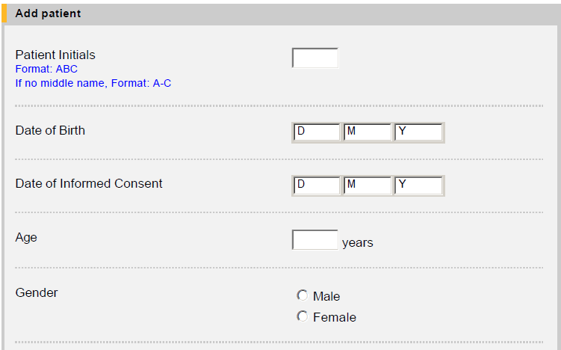
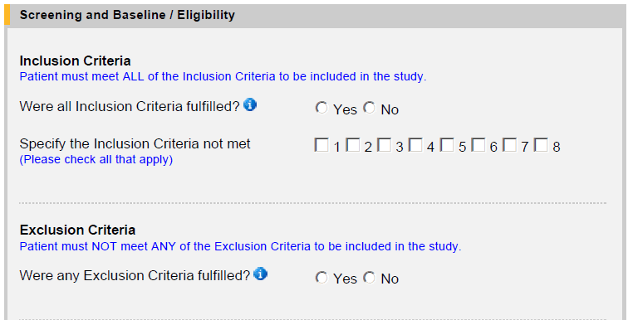
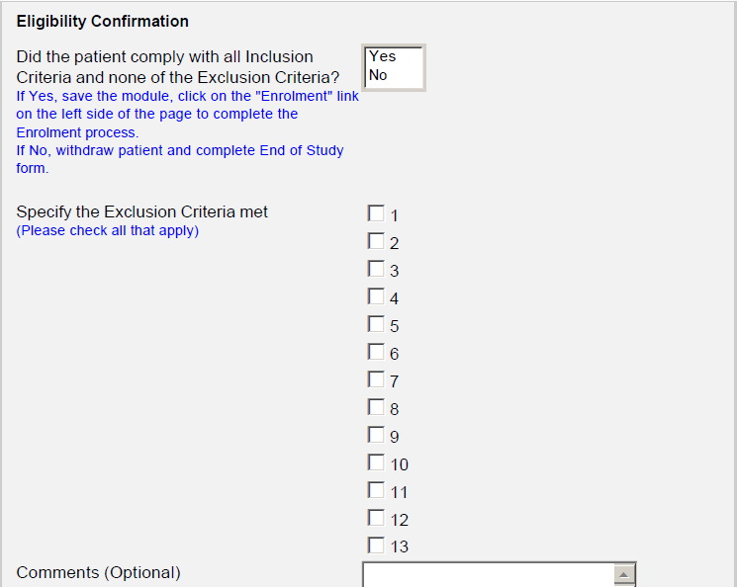
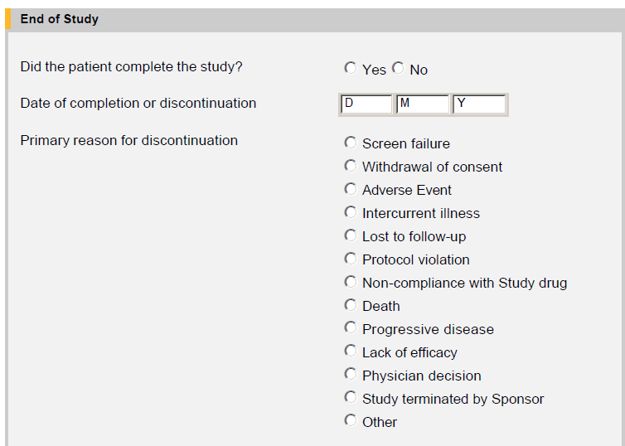
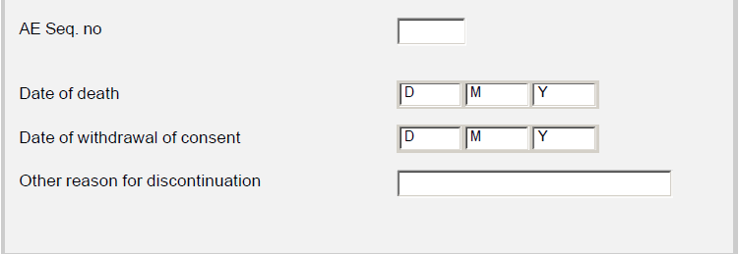
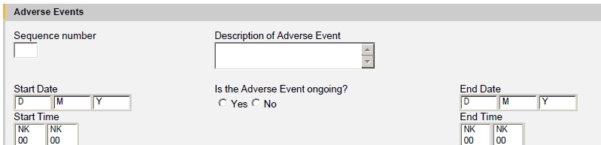
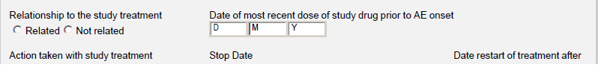
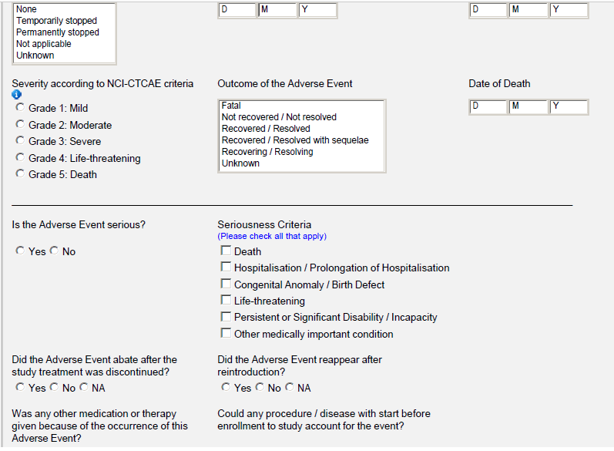

- Disposition of patients
N = 57
Patient screened
N= 48
Patients included
N = 9
Screening failures
Reasons:
Uncontrolled hypertension (1)
Cardiovascular disease (2)
Tromboembolism (2)
Any other serious illness (2)
ECOG 0-2 (1)
Withdrew of consent (1)
N= 48
Patients received medication
N= 39
Withdrawn
Reason:
Study terminated by Sponsor (22)
Death (17)
N= 9
Incorrect included
Reason:
-Untreated metastatic colorectal carcinoma (2)
-Age ≥ 70 (1)
-Patient with histological confirmed diagnosis of adenocarcinoma of the colon or rectum (1)
-Adequate hematological, renal and liver function as measured by: Urine dipstick of proteinuria <2+ (1)
-Any other serious or uncontrolled illness or treatment with a medicinal product that in the opinion of the investigator makes it undesirable for the patient to enter the trial (1)
-Untreated metastatic colorectal carcinoma and other malignancy within 5 years (1)
-Untreated metastatic colorectal carcinoma and Surgical procedure or significant traumatic injury within 28 days prior to first study treatment, or anticipation of need for major surgical procedure during the course of the study (1)
-Untreated metastatic colorectal carcinoma and Any other serious or uncontrolled illness or treatment with a medicinal product that in the opinion of the investigator makes it undesirable for the patient to enter the trial (1)
N= 0
Completed Study

- Adverse Event listning

- Protocol Deviations
Patient: | Protocol Deviations:
01-006 | Does not meet the inclusion criteria:  “Patient with histological confirmed diagnosis of adenocarcinoma of the colon or rectum”
01-008 | Does not meet the inclusion criteria:  “Age ≥ 70”
01-010 | Does not meet the inclusion criteria:  “Untreated metastatic colorectal carcinoma”  Meet the exclusion criteria:  “Other malignancy within 5 years”
01-011 | Does not meet the inclusion criteria:  “Untreated metastatic colorectal carcinoma”
01-012 | Does not meet the inclusion criteria:  “Adequate haematological, renal and liver function as measured by: Urine dipstick of proteinuria <2+”
01-013 | Does not meet the inclusion criteria:  “Untreated metastatic colorectal carcinoma”
01-022 | Does not meet the inclusion criteria:  “Untreated metastatic colorectal carcinoma”  Meet the exclusion criteria:  “Surgical procedure or significant traumatic injury within 28 days prior to first study treatment, or anticipation of need for major surgical procedure during the course of the study.”
01-034 | Meet the exclusion criteria:  “Any other serious or uncontrolled illness or treatment with a medicinal product that in the opinion of the investigator makes it undesirable for the patient to enter the trial.”
01-040 | Does not meet the inclusion criteria:  “Untreated metastatic colorectal carcinoma”  Meet the exclusion criteria:  “Any other serious or uncontrolled illness or treatment with a medicinal product that in the opinion of the investigator makes it undesirable for the patient to enter the trial.”

