2. SYNOPSIS:

Objective of the study was to evaluate the safety, efficacy and tolerability of the combination of electrochemotherapy and Ipilimumab.

PI aimed to recruit 30 patients with advanced melanoma cancer. This target was reduced to 10 patients as these patients are rare. No active control groups are involved in this study.

Patients with advanced malignant melanoma and who as a 1st or 2nd line treatment are due to receive Ipilimumab will be offered the combination of Ipilimumab and electrochemotherapy.

This study was designed to attempt to establish the safety and efficacy of sequential therapy using ipilimumab with electrochemotherapy in either treatment naive or in the second line setting.

Bleomycin was be injected prior to delivery of electroporation to accessible metastatic melanoma tumours after the second IPI administration (IPI delivered in 4 sessions, 3 weeks apart).

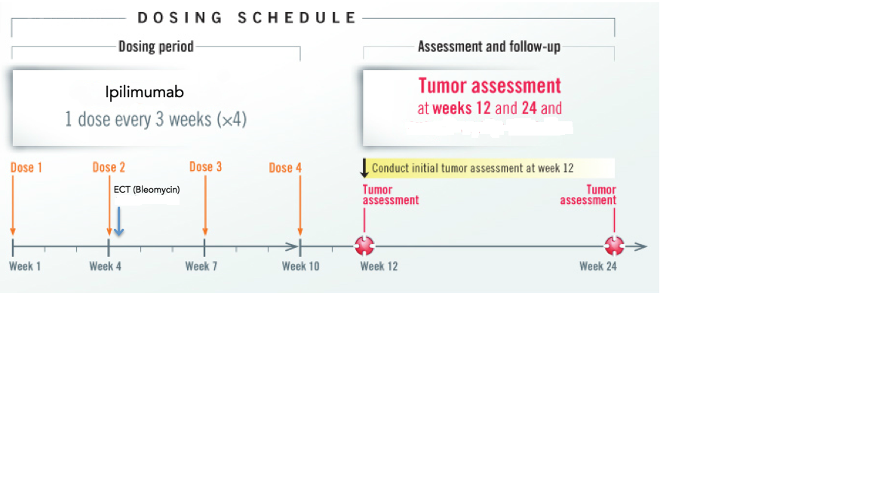

No meaningful statistical conclusions can be drawn from the study data due to the small sample size thus an abbreviated Clinical study report is being submitted to the regulators.

Data presented here will be descriptive only. Patient demographics, disposition of patients (how many completed, withdrew etc.) and data re tumour size pre and post treatment will be presented.
Safety data will also be included.

