Ketamine for Relapse Prevention in Recurrent Depressive Disorder: a randomised, controlled pilot trial (The KINDRED Trial)
EudraCT 2015-002020-37
HPRA reference: CT0900/559/002 - Ketamine/Midazolam Hydrochloride
Sponsor’s Reference: Protocol 20/15
Development phase: pilot trial of a novel use of an investigative medicinal product (ketamine hydrochloride) which has existing market approval
Study initiation date: 10th December, 2015 Study completion date: 28th May, 2018

Chief investigator/ Co-ordinating investigator: Prof. Declan McLoughlin
Contact details: Dept. of Psychiatry, St. Patrick’s University Hospital, James’ St., Dublin 8.
Email: d.mcloughlin@tcd.ie Telephone: 01 2493385
Sponsor: St Patrick’s Mental Health Services
Contact details: The contact person for the sponsor is: Professor J Lucey,
Postal: Office of the Medical Director, St Patrick’s University Hospital, James’ St., Dublin 8
Email: (Secretary) jbraddock@stpatsmail.com Telephone: (Secretary) 01 2493345

GCP Statement: The study was conducted in accordance with the principles that have their origin in the Declaration of Helsinki, in accordance with Good Clinical Practice (GCP), as defined by the International Conference on Harmonisation (ICH) and in accordance with the ethical principles underlying European Union Directive 2001/20/EC and 2005/28/EC.
Date of this report: 6th July, 2019

SYNOPSIS
Background
Depression is a common, serious mental illness, much of the burden of which is related to the relapsing nature of the illness. Effective treatments for acute depression have limited efficacy as relapse prevention methods. The new antidepressant, ketamine, has a different mechanism of action than traditional antidepressants and produces a rapid, robust antidepressant effect when administered as intravenous infusions. However, this agent has not yet been investigated as a possible relapse prevention method following successful treatment for acute depression.
Methods
A randomised, controlled, parallel-group, pilot clinical trial of ketamine vs. midazolam for depression relapse prevention in persons at high risk for relapse. The main purpose of the pilot study was to assess trial processes to help inform a future definitive trial.
Participants were recruited at admission to St Patrick’s University Hospital for treatment of DSM-IV-diagnosed recurrent unipolar depression and followed-up weekly to assess recovery according to standard criteria. Treatment-as-usual continued throughout the entire trial. Participants who met standardised response criteria were invited to be randomised to course of four two-weekly ketamine or midazolam (active comparator) infusions. Block randomisation was independently performed. Physical, psychotomimetic and cognitive outcomes were monitored before, during and after infusions. Participants were randomised to receive four two-weekly infusions of either ketamine at 0.05mg/Kg or midazolam at 0.045mg/Kg. Participants were followed up over six months to assess for relapse according to standardised criteria.
Results
Recruitment commenced Dec 2015 and was paused in Nov 2016 due to staff unavailability due to grant contract difficulties, resolved in April 2017. Researchers commenced employment May 2017 and recruitment recommenced May 16th, 2017.
In total n=3437 admissions were screened for eligibility and only n=103 of these were eligible, including after a trial protocol amendment to widen eligibility. 27% of eligible participants or n=28 participants were recruited to the monitoring phase, of which n=12 were eligible for the randomised treatment phase. In total only nine participants were randomised (five to ketamine, four to midazolam) and only five participants completed the randomised treatment protocol. Two non-serious non-severe suspected adverse reactions took place. Recruitment and randomisation figures were lower than expected and in October 2017, the Data Monitoring Committee advised that as the objectives of investigating feasibility outcomes had been met, the pilot trial was complete and further recruitment should be halted on Oct 31st 2017. Participants already recruited were to be offered randomised treatment, participants already randomised were to be followed up as per the Trial Protocol. The final assessment for the final participant took place on May 28th 2018, and end-of-trial was notified in July 2018. Information was gathered on reasons for non-recruitment, non-randomisation and drop-out, which included practical aspects of infusions and lack of interest in further treatment after recovery from the acute depressive episode.

Conclusions
The proposed treatment protocol is not suitable for a definitive trial. Information collected on reasons for dropout may inform future clinical trials of intravenous ketamine.

TABLE OF CONTENTS
Contents
SYNOPSIS 2
TABLE OF CONTENTS 4
LIST OF ABBREVIATIONS AND DEFINITION OF TERMS 10
1. ETHICS 11
1.1 Independent Ethics Committee (IEC) 11
1.2 Ethical Conduct of the Study 11
1.3 Patient Information and Consent 11
2. INVESTIGATORS AND STUDY ADMINISTRATIVE STRUCTURE 13
3. INTRODUCTION 14
4. STUDY OBJECTIVES 16
5. INVESTIGATIONAL PLAN 17
5.1 Overall Study Design and Plan-Description 17
5.2 Discussion of Study Design, including the Choice of Control Groups 18
5.3 Selection of Study Population 20
5.3.1 Inclusion criteria 20
5.3.2 Exclusion criteria 20
5.3.3 Removal of patients from therapy or assessment 21
5.4 Treatments 22
5.4.1 Treatments administered 22
5.4.2 Identity of investigational product(s) 22
5.4.3 Method of assigning patients to treatment groups 23
5.4.4 Selection of doses in the study 24
5.4.5 Selection and timing of dose for each patient 24
5.4.6 Blinding 24
5.4.7 Prior and concomitant therapy 24
5.4.8 Treatment compliance 26
5.5 Efficacy and Safety Variables 26
5.5.1 Efficacy and safety measurements assessed and flow chart 26
Table 2 Study Procedures at Infusion Clinics 28
5.5.2 Appropriateness of measurements 28
5.5.3 Primary efficacy variable(s) 29
5.5.4 Drug concentration measurements 29
5.6 Data Quality Assurance 29
5.6.1 Staff training and inter-rater reliability 29
Table 3 HRSD-24 Inter-Rater Reliability Assessment 30
5.7 Statistical Methods Planned in the Protocol and Determination of Sample Size 31
5.7.1 Statistical and analytical plans 31
5.7.2 Data Monitoring Committee 31
5.7.3 Determination of sample size 33
5.8 Changes in the Conduct of the Study or Planned Analyses 33
6. STUDY PATIENTS 35
6.1 Disposition of Patients 35
Figure 1. CONSORT Flow Diagram 36
Table 4: Reasons for ineligibility to the KINDRED trial 37
6.2 Deviations from protocol 37
7. EFFICACY EVALUATION 38
7.1 Data Sets Analysed 38
7.2 Demographic and Other Baseline Characteristics 38
Table 5. Baseline clinical and demographic factors 39
7.3 Measurements of Treatment Compliance 39
7.4 Efficacy Results and Tabulations of Individual Patient Data 40
7.4.1 Analysis of efficacy 40
7.4.2 Statistical/analytical issues 40
7.4.3 Tabulation of individual response data 42
Table 6. Weekly HRSD-24 scores in the Monitoring Phase 44
Table 7. Randomised participants in the KINDRED Treatment Phase 45
Table 8. Cognitive assessments at baseline and end of inpatient treatment among the Monitoring Phase participants 46
7.4.4 Drug dose, drug concentration, and relationships to response 46
7.4.5 Drug-drug and drug-disease interactions 47
7.4.6 Efficacy conclusions 47
8. SAFETY EVALUATION 48
Figure 2. Assessment results of participant infusions (n=25 infusions) 48
8.1 Extent of Exposure 50
8.2 Adverse Events (AEs) 50
8.2.1 Brief summary of adverse events 50
8.2.2 Display of adverse events 52
8.2.3 Analysis of adverse events 52
8.3 Deaths, Other Serious Adverse Events, and Other Significant Adverse Events 54
8.4 Clinical Laboratory Evaluation 54
8.4.1 Safety Conclusions 54
9. DISCUSSION AND OVERALL CONCLUSIONS 56
9.1 Conclusion 57
10. REFERENCE LIST 58
11. LIST OF APPENDICES 62
12. OTHER REPORT ITEMS 63
12.1 Listing of patients receiving test drug(s)/investigational product(s) from specific batches, where more than one batch was used 63
12.2 Audit certificates 63
12.3 Documentation of statistical methods 63
12.4 Documentation of inter-laboratory standardisation methods and quality assurance procedures if used 63
12.5 Discontinued patients 63
12.5.1 Protocol deviations 64
12.5.2 Patients excluded from the efficacy analysis 64
12.5.3 Demographic data 64
12.5.4 Compliance and/or Drug Concentration Data 64
12.6 Case Report Forms 64
12.6.1 CRFs of deaths, other serious adverse events and withdrawals for AE 64
12.6.2 Other CRFs submitted 65
12.7 Individual Patient Data Listings (US Archival Listings) 65
Appendix 1 66
Appendix 2 68
Appendix 3 70
Appendix 4 74
Appendix 5 76
Appendix 6 77
Appendix 7 84
Appendix 8 126
Appendix 9 133
Appendix 10 136
Appendix 11 138
Appendix 12 139
Appendix 13 145

LIST OF ABBREVIATIONS AND DEFINITION OF TERMS
BPRS: Brief Psychiatric Rating Scale
CADSS: Clinician-Administered Dissociative States Scale
ECT: electroconvulsive therapy
HRSD-24: Hamilton Rating Scale for Depression, 24-item
MSMTRD: Maudsley Staging Method for Treatment Resistance in Depression
NART: National Adult Reading Test
PRISE: Patient-Rated Inventory of Side Effects
SCID: Structured Clinical Interview for DSM IV Disorders
sMMSE: Standardised Mini Mental State Exam
SSRI: selective serotonin reuptake inhibitor
YMRS: Young Mania Rating Scale

ETHICS

Independent Ethics Committee (IEC)
This study was reviewed by:
The Research Ethics Committee of Mater Misericordiae University Hospitals, Dublin (an authorised REC for the purposes of clinical trials)
The Research Ethics Committee of St Patrick’s Mental Health Services, Dublin (the site REC).

Ethical Conduct of the Study
The study was conducted in accordance with the ethical principles that have their origins in the Declaration of Helsinki.

Patient Information and Consent
People admitted for treatment of a possible depressive episode in St Patrick’s Mental Health Services were screened and if eligible, were recruited to the trial. Prior to commencing recruitment, treating clinicians signed consent for inpatients under their care to be recruited to the trial if eligible. Clinical notes of newly admitted patients were screened for exclusion criteria and then patients who did not have clear exclusion factors were approached by a researcher to request verbal consent for advanced screening such as a HRSD-24 or sMMSE assessment. Patients who met all eligibility criteria were then provided with verbal and written information by a researcher and offered an opportunity to review and ask questions. Researchers returned to eligible potential participants to answer questions and meet with family members if requested, and if a participant expressed interest in participation, the consent form was completed with a clinician. Representative written information for the patient and a sample patient consent form as approved by the REC is provided, Appendices 2 and 3 respectively. Participant assent was confirmed at each step of the Monitoring Phase. On completion of their course of inpatient depression treatment, participants were assessed for eligibility for the Randomised Treatment Phase. On attendance for each randomised treatment session, consent was verbally confirmed with each participant.

INVESTIGATORS AND STUDY ADMINISTRATIVE STRUCTURE
A list of researchers and their qualifications is provided in Appendix 1, Log of Delegated Responsibilities.
This report was authored by Professor Declan McLoughlin and Martha Finnegan.

INTRODUCTION
Background
Depression is projected to become the second greatest cause of disability worldwide by 2020. According to the Irish mental health charity Aware, over 300,000 people in Ireland experience depression at any time (http://www.aware.ie/help/information/information-on-depression ). It is the most costly brain disorder in Europe, accounting for 1% (€118 billion annually) of the total European economy¹. Indeed, depression is currently the second largest cause globally for years lived with disability². It is thus a public health priority, additionally so in Ireland with worryingly high suicide rates (see http://nsrf.ie/wp-content/uploads/reports/SSISReport2013.pdf ).
One of the major reasons for the social and economic costs of depression is that it can be a chronic disorder. Over 50% of people who experience one depressive episode will have further episodes, with on average 5-9 episodes in their lifetime³. Even following successful antidepressant therapy for an acute episode, relapse rates are high, ranging 40-70%⁴. The first six months after remission represent the highest-risk period, with an average time to relapse of 3.5 months³. Much of the burden of depression is therefore contributed to by its relapsing nature.
It is well established that continuation treatment with antidepressants reduces the odds of relapse by 70%, independent of the underlying risk of relapse⁵. Nonetheless, relapse rates within six months are still too high at 40-70%⁶. A major challenge now is how best to prevent relapse after successful treatment of depression. However, remarkably, the evidence base for relapse prevention is small. For example, the National Institute for Health and care Excellence (NICE) in the UK have identified that evidence on relapse prevention in depression is limited and recommended research in this area⁷ (and https://www.nice.org.uk/guidance/cg90/chapter/4-research-recommendations ). To date, the reported randomised controlled trials for relapse prevention following successful antidepressant therapy have focused on the effect of 12 months’ tricyclic or SSRI antidepressant therapy, showing consistent but limited reduction in relapse rates⁸.
Ongoing registered trials of relapse prevention in depression (http://www.controlled-trials.com/isrctn and http://clinicaltrials.gov ) focus on psychological or internet-based interventions. This possibly reflects a lack of industrial interest in this important, but difficult, area. There is clearly a need for other, potentially better, methods for relapse prevention. One such possibility is the anaesthetic/analgesic ketamine.
Ketamine is a competitive glutamate N-methyl-D-aspartate receptor (NMDAR) antagonist with a half-life of 2-3 hours. Ketamine has a remarkably rapid antidepressant effect,^{9,10} targeting core symptoms in treatment-resistant depression when given as single sub-anaesthetic doses (usually a 40 minute 0.5 mg/kg intravenous infusion)¹¹. It is psychotomimetic (with abuse potential) but at low dosage it is safe.^{9;10;11;12} Only 1.45% of sub-anaesthetic infusions in patients and healthy controls have been reported to cause mild dissociative and psychotic symptoms that resolve soon after finishing infusions.^{13,14} To control for these effects, and also avoid “carry-over” effects in crossover studies while improving blinding, midazolam is now being used as an active control in parallel-group design trials rather than inactive placebo saline.¹¹ Thereafter robust antidepressant effects (average four-hour response rate of 77%) ⁹ occur and can persist for a few days, i.e. beyond immediate NMDAR blockade. Chronic, mostly recreational, high-dose ketamine use can cause uropathy and dependency¹⁵. However, repeated (e.g. 2-3/week for two weeks) infusions of sub-anaesthetic ketamine are safe with more sustained antidepressant effects in both antidepressant-free and ongoing-treated patients⁹.
Together, these findings have led to the most exciting development in treating and understanding depression in over 50 years and represent a paradigm shift away from conventional slow-acting monaminergic antidepressants. The PI and team completed a HRB-funded pilot trial of ketamine for depression relapse prevention following electroconvulsive therapy (EudraCT number 2014-004262-14; and NCT02414932 at www.clinicaltrials.gov ). However, no other trials have been reported using ketamine as an adjunctive treatment to reduce relapse rates following successful depression treatment - an important potential use of ketamine. We conducted a randomised, controlled, double-blind pilot trial of ketamine compared to midazolam for depression relapse prevention following successful recovery from a depressive episode in recurrent depressive disorder.

STUDY OBJECTIVES
The goal was to assess feasibility of the treatment protocol and gather information on reasons for non-recruitment, non-randomisation and drop-out to inform a future definitive trial. We hypothesized that the treatment protocol would be feasible and we hoped to randomize up to 40 participants. In particular, we aimed to report on feasibility outcomes: rates of recruitment, randomisation and treatment adherence.

INVESTIGATIONAL PLAN

Overall Study Design and Plan-Description
The trial was conducted at St. Patrick’s Mental Health Services, Dublin, an independent-sector 300-bed academic teaching hospital. The double-blind pilot trial design focused on gathering information about feasibility of the trial protocol.
We conducted a pragmatic parallel-group randomised placebo-controlled pilot trial, recruiting a cohort of patients with recurrent depressive disorder at admission to St Patrick’s Mental Health Services, including both St Patrick’s University Hospital (SPUH) and St Edmundsbury Hospital. Patients continued usual care (pharmacological, psychotherapeutic, occupational, or social) and were assessed weekly during treatment of the acute episode using the primary clinical outcome, the 24-item Hamilton Rating Scale for Depression¹⁶. Those subsequently identified as being treatment responders were invited to participate in a two-group parallel-design randomised controlled pilot trial (www.consort-statement.org ). Randomisation by sealed-envelope system using a computerised random allocation was performed independently at the Centre for Support and Training in Analysis and Research, University College Dublin. Participants were randomly allocated in a 1:1 ratio to an eight-week course of either two-weekly ketamine at 0.5mg/kg or the active comparator midazolam at 0.045mg/ kg, in 50 ml of saline over 40 minutes, as per previous ketamine trials⁹⁻¹³. Raters and participants were blinded to allocation. To facilitate generalizability of results, both groups continued usual care (e.g. regular medications, psychological and other therapies, out-patient review) during the randomised treatment phase and thereafter. Participants were followed-up over six months following treatment response for the index depressive episode (point of entry to the randomised trial) to identify if and when relapse occurred.

Ketamine/midazolam infusions were administered by a consultant anaesthetist and took place in a suite of clinical rooms on a day when there were no other clinical activities. Ketamine psychotomimetic effects and adverse events were assessed before (-60 mins), during (+20 mins) and after (+240 mins) infusions of ketamine or midazolam using the Clinician-Administered Dissociative States Scale (CADSS)¹⁷, Brief Psychiatric Rating Scale (BPRS; four-item positive symptom subscale)¹⁸, Young Mania Rating Scale (YMRS; mood item)¹⁹and Patient-Rated Inventory of Side Effects (PRISE)²⁰. Participants were followed-up over six-months following ECT to assess for relapse. Criteria for relapse were; ≥10 point increase in HRSD-24 compared to post-ECT score plus HRSD score ≥16; or hospital admission, further ECT, or deliberate self-harm. Inter-rater reliability for raters using HRSD-24 was assessed using intra-class correlation on a six-monthly basis and was above 0.96 on each occasion.
Baseline assessments included the Maudsley Staging Method for Treatment Resistance in Depression (MSMTRD)²¹, a multidimensional treatment resistance assessment in which scores 3-6 indicate mild resistance; 7-10: moderate; 11-15: severe treatment resistance. The National Adult Reading Test (NART)²² was performed at baseline and estimated premorbid full-scale IQ was obtained. The standardised Mini Mental State Examination (sMMSE)²³ was performed as a screening tool for eligibility and as a measure of global cognition at baseline.

Discussion of Study Design, including the Choice of Control Groups
The pilot trial design detailed here was chosen based on review of the existing literature on use of ketamine in depression, in which trial sizes have been modest since ketamine’s antidepressant action was first discovered over twenty years ago, and with little focus on the potential for ketamine to be utilised as a relapse prevention method. Success of blinding has rarely been reported and reasons for ineligibility, non-recruitment, non-randomisation and drop-out have not been reported. It is therefore unclear whether there may be unknown obstacles to recruitment of participants to ketamine trials. We chose to perform a pilot trial to assess logistical feasibility such as staffing requirement, safety and tolerability of the protocol, and feasibility in terms of recruitment, retention and follow-up to help inform a future definitive trial.
An active comparator, midazolam, was chosen as previously used by others in controlling for ketamine’s potential psychotomimetic effects. Midazolam is a psychoactive medication which may theoretically improve blinding by controlling for some of the effects of the investigative medicinal product, ketamine. However success of blinding has rarely been reported in ketamine trials, and we planned to asses and report success of blinding.
Selection of participants who had unipolar depression was necessary as, though trials of ketamine in bipolar depression have been published during the course of this trial, at the time of design it was not clear whether ketamine was safe for use in bipolar depression, or if it carried a potential for inducing mood switch in people with bipolar disorder. Similarly, ketamine’s safety in subanaesthetic doses has not been verified for pregnant women, foetuses, or breastfeeding women. In addition, other exclusion criteria were applied to protect vulnerable groups from any potential increased risk of coercion, such as the exclusion of prisoners and those who live in nursing homes, who may perceive their treatment options as limited. To further strengthen the rigour of the study, additional criteria were applied to select a relatively homogenous cohort of depressed inpatients with highly recurrent disorder, without comorbid Axis I illness. However, see details of a protocol amendment which lowered the threshold for recruitment in response to extremely low eligibility figures of those screened for recruitment. Response and remission criteria were standard for depression clinical research. The doses and method of administration of both ketamine and midazolam chosen for the study are standard in ketamine research in depression.

Selection of Study Population

Inclusion criteria
Inclusion Criteria for Monitoring Phase:
- ≥18 years old
- Hamilton Rating Scale for Depression, 24-item score of ≥21
- Voluntary admission for treatment of acute depressive episode
- Meet DSM-V criteria for recurrent depressive disorder (RDD): ≥2 previous depressive episodes with at least 2-months(consecutive) subthreshold or no symptoms in between
- Can provide valid informed consent
Inclusion Criteria for Randomised Treatment Phase:
For the randomised pilot trial, RDD patients must have:
- received antidepressant treatment for the acute depressive episode (pharmacological, psychotherapeutic or multidisciplinary)
- ≥60% decrease from baseline HRSD-24 score and score ≤16
- Mini-Mental State Examination (MMSE) score of ≥24
- be able to provide informed consent

Exclusion criteria
The following exclusion criteria were chosen with the objective of recruiting a representative group of people with recurrent depression. In addition, consideration was given to the balance of ensuring equal access to research participation while protecting from harm or coercion those who may be more vulnerable, e.g. those with limited autonomy.
- Current involuntary admission
- Medical condition rendering unfit for ketamine/midazolam
- Active suicidal intention
- Dementia
- History of Axis 1 diagnosis other than RDD
- ECT for treatment of index depressive episode
- Alcohol/substance abuse in previous six-months
- Pregnancy or inability to confirm use of adequate contraception during the trial

Removal of patients from therapy or assessment
No participants were withdrawn from the trial.
As specified in the Trial Protocol, all participants had the right to voluntarily discontinue study treatment or withdraw from the study at any time for any reason without any consequences. Investigators had the right to discontinue a subject from study treatment or withdraw a subject from the study at any time if it is in the best interest of the subject.
The following reasons were outlined as reasons for discontinuation:
- withdrawal of consent by the subject
- any medical condition that the investigator or sponsor determines may jeopardize the subject’s safety if she or he continues receiving the study treatment
- pregnancy
- ineligibility (either arising during the study or retrospectively having been overlooked at screening)
- an adverse event which requires discontinuation of the study medication
- treatment failure and disease progression
- Lack of compliance with the study and/or study procedures
Loss to follow-up was defined as at least three unsuccessful documented attempts to contact the participant.

Treatments

Treatments administered
The Trial Protocol specifies that participants would receive four infusions of either randomised treatment.
Investigative Medicinal Product - Ketamine Hydrochloride
Active Comparator - Midazolam Hydrochloride (Hypnovel)

Identity of investigational product(s)
Investigative Medicinal Product - Ketamine Hydrochloride 10 mg/ml infusion at 0.5mg/kg (Pfizer Healthcare Ireland) made up as 50ml colourless saline solution and administered intravenously over 40 minutes via syringe driver pump.
Active Comparator - Midazolam Hydrochloride (Hypnovel) 10mg/5ml solution at 0.045mg/kg (Roche Products Ireland Ltd) made up as 50ml colourless saline solution and administered intravenously over 40 minutes via syringe driver pump.
The treatments were securely in a clean dry area of the pharmacy department at St Patrick’s University Hospital. Products were prepared into infusions in the clinical rooms by the consultant anaesthetist who administered them, Dr Enda Shanahan. The anaesthetist was unblinded throughout and patients and raters remained in a separate area for infusions and assessments. Once made up as identical colourless solutions and labelled as trial infusions, infusions began within one hour of preparation. Any unused product was returned to pharmacy and disposed of according to the protocols specified by the pharmacy for destruction of unused pharmaceutical products.
The study treatment was stored at St Patrick’s University Hospital Pharmacy Dept. under the responsibility of the Chief Pharmacist, St. Patrick’s University Hospital.
Temperatures in the storage area of the pharmacy were monitored constantly by electronic thermostat and alarm process was instigated if the temperature varied from the specified room temperature. This did not occur during the course of the trial. The study treatment was stored locked in a secure area (Room 77 Store at St Patrick’s University Hospital) until dispensed for use.
Suppliers:
Ketamine: Pfizer Healthcare Ireland, 9 Riverwalk, Citywest Business Campus, Dublin 24.
Midazolam: Roche Products (Ireland) Ltd., 3004 Lake Drive, Citywest, Naas Rd., Dublin 24.

Method of assigning patients to treatment groups
Participants who met eligibility criteria for randomisation were allocated in a 1:1 ratio to a four-week course of either once-weekly ketamine or the active comparator midazolam. Randomisation by sealed-envelope system using a computerised random allocation was performed independently by statisticians at the Centre for Training and Analysis in Research at University College Dublin (CTSAR). Raters and participants were blinded to allocation.

Selection of doses in the study
Dose selection was based on previous studies, as detailed in Section 5.2. Dose per participant was fixed and dose selection was not performed during the course of the study.

Selection and timing of dose for each patient
Participants were administered randomised treatments according to a fixed dose regimen of up to four infusions on Wednesdays.

Blinding
Depressed participants in the Monitoring Phase who met eligibility criteria for randomisation were allocated in a 1:1 ratio to an eight-week course of either two-weekly ketamine or the active comparator midazolam. Randomisation by sealed-envelope system using a computerised random allocation was performed independently by statisticians at the Centre for Training and Analysis in Research at University College Dublin (CTSAR). Raters and participants were blinded to allocation. Success of blinding of participants and raters was assessed after the first infusion. Both groups continued usual care during the randomised treatment phase and thereafter. A trial-specific protocol for emergency unblinding (Appendix 4) was in place in order to provide for unblinding in the event of situations specified in the Trial Protocol. In order to allow for smooth use of the emergency unblinding protocol, the author met with Assistant Directors of Nursing in both inpatient units at the study centre and a drill emergency unblinding scenario was practiced twice during the recruitment phase with on-call nursing management staff.

Prior and concomitant therapy
Participants continued all usual treatment throughout the trial. Where a participant was identified as having been prescribed any of the following medications that participant was ineligible for participation as they may significantly alter the pharmacokinetics of ketamine. Additionally, the medication theophylline was contraindicated as concomitant use of ketamine and theophylline may significantly reduce the seizure threshold with reports of unpredictable extensor-type seizures.
Medications leading to ineligibility:
- Ketoconazole
- Voriconazole
- Itraconazole
- Telithromycin
- Clarithromycin
- Saquinavir
- Nefazodone
- Erythromycin
- Diltiazem
- Fluconazole
- Verapamil
- Theophylline
Medication history was checked at baseline in the Monitoring Phase and each subsequent assessment. Additionally, it was not permitted for subjects to participate in other investigational treatment studies while participating in this study. No participants were withdrawn due to use of contraindicated medications or other investigational treatment studies. One participant in the monitoring phase elected not to continue to the randomised treatment phase as they joined another clinical trial for a separate medical condition.

Treatment compliance
As all investigative medicinal products were administered in a participant-blinded intravenous infusion, no difficulties with treatment compliance were identified and no measures to increase compliance were necessary.

Efficacy and Safety Variables
The aim of this pilot trial was to assess feasibility of the clinical trial protocol. The variables described below were used to assess safety and tolerability of the investigative medicinal products in the contact of this trial protocol and to assess the feasibility of use of these efficacy outcomes in a well-powered trial. Therefore, these were not used for assessment of efficacy outcomes.

Efficacy and safety measurements assessed and flow chart
Participants in the Monitoring Phase had a baseline assessment (Table 1) and weekly assessments using the HRSD-24 during their inpatient depression treatment, followed by a final monitoring assessment prior to discharge to examine for eligibility to the randomised treatment phase. Participants in the Randomised Treatment Phase had assessments at each infusion session as detailed in Table 2. Adverse event data were collected by researchers and categorised according to EU Regulation No 536/2014 which defines:
(32) ‘Adverse event’ means any untoward medical occurrence in a subject to whom a medicinal product is administered and which does not necessarily have a causal relationship with this treatment;
(33) ‘Serious adverse event’ means any untoward medical occurrence that at any dose requires inpatient hospitalisation or prolongation of existing hospitalisation, results in persistent or significant disability or incapacity, results in a congenital anomaly or birth defect, is life-threatening, or results in death;
(34) ‘Unexpected serious adverse reaction’ means a serious adverse reaction, the nature, severity or outcome of which is not consistent with the reference safety information.
  - Table 1. Flowchart of assessments during the KINDRED pilot trial
Baseline Interview | Monitoring Phase | Post-ECT | Randomised Treatment Phase | Follow-up
Assessment battery  HRSD-24  Standardised Mini Mental State Exam (sMMSE)  Structured Interview for Diagnosis (Mood disorders)  Childhood Trauma Questionnaire  Maudsley Treatment Resistance Scale for Depression  Verbal Fluencies  Verbal Learning (modified ACE III)  Trails A+B  Digit Spans  National Adult Reading Test  Edinburgh Handedness Questionnaire | Depression treatment as usual  Weekly  HRSD-24 | Repeat Assessment battery | Four two-weekly infusions of ketamine or midazolam  Assessments as per Table 2 | Weeks 6, 8, 12, 20 and 26  HRSD-24

Table 2 Study Procedures at Infusion Clinics
Timepoint | -60 minutes | 0 minutes | +20 minutes | +40 minutes | +240 minutes
Timepoint | Pre-infusion | Start of infusion | Mid-infusion | End of infusion | Post-infusion
Depression Severity | HRSD-24 |  |  |  | HRSD-11
Physical Health | Pre-infusion vitals | Vitals monitored every ten minutes | Vitals monitored every ten minutes | Vitals monitored every twenty minutes | Post-infusion vitals
Psychotomimetic Effects | Baseline |  | Mid-infusion |  | Post-infusion
Psychotomimetic Effects | - CADSS |  | - CADSS |  | - CADSS
Psychotomimetic Effects | - BPRS |  | - BPRS |  | - BPRS
Psychotomimetic Effects | - YMRS |  | - YMRS |  | - YMRS
Tolerability | Baseline |  | Mid-infusion |  | Post-infusion
Tolerability | - PRISE |  | - PRISE |  | - PRISE
Participant Comfort | Arrival checklist |  |  |  | Departure checklist

Appropriateness of measurements
The assessments chosen are standard assessments for assessment of depression severity (HRSD-24) and cognition (NART, MMSE – baseline only); (ACE-III, Digit Span forward and backward, Trails A and B).
In addition, the assessments used in assessing for physical and psychotomimetic side effects of ketamine (CADSS, BPRS, PRISE and YMRS) are standard in the field of ketamine clinical trials for depression. None of the safety assessments is novel or unusual in this area.

Primary efficacy variable(s)
This pilot trial did not have primary efficacy variables. The aim of the trial was to assess feasibility of the clinical trial protocol e.g. recruitment and randomisation rates, drop-out, and the reasons for same. The projected sample size was not designed to assess efficacy and no efficacy threshold was set. The small final number of trial participants is not suitable for efficacy analysis.

Drug concentration measurements
No drug concentrations were measured during this study. All participants were fasting for 8 hours and resting for one hour prior to drug administration. No nicotine use was permitted for one hour prior to drug administration. All participants were reclining on surgical trolleys for one hour prior to and during drug administration.

Data Quality Assurance
An eight-step Data Quality Assurance Protocol (Appendix 5) was compiled for application by all researchers to any data collected during the conduct of these studies. As participant numbers were lower than expected, item 7 in the Protocol (“Every six months, statistical analyses will be carried out to uncover any remaining input errors”) did not take place as simple observation by two researchers was sufficient to uncover input errors. Similarly, due to the small numbers of participants, it was sufficient for data entry to be reviewed by the Trial Management Group on a weekly basis rather than by the Data Monitoring Committee on a six-monthly basis.

Staff training and inter-rater reliability
All raters underwent extensive training prior to commencing trial recruitment. Inter-rater reliability analysis for the primary clinical outcome, the HRSD-24, was performed at least six-monthly and results are presented in Table 3 below. Training on use of both the HRSD-24 consisted of the following steps:
- Independent reading of assessment materials
- Consensus meeting to agree detailed criteria for scoring according to manual
- Observation of an experienced rater administering the assessment to depressed inpatients (with written informed consent) with a variety of clinical presentations
- Conduct of five assessments supervised by an experienced rater and discussion
- Video recording of five other assessments conducted independently for playback and discussion with experienced raters (with written informed consent)
Training on all other assessments consisted of independent reading of assessment materials, discussion with experienced raters, supervised conduct, discussion and then independent conduct of assessments.

Table 3 HRSD-24 Inter-Rater Reliability Assessment
Date | No. of raters | Intraclass Correlation Coefficient
Nov 2015 | 2 | 0.97
Mar 2016 | 3 | 0.96
Jul 2016 | 5 | 0.96
Nov 2016 | 3 | 0.99
May 2017 | 4 | 0.95
Jul 2017 | 5 | 0.98
Randomisation to the KINDRED trial was concluded at this time point but raters continued to perform HRSD-24 assessments in the trial follow-up phase and were thus included in inter-rater reliability assessment.

No independent auditing service was utilised, internal audit of all completed case report forms took place on a six-monthly basis.

Statistical Methods Planned in the Protocol and Determination of Sample Size

Statistical and analytical plans
A statistical analysis plan for the pilot trial is attached in full as Appendix 13.

Data Monitoring Committee
An independent Data Monitoring Committee was formed which met on a six-monthly basis throughout the trial to review reports compiled by researcher Martha Finnegan and Principal Investigator Declan McLoughlin. The Charter for the Data Monitoring Committee was ratified at the organisational meeting of the Committee and is attached as Appendix 6.
Members of the Data Monitoring Committee were:
- Dr Brian Hallahan (DMC Chairperson, Clinical Investigator)
- Dr Consilia Walsh (Clinical Investigator)
- Dr Fiona Boland (Statistician)
The Committee met independently on a six-monthly basis to review a report containing blinded data prepared by the team and circulated two weeks prior to the meeting. Meeting dates are as below:
  - 28.1.16
  - 26.5.16
  - 27.10.16
  - 20.4.17
  - 21.9.17
A Trial Steering Committee was formed and met on a six-monthly basis throughout the trial to review the recommendations of the Data Monitoring Committee and a report compiled by researcher Martha Finnegan, and to make a recommendation regarding continuation of recruitment and randomisation. Members of the Trial Steering Committee were:
- Dr John Cooney, TSC Chairperson
- Prof Declan McLoughlin (PI)
- Dr Martha Finnegan (Research Registrar)
- Dr Karen Ryan (Postdoctoral Researcher, TCIN)
- Ms Toni Galligan (Research Assistant, TCD)
- Ms Claire McGrory (Research Assistant, TCIN)
- Ms Gabriele Guscuite (Research Assistant, TCD)
- Professor Leslie Daly (Trial Statistician)
- Ms Claire Slattery (Research Assistant)
- Ms Meabh Foley (Research Assistant)
- Mr Sean Fitzpatrick (Service User Representative)
- Prof Jim Lucey (Trial Sponsor Representative)
- Dr Enda Shanahan (Collaborator, Anaesthetist)
- Ms Louise Donnelly (Research Nurse)
A Trial Management Group consisting of the Principal Investigator, author and other researchers met weekly during the trial to discuss recruitment figures. Due to the small final participant numbers, no interim analyses took place. TMC met on a regular basis, dates as below:
- 7.6.16
- 22.11.16
- 18.5.17
- 2.11.17
- 19.9.18

Determination of sample size
In line with the pilot trial design a formal sample size calculation was not performed. Based on examination of publicly available data about the number of admissions for depression at the study site per year, our own team’s experience in recruitment to interventional trials, and the literature on remission rates following inpatient treatment for depression, we expected N=98 to be recruited upon admission, expecting that at least n=51 would meet response criteria and that n=40 would consent to be randomised. This provided an estimated sample size of n=20 per group for the purposes of this pilot trial.

Changes in the Conduct of the Study or Planned Analyses
An approved amendment to the Trial Protocol was put in place following REC and HPRA approval. Inclusion criteria for the initial Trial Protocol required that participants had ≥ 3 depressive episodes in 2 years for recruitment to the monitoring phase, in order to enrich the sample to achieve a highly recurrent population. This set eligibility at a higher threshold than the standardised DSM IV criteria for recurrent depressive disorder. In 2016, it became apparent that a low percentage of those screened were eligible to take part in the monitoring phase (2.5%), restricting the number of participants who could be randomised after the monitoring phase. A new criterion was proposed and approved: Eligibility of people with recurrent depressive disorder to be amended from ≥ 3 episodes including the instant depressive episode within two years, to ≥2 episodes including the instant episode within 2 years.
- Discussed by DMC, TSC (May 2016)
- Approved by Mater Hospitals REC (Aug 2016)
- Approved by HPRA (Oct 2016)
- Approved by SPMHS (site) REC (Nov 2016)
As randomisation rates were lower than anticipated interim analyses did not take place. Due to the small final number of participants, comparisons as planned in the Statistical Analysis Plan and Trial Protocol were not appropriate and therefore only descriptive statistics are used.

STUDY PATIENTS

Disposition of Patients
Please see the CONSORT flow diagram (Figure 1) for disposition of all patients.
Phase II participants who discontinued the randomised treatment phase are listed individually with reasons for discontinuation in individual line listings. Table 4 outlines in detail reasons for ineligibility.
The trial was deemed complete when the primary objective – to assess feasibility of the trial protocol – had been achieved, and the DMC recommended halting recruitment in October 2017, but continuing to offer existing participants the opportunity of randomisation. Figure 1 (CONSORT flow diagram) illustrates the trial profile and reasons for ineligibility, non-recruitment, non-randomisation and drop-out at each step. Additional detail on reasons for ineligibility is presented in Table 4.

Excluded n=3409
Ineligible: n=3334 (98%)
No consultant consent n=193
Involuntary admission n=90
Other Active Axis I disorder n=1605
Primary Axis II disorder n=202
Subs abuse within 6/12 n=230
MMSE <24 n=41
HRSD <21 n=73
Already in trial n=30
Memory Clinic admission n=29
Not ≥3 episodes depression: n=257
Of these, ≥2 episodes n=39
Then: Not ≥2 episodes depression: n=137
No inter-episode wellness: n=75
Medical condition/medication: n=21
Active suicidal intention: n=14
Early discharge/AMA: n=47
Medication adjustment only: n=15
ECT within last 6/12 or this episode: n=252
Unable to consent: n=2
NH resident n=1
Diagnosis or treatment unclear n=20

Eligible but declined: n=75
Lack of interest in trial: n=27
Anxiety n=15
Assessment burden n=1
Did not want additional medication: n=8
Pt does not believe self depressed: n=1
Could not be reassured re IMP: n=4
Lack of post-trial treatment: n=1
Travel n=5
Pt does not have a person to stay with them for 24 hours n=1
Family advised against n=1
Unspecified = 11

Figure 1. CONSORT Flow Diagram

Admissions assessed for eligibility n=3437
Not randomized (n=19)

Total eligible for Phase II n=12
Declined: n=3 (33% of eligible)
- Travel: n=3
Ineligible for Phase II (n=15, 70%)
Not eligible due to HRSD score (n=11)
New medical problem (n=1)
Withdrew from Phase I due to assessment burden (n=1)
Joined another clinical trial (n=1)
Referred for ECT (n=1)

Allocation
Included Phase I (n=28)
(27% of eligible n=103)

Randomized (n=9)
(66% of eligible)
5% of n=11 eligible)

Allocated to Ketamine (n=5)
Received 4 infusions n=3
Received 1 infusion n=2
Allocated to Midazolam (n=4)
Received 4 infusions n=2
Received 2 infusions n=1
Received 1 infusion n=1

Follow up
Midazolam (n=4)
Relapsed in treatment n=2
Discontinued (travel) n=1

Relapse week 12 follow up n=1

Ketamine (n=5)
Relapsed in treatment n=1
Discontinued (travel) n=1
Discontinued (AR) n=1

Relapse week 20 follow up n=1
Dropped out follow up n=1

Table 4: Reasons for ineligibility to the KINDRED trial
Factor | N
Total number of admissions not recruited | 3409
Exclusions due to ineligibility | 3334
Diagnosis other than RDD | 1807
Other Active Axis I disorder | 1605
BPAD | 511
Schizoaffective disorder | 106
PTSD | 46
Eating disorder | 51
Schizophrenia | 83
GAD | 154
OCD | 85
ADS | 391
Other Axis I disorders | 145
Primary Axis II disorder | 202
MDE not meeting inclusion criteria | 469
Not >3 or >2 episodes | 394
No inter-episode wellness | 75
Factors other than diagnosis | 79
Involuntary admission | 22
Referral for ECT | 13
HRSD-24 score <21 | 73
ECT within 6 months | 252
Subs abuse within 6 months | 230
sMMSE score <24 | 41
Unable to consent | 2
Already in trial | 30
Medical condition | 20
No treating team consent | 193
Involuntary admission | 90
Other | 112
MDE: Major Depressive Episode as per DSM IV diagnostic criteria; BPAD: Bipolar Affective Disorder as per DSM IV; PTSD: Post Traumatic Stress Disorder; GAD: Generalised Anxiety Disorder; SCID: Structured Clinical Interview for DSM disorders; ECT: electroconvulsive therapy; HRSD-24: Hamilton Rating Scale for Depression, 24-item; sMMSE: standardized Mini Mental State Exam.

Deviations from protocol
There were no deviations to the study inclusion or exclusion criteria, conduct of the trial, patient management or patient assessment. In particular, there were no incidents of participants:
• who entered the study even though they did not satisfy the entry criteria
• who developed withdrawal criteria during the study but were not withdrawn
• who received the wrong treatment or incorrect dose
• who received an excluded concomitant treatment

EFFICACY EVALUATION

Data Sets Analysed
Efficacy analysis was not planned as part of the pilot trial design and no efficacy endpoint was outlined. Feasibility outcomes were the primary trial outcomes. Final participant numbers indicate the non-feasibility of the trial protocol at this centre and also indicate that statistical analysis of efficacy is not possible in this data set. Randomised participants are therefore described but not compared according to treatment arm. No randomised participants were excluded from description and the disposition of all randomised participants (drop-out, follow-up etc.) is described with no exclusions.

Demographic and Other Baseline Characteristics
Demographic and baseline data for the Monitoring Phase participants is outlined in Table 6. All participants identified as White Irish ethnicity. Frequencies of medication use at baseline were: SSRI antidepressant (8 people, 28.6%); non-SSRI antidepressant (19, 67.9%); mood stabiliser (9, 32.1%), antipsychotics (10, 35.7%); benzodiazepine (12, 42.9%).

Table 5. Baseline clinical and demographic factors
Variable | Mean (SD)
Age (years) | 51.8 (15.9)
Sex n,% female | 20 (71.4%)
Admission HRSD-24 | 29.3 (5.3)
Age at onset of depression | 36.2 (14.3)
Number of episodes of depression | 5.2 (2.4)
Duration of this episode (days) | 114.2 (99.5)
Years in education | 13.8 (3.5)
Predicted full-scale IQ (NART) | 109.4 (9.2)
Maudsley Staging Method for Treatment Resistance in Depression | 6.7 (1.3)
Baseline sMMSE score | 28 (2)
BMI | 30.3 (6.7)
Marital status (n, % married) | 13 (46.4%)
Employment status (n, % employed) | 11 (39.3%)
Medication (n, %)
SSRI | 8 (28.6%)
Non-SSRI ADT | 19 (67.9%)
Mood Stabiliser | 9 (32.1%)
Antipsychotic | 10 (35.7%)
Benzodiazepine | 12 (42.9%)
Psychotic symptoms (n, %) | 0
Lifetime history of alcohol abuse (n, %) | 4 (14.3%)
Lifetime history of substance abuse (n, %) | 3 (10.7%)
Family history of alcohol abuseª (n, %) | 9 (32.1%)
Data are presented as mean and SD unless otherwise specified. ªfirst and second degree relatives were accepted as family members. Abbreviations: BMI: body mass index; HRSD-24: Hamilton Rating Scale for Depression, 24-item; sMMSE: standardised Mini Mental State Exam.

Measurements of Treatment Compliance
There were no measurements of treatment compliance performed during the study, due to the supervised intravenous administration method chosen.

Efficacy Results and Tabulations of Individual Patient Data

Analysis of efficacy
Due to the pilot trial design and the small number of recruited participants, efficacy analysis was not possible or appropriate. Participant outcomes have therefore been described in narrative fashion and using descriptive statistics.

Statistical/analytical issues
Due to the small final number of participants, comparison between randomised groups is not appropriate, therefore only descriptive statistics were applied.

Adjustments for Covariates
Due to the small number of trial participants, no adjustment for covariates could be performed.

Handling of Dropouts or Missing Data
Due to the small final number of randomised participants, no attempt was made to deal with missing data as comparison between randomised groups is not appropriate. The participant who dropped out from the Monitoring Phase provided consent for baseline information to be reported with other Monitoring Phase participants. Participants who were randomised and discontinued randomised treatment after at least one infusion were followed-up as per the Trial Protocol and are reported here. The participant who dropped out at the follow-up phase provided consent for information collected up to that point to be reported.

Interim Analyses and Data Monitoring
No interim analyses were performed. On one occasion while investigating a suspected adverse event, the blind was broken for one rater and the participant, following the trial-specific emergency unblinding protocol. All ratings for this participant had already been collected under double-blind conditions. No other breaking of the blind occurred until after the last visit of the last participant. Throughout the conduct of the trial, reports were prepared for review by the Data Safety Monitoring Board. These consisted of descriptive reports of rates of recruitment, randomisation and adherence as well as descriptive safety data.

Multiple Comparisons/Multiplicity
Due to the pilot trial design and small number of participants, no comparison was possible between randomised groups. Therefore no correction for multiple comparisons has taken place.

Use of an "Efficacy Subset" of Patients
An intention-to-treat analysis was deemed most appropriate for this study, involving all participants who were randomised and completed at least one randomised treatment infusion session. However due to the small number of participants, no comparison between randomised groups could take place. These groups are therefore described in this report.

Active-Control Studies Intended to Show Equivalence
This pilot trial design was not intended to assess efficacy in terms of non-inferiority or otherwise.

Examination of Subgroups
Due to the small number of participants, no subgroup analysis is possible.

Tabulation of individual response data
Response data are detailed as below. This pilot trial was not designed to assess efficacy and due to low participant numbers, analysis by group is not appropriate. Descriptive statistics are therefore used throughout. The primary outcomes are feasibility outcomes.

Feasibility
This trial protocol was deemed not feasible as randomisation and adherence rates were inadequate, demonstrating that a definitive trial of ketamine for depression relapse prevention would not be possible using this trial protocol. Reasons for ineligibility, non-recruitment, non-randomization and non-adherence are detailed in Figure 1 and Table 5.
Eligibility, recruitment, randomisation, adherence and follow-up rates were lower than expected. Whilst the protocol amendment detailed above lowered the threshold to allow more of those who were screened for the monitoring phase to be deemed eligible, participant numbers were far below those predicted and analysis by groups was therefore not possible.
In assessment of blinding, participants guessed correctly 66% of the time (6 of 9 guesses) and raters guessed correctly 66% of the time (8 of 12 guesses).

Treatment outcomes and symptom rating scores
Weekly HRSD-24 scores in the Monitoring Phase are presented in Table 6. This cohort was recruited due to a history of recurrent depressive disorder. Response criteria were met by 57% of Monitoring Phase participants (n=16) and remission achieved by 41% (n=12). All participants had a baseline HRSD-24 and n=27 participants had a pre-discharge HRSD-24 (one participant withdrew from the monitoring phase citing assessment burden). Weekly HRSD-24 scores on decreasing numbers of participants reflect the end of inpatient treatment due to response or other factors, such as medical illness. In order to progress to randomisation, participants had to display a ≥60% decrease from baseline HRSD-24 score and score ≤16.

Table 6. Weekly HRSD-24 scores in the Monitoring Phase
Variable | Mean (SD) | n
Admission HRSD-24 | 29.4 (2.5) | 28
Monitoring Phase Week 1 HRSD-24 | 20.8 (6.2) | 24
Monitoring Phase Week 2 HRSD-24 | 23.3 (3.4) | 21
Monitoring Phase Week 3 HRSD-24 | 19.5 (4.1) | 15
Monitoring Phase Week 4 HRSD-24 | 23.4 (4.1) | 10
Monitoring Phase Week 5 HRSD-24 | 24.1 (3.4) | 7
Monitoring Phase Week 6 HRSD-24 | 23.4 (3.7) | 5
Monitoring Phase Week 7 HRSD-24 | 22.7 (2.1) | 4
Monitoring Phase Week 8 HRSD-24 | 19 | 1
End-of-admission HRSD-24* | 15.04 (10.2) | 27
Response criteria met (n, %) | 16 (57%) | 28
Remission criteria met (n, %) | 12 (41%) | 28
Data are presented as mean (SD) unless otherwise specified. Monitoring Phase participants were monitored weekly during admission using the HRSD-24 . *One participant withdrew after baseline assessments and did not have an End-of-admission HRSD-24

Table 7. Randomised participants in the KINDRED Treatment Phase
 | Age | Sex |  | Infusions |  | Baseline  HRSD-24 |  |  | Adverse reaction | Reason for discontinuation |  | Relapse during 6-month follow-up |  | Time to relapse
1 | 50 | M | Ketamine |  | 4 |  | 32 |  |  |  | Nil |  | Yes | Week 20
2 | 50 | F | Midazolam |  | 1 |  | 32 |  |  |  | Relapse |  | N/A | Treatment phase
3 | 72 | F | Ketamine |  | 1 |  | 45 |  |  |  | Travel |  | Dropout | Unknown
4 | 37 | F | Midazolam |  | 1 |  | 32 | Pruiritis, urticaria |  |  | Relapse |  | N/A | Treatment phase
5 | 46 | F | Ketamine |  | 1 |  | 22 | Hypersensitivity |  |  | AR |  | No | N/A
6 | 40 | M | Midazolam |  | 4 |  | 21 |  |  |  | Travel |  | No | N/A
7 | 40 | F | Midazolam |  | 4 |  | 34 |  |  |  | Nil |  | Yes | Week 12
8 | 31 | M | Ketamine |  | 4 |  | 23 |  |  |  | Nil |  | No | N/A
9 | 56 | M | Ketamine |  | 2 |  | 34 |  |  |  | Nil |  | No | N/A

Randomised Participants
Nine participants were randomised, aged between 31 and 72 years, five females and four males, all of White Irish ethnicity (Table 7). The groups were too small for formal comparison of clinical outcomes or baseline variables. Two participants relapsed within the randomised treatment phase, both in the midazolam treatment group. Three further participants elected to discontinue randomised treatment, two citing travel and one citing discomfort due to a suspected adverse reaction as the primary reason and travel as the secondary reason. Within the six-month follow up phase, one participant elected to discontinue follow-up, citing lack of interest in continuing assessments. Of the remaining six participants who completed full follow-up to relapse or to 26 weeks, two participants relapsed within the follow-up period (one in the ketamine group and one in the midazolam group), at weeks 20 and 26 respectively.

Cognition
Cognitive measures including a modified Addenbrooke’s Cognitive Examination- Revised (ACE-R)²⁴; Digit Spans²⁵; Trails A and B²⁶ were performed at baseline and end-of-inpatient-treatment, as well as at final follow-up at week 26 among those who completed to week 26 (n=3). Parallel versions were used where available. National Adult Reading Test (NART) is a measure of premorbid intelligence relative to expected intelligence (i.e. NART assesses IQ) and was performed once at baseline assessment (see baseline demographics). These were non-prioritised secondary outcomes completed by a subset of participants. Comparative analyses were not performed and data are presented below, with a general trend toward improvement of cognitive outcomes at the end of inpatient treatment for depression.

Table 8. Cognitive assessments at baseline and end of inpatient treatment among the Monitoring Phase participants
Instrument | Baseline |  |  | Follow-up
Instrument | N | Median (Range) |  | N | Median (Range)
Letter fluency (of 7) | 24 | 5 (1-7) |  | 24 | 5 (3-7)
Category fluency (of 7) | 24 | 5 (2-7) |  | 24 | 6 (0-7)
Immediate recall (of 7) | 24 | 7 (5-7) |  | 24 | 7 (7-7)
Delayed recall (of 10) | 24 | 9 (7-10) |  | 24 | 10 (4-10)
Retrograde semantic memory (of 4) | 24 | 4 (0-4) |  | 24 | 4 (3-4)
Modified ACE-III (of 35) | 25 | 29 (20-35) |  | 24 | 30.5 (20-35)
Forward digit span (of 14) | 27 | 8 (3-14) |  | 22 | 8.5 (4-14)
Backward digit span (of 14) | 27 | 6 (2-12) |  | 22 | 4.5 (2-12)
Trail-making test A (seconds) | 26 | 32.5 (15-62) |  | 22 | 30 (15-53)
Trail-making test B (seconds) | 26 | 91 (28-210) |  | 22 | 68 (25-174)
sMMSE (of 30) | 26 | 29 (21-30) |  | 24 | 29 (22-30)
Data are presented as median (range) due to non-parametric distribution.

Drug dose, drug concentration, and relationships to response
Doses did not vary between participants. All infusions were administered as per the Trial Protocol and no assessment of drug concentration was required.

Drug-drug and drug-disease interactions
Due to the pilot trial design and small number of participants, no efficacy analysis can take place, Therefore, no analyses to account for the effects of concomitant therapy or comorbid illness can take place.

Efficacy conclusions
Due to the pilot trial design and small number of participants, no efficacy analysis can take place.

SAFETY EVALUATION
Tolerability of the trial agents was assessed at multiple points before, during and after treatment sessions according to the assessments outlined in Table 2.

Figure 2. Assessment results of participant infusions (n=25 infusions)
PRISE: Patient-Rated Inventory of Side Effects, YMRS: Young Mania Rating Scale, BPRS: Brief Psychiatric Rating Scale, CADSS: Clinician-Administered Dissociative States Scale, HRSD: Hamilton Rating Scale for Depression. A 24-item HRSD was performed at 0 minutes, thereafter a modified 11-item HRSD was performed to assess for change on sensitive items.

Figure 2 illustrates pre-infusion, intra-infusion and post-infusion assessments each infusion for each randomised participant. As all participants were euthymic responders to inpatient treatment for depression, HRSD-24 scores were low pre-infusion, and small changes in HRSD scores during and after infusions cannot be compared across treatment arms in this limited trial population. As expected, on completion of the modified 11-item HRSD which allows for change, absolute scores were lower during and after infusions, an effect which is not present on controlling for baseline scores on the items carried over.
The figure illustrates a lack of change on BPRS and YMRS scales in both treatment arms, with most scores remaining at baseline throughout the assessment process across all infusions. In contrast, PRISE scores in both treatment arms demonstrate great variability in pattern, with a variety of baseline and end-of-infusion scores, and patterns of both increasing and decreasing scores during infusions. This may suggest that these instruments are not ideal for assessing participant experience during infusions, due to either not sufficiently sensitive or overly sensitive to change, but participant numbers are too small in this trial to explore this issue.
CADSS scores displayed an expected pattern of low baseline scores, some elevation during infusions, and return to baseline scores. The majority of midazolam infusions did not display this pattern, and overall intra-infusion CADSS scores were higher in the ketamine treatment arm, consistent with the reported adverse effects of ketamine and the experience of some participants of dissociation in this trial as reported in detail in 8.2.1.
Vital signs (heart rate, blood pressure, oxygen saturations and blood glucose) were monitored as per the trial protocol. No persisting hemodynamic changes (defined as heart rate >110/minute or systolic/diastolic blood pressure >180/100 or >20% increase above pre-infusion BP for more than 15 minutes) were noted. Stable oxygen saturation, heart rate, electrocardiogram (EKG) rhythm were observed in all participants at fourteen timepoints over 300 minutes before, during and after infusions.
Statistical analysis was not performed due to the small number of completed assessments.

Extent of Exposure
Due to the small number of participants randomised in this pilot trial, exposure cannot be analysed according to race or gender.
• Duration:
Ketamine: three participants received an eight-week course of four fortnightly infusions; one participant received only one infusion.
Midazolam: Two participants received an eight-week course of four fortnightly infusions, one participant received a four-week course of two fortnightly infusions, and one participant received only one infusion.
The highest extent of duration of exposure was therefore eight weeks.
• Dose:
Ketamine: participants received between one and four doses of 0.5mg/Kg to a maximum cumulative dose of 2.0 mg/Kg in an eight-week period.
Midazolam: participants received between one to four dose/s of 0.045mg/Kg, to a maximum cumulative dose of 0.18mg/Kg in an eight-week period.
• Drug concentration: drug concentration data are not available.

Adverse Events (AEs)

Brief summary of adverse events
No serious adverse events or reactions occurred. Two non-serious suspected adverse reactions occurred, one after a first ketamine infusion (a) and one after a first midazolam infusion (b). In the first adverse reaction (a), the participant experienced a possible delayed hypersensitivity reaction a number of hours following the end of the interventional clinic, consisting of rash and hypertension with no airway interference or swelling. This resolved within hours and did not require treatment. The emergency unblinding protocol was followed by researchers and the blind was broken for one rater and the participant. All ratings for this participant had already been collected under double-blind conditions. There was no history of allergy to latex, adhesive or any other product to which the participant was exposed during the randomised treatment clinic, however it was found that the participant had been prescribed a penicillin-containing antimicrobial by the treating team in the days prior to the first ketamine infusion and had a non-documented history of previous rash when administered penicillin in the past. However, it could not be outruled as a possible adverse event and has been documented as a suspected non-serious adverse reaction. Though not withdrawn from randomised treatment by researchers, the participant elected to discontinue randomised treatment citing adverse event as the primary reason and travel as a secondary reason.
One non-severe, non-serious, suspected adverse reaction occurred in a participant a number of days following a first midazolam infusion. The participant reported pruritis and urticaria developing two days after the first randomised treatment clinic causing discomfort. There were no associated abnormalities in vital signs or laboratory testing. The symptoms resolved quickly and completely on instituting of oral antihistamine therapy, which was continued for three days. There was no history of latex or adhesive allergy, but other possible contributory causes were identified including a change in laundry detergent at the time. As midazolam could not be outruled as a contributory or causative agent, the events were documented as a suspected non-serious adverse reaction. The participant elected to continue randomised treatment but relapsed before the second schedule randomised treatment session and was therefore ineligible. Please see Table 7 and Figure 2.

Display of adverse events
It is not possible to compare adverse events in randomised treatment groups according to treatment arm, age, race or gender due to the small number of overall participants and small number of adverse events. Individual-level pseudonymised participant data regarding the profiles of participants who experienced adverse events is detailed in Table 7.

Analysis of adverse events
The small number of randomised participants means that analysis of adverse events is not possible.

Listing of adverse events by patient
Please see Table 7 for these details in tabular format.
Participant No 4
- Age: 37
- Sex: Female
- Race: White Irish
- CRF Location: Research Dept, St Patrick’s University Hospital
- Adverse event: possible delayed hypersensitivity reaction consisting of rash and hypertension without swelling or airway compromise
- Duration: onset at six hours following infusion, resolved by ten hours following infusion
- Severity: Moderately severe
- Seriousness: Non-serious
- Action taken: monitoring of vital signs, investigation of possible causes, comfort measures including reassurance, oral hydration
- Outcome: resolved within four hours
- Causality: likely caused by pre-existing penicillin sensitivity, cannot outrule causative relationship to ketamine, therefore assumed to be causally related to investigative medicinal product
- Timing of onset of the adverse event: after first dose
- Study treatment at time of event: ketamine
- Test drug/investigational product dose: 0.5 mg/Kg
- Drug concentration: not available
- Duration of test drug/investigational product treatment: 40 minutes
- Concomitant treatment during study: regular medications as prescribed by treating team including one course of penicillin-containing medication in the days prior to events
Participant No 5
- Age: 46
- Sex: Female
- Race: White Irish
- CRF Location: Research Dept, St Patrick’s University Hospital
- Adverse event: pruiritis and urticaria
- Duration: three days
- Severity: Non-severe
- Seriousness: Non-serious
- Action taken: oral antihistamine prescribed, investigation of possible contributors, monitoring of vital signs
- Outcome: resolved within hours of instituting oral antihistamine therapy
- Causality: assumed to be causally related to investigative medicinal product
- Timing of onset of the adverse event: two days after first dose of IMP
- Study treatment at time of event: midazolam
- Test drug/investigational product dose: 0.045 mg/Kg
- Drug concentration: not available
- Duration of test drug/investigational product treatment: 40 minutes
- Concomitant treatment during study: regular medications as prescribed by treating team

Deaths, Other Serious Adverse Events, and Other Significant Adverse Events
There were no deaths or serious adverse events.

Clinical Laboratory Evaluation
Phlebotomy was performed as part of the trial procedures to collect samples for planned biomarker studies. However, due to the small final number of participants, these studies could not take place and results are not available for reporting. No clinical laboratory evaluation took place as part of the trial procedures.

Safety Conclusions
The results of the randomised participants reported here do not raise any new safety concerns for the use of sub-anaesthetic dose ketamine in healthy participants (here, a population of people recovered from acute depression), and no new information regarding use of low-dose midazolam as an active comparator in this group. We conclude that the trial agents were well-tolerated overall but the small number of participants means the trial results cannot contribute to any scientific conclusion regarding the general safety of these agents.

DISCUSSION AND OVERALL CONCLUSIONS
This pilot trial was designed to assess feasibility of the trial protocol for a future definitive trial. This is the first trial to investigate the novel use of ketamine for depression relapse prevention in a highly recurrent population, under real-world conditions. We found that although the screening capture rate was high, with all potentially eligible participants screened (100% of n=3437), the percentage of eligible participants was strikingly low, at only 2% of all those screened. Examination of the inclusion criteria led to an approved amendment to the protocol, aiming to increase the eligible proportion of those depressed inpatients who were screened for recruitment. Despite this and measures to improve the recruitment rate of those who were eligible but declined e.g. due to anxiety about the investigative medicinal product, recruitment to the monitoring phase remained low and only n=28 participants completed the monitoring phase, 27% of the n-103 potentially eligible participants. Of these, 33% did not meet the inclusion criteria for the randomised controlled trial and n=9, or 66% of those eligible, were randomised to ketamine (n=5) or midazolam infusions (n=4). Attrition and relapse during the randomised treatment phase presented further challenges, and only n=3 participants in the ketamine arm and n=3 participants in the midazolam arm completed the eight-week course of treatment and n=3 participants in total remained relapse-free to week 26 follow-up. Process outcomes including rates of recruitment, randomisation, adherence and follow-up indicate clearly that this protocol is not feasible as a definitive trial.
The primary reasons for non-eligibility to the monitoring phase were the presence of another Axis I disorder and absence of recurrent depressive episodes, however these criteria are fundamental to achieving a study sample most likely to benefit from effective relapse prevention.
Some of the data reported here on logistical reasons for ineligibility, non-recruitment and non-adherence may help to identify ways to improve trial design and recruitment for a future potential successful trial of ketamine for depression relapse prevention. In particular, travel was a major contributor to difficulty in recruitment, randomisation and dropout. It is likely that our study centre, which serves the national population, would not be successful as a study centre for relapse prevention trials that require returning to the study centre regularly after discharge. To investigate the potential for use of ketamine for depression relapse prevention, an open-label trial may be the most prudent next step.

Conclusion
This pilot trial was not designed to assess efficacy and the final participant numbers are also too small to lead to conclusions about the safety of these agents. In general, the agents were well-tolerated. This pilot trial protocol was not feasible but identified some of the barriers to successful conduct of clinical trials of ketamine for depression.

REFERENCE LIST
1. Wittchen HU1, Jacobi F, Rehm J, Gustavsson A, Svensson M, Jönsson B, Olesen J, Allgulander C, Alonso J, Faravelli C, Fratiglioni L, Jennum P, Lieb R, Maercker A, van Os J, Preisig M, Salvador-Carulla L, Simon R, Steinhausen HC. The size and burden of mental disorders and other disorders of the brain in Europe 2010. European Neuropsychopharmacology. 2011;21: 655-679
2. Vos T, Flaxman AD, Naghavi M, Lozano R, Michaud C, Ezzati M, et al. Years lived with disability (ylds) for 1160 sequelae of 289 diseases and injuries 1990-2010: A systematic analysis for the global burden of disease study 2010. Lancet. 2012;380: 2163-2196
3. Kessler RC1, Berglund P, Demler O, Jin R, Koretz D, Merikangas KR, Rush AJ, Walters EE, Wang PS; National Comorbidity Survey Replication. The epidemiology of major depressive disorder: results from the National Comorbidity Survey Replication (NCS-R). Journal of the American Medical Association. 2003;289: 3095-3105
4. Rush A, Trivedi M, Wisniewski S, Nierenberg A, Stewart J, Warden D, et al. Acute and Longer-Term Outcomes in Depressed Outpatients Requiring One or Several Treatment Steps: A STAR*D Report. American Journal of Psychiatry. 2006;163:1905-1917
5. Geddes JR, Carney SM, Davies C, Furukawa TA, Kupfer DJ, Frank E, et al. Relapse prevention with antidepressant drug treatment in depressive disorders: A systematic review. The Lancet. 2003;361: 653-661
6. Kaymaz, N; van Os, J; Loonen, AJ; Nolen, WA. 2008 "Evidence that patients with single versus recurrent depressive episodes are differentially sensitive to treatment discontinuation: a meta-analysis of placebo-controlled randomized trials." Journal of Clinical Psychiatry 69.9: 1423.
7. National Institute for Health and Care Excellence (2009): Depression in adults: The treatment and management of depression in adults, CG 90, October 2009. Section 4: Research Recommendations; Point 4.9.
8 Glue, P; Donovan, MR; Kolluri, S. 2010. "Meta-analysis of relapse prevention antidepressant trials in depressive disorders." Australian and New Zealand Journal of Psychiatry 44.8: 697-705.
9. Katalinic N, Lai R, Somogyi A, Mitchell PB, Glue P, Loo CK. 2013 Ketamine as a new treatment for depression: A review of its efficacy and adverse effects. Australian and New Zealand Journal of Psychiatry.;47:710-727
10. Caddy C, Giaroli G, White TP, Shergill SS, Tracy DK. 2013 Ketamine as the prototype glutamatergic antidepressant: Pharmacodynamics actions, and a systematic review and meta-analysis of efficacy. Therapeutic Advances in Psychopharmacology:2045125313507739
11. McGirr A, Berlim M, Bond D, Fleck M, Yatham L, Lam R .2014. A systematic review and meta-analysis of randomized, double-blind, placebo-controlled trials of ketamine in the rapid treatment of major depressive episodes. Psychological Medicine:1-12
12. Fond G, Loundou A, Rabu C, Macgregor A, Lançon C, Brittner M, et al. 2014 Ketamine administration in depressive disorders: A systematic review and meta-analysis. Psychopharmacology;231:3663-3676
13. Perry Jr EB, Cramer JA, Cho H-S, Petrakis IL, Karper LP, Genovese A, et al. 2007 Psychiatric safety of ketamine in psychopharmacology research. Psychopharmacology;192:253-260
14. Diamond PR, Farmery AD, Atkinson S, Haldar J, Williams N, Cowen PJ, et al. 2014 Ketamine infusions for treatment resistant depression: A series of 28 patients treated weekly or twice weekly in an ECT clinic. Journal of Psychopharmacology: 0269881114527361
15. Forster, JA; Harrison, S (2012): "Ketamine uropathy: rising to the challenges of a new condition." British Journal of Urology, International 109.9 1277-1278.
16. Hamilton Rating Scale for Depression ECDEU Version used in the Treatment of Depression Collaborative Research Program. In: Beckham EE LW, ed. Handbook of Depression-Treatment, Assessment and Research. Homewood, The Dorsey Press:992-995.
17. Bremner JD, Krystal JH, Putnam FW, et al. Measurement of dissociative states with the clinician-administered dissociative states scale (CADSS). J Trauma Stress. 1998;11:125-136.
18. Overall JE, Gorham DR. The brief psychiatric rating scale. Psychol Rep. 1962;10:799-812.
19. Young R, Biggs J, Ziegler V, et al. A rating scale for mania: reliability, validity and sensitivity. Br J Psychiatry. 1978;133:429-435.
20. Wisniewski SR, Rush AJ, Balasubramani GK, et al. Self-rated global measure of the frequency, intensity, and burden of side effects. J Psychiatr Pract. 2006;12:71-79.
21. Fekadu A, Wooderson S, Donaldson C, et al. A multidimensional tool to quantify treatment resistance in depression: the Maudsley staging method. J Clin Psychiatry. 2009;70:177-184.
22. Nelson HE, Willison J. National Adult Reading Test (NART). Windsor, UK: NFER-Nelson; 1991.
23. Molloy DW, Alemayehu E, Roberts R. Reliability of a standardized mini-mental state examination compared with the traditional mini-mental state examination. Am J Psychiatry. 1991;148:102-105.
24. Mioshi E, Dawson K, Mitchell J, Arnold R, Hodges JR. The Addenbrooke's Cognitive Examination Revised (ACE-R): a brief cognitive test battery for dementia screening. International Journal of Geriatric Psychiatry. 2006;21:1078-1085
25. Blackburn, HL, Benton, AL. 1957 "Revised administration and scoring of the digit
span test." Journal of Consulting Psychology 21.2: 139.
26. Reitan, R. 1992. Trail Making Test: Manual for administration and scoring. Reitan
Neuropsychology Laboratory.

LIST OF APPENDICES
Appendix 1 | Log of delegated responsibility, staff record
Appendix 2 | Consent form
Appendix 3 | Participant Information sheet
Appendix 4 | Emergency Unblinding Protocol
Appendix 5 | Data entry and quality assurance protocol
Appendix 6 | Data Monitoring Committee Charter
Appendix 7 | Trial Protocol
Appendix 8 | CV for principal investigator, Prof Declan McLoughlin
Appendix 9 | Case Report Form structure
Appendix 10 | Allocation list
Appendix 11 | Pharmacy Dispensing and Return Protocol
Appendix 12 | TSC Charter
Appendix 13 | Statistical Analysis Plan

OTHER REPORT ITEMS

Listing of patients receiving test drug(s)/investigational product(s) from specific batches, where more than one batch was used
One batch of investigational products was used during the conduct of the trial.

Audit certificates
External audit was not performed during the conduct of the trial due to the small number of participants.

Documentation of statistical methods
Statistical methods are as outlined in the clinical trial protocol and attached Statistical Analysis Plan. However, due to the small final number of participants, no comparisons were performed between randomised groups.

Documentation of inter-laboratory standardisation methods and quality assurance procedures if used
No laboratory procedures took place as part of this pilot trial and no standardisation was required.

Discontinued patients
Participants who elected to discontinue either the Monitoring Phase (n=1) or the Randomised Treatment Phase (n=6) are described in the results sections above (see Table 7). No attempt was made to address missing data as descriptive statistics only are provided throughout this report due to the small number of participants.

Protocol deviations
There were no deviations from the protocol.

Patients excluded from the efficacy analysis
No efficacy analysis was performed due to the pilot trial design.

Demographic data
Demographic data have been presented in tabular form in this report and are not presented as a separate appendix.

Compliance and/or Drug Concentration Data
No compliance data are available as all infusions of investigative medicinal agents were administered by a consultant anaesthetist and there was no possibility of non-adherence. Drug concentration data were not obtained.

Individual Efficacy Response data
No individual efficacy response data are available as an efficacy analysis was not possible due to the pilot trial design and small number of participants.

Listing of individual laboratory measurements by patient
No laboratory measurements are available as part of the pilot trial.

Case Report Forms

CRFs of deaths, other serious adverse events and withdrawals for AE
No deaths or serious adverse events occurred during this trial. No participants were withdrawn by researchers due to adverse events. One participant experienced an adverse event as detailed in this report and this participant elected to discontinue randomised treatment citing adverse event as the primary reason and travel as a secondary reason.

Other CRFs submitted
No other CRFs are submitted as part of this report.

Individual Patient Data Listings (US Archival Listings)
Individual patient data are provided in the safety and efficacy results sections (please see Table 7). Participant dispositions (drop-out, follow-up, etc) are described in the trial flow chart. As no participants were excluded from the disposition, efficacy or safety results descriptions, further individual patient data listings are not provided.

Appendix 1
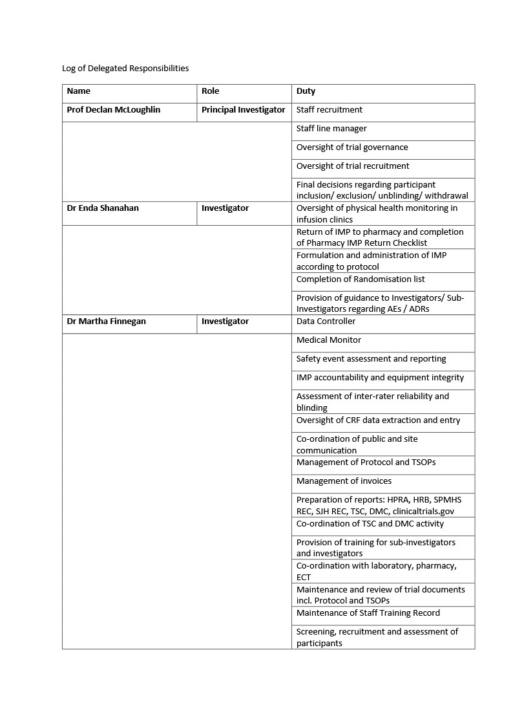
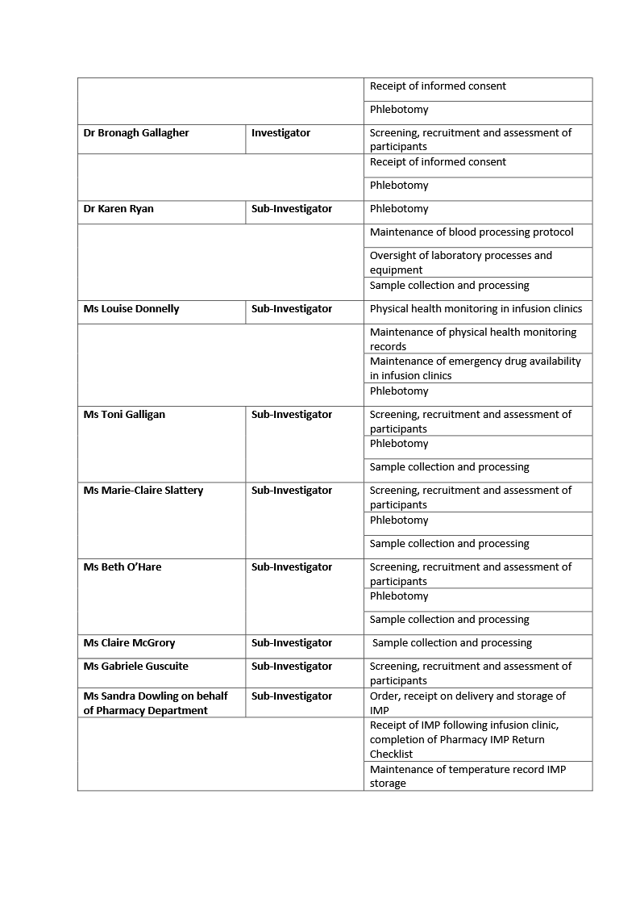

Appendix 2
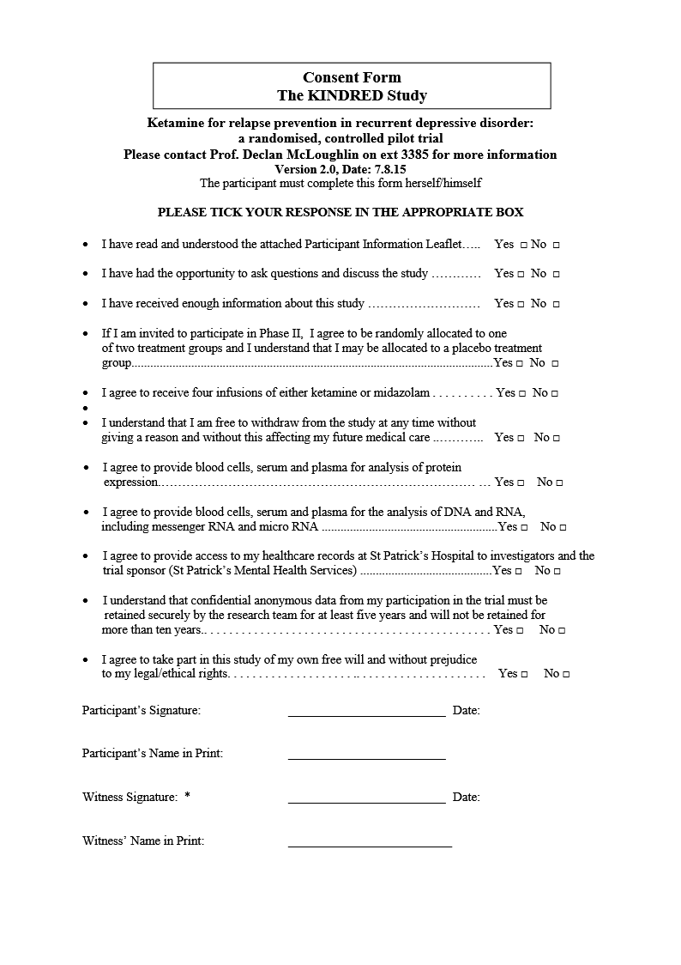



Appendix 3
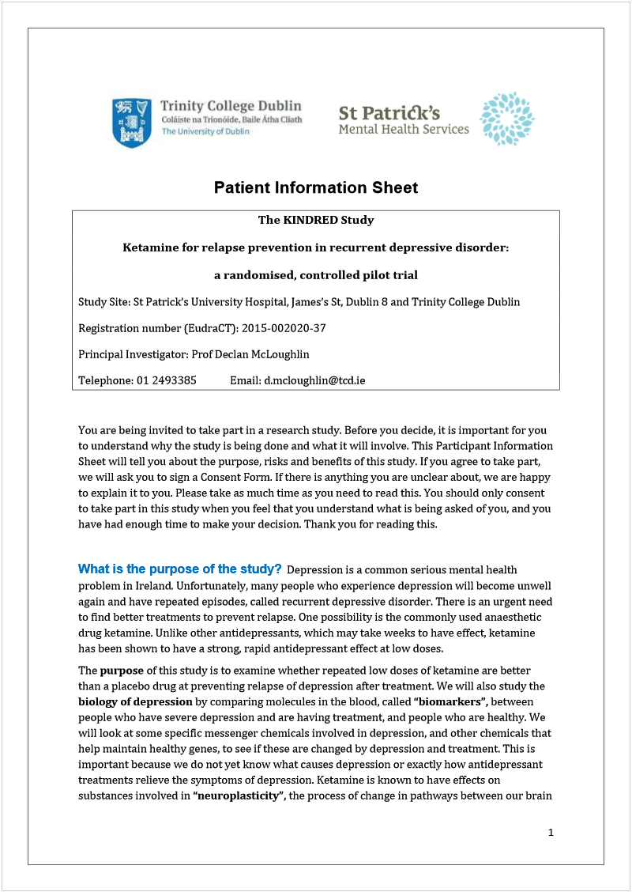







Appendix 4
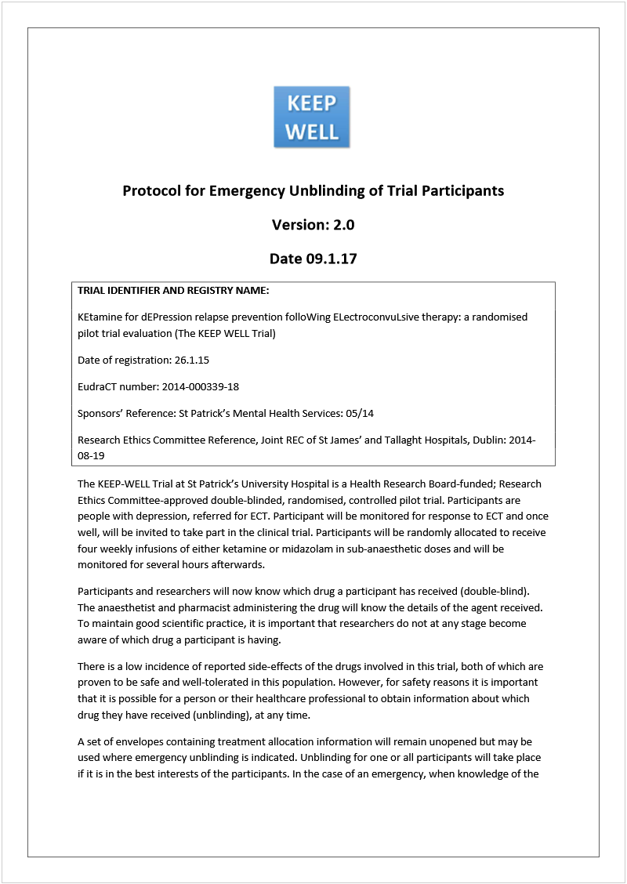

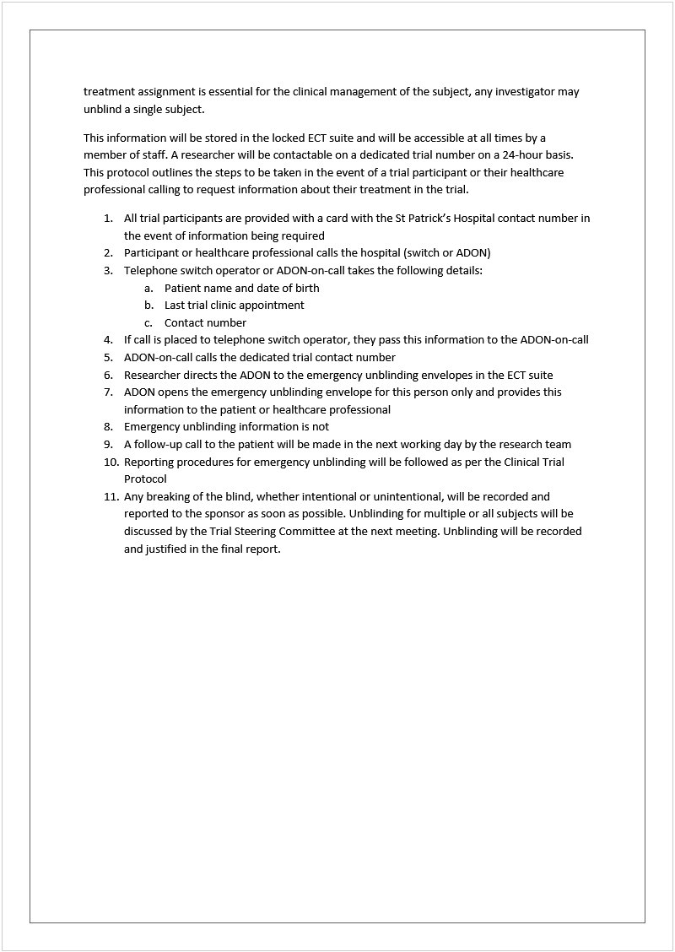

Appendix 5
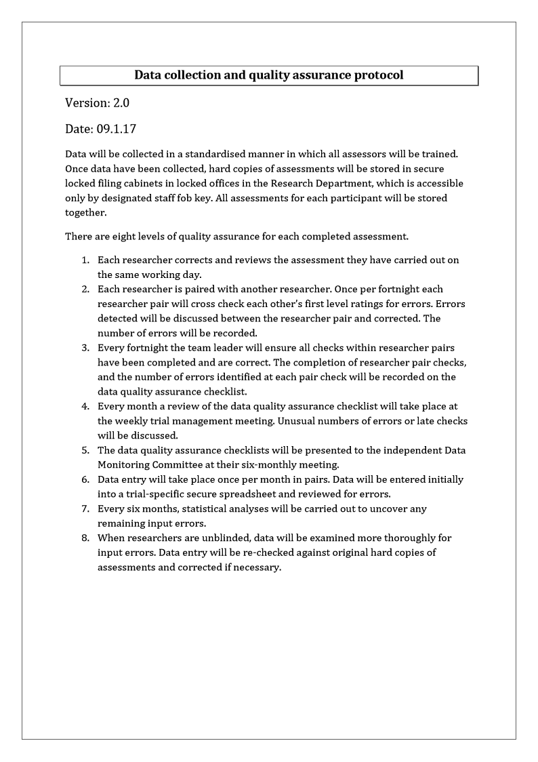

Appendix 6
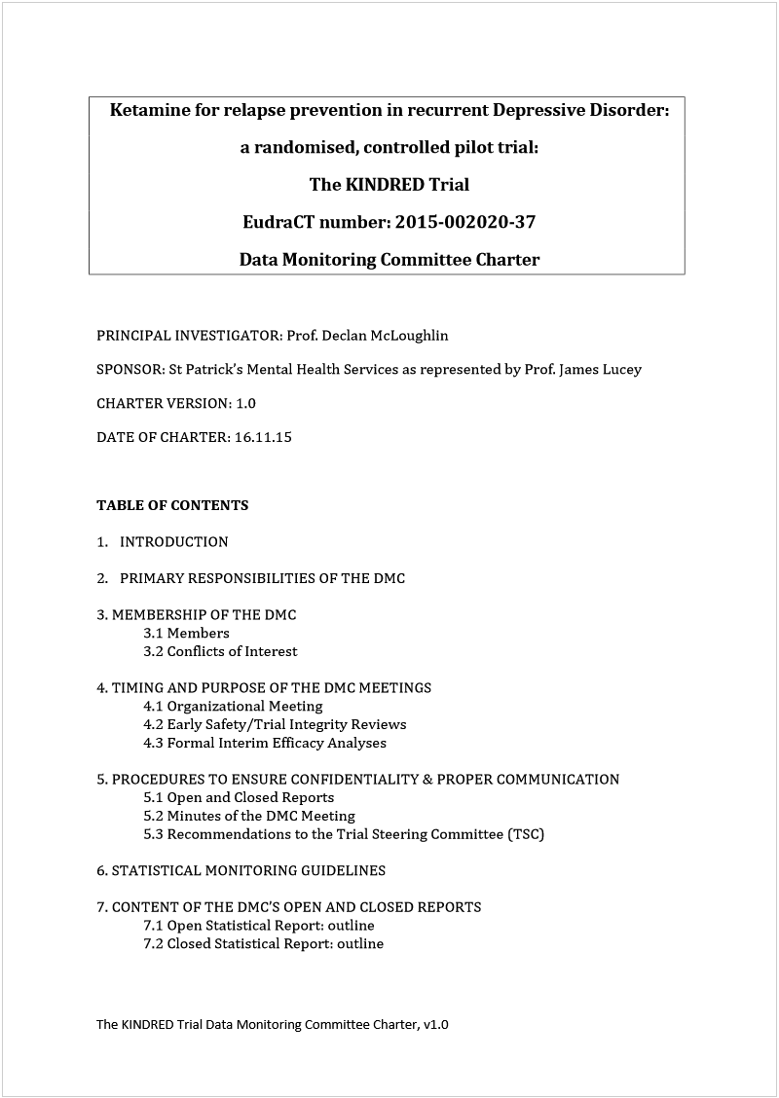





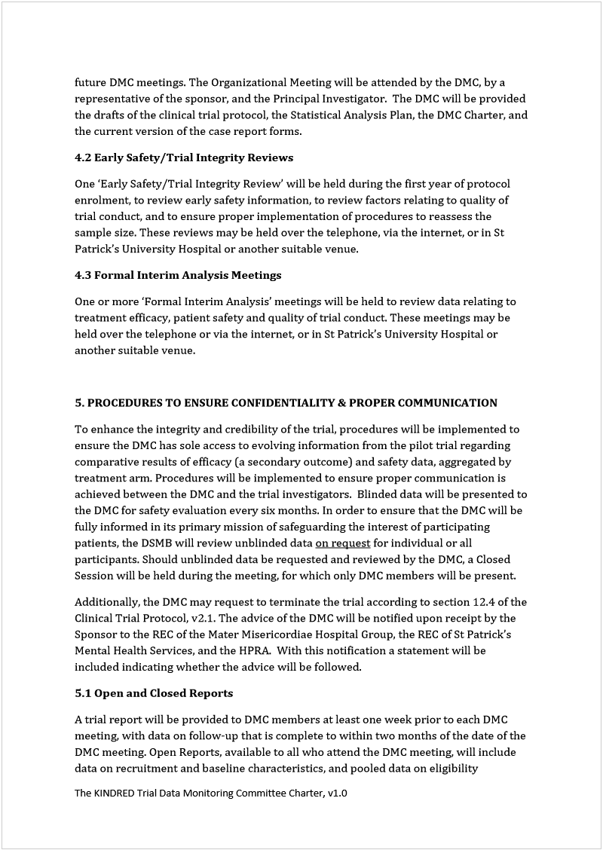



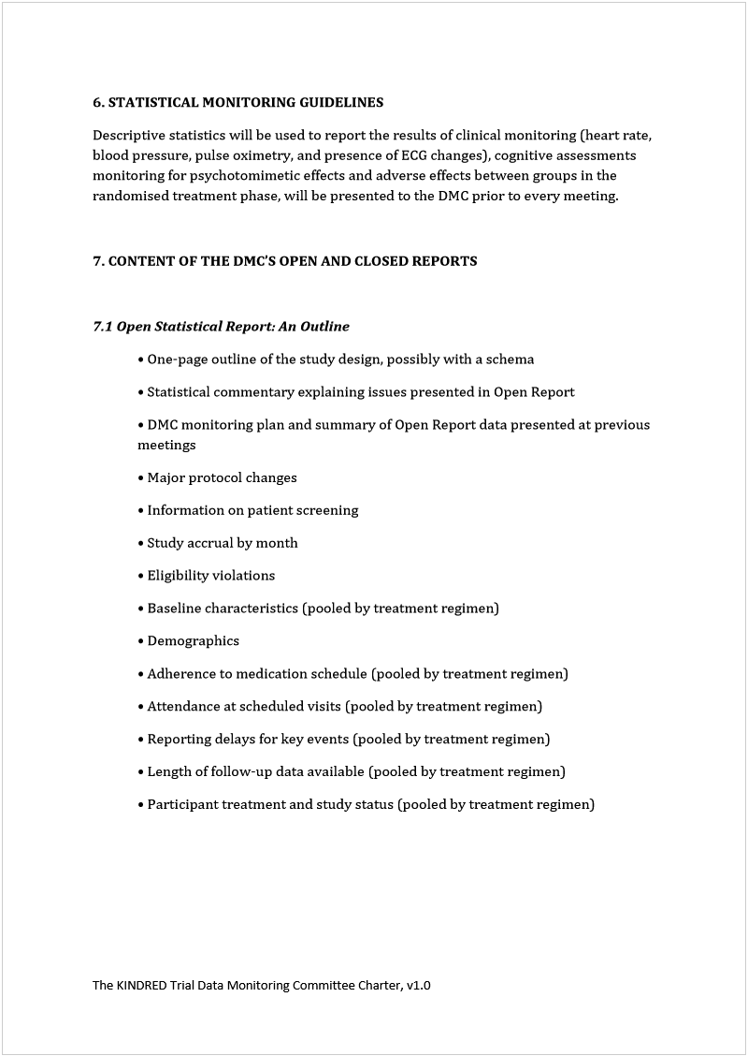

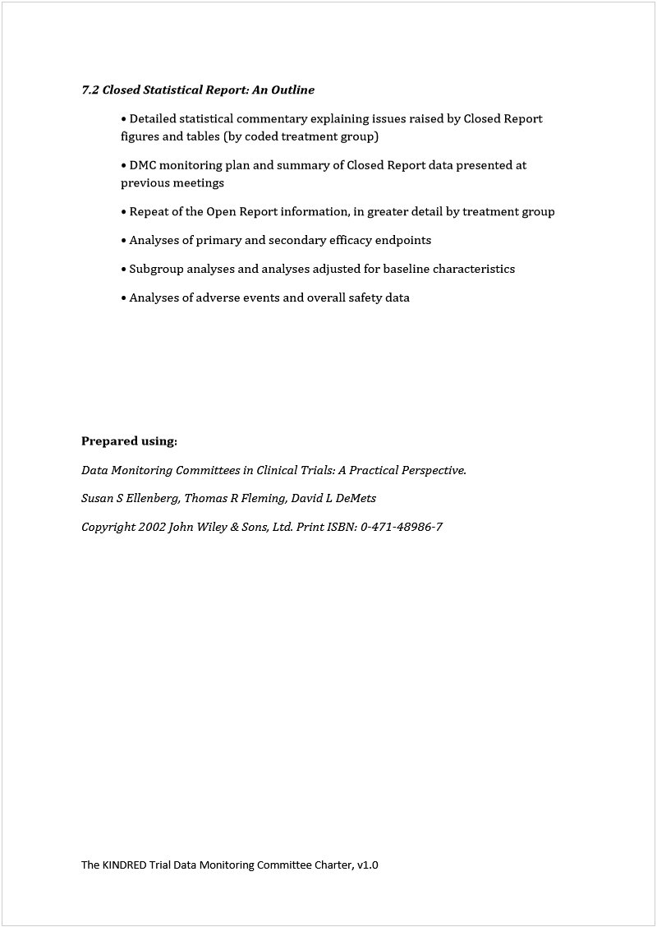

Appendix 7
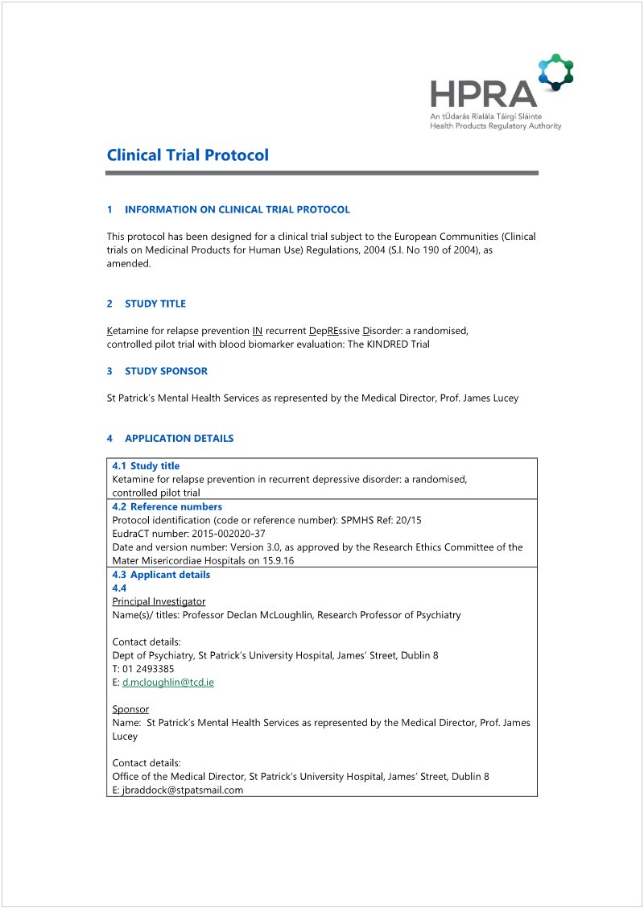

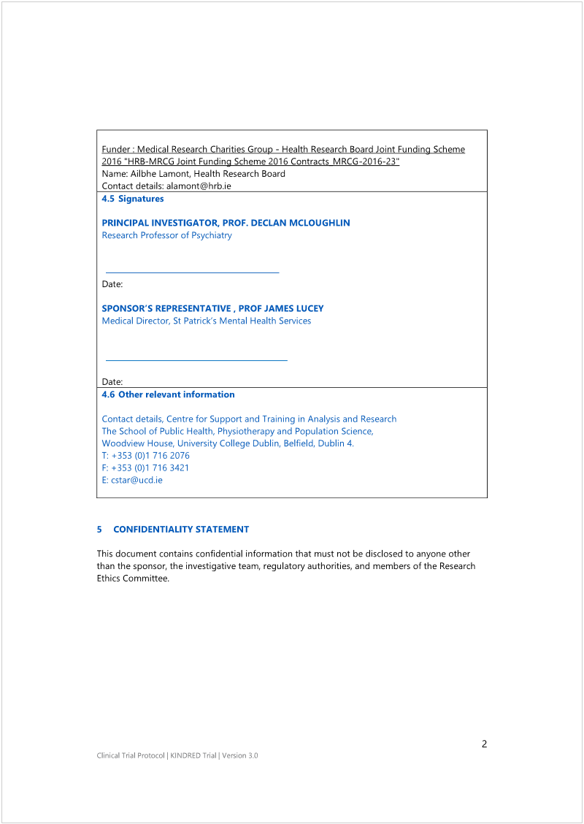



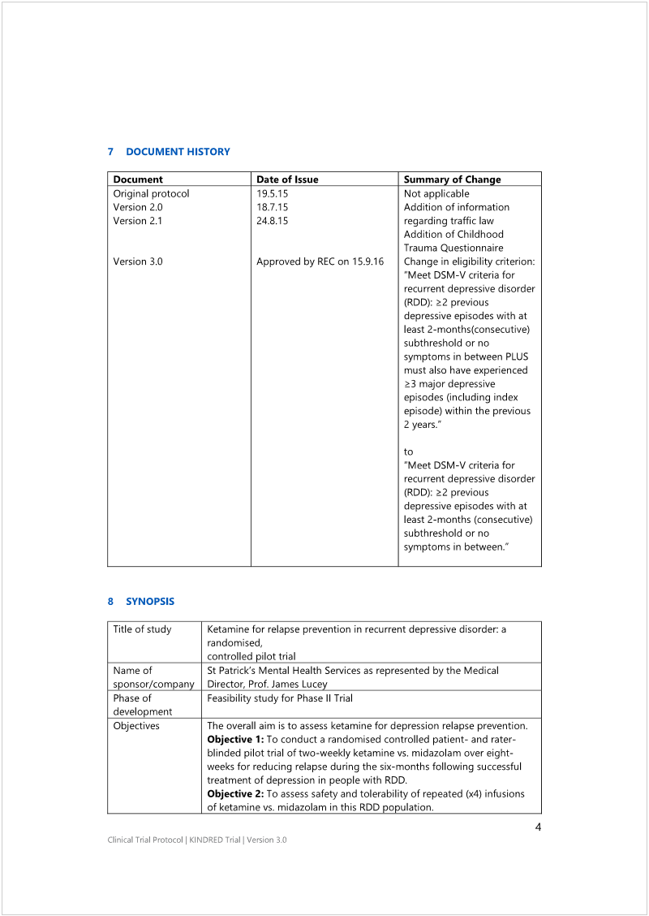

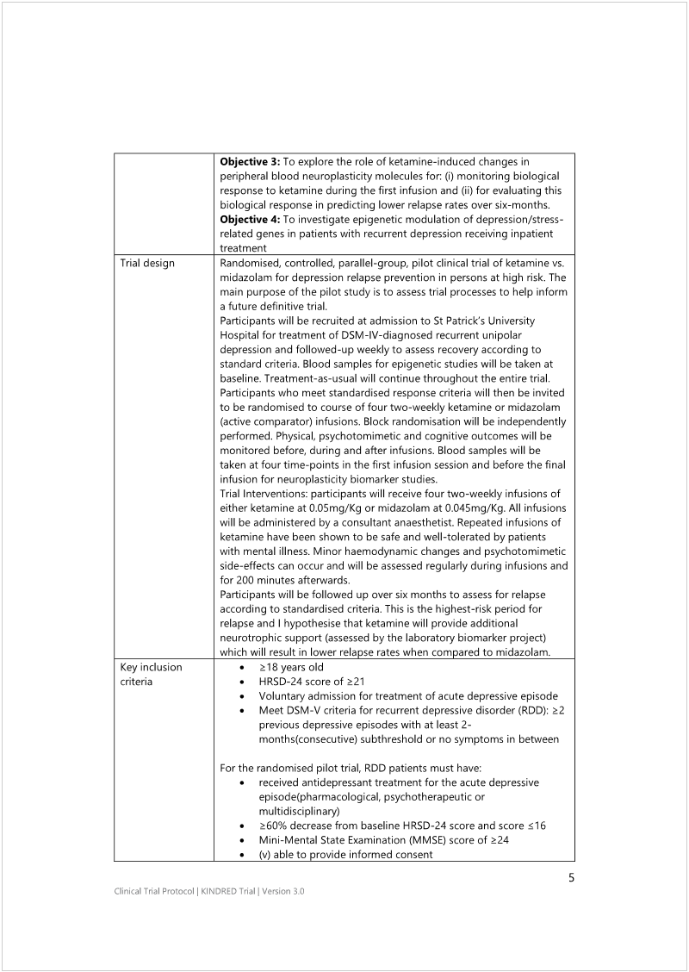

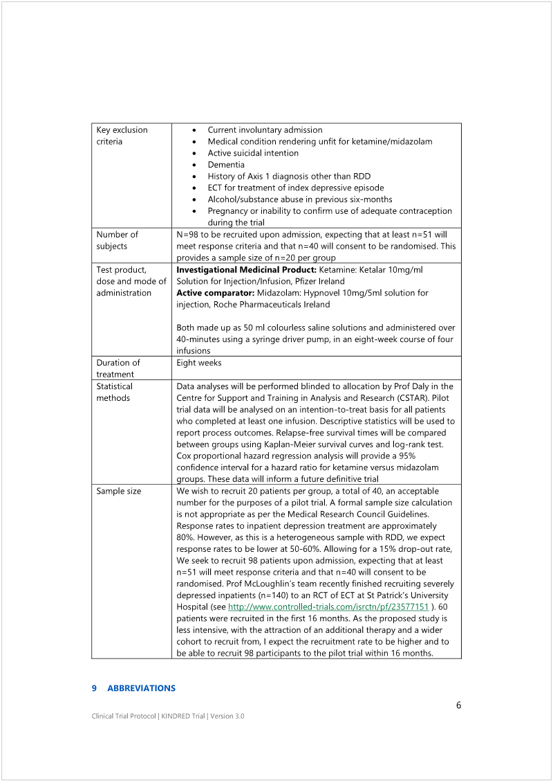



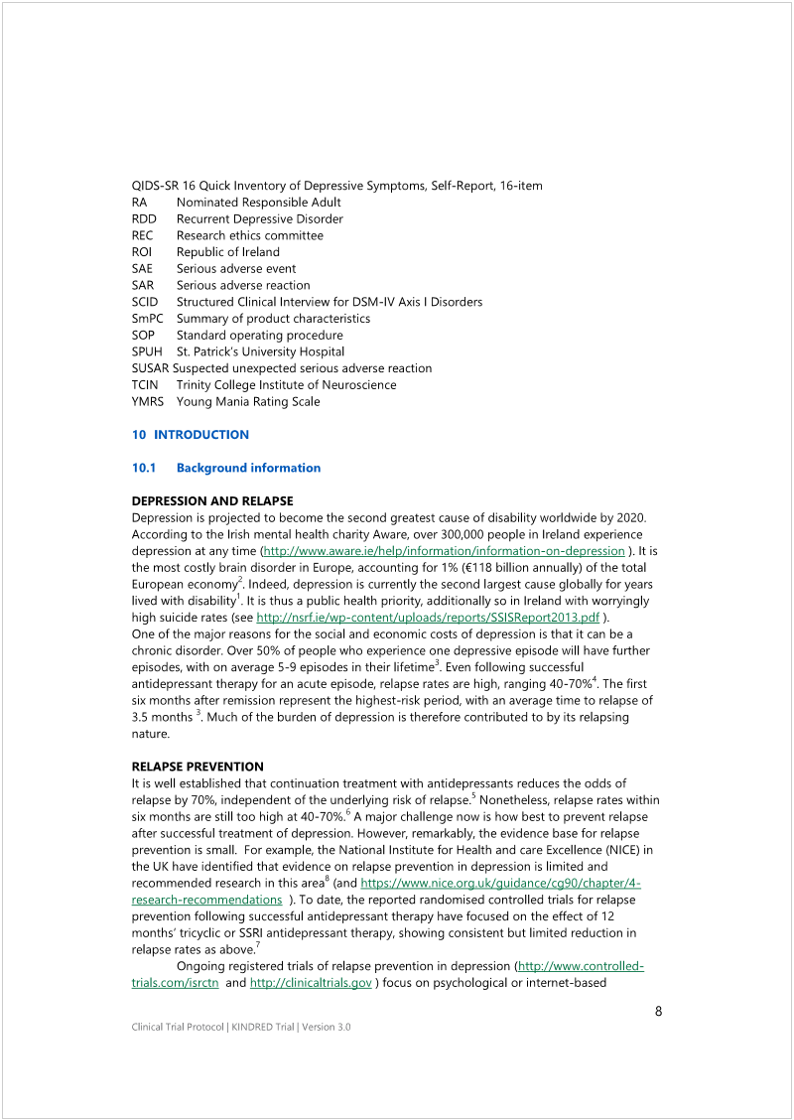

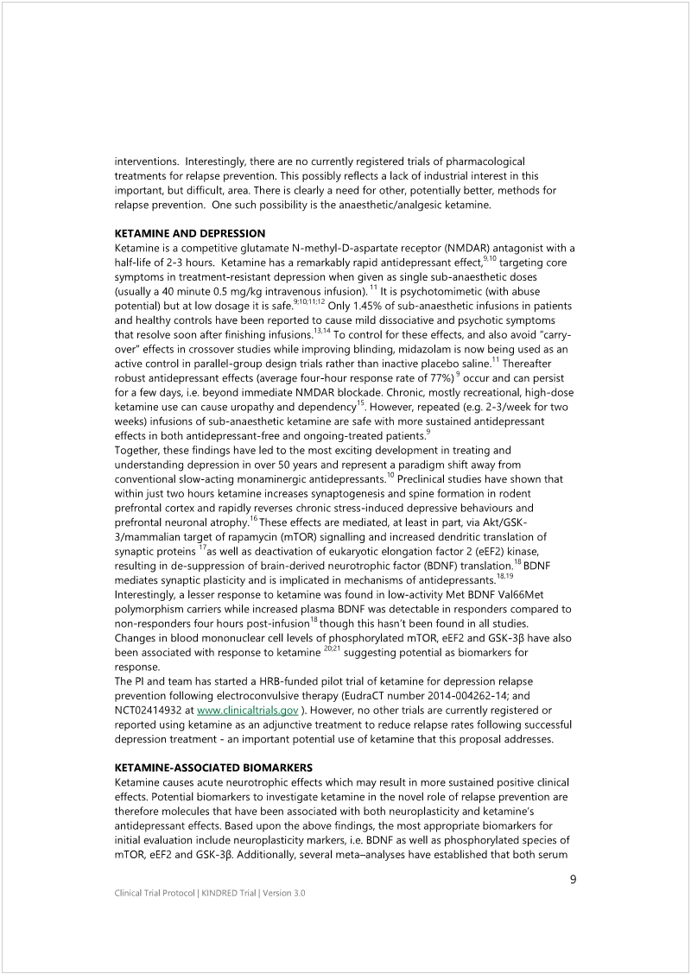

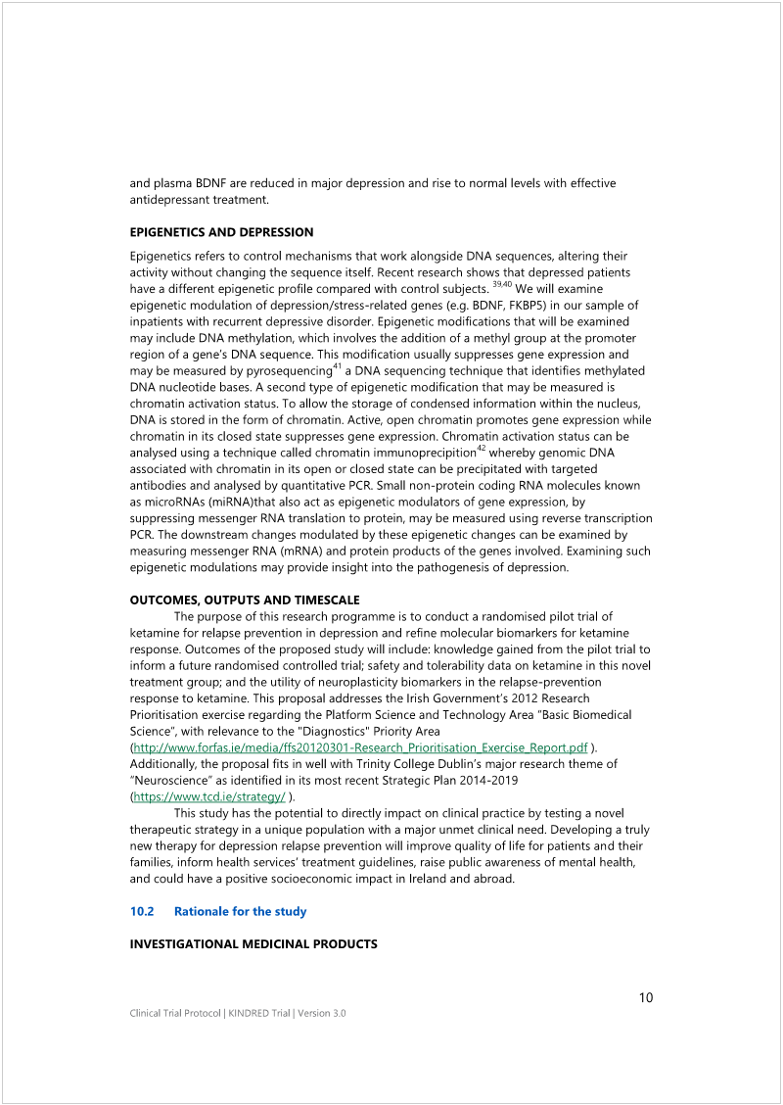

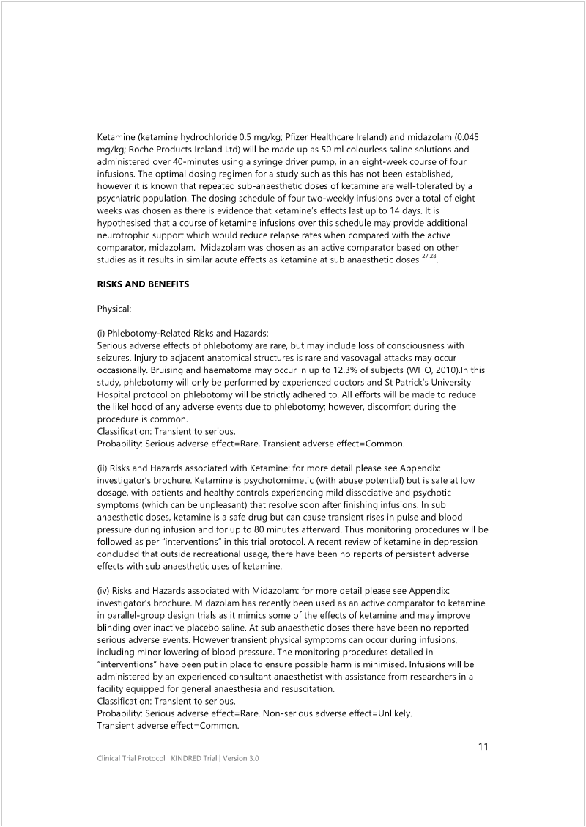

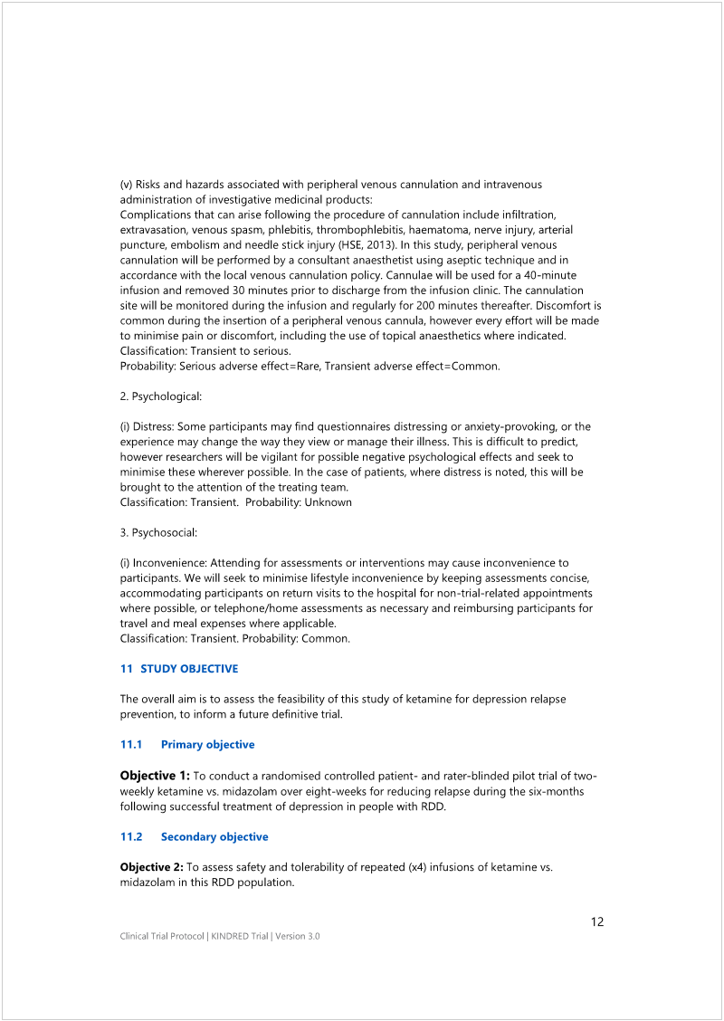

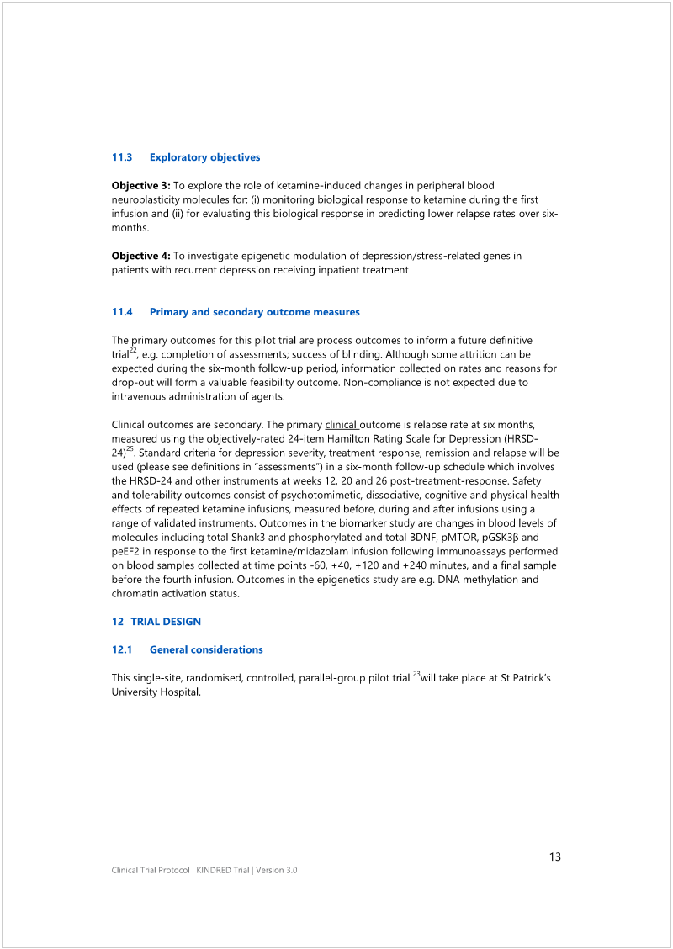

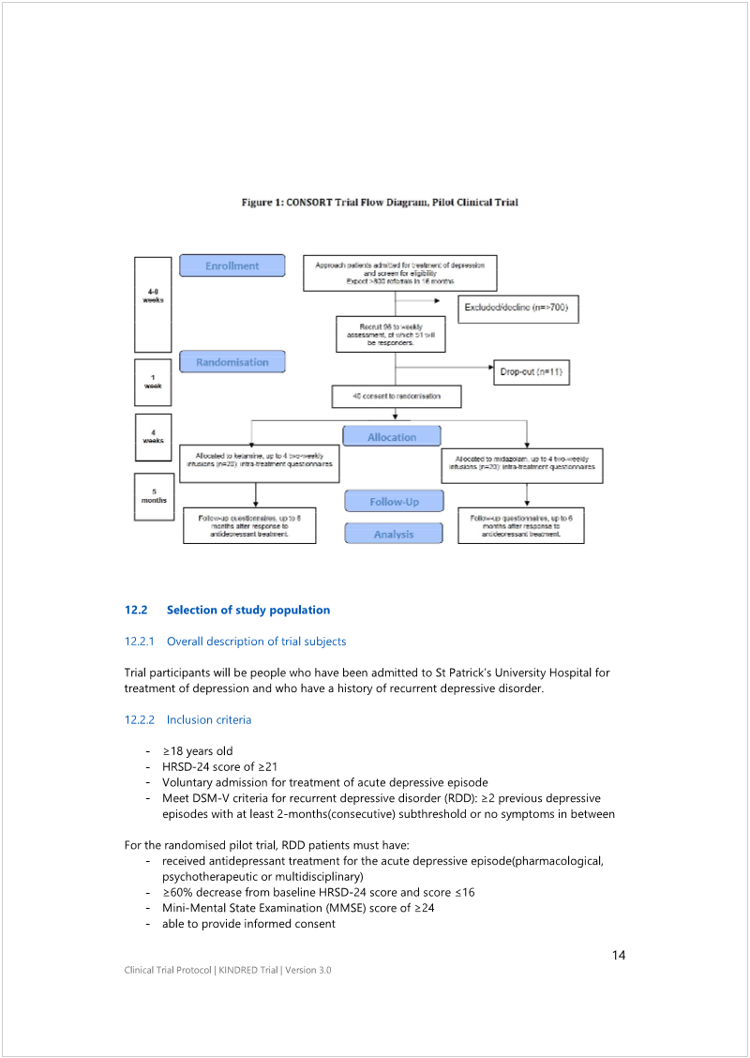

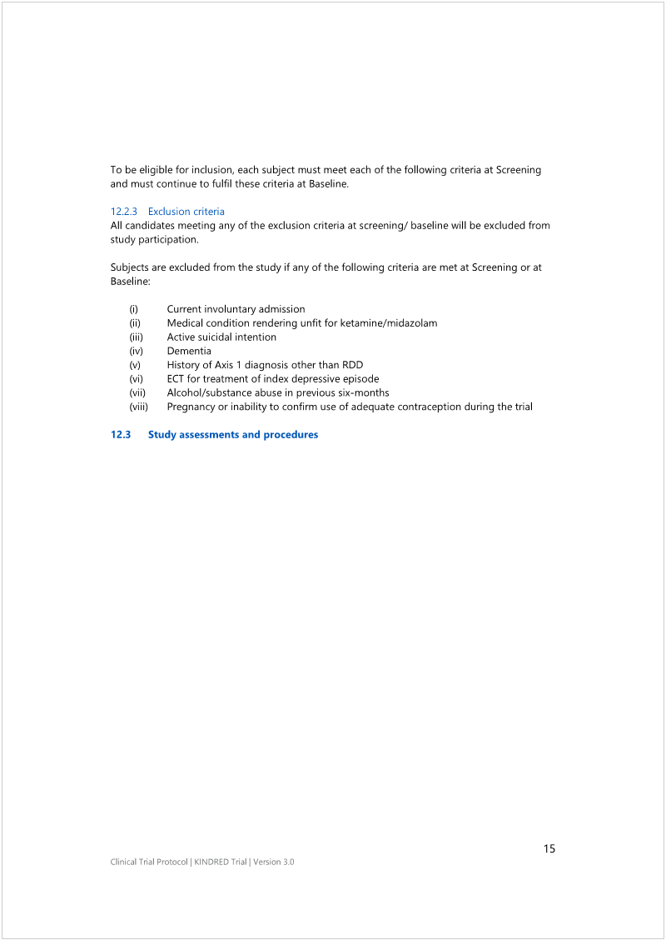

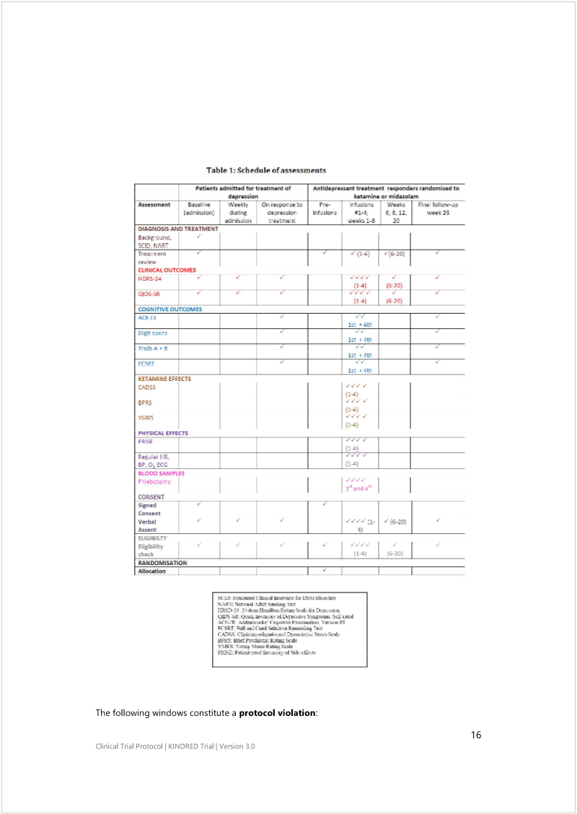

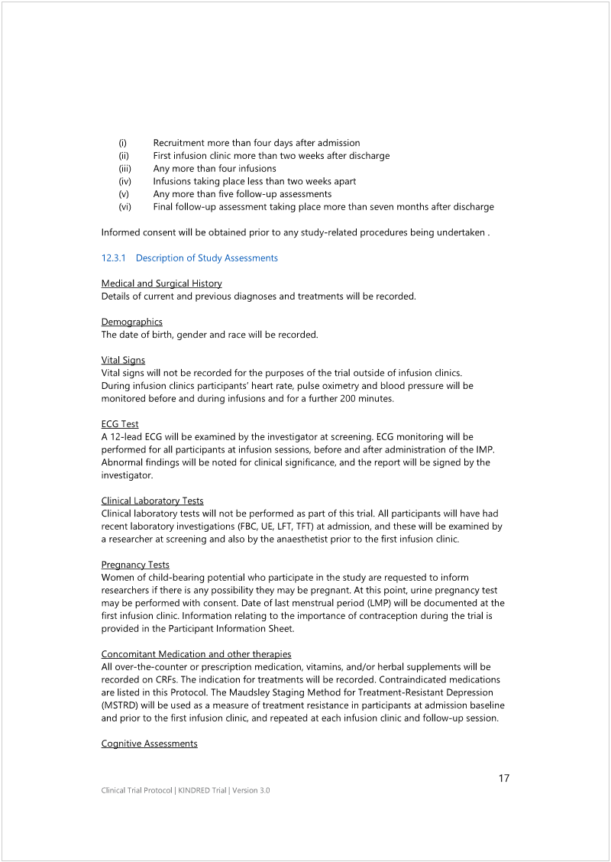

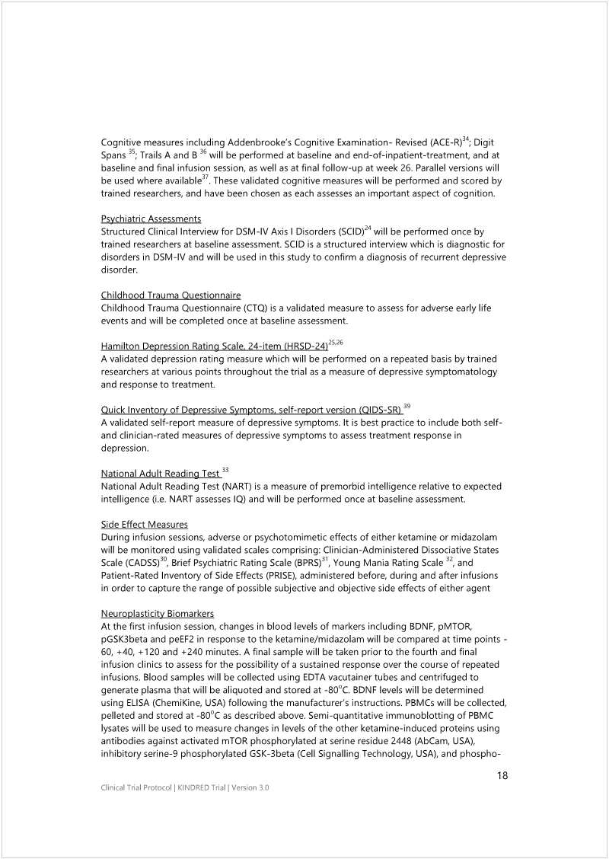

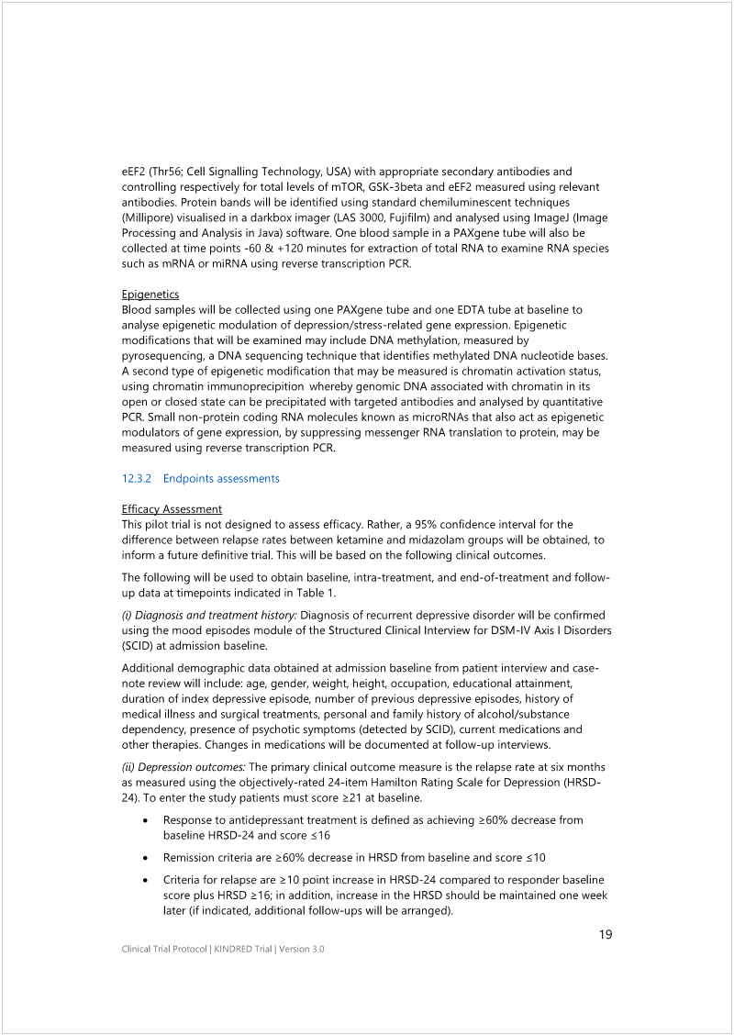

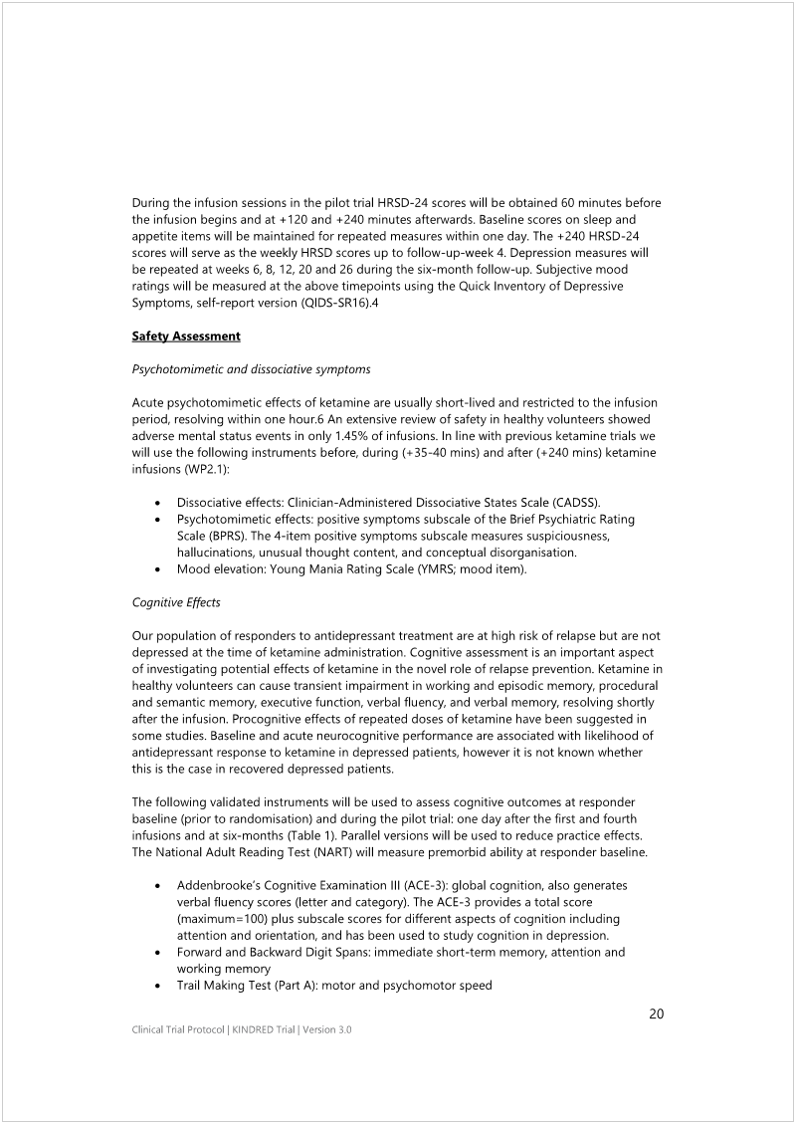

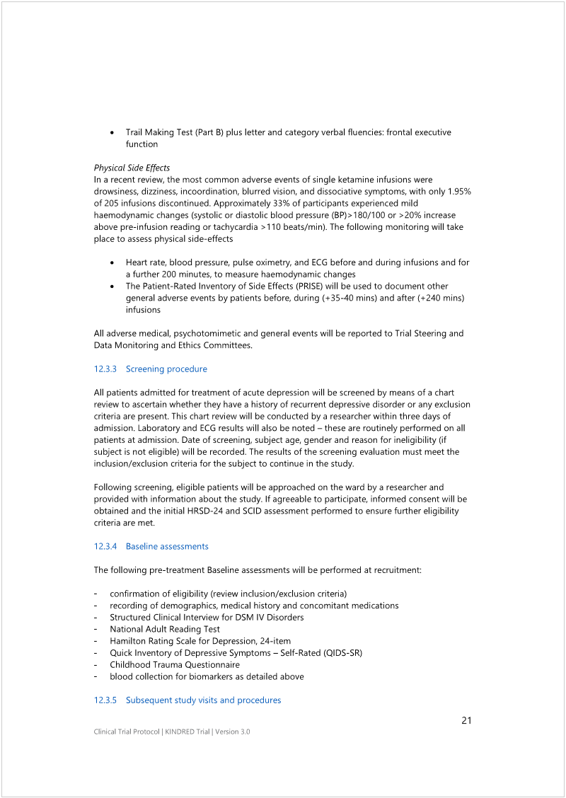

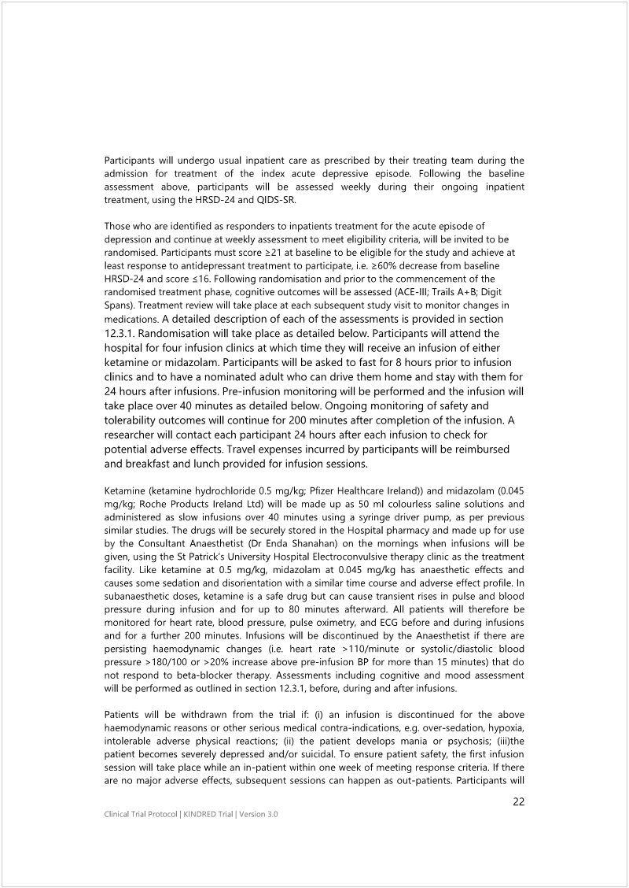

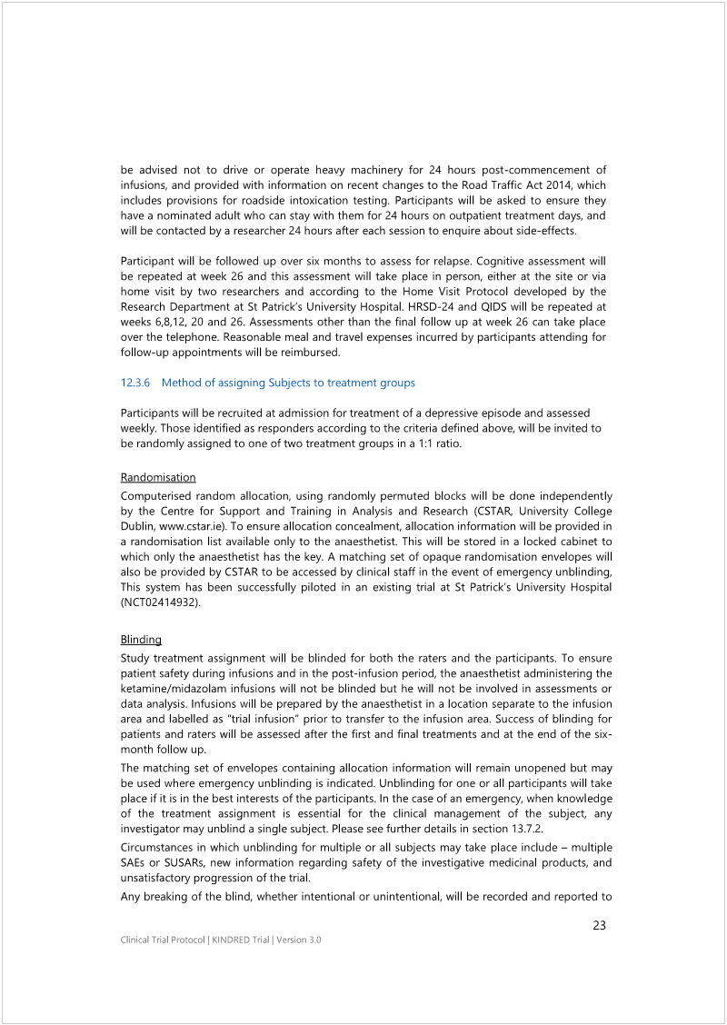

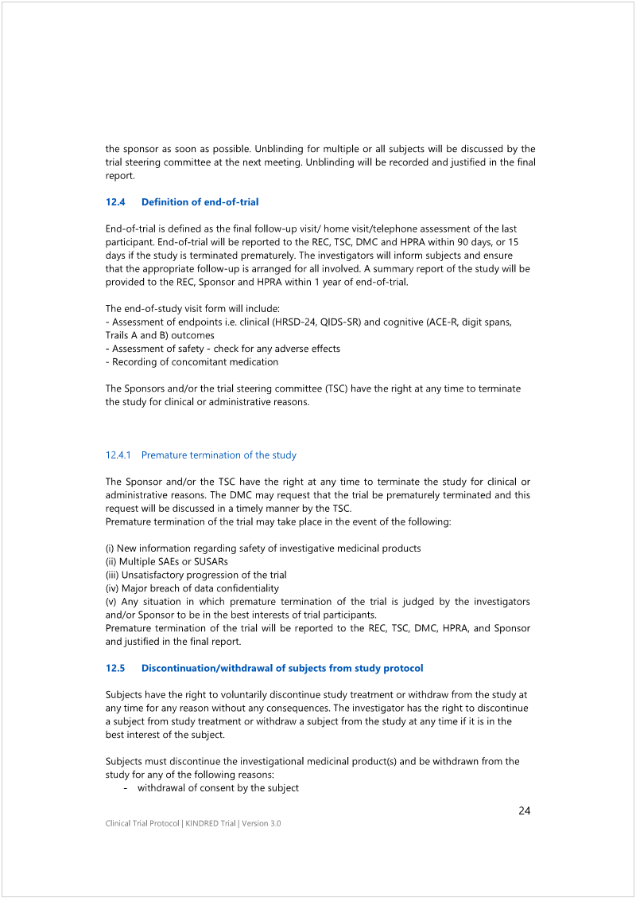

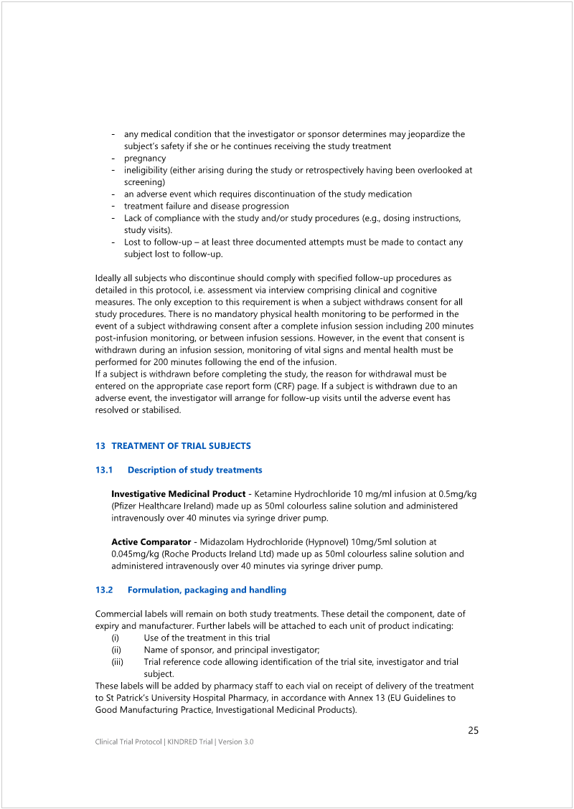

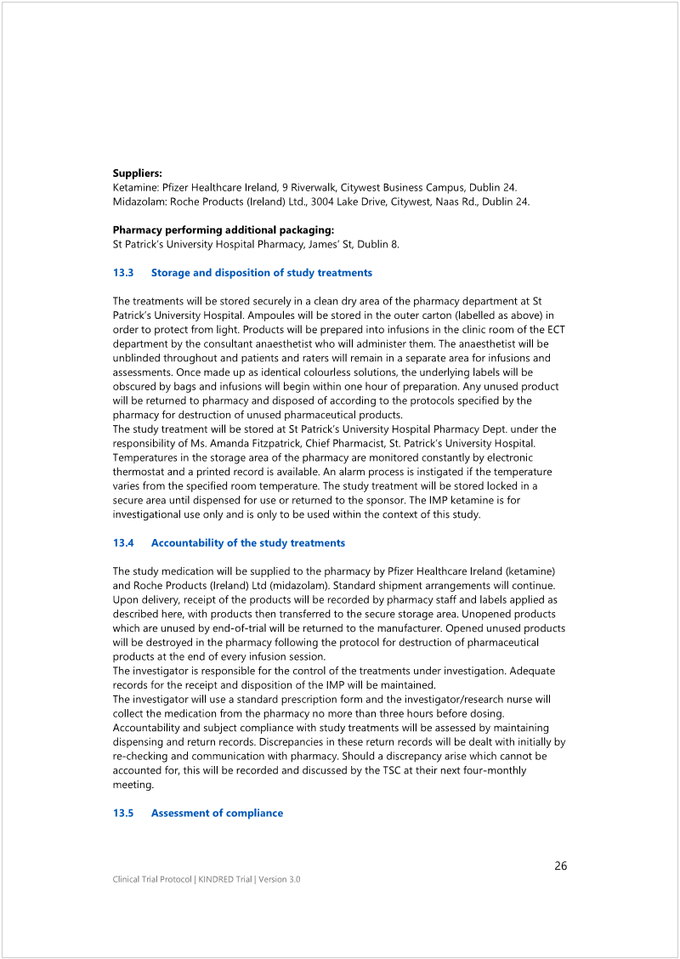

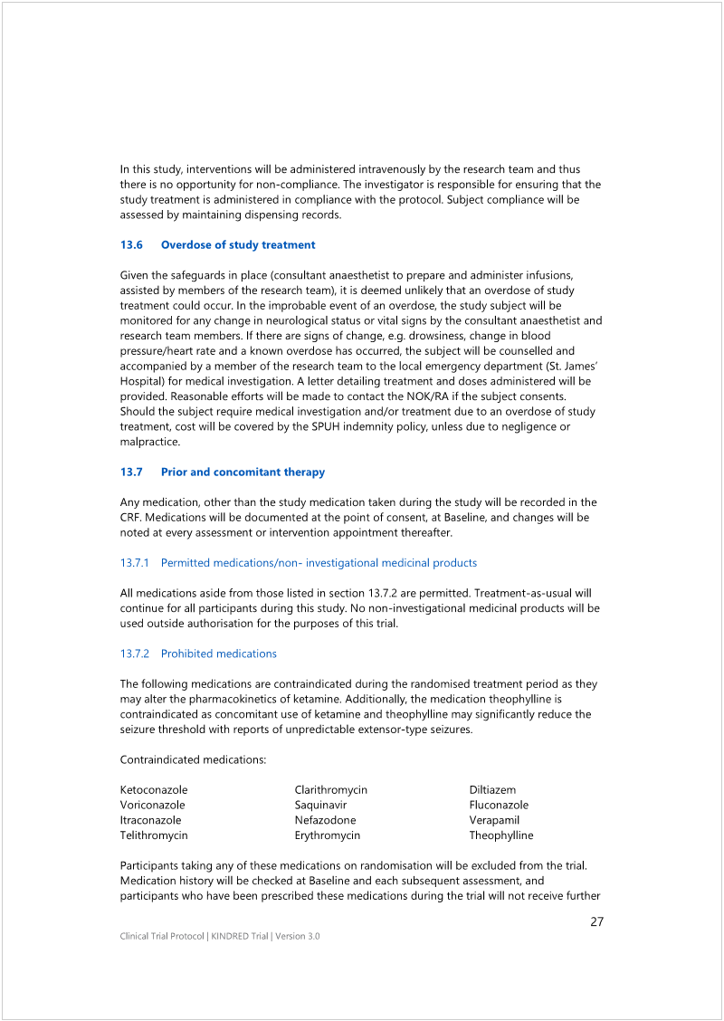

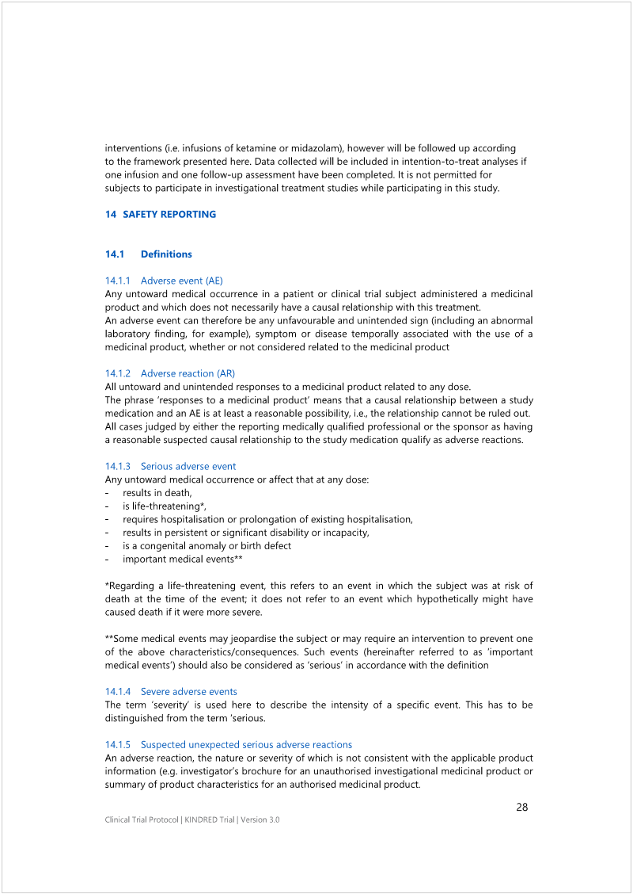

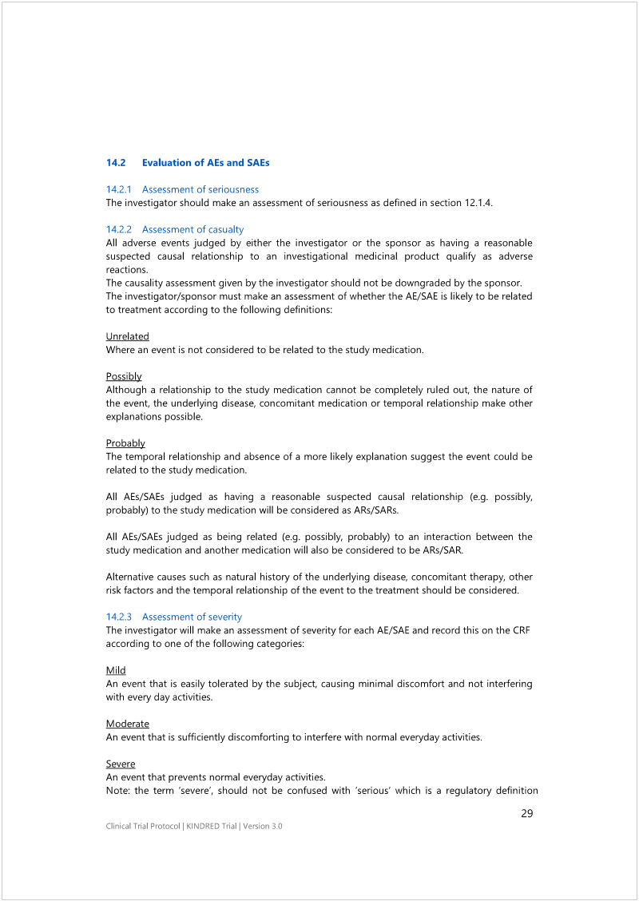

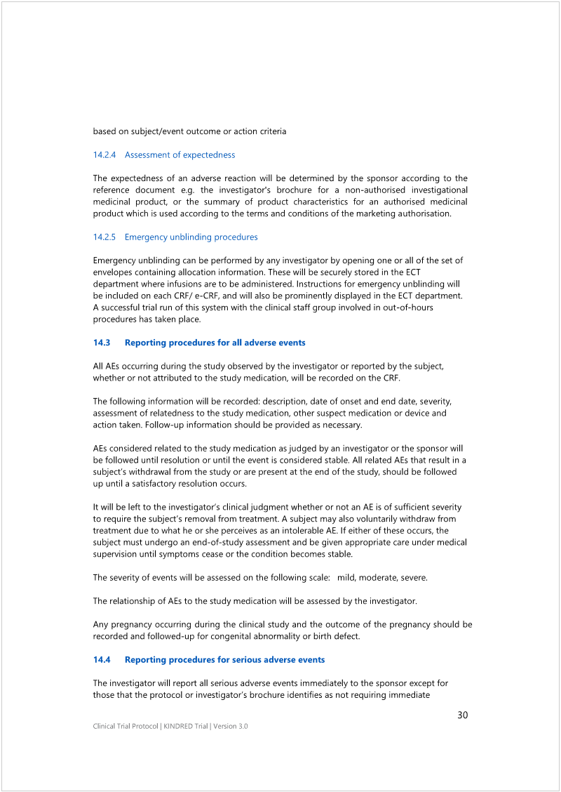

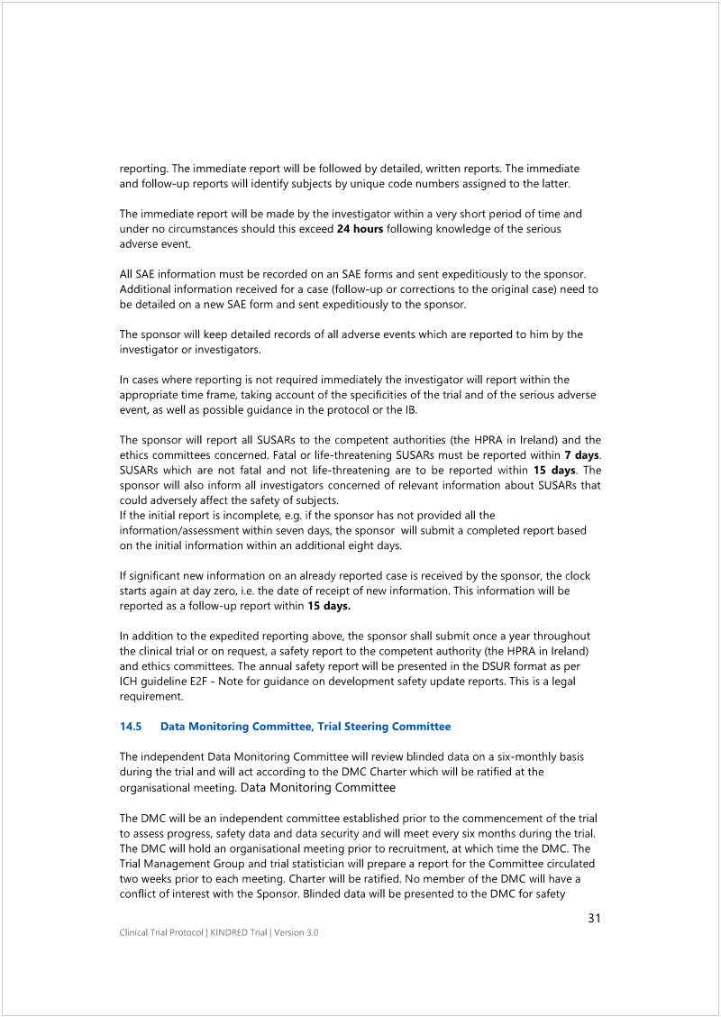

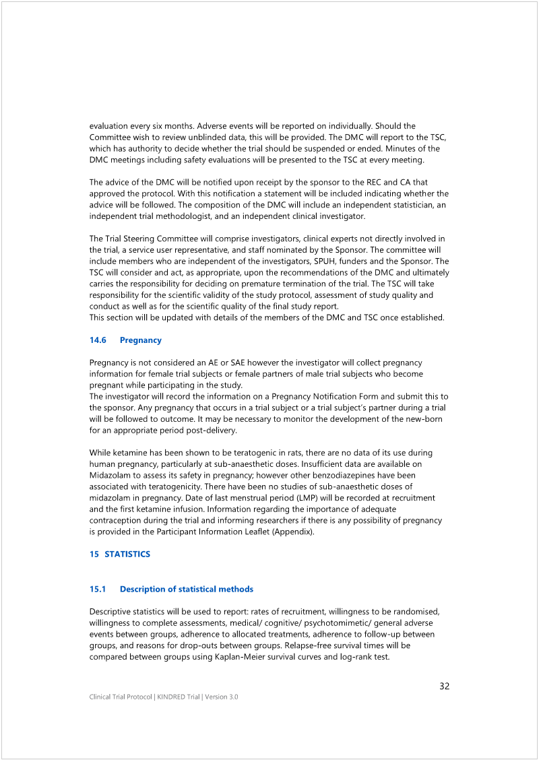

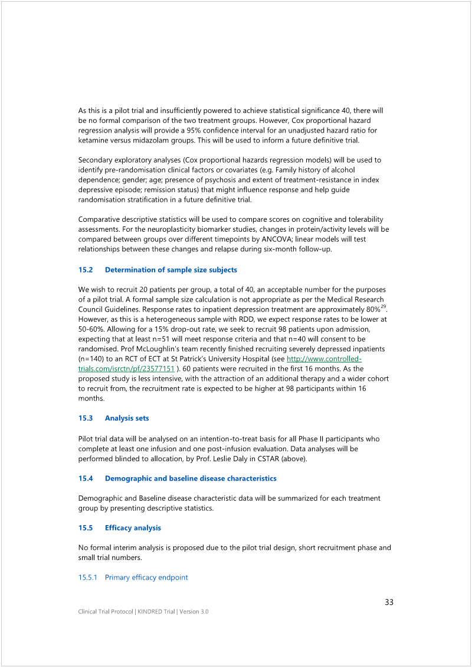

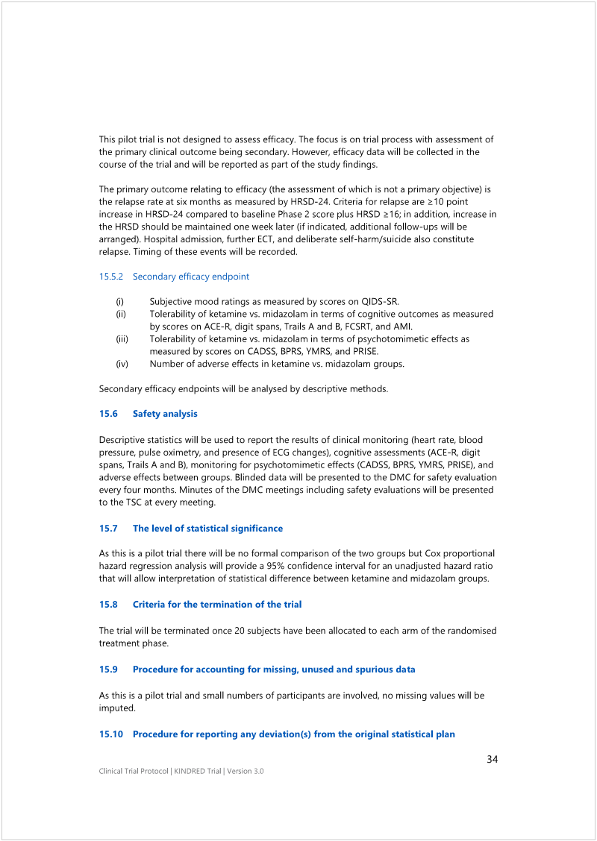

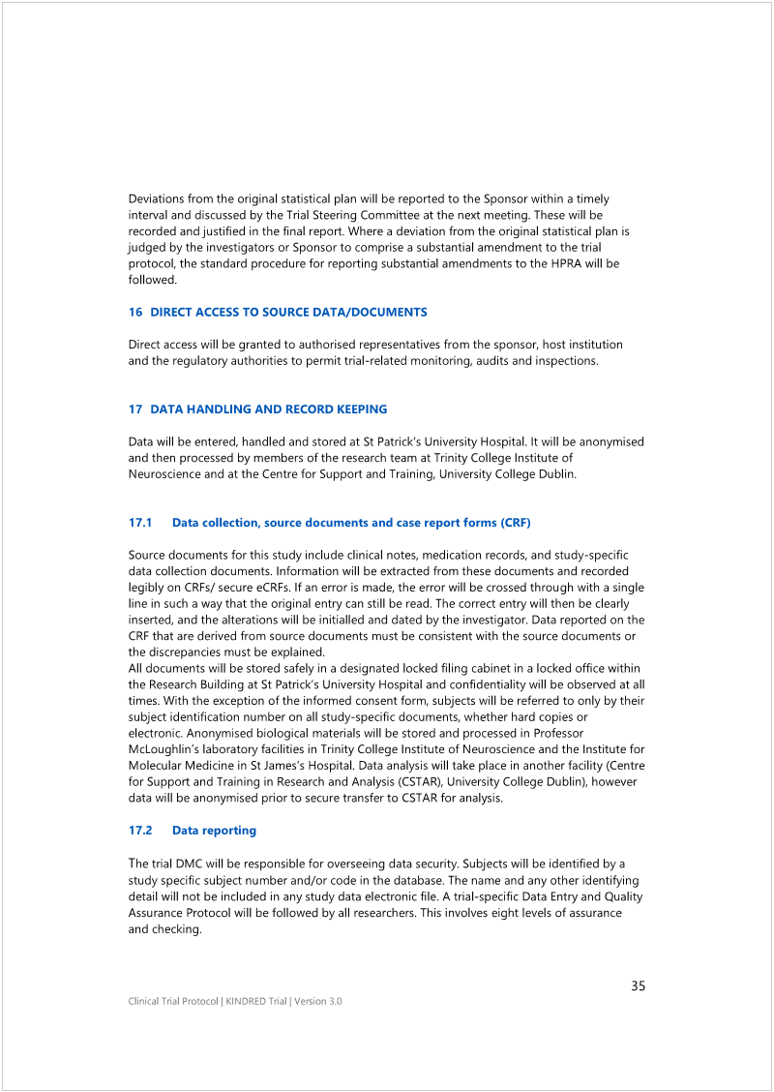

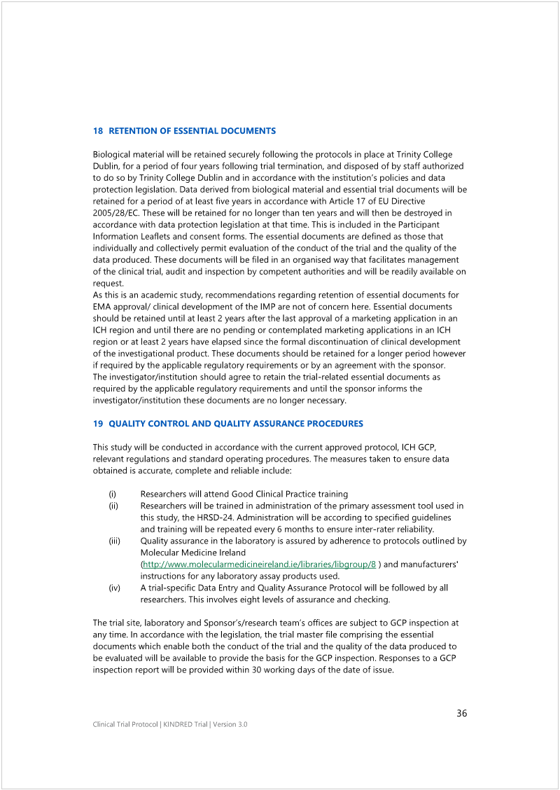

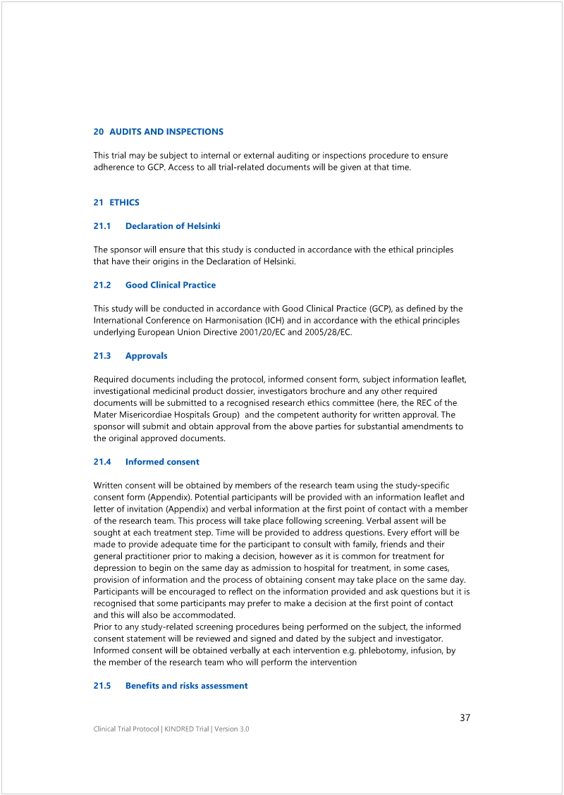

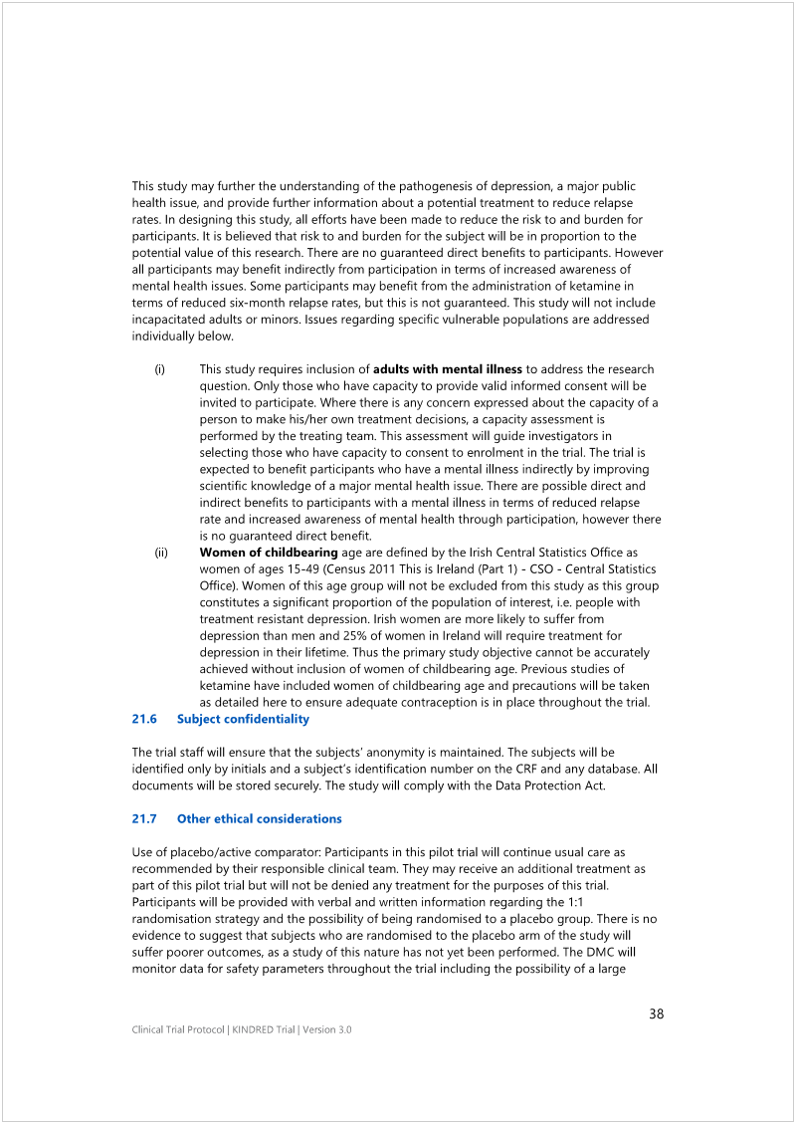

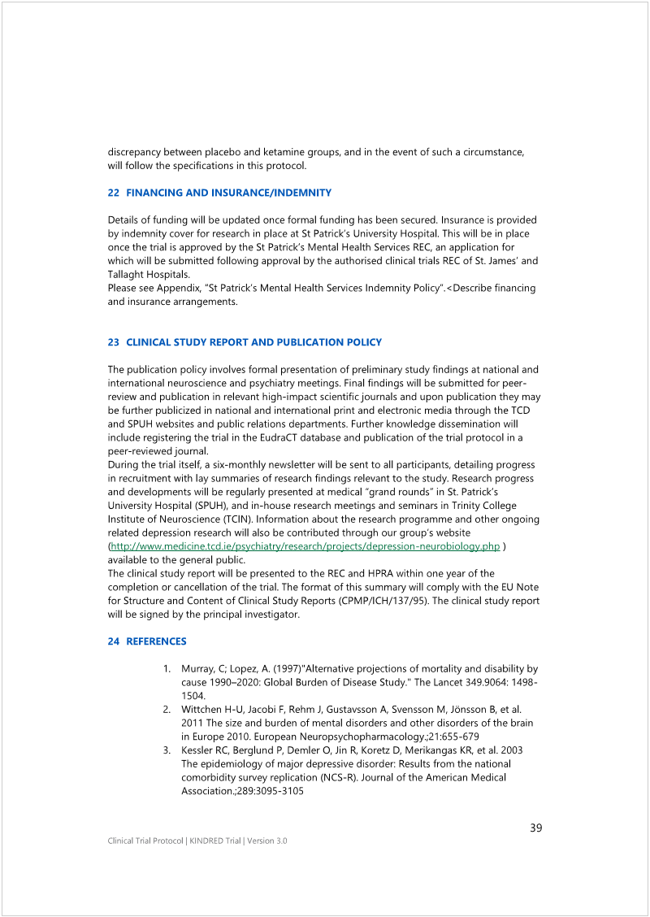

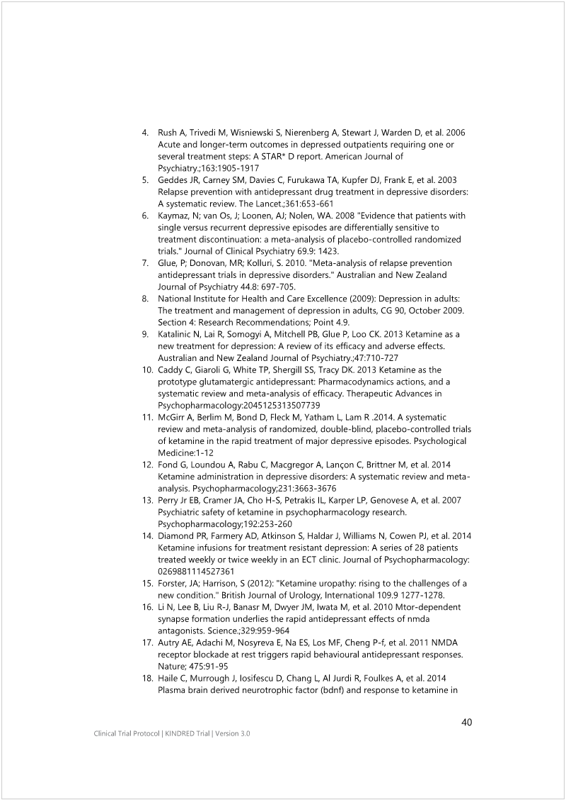

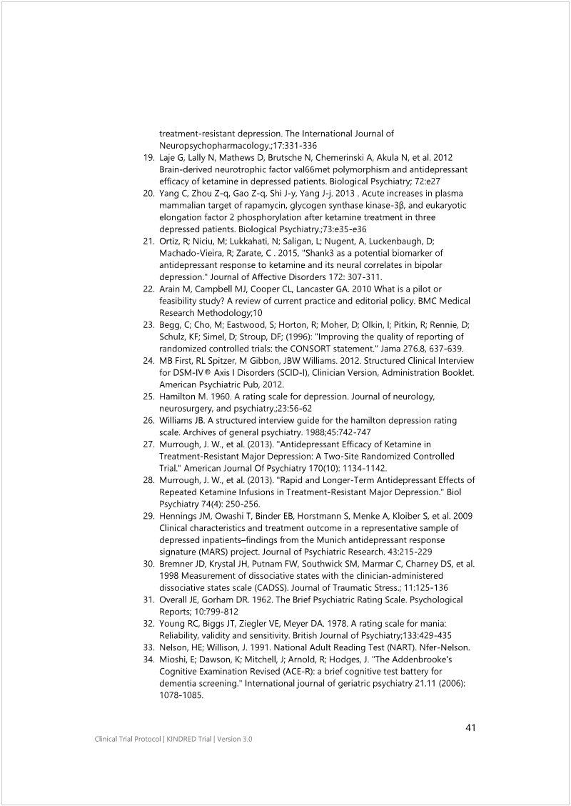

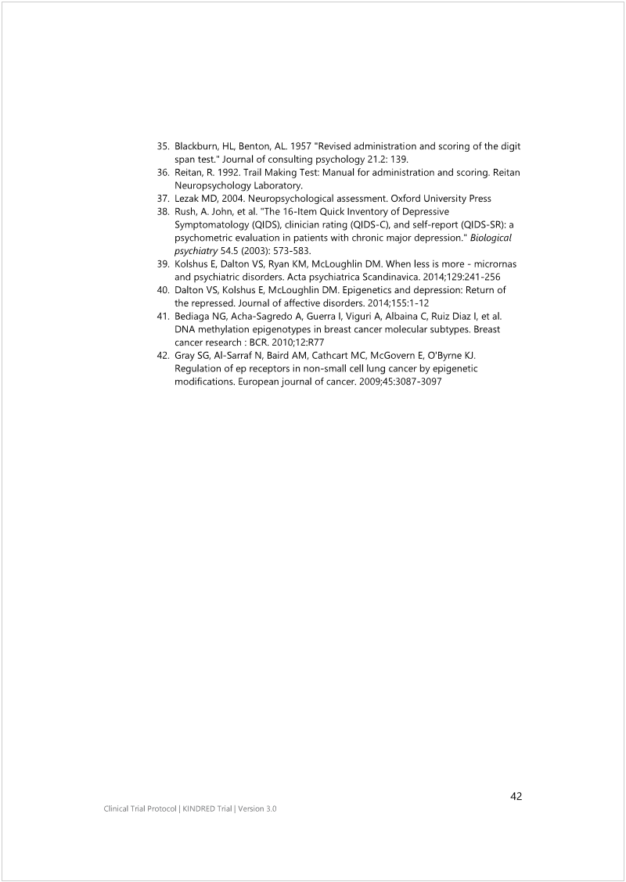

Appendix 8
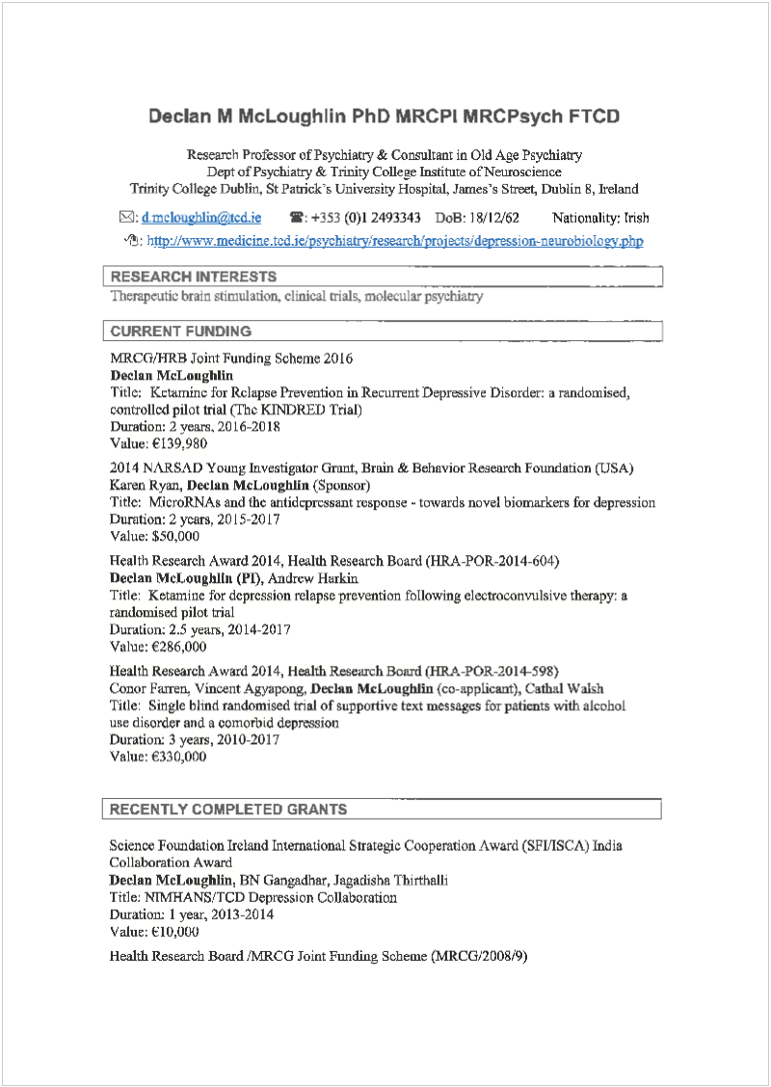
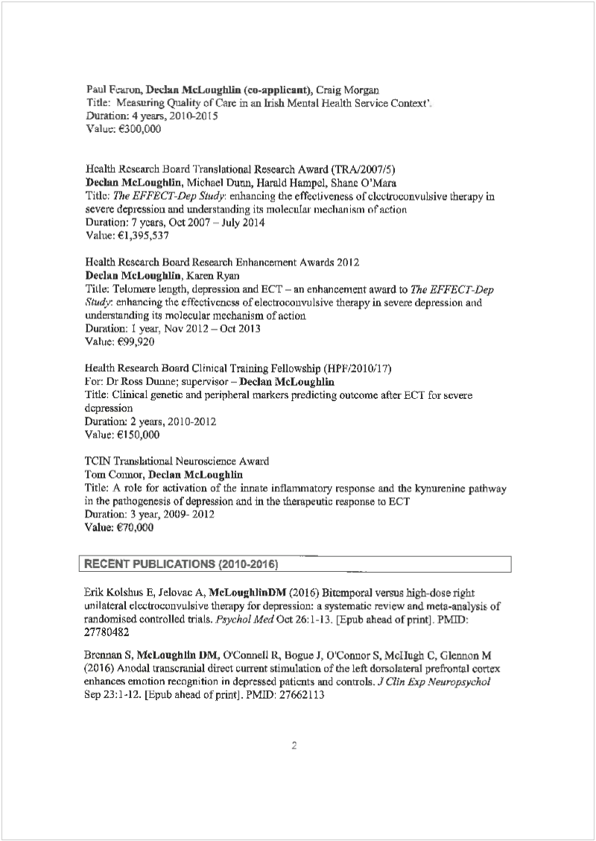
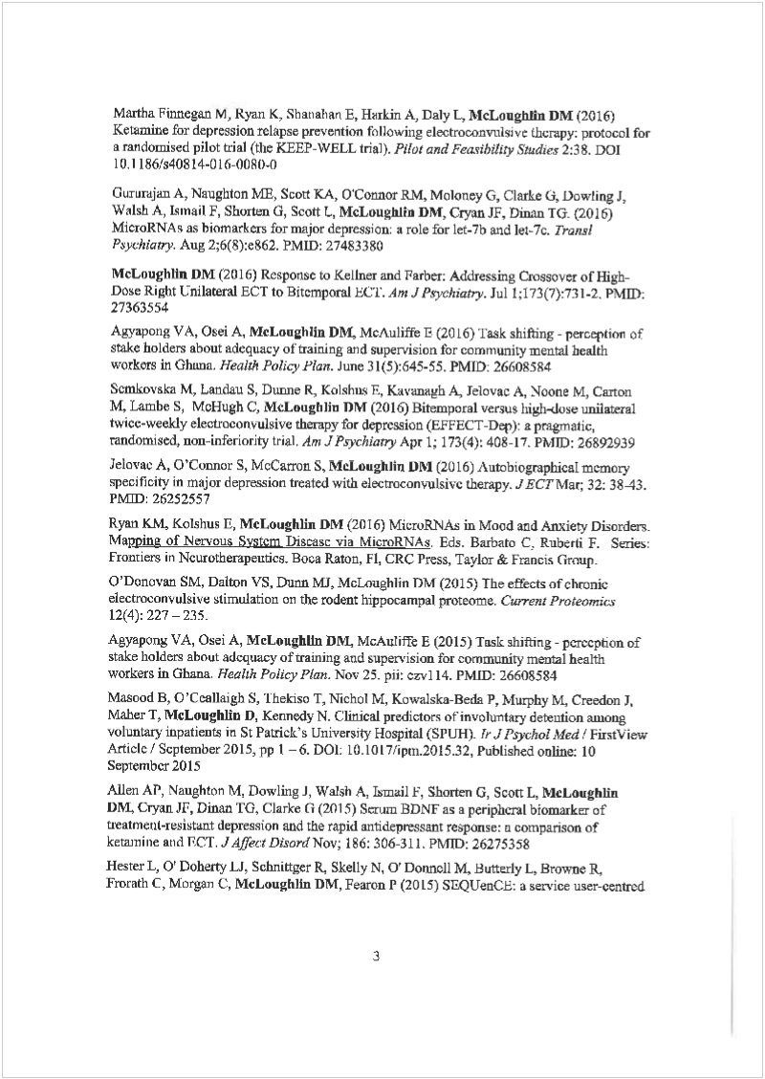
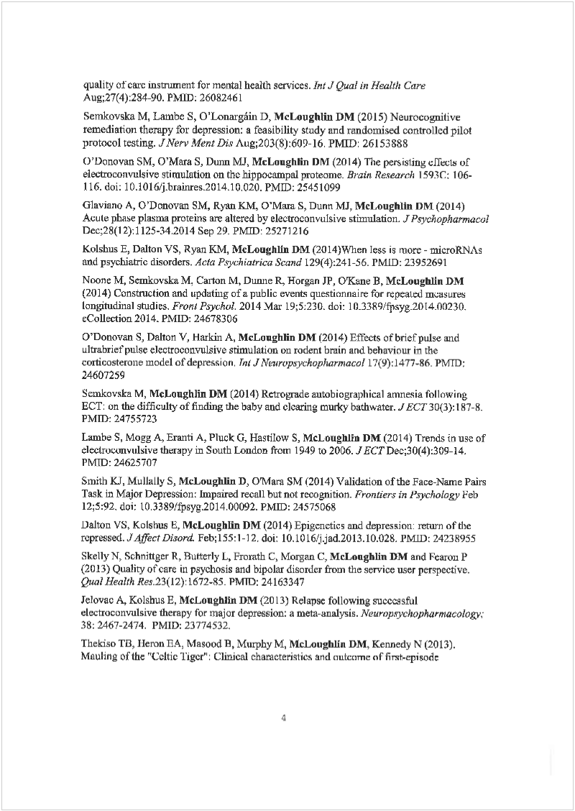
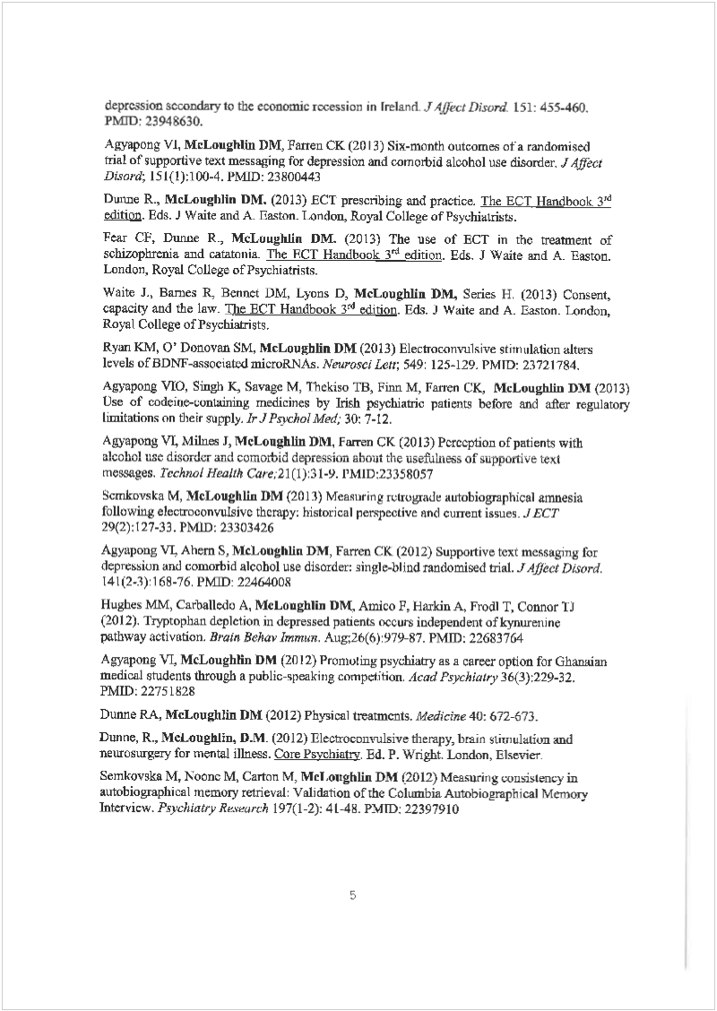
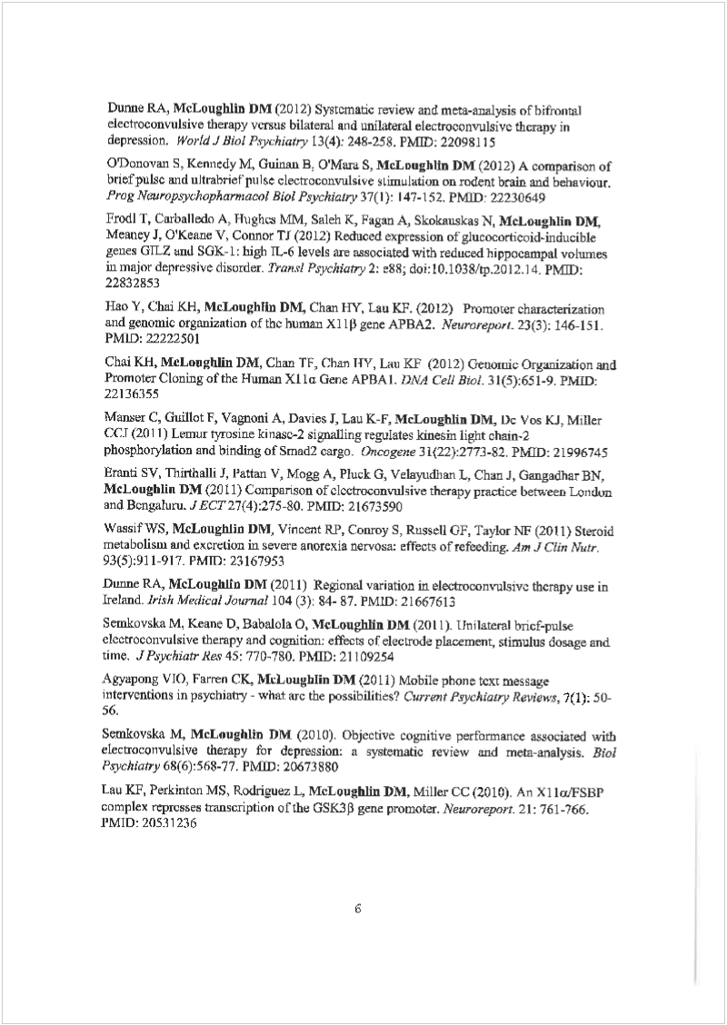
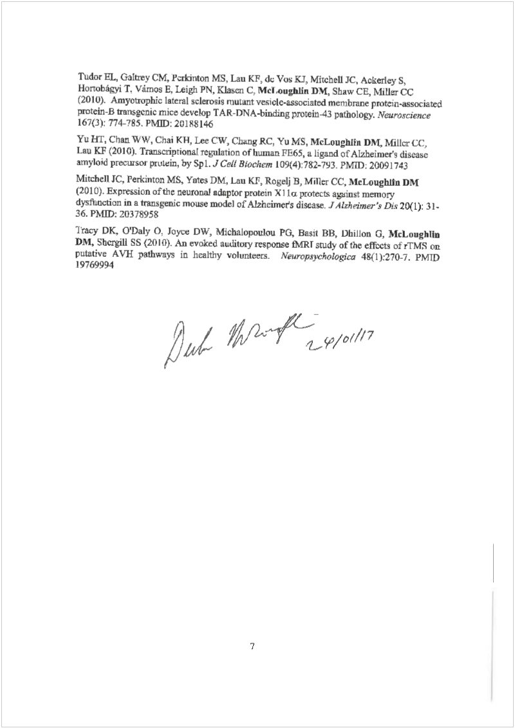

Appendix 9
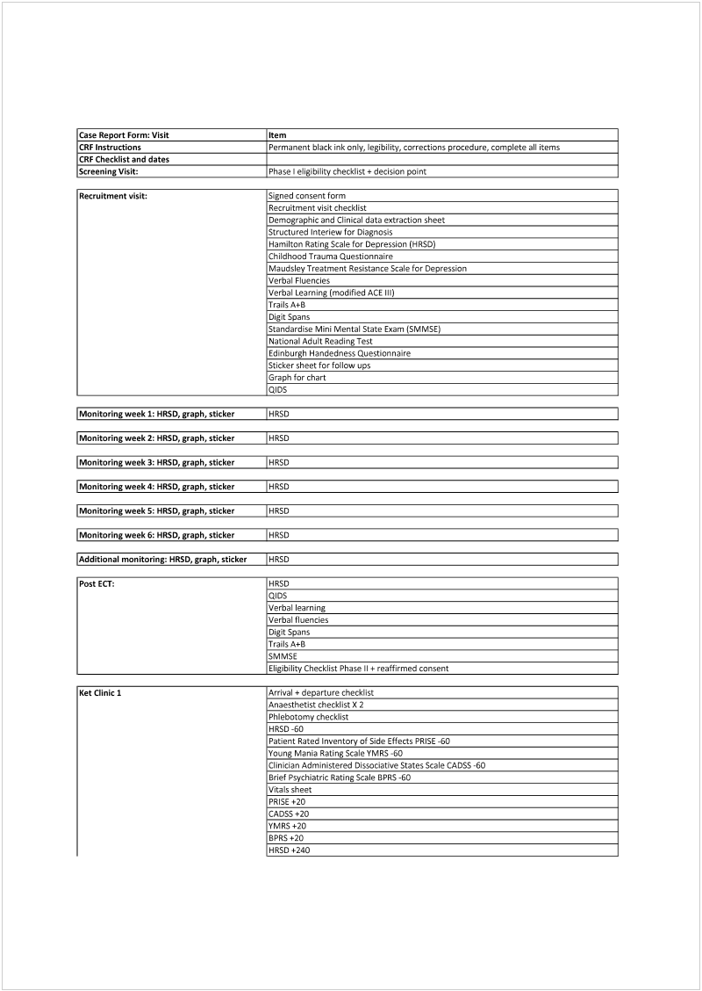
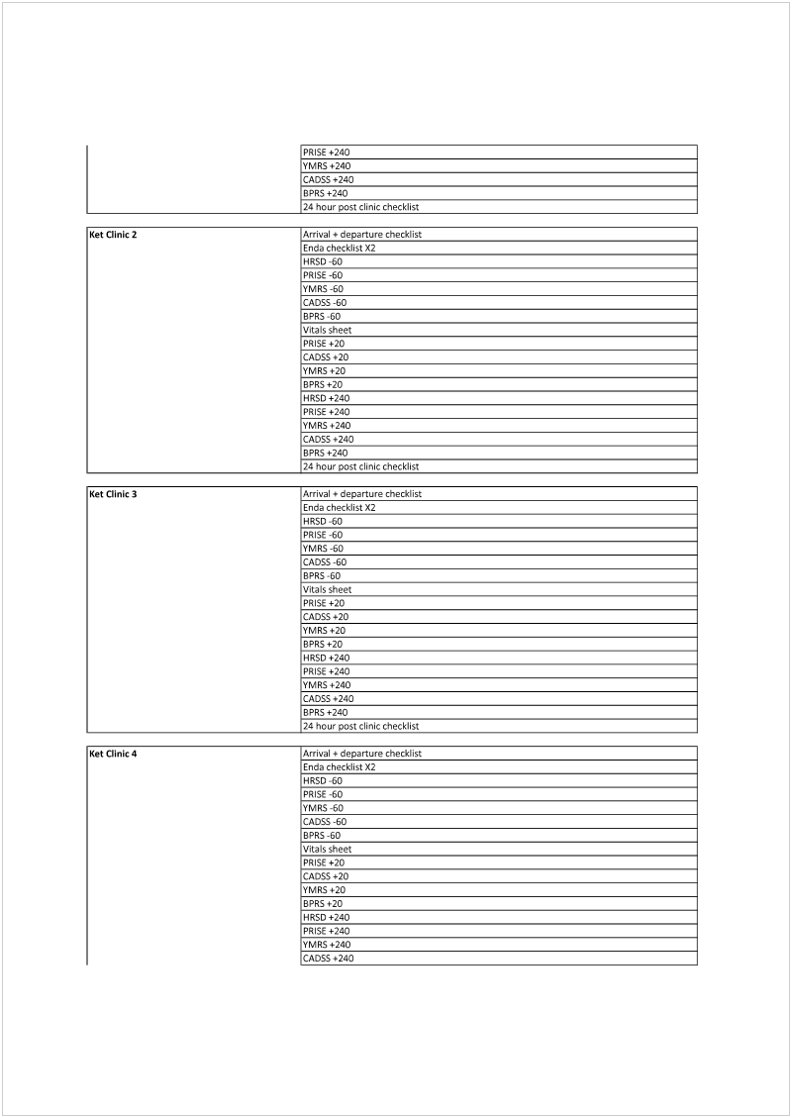
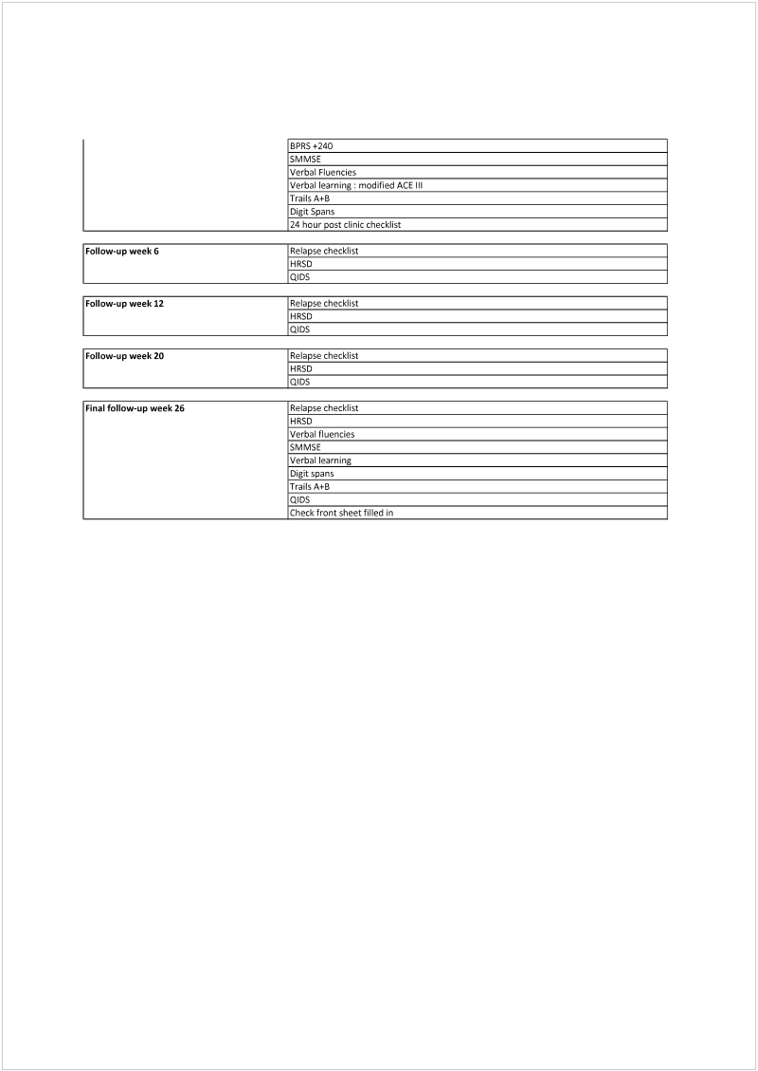

Appendix 10
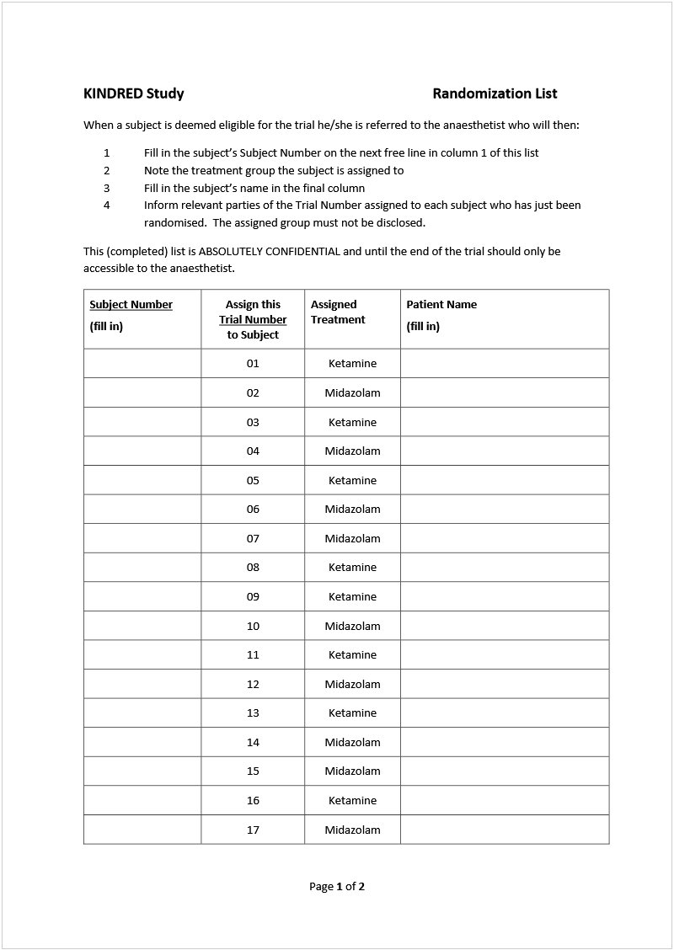
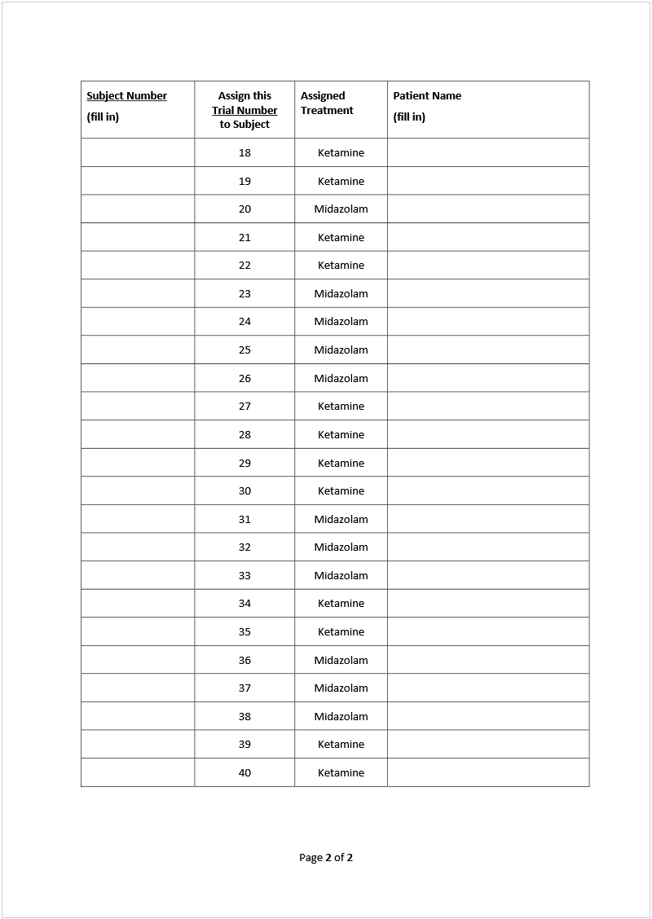

Appendix 11
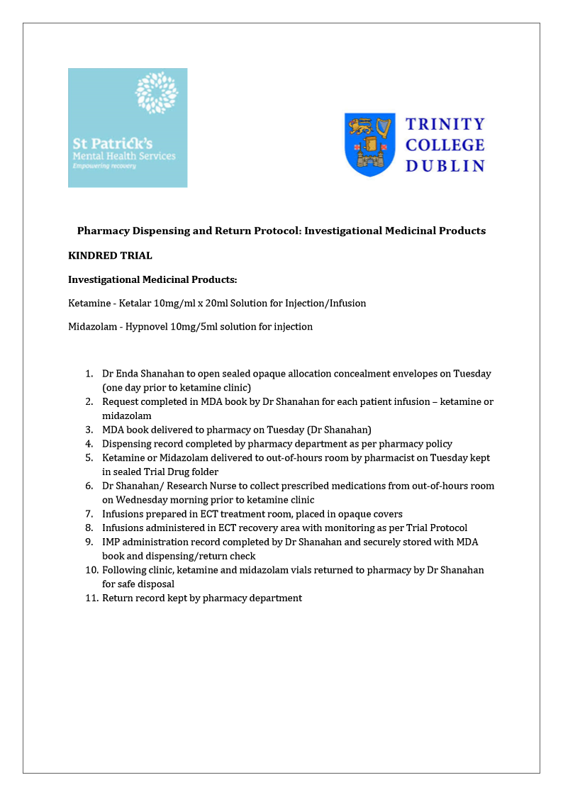

Appendix 12
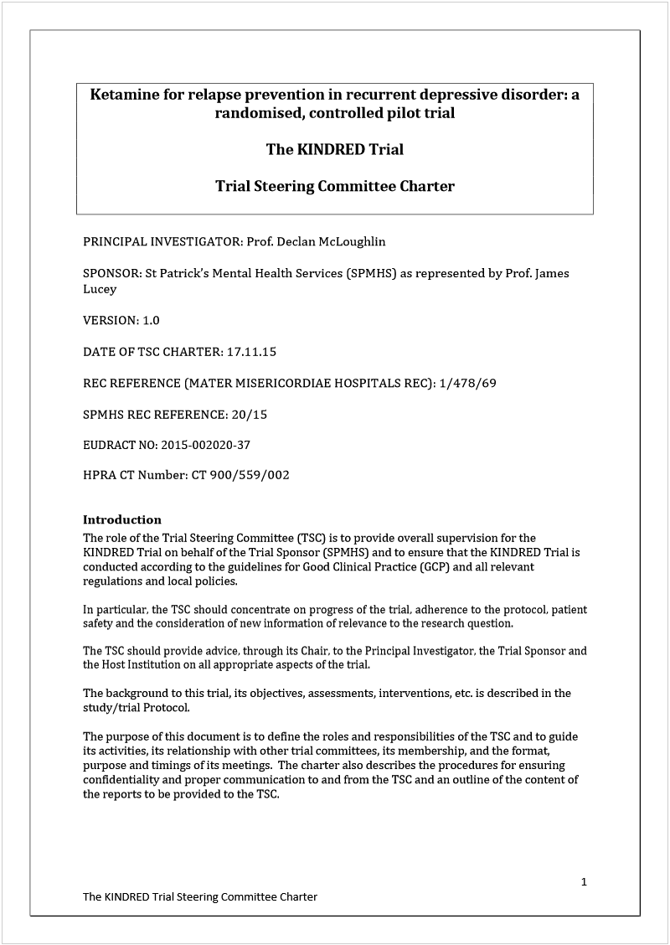

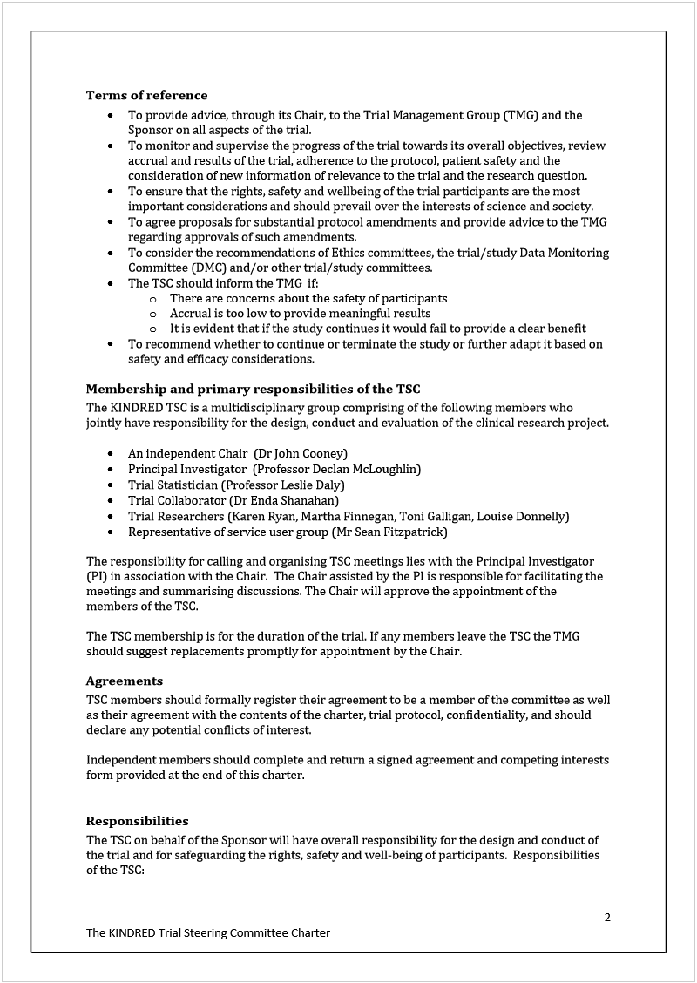

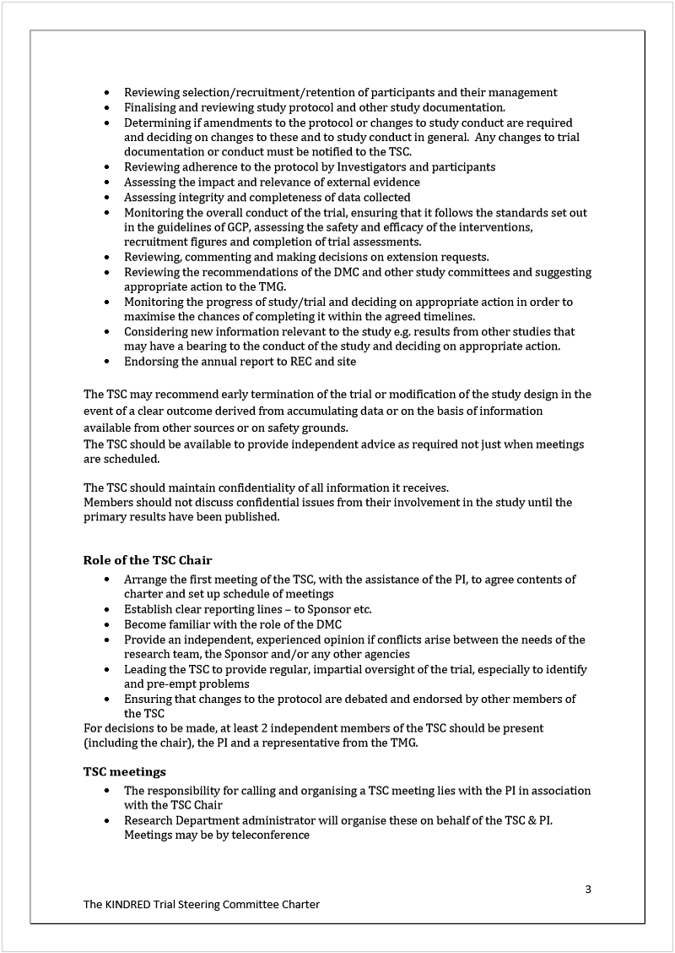

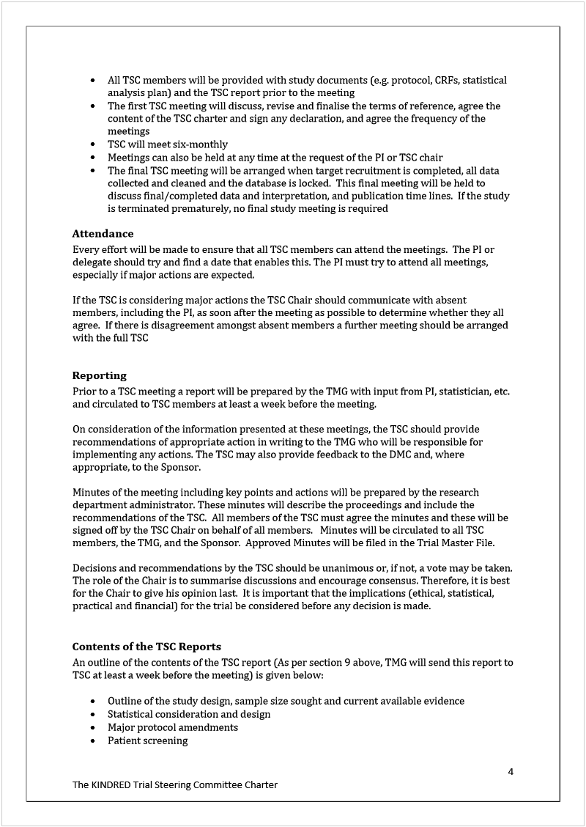

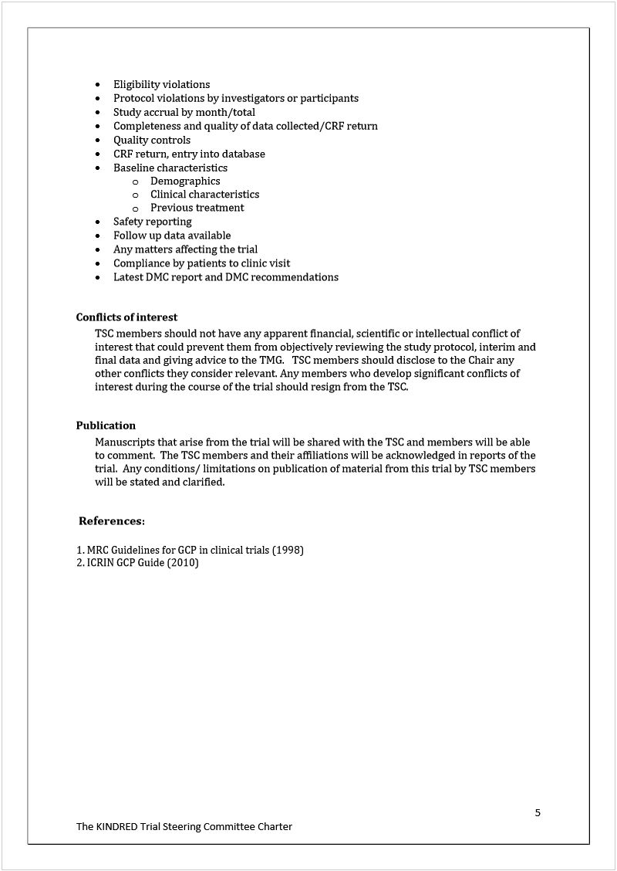

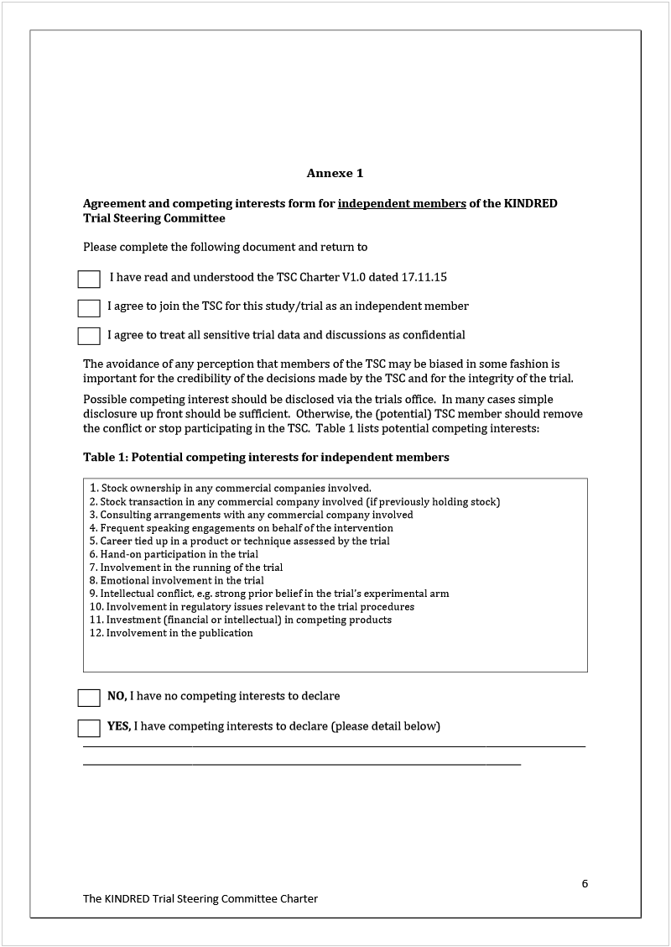

Appendix 13


