Statistical analysis final report


A phase 2 trial of the monocyte-targeted histone deacetylase inhibitor tefinostat (CHR-2845) in chronic myelomonocytic leukaemia (CMML)

 | Name | Title | Signature | Date
Written by: | Sharon Ayayo | Trial Statistician
Validated and reviewed by: | Cono Ariti | Senior Statistician
Approved by: | Steve Knapper | Principal Investigator

Version history
Version | Version date | Changes
0.1 | 02/06/2021 | Initial draft
0.2 | 23/08/2021 | Second daft
0.3 | 26/10/2021 | Third draft

Introduction

This document details the analysis for the main paper(s) reporting results from the MONOCLE trial. Subsequent analyses of a more exploratory nature will not be bound by this strategy, though they are expected to follow the broad principles within this report.
The analysis strategy will be available on request when the principal papers are submitted for publication in a journal. Suggestions for subsequent analyses by journal editors or referees, will be considered carefully, and carried out as far as possible in line with the principles of this analysis strategy; if reported, the source of the suggestion will be acknowledged.

This report is based on the statistical analysis plan for MONOCLE version 1.2 dated January 2021.

Any deviations from the statistical analysis plan will be described and justified in this report.

Report written by:
Sharon Ayayo

Chief Investigators:
Dr Steven Knapper

Trial/Trial Manager:
Laura Upton

Validation
Validation of primary results presented in this report were conducted by Cono Ariti. Results from output were checked for transcription errors. Further details of validation including validation programs are saved in: S:\HAEMY\Haematology Clinical Trials\Statistics\MONOCLE\Final report\Stata\Do.

Software employed
The analysis was carried out using Stata version 16 and 17

Results

TRIAL/TRIAL SAMPLE AND PARTICIPANT THROUGHPUT
SCREENING / ELIGIBILITY/ RECRUITMENT
Figure 1 – CONSORT diagram

21 patients enrolled
2 discontinued prior to treatment:
1 ineligible for inclusion
1 Enrolled following recruitment freeze

19 patients received at least one dose

1 excluded from toxicity analysis

13 discontinued
4 toxicity
4 clinical disease progression
2 patient choice
3 clinician’s choice
0 died
6 included in efficacy analysis

Table 1 Eligibility by Cohort for all enrolled patients

Number of ineligible patients enrolled | n = 2
Reason for ineligibility:
Ineligible for enrolment  Enrolled following recruitment freeze | n = 1  n = 1

RECRUITMENT
Twenty (20) patients were recruited from January 2017 to September 2017. One patient was recruited after the trial was stopped and they are excluded from the analysis. Full details of the recruitment and participating centres is given below in Table 2.

Table 2: Recruitment by centre

No | Centre | Jan-17 | Feb-17 | Mar-17 | Apr-17 | May-17 | Jun-17 | Jul-17 | Aug-17 | Sep-17 |  |  | Sum
 | University Hospital of Wales | 1 | 1 | 1 |  |  | 1 |  |  |  |  |  | 4
 | St James (Leeds)
 | Beatson West of Scotland Cancer Centre (Glasgow)
 | The Christie Hospital (Manchester) |  |  |  |  |  | 1 | 1 |  |  |  |  | 2
 | Aberdeen Royal Infirmary |  | 1 |  | 1 |  |  |  |  |  |  |  | 2
 | Churchill Hospital (Oxford) |  |  |  |  |  |  | 1 | 1 |  |  |  | 2
 | Guys |  |  |  |  |  |  | 3 | 1 |  |  |  | 4
 | Nottingham
 | Bristol Royal Infirmary |  |  |  |  |  |  | 1 |  |  |  |  | 1
 | Kent and Canterbury |  |  |  |  |  |  |  | 3 | 1 |  |  | 4
 | Ysbyty Gwynedd |  |  |  |  |  |  |  | 1 |  |  |  | 1
 | Castle Hill |  |  |  |  |  |  |  | 1 |  |  |  | 1
 | Total accrual | 1 | 2 | 1 | 1 | 0 | 2 | 6 | 7 | 1
 | Cumulative | 1 | 3 | 4 | 5 | 5 | 7 | 13 | 20 | 21 |  |  | 21

WITHDRAWAL/FOLLOW UP
Table 3 below shows the patient status at the end of each cycle of treatment. Over the course of the trial 13 patients withdrew: four for disease progression, three patients ceased treatment and withdrew consent for follow up, five patients experienced toxicity (one unacceptable toxicity) that necessitated withdrawal from the trial and one patient was withdrawn because they still required hydroxycarbamide beyond cycle 3.

Table 3: Patient withdrawal at each cycle

 | Stage 1 (n=19)
 | 1 | 2 | 3 | 4 | 5 | 6
Patients evaluable this cycle | 19 | 17 | 14 | 9 | 6 | 6
Reason for cessation/withdrawal from therapy*
Disease progression | 1 (5.3%) | 0 (0.0%) | 1 (7.1%) | 2 (22.2%) | 0 (0.0%) | 0 (0.0%)
Unacceptable toxicity | 1 (5.3%) | 0 (0.0%) | 0 (0.0%) | 0 (0.0%) | 0 (0.0%) | 0 (0.0%)
Toxicity | 0 (0.0%) | 3 (17.6%) | 1 (7.1%) | 0 (0.0%) | 0 (0.0%) | 0 (0.0%)
Patient withdraws consent for treatment (but permits follow-up) | 0 (0.0%) | 0 (0.0%) | 0 (0.0%) | 0 (0.0%) | 0 (0.0%) | 0 (0.0%)
Patient withdraws consent for treatment and follow-up | 0 (0.0%) | 0 (0.0%) | 3 (21.4%) | 0 (0.0%) | 0 (0.0%) | 0 (0.0%)
Lost to follow-up | 0 (0.0%) | 0 (0.0%) | 0 (0.0%) | 0 (0.0%) | 0 (0.0%) | 0 (0.0%)
Concomitant use of Hydroxycarbamide | 0 (0.0%) | 0 (0.0%) | 0 (0.0%) | 1 (11.1%) | 0 (0.0%) | 0 (0.0%)
Death | 0 (0.0%) | 0 (0.0%) | 0 (0.0%) | 0 (0.0%) | 0 (0.0%) | 0 (0.0%)
Numbers are Frequency (%).
*Percentages of those evaluable.

BASELINE CHARACTERISTICS OF PARTICIPANT
Table 4 gives the patients characteristics at the time of recruitment and the baseline assessment. The patient group is older (mean age 74) and male (14/20 , 70%). Most patients were of CMML subtype 1 (18/20, 90%) and had a low risk cytogenetic profile (17/20, 85%). 13/20, 65% of patients had prior red blood cell transfusions but only 1 patient (5%) had a prior platelet transfusion. A detailed summary of the baseline blood assessment is shown in Table 5.

Table 4: Baseline Demographics and assessment

 |  | Stage 1 (n=20)
Age group
60-69 | 3 | (15.0)
70-79 | 13 | (65.0)
80+ | 4 | (20.0)
Missing (%) | 0 | (0.0)
Sex
Male | 14 | (70.0)
Female | 6 | (30.0)
Missing (%) | 0 | (0.0)
ECOG
0 | 2 | (10.0)
1 | 15 | (75.0)
2 | 3 | (15.0)
Missing (%) | 0 | (0.0)
CMML subtype
CMML-1 | 18 | (90.0)
CMML-2 | 2 | (10.0)
Missing (%) | 0 | (0.0)
Cytogenetic risk status at diagnosis
Low | 17 | (85.0)
Intermediate | 1 | (5.0)
High | 2 | (10.0)
Missing (%) | 0 | (0.0)
Previous red cell transfusion
Yes | 13 | (65.0)
No | 7 | (35.0)
Missing (%) | 0 | (0.0)
Previous platelet transfusion
Yes | 1 | (5.0)
No | 19 | (95.0)
Missing (%) | 0 | (0.0)
WBC×109/L categories
≤13 | 8 | (40.0)
13+ | 12 | (60.0)
Missing (%) | 0 | (0.0)
Aspirate Cellularity
Increased | 17 | (85.0)
Decreased | 3 | (15.0)
Missing (%) | 0 | (0.0)
Numbers are Frequency(%)

Table 5: Baseline blood assessment

 |  | Stage 1 (n=20)
Haemoglobin (g/L)
Mean (SD) | 92.3 | (13.9)
Median (IQR) | 91.0 | (83.0, 97.5)
Range |  | (72.0, 126.0)
Missing (%) | 0 | (0.0)
MCV (x 10-15/L)
Mean (SD) | 96.2 | (8.8)
Median (IQR) | 96.0 | (91.5, 101.0)
Range |  | (74.0, 110.0)
Missing (%) | 0 | (0.0)
Total WBC (x 109/L)
Mean (SD) | 23.5 | (18.7)
Median (IQR) | 19.9 | (6.5, 35.0)
Range |  | (2.8, 60.2)
Missing (%) | 0 | (0.0)
Neutrophils (x 109/L)
Mean (SD) | 14.6 | (14.3)
Median (IQR) | 9.4 | (2.9, 25.0)
Range |  | (1.2, 47.0)
Missing (%) | 0 | (0.0)
Eosinophils(x109/L)
Mean (SD) | 0.2 | (0.5)
Median (IQR) | 0.1 | (0.0, 0.2)
Range |  | (0.0, 2.2)
Missing (%) | 3 | (15.0)
Basophils(x109/L)
Mean (SD) | 0.2 | (0.4)
Median (IQR) | 0.1 | (0.0, 0.3)
Range |  | (0.0, 1.6)
Missing (%) | 2 | (10.0)
Lymphocytes(x109/L)
Mean (SD) | 2.6 | (1.4)
Median (IQR) | 2.9 | (1.3, 3.7)
Range |  | (0.5, 4.8)
Missing (%) | 0 | (0.0)
Monocytes(x109/L)
Mean (SD) | 4.5 | (4.0)
Median (IQR) | 2.2 | (1.1, 9.1)
Range |  | (0.4, 11.9)
Missing (%) | 1 | (5.0)
Blasts (%)
Mean (SD) | 4.3 | (4.9)
Median (IQR) | 2.0 | (1.0, 5.0)
Range |  | (0.0, 13.0)
Missing (%) | 7 | (35.0)
Platelets(x109/L)
Mean (SD) | 88.9 | (85.8)
Median (IQR) | 54.5 | (34.0, 122.5)
Range |  | (14.0, 384.0)
Missing (%) | 0 | (0.0)
APTT: (s)
Mean (SD) | 31.7 | (6.6)
Median (IQR) | 30.7 | (29.0, 34.2)
Range |  | (22.2, 44.8)
Missing (%) | 3 | (15.0)
PT(s)
Mean (SD) | 14.6 | (3.6)
Median (IQR) | 13.6 | (12.7, 15.6)
Range |  | (11.4, 26.4)
Missing (%) | 4 | (20.0)
Fibrinogen (g/L)
Mean (SD) | 3.3 | (1.0)
Median (IQR) | 3.0 | (2.5, 4.1)
Range |  | (1.8, 5.8)
Missing (%) | 1 | (5.0)
Absolute Reticulocyte Count (cells/uL)
Mean (SD) | 70.4 | (46.3)
Median (IQR) | 72.5 | (29.0, 99.0)
Range |  | (0.0, 149.0)
Missing (%) | 4 | (20.0)
Sodium(mmol/L)
Mean (SD) | 138.5 | (2.8)
Median (IQR) | 139.0 | (137.0, 140.0)
Range |  | (133.0, 144.0)
Missing (%) | 0 | (0.0)
Potassium (mmol/L)
Mean (SD) | 4.2 | (0.4)
Median (IQR) | 4.1 | (3.9, 4.5)
Range |  | (3.4, 4.9)
Missing (%) | 0 | (0.0)
Creatinine (umol/L)
Mean (SD) | 110.4 | (33.2)
Median (IQR) | 101.0 | (87.5, 126.5)
Range |  | (64.0, 192.0)
Missing (%) | 0 | (0.0)
eGFR (ml/min)
Mean (SD) | 57.7 | (17.0)
Median (IQR) | 59.0 | (40.0, 70.0)
Range |  | (29.0, 85.0)
Missing (%) | 0 | (0.0)
Magnesium (mEq/L)
Mean (SD) | 0.9 | (0.3)
Median (IQR) | 0.8 | (0.8, 0.9)
Range |  | (0.5, 1.8)
Missing (%) | 2 | (10.0)
Corrected Calcium (mEq/L)
Mean (SD) | 2.3 | (0.1)
Median (IQR) | 2.3 | (2.2, 2.4)
Range |  | (2.1, 2.5)
Missing (%) | 1 | (5.0)
Phosphate (mmol/L)
Mean (SD) | 1.2 | (0.2)
Median (IQR) | 1.2 | (1.1, 1.3)
Range |  | (0.7, 1.5)
Missing (%) | 0 | (0.0)
Glucose (mmol/L)
Mean (SD) | 5.7 | (2.2)
Median (IQR) | 5.2 | (4.7, 6.4)
Range |  | (2.9, 12.9)
Missing (%) | 1 | (5.0)
Albumin (g/L)
Mean (SD) | 38.4 | (3.6)
Median (IQR) | 38.0 | (35.5, 41.0)
Range |  | (32.0, 45.0)
Missing (%) | 0 | (0.0)
Total Protein (g/L)
Mean (SD) | 70.5 | (5.7)
Median (IQR) | 72.0 | (67.0, 75.0)
Range |  | (58.0, 77.0)
Missing (%) | 1 | (5.0)
Bilirubin (umol/L)
Mean (SD) | 13.6 | (7.9)
Median (IQR) | 10.5 | (8.5, 16.5)
Range |  | (6.0, 34.0)
Missing (%) | 0 | (0.0)
Numbers are Mean (SD), Median (IQR), Minimum and Maximum

Analysis

PRIMARY OUTCOMES
MONOCLE is a single-arm, multi-centre, two stage phase 2 clinical trial with the dual primary objectives of evaluating the safety and clinical efficacy of Tefinostat monotherapy in CMML.

Overall clinical response rate is defined as the cumulative proportion of patients achieving clinical benefit (or better) according to International Consortium MDS/MPN Response Criteria at day 29 of the sixth cycle of Tefinostat.

Safety and tolerability of Tefinostat is defined as the proportion of patients experiencing death thought to be at least possibly related to Tefinostat or a CTC grade 3-4 non-haematological adverse reaction, during the first two cycles of treatment. Adverse reaction is defined as an adverse event judged by either the principal investigator or the chief investigator (or his delegate) as having a reasonable suspected causal relationship to Tefinostat.

Primary analysis
As per the Bryant and Day trial design, interim analysis takes place following the recruitment of 19 evaluable patients (defined as any patient starting one cycle of Tefinostat therapy) and requires 6 or fewer to have unacceptable toxicity, with at least 3 patients showing clinical benefit in order to proceed to the second stage.

The following tables show the results of the primary analysis. As can be seen in Table 5a only one patient showed a clinical benefit or better at the evaluation time point. Table 5b shows only one patient experienced an unacceptable toxicity. However, based on the requirements of the trial design the trial did not proceed to stage 2 as it did not show the response criteria being met.

Table 6a: Response criteria outcomes

 | Toxicity (evaluated at the end of cycle 2) |  |  |  |  | Response (clinical benefit or better - evaluated at the end of cycle 6)
 | Died before the end of cycle 2 | No unacceptable toxicity, but withdrew before the end of cycle 2 | Evaluable for toxicity | Safety criteria met | Unacceptable toxicity (by end of cycle 2) | Died before the end of cycle 6 | Withdrew before the end of cycle 6 | Evaluable for response | No response by end of cycle 6 | Response criteria met
19 evaluable patients | 0 | 4 | 18 | 17 | 1* | 4^ | 13 | 6 | 5 | 1**
*13+ required to proceed to stage 2; **3+ responses required to proceed to stage 2
^ all withdrew from treatment before death

Table 6b: Unacceptable toxicities line listing

At the evaluable time point (end of cycle 6) one patient had achieved a clinical benefit, four patients were in stable disease status and one patient had experienced disease progression (Table 7a).
Table 7a: Response outcome

Disease response at the end of cycle 6 - all patients starting one cycle of Tefinostat | Stage 1 (19)
Clinical benefit or better (% (95% CI)) | 5.3 (0.1 to 26.0)
Disease response at the end of cycle 6 - all patients starting one cycle of Tefinostat | Stage 1 (19)
Clinical benefit or better | 1 (5.3%)
Complete remission | 0 (0.0%)
Complete cytogenic remission | 0 (0.0%)
Partial remission | 0 (0.0%)
Optimal marrow response | 0 (0.0%)
Partial marrow response | 0 (0.0%)
Clinical benefit | 1 (5.3%)
Disease progression | 1 (5.3%)
Stable disease | 4 (21.1%)

7b. Toxicity
Toxicity at the end of cycle 2 | Stage 1 (18)*
Unacceptable toxicity (%(95% CI)) | 5.6 (0.1 to 27.3)
*excludes 1 patient who withdrew for non-toxicity related reason before the end of cycle 2

7c. Treatment response
Disease response at the end of cycle 6 - all patients starting one cycle of Tefinostat | Stage 1 (19)
Clinical benefit or better (%(95% CI)) | 5.3 (0.1 to 26.0)

SECONDARY OUTCOMES
Secondary trial objectives include: rates and duration of remission, duration of therapy, survival times of patients, assessing quality of life of patients, red blood cell and platelet transfusion independence and transformation of CMML to AML.

The secondary objective of determining if clinical responses to Tefinostat correlate with baseline biological measures of disease, including hCE-1 expression level and molecular mutational profile and with differential effects of Tefinostat on protein acetylation between monocytes and other haematological cell lineages is a translational sub-trial and will have its own analysis plan and separate report.

Secondary analysis

Survival endpoints

Table 8: Survival end points

Survival endpoints
Median follow-up time (months) | 9.7
30 day mortality | 0.0 (0.0, 17.6)
6 month overall survival | 66.7 (40.4, 83.4)
12 month overall survival | 38.9 (17.5, 60.0)
18 month overall survival | 22.2 (6.9, 42.9)
Median overall survival(months) | 9.7 (5.2, 13.1)
Median progression free survival(months) | 8.6 (3.5, 13.1)
Median time until AML transformation (months) | Insufficient events to calculate.
Overall survival, progression free survival and time until AML transformation will be presented as Kaplan Meier curves

Figure 2: Overall survival

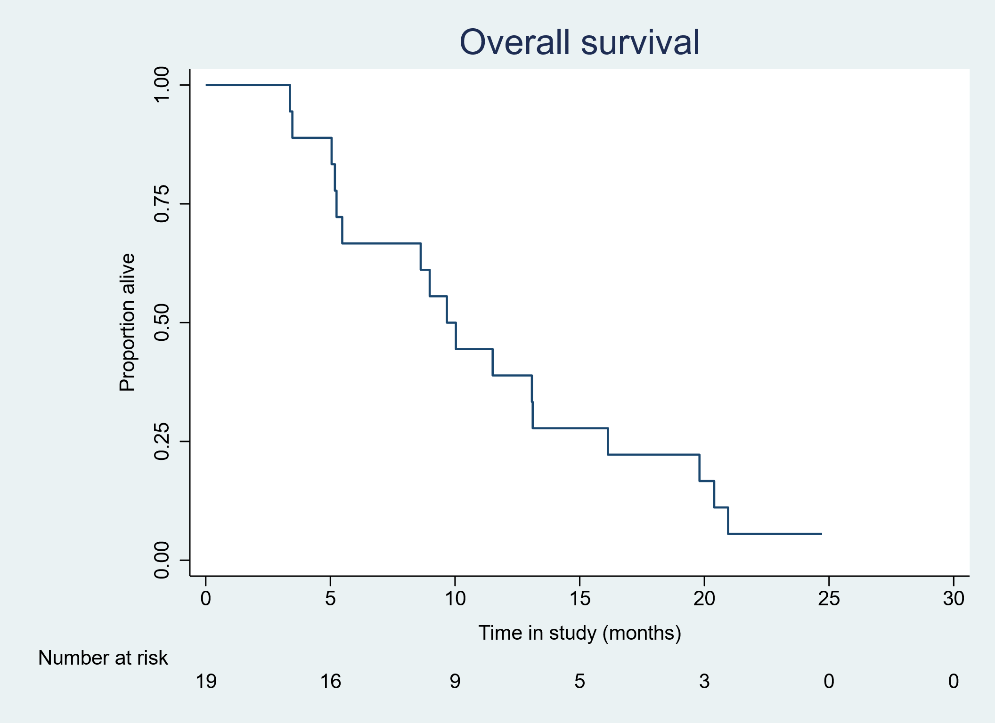
Figure 3: Progression free survival

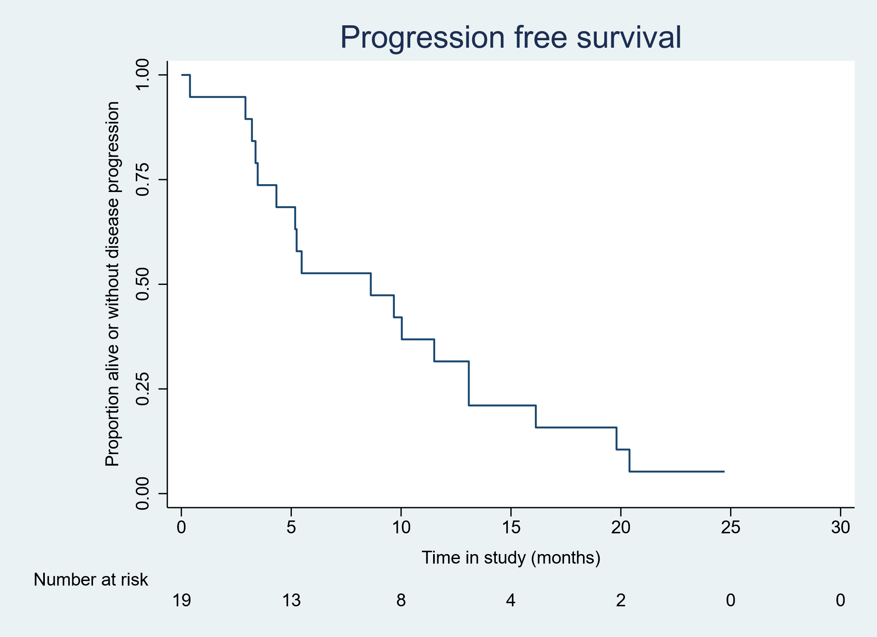

Figure 4: Time until AML transformation

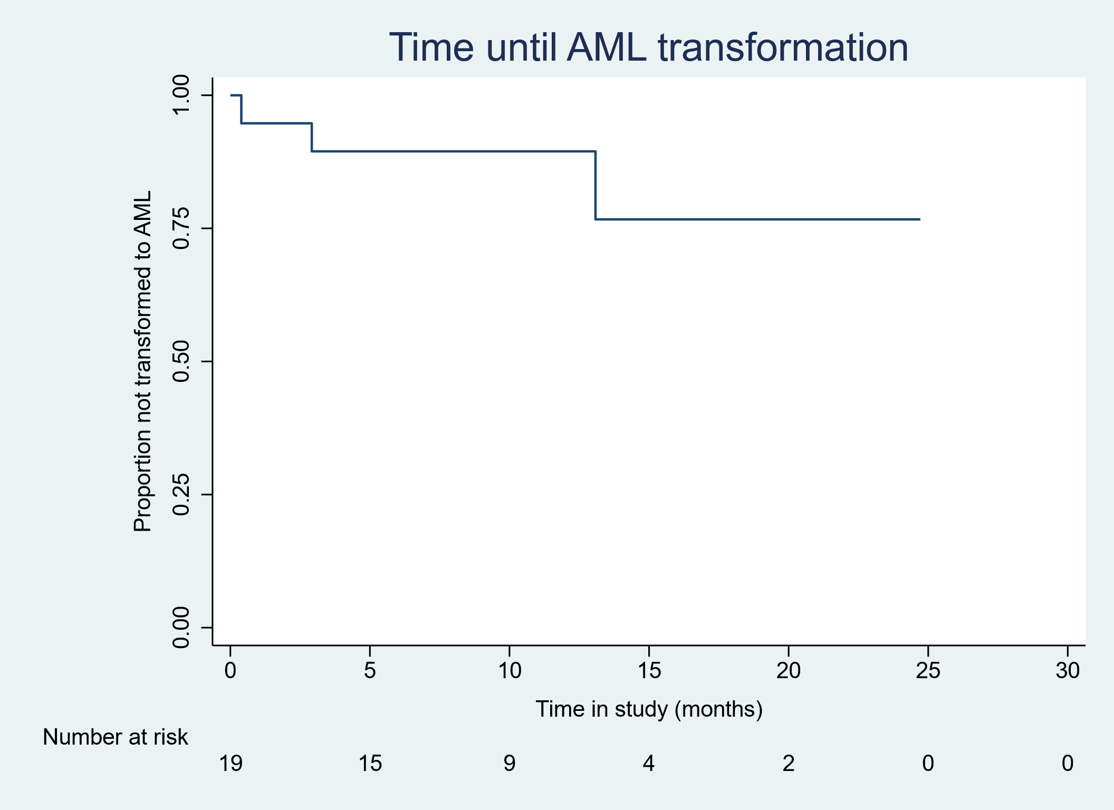

Quality of life endpoints

Table 9a: Quality of life assessment (BFI & MPN-SAF)

 | Time of assessment
 | Baseline |  | Day 1, cycle 4 |  | Day 15, cycle 6
 | (N=19) |  | (N=9) |  | (N=6)
Brief Fatigue Inventory (BFI) (Number (%) reporting symptom (1-10))
Fatigue - now | 16 | (84.2) | 9 | (100.0) | 6 | (100.0)
Fatigue - usual last 24 hours | 17 | (89.5) | 9 | (100.0) | 6 | (100.0)
Fatigue - worst last 24 hours | 17 | (89.5) | 9 | (100.0) | 6 | (100.0)
General activity | 18 | (94.7) | 8 | (88.9) | 6 | (100.0)
Mood | 15 | (78.9) | 9 | (100.0) | 6 | (100.0)
Walking ability | 17 | (89.5) | 9 | (100.0) | 6 | (100.0)
Normal working | 19 | (100.0) | 9 | (100.0) | 6 | (100.0)
relations with others | 14 | (73.7) | 8 | (88.9) | 6 | (100.0)
Enjoyment of life | 17 | (89.5) | 8 | (88.9) | 6 | (100.0)
Fatigue (global BFI score) | 19 | (100.0) | 9 | (100.0) | 6 | (100.0)
MPN-SAF (Number (%) reporting symptom (1-10))
Early satiety | 17 | (89.5) | 5 | (55.6) | 6 | (100.0)
Abdominal pain | 9 | (47.4) | 4 | (44.4) | 2 | (33.3)
Inactivity | 11 | (57.9) | 8 | (88.9) | 6 | (100.0)
Headaches | 7 | (36.8) | 1 | (11.1) | 3 | (50.0)
Concentration problems | 14 | (73.7) | 7 | (77.8) | 5 | (83.3)
Dizziness | 13 | (68.4) | 6 | (66.7) | 3 | (50.0)
Numbness | 8 | (42.1) | 5 | (55.6) | 2 | (33.3)
Insomnia | 13 | (68.4) | 7 | (77.8) | 2 | (33.3)
Sad mood | 11 | (57.9) | 8 | (88.9) | 5 | (83.3)
Sexual problems | 12 | (63.2) | 4 | (44.4) | 2 | (33.3)
Cough | 12 | (63.2) | 6 | (66.7) | 4 | (66.7)
Night sweats | 12 | (63.2) | 5 | (55.6) | 3 | (50.0)
Itching | 8 | (42.1) | 5 | (55.6) | 3 | (50.0)
Bone pain | 7 | (36.8) | 4 | (44.4) | 3 | (50.0)
Fever | 2 | (10.5) | 2 | (22.2) | 2 | (33.3)
Weight loss | 14 | (73.7) | 6 | (66.7) | 6 | (100.0)
Quality of life | 17 | (89.5) | 7 | (77.8) | 6 | (100.0)
Numbers are Frequency (%)

Table 9b: Quality of life assessment (EQ-5D-5L)

 | Time of assessment
 | Baseline |  | Day 1, cycle 4 |  | Day 15, cycle 6
 | (N=19) |  | (N=9) |  | (N=6)
EQ-5D-5L
Mobility
I have no problems in walking about | 7 | (36.8) | 1 | (11.1) | 1 | (16.7)
I have slight problems in walking about | 5 | (26.3) | 4 | (44.4) | 3 | (50.0)
I have moderate problems in walking about | 6 | (31.6) | 2 | (22.2) | 2 | (33.3)
I have severe problems in walking about | 1 | (5.3) | 2 | (22.2) | 0 | (0.0)
Missing (%) | 0 | (0.0) | 0 | (0.0) | 0 | (0.0)
Self-Care
I have no problems washing or dressing myself | 18 | (100.0) | 4 | (44.4) | 5 | (83.3)
I have slight problems washing or dressing myself | 0 | (0.0) | 3 | (33.3) | 0 | (0.0)
I have moderate problems washing or dressing myself | 0 | (0.0) | 2 | (22.2) | 0 | (0.0)
I have severe problems washing or dressing myself | 0 | (0.0) | 0 | (0.0) | 1 | (16.7)
Missing (%) | 1 | (5.3) | 0 | (0.0) | 0 | (0.0)
Usual Activities
I have no problems doing my usual activities | 7 | (36.8) | 0 | (0.0) | 0 | (0.0)
I have slight problems doing my usual activities | 5 | (26.3) | 4 | (44.4) | 4 | (66.7)
I have moderate problems doing my usual activities | 6 | (31.6) | 3 | (33.3) | 1 | (16.7)
I have severe problems doing my usual activities | 1 | (5.3) | 1 | (11.1) | 1 | (16.7)
I am unable to do my usual activities | 0 | (0.0) | 1 | (11.1) | 0 | (0.0)
Missing (%) | 0 | (0.0) | 0 | (0.0) | 0 | (0.0)
Pain/Discomfort
I have no pain or discomfort | 9 | (50.0) | 5 | (62.5) | 3 | (50.0)
I have slight pain or discomfort | 3 | (16.7) | 1 | (12.5) | 3 | (50.0)
I have moderate pain or discomfort | 3 | (16.7) | 1 | (12.5) | 0 | (0.0)
I have severe pain or discomfort | 3 | (16.7) | 1 | (12.5) | 0 | (0.0)
Missing (%) | 1 | (5.3) | 1 | (11.1) | 0 | (0.0)
Anxiety/Depression
I am not anxious or depressed | 11 | (61.1) | 3 | (33.3) | 2 | (33.3)
I am slightly anxious or depressed | 5 | (27.8) | 2 | (22.2) | 1 | (16.7)
I am moderately anxious or depressed | 2 | (11.1) | 4 | (44.4) | 3 | (50.0)
Missing (%) | 1 | (5.3) | 0 | (0.0) | 0 | (0.0)
Your health today (VAS 0-100)
Mean (SD) | 72.4 | (15.8) | 53.9 | (20.6) | 46.7 | (16.3)
Median (IQR) | 75.0 | (60.0, 90.0) | 50.0 | (35.0, 70.0) | 45.0 | (30.0, 60.0)
Min, max |  | (45.0, 90.0) |  | (30.0, 90.0) |  | (30.0, 70.0)
Missing (%) | 0 | (0.0) | 0 | (0.0) | 0 | (0.0)

Red blood cell and platelet transfusion independence

Table 10: Red blood cell and platelet transfusion independence
Disease response at the end of cycle 6 - all patients starting one cycle of Tefinostat | Stage 1 (19)
Red blood cell transfusion independence (% (95% CI)) | 5.3 (0.1 to 26.0)
Platelet transfusion independence (% (95% CI)) | 5.3 (0.1 to 26.0)

Compliance
Table 11a: Treatment by cycle compliance

Stage 1 | Cycle
 | 1 | 2 | 3 | 4 | 5 | 6
No of patients starting cycle | 19 | 17 | 14 | 9 | 6 | 6
No of patients not treated | 0 (0.0%) | 2 (10.5%) | 5 (26.3%) | 10 (52.6%) | 13 (68.4%) | 13 (68.4%)
Treatment cessation
Withdrawal | 2 (10.5%) | 3 (17.6%) | 5 (35.7%) | 3 (33.3%) | 0 (0.0%) | 0 (0.0%)
Unacceptable toxicity | 1 (5.3%) | 0 (0.0%) | 0 (0.0%) | 0 (0.0%) | 0 (0.0%) | 0 (0.0%)
Toxicity | 0 (0.0%) | 3 (17.6%) | 1 (7.1%) | 0 (0.0%) | 0 (0.0%) | 0 (0.0%)
Disease progression | 1 (5.3%) | 0 (0.0%) | 1 (7.1%) | 2 (22.2%) | 0 (0.0%) | 0 (0.0%)
Patient's decision | 0 (0.0%) | 0 (0.0%) | 3 (21.4%) | 0 (0.0%) | 0 (0.0%) | 0 (0.0%)
Lost to follow-up | 0 (0.0%) | 0 (0.0%) | 0 (0.0%) | 0 (0.0%) | 0 (0.0%) | 0 (0.0%)
Death | 0 (0.0%) | 0 (0.0%) | 0 (0.0%) | 0 (0.0%) | 0 (0.0%) | 0 (0.0%)
Concomitant use of Hydroxycarbamide | 0 (0.0%) | 0 (0.0%) | 0 (0.0%) | 1 (11.1%) | 0 (0.0%) | 0 (0.0%)
Treatment received
Cycle started with 360mg | 19 (100.0%) | 11 (64.7%) | 11 (78.6%) | 5 (55.6%) | 2 (33.3%) | 2 (33.3%)
Cycle started with 240mg | 0 (0.0%) | 1 (5.9%) | 0 (0.0%) | 1 (11.1%) | 1 (16.7%) | 1 (16.7%)
Cycle started with 480mg | 0 (0.0%) | 5 (29.4%) | 3 (21.4%) | 3 (33.3%) | 3 (50.0%) | 3 (50.0%)
Tefinostat taken per protocol | 14 (73.7%) | 16 (94.1%) | 13 (92.9%) | 8 (88.9%) | 5 (83.3%) | 3 (50.0%)

Table 11b: Compliance overview
 |  |  |  | Stage 1
 | Number starting one cycle of Tefinostat* |  |  | 19
 | Treatment cessation
Withdrawal |  |  | 13 (68.4%)
 |  | Unacceptable toxicity |  |  | 1 (7.7%)
 |  | Toxicity |  |  | 4 (30.8%)
 |  | Disease progression |  |  | 4 (30.8%)
 |  | Patient's decision |  |  | 3 (23.1%)
 |  | Lost to follow-up |  |  | 0 (0.0%)
 |  | Death |  |  | 0 (0.0%)
 |  | Concomitant use of Hydroxycarbamide |  |  | 1 (7.7%)
 | Median number of cycles to withdrawal |  |  | 3 [2,3]
 | Treatment received
 | Number of cycles started |  |  | 19
 | Number receiving protocol dose for 6 cycles (360mg daily) |  |  | 2 (10.5%)
 | 6 cycles completed with delays due to toxicity |  |  | 0 (0.0%)
 | 6 cycles completed with dose adjustments |  |  | 4 (21.1%)
 | Median number of cycles received |  |  | 3 [2,3]
 | Median dose received |  |  | 360 [360,480]
 | Number of patients with dose reduction |  |  | 3 (15.8%)
 | Median number of cycles to dose reduction |  |  | 3 [3,4]
 | Number of patients with dose escalation |  |  | 4 (21.1%)
 | Median number of cycles to dose escalation |  |  | 2 [2,3]
Numbers are n (%) or median [IQR]

Table 11c: Patients continuing with Tefinostat
 | 1 | 2 | 3 | 4 | 5 | 6
Patients evaluable at time point | 19 | 17 | 14 | 9 | 6 | 6
Patients still on Tefinostat | 17 (89.5%) | 14 (82.4%) | 9 (64.3%) | 6 (66.7%) | 6 (100.0%) | 6 (100.0%)
Numbers are Frequency (%).

HARMS/SAFETY ANALYSES
Table 12 and 13 list all grade 3-4 toxicities by course with table 13 listing toxicities related to the drug. A summary of SAEs by system organ class is given in table 14a. Table 15a provides the death information. No formal statistical testing will be undertaken.

Toxicity analysis

Table 12: Grade 3-5 toxicities
 | Stage 1 (n=19)
 | 1 | 2 | 3 | 4 | 5 | 6 | Post Withdrawal
Patients evaluable this cycle | 19 (100.0%) | 17 (89.5%) | 14 (73.7%) | 9 (47.4%) | 6 (31.6%) | 6 (31.6%) | 17 (89.5%)
Tefinostat taken as per protocol^ | 14 (73.7%) | 16 (94.1%) | 13 (92.9%) | 8 (88.9%) | 5 (83.3%) | 3 (50.0%) | 0 (0.0%)
Adverse events grade 3-5^
Nausea/vomiting | 0 (0.0%) | 0 (0.0%) | 1 (7.1%) | 0 (0.0%) | 0 (0.0%) | 0 (0.0%) | 0 (0.0%)
Oral | 1 (5.3%) | 0 (0.0%) | 0 (0.0%) | 0 (0.0%) | 0 (0.0%) | 0 (0.0%) | 0 (0.0%)
Diarrhoea | 0 (0.0%) | 0 (0.0%) | 0 (0.0%) | 0 (0.0%) | 0 (0.0%) | 0 (0.0%) | 0 (0.0%)
Cardiac Function (LVEF) | 0 (0.0%) | 0 (0.0%) | 0 (0.0%) | 0 (0.0%) | 0 (0.0%) | 0 (0.0%) | 0 (0.0%)
Cardiac Arrhythmia | 1 (5.3%) | 0 (0.0%) | 0 (0.0%) | 0 (0.0%) | 0 (0.0%) | 0 (0.0%) | 1 (5.9%)
Cardiac Other | 0 (0.0%) | 0 (0.0%) | 0 (0.0%) | 0 (0.0%) | 0 (0.0%) | 0 (0.0%) | 0 (0.0%)
Liver Toxicity - ALT | 0 (0.0%) | 0 (0.0%) | 0 (0.0%) | 0 (0.0%) | 0 (0.0%) | 0 (0.0%) | 0 (0.0%)
Liver Toxicity - Bilirubin | 0 (0.0%) | 0 (0.0%) | 0 (0.0%) | 0 (0.0%) | 0 (0.0%) | 0 (0.0%) | 0 (0.0%)
Renal Toxicity - Creatinine | 0 (0.0%) | 0 (0.0%) | 1 (7.1%) | 0 (0.0%) | 0 (0.0%) | 0 (0.0%) | 0 (0.0%)
Renal Toxicity - Proteinuria | 0 (0.0%) | 0 (0.0%) | 0 (0.0%) | 0 (0.0%) | 0 (0.0%) | 0 (0.0%) | 0 (0.0%)
Renal Toxicity - Haematuria | 0 (0.0%) | 0 (0.0%) | 0 (0.0%) | 0 (0.0%) | 0 (0.0%) | 0 (0.0%) | 0 (0.0%)
Other | 3 (15.8%) | 3 (17.6%) | 4 (28.6%) | 4 (44.4%) | 1 (16.7%) | 0 (0.0%) | 0 (0.0%)
Death | 0 (0.0%) | 0 (0.0%) | 0 (0.0%) | 0 (0.0%) | 0 (0.0%) | 0 (0.0%) | 17 (100.0%)
^percentage of those evaluable
Note: This is a per patient analysis. For full details of the “other” toxicities reported see Appendix.

Table 13: Grade 3-5 drug-related toxicities
 | Stage 1 (n=19)
 | 1 | 2 | 3 | 4 | 5 | 6 | Post Withdrawal
Patients evaluable this cycle | 19 (100.0%) | 17 (89.5%) | 14 (73.7%) | 9 (47.4%) | 6 (31.6%) | 6 (31.6%) | 17 (89.5%)
Tefinostat taken as per protocol^ | 14 (73.7%) | 16 (94.1%) | 13 (92.9%) | 8 (88.9%) | 5 (83.3%) | 3 (50.0%) | 0 (0.0%)
Adverse events grade 3-5^
Nausea/vomiting | 0 (0.0%) | 0 (0.0%) | 1 (7.1%) | 0 (0.0%) | 0 (0.0%) | 0 (0.0%) | 0 (0.0%)
Oral | 0 (0.0%) | 0 (0.0%) | 0 (0.0%) | 0 (0.0%) | 0 (0.0%) | 0 (0.0%) | 0 (0.0%)
Diarrhoea | 0 (0.0%) | 0 (0.0%) | 0 (0.0%) | 0 (0.0%) | 0 (0.0%) | 0 (0.0%) | 0 (0.0%)
Cardiac Function (LVEF) | 0 (0.0%) | 0 (0.0%) | 0 (0.0%) | 0 (0.0%) | 0 (0.0%) | 0 (0.0%) | 0 (0.0%)
Cardiac Arrhythmia | 0 (0.0%) | 0 (0.0%) | 0 (0.0%) | 0 (0.0%) | 0 (0.0%) | 0 (0.0%) | 0 (0.0%)
Cardiac Other | 0 (0.0%) | 0 (0.0%) | 0 (0.0%) | 0 (0.0%) | 0 (0.0%) | 0 (0.0%) | 0 (0.0%)
Liver Toxicity - ALT | 0 (0.0%) | 0 (0.0%) | 0 (0.0%) | 0 (0.0%) | 0 (0.0%) | 0 (0.0%) | 0 (0.0%)
Liver Toxicity - Bilirubin | 0 (0.0%) | 0 (0.0%) | 0 (0.0%) | 0 (0.0%) | 0 (0.0%) | 0 (0.0%) | 0 (0.0%)
Renal Toxicity - Creatinine | 0 (0.0%) | 0 (0.0%) | 0 (0.0%) | 0 (0.0%) | 0 (0.0%) | 0 (0.0%) | 0 (0.0%)
Renal Toxicity - Proteinuria | 0 (0.0%) | 0 (0.0%) | 0 (0.0%) | 0 (0.0%) | 0 (0.0%) | 0 (0.0%) | 0 (0.0%)
Renal Toxicity - Haematuria | 0 (0.0%) | 0 (0.0%) | 0 (0.0%) | 0 (0.0%) | 0 (0.0%) | 0 (0.0%) | 0 (0.0%)
Other | 0 (0.0%) | 0 (0.0%) | 0 (0.0%) | 0 (0.0%) | 0 (0.0%) | 0 (0.0%) | 0 (0.0%)
Death | 0 (0.0%) | 0 (0.0%) | 0 (0.0%) | 0 (0.0%) | 0 (0.0%) | 0 (0.0%) | 17 (100.0%)

^percentages of those evaluable

SAEs

Table 14a: SAEs by system organ class

System organ class | n (%)
Blood and Lymphatic disorders
Anaemia | 3 (14.3%)
Cardiac disorders
Atrioventricular block | 1 (4.8%)
Pulmonary oedema | 1 (4.8%)
Gastrointestinal disorders
Nausea | 1 (4.8%)
Stomatitis | 1 (4.8%)
General disorders and administration site conditions
Pyrexia | 3 (14.3%)
Infections and infestations
Kidney infection | 1 (4.8%)
Lower respiratory tract infection | 2 (9.5%)
Lung infection | 3 (14.3%)
Pneumonia | 1 (4.8%)
Investigations
Gamma glutamyl transferase | 1 (4.8%)
Renal and urinary disorders
Acute kidney injury | 2 (9.5%)
Respiratory, thoracic and mediastinal disorders
Sore throat | 1 (4.8%)

Table 14b: SAE line listing
Patient number | seriousness | Event name | Onset date | Grade | Resolution date | Category
104 | 3 = required inpatient hospitalisation or prolongation of existing hospital stay | Pyrexia | 27/03/2017 | 1 | 27/03/2017 | 1 = SAE
104 | 3 = required inpatient hospitalisation or prolongation of existing hospital stay | LRTI (previously reported as Fever ) | 12/06/2017 | 3 | 15/06/2017 | 1 = SAE
105 | 6 = other medically important condition | increased GGT | 17/04/2017 | 3 | 02/05/2017 | 1 = SAE
106 | 3 = required inpatient hospitalisation or prolongation of existing hospital stay | Community acquired pneumonia | 01/07/2017 | 3 | 09/07/2017 | 1 = SAE
106 | 3 = required inpatient hospitalisation or prolongation of existing hospital stay | Pyrexia | 17/07/2017 | 1 |  | 1 = SAE
106 | 3 = required inpatient hospitalisation or prolongation of existing hospital stay | Abdominal pain (on coughing) | 06/08/2017 | 2 | 07/08/2017 | 1 = SAE
106 | 3 = required inpatient hospitalisation or prolongation of existing hospital stay | Lung infection (previously reported as Low oxygen saturations (hypoxia)) | 14/08/2017 | 3 | 16/08/2017 | 1 = SAE
106 | 3 = required inpatient hospitalisation or prolongation of existing hospital stay | chest infection | 22/09/2017 | 3 | 03/10/2017 | 1 = SAE
108 | 3 = required inpatient hospitalisation or prolongation of existing hospital stay | Anaemia | 21/08/2017 | 3 | 22/08/2017 | 1 = SAE
108 | 3 = required inpatient hospitalisation or prolongation of existing hospital stay | Pulmonary oedema | 06/09/2017 | 3 | 26/09/2017 | 1 = SAE
111 | 3 = required inpatient hospitalisation or prolongation of existing hospital stay | Sore throat | 17/07/2017 | 2 | 20/07/2017 | 1 = SAE
111 | 3 = required inpatient hospitalisation or prolongation of existing hospital stay | Pulmonary Infection | 02/10/2017 | 3 | 09/10/2017 | 1 = SAE
112 | 3 = required inpatient hospitalisation or prolongation of existing hospital stay | Fever | 16/08/2017 | 1 | 22/08/2017 | 1 = SAE
112 | 3 = required inpatient hospitalisation or prolongation of existing hospital stay | Mucositis oral | 19/08/2017 | 3 | 05/09/2017 | 1 = SAE
113 | 3 = required inpatient hospitalisation or prolongation of existing hospital stay | Nausea/Vomiting | 02/10/2017 | 3 | 13/10/2017 | 4 = 15 DAY SUSAR
114 | 3 = required inpatient hospitalisation or prolongation of existing hospital stay | Acute kidney injury | 05/10/2017 | 2 | 17/10/2017 | 4 = 15 DAY SUSAR
114 | 3 = required inpatient hospitalisation or prolongation of existing hospital stay | Anaemia | 11/12/2017 | 4 | 07/03/2018 | 1 = SAE
118 | 3 = required inpatient hospitalisation or prolongation of existing hospital stay | Atrioventricular block - complete | 07/09/2017 | 3 | 08/09/2017 | 4 = 15 DAY SUSAR
119 | 3 = required inpatient hospitalisation or prolongation of existing hospital stay | Kidney infection | 25/09/2017 | 3 | 06/10/2017 | 1 = SAE
119 | 3 = required inpatient hospitalisation or prolongation of existing hospital stay | Anaemia | 26/10/2017 | 3 | 14/12/2017 | 4 = 15 DAY SUSAR
119 | 3 = required inpatient hospitalisation or prolongation of existing hospital stay | Lung infection | 09/11/2017 | 3 | 14/12/2017 | 1 = SAE
121 | 3 = required inpatient hospitalisation or prolongation of existing hospital stay | Acute on chronic kidney injury | 23/10/2017 | 3 | 08/06/2020 | 4 = 15 DAY SUSAR

Deaths

Table 15a: Summary of cause of death

Cause of death | Stage 1 (n= 19)
Infection | 4 (21.1%)
Haemorrhage | 1 (5.3%)
Second malignancy | 1 (5.3%)
Cardiac | 0 (0.0%)
Renal | 0 (0.0%)
Resistant/recurrent disease | 8 (42.1%)
Pulmonary | 0 (0.0%)
AML | 1 (5.3%)
Multiple known | 1 (5.3%)
Unknown | 1 (5.3%)
Numbers are frequency (%)

Table 15b: Death line listing

Patient ID | Site | Date of death | Cause of death
102 | University Hospital Wales, Cardiff | 23/06/2018 | Infection
103 | Aberdeen | 30/03/2018 | Resistant/recurrent disease
104 | UHW, Cardiff | 01/12/2018 | Haemorrhage
105 | Aberdeen | 10/12/2017 | Infection
106 | University Hospital of Wales, Cardiff | 10/04/2018 | Resistant/recurrent disease
107 | The Christie | 06/04/2018 | Resistant/recurrent disease
108 | Guy's | 11/10/2017 | Infection, cardiac,renal, pulmonary
109 | The Christie | 09/08/2018 | Unknown
110 | Churchill | 26/06/2018 | Resistant/recurrent disease
111 | Guys | 26/03/2019 | Second malignancy
112 | Bristol | 24/12/2017 | Infection
113 | Guy's | 01/01/2018 | Infection
114 | Castle Hill | 02/01/2018 | Resistant/recurrent disease
115 | Kent and Canterbury | 11/05/2018 | AML
117 | East Kent Hospital | 13/04/2019 | Resistant/recurrent disease
118 | Churchill | 09/01/2018 | Resistant/recurrent disease
119 | Ysbyty Gwynedd | 14/12/2017 | Resistant/recurrent disease

DEVIATIONS FROM STATISTICAL ANALYSIS PLAN

- We included 2 additional tables (Table 14a: SAEs by system organ class and Table 15a: Summary of cause of death) together with death line listing (table 15b) which were not there in the original SAP.
- We could not be able to estimate the secondary outcome of overall clinical response rate (according to Wattel and modified IWG Criteria) from the available data so these are not included in this report.

APPENDIX

Summary of toxicities by grade and by cycle.
Cycle 1

Cycle 2

Cycle 3

Cycle 4

Cycle 5

Cycle 6

