Outcomes
The co-primary end-points were of safety and efficacy, adjudged respectively on
the occurrence of adverse events and serious adverse events as classified by use of
the Medical Dictionary for Regulatory Activities, and pulmonary vascular
resistance (PVR) delta as measured by invasive haemodynamic assessment via
fluid-filled right heart catheter using cardiac output measured by thermodilution
technique.

Statistical analysis
The sample size (n) was decided to detect a 30% reduction in PVR after 6 months
of treatment with 90% power and 5% statistical significance was n=17,
accounting for a conservative drop-out rate, the minimum target for recruitment
was n=21. The main analysis reported here are specified on the
modified intention to treat (mITT) set. This is defined as the set of patients who
have had at least one dose of Tocilizumab and at least one post-baseline result. An
additional ITT analysis as a sensitivity analysis, i.e. to assess the existence of
potential bias did not differ from the mITT. Estimates of treatment response rate
and associated confidence intervals (or credible intervals and posterior
probabilities) are reported. The exception to this is the Wilcoxon signed rank test
which is carried out on the PVR fold change.
An additional Bayesian analysis, considered to be more informative of the
treatment response of Tocilizumab on PVR was prespecified using an expert
elicited prior. Any predictor effect on secondary outcomes are reported with
confidence intervals. All analysis reported here were performed using R (version
3.3.3).

Results

Twenty-nine patients (M/F 10/19; mean age 54.9 (SD11.4) were recruited in total
between January 2016 to April 2017. Fifteen patients had idiopathic PAH, ten
connective tissue disease associated PAH (CTD-PAH), and four heritable/ BMPR2
associated PAH (figure 1). Six patients were withdrawn prior to drug
administration; one chest infection, one exacerbation of co-morbid disease, four
at baseline RHC. Twenty-three patients received study drug.

Figure 1 Consort diagram
There was no significant difference in delta PVR at 6 months (figure 3A,B). In apriori
analyses of PVR stratified by aetiology, 4 of the 6 CTD-PAH patients
receiving study drug with an EOS RHC had a greater than 15% reduction in PVR
vs 3 of 13 F/IPAH (figure 3C).

Figure 3 Co-primary endpoint- change in PVR

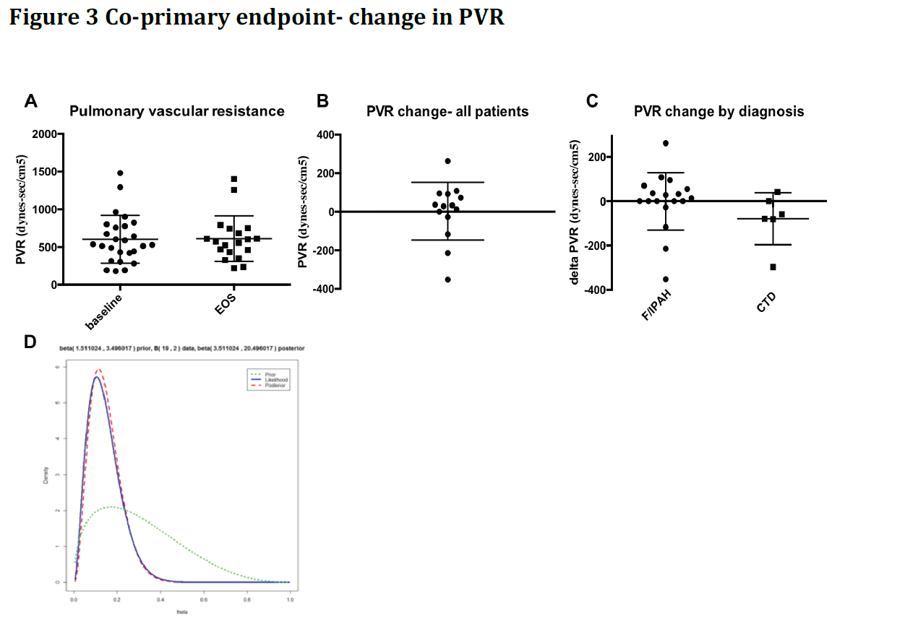

A Bayesian analysis led to the same conclusions as the frequentist analysis (figure
3d). The expert elicited prior was combined with the observed data to produce a
posterior density for the probability of the study drug achieving a PVR fold-change
of at least -30%. (Figure 3D). The posterior probability of the study drug being
successful in the above sense with at least a 30% chance was less than 1%.

