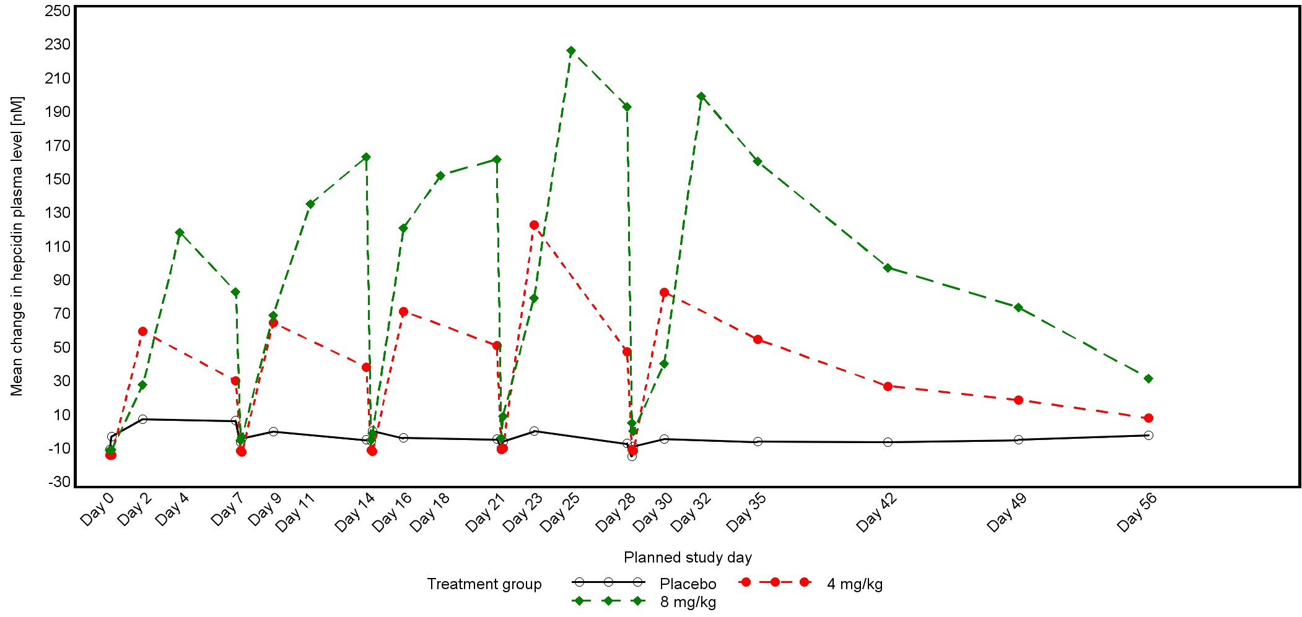

The last value obtained prior to first infusion is used as baseline value.
Due to protocol amendment, assessments at visits on Day 4, Day 11, Day 18, Day 25 and Day 32 were added; only done in one patient treated with 8 mg/kg BW PRS-080#022-DP.

