Metronomic oral vinorelbine doublet chemotherapy with carboplatin in treatment of advanced lung cancer: a feasibility and safety study
Maria Kandi; https://orcid.org/0000-0001-9762-1695, Peter Meldgaard; https://orcid.org/0000-0002-5788-4463, Marianne Marquard Knap

Non-small cell lung cancer (NSCLC) is the second most common cancer in the world. Palliation needs to be balanced against survival and toxicity. Metronomic regimens, small frequent doses of chemotherapy, have been proposed to achieve lower treatment-related toxicity while maintaining or even improving efficacy. The hypothesis is that the frequent administration aims to expose tumour cells continuously to the drug and prevent their ability to regenerate between the chemotherapy series resulting in better tumour control. This study assesses the tolerability of carboplatin in combination with metronomic vinorelbine during 12 weeks of treatment.
Method:
From May 2018 to February 2019 patients with incurable NSCLC, candidates for 1st-line chemotherapy (PD-L1 < 50%), were included. This study was investigator initiated and designed as a prospective non-randomized, open-label, single-arm, safety and feasibility study. Patients received standard dose carboplatin AUC-5 every 3rd week and metronomic oral Navelbine® (20/30 mg) daily for 12 weeks, followed by CT scans for evaluation. Maximum of 4 cycles were delivered.
Overview of standard treatment schedule comparing with metronomic schedule:
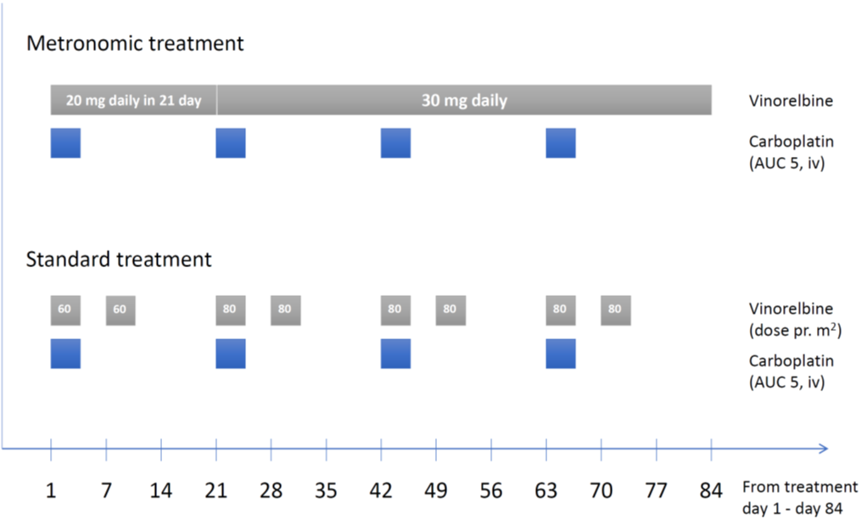

Study design:
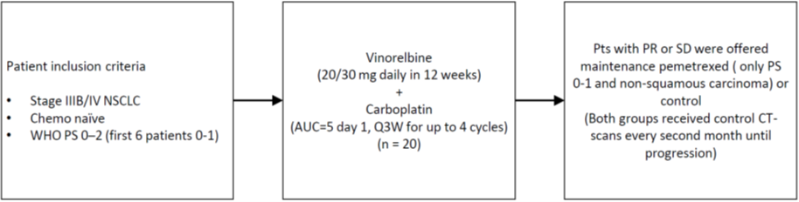
Patient characteristics
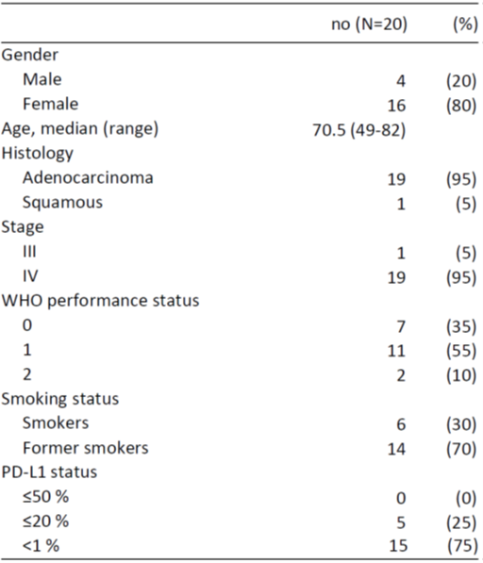

Results:
Twenty patients were included. Median age was 70.5 years (range 49-83); 19 (95%) had adenocarcinoma. Two withdrew their consent within seven days. Eighteen patients included in safety analysis. Thirteen (72 %) received all four cycles. One patient received only three cycles, doctor's decision. Four received only 1-2 cycles of treatment; two had decline in performance-status; and two had disease progression. Majority had CTCAE version 4.03 grade 1 or 2 toxicity such as constipation 13 (72 %) and diarrhoea 13 (72 %), table 2. Two (11 %) had grade 4 febrile neutropenia and recovered. None had CTCAE grade 5 toxicity.
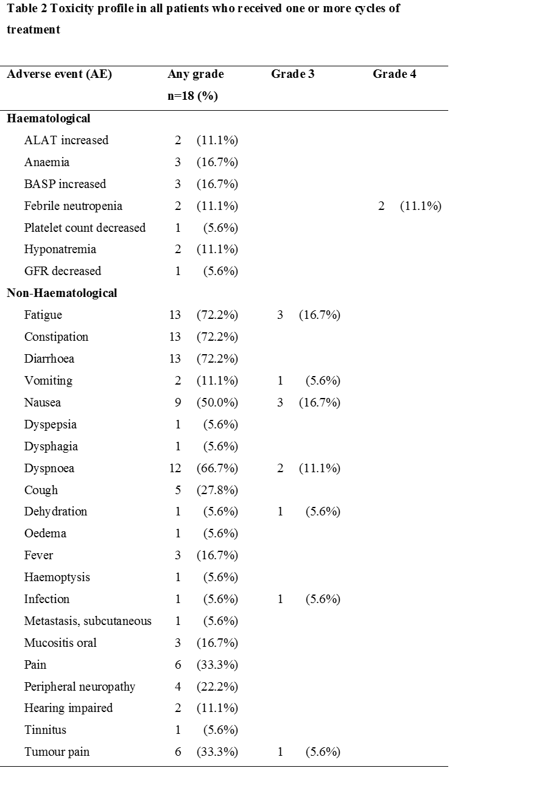

This is the first study evaluating a combination regimen with standard carboplatin given together with metronomic daily oral Navelbine for advanced NSCLC. Doublet chemotherapy with oral Navelbine daily is a safe and feasible option. This regimen could be used in future trials with immunotherapy combinations.

