
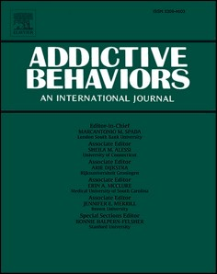
Addictive Behaviors 125 (2022) 107127
Contents lists available at ScienceDirect

Addictive Behaviors
journal homepage: www.elsevier.com/locate/addictbeh

Intranasal as needed naloxone in the treatment of gambling disorder: A  randomised controlled trial
Hannu Alho a, b, Niklas Ma¨kela¨ ª, Jarkko Isotalo c, Lilianne Toivonen c, Jyrki Ollikainen d,
Sari Castr´en b, e, a,*
a University of Helsinki, Department of Medicine, Helsinki, Finland
b Finnish Institute for Health and Welfare, Health and Well-Being Promotion Unit, Finland
c University of Tampere, Tampereen Yliopisto, Finland
d Tampere University, Computing Sciences, Finland
e University of Turku, Social Sciences Department of Psychology and Speech-Language Pathology, Turku, Finland

A R T I C L E I N F O

Keywords: Gambling disorder Pharmacotherapy
Randomised controlled trial Intra nasal naloxone
A B S T R A C T

Background: Gambling disorder (GD) is a global phenomenon affecting millions of people. GD can result in severe social and financial difficulties and efficacious treatments are warranted. Psychosocial treatments form the basis of treatment. Opioid antagonists (OAs) have however shown promise in previous studies. In a recent imaging study intranasal naloxone was found to rapidly and fully occupy brain μ-opioid receptors. This trial investigates the effect and safety of as needed naloxone in the treatment of gambling disorder.
Methods: This was a 12-week double blind, randomised control trial comparing intranasal naloxone to placebo. The primary endpoint was gambling urge measured by the Gambling symptom Assessment Scale (G-SAS). Sec- ondary outcome measures were gambling severity measures (PGSI) as well as quality of life (WHO:EUROHIS-8), alcohol consumption (AUDIT), depression (MARDS) and internet use (IDS-9SF). In addition, safety of treatment was assessed. Both treatment groups received psychosocial support.
Results: 126 participants were randomised to treatment groups in a 1:1 ratio. 106 patients completed the study. Gambling urge (GSAS) and other gambling related measured improved in both groups, but no statistically sig- nificant difference could be found. Intranasal naloxone was well tolerated, no subjects discontinued the study due to adverse events. No serious adverse drug reactions were observed.
Conclusions: This study found no difference between the as-needed administration of intranasal naloxone and placebo in reducing gambling urge in persons with GD. Intranasal naloxone was safe and well tolerated.

Introduction
Gambling disorder (GD) is characterised by inability to control one’s time and resources spent on gambling (The Diagnostic and Statistical Manual of Mental Disorders (5th ed.; DSM–5; American Psychiatric As- sociation, 2013) causing multitudinous harm to gamblers and affecting significant others (Langham et al., 2015). Gambling disorder is classified as a behavioural addiction due to the similarities it shares with sub- stance use disorders (Potenza et al., 2019) both in DSM-5 and ICD-11 criteria (APA, 2013; WHO, 2018). This behavioural addiction shares a similar neurobiology and characteristics such as preoccupation, prob- lems with relationships, loss of control, escapism, withdrawal, tolerance
and craving, and is additionlly fueled by the thought of winning back lost money (chasing losses) (APA, 2013).
Treatments for GD are mostly psychosocial interventions such as cognitive therapy, motivational interview (MI) and cognitive- behavioural therapy (CBT) (Petry, Ginley, & Rash, 2017). Pharmaco- logical treatments have been investigated, but no medication has gained a formal indication for treatment despite clinical trials showing some efficacy, especially with opioid antagonists (OAs) (Kraus, Etuk, & Potenza, 2020).
The dopaminergic systems involved in gambling responses are modulated by the opioid system. The mesolimbic and mesocortical pathways are important mediators of the gambling response and express

* Corresponding author at: Finish Institute for Health and Welfare, P.O. Box 30, FI-00271, Helsinki, Finland.
E-mail addresses: hannu.alho@thl.fi (H. Alho), niklas.makela@helsinki.fi (N. M¨akela¨), jarkko.isotalo@tuni.fi (J. Isotalo), lilianne.toivonen@tuni.fi (L. Toivonen), Jyrki.ollikainen@tuni.fi (J. Ollikainen), sari.castren@thl.fi (S. Castr´en).
https://doi.org/10.1016/j.addbeh.2021.107127
Received 20 May 2021; Received in revised form 23 September 2021; Accepted 27 September 2021
Available online 30 September 2021
0306-4603/© 2021 The Author(s). Published by Elsevier Ltd. This is an open access article under the CC BY license (http://creativecommons.org/licenses/by/4.0/).

opioid receptors. The principal hypothesis is that inhibition of opioid receptors in these pathways would dampen the dopamine-associated cue and reward responses to gambling and aid in gambling cessation (Aboujaoude & Salame, 2016; Victorri-Vigneau et al., 2018). In a PET study, subjects diagnosed with GD were found to have lower μ-opioid receptor (MOR) availability in regions of the brain associated with dopaminergic responses, which was hypothesised to be due to lower baseline availability of receptors or strengthened dopaminergic response (Majuri et al., 2017). The study demonstrated that the neuro- biology of GD is like that of
substance use disorders (SUDs), and that persons with GD may have abnormal opioid system function. However, there are implications that the complexity of the opioid-dopamine system exceeds our current un- derstanding (Nutt, 2013).
Previous studies of OAs for the treatment of GD have yielded only a small observable treatment effect (Grant, Odlaug, Potenza, Hollander, & Kim, 2010; Grant et al., 2006; Kovanen et al., 2016; Kim, Grant, Adson, & Shin, 2001). The small number of trials, patient selection, effective placebo response, amount of psychosocial support and pharmacological properties/dosages have been hypothesised to be contributors to the meager results (Victorri-Vigneau et al., 2018). Orally taken opioid an- tagonists cause, among other side-effects, gastric discomfort and nausea in some patients, limiting treatment adherence. The time delay in the onset of the drug effect may also limit the as-needed usability of oral formulations. Compared to naltrexone, naloxone has a lower MOR- affinity and a significantly shorter half-life both in plasma and dura- tion of occupancy of the MOR (Krieter, Chiang, Gyaw, Skolnick, & Snyder, 2019).
Research has expanded to explore the delivery route of OAs from
tablets to intranasal (IN) administration. A recent study demonstrates that IN naloxone is readily absorbed and quickly occupies brain MOR (Johansson et al., 2019). They showed that naloxone plasma concen- trations peaked in about 20 min, associated with likely delayed devel- opment of brain MOR occupancy, given that half of peak occupancy is reached at approximately 20 min. After 2 and 4 mg IN doses, estimated peak occupancies were 67% and 85%, respectively. The estimated half- life of occupancy disappearance was approximately 100 min. Similar formulation and dosing of IN naloxone was used in this study, as well as in our earlier feasibility study, which showed that IN naloxone is readily tolerated (Castr´en et al., 2019).
GD often presents itself with other comorbid disorders such as SUD and depression (Rash, Weinstock, & Van Patten, 2016; Lorains, Cow- lishaw, & Thomas, 2011) and has the impact of reducing quality of life in several respects. (Ekholm, Davidsen, Larsen, & Juel, 2018). Earlier studies have found that improvement of quality-of-life reduces the fre- quency of gambling and leads to a decrease of depressive symptoms (Kovanen et al., 2016; Castr´en et al., 2019).

  - Study aims
It was hypothesised that IN naloxone, which has been reported to be readily absorbed and to quickly occupy brain mu-opioid receptors (MOR) rapidly would reduce the urge to gamble and have a positive effect on gambling-related measurements and thus improve the overall conditions and other related comorbid symptoms (such as QoL, alcohol consumption and depressive symptoms) better than placebo. With this trial being the first one to investigate long-term usage of IN naloxone, it is novel amongst studies of its kind and as it was conducted, special attention was paid to adverse events and safety issues.
This trial investigates the efficacy of as-needed IN naloxone compared to placebo with adjunct brief psychosocial support using a motivational interviewing approach in the treatment of GD. We hypothesise that the rapid occupation of mu-receptors, the bypass of first-pass metabolism and reduced gastric side-effects would make this formulation more effective than oral OAs in treating GD.

Table 1
Trial endpoints.

Primary endpoint

Gambling symptoms (Gambling Symptom Assessment Scale [G-SAS]) from Baseline to Week 12.
Secondary endpoints
Visual analogue scale (VAS) (gambling craving) from Baseline to Week 3, 6, 9 and 12.
Gambling severity (Problem Gambling Severity Index [PGSI]) from Baseline to Week 6 and 12
Gambling severity (Diagnostic and Statistical Manual for Mental Disorders, 5th edition [DSM-5]) from Baseline to Week 6 and 12
Gambling problems (National Opinion Research Centre DSM Screen for Gambling Problems [NODS]) from Baseline to Week 3, 6, 9 and 12
Gambling expenditure and frequency from Baseline to Week 12 (eDiary) Abstinence of gambling (Gambling Abstinence Self-Efficacy Scale [GASS]) from
Baseline to Week 3, 6, 9 and 12.
Internet use (Internet Disorder Scale-9 Short Form [IDS-9 SF]) from Baseline to Week 6 and 12.
QoL (World Health Organization European Health Interview Survey for QoL [WHO: EUROHIS-8]) from Baseline to Week 6 and 12.
Alcohol consumption (Alcohol Use Disorders Identification Test [AUDIT]) from Baseline to Week 6 and 12
Smoking from Screening to Week 12
Depression (Montgomery-Asberg Depression Rating Scale [MADRS]) from Baseline to Week 6 and 12
Gambling symptoms (G-SAS) from Baseline to Week 3, 6 and 9
Safety endpoints

Number and proportion of subjects with adverse events (AEs) Assessment of clinical laboratory parameters from Baseline to Week 12 Assessment of vital signs from Baseline to Week 6 and 12
Assessment of physical examination from Baseline to Week 12 Assessment of body weight from Baseline to Week 12
Assessment of examination of nasal mucosa from Baseline to Week 6 and Assessment of smell test from Baseline to Week 12

All measures scoring and cut-points used; question of smoking; craving (VAS); nasal irritation score are available in Appendix 1. Expenditure and frequency (eDiary) are described in at baseline visit.

Materials and methods
  - Trial objectives
The primary objective was to determine whether treatment with IN naloxone hydrochloride nasal spray reduces symptoms of the urge to gamble as measured by the primary endpoint measure of the study.
The Gambling Assessment Scale (G-SAS; Kim et al., 2001; Kim et al., 2009). The secondary objectives of the study were to: determine the effects of IN naloxone on gambling severity with the following measures: (the DSM-5- criteria; APA, 2013), The Canadian Problem Gambling Index (PGSI; Ferris & Wynne, 2001), The National Opinion Research Center DSM Screen for Gambling Problems (NODS; Gerstein et al., 1999), gambling craving: Visual Analogue Scale (VAS; Hayes & Patter- son, 1921), frequency, gambling expenditure (e-Diary), internet use: The Internet Disorder Scale Short-Form (IDS-9-SF; Pontes & Griffiths, 2016), self-efficacy: The Gambling Abstinence Self-efficacy Scale (GASS; Hodgins, Peden, & Makarchuk, 2004), quality of life: (The EUROHIS- QOL-8 item index; Schmidt, Muhlan, & Power, 2006), 8), alcohol use: The Alcohol use Disorders Identification test (AUDIT; Saunders, Aasland, Babor, de la Fuente, & Grant, 1993), smoking with a single question, depression: (the Montgomery-Åsberg Depression Rating Scale (MADRS; Montgomery & Åsberg, 1979) and to evaluate the safety of IN naloxone in the treatment of GD. Trial endpoints are presented in Table 1. All data were collected to the Viedoc™ electronic data capture system (eCRF and e-diary, Viedocv4 and ViedocMe, www.v4.viedoc. net) with paper copy source data and backups.
—

Table 2
Inclusion and exclusion criteria.

Inclusion criteria:

    - Aged 18 to 75 years, fluent in Finnish and able to read and understand the SIS
    - Provide written, informed consent prior to any study specific procedure being conducted
    - Gambling problem at pre-screening (SOGS ≥ 5)
    - Moderate (6 to 7 criteria met) or severe (8 to 9 criteria met) GD (DSM-5) assessed by clinical interview with medical doctor
    - At least 4 weeks since completion of any other previous treatment for GD
    - At least 8 weeks since completion of any previous treatment with naltrexone or nalmefene
    - Willingness to comply with all study procedures and visit schedules
Exclusion criteria:

- Two weeks or longer abstinence from gambling prior to randomisation
- Known allergic reactions to naloxone or excipients of investigational medicinal product IMP and placebo
- Current use of drugs (opiates, amphetamine, methamphetamine, cocaine, cannabis or benzodiazepines) (as assessed by saliva drug screen, DrugWipe-6)
- Subject was taking any prohibited medication (opioid analgesics, any medication delivered to the nose)
- Serious mental illness or severe depression assessed by Structured Clinical Interview for DSM-5 and MADRS scores ≥ 24
- Clinically significant risk of suicide (Columbia-Suicide Severity Rating Scale)
- Women who were pregnant or breastfeeding at Screening or Baseline
- Serious kidney (P-Creatinine > 110 umol/ml) insufficiency
- The subject, in the opinion of the Investigator, was unlikely to comply with the clinical study protocol or was unsuitable for any reason
- Liver cirrhosis or liver enzyme elevations, aspartate aminotransferase (ASAT) or
alanine aminotransferase (ALAT) > 200 (by blood drop test)
- Active HCV infection (saliva test, OraQuick-HCV)
- Subjects that met the criteria of vulnerable person according to Finnish Medical Research Act No188/1999 7-10§
- Women of childbearing potential, defined as all women physiologically capable of becoming pregnant, unless surgically sterile had to use effective contraception and willing and able to continue contraception for 1 month after the last administration of IMP.
- Severe comorbidity (e.g., substance abuse, drug addiction, psychosis, uncontrolled diabetes)
- Experimental agents must have been discontinued at least 8 weeks prior to screening for a period equivalent to 5 half-lives of the agent (whichever is longer)
- Any nasal conditions including abnormal nasal anatomy, nasal symptoms (i.e. blocked nose, nasal polyps etc.), or having product sprayed into the nasal cavity prior to drug administration
- Subject with concurrent disease considered by the Investigator to be clinically significant in the context of the study

  - Trial recruitment
A total of 126 participants were planned to be recruited for the trial. Participants were recruited through advertising online and in newspa- pers directing them to the study website where potential study partici- pants completed the South Oaks Gambling Screen-Revised (SOGS-R; Abbott & Volberg, 1996) test as an online pre-screening assessment. Individuals fulfilling the symptom criteria (SOGS-R score ≥ 5) were
instructed by the website to contact the study staff for a pre-screening to evaluate eligibility criteria (see Table 2 inclusion and exclusion criteria for the study). Prospective participants were sent the study information sheet for review and a screening visit was scheduled with eligible participants.
This study was conducted between February 2018 to August 2019 in a single center at the National Institute for Health and Welfare, Helsinki, Finland. The study included a screening period of up to 9 days, a 12- week treatment period (including a baseline visit) and a 2-week follow-up period. In total, the maximum duration of a subject’s partic- ipation was 15 weeks and 2 days. A flow chart defining the study visits is provided in Fig. 1.
  - Study treatments and psychosocial support
Participants were randomised on a 1:1 basis to receive either the naloxone hydrochloride nasal spray or a matching placebo spray. The Investigational medicinal product manufacturer was Sharp Clinical Service (UK) Limited, Crickhowell, UK and was donated by Opiant Pharmaceuticals in Santa Monica, California, without terms or conditions.
Participants were instructed to administer the investigational me- dicinal product (IMP) nasally, 1 spray (0.1 mL 4 mg) into 1 nostril up to 4 times per day (maximum daily dose: 16 mg) as needed in response to a gambling urge or when the likelihood of gambling was considered high, for 12 weeks. Participants were provided 2 packets of IMP at the baseline visit, which were to be returned and weighed at the visits during week 6 before dispensing additional IMP. Medication compliance (doses of IMP taken) was calculated by participants’ self-report. Par- ticipants also recorded daily any possible adverse events in the e-Diary. Safety assessments were performed at each visit.
=
In conjunction with pharmacotherapy, all participants received psychosocial support with the goal of enhancing medication uptake and treatment compliance. Motivational interviewing as an approach was used with the contents of a self-help manual for problem gamblers “Defeating Problem Gambling” translated version (Hodgins & Makarchuk, 2002). Psychosocial support was offered at the baseline, weeks 3, 6, 9 visits by two experienced clinical psychologists, one trained in MI approach (PhD level) and another clinician (at the Master level) who received one day of training, practice and supervision for MI. Visits were structured, using visit charts for each session to ensure that the same approach was used for everyone. No integrity check for con- ducting psychosocial support was conducted (see Supplementary Table 2 for the visit content of each clinical psychologist). In this trial treatment, the goals of abstinence and controlled gambling were accepted goals. Concomitant medication, except for opioid antagonists or agonists, were accepted.

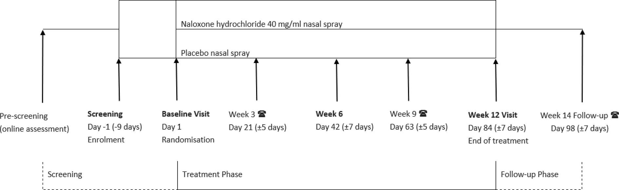
Fig. 1. Study Flow Chart.

Table 3
Study inclusion and exclusion criteria. *DSM-V: Diagnostic and Statistical Manual of Mental Disorders, Fifth Edition. ** MADRS: Montgomery and Asberg Depression Rating Scale. ***C-SSRC: Columbia-Suicide Severity Rating Scale. Table 3. Subject demographic and baseline characteristics.
Naloxone (n Placebo (n ¼ Test p-
    - Screening
Clinic visit: Informed consent was obtained. After initial screening assessments, eligible participants repeated the SOGS-R test and were assessed for gambling craving (G-SAS, VAS), gambling severity (PGSI, NODS, DSM-5), internet use (IDS9-SF), QoL (EUROHIS-8) alcohol con- sumption (AUDIT), smoking and depression (MADRS) and clinical

¼ 62) 64) statistic value
Gender
Male 45 43
Female 17 21 0.217 0.642
Age
assessment of suicide (The Columbia-Suicide Severity Rating Scale (C- SSRC; Posner et al., 2011). At the study site, the screening for drugs, active hepatitis C and a pregnancy test were performed. Laboratory tests were performed and analysed by an authorised laboratory Mehila¨inen Ltd. in Helsinki, Finland.

Male 41.40 ± 13.52 43.09 ± 16.99 —0.515 0.607

Female
Education
(21,39,74)
50.82 ± 15.93
(25,51,71)
(18,39,75)
49.62 ± 14.18
(22,54,66)

0.243 0.809
    - Baseline
Clinic visit: (Day 1), the following assessments of screening labora- tory results were reviewed: vital signs, physical examination including

Up to lower secondary Vocational qualification University degree
Employment status
17 15

33 32

12 17 0.970 0.615
height and weight, nasal examination and smell test (NIH Toolbox Odour Identification Test) was conducted. Eligible participants were placed randomly into treatment groups (Table 2).
After randomisation, participants were assessed for gambling absti- nence and self-efficacy (GASS). The preceding four weeks of gambling activity (expenditure, frequency and type of gambling) was assessed via
interviews using the modified Timeline-Follow-Back (TLFB) method

Employed 38 38
Unemployed 8 3
Pension 11 19
Student 3 4
Other 2 0 7.935 0.160
MADRS
(Weinstock, Whelan, & Meyers, 2004). Expenditure was calculated as the total sum of money spent on gambling during the preceding four weeks. Game types were listed in all 19 game types that are available in Finland (Salonen, Lind, Hagfors, Castr´en, & Kontto, 2020) and are presented in Table 3.

AUDIT
13.13 ± 6.34
(2,13,23)

8.34 ± 5.66
(0,7,26)
11.39 ± 5.57
(1,11.5,23)

7.28 ± 5.46
(0,6,28)
1.639 0.104

1.0668 0.288
Participants were also asked about the age when regular gambling started and when the gambling became a problem with the questions of:
a) at what age did you start gambling regularly, i.e., at least three times per week?” and b) “At what age did gambling became a problem to the extent that you sought help or someone close to you told that you have a

Started regular gambling (age)
24.45 ± 14.80
(7,18,66)
Gambling became a problem (years)
5.08 ± 6.22
(0,3,35)
Gambling game type (primary)*
30.53 ± 16.65
(10,25,63)

3.77 ± 5.44
(0,2,30)

123.090 0.032

1.263 0.209
gambling problem and advised you to seek help?”. The years of onset of problem gambling was calculated b-a. In addition, participants were asked about readiness for change using a scale from 0 to 10 with the question “How well do you think you will succeed with this treatment?”. Subjects were trained on how to use the IMP and in the use of the electronic diary. The eDiary was completed daily to capture IMP use, the
number of doses, gambling expenditure and frequency and possible

Chance games 4 9
(lotteries)
adverse events (AEs). Afterward, initial assessment participants received a psychosocial supportive session.

Betting games 8 8

Chance games (slots)
Online gambling
31 30
19 17 2.019 0.545
    - Week 3
Telephone follow-up: the eDiary was reviewed and a brief psycho- social support session was delivered (see Supplementary Table 2 for

Table contains either frequency counts or mean ± sd values, in parentheses minimum, median, and maximum is given. Test statistic is either independent two-sample t-test or chi squared test.
*Game types were categorized in five game types respectively as follows: chance games (lottery type games); betting games; Casino games (Helsinki Casino); chance games (slot machines) and online gambling. After grouping/categorizing game types, participants game type was determined from past 4 weeks data (TLFB) based on what game type the participant had gambled the most (each participant received his/her favorite gambling type). Helsinki Casino – gambling type resulted in 0 participants in this category, and was thus omitted and the resulting 4 game types are presented in this table.

  - Trial design
The trial included five visits (screening visit not included) as follows: face-to-face visits: baseline, week 6 and 12 visits, two phone calls during week 3 and week 9 and an additional follow-up call during week 14. The study schedule is presented in Fig. 1. The contents of specific study visits and measures used is presented in Supplementary Table 1. Detailed in- formation on study visits is provided in Supplementary Table 2.
contents and measures of visit).
    - Week 6
Clinic visit: Clinical assessment, and participants received another supply of IMP, a review of their e-Diary; additionally, a brief psycho- social support session was carried out. For specific visit measures, see Supplementary Table 2.
    - Week 9
Telephone follow-up: with the same assessments and procedures as during the call during Week 3 (see Supplementary Table 2).
    - Week 12
Clinic visit: Clinical assessment, review of eDiary and assessment of overall situation after the treatment and if needed, referral to continu- ation of treatment. In addition, all participants were asked for feedback on the study (see Supplementary Table 2)
    - Week 14
Telephone follow-up inquiry on AEs and medications.

  - Safety assessments
Haematology and biochemistry analysis was performed at a screening and Week 12 for ALAT, ASAT and creatinine. Vital signs (blood pressure, pulse, and body temperature) were recorded at Baseline during Week 6 and Week 12. The Investigator examined the nasal mu- cosa at the Baseline, Week 6 and Week 12 visits using a nasal irritation score from 0 to 5 (see Appendix 1).
A smell test was conducted at Baseline and the Week 12 visit, using the NIH Toolbox Odour Identification Test. This validated smell iden- tification test used ‘scratch and sniff’ technology and pictures for multiple-choice options of nine common smells. It was intended for a rapid research assessment of olfactory capacity.
Physical examination was performed during the Baseline and Week 12 visits. The examination included height, body weight, appearance, skin, lungs and chest, heart, abdomen and extremities.
  - Recording of adverse events
The study eDiary was used to record changes in participant health status and was reviewed via each participant’s eDiary during their visit. The severity of each adverse event (AE) was to be characterised and then classified into 1 of the following 3 categories by the Investigator: Mild: The AE did not interfere in a significant manner with the subject’s normal functioning level. Moderate: The AE produced some impairment of functioning that was not hazardous to health. It was uncomfortable or an embarrassment. Severe: The AE produced significant impairment of functioning or incapacitation and was a definite hazard to the subject’s
health.
The Investigator made a judgement regarding the likelihood of a causal relationship between the IMP and the AE. An AE was considered ‘not related’ to the use of the IMP if any of the following applied: An unreasonable temporal relationship between administration of the IMP and the onset of the AE (e.g., the event occurred either before or too long after administration of the product for it to be considered product- related). A causal relationship between the IMP and the AE was bio- logically implausible (e.g., death as a passenger in an automobile acci- dent). An AE was considered ‘related’ to the use of the IMP when there was ‘a reasonable possibility’ that the event may have been caused by the product under investigation (i.e., there were facts, evidence, or ar- guments to suggest reasonably possible causation).
  - Statistical analysis
The primary endpoint G-SAS total score was modelled by the linear mixed-effects model. The effect of treatment and time factors were tested by the likelihood ratio test. Similarly, the linear mixed-effects model analysis was performed for total scores of second endpoint vari- ables. Each separate G-SAS variable was also modelled by the proportional-odds cumulative logit mixed model with use of the ordinal package in R software 4.0.5. Multivariate repeated measures analysis for G-SAS variables was conducted to support the findings of mixed model G-SAS total score analysis. (See Supplementary Table 3 for a more detailed description of the utilised models).
An independent samples t-test was performed to test the differences between treatment groups for the variables age, MADRS, AUDIT, regular gambling age, and regular gambling problem age. For the categorical variables gender, education, employment status, and primary gambling game types, the chi-squared test was conducted.
The data was analysed with an intention-to-treat (ITT) principle. In this study, considered variables contained relatively few missing values, hence multiple imputation was not applied and thus missing values were assumed to be missing at random.
Prior to the study, the sample size calculation was carried out by setting the effect size to the 0.7 level, and by assuming that standard deviation for the total score would be 5.502 and the dropout rate would
be 30%.

  - Ethics
The study was performed in accordance with the ethical principles that have their origin in the Declaration of Helsinki that are consistent with the International Council for Harmonisation of Technical Re- quirements for Pharmaceuticals for Human Use (ICH)/Good Clinical Practice (GCP) and applicable regulatory requirements. This trial was approved by the Finnish National Ethics Board (Ethics committee registration number 148/06.000.01/2017). Informed consent was ob- tained, both written and vocally explained. If needed, due to any med- ical and psychiatric condition, participants were referred to healthcare services. All participants who required continuation of treatment or to the EU support were referred to other healthcare services at the end of the trial. The study was a registered clinical study registry (EudraCT number: 2017-001946-93 and to the ClinicalTriels.gov (NCT03430180).

Results
A total of 127 subjects were screened for the study, of which one withdrew consent before the randomisation, thus 126 were randomised and treated; 62 received IN naloxone and 64 received IN placebo treatment. In total, 106 participants (84%) completed the study. Twenty participants were withdrawn from the study due to the reasons “with- drawal of consent” (12 subjects, 60% of the withdrawn subjects) and “lost to follow-up” (8 subjects, 40%).
Overall, no differences were found between the treatment groups in terms of recruitment, but a larger proportion of subjects in the placebo group withdrew from the study as compared to the IN naloxone group (23.4% vs. 8.1%).
  - Demographic and baseline characteristics
Participants’ demographic and baseline characteristics are sum- marised in Table 3. The participants were on average 45 years old (within the group’s overall age range of 18 to 75 years). Approximately 70% (n 88) of the subjects were males. The majority of participants were Caucasians (n 125, 99%). There were no notable differences in demographics between the treatment groups (Table 3).
=
=
Sixty-eight participants (54%) were married or cohabiting. Most participants lived either alone (n 52, 41%) or with their family (n 71, 56%). Participants were mainly employed as office workers or clerks (n 69, 55%), and 30 participants (24%) had retired. Almost all par- ticipants (n 115, n 91%) reported that they currently consumed alcohol and 56 participants (44%) were current smokers. The proportion of current smokers was higher in the IN naloxone group (55%) as compared to the placebo group (34%).
= =
= =
=
No participant was excluded due the risk of suicide or suicidal ideation (C-SSRS). Both groups were on average equally ready and motivated for change as measured on a 10 cm VAS scale (total mean: 7.36 cm [SD: 1.73]).
  - Measurement of treatment compliance
Treatment compliance was calculated based on eDiary data, the compliance criteria being the use of 75–120% of the intended doses of IMP (i.e., a participant used IMP on days that they had a gambling urge or where gambling was considered a strong likelihood or had gambled). The mean compliance rate (number of days with dose administration/ expected number of days with dose administration from baseline to week 12) was 70.66% (SD: 47.70) for all subjects. There was no statis- tically significant difference in compliance between the naloxone and placebo groups (73.57% vs. 67.83%, respectively). Only 35 participants (28%) were considered compliant for the entire study by preset study conditions (29% vs. 27% in the naloxone and placebo groups,

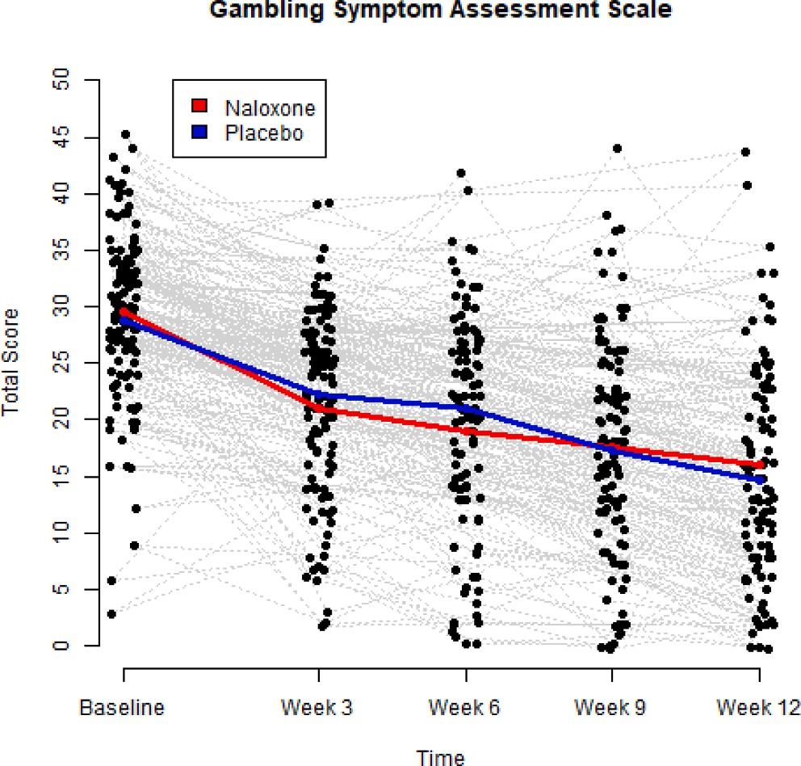
Fig. 2. A scatterplot of G-SAS total score values from Baseline to Week 12. Data points jittered around the observed values to avoid overlapping dots. Profiles of conditional sample means of Naloxone group and placebo group are given by
red and blue curves, respectively. Based on linear mixed effects analysis, treatment effect: p-value = 0.249, time effect: p-value < 0.001. (For interpre- tation of the references to colour in this figure legend, the reader is referred to
the web version of this article.)

respectively).

  - Efficacy results

    - Primary endpoint
The results showed no statistically significant difference in G-SAS
total score from Baseline to Week 12 between the IN naloxone group and the placebo group. The total G-SAS scores are presented in Fig. 2, which reveals a statistically significant time effect on both treatment groups.
Based on cumulative logit mixed model analysis, the variable 11: Emotional distress has a p-value<0.05 for the treatment effect (see the relative percentages of Emotional distress in Fig. 3). Multivariate repeated measures analysis further confirmed that a statistically signif- icant treatment effect was not achieved, but a statistically significant
time effect was obtained, see the sample means in Fig. 4 and the results of likelihood ratio tests in Table 4.
    - Secondary endpoints

      - Gambling-related. There was no statistically significant differ- ence between the treatment groups in the secondary endpoint variables. Both treatment groups had reduction in and severity of gambling (PGSI) and expenditure as presented in Table 5 as well as in Figs. 5 and 6.
    - Comorbidities and quality of life
Scores in co-occurring conditions such as level of alcohol consump- tion (AUDIT) (Fig. 7) and depressive symptoms (MADRS) (Fig. 8), Internet use (IDS-9 SF) (Fig. 9) decreased equally in both groups over time with no statistically significant difference between groups, indi- cating overall improvement as confirmed by an increase in quality of life scores (EUROHIS-8) (Fig. 10). All comorbidities and QoL are presented in Table 5.
Please also see the sample means and standard deviations (SD) for primary and secondary variable endpoints in Supplementary Table 5.

  - Summary of adverse events
In total, 308 adverse events (AEs) were reported, the proportion of participants reporting AEs was larger in the IN naloxone group (82%) as compared to the placebo group (64%). The most common
AEs, defined as those reported by at least 20% of participants in total, were nasal symptoms (N = 42, [33%]) and headache (N = 27, [21%]). It

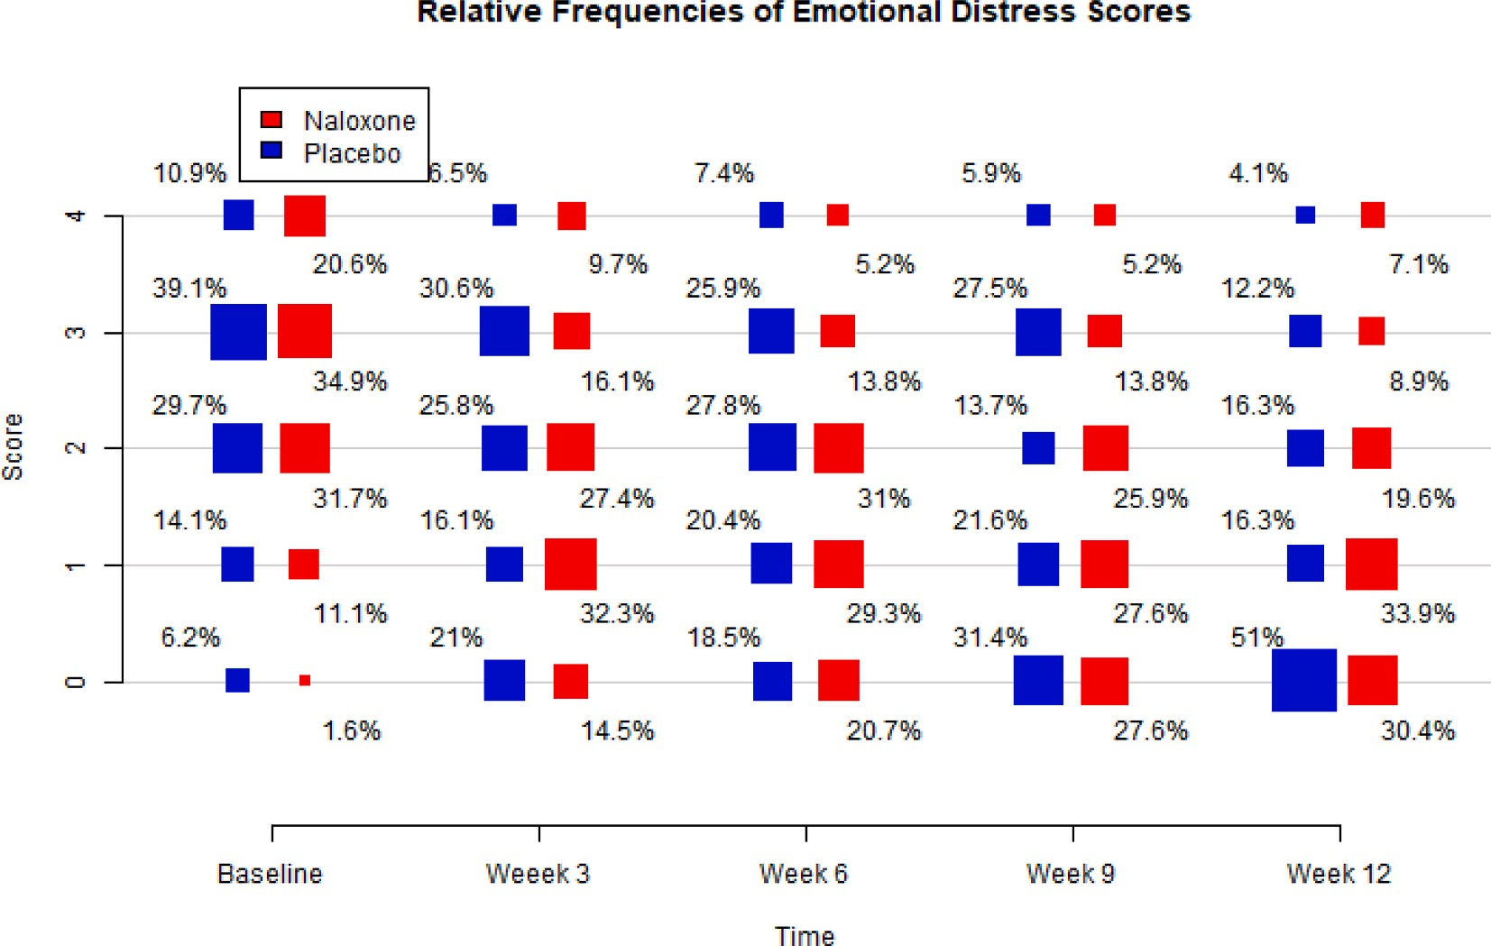
Fig. 3. Relative frequencies of Emotional Distress Scores from Baseline to Week 12. Size of each box depicts the observed relative frequency of the outcome at the given treatment group and the time point. Each column of percentages adds up to 100%. Based on cumulative logit mixed model analysis, treatment effect: p-value
= 0.033.

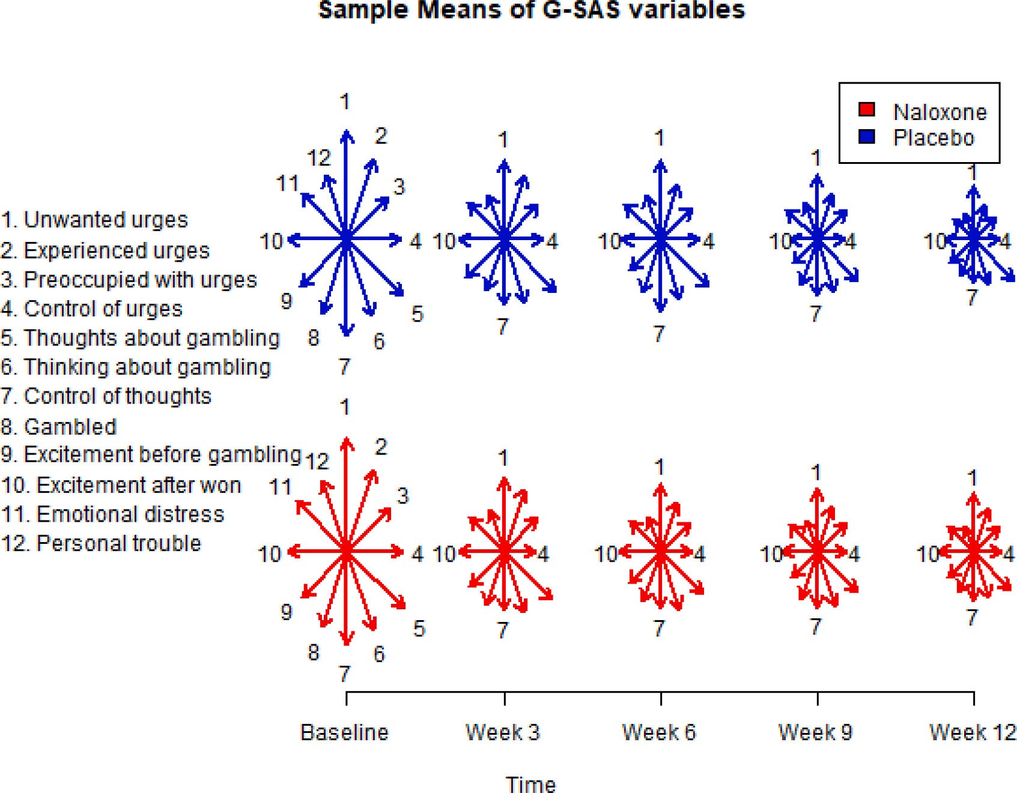
Fig. 4. Sample means of G-SAS variables from Baseline to Week 12. Length of each arrow is the observed conditional mean of the considered G-SAS variable at the given treatment group and the time point. Based on multivariate analysis, treatment effect: p-value = 0.6795, time effect: p-value < 0.001.

Table 4
Likelihood ratio test results for G-SAS, see also Supplement 4.
Table 5
Likelihood ratio test results for secondary endpoint variables, see also Supple-

Response variable Effect Test statistic
df p-value
mentary Table 4.
Response variable Effect Test statistic df p-value PGSI Treatment 2.521 2 0.2835
Time 61.566 2 <0.001
Expenditure Treatment 3.816 4 0.4314
Time 23.386 6 <0.001
AUDIT Treatment 3.473 3 0.3242
Time 9.945 4 0.0414
MARDS Treatment 6.062 3 0.1090

Control of thoughts Treatment 7.522 5 0.1846
G-SAS Total Score Treatment | 6.640 | 5 | 0.2488
Time | 268.952 | 8 | <0.001
Unwanted urges Treatment | 8.774 | 5 | 0.1184
Experienced urges Treatment | 3.588 | 5 | 0.6101
Preoccupied with urges Treatment | 4.693 | 5 | 0.4544
Control of urges Treatment | 8.512 | 5 | 0.1302
Thoughts about gambling Treatment | 7.955 | 5 | 0.1587
Thinking about gambling Treatment | 1.703 | 5 | 0.8885

Gambled Treatment 1.090 5 0.9549
Time 66.407 4 <0.001

Excitement before gambling
Excitement after won | Treatment | 2.412 | 5 | 0.7897
Emotional distress | Treatment | 12.131 | 5 | 0.0330
Personal trouble | Treatment | 5.944 | 5 | 0.3116
All G-SAS variables | Treatment | 0.879 | 60, 42 | 0.6795
 | Time | 2.669 | 96, | <0.001
 |  |  | 108

Treatment 2.564 5 0.7667
IDS-9(SF) Treatment 0.454 3 0.9288
Time 34.598 4 <0.001
Quality of Life Treatment 3.873 3 0.2754
Time 47.455 4 <0.001

For each variable, total score was modelled by the linear mixed-effects model.

AEs with moderate intensity reported by 3 participants, all in the pla-

Total score was modelled by the linear mixed-effects model, each separate G-SAS variable by the cumulative logit mixed model, and multivariate repeated mea- sures analysis for G-SAS variables was performed with use of Wilks lambda and its F approximation.

can be noted that nasal congestion and flu symptoms were more com- mon in the IN naloxone than in the placebo group (44% vs. 23% of the participants). However, there were no differences in nasal mucosa (clinical assessment) or smell tests between the groups (Table 6).
Most AEs experienced mild intensity (305 AEs). There were three
cebo group: headache, depression, and pneumonia. No severe AEs were reported in the study. No participant discontinued the study due to adverse events (see Table 7 overview of AEs and Table 8 summary of AEs).

Discussion
We hypothesised that IN naloxone would be superior to placebo - both in conjunction with motivational intervention - in reducing gambling urge in participants with gambling disorder. This trial was

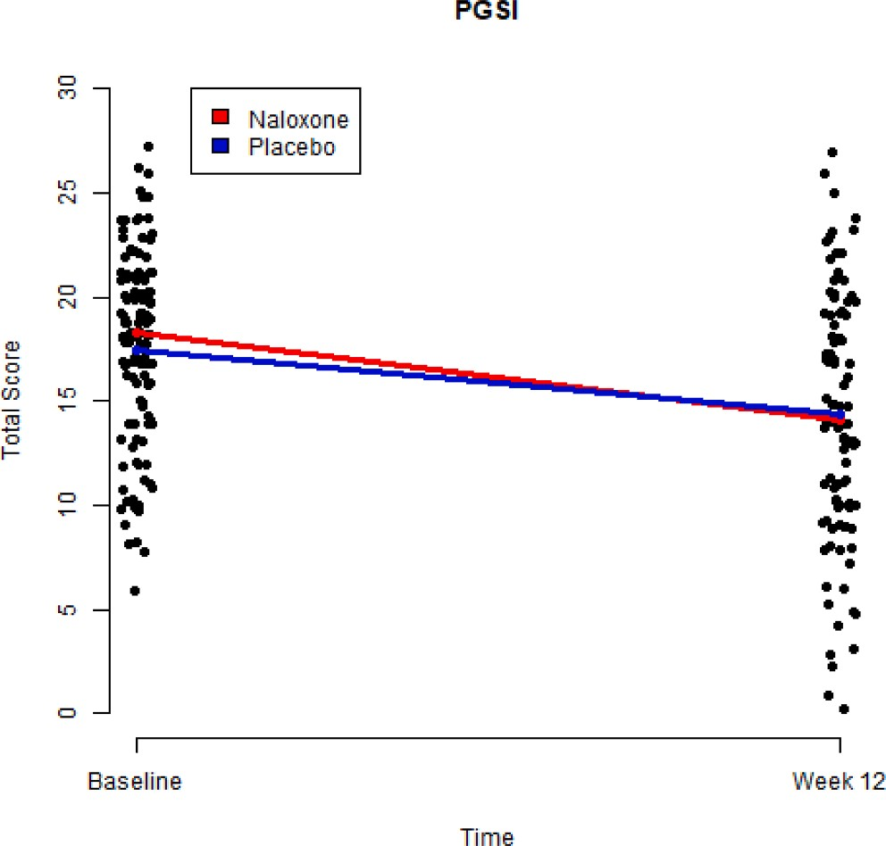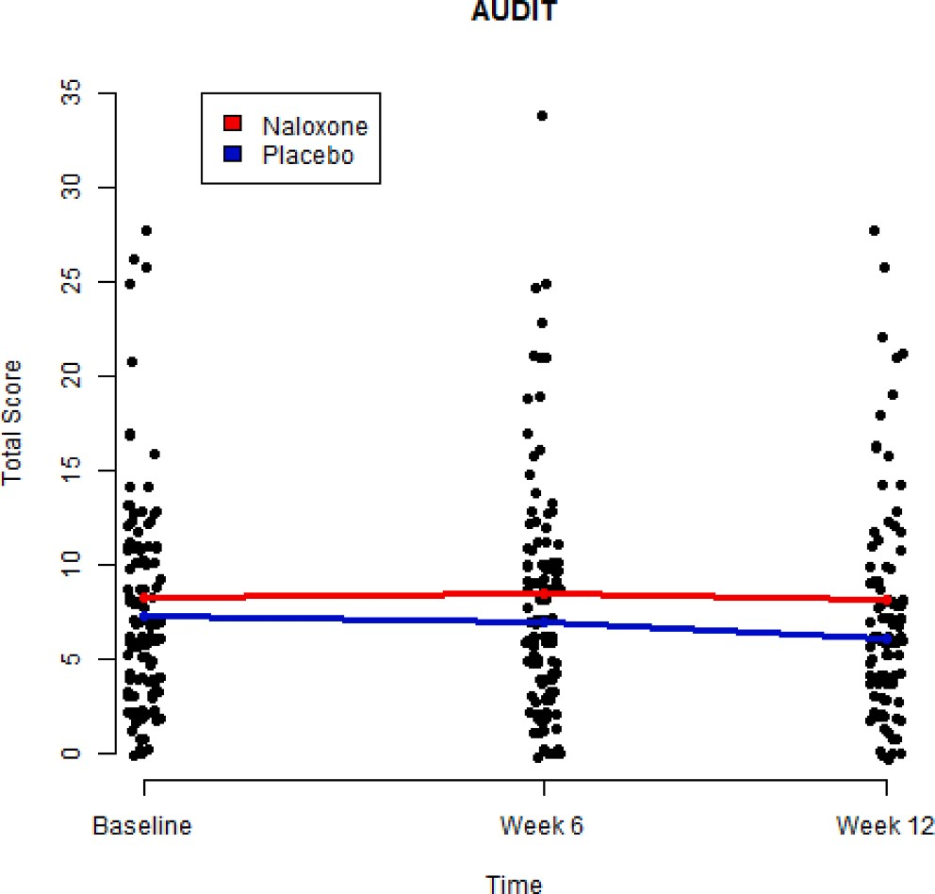

Fig. 5. A scatterplot of PGSI total score values from Baseline to Week 12. Data points jittered around the observed values to avoid overlapping dots. Profiles of conditional sample means of Naloxone group and placebo group are given by red and blue curves, respectively. Based on linear mixed effects analysis,
treatment effect: p-value = 0.284, time effect: p-value < 0.001. (For interpre-
tation of the references to colour in this figure legend, the reader is referred to the web version of this article.)
Fig. 7. A scatterplot of AUDIT total score values from Baseline to Week 12. Data points jittered around the observed values to avoid overlapping dots. Profiles of conditional sample means of Naloxone group and placebo group are given by red and blue curves, respectively. Based on linear mixed effects analysis, treatment effect: p-value = 0.324, time effect: p-value = 0.041. (For interpretation of the references to colour in this figure legend, the reader is referred to the web version of this article.)

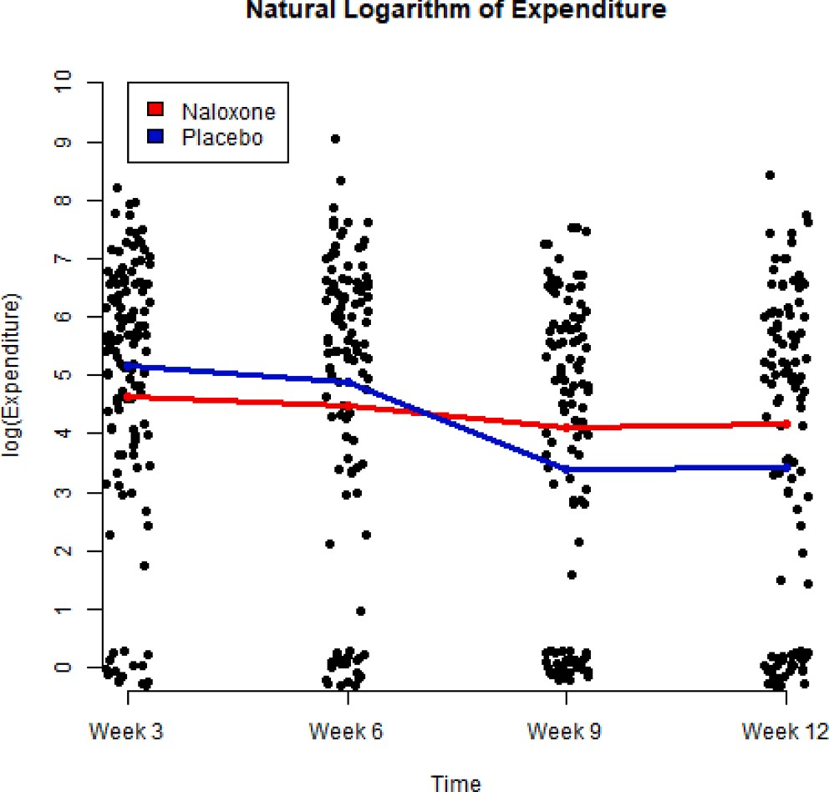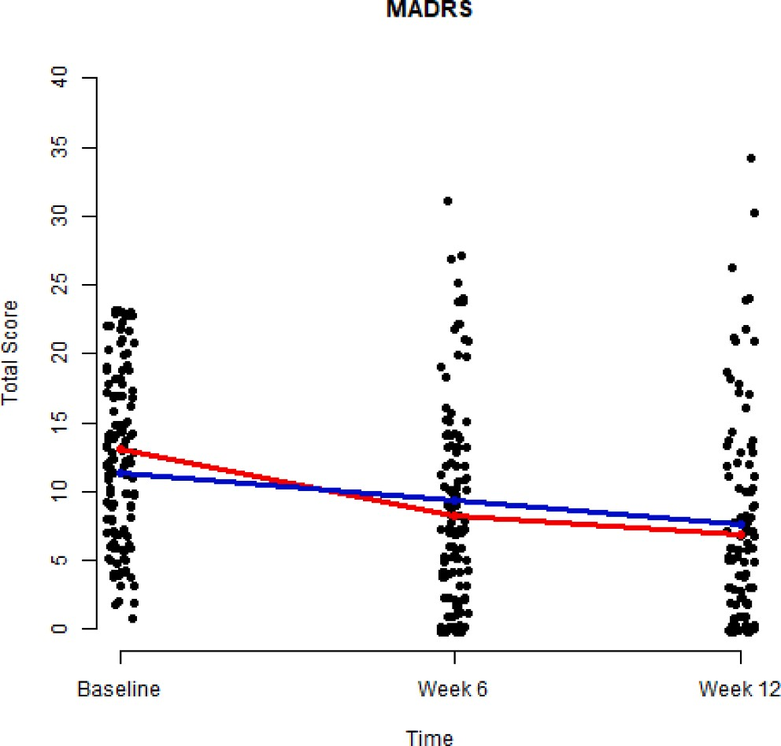

Fig. 6. A scatterplot of natural logarithm values of gambling expenditure from Week 3 to Week 12. Data points jittered around the observed values to avoid overlapping dots. Profiles of conditional sample means of Naloxone group and placebo group are given by red and blue curves, respectively. Based on linear
mixed effects analysis, treatment effect: p-value = 0.431, time effect: p-value <
0.001. (For interpretation of the references to colour in this figure legend, the reader is referred to the web version of this article.)

supported by a previous imaging trial where IN naloxone was reported to be rapidly absorbed and fully occupied brain mu-opioid receptors (Johansson et al., 2019). The use of this trial formulation was also supported by our previous feasibility trial (Castr´en et al., 2019).
Fig. 8. A scatterplot of MADRS total score values from Baseline to Week 12. Data points jittered around the observed values to avoid overlapping dots. Profiles of conditional sample means of Naloxone group and placebo group are given by red and blue curves, respectively. Based on linear mixed effects
analysis, treatment effect: p-value = 0.109, time effect: p-value < 0.001. (For
interpretation of the references to colour in this figure legend, the reader is referred to the web version of this article.)

This study found no difference in gambling urge as measured by the G-SAS total score between the treatment groups after the treatment period of twelve weeks. A statistically significant difference favoring the naloxone group was detected on G-SAS question 11, which enquires

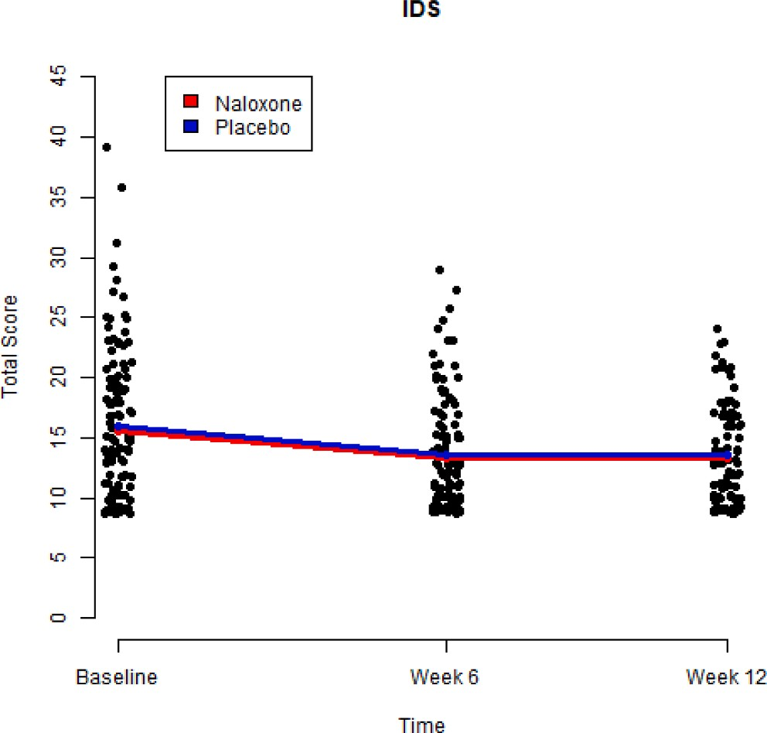
Table 6
Descriptive statistics and likelihood ratio test result for smell test.

Response variable Mean SD Effect Test
statistic
df p-
value

Smell test Treatment 1.136 2 0.5666

Baseline - Naloxone
7.468 1.264

Fig. 9. A scatterplot of IDS total score values from Baseline to Week 12. Data points jittered around the observed values to avoid overlapping dots. Profiles of conditional sample means of Naloxone group and placebo group are given by red and blue curves, respectively. Based on linear mixed effects analysis,
treatment effect: p-value = 0.929, time effect: p-value < 0.001. (For interpre-
tation of the references to colour in this figure legend, the reader is referred to the web version of this article.)

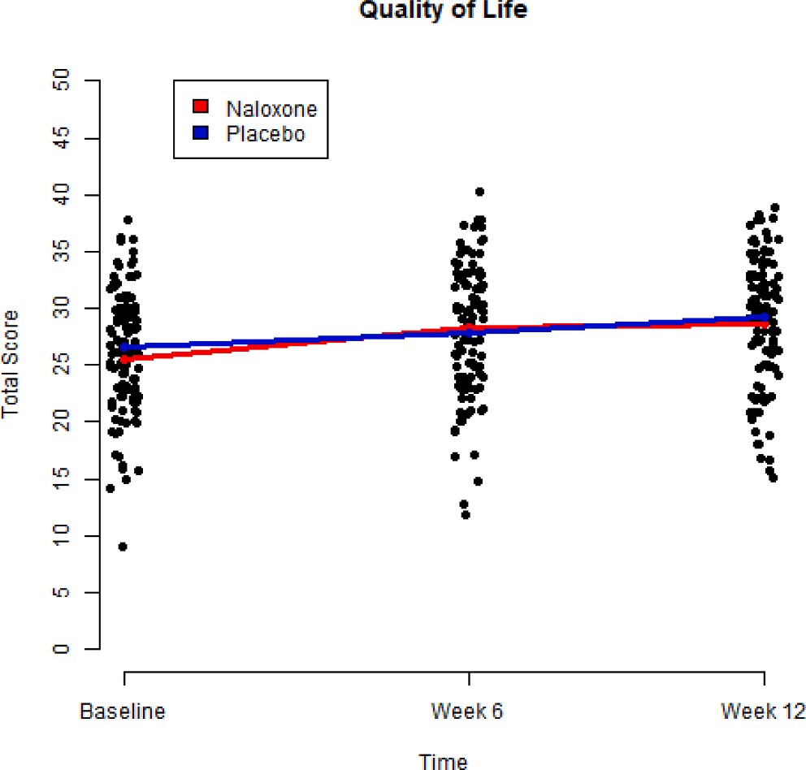
Fig. 10. A scatterplot of Quality of Life total score values from Baseline to Week 12. Data points jittered around the observed values to avoid overlapping dots. Profiles of conditional sample means of Naloxone group and placebo group are given by red and blue curves, respectively. Based on linear mixed
effects analysis, treatment effect: p-value = 0.275, time effect: p-value < 0.001.
(For interpretation of the references to colour in this figure legend, the reader is referred to the web version of this article.)

about emotional distress related to gambling. The clinical significance of this observation is unclear. Decreases in other gambling related mea- surements (severity of gambling, expenditure in gambling) and internet use were observed equally in both groups. A similar improvement in
Baseline - Placebo | 7.281 | 1.105
Week 12 - | 7.754 | 1.090
Naloxone
Week 12 - Placebo 7.820 0.850

Total score was modelled by the linear mixed-effects model.

Table 7
Overview of trial adverse events
Overview of adverse events (Safety analysis set) | Naloxone (N ¼  62) | Placebo (N ¼ | Total (N ¼ 126)
 | n (%) m | n (%) m | n (%) m
Any adverse event | 51 211 | 41 97 | 92 308

64)

 | (82.3%) |  | (64.1%) |  | (73.0%)
Any serious adverse | 0 | 0 | 0 | 0 | 0 | 0
event
Any adverse event | 0 | 0 | 0 | 0 | 0 | 0
leading to withdrawal
of the study treatment
Any adverse event | 0 | 0 | 0 | 0 | 0 | 0
leading to death
Adverse events by severity
Mild | 51 | 211 | 40 | 94 | 91 | 305
 | (82.3%) |  | (62.5%) |  | (72.2%)
Moderate | 0 | 0 | 3 (4.7%) | 3 | 3 (2.4%) | 3
Severe | 0 | 0 | 0 | 0 | 0 | 0
Adverse events by causality
Not related | 45 | 155 | 35 | 69 | 80 | 224
 | (72.6%) |  | (54.7%) |  | (63.5%)
Related | 23 | 56 | 15 | 28 | 38 | 84
 | (37.1%) |  | (23.4%) |  | (30.2%)
Analysed from the safety analysis set.

depressive symptoms and quality of life was also observed between the groups as found previously (Kovanen et al., 2016). Overall, the IN naloxone treatment group did not differ from placebo in this trial. However, it is noteworthy to mention a relatively high within-group variability on both key outcome measures (G-SAS and PGSI). It is possible that some of this variance is systematic. This would align with several other negative studies on opioid antagonists that have been using the oral route instead of the intranasal route with GD participants (Kovanen et al., 2016). Our trial used a novel approach (IN adminis- tration) with the aim of achieving better results than previous trials, but was ultimately unsuccessful. It would be useful to explore reasons further (i.e., subgroup effects) and consider the investigative approach in the future. This may be especially true in the case of GD, where the addictive reinforcer itself is heterogeneous, quite separate from the people exposed to it. It could be that the provided psychosocial support content (Hodgins & Makarchuk, 2002) along with the motivational intervention used in all sessions provided by trained clinical psycholo- gist may have masked the differences between the treatment groups via the therapist effect (Meier, Barrowclough, & Donmall, 2005). It is also possible that use of self-help material that was provided to take home
during the first session was sufficient help (Hodgins, Cunningham,
Murray, & Hagopian, 2019; Boudreault et al., 2018; Hodgins, Currie, Currie, & Fick, 2009; LaBrie et al., 2012; Oei, Raylu, & Lai, 2018) or enhanced some participants’ motivation, and/or daily recording of their own behaviour (reminding yourself of your intent not to gamble) and may have been therapeutic on its own. One may also speculate that the IN route may also have affected the placebo effect.

Table 8
Summary of adverse events in the trial.
 | Related |  |  | Not related |  |  | Related |  |  | Not Related
System Organ Class/Preferred Term | n (%) | m |  | n (%) | m |  | n (%) | m |  | n (%) | m
Any adverse event | 45 (72.6%) | 155 | 23 (37.1%) |  | 56 | 35 (54.7%) |  | 69 | 15 (23.4%) 28

Naloxone (N ¼ 62) Placebo (N ¼ 64)

Infections and infestations (incl. nasal congestion and irritation) | 28 (45.2%) | 53 | 0 | 0 | 18 (28.1%) | 25 | 0 | 0
Nervous system disorders | 9 (14.5%) | 15 | 15 (24.2%) | 29 | 5 (7.8%) | 8 | 9 (14.1%) | 15
Respiratory, thoracic and mediastinal disorders | 17 (27.4%) | 43 | 4 (6.5%) | 5 | 9 (14.1%) | 14 | 1 (1.6%) | 1
Psychiatric disorders | 3 (4.8%) | 3 | 9 (14.5%) | 12 | 2 (3.1%) | 2 | 4 (6.3%) | 5
Gastrointestinal disorders | 7 (11.3%) | 12 | 6 (9.7%) | 6 | 7 (10.9%) | 9 | 3 (4.7%) | 3
n = number of subjects with adverse events, m = number of adverse events. Percentages are based on the number of subjects within each treatment group.

Intranasal administration was deemed safe in this trial. Although there were more adverse events in the trial group receiving IN naloxone treatment, most of these adverse events were deemed not to be related to the trial formulation. No severe adverse events were reported during the trial. Notably fewer gastric side-effects were reported in this trial with an IN naloxone formulation during previous trials than in our previous trial with an oral opioid-antagonist treatment (Kovanen et al., 2016).
Some previous studies have found oral opioid antagonists to be su- perior to placebo in treating GD (Kraus et al., 2020). However other studies, have found no difference between opioid antagonists and pla- cebo (Kovanen et al., 2016; Potenza et al., 2019). Previous studies have mostly used stable dosing schedules, while this study used as-needed dosing as supported by existing reports of rapid occupation of target receptors after nasal dosing. Only 28% of participants were medication- compliant according to the trial standards, however overall medication was used 70% of the intended times during the trial. The low number of completers may make some of the treatment effect undetectable. How- ever, the compliance criteria may have been too stringent for this type of trial. Authors also suggest that a stable dosing regimen may prove more effective than as-needed dosing, and this should be investigated in future trials.
It would be beneficial to investigate subgroups of participants who
might benefit more from this intervention as discussed earlier (Victorri- Vigneau et al., 2018). Further investigation and analysis of trial data (i. e., subgroup analysis and predictors of compliance to identify possible patterns) are in progress, yet null effects that are reported here will not change substantially.

  - Strengths and limitations
The study treatment was novel, no previous studies have investigated IN formulations for the treatment of gambling disorder. The naloxone nasal spray was documented to quickly and completely occupy brain mu-opioid receptors in a previous imaging study. The study population can be considered representative of typical patients with gambling dis- order and large enough to display differences. The use of psychosocial support in conjunction with pharmacological treatment provides a realistic and effective treatment approach. On the other hand, im- provements can be done in the future to better detect the effect of psy- chosocial support applied in pharmacological studies, for example, including a third arm of the MI workbook and ensuring that the doses of contact are equal in all three groups by performing a systematic integrity check and using a coding tool as suggested by Rodda et al. (2018). In addition, the modified timeline followback procedure used in this trial has not been validated in Finland.
The duration of the trial may have been too short to display the
treatment effect or its persistence. The low number of completers may make a treatment effect undetectable. As-needed intranasal naloxone has not been investigated in previous trials. The compliance criteria were based on percentage values (75% to 125% of times gambled/ experienced gambling urge) used in trials in other therapy areas. The criteria may not be feasible for this type of trial, as evidenced by the low
% of participants with a completer status. However, the overall compliance rate was around 70%, which indicates that subjects did use IMP, just not on every occasion with gambling involved. Due to strict criteria, many subjects may have been ruled out of being compliant despite using IMP (mostly) as advised. The as-needed treatment regimen may provide inferior results compared to a stable dosing regimen.

  - Conclusion
As-needed administration of IN naloxone in conjunction with brief psychosocial support did not reduce gambling urge or other gambling- related variables compared to placebo in this trial. Clear improve- ments over time were observed in gambling urge, gambling severity and depressive symptoms as well as an increase in quality of life were observed regardless of treatment group. IN naloxone was safe and well tolerated, with no severe adverse events attributable to the trial medi- cation. The authors of this study suggest IN naloxone may be better tolerated than oral formulations of the drug and should be subjected to further trials.

CRediT authorship contribution statement
Hannu Alho: Conceptualization, Writing – original draft, Writing - review & editing. Niklas Ma¨kela¨: Writing – original draft, Writing - review & editing. Jarkko Isotalo: Formal analysis, Data curation, Writing - review & editing. Lilianne Toivonen: Formal analysis, Data curation, Writing - review & editing. Jyrki Ollikainen: Formal analysis, Writing - review & editing. Sari Castre´n: Writing – original draft, Writing - review & editing.

Declaration of Competing Interest
The authors declare that they have no known competing financial interests or personal relationships that could have appeared to influence the work reported in this paper.

Appendix A. Supplementary data
Supplementary data to this article can be found online at https://doi. org/10.1016/j.addbeh.2021.107127.

References
Abbott, M. W., & Volberg, R. A. (1996). The New Zealand national survey of problem and pathological gambling. Journal of Gambling Studies, 12, 143–160.
Aboujaoude, E., & Salame, W. O. (2016). Naltrexone: A pan-addiction treatment? CNS Drugs, 30(8), 719–733. https://doi.org/10.1007/s40263-016-0373-0
American Psychiatric Association. (2013). Diagnostic and Statistical Manual of Mental Health Disorders (5th ed.). Washington, DC: Author.
Boudreault, C., Giroux, I., Jacques, C., Goulet, A., Simoneau, H., & Ladouceur, R. (2018). Efficacy of a self-help treatment for at-risk and pathological gamblers. Journal of Gambling Studies, 34(2), 561–580. https://doi.org/10.1007/s10899-017-9717-z
Castr´en, S., Ma¨kel¨a, N., Haikola, J., Salonen, A. H., Crystal, R., Scheinin, M., et al. (2019). Treating gambling disorder with as needed administration of intranasal naloxone: A

pilot study to evaluate acceptability, feasibility and outcomes. e023728 BMJ Open, 9
(8). https://doi.org/10.1136/bmjopen-2018-023728.
Ferris, J., & Wynne, H. (2001). The Canadian Problem Gambling Index: User manual.
Ottawa, Canada: Canadian Centre on Substance Abuse.
Gerstein, D., Hoffmann, J., Larson, C., Engelman, L., Murphy, S., Palmer, A., et al. (1999). Gambling impact and behavior study, (Report to The National Gambling Impact Study Commission). Chicago: National Opinion Research Center at the University of Chicago.
Grant, J. E., Odlaug, B. L., Potenza, M. N., Hollander, E., & Kim, S. W. (2010). Nalmefene in the treatment of pathological gambling: Multicentre, double-blind, placebo- controlled study. British Journal of Psychiatry, 197(4), 330–331. https://doi.org/ 10.1192/bjp.bp.110.078105
Grant, J. E., Potenza, M. N., Hollander, E., Cunningham-Williams, R., Nurminen, T., Smits, G., et al. (2006). Multicenter investigation of the opioid antagonist Nalmefene in theTreatment of pathological gambling. American Journal of Psychiatry, 163(2), 303–312. https://doi.org/10.1176/appi.ajp.163.2.303
Ekholm, O., Davidsen, M., Larsen, C. V. L., & Juel, K. A. (2018). Nationwide study of health-related quality of life, stress, pain or discomfit and the use of medicine among problem gamblers. Scandinavian Journal of Public Health., 46(5), 514–521. https:// doi.org/10.1177/1403494817739501
Hayes, M. H. S., & Patterson, D. G. (1921). Experimental development of the graphic rating method. Psychol. Bull., 18, 98–99.
Hodgins, D. C., Peden, N., & Makarchuk, K. (2004). Self-efficacy in pathological gambling treatment outcome: Development of a Gambling Abstinence Self-efficacy Scale (GASS). International Gambling Studies, 4(2), 99–108. https://doi.org/10.1080/ 14459790412331296947
Hodgins, D. C., Currie, S. R., Currie, G., & Fick, G. H. (2009). Randomized trial of brief motivational treatments for pathological gamblers: More is not necessarily better. Journal of Consulting and Clinical Psychology, 77(5), 950–960. https://doi.org/ 10.1037/a0016318
Hodgins, D. C., Cunningham, J. A., Murray, R., & Hagopian, S. (2019). Online Self- directed interventions for gambling disorder: Randomized controlled trial. Journal of Gambling Studies, 35(2), 635–651. https://doi.org/10.1007/s10899-019-09830-7
Hodgins, D. C., & Makarchuk, K. (2018). Becoming a Winner – Defeating Problem Gambling. A self-help manual for problem gamblers: Addictive Behaviours Laboratory. University of Calgary and Addiction Centre –Alberta Health Services, 2002. Semantex, Castr´en S (Translated). Avaimia rahapeliongelman hallintaan – oma-apuopas, THL. Helsinki: Grano oy.
Johansson, J., Hirvonen, J., Lovro´, Z., Ekblad, L., Kaasinen, V., Rajasilta, O., …
Scheinin, M. (2019). Intranasal naloxone rapidly occupies brain mu-opioid receptors in human subjects. Neuropsychopharmacology, 44(9), 1667–1673. https://doi.org/ 10.1038/s41386-019-0368-x
Kim, S. W., Grant, J. E., Adson, D., & Shin, Y. C. (2001). Double-blind naltrexone and placebo comparison study in the treatment of pathological gambling. Biological Psychiatry, 49, 914–921.
Suck Won Kim, Jon E. Grant, Marc N.. Potenza, Carlos Blanco, & Eric Hollander. (2009). The Gambling Symptom Assessment Scale (G-SAS): A reliability and validity study, Psychiatry Research (Vol. 166, Issue 1, Pages 76-84), ISSN 0165-1781, https://doi. org/10.1016/j.psychres.2007.11.008.
Kovanen, L., Basnet, S., Castr´en, S., Pankakoski, M., Saarikoski, S. T., Partonen, T., … Lahti, T. (2016). A Randomised, double-blind, placebo-controlled trial of as-needed naltrexone in the treatment of pathological gambling. European Addiction Research, 22(2), 70–79. https://doi.org/10.1159/000435876
Kraus, S. W., Etuk, R., & Potenza, M. N. (2020). Current pharmacotherapy for gamblingdisorder: A systematic review. Expert Opinion on Pharmacotherapy, 21(3), 287–296. https://doi.org/10.1080/14656566.2019.1702969
Krieter, P., Chiang, C. N., Gyaw, S., Skolnick, P., & Snyder, R. (2019). Pharmacokinetic interactionbetween naloxone and naltrexone following intranasal administration to healthy subjects. Drug Metabolism and Disposition: The Biological Fate of Chemicals, 47 (7), 690–698. https://doi.org/10.1124/dmd.118.085977e
LaBrie, R. A., Peller, A. J., LaPlante, D. A., Bernhard, B.o., Harper, A., Schrier, T., et al. (2012). A brief self-help toolkit intervention for gambling problems: A randomized multisite trial. American Journal of Orthopsychiatry, 82(2), 278–289. https://doi.org/ 10.1111/j.1939-0025.2012.01157.x
Langham, E., Thorne, H., Browne, M., Donaldson, P., Rose, J., & Rockloff, M. (2015).
Understanding gambling related harm: A proposed definition, conceptual

framework, and taxonomy of harms. BMC Public Health, 16(1). https://doi.org/ 10.1186/s12889-016-2747-0
Lorains, F. K., Cowlishaw, S., & Thomas, S. A. (2011). Prevalence of comorbid disorders in problem and pathological gambling: Systematic review and meta-analysis of population surveys. Addiction (Abingdon, England), 106(3), 490–498. https://doi. org/10.1111/j.1360-0443.2010.03300.x
Majuri, J., Joutsa, J., Johansson, J., Voon, V., Alakurtti, K., Parkkola, R., … Kaasinen, V. (2017). Dopamine and opioid neurotransmission in behavioral addictions: A comparative PET studyin pathological gambling and binge eating.
Neuropsychopharmacology: Official Publication of the American College of Neuropsychopharmacology, 42(5), 1169–1177. https://doi.org/10.1038/ npp.2016.265
Meier, P. S., Barrowclough, C., & Donmall, M. C. (2005). The role of the therapeutic alliance in the treatment of substance misuse: A critical review of the literature. Addiction, 100, 304–316.
Montgomery, S. A., & Åsberg, M. (1979). A new depression scale designed to be sensitive to change. British Journal of Psychiatry, 134(4), 382–389.
Nutt, D. J. (2013). The role of the opioid system in alcohol dependence. Journal of Psychopharmacology, 28(1), 8–22. https://doi.org/10.1177/0269881113504017
Oei, T. P. S., Raylu, N., & Lai, W. W. (2018). Effectiveness of a self help cognitive behavioural treatment program for problem gamblers: A randomised controlled trial. Journal of Gambling Studies, 34(2), 581–595. https://doi.org/10.1007/s10899-017- 9723-1
Petry, N. M., Ginley, M. K., & Rash, C. J. (2017). A systematic review of treatments for problem gambling. Psychology of Addictive BehavLanghamiors, 31, 951–961. https:// doi.org/10.1037/adb0000290
Pontes, H. M., & Griffiths, M. D. (2016). The development and psychometric properties of the Internet Disorder Scale–Short Form (IDS9-SF). Addicta: The Turkish Journal on Addictions, 3, 303–318. https://doi.org/10.15805/addicta.2016.3.0102
Potenza, M. N., Balodis, I. M., Derevensky, J., Grant, J. E., Petry, N. M., Verdejo- Garcia, A., et al. (2019). Gambling disorder. Nature Reviews Disease Primers, 5(1). https://doi.org/10.1038/s41572-019-0099-7
Posner, K., Brown, G. K., Stanley, B., Brent, D. A., Yershova, K. V., Oquendo, M. A., et al. (2011). The Columbia-Suicide Severity Rating Scale: Initial validity and internal consistency findings from three multisite studies with adolescents and adults. The American journal of psychiatry, 168(12), 1266–1277. https://doi.org/10.1176/appi. ajp.2011.10111704
Rash, C. J., Weinstock, J., & Van Patten, R. (2016). A review of gambling disorder and substance use disorders. Substance Abuse and Rehabilitation, 2016(7), 3–13.
Rodda, S., Merkouris, S. S., Abraham, C., Hodgins, D. C., Cowlishaw, S., & Dowling, N. A. (2018). Therapist-delivered and self-help interventions for gambling problems: A review of contents. Journal of Behavioral Addictions, 7(2), 211–226. https://doi.org/ 10.1556/2006.7.2018.44
Salonen, A. H., Lind, K, Hagfors, H., Castr´en, S., & Kontto. J. (2020). Gambling, problem gambling and attitudes and opinions towards gambling in 2007–2019. In Finnish Gambling 2019. Finnish Institute for Health and Welfare (THL). Report 18/2020. (241 pages). Helsinki 2020. ISBN 978-952-343-593-3 (printed); ISBN 978-952-343-
594-0 (online publication).
Saunders, J. B., Aasland, O. G., Babor, T. F., de la Fuente, J. R., & Grant, M. (1993).
Development of the alcohol use disorders identification test (AUDIT): WHO collaborative project on early detection of persons with harmful alcohol consumption–II. Addiction, 88, 791–804.
Schmidt, S., Muhlan, H., & Power, M. (2006). The EUROHIS-QOL 8-item index: Psychometric results of a cross-cultural field study. European Journal of Public Health, 16, 420–428.
Victorri-Vigneau, C., Spiers, A., Caillet, P., Bruneau, M., Ignace-Consortium, Challet- Bouju, G., & Grall-Bronnec, M. (2018). Opioid antagonists for pharmacological treatment of gambling disorder: Are they relevant? Current Neuropharmacology, 16 (10), 1418–1432. https://doi.org/10.2174/1570159X15666170718144058
Weinstock, J., Whelan, J. P., & Meyers, A. W. (2004). Psychol Assess, 16(1), 72–80. https://doi.org/10.1037/1040-3590.16.172
World Health Organization (2018). International classification of diseases for mortality and morbidity statistics (11th revision). Retreived from <https//icd.who.int/ browse11/l-m7en>.

