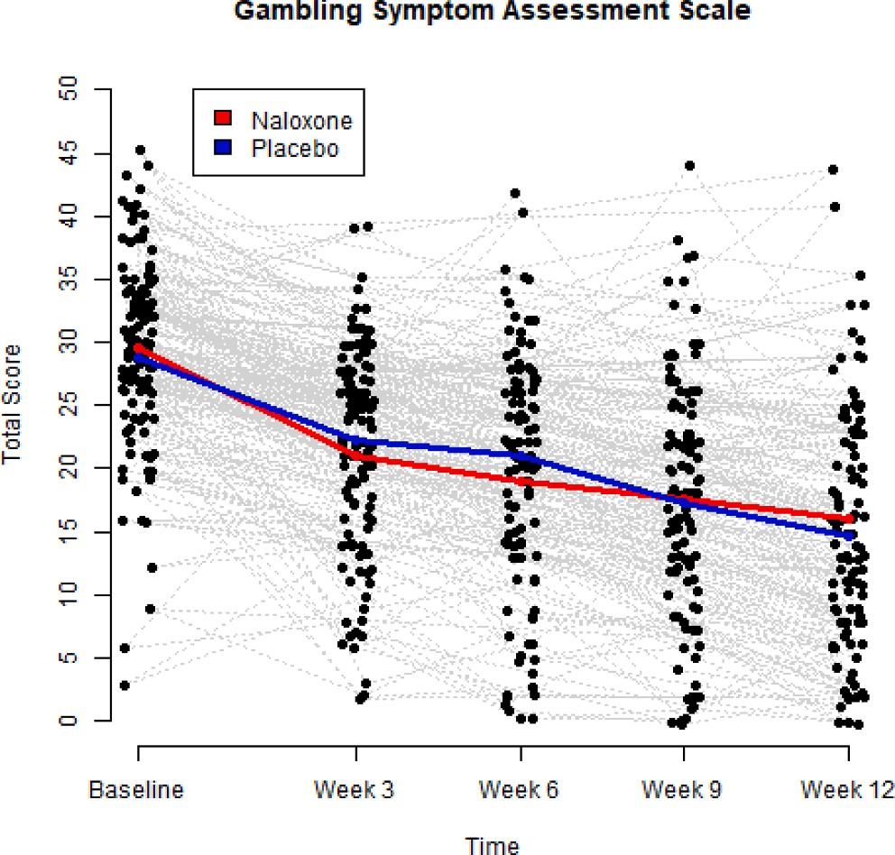
Fig. 2. A scatterplot of G-SAS total score values from Baseline to Week 12. Data points jittered around the observed values to avoid overlapping dots. Profiles of conditional sample means of Naloxone group and placebo group are given by
red and blue curves, respectively. Based on linear mixed effects analysis, treatment effect: p-value = 0.249, time effect: p-value < 0.001. (For interpre- tation of the references to colour in this figure legend, the reader is referred to
the web version of this article.)

