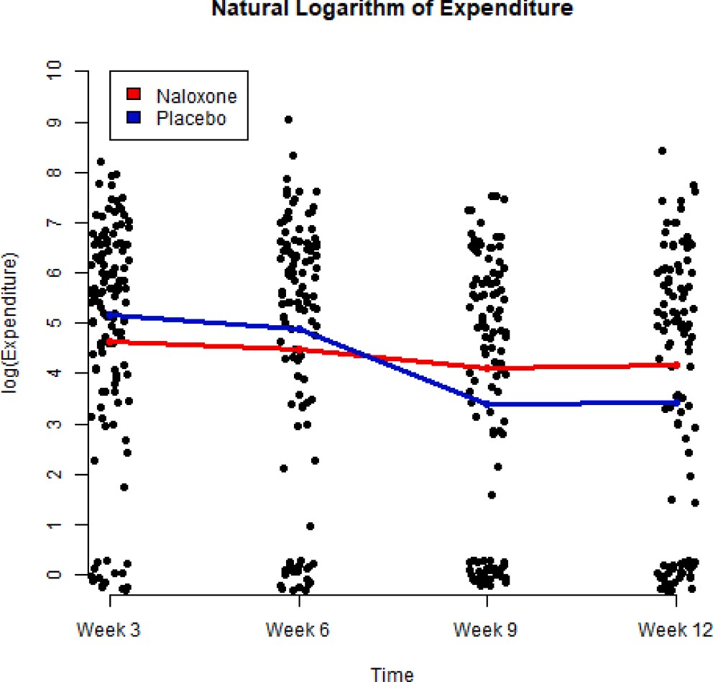

A scatterplot of natural logarithm values of gambling expenditure from Week 3 to Week 12. Data points jittered around the observed values to avoid overlapping dots. Profiles of conditional sample means of Naloxone group and placebo group are given by red and blue curves, respectively. Based on linear
mixed effects analysis, treatment effect: p-value = 0.431, time effect: p-value <
0.001. (For interpretation of the references to colour in this figure legend, the reader is referred to the web version of this article.)

