SYNOPSIS
Name of the Sponsor/Company: Krka, tovarna zdravil, d. d., Novo mesto.
Names of Finished Products:
Trade names of finished products vary depending on the country of the product.
Pregabalin, tested in this study, appears in following trade names, in the countries where this study was conducted: Pragiola® and Pregabalin Krka. Throughout this document, it is refered to Pregabalin Krka. Duloxetine appears only in trade name Dulsevia® in the countries where this study was conducted.
Names of Active Ingredients: pregabalin ((3S)-3-(aminomethyl)-5-methylhexanoic acid), duloxetine ((3S)-N-methyl-3-naphthalen-1-yloxy-3-thiophen-2-ylpropan-1-amine)
Title of Study: Efficacy of pregabalin and duloxetine in patients with painful diabetic peripheral neuropathy (PDPN): the effect of pain on cognitive function, sleep and quality of life (BLOSSOM)
Protocol no.: KCT 11/2017
Studies period (years): 2 years and 1 month  Date of first enrolment: 12 November 2019  Date of last completed: 21 December 2021 | Phase of development: Phase III/IV
Objectives:
The objectives of the study was to assess the efficacy of Pregabalin Krka and Dulsevia® in patients with PDPN, investigate the effect of Pregabalin Krka and Dulsevia® on pain and on quality of life (QOL), depression symptoms, cognitive functions, sleep quality and daytime sleepiness, and assess the safety of Pregabalin Krka and Dulsevia® in patients with PDPN.
Methodology:
This study was an interventional, open-label, prospective, international, multi-centre, phase III/IV clinical study. Study started with an initial screening visit (visit 1), to assess patient eligibility.
All patients started study with an initial Screening visit (Visit 1) which was performed to verify patients’ eligibility. During the visit the following procedures were scheduled/performed by the investigator: laboratory analyses (concentrations of Thyroid-stimulating hormone (TSH), vitamin B12, folic acid, glucose, glycated hemoglobin (HbA1c), pregnancy test for women of childbearing potential), assessment of PDPN (with questionnaire Douleur Neuropathique (DN4), assessment of cognition (with questionnaire Montreal Cognitive Assessment (MoCA), habits, medical history (medical/surgical history and concomitant diseases, previous and/or existing therapy of pain in PDPN, concomitant medications), measurements and evaluation of pain according to Visual Analog Scale (VAS).
On Visit 2 (Baseline visit) the results of laboratory tests, pregnancy test (if required), vital signs (heart rate, blood pressure), pain in PDPN according to VAS (separate assessments of current pain intensity, average pain intensity in last 24-h, worst pain intensity in last 24-h, average pain intensity in last 4 weeks and worst pain intensity in last 4 weeks), previous analgesic therapy and concomitant medications were assessed by the investigator.
If a patient met all inclusion criteria and did not meet any of the exclusion criteria, he/she was assessed as eligible and was randomly assigned (automatically through electronic version of case report form (eCRF)) into one of two therapy groups (treatment arms): Krka’s pregabalin (Pregabalin Arm) or Krka’s duloxetine (Dulsevia Arm). Additionally, assessments of quality of life (QoL) (with 36-Item Short Form Survey Instrument (SF-36), sleep quality and daytime sleepiness (with questionnaires The Insomnia Severity Index (ISI) and Epworth Sleepiness Scale (ESS), depression (with questionnaire Major depression inventory (MDI) and adverse events were performed.
Eligible patients were randomised to treatment with one of the two study medications Pregabalin Krka or Dulsevia®.

At week 1 (7 ± 3 days after Visit 2), the patient was called by phone by the investigator (Phone call 1) and asked about possible adverse events and to evaluate the pain intensity in PDPN by VAS (separate assessments of current pain intensity, average pain intensity in last 24-h and worst pain intensity in last 24-h) which is a part of a Patient diary 1.
At Visit 3, compliance monitoring was done, pain intensity in PDPN by VAS was evaluated (separate assessments of current pain intensity, average pain intensity in last 24-h and worst pain intensity in last 24-h), concomitant therapy was checked, vital signs were measured, doses of Investigational Medicinal Product (IMP) were adjusted and adverse events assessment were carried out.
At week 6 (28 ± 3 days after Visit 3), the patient was again called by phone by the investigator (Phone call 2) and asked about possible bothersome adverse events and to evaluate the pain intensity in PDPN by VAS (separate assessments of current pain intensity, average pain intensity in last 24-h and worst pain intensity in last 24-h) which is a part of a Patient diary 2.
At Visit 4, pregnancy test for women of childbearing potential and compliance monitoring were carried out; concomitant medications were checked, vital signs were measured, pain intensity in PDPN by VAS was evaluated (separate assessments of current pain intensity, average pain intensity in last 24-h and worst pain intensity in last 24-h, average pain intensity in last 4 weeks and worst pain intensity in last 4 weeks), IMP were adjusted and assessment of adverse events was carried out. Investigator collected the Patient Diary 2.
At Visit 5 again assessments of: QoL (with SF-36), sleep quality and daytime sleepiness (with ISI and ESS), depression (with MDI), cognition (with MoCA) and PDPN (with DN4) were performed. Also, evaluated the pain intensity in PDPN by VAS (separate assessments of current pain intensity, average pain intensity in last 24-h and worst pain intensity in last 24-h, average pain intensity in last 4 weeks and worst pain intensity in last 4 weeks) and assessment of the adverse events were performed. Pregnancy test for women of childbearing potential was carried out. Completion of all the procedures at Visit 5 determined the end of the patient's involvement in this clinical study.
On a day of Visit 2 or on the next day patients started with the treatment of Pregabalin Krka or Dulsevia®.
During the first 14 days (±3 days) of treatment (PERIOD 1/FLEXIBLE-DOSE REGIMEN) the investigator was allowed to give each patient an optimal dose of IMP. Available daily doses of Pregabalin Krka were 25 mg/day, 50 mg/day, 75 mg/day, 150 mg/day and 300 mg/day (from Phone call 1 further on). Available daily doses of Dulsevia® were 30 mg/day or 60 mg/day.
On a day of Visit 3 or on the next day patients continued the treatment with a minimum daily dose of 150 mg of Pregabalin Krka or 60 mg of Dulsevia®. If in the opinion of the investigator the minimum IMP dose could not be reached after Visit 3, the patient was excluded from the study.
After Visit 3 (PERIOD 2) available daily doses of Pregabalin Krka were 150 mg/day, 300 mg/day or 600 mg/day. Available daily doses of Dulsevia® were 60 mg/day, 90 mg/day or 120 mg/day.
After Visit 4 (PERIOD 3) available daily doses of Pregabalin Krka were 75 mg/day (only in case of bothersome adverse events), 150 mg/day, 300 mg/day or 600 mg/day. Available daily doses of Dulsevia® were 30 mg/day (only in case of bothersome adverse events), 60 mg/day, 90 mg/day or 120 mg/day.

Number of patients (planned and analysed):
According to protocol it was planned that a total of 280 patients would conclude the efficacy assessments and a per-protocol population of 160 patients was planned.

There were less recruited patients as planned according to the protocol and the study was terminated earlier. The justification for the early termination of the study was: despite less recruited patients as planned in the protocol, the statistical analysis still provided relevant results with the same statistical power as initially planned. Due to Economic point of view, the Sponzor decided for early termination.
The notification about the early termination of Blossom clinical study was sent to all local Regulatory agencies, Ethics committees and investigators in the countries where this study was conducted.
Of the 254 patients who were screened, 201 (79.1%) were assigned to study treatment. 201 patient was analysed for main safety endpoints. A total of 201 patients provided sufficient efficacy data for inclusion to Full Analyses Set (FAS). Out of the 53 (20.9%) patients who were not randomized, 6 (2.4%) patients withdrew their Informed Consent Forms (ICFs), 43 (16.9%) patients were screening failures (SFs), and 4 (1.6%) were classified as other exclusions (3 due to the epidemic in Serbia, 1 patient was noncooperative).

Out of the 201 randomized patients, constituting the FAS, 158 (78.6%) completed the study (i.e., completed Visit 5), while 43 (21.4%) were prematurely excluded. The reported reasons for premature exclusions were:
• Adverse events : 26 (12.9%)
• ICF withdrawal : 8 (4.0%)
• Incorrect inclusion*: 4 (2.0%)
• Noncompliance: 1 (0.5%)
• IMP inefficiency: 1 (0.5%)
• Other exclusions: 3 (1.5%)

One patient who completed the study was found to have been incorrectly included after data-management had been completed. One patient was found to have been incorrectly included after the compilation of Statistical analysis report (SAR) Version 1.2. Thus, the total number of incorrectly included patients is 6 (3.0%).

A total of 125 patients were included in Per Protocol Set (PPS).

FAS population was used as the main population for the assessment of study efficacy endpoints.
* Two randomized patients who were excluded at Visit 3 were reported as screening failures. They are reported as incorrectly included patients here.

Diagnosis and main criteria for inclusion:
The study population consists of adult men and women, aged 18-85, satisfying the following two criteria:
- Diagnosis of painful diabetic peripheral neuropathy caused by type 2 diabetes mellitus based on Douleur Neuropathique questionnaire (DN4 total score ≥ 4).
- Average pain intensity in the last 24 hours equal on the 0-100mm VAS equal to 40mm or more (0mm corresponding to “no pain” and 100mm corresponding to “worst possible pain”).
Patients were able to participate in the study only after signing the ICF.
Test product, dose and mode of administration, batch number:
- Pregabalin Krka 25 mg hard capsules. Each hard capsule contains 25 mg of pregabalin. Oral use. Batch numbers: SE9228, SE3234, SF8194
- Pregabalin Krka 75 mg hard capsules. Each hard capsule contains 50 mg of pregabalin. Oral use. Batch numbers: SE7721, V30995, SE5310
- Pregabalin Krka 150 mg hard capsules. Each hard capsule contains 150 mg of pregabalin. Oral use. Batch numbers: SE7824, SE8330
- Pregabalin Krka 300 mg hard capsules. Each hard capsule contains 300 mg of pregabalin. Oral use. Batch numbers: SE4639, SE4634, SH1729
- Dulsevia® hard gastro-resistant capsules. Each hard gastro-resistant capsule contains 30 mg of duloxetine (as duloxetine hydrochloride). Oral use. Batch numbers: SE9318, SH4472, SH6399
- Dulsevia® hard gastro-resistant capsules. Each hard gastro-resistant capsule contains 60 mg of duloxetine (as duloxetine hydrochloride). Oral use. Batch numbers: SE8950, SH4276, SH7433

Rescue medicine, dose and mode of administration, batch number:
Doreta® film coated tablets. Each film coated tablet contains 37.5 mg of tramadol hydrochloride and 325 mg of paracetamol. Batch numbers: D78505, D74646, D78385, D88256

Duration of treatment:
The total active treatment duration was 12 weeks, with maximal allowed prolongation of three additional days per each active treatment period (in total up to 12 days) due to possible unpredicted causes for the delay in the follow-up visits.
Reference therapy, dose and mode of administration, batch number:
Not applicable. This study was open-label and non-comparative.
Criteria for evaluation:
Efficacy:
The following parameters were used to evaluate efficacy: evaluation of average pain intensity according to VAS in last 24 hours, average pain intensity in last 4 weeks, current pain intensity, worst pain intensity in last 24-h, worst pain intensity in last 4 weeks; assessment of PDPN (with questionnaire DN4), assessment of cognition (with questionnaire MoCA), assessment of QoL (with questionnaire SF-36), assessment of sleep quality and daytime sleepiness (with questionnaires ISI and ESS), assessment of depression (with questionnaire MDI).
Safety:
The following parameters were used to evaluate safety: adverse events (AEs) were recorded and evaluated throughout the study and up to Visit 5. Vital signs (heart rate, office BP) were performed at each study visits. Clinical laboratory tests were performed at Visit 1: concentrations of TSH, vitamin B12, folic acid, glucose, HbA1c.
Pregnancy test for women of childbearing potential was performed on Visits 1, 4 and 5.
Statistical methods:
The primary and secondary efficacy have been made on the FAS and PPS. Safety analyses have been done on FAS (which is the same as SAS). Summary statistics consist of number of patients/observations, frequencies and corresponding percentages for categorical variables. For numeric variables, descriptive statistics (number of patients/observations, mean, median, standard deviation, minimum and maximum, first and third quartile) have been tabulated.
Inferential methods for efficacy analyses on the PPS and on observed data:
On the PPS and on observed data, the methods described in Subsection 9.1 of the study protocol have been applied. Namely, for the assessment of each proportion, the two-sided “equal-tails” Clopper-Pearson exact 95%-confidence interval has been employed. For the assessment of each mean difference, the standard 95%-confidence interval for the mean (with unknown variance) based on the limiting distribution of the standardized sample mean has been applied to the difference of the two time-point evaluations of the variable in question.
Inferential methods for efficacy analyses on the FAS:
Records of patients in the FAS had missing values. For a randomized patient, any record at any time-point from Visit 2 onwards that was necessary for the evaluation of an efficacy endpoint was treated as a missing value if it was unavailable for any reason (e.g., was not entered into the eCRF by error, was not entered into the eCRF because a measurement was not performed or was not entered into the eCRF because of premature exclusion). Missing values have been imputed by means of multiple imputation (MI), and on estimates obtained by multiple imputation statistical inference methods specifically devised for multiple imputation was employed.
Software:
Microsoft Office Excel 365 was used for the preparation of tables. Microsoft Visual Basic for Applications and IBM SPSS 28.0 were used for computations.
Subject Disposition and Demography:
The number of patients treated, completed, discontinued from the study and analyzed, are summarized for each treatment arm in the table below.
 | Pregabalin Arm  (no. patients) | Dulsevia Arm  (no. patients) | All patients  (no. patients)
Assigned to treatment (overall) | 99 | 102 | 201
Assigned to treatment (FAS) | 99 | 102 | 201
Completed (FAS) | 82 | 76 | 158
Discontinued (FAS) | 17 | 26 | 43
Reason: AE (FAS) | 11 | 15 | 26
Other reasons (FAS) | 6 | 11 | 17
Analyzed for efficacy
FAS | 99 | 102 | 201
PPS | 66 | 59 | 125
Analyzed for AEs | 99 | 102 | 201

In FAS, mean age in Pregabalin Arm was 64.4 ± 9.1 years and in Dulsevia Arm was 63.4 ± 10.1 years. Notably more female (58.2%) than male (41.8%) patients were recruited to this study and included in FAS (in Pregabalin Arm 56.6% of women, in Dulsevia Arm 59.8% women). Mean BMI in Pregablin Arm was 30.3 ± 5.6 and in Dulsevia Arm 29.3 ± 4.8. Majority of recruited patients were non-smokers (more than 70% in both arms).

Efficacy Results:
Improvement of pain in PDPN was considered as clinically meaningful if reduction of average pain intensity in PDPN in last 24-h (measured by VAS) was equal or more than 30 % in comparison to the initial level (baseline) AND/OR if averege pain intensity in PDPN in last 24-h (measured by VAS) did not exceed 30 mm at the end of the study (after 12 weeks).
Primary efficacy endpoint
The proportion of patients with clinically meaningful improvement of 24h-average pain intensity (API) after 12 weeks by Treatment Arm and Overall in FAS
Patients with clinically meaningful improvement of 24h-API | Pregabalin Arm | Dulsevia Arm | FAS patients
Patients with clinically meaningful improvement of 24h-API | (n=99) | (n=102) | (n=201)
Proportion | 88.3% | 86.9% | 87.6%
95% CI | [81.7%,94.8%] | [76.7%,97.1%] | [81.7%,93.5%]

Treatment Pathways
In FAS analysis set at Visit 2, 7 patients received Pregabalin 25 mg, 41 patients received Pregabalin 50 mg, 40 patients received Pregabalin 75 mg and 11 patients received Pregabalin 150 mg. At Phone call 1, 3 patients were withdrawn, 5 patients received Pregabalin 50 mg, 7 patients received Pregabalin 75 mg, 83 patients received Pregabalin 150 mg and 1 patient received Pregabalin 300 mg. At Visit 3 another patient was withdrawn, 52 patients received Pregabalin 150 mg (minimum allowed daily dose of Pregabalin on Visit 3 according to the protocol), 41 patients received Pregabalin 300 mg and 2 patients received Pregabalin 600 mg. At Phone call 2 another 5 patients were withdrawn, 42 patients received Pregabalin 150 mg, 40 patients received Pregabalin 300 mg and 8 patients received Pregabalin 600 mg. At Visit 4 another 5 patients were withdrawn, 35 patients received Pregabalin 150 mg, 34 patients received Pregabalin 300 mg and 16 patients (16.2%) received Pregabalin 600 mg (maximum allowed dose of Pregabalin according to the protocol).
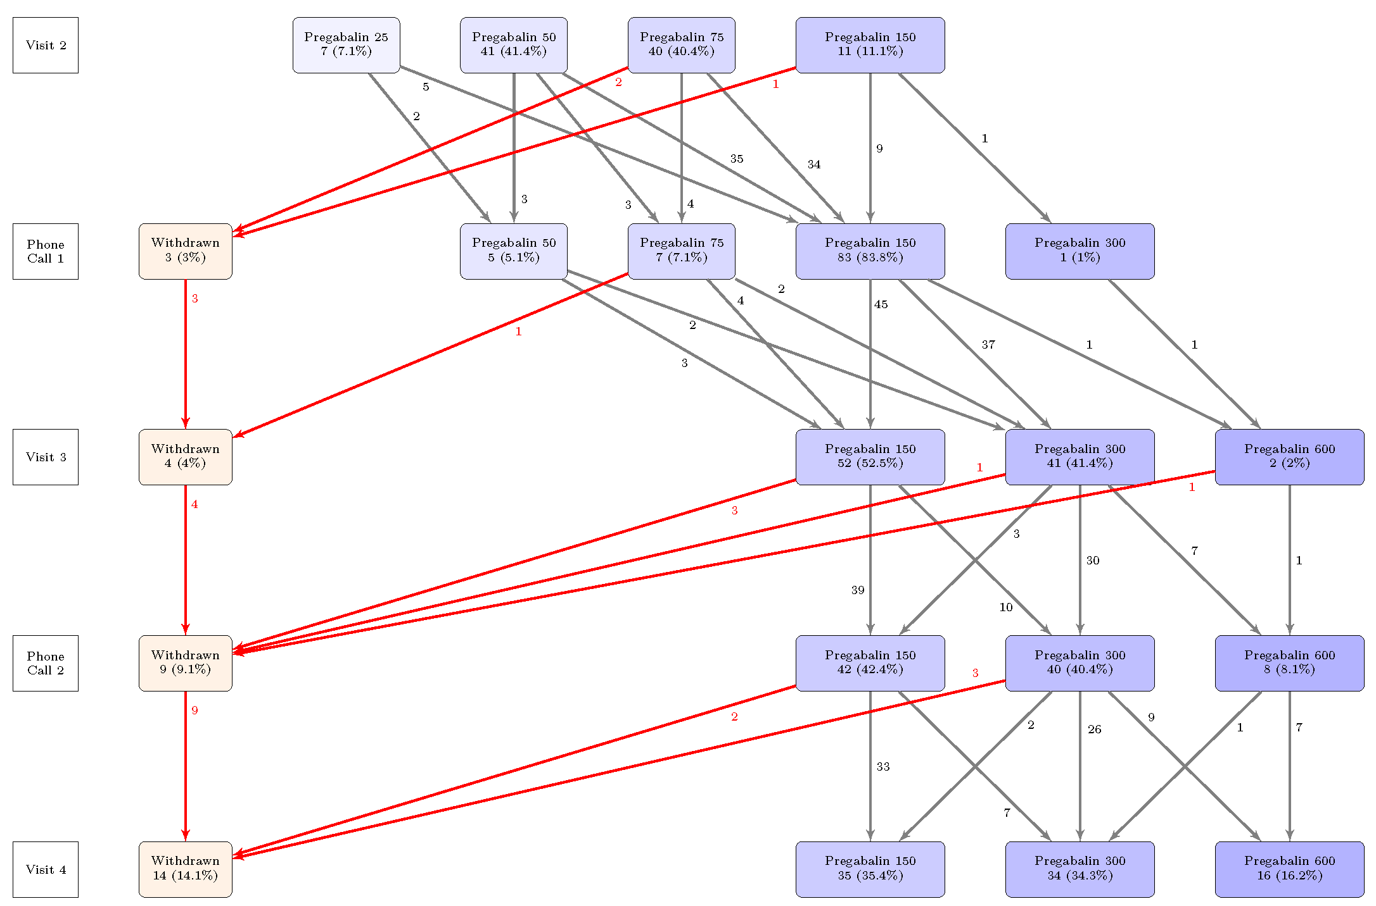

In FAS analysis set at Visit 2, 85 patients received Dulsevia 30 mg and 17 patients received Dulsevia 60 mg. At Phone call 1, 3 patients were withdrawn, 18 patients received Dulsevia 30 mg and 81 patients received Dulsevia 60 mg. At Visit 3 another 14 patients were withdrawn, 63 patients received Dulsevia 60 mg (minimum allowed daily dose of Dulsevia on Visit 3 according to the protocol), 14 patients received Dulsevia 90 mg and 8 patients received Dulsevia 120 mg. At Phone call 2 another 5 patients were withdrawn, 49 patients received Dulsevia 60 mg, 19 patients received Dulsevia 90 mg and 12 patients received Dulsevia 120 mg. At Visit 4 another 4 patients were withdrawn, 1 patient received Dulsevia 30 mg, 42 patients received Dulsevia 60 mg, 14 patients received Dulsevia 90 mg and 19 (18.6%) patients received Dulsevia 120 mg (maximum allowed dose of Dulsevia according to the protocol).

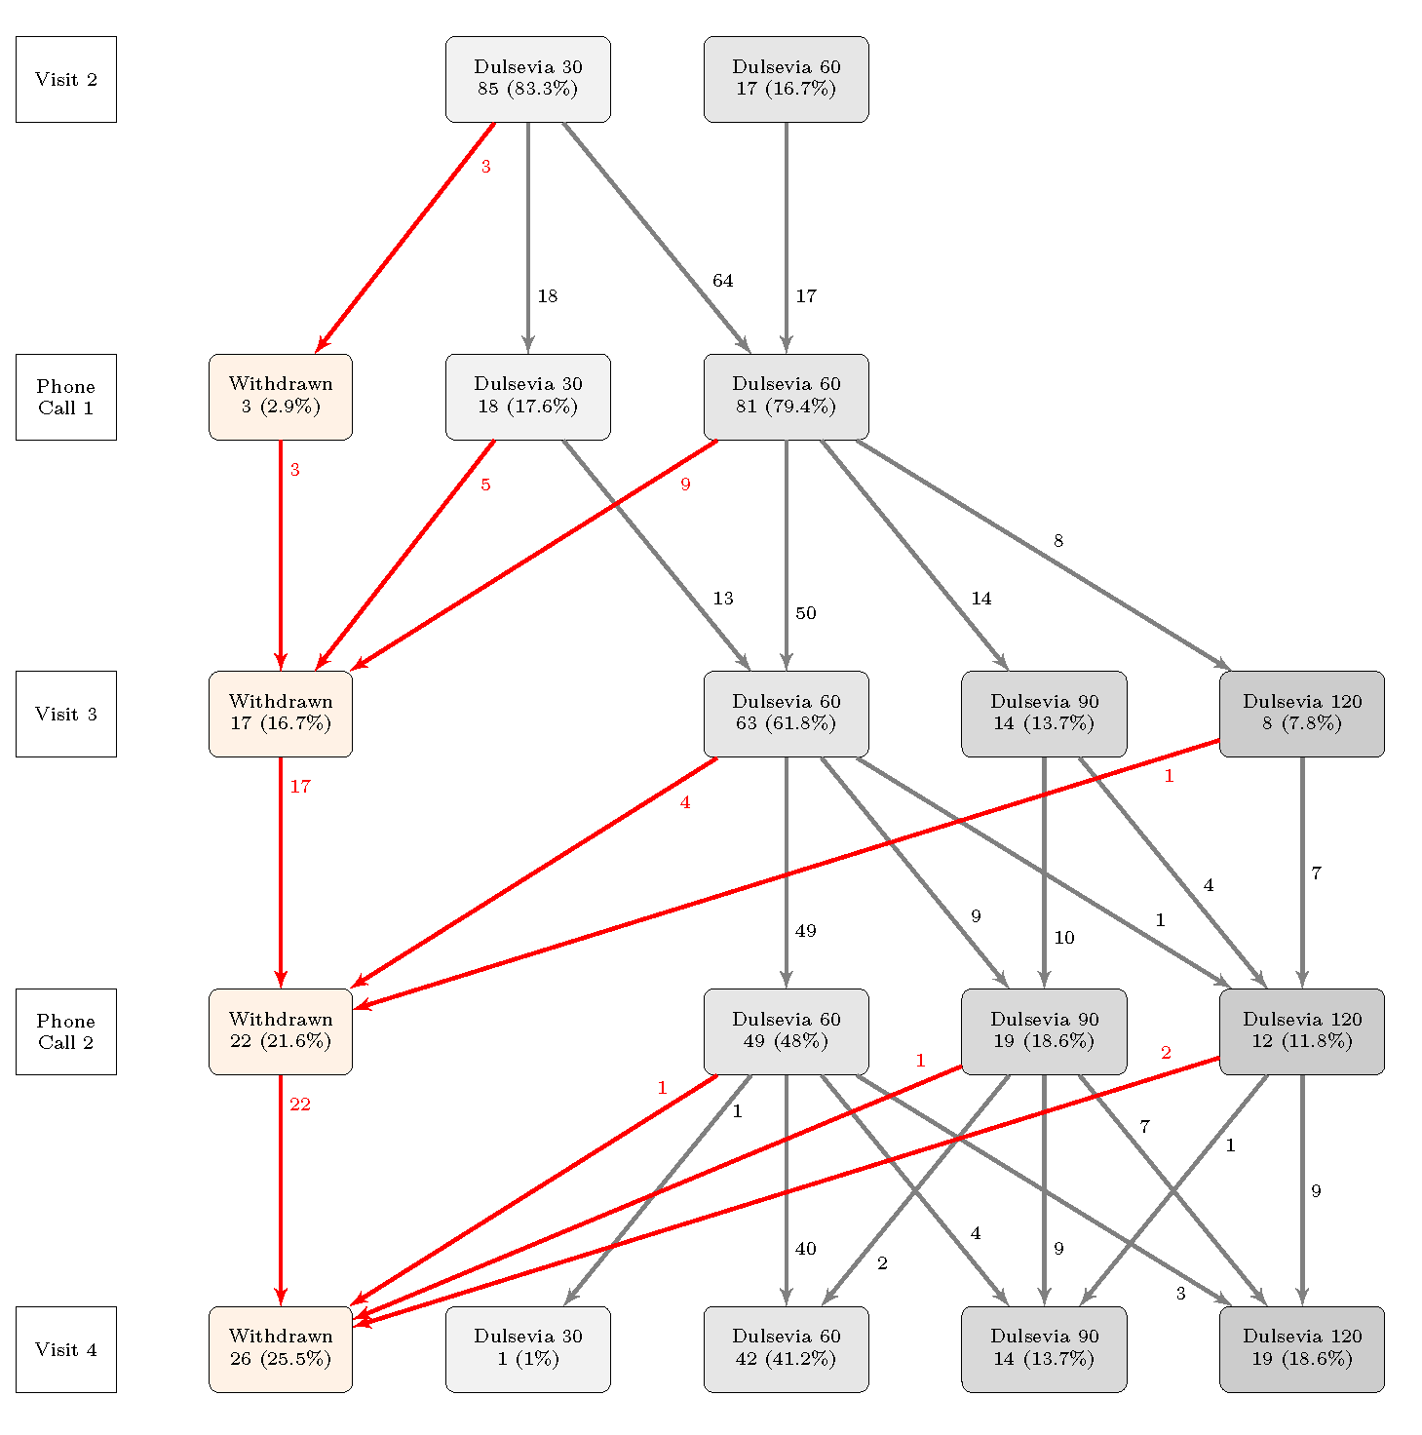

Safety Results:
Out of 201 patients in FAS, 34% of patients reported AE. Proportion of patients with any reported AE in Pregabalin Arm was 35% and proportion in Dulsevia Arm was 33%. Proportion of patients with any reported ADR was lower: 30% in Pregabalin Arm and 30% in Dulsevia Arm.
Out of 254 patients who signed the ICF, there were no reported adverse events during the screening period, until baseline visit (Visit 2).

Conclusions:
The results of the BLOSSOM study demonstrate that the treatment strategies with Pregabalin Krka and Dulsevia®, tested in this study, result in effective reduction of pain in PDPN after three months of treatment. The proportion of patients with clinically meaningful improvement of pain in PDPN was more than 86% in both treatment arms.
The pattern of safety information in this study indicates good tolerability of the tested medications.
Taking into consideration the findings of this study, it can be concluded that Pregabalin Krka and Dulsevia® represent a useful tool not only for decreasing the pain in PDPN, but also have positive effect on depressive symptoms, cognition, quality of life and sleep; thus widening the possibility of a comprehensive management of pain in PDPN.

