Single-Dose Effects of Citalopram on Neural Responses to Affective Stimuli in Borderline Personality Disorder:
A Randomized Clinical Trial

Supplement 1

Table of contents
1 Exclusion criteria 2
2 Original statistical analysis plan 4
Methods 4
Results 4
3 Perfusion imaging 6
Data acquisition parameters 6
ASL imaging 6
4 Supplementary Tables 8
Table S1. Adverse events 10
Table S2. Psychometric control variables by treatment (M/SD). 11
Table S3. Accuracy (percentage of hit responses) and response times (RT in ms) in decisions (M/SD) per treatment. 11
Table S4. Pearson correlations between BSL-23 score at baseline and neural response to Citalopram (vs. Placebo, for main effect aversive condition > neutral condition) 12
Table S5. Arterial Spin Labeling (ASL) results did not differ significantly between treatment conditions. 13
5 Supplementary Figures 14
Figure S1. Regions of interest (ROIs) 14
Figure S2. Within-subject between-session difference in accuracy (hit responses). 14
Figure S3. Within-subject between-session difference in response times (hit responses) 14
Figure S4. Whole-brain comparison of neural response to scences vs. scrambled pictures. 16
Figure S5. Whole-brain comparison of neural response to faces vs. scrambled pictures. 18
Figure S6. ASL perfusion of amygdala was not affected by the compound. 18
6 CONSORT checklist of information to include when reporting randomised crossover trials 19
7 Supplementary References 22

Exclusion criteria
Subjects presenting with any of the following criteria were not included in the trial:
- A history of alcohol or substance dependence within the last 12 months from Visit
- A positive urine drug screen at Visit 1. One re-test within 1 to 3 days is permitted if positive result is believed to be due to licenced opiate-based medication or ingestion of poppy seeds. In this event, re-test result will be used for assessing entry criterion and must be completed prior to randomisation.
- A positive alcohol breath test at Visit 1.
- Positive pregnancy test at Visit 1.
- Currently pregnant or trying to get pregnant or currently breast feeding.
- Consumption of large amounts of caffeinated drinks (more than 8 cups of standard caffeinated drinks (tea, instant coffee) or 6 cups of stronger coffee or other drinks containing methylxanthines such as coca cola or Red Bull per day).
- Blood pressure (5 minutes sitting) outside normotensive range of 90 to 150 mm Hg systolic, inclusive, and 60 to 90 mm Hg diastolic, inclusive, at Visit 1
- Heart rate (5 minutes sitting) ≤50 beats per minute at screening
- Abnormal ECG results, including QTcF > 470 ms (for women) (based on the Fridericia correction where QTcF = QT/RR0.33) at Visit 1.
- Weight as defined by BMI (weight [kg]/height [m]²) outside range of 18 to 35 kg/m², inclusive at Visit
- Left-handedness
- Smoking ≥20 cigarettes per day
- With a relevant history, or presence upon clinical examination, of cardiac, ophthalmologic, pulmonary, endocrine (diabetes), blood disease, gastro-intestinal, hepatic or renal disease or other condition which in the opinion of the Investigator could interfere with the test procedures.
- A history of cancer, except for basal cell or Stage 1 squamous cell carcinoma of the skin which has been in remission for at least 5 years prior to Visit 1.
- The diagnostic criteria for a psychotic disorder or schizophrenia, as determined by the SCID-I at Visit 1 are met.
- Current or history of significant neurological conditions (such as stroke, traumatic brain injury, space occupying lesions, multiple sclerosis, Parkinson’s disease, vascular dementia, transient ischemic attack).
- A history of positive HIV test.
- A medical history of cranial surgery.
- With a significant visual impairment including colour blindness, or history of ocular treatment including corrective laser eye surgery, or ongoing condition, which in the opinion of the Investigator may interfere with the performance of the behavioural tasks or fMRI tasks.
- Has received prescribed psychotropic medication within 28 days prior to Visit 1. Participants who have taken prescription medication may still be entered into the study, if, in the opinion of the Investigator, the medication received will not interfere with the study procedures or compromise safety.
- Has received an experimental drug and / or used an experimental medical device within 30 days of randomisation or within a period less than 5 times the drug’s half-life, whichever is longer.
- With a known hypersensitivity to Citalopram or any of their excipients.
- With a history of severe drug allergy or hypersensitivity.
- Who is unable or unwilling to comply with study procedures, including study prohibitions and restrictions
- With a history of claustrophobia or inability to tolerate scanner environment.
- Who fulfils any of the MRI contraindications on the standard site radiography screening questionnaire (e.g. history of surgery involving metal implants).
- With a clinically relevant structural brain abnormality as determined by prior MRI scan.
- With planned medical treatment within the study period that might interfere with the study procedures.
- Is a staff member or the relative of a staff member, or is in a subordinate relationship with the Investigator.
- Is held in an institution by legal or official order.
- Participation in other clinical trials or observation period of competing trials, respectively.
- Previous participation in this trial

Original statistical analysis plan

Methods
In the original statistical analysis plan that we agreed upon before data collection we stated that “we will conduct region-of-interest analyses in each of the brain regions, as defined by AAL atlas (Tzourio-Mazoyer et al., 2002), by applying small volume correction (SVC) with a threshold of p(FWE)<.05.” (ECEP-BPD_Study Protocol_V1.3, Section 7.2 Efficacy parameters). The statistical analysis plan was revised after data collection, because SVC analysis is a method for cluster inference, but our research questions asks about activation in circumscribed anatomical regions. Therefore, the approach described in the main paper is deemed more adequate. Here we provide results according to original approach layed down in the original study protocol. Note that AAL atlas masks were built according to the most recent AAL release and comprised ACC, amygdala, insula, and medial frontal gyrus, where the latter included the DLPFC (ROI masks: leftACC, rightACC, leftAMYG, rightAMYG, leftINS, rightINS, leftMFG, and rightMFG) (Rolls et al., 2020). The two-sample t-test implemented in Statistical Parametric Mapping (SPM12) software (Wellcome Department of Cognitive Neurology, London, UK) was used for mass-univariate GLM analysis of the first-level AC>NC contrast images to estimate the contrast Placebo>Citalopram on the second level. First, whole-brain activation was thresholded with P<0.01 (uncorrected). Next, small volume correction was applied to each ROI separately. Results were deemed significant if at least one voxel exceeded the P<0.05 family-wise error (FWE) corrected threshold. XYZ-coordinates are reported in MNI space, together with descriptive statistics in case analyses returned significant findings.

Results
We found significant lower response to faces vs. scrambled images in the Citalopram vs. the Placebo condition in left ([-20,0,-22], T(24)=3.45, P<0.031) and right amygdala ([32,-2,-22], T(24)=3.98, P<0.034). Figures below illustrate results (crosshairs mark significant voxels) with whole-brain maps thresholded with P<0.01 (uncorrected). No remaining analysis did return significant findings.

Left amygdala:
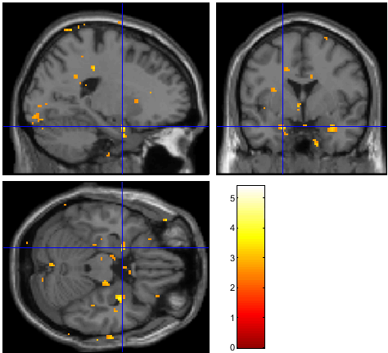

Right amygdala:
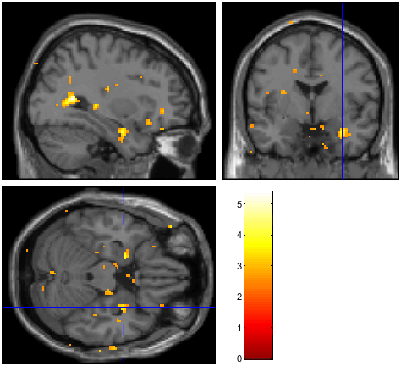

Perfusion imaging

Data acquisition parameters
To study blood diffusion in the brain, we used arterial spin labeling (ASL). During ASL, participants engaged in no special task, but were asked to close their eyes and relax for 8 minutes. ASL provides quantitative parametric images of tissue perfusion. For that purpose, it uses the water in arterial blood as an endogenous, freely diffusible contrast medium. During ASL, water molecules are labelled magnetically as an endogenous tracer as they travel to a brain region of interest. Selective radiofrequency (RF) irradiation inverts the magnetisation of arterial blood water in the neck region, and a downstream measurement is taken as labeled spins exchange into the tissue of interest (Williams et al., 1992). The resulting images, assessed with a standard echo-planar imaging sequence, were compared to control images in which no inversion pulse was applied. The difference image is a measure of perfusion, which is related to the quantification of cerebral blood flow in well-characterised units of millilitres of blood per 100 g of tissue per minute. For the current study we use a pseudo-continuous ASL pulse train (labeling duration 1800 ms), with the labeling plane positioned 90 mm inferior to the centre of the imaging volume. Pre-saturation and two inversion pulses were used for background suppression (Günther et al., 2005) and data were acquired at a range of post-labeling delays (400, 700, 1000, 1300, 1600, 1900, 2200 and 2500 ms). A segmented 3D-GRASE readout was used for image acquisition (4 shots, 36 slices, voxel size 3.4 x 3.4 x 3.3 mm, 6/8ths partial Fourier in the slice direction, left-right in-plane phase-encoding, refocussing flip angle 120 degrees, TE 35 ms, TR 5000 ms, one label-control pair per post-labeling delay). Two calibration scans were acquired with identical imaging parameters to the main ASL data, but with the labeling and background suppression switched off, using a TR of 6000 ms. In the second calibration scan the in-plane phase-encoding direction was reversed to allow correction for distortions due to main magnetic field inhomogeneity. The total acquisition time, including calibration scans, was 6 min 8 sec. Data were saved both with and without a correction for receive coil non-uniformity (using the “pre-scan normalise” option).

ASL imaging
ASL data were processed using the BASIL toolbox (Chappell et al., 2009) within FSL. Preprocessing included motion correction using MCFLIRT (using the calibration image with matched in-plane phase-encoding as a reference), distortion correction using topup (estimated from the calibration images with opposed in-plane phase-encoding, then applied to all ASL data), correction for receive coil non-uniformity (using a sensitivity map derived by dividing the uncorrected calibration image by the “pre-scan normalised” version) and subtraction of label and control pairs to generate perfusion-weighted images at each post-labeling delay. The perfusion-weighted images were then fit to a well-established kinetic model (Buxton et al., 1998), incorporating a macrovascular component (Chappell et al., 2010) to separate signals within large arteries from tissue perfusion signal to prevent bias in the resulting cerebral blood flow estimates. A spatial prior on the cerebral blood flow values is used to regularise the fitting procedure without directly smoothing the data (Groves et al., 2009). The resulting parameter estimates are registered on to the T1-weighted structural image acquired in the same participant. Signal calibration is achieved through automatic generation of a ventricle mask registered from MNI152 standard space to the participant's structural image and then on to the ASL calibration data. This is used to estimate the equilibrium magnetisation of cerebrospinal fluid, which can be converted into a calibration factor to allow the cerebral blood flow estimates to be expressed in absolute physiological units (ml/100g/min), accounting for the specific scan parameters used in the study.
For each ASL dataset we extracted the absolute cerebral blood flow within the left and right amygdala extracted from participant-level segmentation of the T1 anatomical image using FSL FIRST. We also calculated flow values normalised by the mean cerebral blood flow within the participant's grey matter, which can help to account for subject-to-subject differences in physiology, such as those arising from factors such as age and caffeine intake.

Supplementary Tables
Adverse event |  | Number of  adverse events
Headache | No adverse event either under Citalopram or Placebo | 17
Headache | No adverse event under Citalopram but adverse events under Placebo | 6
Headache | Adverse events observed under Citalopram but not under Placebo | 5
Headache | Adverse events observed under both Citalopram and Placebo | 0
Sleep disorder | No adverse event either under Citalopram or Placebo | 27
Sleep disorder | No adverse event under Citalopram but adverse events under Placebo | 0
Sleep disorder | Adverse events observed under Citalopram but not under Placebo | 1
Sleep disorder | Adverse events observed under both Citalopram and Placebo | 0
Tightness of  jaw muscles | No adverse event either under Citalopram or Placebo | 26
Tightness of  jaw muscles | No adverse event under Citalopram but adverse events under Placebo | 0
Tightness of  jaw muscles | Adverse events observed under Citalopram but not under Placebo | 2
Tightness of  jaw muscles | Adverse events observed under both Citalopram and Placebo | 0
Sweating  increased | No adverse event either under Citalopram or Placebo | 25
Sweating  increased | No adverse event under Citalopram but adverse events under Placebo | 1
Sweating  increased | Adverse events observed under Citalopram but not under Placebo | 2
Sweating  increased | Adverse events observed under both Citalopram and Placebo | 0
Musculoskeletal  chest pain | No adverse event either under Citalopram or Placebo | 27
Musculoskeletal  chest pain | No adverse event under Citalopram but adverse events under Placebo | 0
Musculoskeletal  chest pain | Adverse events observed under Citalopram but not under Placebo | 1
Musculoskeletal  chest pain | Adverse events observed under both Citalopram and Placebo | 0
Nausea | No adverse event either under Citalopram or Placebo | 25
Nausea | No adverse event under Citalopram but adverse events under Placebo | 1
Nausea | Adverse events observed under Citalopram but not under Placebo | 2
Nausea | Adverse events observed under both Citalopram and Placebo | 0
Muscle pain | No adverse event either under Citalopram or Placebo | 27
Muscle pain | No adverse event under Citalopram but adverse events under Placebo | 1
Muscle pain | Adverse events observed under Citalopram but not under Placebo | 0
Muscle pain | Adverse events observed under both Citalopram and Placebo | 0
Thirst | No adverse event either under Citalopram or Placebo | 27
Thirst | No adverse event under Citalopram but adverse events under Placebo | 0
Thirst | Adverse events observed under Citalopram but not under Placebo | 1
Thirst | Adverse events observed under both Citalopram and Placebo | 0
Cough | No adverse event either under Citalopram or Placebo | 26
Cough | No adverse event under Citalopram but adverse events under Placebo | 0
Cough | Adverse events observed under Citalopram but not under Placebo | 2
Cough | Adverse events observed under both Citalopram and Placebo | 0
Neck stiffness | No adverse event either under Citalopram or Placebo | 26
Neck stiffness | No adverse event under Citalopram but adverse events under Placebo | 1
Neck stiffness | Adverse events observed under Citalopram but not under Placebo | 1
Neck stiffness | Adverse events observed under both Citalopram and Placebo | 0
Stress symptoms | No adverse event either under Citalopram or Placebo | 27
Stress symptoms | No adverse event under Citalopram but adverse events under Placebo | 0
Stress symptoms | Adverse events observed under Citalopram but not under Placebo | 1
Stress symptoms | Adverse events observed under both Citalopram and Placebo | 0
Tinnitus | No adverse event either under Citalopram or Placebo | 27
Tinnitus | No adverse event under Citalopram but adverse events under Placebo | 0
Tinnitus | Adverse events observed under Citalopram but not under Placebo | 1
Tinnitus | Adverse events observed under both Citalopram and Placebo | 0
Delusional disorder,  paranoid type | No adverse event either under Citalopram or Placebo | 27
Delusional disorder,  paranoid type | No adverse event under Citalopram but adverse events under Placebo | 0
Delusional disorder,  paranoid type | Adverse events observed under Citalopram but not under Placebo | 1
Delusional disorder,  paranoid type | Adverse events observed under both Citalopram and Placebo | 0
Dissociative disorder | No adverse event either under Citalopram or Placebo | 26
Dissociative disorder | No adverse event under Citalopram but adverse events under Placebo | 1
Dissociative disorder | Adverse events observed under Citalopram but not under Placebo | 1
Dissociative disorder | Adverse events observed under both Citalopram and Placebo | 0
Attention impaired | No adverse event either under Citalopram or Placebo | 27
Attention impaired | No adverse event under Citalopram but adverse events under Placebo | 1
Attention impaired | Adverse events observed under Citalopram but not under Placebo | 0
Attention impaired | Adverse events observed under both Citalopram and Placebo | 0
Depressed mood | No adverse event either under Citalopram or Placebo | 27
Depressed mood | No adverse event under Citalopram but adverse events under Placebo | 1
Depressed mood | Adverse events observed under Citalopram but not under Placebo | 0
Depressed mood | Adverse events observed under both Citalopram and Placebo | 0
Diarrhea | No adverse event either under Citalopram or Placebo | 26
Diarrhea | No adverse event under Citalopram but adverse events under Placebo | 0
Diarrhea | Adverse events observed under Citalopram but not under Placebo | 2
Diarrhea | Adverse events observed under both Citalopram and Placebo | 0
Vertigo | No adverse event either under Citalopram or Placebo | 26
Vertigo | No adverse event under Citalopram but adverse events under Placebo | 0
Vertigo | Adverse events observed under Citalopram but not under Placebo | 2
Vertigo | Adverse events observed under both Citalopram and Placebo | 0
Muscle tension | No adverse event either under Citalopram or Placebo | 28
Muscle tension | No adverse event under Citalopram but adverse events under Placebo | 0
Muscle tension | Adverse events observed under Citalopram but not under Placebo | 0
Muscle tension | Adverse events observed under both Citalopram and Placebo | 0
Tiredness | No adverse event either under Citalopram or Placebo | 28
Tiredness | No adverse event under Citalopram but adverse events under Placebo | 0
Tiredness | Adverse events observed under Citalopram but not under Placebo | 0
Tiredness | Adverse events observed under both Citalopram and Placebo | 0
Tremor | No adverse event either under Citalopram or Placebo | 27
Tremor | No adverse event under Citalopram but adverse events under Placebo | 0
Tremor | Adverse events observed under Citalopram but not under Placebo | 1
Tremor | Adverse events observed under both Citalopram and Placebo | 0
Restlessness | No adverse event either under Citalopram or Placebo | 27
Restlessness | No adverse event under Citalopram but adverse events under Placebo | 0
Restlessness | Adverse events observed under Citalopram but not under Placebo | 1
Restlessness | Adverse events observed under both Citalopram and Placebo | 0
Dizziness | No adverse event either under Citalopram or Placebo | 27
Dizziness | No adverse event under Citalopram but adverse events under Placebo | 0
Dizziness | Adverse events observed under Citalopram but not under Placebo | 1
Dizziness | Adverse events observed under both Citalopram and Placebo | 0
Mucus nasal  increased | No adverse event either under Citalopram or Placebo | 27
Mucus nasal  increased | No adverse event under Citalopram but adverse events under Placebo | 0
Mucus nasal  increased | Adverse events observed under Citalopram but not under Placebo | 1
Mucus nasal  increased | Adverse events observed under both Citalopram and Placebo | 0
Pain behind eyes | No adverse event either under Citalopram or Placebo | 27
Pain behind eyes | No adverse event under Citalopram but adverse events under Placebo | 0
Pain behind eyes | Adverse events observed under Citalopram but not under Placebo | 1
Pain behind eyes | Adverse events observed under both Citalopram and Placebo | 0

Table S1. Adverse events

Variable | Citalopram (n=14) |  |  | Placebo (n=14) |  |  | Treatment difference |  |  | P
PA | 23.83 | ± | 6.67 | 24.45 | ± | 6.84 | -0.60 | ± | 10.88 | 0.86
NA | 18.97 | ± | 7.41 | 18.86 | ± | 8.19 | 0.10 | ± | 7.73 | 0.89
Table S2. Psychometric control variables by treatment (M/SD). PA=Positive Affect, NA=Negative affect.

A) Scenes task  (N=23) |  | Citalopram |  |  | Placebo |  |  | Treatment difference |  |  | P
Scene  pictures | hits % | 96.89# |  |  | 95.94# |  |  | 0.60 | ± | 6.92 | 0.64
Scene  pictures | RT ms | 1307.51 | ± | 222.70 | 1303.79 | ± | 180.82 | -1.66 | ± | 209.05 | 0.48
Scrambled  pictures | hits % | 99.91# |  |  | 98.50# |  |  | 1.59 | ± | 4.25 | 0.99
Scrambled  pictures | RT ms | 1026.13 | ± | 185.68 | 1057.09 | ± | 162.46 | -49.59 | ± | 179.99 | 0.10
B) Faces task  (N=25) |  | Citalopram |  |  | Placebo |  |  | Treatment difference |  |  | P
Face  pictures | hits % | 98.40# |  |  | 98.66# |  |  | -0.29 | ± | 3.75 | 0.36
Face  pictures | RT ms | 824.75 | ± | 127.31 | 858.98 | ± | 130.28 | -24.06 | ± | 103.70 | 0.14
Scrambled  pictures | hits % | 97.65# |  |  | 96.60# |  |  | 1.45 | ± | 5.19 | 0.90
Scrambled  pictures | RT ms | 804.98 | ± | 129.19 | 858.80 | ± | 127.23 | -53.16 | ± | 130.24 | 0.03
Table S3. Accuracy (percentage of hit responses) and response times (RT in ms) in decisions (M/SD) per treatment. Patients had to decide whether they could see a person or no person on a scene picture, and whether the face was male or female. They had to decide whether the color of the bounding box around the scrambled picture was blue or green in control conditions. #Standard deviation of accuracy not calculated as data is not normally distributed and bound by maximum of 100%.

Task | ROI | Correlation (r) | p
faces | ACC | -0.1133 | 0.5896
faces | Amygdala | -0.2121 | 0.3088
faces | DLPFC | -0.2510 | 0.2262
faces | Anterior insula | -0.3531 | 0.0833
scenes | ACC | -0.2032 | 0.3523
scenes | Amygdala | -0.0430 | 0.8456
scenes | DLPFC | -0.2247 | 0.3027
scenes | Anterior insula | -0.0564 | 0.7982
Table S4. Pearson correlations between BSL-23 score at baseline and neural response to Citalopram (vs. Placebo, for main effect aversive condition > neutral condition)

A) Absulute perfusion  N=21 |  | Citalopram |  |  | Placebo |  |  | Treatment difference |  |  | P
Amygdala | left | 34.31 | ± | 8.26 | 34.86 | ± | 7.36 | -1.77 | ± | 8.51 | 0.17
Amygdala | right | 36.69 | ± | 10.29 | 37.70 | ± | 8.57 | -2.04 | ± | 10.19 | 0.18
B) Relative perfusion  N=21 |  | Citalopram |  |  | Placebo |  |  | Treatment difference |  |  | P
Amygdala | left | 0.82 | ± | 0.12 | 0.85 | ± | 0.17 | -0.02 | ± | 0.16 | 0.25
Amygdala | right | 0.87 | ± | 0.12 | 0.91 | ± | 0.15 | -0.02 | ± | 0.14 | 0.22

Table S5. Arterial Spin Labeling (ASL) results did not differ significantly between treatment conditions.

Supplementary Figures
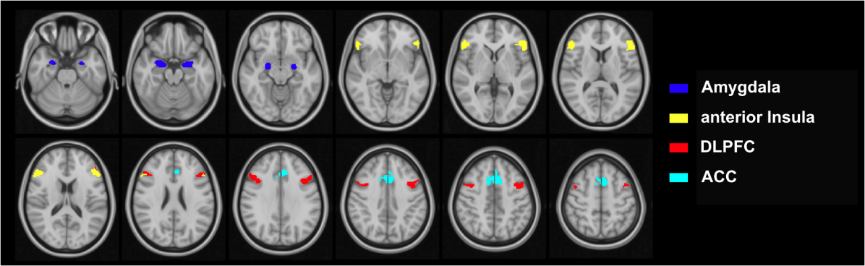

Figure S1. Regions of interest (ROIs)
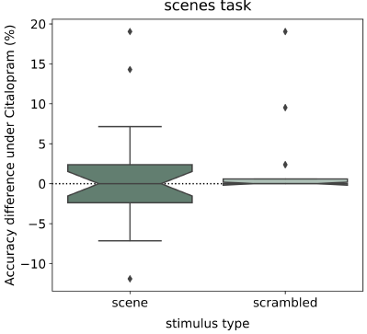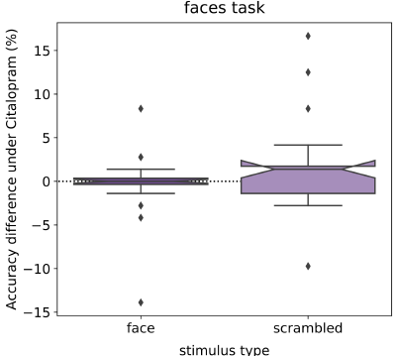

Figure S2. Within-subject between-session difference in accuracy (hit responses).

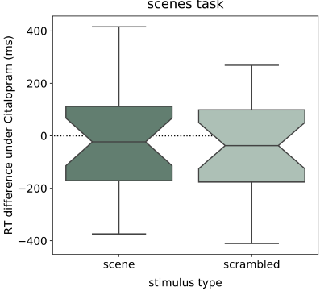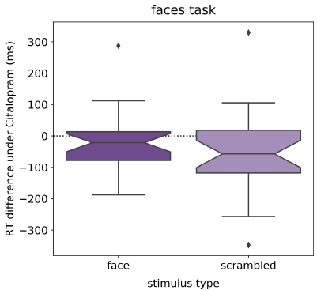

Figure S3. Within-subject between-session difference in response times (hit responses).
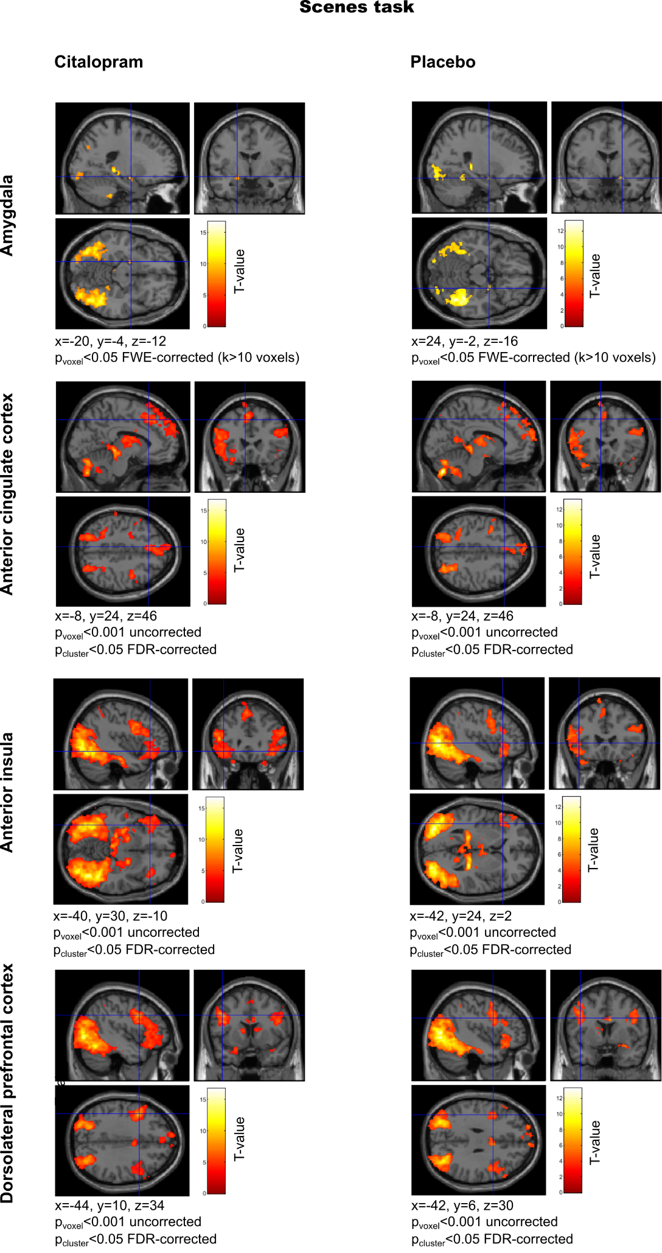
Figure S4. Whole-brain comparison of neural response to scences vs. scrambled pictures. Significant brain activation was observed in all a priori regions of interest. Activated voxels were obtained from one-sample t-tests in the whole brain and are visualized with SPM software (SPM12, Wellcome Department of Cognitive Neurology, London, UK).

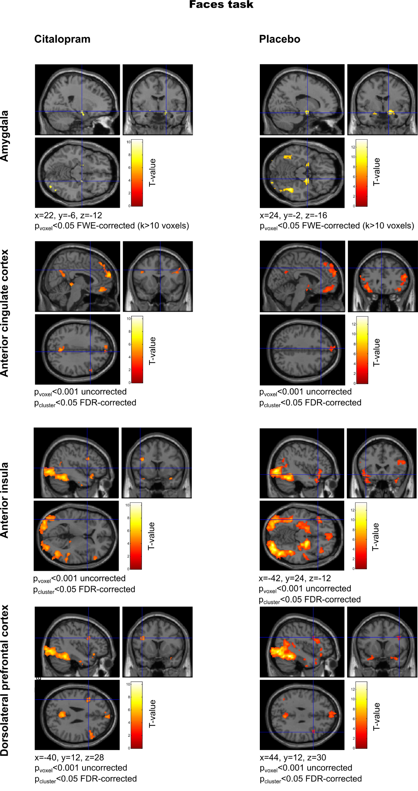
Figure S5. Whole-brain comparison of neural response to faces vs. scrambled pictures. Consistent significant brain activation was observed in the amygdala and in the dorsolateral prefrontal cortex. Activated voxels were obtained from one-sample t-tests in the whole brain and are visualized with SPM software (SPM12, Wellcome Department of Cognitive Neurology, London, UK).

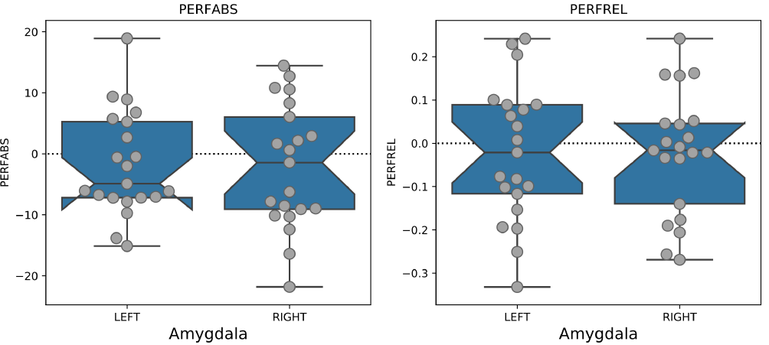
Figure S6. ASL perfusion of amygdala was not affected by the compound. N=21. PERFABS, left: absolute perfusion. PERFREL, right: relative perfusion. The notches indicate 95% intervals and the median is displayed as the waist. The Whiskers mark minimum and maximum values.

CONSORT checklist of information to include when reporting randomised crossover trials
Section/topic | Item No | Description | Page No
Title | 1a | Identification as a randomised crossover trial in the title | 1
Abstract | 1b | Specify a crossover design and report all information outlined in table 2 | 3, 4
Introduction:
Backround | 2a | Scientific background and explanation of rationale | 5, 6
Objectives | 2b | Specific objectives or hypotheses | 6
Methods:
Trial design | 3a | Rationale for a crossover design. Description of the design features including allocation ratio, especially the number and duration of periods, duration of washout period, and consideration of carry over effect | 7, 8
Change from protocol | 3b | Important changes to methods after trial commencement (such as eligibility criteria), with reasons | NA
Participants | 4a | Eligibility criteria for participants | 6, 7, Supplement
Settings and location | 4b | Settings and locations where the data were collected | 3
Interventions | 5 | The interventions with sufficient details to allow replication, including how and when they were actually administered | 7, 8
Outcomes | 6a | Completely defined prespecified primary and secondary outcome measures, including how and when they were assesed | 8, 10, Supplement
Changes to outcomes | 6b | Any changes to trial outcomes after the trial commenced, with reasons | NA
Sample size | 7a | How sample size was determined, accounting for within participant variability | 7, Study Protocol p27
Interim analyses and stopping guidelines | 7b | When applicable, explanation of any interim analyses and stopping guidelines | NA
Randomisation:
Sequence generation | 8a | Method used to generate the random allocation sequence | Study Protocol p27
Sequence generation | 8b | Type of randomisation; details of any restriction (such as blocking and block size) | Study Protocol p27
Allocation concealment mechanism | 9 | Mechanism used to implement the random allocation sequences (such as sequentially numbered containers), describing any steps taken to conceal the sequence until interventions were assigned | Study Protocol p27
Implementation | 10 | Who generated the random allocation sequence, who enrolled participants, and who assigned participants to the sequence of interventions | Study Protocol p27
Blinding | 11a | If done, who was blinded after assignment to interventions (for example, participants, care providers, those assessing outcomes) and how | Study Protocol p27
Similarity interventions | 11b | If relevant, description of the similarity of interventions | NA
Statistical methods | 12a | Statistical methods used to compare groups for primary and secondary outcomes which are appropriate for crossover design (that is, based on within participant comparison) | 10-12
Additional analyses | 12b | Methods for additional analyses, such as subgroups analyses and adjusted analyses | NA
Results
Participant flow (a diagram is strongly recommended) | 13a | The numbers of participants who were randomly assigned, received intended treatment, and were analysed for the primary outcome, separately for each sequence and period | Figure 1
Losses and exclusions | 13b | No of participants excluded at each stage, with reasons, seperately for each sequence and period | 11, Figure 1
Recruitment | 14a | Dates defining the periods of recruitment and follow-up | Study Protocol p19
Trial end | 14b | Why the trial ended or was stopped | 7
Baseline data | 15 | A table showing baseline demographic and clinical characteristics by sequence and period | Table 1
Numbers analysed | 16 | Number of participants (denominator) included in each analysis and whether the analysis was by original assigned groups | Figure 1, Results Tables
Outcomes and estimation | 17a | For each primary and secondary outcome, results including estimated effect size and its precision (such as 95% confidence interval) should be based on within participants comparisons. In additon, results for each intervention in each period are recommended | Table 2, Supplement  Table S4
Binary outcomes | 17b | For binary outcomes, presentation of both absolute and relative effect sizes is recommended | NA
Ancillary analyses | 18 | Results of any other analyses performed, including subgroub analyses and adjusted analyses, distinguishing prespecified from exploratory | Supplement  Tables S2, S3
Harms | 19 | Describe all important harms or untinded effects in way that accounts for the design (for specific guidance, see CONSORT for harms) | 8, Supplement Table S1
Discussion:
Limitations | 20 | Trial limitations, addresing sources of potential bias, imprecision, and if relevant, multiplicity of analyses. Consider potential carry over effects | 15, 16
Generalisability | 21 | Generalisability (external validity, applicability) of the trial findings | 16
Interpretation | 22 | Interpretation consistent with results, balancing benefits and harms, and considering other relevant evidence | 13-15
Other information:
Registration | 23 | Registration number and name of trial registry | 4
Protocol | 24 | Where the full trial protocol can be accessed, if available | 4
Funding | 25 | Sources of funding and other support (such as supply of drugs), role of funders | 16, Study Protocol p24

Supplementary References
Buxton, R. B., Frank, L. R., Wong, E. C., Siewert, B., Warach, S., & Edelman, R. R. (1998). A general kinetic model for quantitative perfusion imaging with arterial spin labeling. Magnetic Resonance in Medicine, 40(3), 383–396. https://doi.org/10.1002/mrm.1910400308
Chappell, M. A., Groves, A. R., Whitcher, B., & Woolrich, M. W. (2009). Variational Bayesian Inference for a Nonlinear Forward Model. IEEE Transactions on Signal Processing, 57(1), 223–236. https://doi.org/10.1109/TSP.2008.2005752
Chappell, M. A., MacIntosh, B. J., Donahue, M. J., Günther, M., Jezzard, P., & Woolrich, M. W. (2010). Separation of macrovascular signal in multi-inversion time arterial spin labelling MRI. Magnetic Resonance in Medicine, 63(5), 1357–1365. https://doi.org/10.1002/mrm.22320
Groves, A. R., Chappell, M. A., & Woolrich, M. W. (2009). Combined spatial and non-spatial prior for inference on MRI time-series. NeuroImage, 45(3), 795–809. https://doi.org/10.1016/j.neuroimage.2008.12.027
Günther, M., Oshio, K., & Feinberg, D. A. (2005). Single-shot 3D imaging techniques improve arterial spin labeling perfusion measurements. Magnetic Resonance in Medicine, 54(2), 491–498. https://doi.org/10.1002/mrm.20580
Rolls, E. T., Huang, C.-C., Lin, C.-P., Feng, J., & Joliot, M. (2020). Automated anatomical labelling atlas 3. NeuroImage, 206, 116189. https://doi.org/10.1016/j.neuroimage.2019.116189
Williams, D. S., Detre, J. A., Leigh, J. S., & Koretsky, A. P. (1992). Magnetic resonance imaging of perfusion using spin inversion of arterial water. Proceedings of the National Academy of Sciences of the United States of America, 89(1), 212–216. https://doi.org/10.1073/pnas.89.1.212

