Part I: Trial related part of the protocol

Title of the trial

Influence of continuous administration of phenylephrine versus dobutamine on spinal oxygen saturation, measured with near-infrared spectroscopy (NIRS).

Trial number

Protocol: AGO/2018/005

EudraCT number: 2018-003687-31

Objective of the study

Main objective:

Evaluation of the effect of continuous administration of phenylephrine or dobutamine on the spinal vasculature, by measuring spinal oxygen saturation with NIRS.

Secondary objectives:

Relationship between cerebral oxygen saturation, muscle saturation and the type of hemodynamic support provided.
Relationship between NIRS and MAP and CO.
Influence of sympathetic stimulation (during intubation) on cerebral, spinal and muscle oxygen saturation.

Endpoints of the study

Primary endpoint

Spinal oxygen saturation measured by NIRS

Secondary endpoint
Cerebral oxygen saturation
Deltoid muscle oxygen saturation

General information

Investigator(s)

Dr. Vanpeteghem Caroline, dept of anesthesia, UZ Ghent
Dr. Delforche Jonas, dept of anesthesia, UZ Ghent
Dr. Besard Milan, dept of anesthesia, UZ Ghent
Dr. Wolfskeil Martha, dept of anesthesia, UZ Ghent
Prof. Dr. S. De Hert, dept of anesthesia, UZ Ghent
Prof. Dr. A. Moerman, dept of anesthesia, UZ Ghent
Prof. Dr. F. Vermassen, dept of vascular and thoracic surgery, UZ Ghent

Sponsor

Ghent University Hospital

Departments/laboratories involved in the study

Department of Anesthesia, University Hospital Ghent.
Department of Vascular and Thoracic Surgery, University Hospital Ghent.

Introduction

Paraplegia and/or paraparesis is a feared and devastating complication following surgical repair of thoracic and thoraco-abdominal aortic aneurysms and dissections. The cause is thought to be a compromised perfusion of the spinal cord, and this might occur either during or after the surgical procedure.
According to the literature, the incidence of paraplegia and/or paraparesis following open surgical repair varies between 8% and 28%.^{1,2} Following endovascular repair, the incidence varies between 0% to 14.5%.^{3,4}
In patients with a risk of perioperative compromised spinal cord perfusion, a lumbar cerebrospinal fluid drainage is placed in order to measure and regulate the pressure into the spinal canal. It enhances the spinal cord perfusion and decreases the ischemic injury of the spinal cord.⁵ In addition, higher systemic blood pressures are often aimed for in order to increase and optimize spinal cord perfusion.
Motor evoked potentials (MEPs) and somatosensory evoked potentials (SSEPs) have been proven to be efficient to detect spinal ischemia and might guide therapeutic actions. Unfortunately, MEPs and SSEPs are time consuming, expensive, and they require trained and experienced personel as well as a modification of the standard anesthetic approach (e.g. avoidance of neuromuscular blocking agents, …).
Near-infrared spectroscopy (NIRS) is gaining popularity as a non-invasive monitor of spinal cord oxygenation.⁶ Therefore, NIRS is increasingly used in daily practice to measure spinal saturation and to monitor spinal ischemia.
There is ample literature describing the effect of hemodynamic supportive medication on NIRS measured cerebral saturation, ⁷, however their effect on spinal vasculature is still unknown.

Phenylephrine and dobutamine act completely different. Phenylephrine causes vasoconstriction, thereby increasing blood pressure, whereas the increase in blood pressure with dobutamine is related to an increase in cardiac output.

To assess the effect of hemodynamic supportive medication on spinal vasculature, patients scheduled for arterial dilation of the lower limb were chosen as our study population. The spinal cord perfusion is not compromised in these patients, however, most patients suffer from hypotension during this kind of surgery, due to the non-invasive type of surgery and the vasodilating effects of the anesthetics. Therefore, continuous administration of vasoactive medication (phenylephrine or dobutamine) is often required in order to increase blood pressure.

The aim of our study is to evaluate the effect of a continuous administration of phenylephrine or dobutamine on the spinal oxygenation, assessed by NIRS.

References

- Greenberg et al. Contemporary analysis of descending thoracic and thoracoabdominal aneurysms repair: a comparison of endovascular and open techniques. Circulation 2008 vol 118(8), p 808-817
- Messé et al. Neurologic outcomes from high risk descending thoracic and thoracoabdominal aortic operations in the era of endovascular repair. Neurocrit care 2008 vol 9(3), p 344-351
- Martin et al. Spinal cord ischemia after TEVAR in patients with abdominal aortic aneurysms. J Vasc Surg 2009 vol 49(2), p 302-306; discussion p 306-307
- Nicolaou et al. thoracic endovascular aortic repair. Anesthesiology clinics 2013 vol 31(2), p 451-478
- Sinha et al. Spinal cord protection and thoracic aortic surgery. Curr opin in anaesthesiol 2010 vol 23(1), p 95-102
- Etz et al. Near-infrared spectroscopy monitoring of the collateral network prior to, during and after thoracoabdominal aortic repair: a pilot study. Eur J Vasc Endovasc Surg 2013 vol 46(6),p 641-646
- Pennekamp et al. differential effect of phenylephrine and ephedrine on cerebral haemodynamics before carotid cross-clamping during carotid endarterectomy. BJ Anaesth 2012 Nov: 109(5): p 831-833

The present study

Study design

Prospective, randomized, interventional study.

Medication

Composition and dosing

Phenylephrine Unimedic10mg/ml
Dobutamine Hydrochloride EG (250 mg/20ml)

Producer

Phenylephrine Unimedic 10mg/ml : Unimedic AB (Sweden)
Dobutamine Hydrochloride EG: Eurogenerics NV, Brussel (Belgium)

Distributor

Phenylephrine Unimedic 10mg/ml : Unimedic Pharma AB (Sweden)
Dobutamine Hydrochloride EG: Ecopharma supply

Packaging

Phenylephrine Unimedic 10mg/ml: glass vial (10mg/ml); diluted in syringe (10mg/ml in 100 ml NaCl 0,9%) => 0,1mg/ml, for continuous use

Dobutamine EG 250mg/20ml: glass vial (250mg/20ml); diluted in syringe (30mg in 50ml NaCl 0.9%) => 0,6 mg/ml, for continuous use

Administration way

Continuous Intravenous use

Labelling

Phenylephrine Unimedic 10mg/ml: date, hour of preparation, ldap code of person who prepared the syringe, ldap of person who controlled the preparation of the syringe, concentration 0,1mg/ml, following particulars will be added: sponsor, study reference code, investigator, study participant, for clinical trial use only, direction for use.

Dobutamine EG 250mg/20ml: date, hour of preparation, ldap code of person who prepared the syringe, ldap of person who controlled the preparation of the syringe concentration 0,6mg/ml, following particulars will be added: sponsor, study reference code, investigator, study participant, for clinical trial use only, direction for use.

Storage conditions

Phenylephrine Unimedic 10mg/ml and dobutamine EG 250mg/ml will be delivered by the pharmacy and stored in a locked closet in the OR under standard room temperature and pressure.

Known side effects of the medication

Phenylephrine:

Common:
headache, reflex bradycardia, anxiety, restlessness, high blood pressure, abnormal heart beats

Dobutamine:

Very Common:
Increased heart rate, chest pain, arrhythmia

Common :
Blood pressure alterations, vasoconstriction, palpitations, shortness of breath, headache, bronchospasm, nausea, fever, skin rash, VT.

Occasional:
Myocardial infarction, VF

Drug accountability

Drug accountability will be documented.

The subjects

Number of subjects

Thirty-four patients will be included, according to the sample size calculation.

Inclusion criteria

Subject eligibility is determined according to the following criteria at enrolment:
- Patients ≥ 18y
- Patient is scheduled for dilation of arterial blood vessels of the lower limb.

Exclusion criteria

- Age < 18y
- BMI > 30
- severe valvular disease
- previous aortic surgery
- paraplegia/ paraparesis
- kidney replacement therapy
- pacemaker
- pregnancy
- lactating participants
- preoperative use of ACE inhibitors.
- No sinus rhythm on preoperative ECG or at induction of anesthesia (patients with a history of atrial fibrillation can be included if they have a sinus rhythm on their preoperative ECG)

Replacement of subjects

Possible drop-outs (maximum 10) will be replaced to achieve the goal of 17 patients in each observation arm.

Restrictions and prohibitions for the subjects

No restrictions are needed.

Possible advantages and risks for the subjects

There are no specific advantages related to this study.

There are no specific risks related to this study, with the exception of the risks inherent to the administration of vasoactive drugs, which are routinely administered in this kind of procedure, independent of the study.

Procedures

Procedures

All patients receive standard anesthesia care during the surgical procedure.
Before induction of anesthesia, baseline MAP will be defined and 6 additional sensors (stickers) will be applied to the back of the patient at three levels: 1 at the upper thoracic level(T₃-T₄), 2 at the lower thoracic level (T₉-T₁₀) and 2 at the lumbar region (L₁-L₂) and 1 on the deltoid muscle of the upper arm. Two sensors are routinely applied to the forehead to measure cerebral oxygenation and a BIS sensor is applied to measure depth of anesthesia. In all patients a non-invasive cardiac output monitor (Clearsight; EdwardsTM LifeScience, Irvine, CA, USA) is routinely used. This monitor provides a continuous arterial pressure waveform in a non-invasive way and facilitates continuous evaluation of blood pressure. Hereby, efficient adaptation of the administration of vasopressors is feasible. Through an intravenous line, anesthetics will be administered. Vasopressor agents will be administered through a dedicated second intravenous line. After induction of anesthesia, an endotracheal tube is placed.
A vasopressor agent will be administered continuously after intubation in order to maintain blood pressure in a range from MAP_{baseline} -20% to normal (preoperative) values (MAP_{baseline}). If MAP decreases to a value lower than MAP_{baseline} -20%, a higher dose of vasopressor will be administered. If MAP increases to a value above MAP_{baseline}, the dosing rate will be decreased. According to the group to which the patient has been randomized, phenylephrine or dobutamine will be administered and the dose will be adjusted to MAP during a 30-minute study period.
The total drug amount for phenylephrine and dobutamine will not exceed 5 mg, resp. 30 mg.
The study will be completed after 30 minutes of continuous medicamentous hemodynamic support administration (i.e. 30 minutes after intubation) or if administration of phenylephrine or dobutamine exceeds 1 μg/kg/min or 10 µg/kg/min, respectively.
If the administration of the study medication does not achieve the desired result, management of the hemodynamics will be left to the discretion of the attending anesthesiologist and the patient will be excluded from further data analysis.
The endovascular surgical procedure can start without delay and the duration of surgery will not be prolonged because of the measurements and blood pressure management.

Flowchart

- Preoperative evaluation

- Baseline blood pressure measurement

- Randomization in 2 groups:

- Group 1: Phenylephrine continuous infusion (30 minutes)
- Group 2: Dobutamine continuous infusion (30 minutes)

- Application of 5 NIRS sensors on the back and 1 on the upper arm

- Application of routine monitoring (ECG, pulse oximetry, cerebral oximetry, NIBP, BIS, respiratory monitoring, non-invasive cardiac output monitor (ClearSightTM).

- Induction of anesthesia

- Continuous administration of phenylephrine or dobutamine will be started immediately after intubation.

Phenylephrine: 10 mg/100ml
Start 0,2 μg/kg/min; to be adjusted according to the patient’s hemodynamic status (Fig. 1)

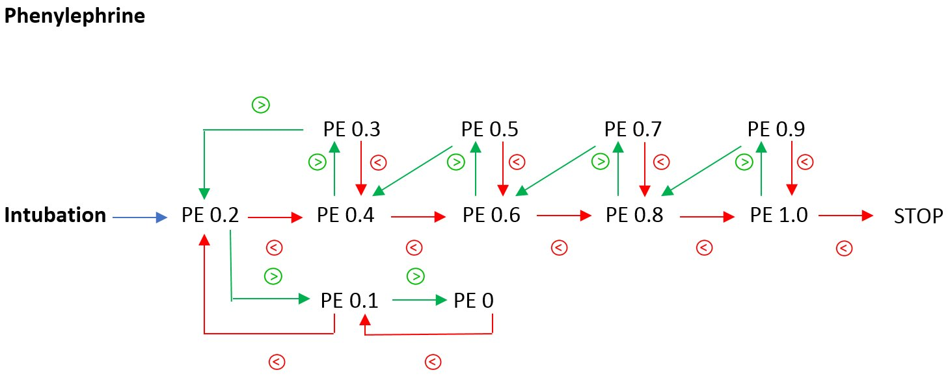

Phenylephrine represented in μg/kg/min.

: MAP > MAP_{baseline}
: MAP < MAP_{baseline}- 20%

- Dobutamine: 30 mg/50ml
Start 2 μg/kg/min; to be adjusted according to the patient’s hemodynamic status (Fig. 1)

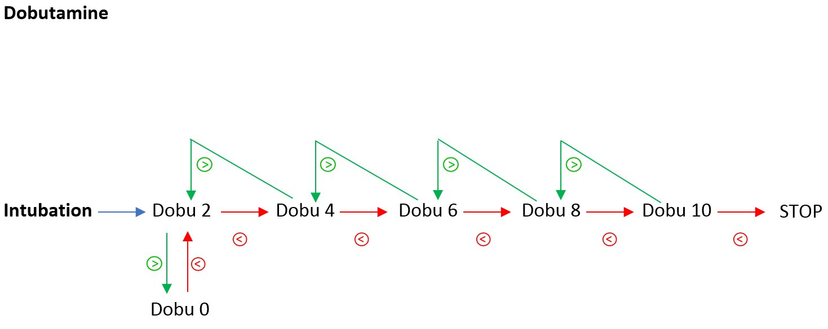

Dobutamine represented in μg/kg/min.

: MAP > MAP_{baseline}
: MAP < MAP_{baseline}- 20%

- End of study:

- after 30 minutes of continuous vasopressor administration.
- if MAP does not exceed MAP_{baseline} – 20% despite administration of 1 µg/kg/min phenylephrine or 10 μg/kg/min dobutamine (according to the randomization) during 4 minutes.

Routine hemodynamic management will be continued.

The total amount of administered medication will be registered.

The expected total duration of the trial is 30 months.

Randomisation / blinding

Only subjects who meet all of the inclusion criteria and none of the exclusion criteria are eligible for randomization into one of the two observational arms.

Eligible participants will be randomized in 2 groups using sealed envelopes:

- Group 1: Phenylephrine continuous infusion (max 30 minutes)
- Group 2: Dobutamine continuous infusion (max 30 minutes)
The sealed envelopes will be stored in a locked closet in the locked office of our study nurse.
The study nurse will be responsible for the randomization and the randomization list.
The persons responsible for the preparation of the syringes with the study medication will be Dr. Caroline Vanpeteghem, Dr. Jonas Delforche, Dr. Milan Besard and Dr. Martha Wolfskeil. The syringes will be prepared in the operating room at the beginning of the procedure, before the induction of anesthesia.
Since this is an open label study, participants will be informed before the start of the procedure about the observation arm they’re in.

Prior and concomitant therapy

Not relevant.

Adverse event reporting

List of abbreviations
AE Adverse Event
CA Competent Authority
EC Ethics Committee
SAE Serious Adverse Event
SSAR Suspected Serious Adverse Reaction
SUSAR Suspected Unexpected Serious Adverse Reaction

Adverse events (AE)
The following information will be recorded:
- nature of adverse event
- date and time of occurrence and disappearance
- intensity: mild, moderate or severe
- frequency: once, continuous or intermittent
- decision regarding study: continuation or withdrawal
- relation to the study medication (see below)

AE’s will be recorded from the first drug administration until 24 hours after last administration of study medication.
Special attention will be given to those subjects who have discontinued the trial for an AE, or who experienced a severe or a serious AE.

Definitions of Adverse Event (AE)
Any untoward medical occurrence in a patient or clinical investigation subject administered a pharmaceutical product and which does not necessarily have a causal relationship with this treatment. An adverse event (AE) can therefore be any unfavourable and unintended sign (including an abnormal finding), symptom, or disease temporally associated with the use of a medicinal (investigational) product, whether or not related to the medicinal (investigational) product.

Serious Adverse Event (SAE)
Any untoward medical occurrence that at any dose:
- results in death
- is life-threatening
- requires inpatient hospitalization or prolongation of existing hospitalization,
- results in persistent or significant disability/incapacity,
or
- is a congenital anomaly/birth defect.

Note: Medical and scientific judgment should be exercised in deciding whether expedited reporting is appropriate in other situations, such as important medical events that may not be immediately life-threatening or result in death or hospitalization but may jeopardize the subject or may require intervention to prevent one of the outcomes listed in the definition above.

Unexpected adverse event
An adverse event, the nature or severity of which is not consistent with the applicable product information (e.g., Investigator's Brochure for an unapproved investigational product or package insert/summary of product characteristics for an approved product).

Life-threatening
Any event in which the subject was at risk of death at the time of the event; it does not refer to an event which hypothetically might have caused death if it were more severe.

Associated with the use of the drug
An adverse event is considered associated with the use of the drug if the attribution is possible, probable or definitive.

Attribution definitions

Not related
An adverse event which is not related to the use of the drug.

Unlikely
An adverse event for which an alternative explanation is more likely - e.g. concomitant drug(s), concomitant disease(s), and/or the relationship in time suggests that a causal relationship is unlikely.

Possible
An adverse event which might be due to the use of the drug. An alternative explanation - e.g. concomitant drug(s), concomitant disease(s), - is inconclusive. The relationship in time is reasonable; therefore the causal relationship cannot be excluded.

Probable
An adverse event which might be due to the use of the drug. The relationship in time is suggestive (e.g. confirmed by dechallenge). An alternative explanation is less likely - e.g. concomitant drug(s), concomitant disease(s).

Definitely
An adverse event which is listed as a possible adverse reaction and cannot be reasonably explained by an alternative explanation - e.g. concomitant drug(s), concomitant disease(s). The relationship in time is very suggestive (e.g. it is confirmed by dechallenge and rechallenge).

Reporting of adverse events

Adverse events will be reported between the first dose administration of trial medication and 24 hours after last administration of trial medication.

(S)AE’s due to the surgical procedure will not be monitored. The following events will not be considered as AE/SAE and will therefore not be recorded : bleeding, vessel dissection, pseudoaneurysm, thrombosis.

The AEs and SAE’s will be recorded in the patient’s file and in the CRF. SAE’s will be reported as described below.

Medical events that occur between signing of the Informed Consent and the first intake of trial medication will be documented on the medical and surgical history section and concomitant diseases page of the CRF.
SAE’s occurring within a period of 24 hours following the last administration of trial medication will also be handled as such if spontaneously reported to the investigator.

All serious adverse events (SAE) and pregnancies occurring during clinical trials must be reported by the local Principal Investigator within 24 hours after becoming aware of the SAE to:
- The local EC
- Bimetra Clinics of the Ghent University Hospital

This reporting is done by using the appropriate SAE form. For the contact details, see below.

It is the responsibility of the local Principal Investigator to report the local SAE’s to the local EC.

In case the investigator decides the SAE is a SUSAR (Suspected Unexpected Serious Adverse Reaction), Bimetra Clinics will report the SUSAR to the Central EC and the CA within the timelines as defined in national legislation.

In case of a life-threatening SUSAR the entire reporting process must be completed within 7 calendar days. In case of a non-life threatening SUSAR the reporting process must completed within 15 calendar days.

The first report of a serious adverse event may be made by telephone, e-mail or facsimile (FAX).

Contact details of Bimetra Clinics:
e-mail: bimetra.clinics@uzgent.be
tel.: 09/332 05 00
fax: 09/332 05 20

The investigator must provide the minimal information: i.e. trial number, subject's initials and date of birth, medication code number, period of intake, nature of the adverse event and investigator's attribution.
This report of a serious adverse event by telephone must always be confirmed by a written, more detailed report. For this purpose, the appropriate SAE form will be used. Pregnancies occurring during clinical trials are considered immediately reportable events. They must be reported as soon as possible using the same SAE form. The outcome of the pregnancy must also be reported.

Annual Safety Reporting

Bimetra Clinics will ask the Principal Investigator for an annual report containing an overview of all SSARs (Suspected Serious Adverse Reaction) and a summary regarding the safety of the trial subjects. Bimetra Clinics will send this report to the Central EC and the CA within the timelines as defined in national legislation.

Study analysis

Sample size calculation

Sample size calculation was based on previous data from our study group. We observed a statistically significant difference in response between Phenylephrine and Ephedrine of 2%. To obtain the same difference in response between phenylephrine and dobutamine with standard deviation of 2% for a power of 0.8 and an p of 0.05, 17 patients in each observation arm were calculated to be necessary to address the experimental question. Drop outs will be replaced.

Analysis of the samples

Not applicable.

Statistical analysis

Data will be analyzed using a two-way analysis of variance for repeated measurements. Statistical significance will be accepted at p < 0.05.

Quality control and quality assurance

Monitoring of this study will be organized by Bimetra Clinics from the Ghent University Hospital. The nature and extent of the monitoring will be discussed in the monitoring plan.

Indemnity insurance

For this study, a ¨no fault¨ insurance will be taken by the Ghent University Hospital.

Publication policy

The results of the study will be presented at international anesthesiology and surgery congresses and submitted to international high level anesthesiology and vascular surgery journals.
Part II : General part of the protocol

Independent Ethics Committee (IEC) / Institutional Review Board (IRB)

This trial can only be undertaken after full approval of the protocol and addenda has been obtained from the IEC/IRB. This document must be dated and clearly identify the protocol, amendments (if any), the informed consent form and any applicable recruiting materials and subject compensation programs approved.
During the trial, the following documents will be sent to the IEC/IRB for their review:
- reports of adverse events that are serious, unexpected and associated with the investigational drug
- all protocol amendments and revised informed consent form (if any).
Amendments should not be implemented without prior review and documented approval / favorable opinion form the IEC/IRB except when necessary to eliminate an immediate hazard to trial subjects or when the change involves only logistical or administrative aspects of the trial.
Reports on, and reviews of the trial and its progress will be submitted to the IEC/IRB by the investigator at intervals stipulated in their guidelines.
At the end of the trial, the investigator will notify the IEC/IRB about the trial completion.

ICH/GCP guidelines

This trial will be conducted in accordance with the protocol, current ICH-GCP guidelines and applicable law(s).
Good Clinical Practice (GCP) is an international ethical and scientific quality standard for designing, conducting, recording and reporting trials that involve the participation of human subjects. Compliance with this standard provides public assurance that the rights, safety and well-being of trial subjects are protected, consistent with the principles that have their origin in the Declaration of Helsinki, and that the clinical trial data are credible.

Subject information and informed consent

Prior to entry in the trial, the investigator must explain to potential subjects or their legal representatives the trial and the implication of participation. Subjects will be informed that their participation is voluntary and that they may withdraw consent to participate at any time. Participating subjects will be told that their records may be accessed by competent authorities and by authorized persons without violating the confidentiality of the subject, to the extent permitted by the applicable law(s) and/or regulations. By signing the Informed Consent Form (ICF), the subjects or legally acceptable representatives are authorizing such access.
After this explanation and before entry to the trial, written, dated and signed informed consent should be obtained from the subject or legally acceptable representative. The ICF should be provided in a language sufficiently understood by the subject. Subjects must be given the opportunity to ask questions.
The subject or legally acceptable representative will be given sufficient time to read the ICF and to ask additional questions. After this explanation and before entry to the trial, consent should be appropriately recorded by means of either the subject's or his/her legal representative's dated signature or the signature of an independent witness who certifies the subject's consent in writing. After having obtained the consent, a copy of the ICF must be given to the subject.
In case the subject or legally acceptable representative is unable to read, an impartial witness must attest the informed consent.
Subjects who are unable to comprehend the information provided or pediatric subjects can only be enrolled after consent of a legally acceptable representative.
The following information should be added to the electronic patient dossier (EPD):
• which version of the ICF was obtained
• who signed the ICF
• if sufficient time has been given to consider participation into the trial
• which investigator obtained ICF with the date of signature
• if a copy was provided to the patient
• start and end of participation in the study

Case Report Forms

The source documents are to be completed at the time of the subject’s visit. The CRFs are to be completed within reasonable time after the subject’s visit.
The investigator must verify that all data entries in the CRFs are accurate and correct. If certain information is Not Done, Not Available or Not Applicable, the investigator must enter "N.D." or "N.AV." or "N.AP", respectively in the appropriate space.

Direct access to source data / documents

The investigator will permit trial-related monitoring, audits, IRB/IEC review, and regulatory inspection(s), providing direct access to source data/documents.

Data handling and record keeping

The investigator and sponsor specific essential documents will be retained for at least 20 years. At that moment, it will be judged whether it is necessary to retain them for a longer period, according to applicable regulatory or other requirement(s).

Signature page

Investigator:

Name: ________________________________________________

Title: ________________________________________________

Signature: ________________________________________________

Date: ________________________________________________

Investigator:

Name: ________________________________________________

Title: ________________________________________________

Signature: ________________________________________________

Date: ________________________________________________

