Synopsis
Name of product: RP-L201 (marnetegragene autotemcel)
Protocol identification number: RP-L201-0318, EudraCT no. 2020-000517-33
Title of study: Gene Therapy for Leukocyte Adhesion Deficiency-I (LAD-I): A Phase 1/2 Clinical Trial to Evaluate the Safety and Efficacy of the Infusion of Autologous Hematopoietic Stem Cells Transduced with a Lentiviral Vector Encoding the ITGB2 Gene.
Investigator(s):
Claire Booth, MBBS, PhD
Donald B. Kohn, MD.
Julián Sevilla Navarro, MD, PhD.
Study center(s):
University College London Great Ormond Street Institute of Child Health, London, UK.
University of California Los Angeles, CA, USA.
Hospital Infantil Universitario Niño Jesús, Madrid, Spain.
Publication (reference): None.
Study period:
Study initiation date: 27-Mar-2019 (first patient first visit)
Data cut-off date: 12-Sep-2023
Phase of development (phase of this clinical study): 1/2
Objectives: The purpose of this final clinical study report is to provide results of the study with a data cut-off date of 12-Sep-2023.
The primary objective(s) of the study were HSCT-free survival, determined by the proportion of subjects alive at least 1-year post-IP and alive at age 2 (24 months) without allogeneic HSCT for subjects less than 1 year of age at study enrollment, and characterization of the safety and toxicity associated with the IP.
The secondary objectives of the study included the assessment of OS, the reduction in the incidence of significant infections, infection-related hospitalizations and infection-related prolonged hospitalizations, the partial or complete resolution of LAD-I-related skin rash or periodontal abnormalities, percentage of subjects with genetic correction of peripheral blood (PB) cells as demonstrated by vector copy number (VCN) of at least 0.1 in PB mononuclear cells (PBMCs) and PB CD15+ granulocytes at 6 months, increases in CD18-expressing neutrophils ≥10%; the evaluation of decreases in LAD-I-associated neutrophilia and leukocytosis, and the assessment of EFS in the absence of graft failure and grade 2-4 acute GvHD.
Study design and methodology: This was an adaptive design, 2 phase, open label, single arm study using an infusion of RP-L201. The number of subjects planned was 9. In Phase 1 of the trial, 2 subjects were treated to determine the safety/AE profile associated with the IP treatment. Phase 2 of the trial was activated upon determination of an acceptable safety profile, and evidence of gene-correction and preliminary efficacy as determined by an increase in PB neutrophil CD18-expressing cells to at least 10% at 6 months after IP infusion in at least 1 subject and after hematopoietic reconstitution in the second subject. Seven additional subjects were to be enrolled in Phase 2 (to a total of 9 subjects). The planned duration of the study was 24 months post-infusion.
During all trial phases, IP infusion (and antecedent busulfan conditioning) was considered feasible if ≥ 2 ×10⁶ viable CD34+ cells/kg of body weight were available for infusion following transduction and cryopreservation and complied with specifications.
An overview of the study design is provided below:
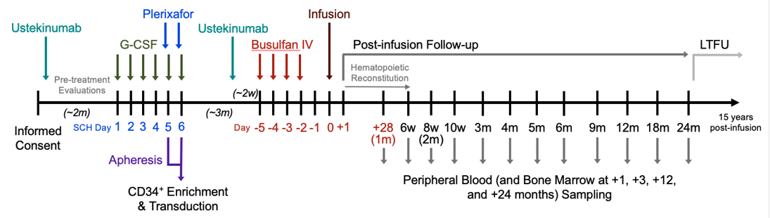
Diagnosis and main criteria for inclusion: The planned trial population was patients aged at least 3 months with a confirmed diagnosis of severe LAD-I and at least one prior significant bacterial or fungal infection, except for patients with documented ITGB2 mutation and clinical history consistent with LAD-I (or known family history). Patients for whom an HLA-identical sibling donor transplant was available were excluded.
Test and reference therapies, dose and mode of administration, batch number: The test therapy was RP-L201, an ex vivo LV gene therapy consisting of autologous hematopoietic stem cells transduced with an LV (Chim-CD18-WPRE LV) that encodes for the human ITGB2 gene, administered as an I.V. infusion after CD34+ cell mobilization, harvest via PB apheresis, cryopreservation of rescue cells, enrichment for pre-stimulation, transduction, and cryopreservation of IP, followed by busulfan conditioning, and thawing of the IP.
Protocol amendments and other changes to study conduct: The original study protocol was approved on 12-Jul-2018. This CSR describes the conduct of the study according to the final protocol version 3.0. The final protocol was dated 23-Feb-2023. Important changes from each amendment are summarized below.

Version  Approval Date | Description of Substantive Changes from Prior Version
Version 1.1  25-Sep-2018 | Protocol Version 1.1 modified the method by which CD34+ dose is calculated to be derived from Drug Product (as opposed to Drug Substance).
Version 1.2  06-Nov-2018 | Per FDA recommendation, stopping criteria were modified to remove attribution of causality due to possibility of bias.
Version 1.3  22-May-2019 | The cGMP facility for manufacturing of the IP was transitioned. The protocol was amended to reflect this change, including additional viral and microbial serology requirements.
Version 1.4  05-Aug-2019 | The protocol was modified to reflect changes to the administration of busulfan conditioning.
Version 1.5  19-Dec-2019 | The primary purpose of this amendment was to clarify the basis for activation of Phase 2 of the study.
Version 2.1  01-Apr-2020 | The primary purpose of this amendment was to reflect the addition of investigative sites in Spain and the UK for the Phase 2 portion of the study.
Version 2.2  02-Oct-2020 | This amendment revised the cumulative target AUC for busulfan from 65,000 ng/mL*hour to 75,000 ng/mL*hour.
Version 2.3  07-Jun-2021 | This amendment incorporated recommendations from this study’s Independent Data Monitoring Committee for additional assessments to monitor for pulmonary arterial hypertension and thrombotic microangiopathy.
Version 3.0  03-Feb-2023 | This amendment incorporated recommendations from the FDA on monitoring of Insertional mutation analysis (ISA) and clarified endpoints and the associated definitions. The modifications did not substantively modify the efficacy and safety objectives and endpoints.
Changes in Planned Analysis
As of the finalization of the CSR, there was one SAP amendment. SAP Version 2.0 updated the section on neutrophil CD18 expression to remove the use of level data for the analysis of CD18 and added AE tables to display relationship to IP and pre-infusion procedures and treatments. There were no other changes to the planned analyses as outlined in the SAP.
Criteria for evaluation:
Efficacy: The primary efficacy endpoint was survival, defined as the proportion of patients alive at least 1-year post-IP infusion without allogeneic HSCT and at age 2 without allogeneic HSCT for patients less than 1 year of age at study enrollment.
Secondary efficacy endpoints were:
• Statistically significant reduction in 1) the incidence of significant infections, defined as requiring hospitalization or parenteral antimicrobials, 2) of infection-related hospitalizations, and 3) of prolonged infection-related hospitalizations (≥7 days), analyzed per patient and across the entire cohort, comparing event rates pre-infusion to those following hematologic reconstitution.
• EFS without graft failure and without aGvHD grade 2 to 4.
• Chim-CD18-WPRE LV VCN in blood and BM cells, as determined via quantitative Polymerase Chain Reaction (PCR) or digital droplet PCR at specified time points pre- and post-infusion, including assessment of the percentage of patients with PBMC and PB CD15+ cell VCN of at least 0.1.
- Change in the CD18 expression from pre- to post-infusion (and increased expression of additional β-2 integrin components CD11a and CD11b) in PB neutrophils, as determined by flow cytometry, including assessment of the percentage of patients with CD18 expression on at least 10% of neutrophils.
• Decrease (from pre-infusion) of LAD-I-associated neutrophilia and leukocytosis.
• Resolution (partial or complete) of any underlying LAD-I-related skin rash or periodontal abnormalities as determined by the treating Investigator. Lesions were to be graded based on interval changes from baseline to show worsening, no change, partial improvement, or resolution of lesions.
Safety: Safety in this study included AEs and SAEs. Safety assessments germane to gene therapy are:
• Insertional mutagenesis by evaluation of gene modified clonal repertoire and lentiviral ISA in blood.
• RCL in blood.
• Immunogenicity by evidence of antibodies against CD18 (or other β2-integrin components CD11a or CD11b, or LV components) in blood.
• Incidence of respiratory complications (including, but not limited to, pneumonitis).
• Incidence of hepatic complications (including, but not limited to, VOD).
Safety assessments relevant to LAD-I patients included assessments for the development of bacterial, fungal, and viral infections.
Statistical methods: The frequency of qualitative endpoints is described by the cumulative incidence and its 95% confidence interval. Due to the small sample size, the exact confidence interval based on binomial distribution was calculated. The Kaplan-Meier survivor function and the Nelson-Aalen cumulative hazard function were estimated for those endpoints for which the time to event occurrence was recorded. Descriptive statistics (mean, median, standard deviation, quartiles, minimum and maximum) are presented for the values of quantitative endpoints and their absolute and relative changes from baseline at scheduled visits. The 95% confidence intervals are presented for both mean and median values.
Summary - Results
Demographic and background characteristics: Of 9 total subjects, there were 5 male, and 4 female subjects enrolled in the study. 7 subjects were <48 months of age at screening, including 3 subjects under 12 months of age. The median age at screening was 36.0 months and at infusion was 42 months. Most subjects were from the United States.
Protocol deviations: Major protocol deviations were observed during the study; all but one were due to lack of reconsenting with latest ICF version prior to a visit. None of the protocol deviations impacted the data collected from the patients or their analysis.
Exposure: All 9 subjects in the ITT population received the IP; the median cell dose was 4.3 x 10⁶ CD34+cells/kg (range: 2.8 x 10⁶ CD34+cells/kg – 10.0 x 10⁶ CD34+cells/kg).
Compliance: One of 9 treated subjects received IP that had been collected via two separate apheresis sequences and was administered sequentially, with a 73-minute observation period between infusions, as per protocol which stipulated a 60-minute minimum observation period between sequences.
Efficacy results: In study RP-L201-0318, all 9 subjects received treatment with RP-L201 (median CD34+ cell dose = 4.3 ×10⁶ cells/kg; median VCN in IP Liquid Culture = 3.46). The subject demographic information provided in the study is consistent with the defined population. The study met its primary endpoint of survival at least 1-year post-infusion of IP without allogeneic HSCT and at age 2 years without allogeneic HSCT for subjects less than 12 months of age at enrollment with a statistically significant p-value at 1 year of 0.0002 (vs. anticipated transplant-free survival of 39%). No treated subject died or required allogeneic HSCT during the study. The transplant-free survival probability at every timepoint was therefore 1.0000.
HSCT-Free Survival Kaplan-Meier Curve (PPT Population)
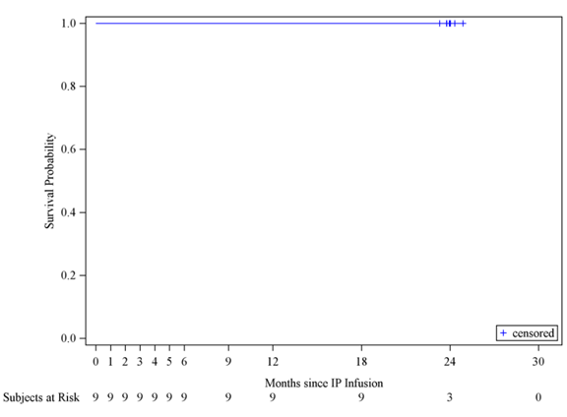
Abbreviations: HSCT=hematopoietic stem cell transplant; IP=investigational product; PPT=per protocol treated.
Source: Figure 16.2.1.1
The study met the secondary endpoint of EFS without any incidences of GF or aGvHD grade 2 to 4 in all 9 subjects. At the end of the study, there have been no events of GF or GvHD, acute or chronic. An EFS and an OS of 100% were reported, indicating the favorable tolerability of the IP.
Annualized event rates for significant infections, infection-related hospitalization, and prolonged infection-related hospitalization showed statistically significant decreases in annualized event rates relative to those pre-infusion, indicating a clinical benefit that is substantial and highly unlikely to have resulted from extrinsic factors.
In all subjects who have received IP to date, Chim-CD18-WPRE LV effectively transduced autologous CD34+ enriched cells, which when infused into these subjects has led to an improvement in hematopoietic cell integrin expression and function:
- Sustained genetic cell correction in PBMCs and CD15+ cells (VCN) were observed in all subjects.
- As a result, neutrophil CD18 expression has been stable and significantly exceeded target threshold levels in all subjects with 24-month post-infusion follow-up.
- Circulating levels of neutrophils and WBCs decreased to age-appropriate (normal) ranges in most subjects (8/9) after IP-mediated restoration of functional CD18 on leukocyte surfaces.
Taken together, these efficacy parameters strongly suggest that RP-L201 provides durable and clinically transformative benefit to a study population (ages at treatment 3 months to 9 years, median 36 months) facing a disorder that is fatal in childhood and for which the only viable therapeutic option has been allogeneic HSCT.
Safety results: RP-L201 is associated with a highly favorable safety profile, particularly in the context of the uniform childhood mortality in the absence of allogeneic HSCT, and the extensive morbidity of SoC treatment (allogeneic HSCT) when available for this life-threatening disease. No treatment-related AEs were reported. AEs related to other study procedures (such as busulfan conditioning) have been consistent with the expected safety profiles of those agents and procedures. SAEs observed post-treatment were infrequent and unrelated to any study treatment.
No deaths, GvHD, graft failures, IP-related SAEs, or treatment discontinuations were reported. The observed AEs were manageable and tolerable. The incidence of both SAEs and severe AEs (Grade ≥3) declined after engraftment. These TEAEs were largely hematologic in nature, which is expected in the context of myeloablative busulfan conditioning, and most included anemia, thrombocytopenia, neutropenia, and WBC count decreased. Beginning 91 days post-engraftment to end of study, there were few new AEs and no Grade 4 events. None of these AEs were assessed as related to RP-L201 by the investigator. Most infections observed after immune reconstitution did not require hospitalization or I.V. antimicrobials; most were common childhood infections which are expected in a pediatric subject population. The total number of subjects with any infection or any severe/significant infection was similar in the pre- and post-infusion periods. However, the absolute number of events was notably lower in the post-infusion period which suggests that the frequency of severe or significant infection (and serious infection) for any given subject decreased following treatment.
RCL testing from all 9 subjects was negative on at least 3 consecutive measures post-infusion up to 12 months. Concomitantly, sequential ISA has demonstrated highly polyclonal lentiviral integration patterns without evidence of clonal dominance or dominant integrations in proximity to oncogenic loci across the entire cohort.
Conclusions: Study RP-L201-0318 met its primary and secondary endpoints, demonstrating clinical benefit with all subjects alive and without allogeneic HSCT at data cut-off, no events of graft failure or GvHD and a marked post-treatment reduction in significant infections, infection-related hospitalizations, and prolonged infection-related hospitalizations. In addition, all subjects had evidence of genotypic and phenotypic correction with sustained PBMC VCN levels above 0.1 and neutrophil CD18 expression above 10%, with concomitant restored CD11a/CD11b expression. All evaluable parameters of efficacy indicate resolution of the severe LAD-I phenotype at genetic, molecular, cellular and clinical levels. In addition, Study RP-L201-0318 demonstrated a favorable RP-L201 tolerability profile in subjects with severe LAD-I, a rare primary immunodeficiency causing near-universal pediatric mortality. The transformative therapeutic effect of RP-L201 favorably and comprehensively impacts survival and the quality of life of subjects, who can participate in age-appropriate normal educational and recreational activities despite extensive pre-study restrictions; there is concomitant substantive improvement in their caregivers’ and parents’ ability to pursue unrestricted family- and work-related endeavors.

