Table 7 Subject Disposition Numbers for Patients with 5 Day Follow-Up, Deceased and/or Discharged within 5 Days for A. the Total Study Population and B. for both Treatment Arms.
A.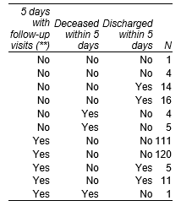 B.

