Table 23 Descriptives Maximal SOFA Score A. for the FAS, B. for the PPS and C for Both Treatment Arms
A. 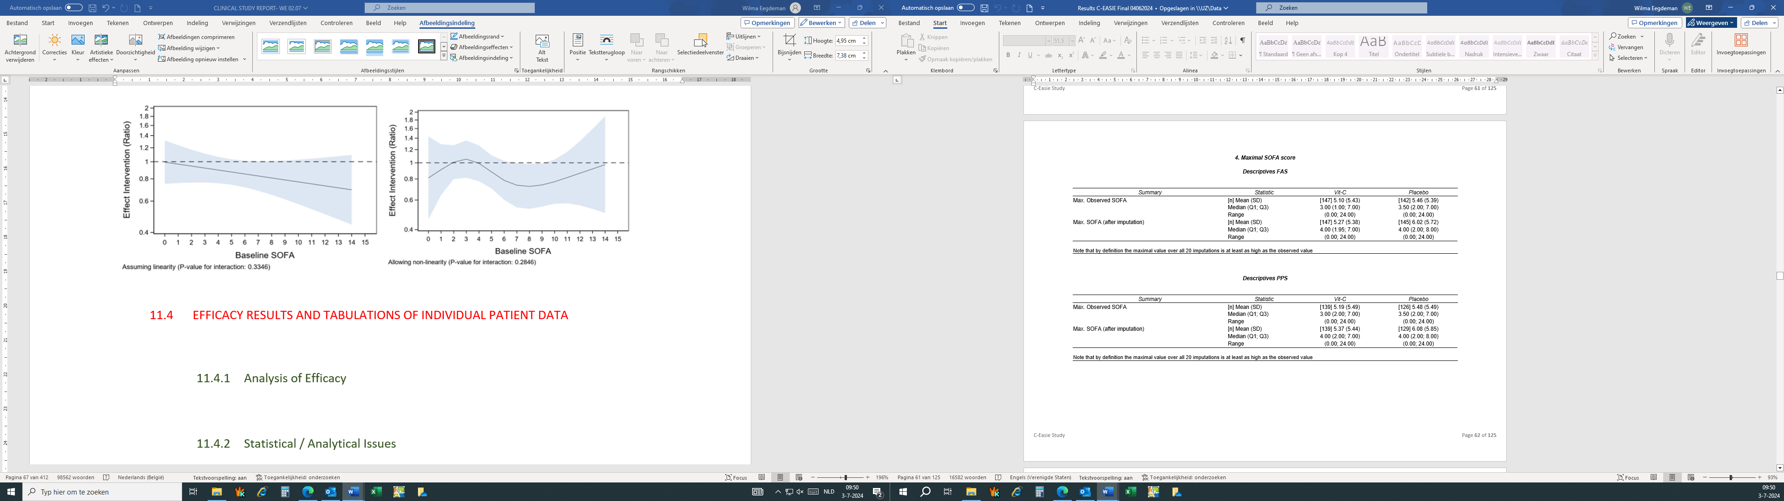
B.
C.

