Table 24 28d Mortality Descriptives FAS
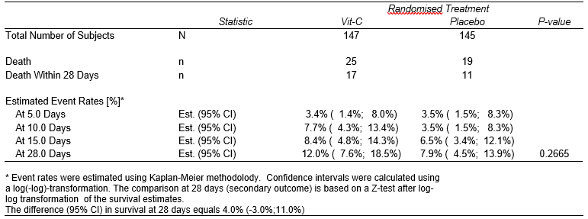
An effect size has been added in the table, i.e. the difference in percentage survival at 28 days with a 95% confidence interval.

