Table 26 Length of Hospital Stay Descriptives FAS
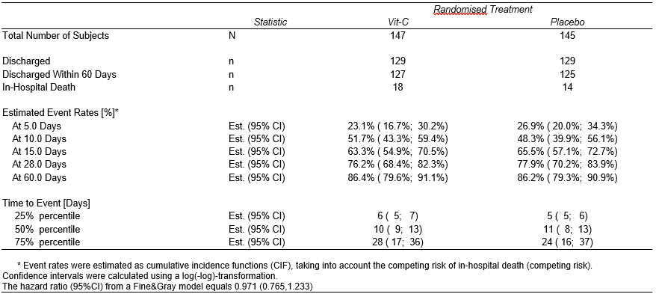
An effect size has been added in the legend of the table, i.e. the hazard ratio from a Fine&Gray model with a 95% confidence interval.

