Table 27 Length of Hospital Stay Descriptives PPS
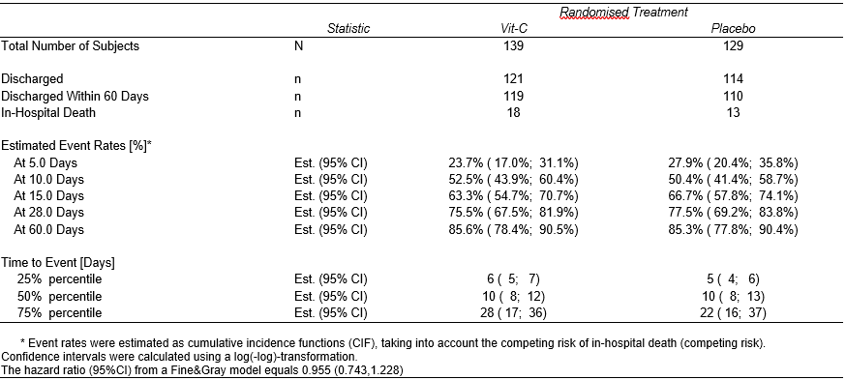
An effect size has been added to the legend of the table, i.e. the hazard ratio from a Fine&Gray model with a confidence interval.

