Table 28 Length of ICU Stay FAS A. for Discharged Alive from ICU and B. for Died in ICU
A. 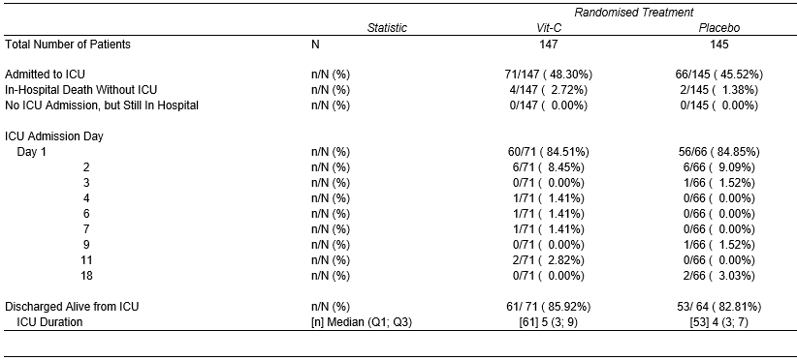
B. 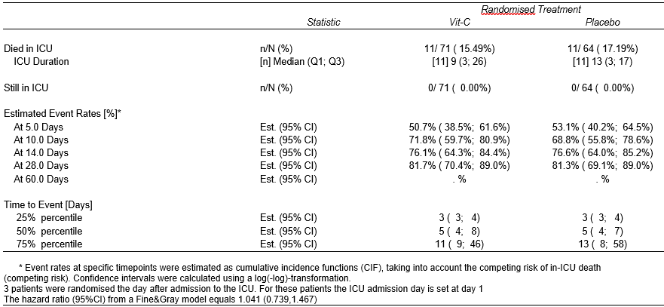
An effect size has been added in the legend of the table, i.e. the hazard ratio from a Fine&Gray model with a 95% confidence f interval.

