Table 29 Length of ICU Stay PPS A. for Discharged Alive from ICU and B. for Died in ICU
A.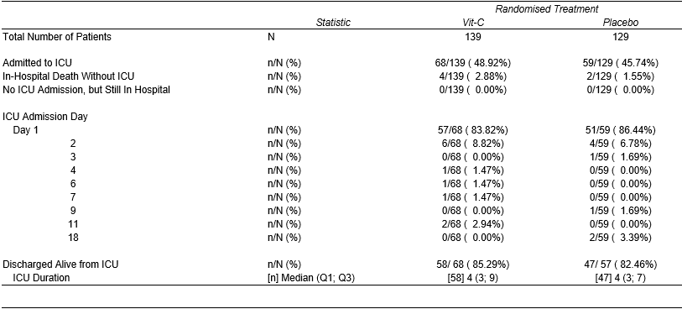
B.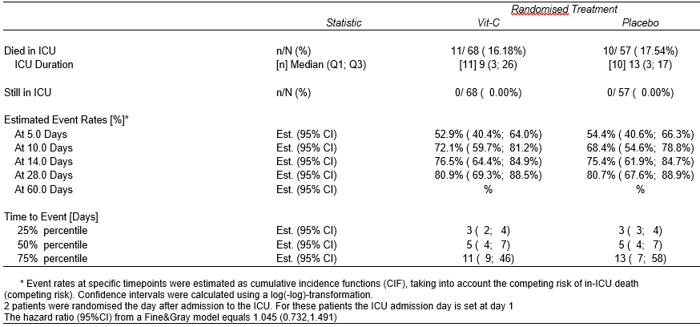
An effect size has been added in the legend of the table, i.e. the hazard ratio from a Fine&Gray model with a 95% confidence f interval.

