Table 33 Vasopressor Requirement PPS
A. for the Dose of Vasoactive Agent,
B. the Probability of Receiving Vaso-Active Agents,
C. the Probability of Receiving at Least Dopamine >5, Epinephrine = 0.1 or Norepinephrine = 0.1 and
D. the Probability of Receiving Dopamine >15, Epinephrine >0.1 or Norepinephrine >0.1
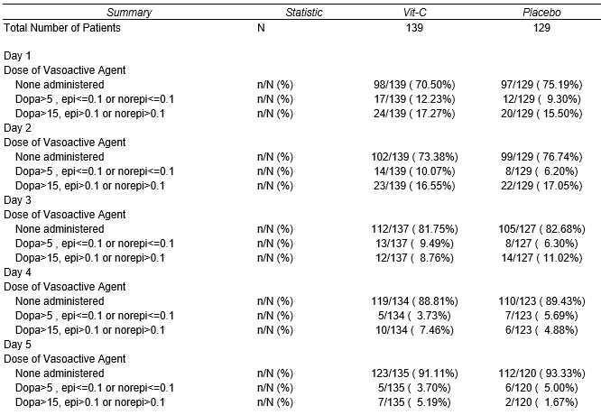
A.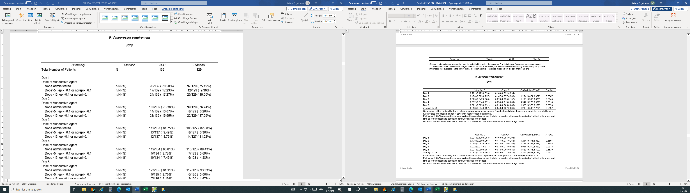
B.
C.
D. 

