Table 34 Renal Replacement Therapy PPS A. for Observed Information and B. for Predicted Probability
A. 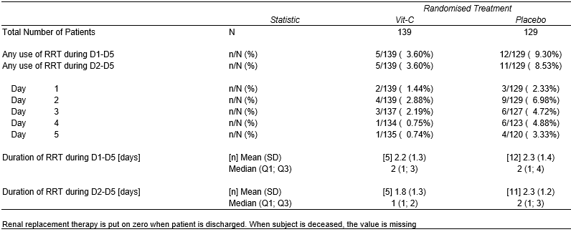
B. 

