Table 35 Need of Steroids FAS A. for Observed Information and B. for Predicted Probability
A. 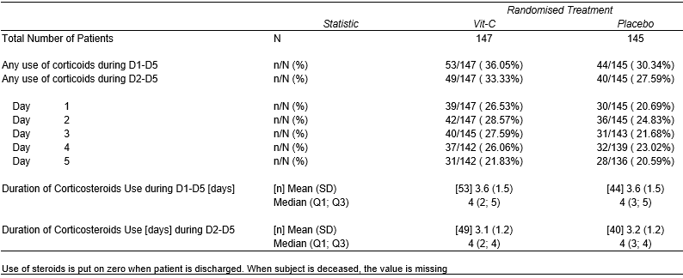
B. 

