Table 36 Need of Steroids PPS A. for Observed Information and B. for Predicted Probability
A. 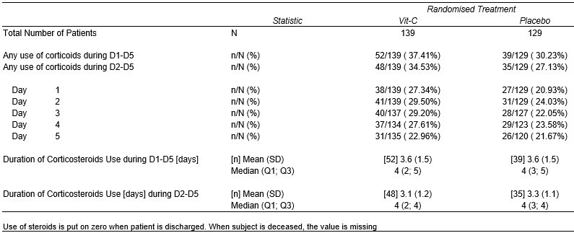
B. 

