Table 37 Dose of Steroids FAS
A. Including Patients Without Steroids,
B. Excluding Patients Without Steroids,
C. Estimates of Steroid Dose
A. 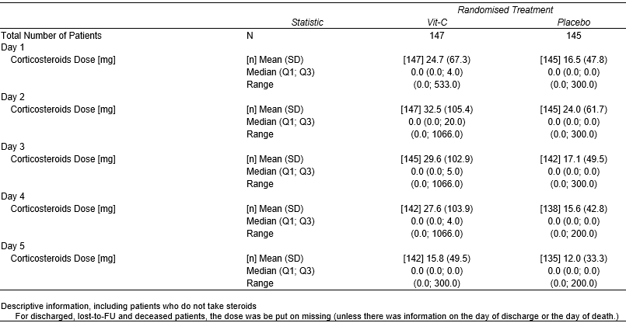
B. 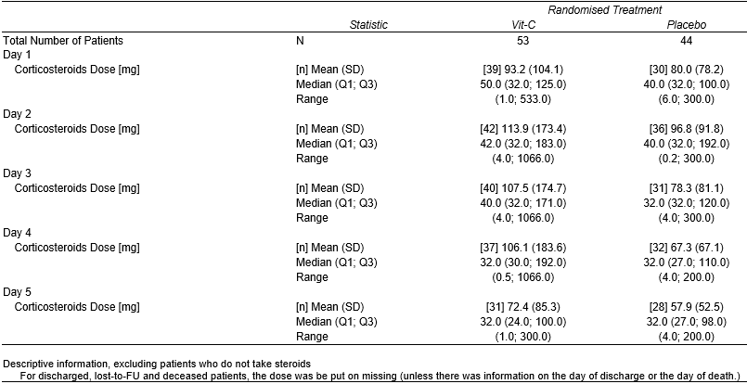
C. 

