Table 38 Dose of Steroids PPS
A. Including Patients without Steroids,
B. Excluding Patients without Steroids,
C. Estimates of Steroid Dose
A. 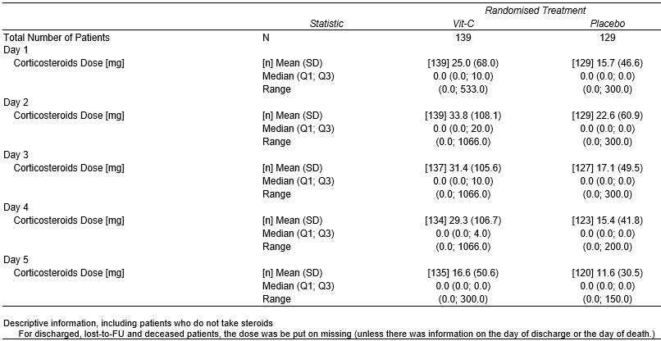
B. 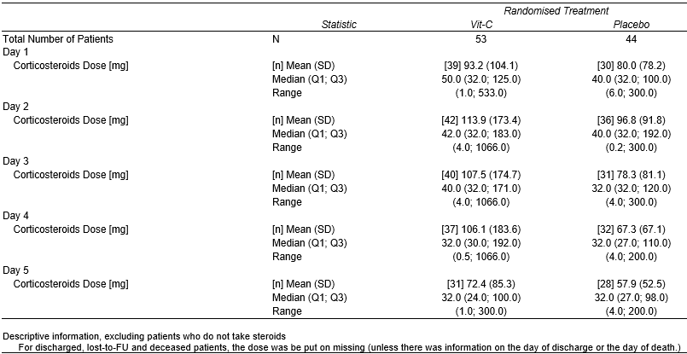
C. 

