Table 39 IV Fluid Balance FAS A. Descriptive Information and B. Estimates of Mean Fluid Balance
A. 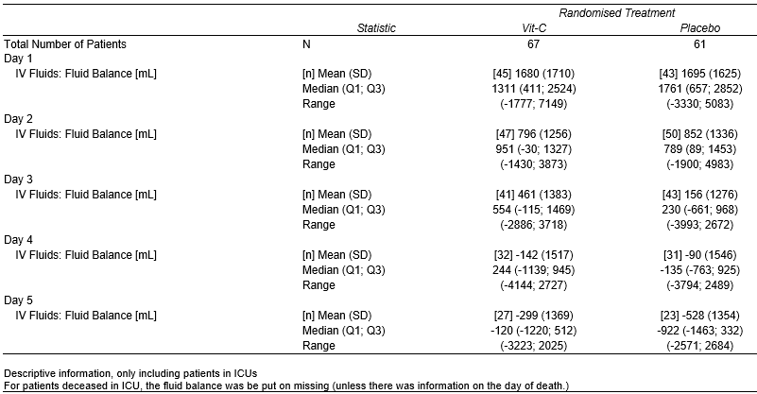
B. 

