Table 40 IV Fluid Balance PPS A. Descriptive Information and B. Estimates of Mean Fluid Balance
A. 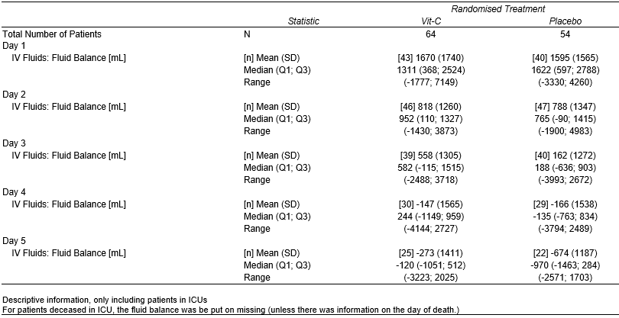
B. 

