Table 41 EQ Index FAS A. Calculated and B. Estimates of Mean
A. 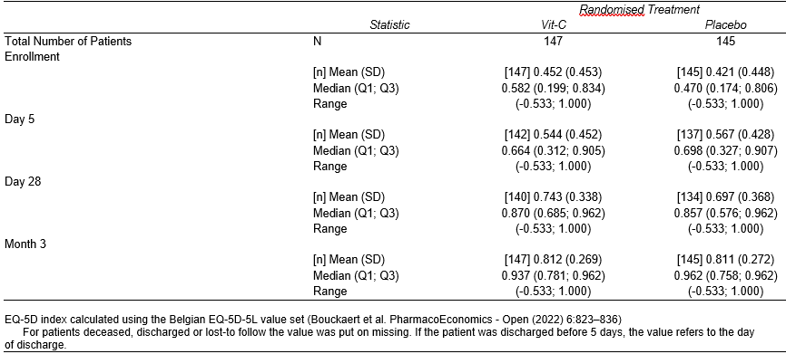
B. 

