Table 42 EQ-VAS FAS A. Descriptives and B. Estimates of Mean
A. 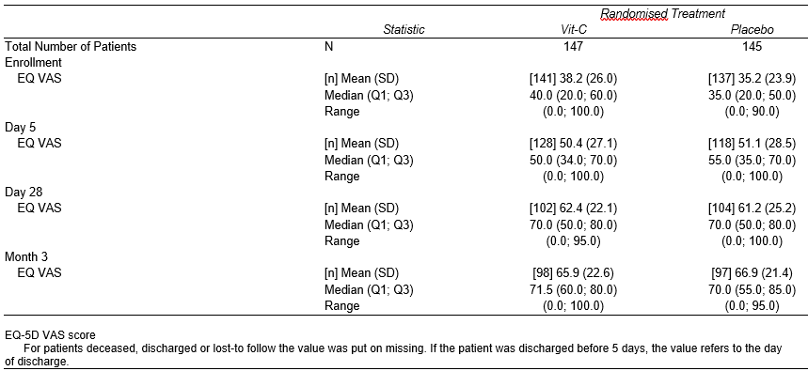
B. 

