Table 43 EQ Index PPS A. Calculated and B. Estimates of Mean
A. 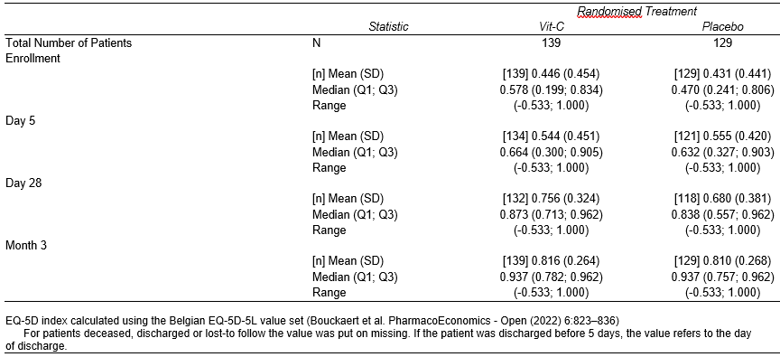
B. 

