Table 44 EQ-VAS PPS A. Descriptives and B. Estimates of Mean
A. 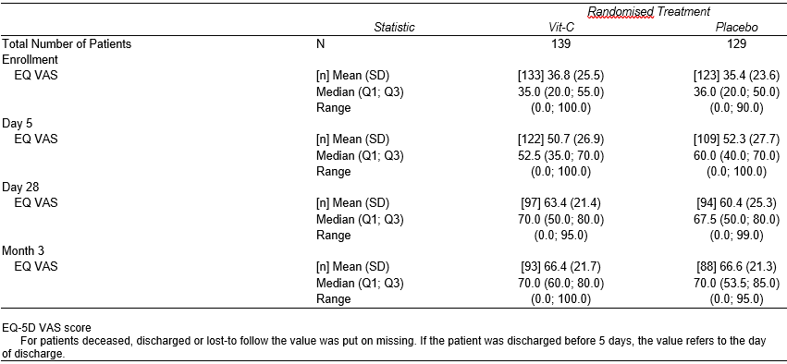
B. 

