Intralymphatic immunotherapy is effective with allergen extract containing 60 ng of phl p5
Reducing the amount of allergen injected during intralymphatic immunotherapy.

Bjarke Hviid-Vyff¹, Johannes Schmid¹, Søren Helbo Skaarup¹, Hans Jürgen Hoffmann^{1,2}

- Department of Clinical Medicine, Aarhus University, Denmark
- AITSU ApS, Aarhus, Denmark

Introduction
Allergic rhinoconjunctivitis (ARC) is a frequent worldwide disease affecting both young and old [1-3]. Despite access to symptom-relieving medications, many patients experience refractory symptoms that negatively impact quality of life [3-5]. Allergen-specific immunotherapy (AIT) is the only current option for long-term disease modification [3]. However, the available options for AIT are burdened by extended treatment regimens, side effects, and consequently low adherence [6, 7]. Recently, intralymphatic immunotherapy (ILIT) has shown promise as a more practical alternative [8-13]. Grass pollen has been a common target; however, a dose equivalent to 1000 SQU of ALK Alutard® corresponding to 1 % of the maintenance dose for subcutaneous immunotherapy (SCIT) has been mostly consistent [10, 12]. Higher doses have been tested accidentally or intentionally but have not proven safe or more effective than a lower dose [9, 14]. Many immunological responses follow a bell-shaped curve [15] and others follow a more linear response. With available data on doses higher than 1000 SQU, it seems unlikely this dose escalation is beneficial. However, this leaves the question, of whether a lower dose is even more potent at reducing allergy symptoms (Figure 1). To this day we’ve found no published studies testing doses significantly below 1000 SQU. However, because allergen manufacturers use in-house units; direct comparison between different allergen products is complicated. European regulatory authorities and allergen manufacturers are currently working on standardizing measurement and units for allergen immunotherapy products. The content of major allergen Phleum pratense 5 (Phl p 5) is promising as a standard measurement for grass pollen allergen products [16, 17]. By this standard, 1000 SQU ALK Alutard corresponds to 200 ng Phl p5.
This study tests two very low doses of allergen; 20 ng Phl p 5 and 60 Phl p 5 for ILIT for grass pollen allergy.
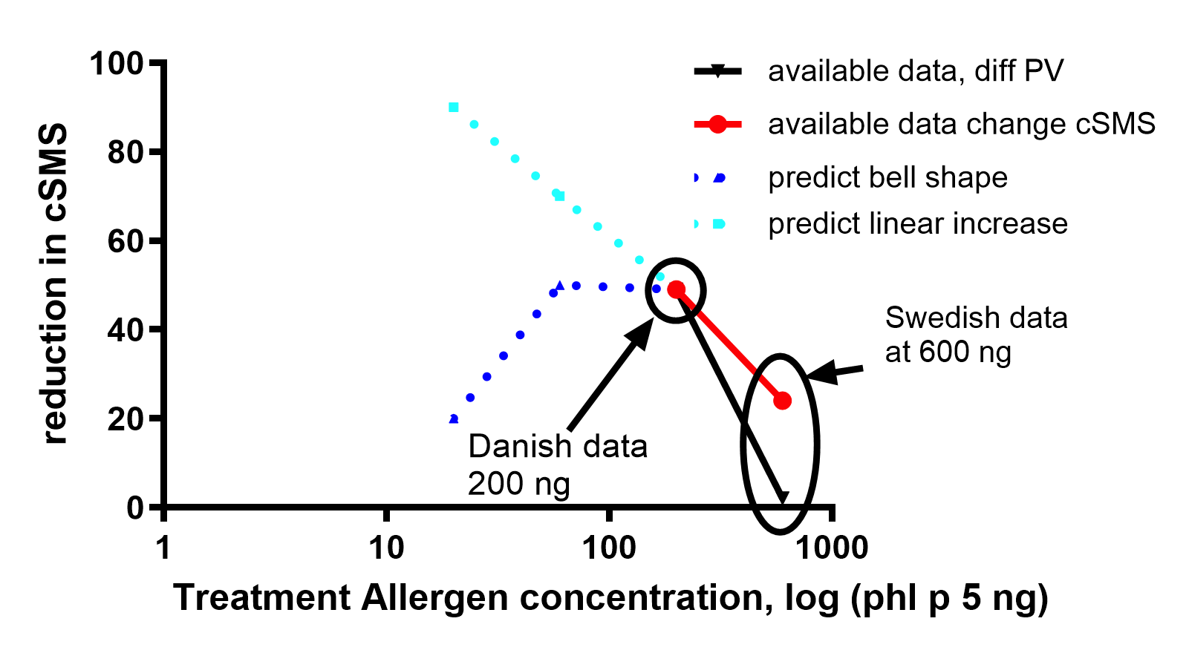
Figure 1: Proposed dose-response curves extrapolated from Danish and Swedish trial data with similar trial design.

Abbreviations

Methods

Trial design
The trial was designed as a double-blind randomized clinical trial with 1:1 allocation to one of two ILIT treatment doses. Participants in a larger concurrent trial (ILIT.NU - EudraCT 2020-001060-28) served as an untreated control group. This study was approved by Danish ethics and medical agencies, and the European Medical Agency (EudraCT Number: 2020-005823-35).

Participants
Participants were made aware of the study on the Facebook pages of Central Denmark Region and Aarhus University Hospital among others, and by physical fliers at Aarhus University Hospital.
Individuals interested in participation signed up on the ILIT.NU website, which served as a prescreening tool. Only candidates who passed the prescreening were invited to a physical screening visit, where eligibility was assessed, and baseline measurements were collected. Participants who passed the online screening but who were not invited to physical screening for this trial continued unchanged for potential recruitment into the larger ILIT.NU trial. The control group consisted of 20 consecutive participants in the ILIT.NU trial that agreed to serve as controls.

Inclusion and exclusion criteria
Inclusion criteria: Adults aged 18 years or older, a prescreening retrospective Rhinoconjunctivitis Total Symptom Score (RTSS) of 8 or higher (0-18) and allergic sensitization to grass pollen, largest diameter > 3 mm (Soluprick®, ALK-Abelló) at the inclusion visit.
Exclusion criteria: Previous allergen immunotherapy; sensitization and significant symptoms due to mugwort (Artemisia vulgaris) or pet allergies with persistent exposure; pregnancy at the time of treatments; uncontrolled asthma (Asthma Control Test (ACT) < 19) or high-dose inhaled corticosteroid treatment for asthma (> 800 µg budesonide or equivalent); planned steroid injections for allergy; among others.
A more complete list of inclusion and exclusion criteria can be seen in the supplementary material.

Randomization, data collection, and double blinding
Data collection and randomization were done using Research Electronic Data Capture (REDCap) [18, 19].
Participants were stratified into four strata based on previous symptom burden according to retrospective rhinoconjunctivitis total symptoms score (RTSS) threshold of > 15 and skin prick test reactivity based on the maximal grass pollen wheal diameter threshold of > 10 mm. All four strata were randomized 1:1 to 60 ng or 20 ng treatment.
Participants, nurse, and physicians were blinded to the dose prepared by lab personnel and labeled with unique participant and treatment identifiers.

Study drug and dose
The study drug and doses were 20 ng Phl p5 (0.1% of the SCIT maintenance dose) and 60 Phl p 5 (0.3 % of the SCIT maintenance dose) ALK 225 Phleum Pratense, Alutard (ALK-Abelló, Hoersholm, Denmark). The doses were selected to explore the dose-response curve at doses below 200 ng phl. Extrapolating from published Danish[8] and Swedish data[14], a dose reduction could potentially yield a better clinical response to treatment, and will potentially further improve safety. At a 10-fold dilution, it is likely to see a change in response (Figure 1). Doses were diluted to 20 ng or 60 ng / 0.1 mL for practical administration.

Drug delivery
Intralymphatic immunotherapy was guided using a General Electric LogiQ S8 ultrasound device (GE Healthcare, Chicago, Ill) with a high-frequency linear transducer. The injection was done free-hand with a 23G needle attached to a 1 ml syringe. The procedure was done according to what has been recently described [20].

Quality assurance
Due to the low dose and the number of injections, it is expected that successfully hitting the lymph nodes with each injection is of great importance. Indeed, a strong association has been reported between the number of successful injections and the effect of the treatment [9]. To evaluate each injection outcome, a video of each treatment was recorded for later evaluation. All videos were evaluated according to a previously proposed five-point scale (1 - 5) [8]. However, for the primary outcome of this study, the five-point scale was condensed to a binary scale. The scores 4 and 5 corresponding to successful intranodal injection were considered injection success and <4 considered injection failure. Evaluation of all videos was done by a single physician (BHV) before unblinding.

Endpoints
The primary endpoint was a reduction in the EAACI-endorsed Combined Symptom and Medication Score (CSMS)[21] compared to the untreated control group. Data was collected from May 8 until August 15 corresponding to the expected Danish grass pollen season with a safety margin. Participants received a daily text message on their cell phone containing a hyperlink to an individual and unique REDCap questionnaire.
Secondary endpoints
To support the daily CSMS scoring and to include a quality of life assessment, a more extensive Rhinoconjunctivitis Quality of Life Questionnaire was employed [22, 23]. Questionnaire delivery was once a week but otherwise like that of the CSMS questionnaires.
Other paraclinical outcome measurements were potential differences in airway measurements; spirometry and airwave oscillometry (AOS) were collected at inclusion (baseline), during the pollen season (summer), and at the final visit (winter). A standardized SPT panel was done at the inclusion and final visit for the treatment groups. Only a baseline SPT panel was available for the control group.
Safety
All patients were pre-treated with 1 tablet antihistamine (10 mg cetirizine or 5 mg desloratadine) 30 minutes before treatment.
The best of three peak expiratory flow rate (PEFR) measurements was recorded just before each ILIT treatment, and 40 minutes after treatment to monitor for a potential drop.
At 40 minutes, participants received an electronic questionnaire regarding local or and systemic side effects; erythema and swelling, chest tightness, and urticaria. All symptoms were graded if present on a three-point scale from mild 1 to severe 3. A nurse subsequently interviewed the participants. Additionally, participants completed questionnaires after they left the clinic; later the same day (day 0), as well as the three days following treatment (day 1, day 2, and day 3). The online questionnaires were supplemented with questions regarding more unspecific symptoms; fatigue, and difficulties in concentrating.

Data analysis
Data analysis was performed in R statistical software (version 4.3.3; R Core Team 2024). Analyses on primary outcome and secondary effect parameters were performed per protocol, adjusting for successful injections, that is, only participants receiving three successful injections were included. Additionally, for CSMS only data from individuals reporting at least 60 % of the season was included. For CSMS, because many participants in the treatment groups had identical median CSMS scores, including 0, statistical testing for differences in group medians was impractical. Daily CSMS means were grouped by treatment group. For total season means, each participant’s mean was determined, and then a group mean of means was produced.
Safety data was analyzed as intention-to-treat analysis, but a potential correlation between injection outcome and side effects was investigated. Previously, no correlation between injection outcome and side effects has been shown [9].
Estimates are represented as group means with the corresponding 95% CI – mean (lower – upper), or as group medians with the corresponding 25 % and 75% percentiles – median (Q1 – Q3). Group comparisons for CSMS were done pairwise with the T-test, the rest were done with the Wilcoxon rank sum test when comparing two groups and Kruskal-Wallis rank sum test when comparing across all three groups.
According to available pollen counts of the Danish grass pollen season of 2021; data reported outside the EAACI-defined grass pollen season or peak pollen season [24], was not included in analyses. Pollen counts were provided by the patient interest organization Astma - Allergi Danmark (Asthma – Allergy Denmark).

Results
As planned a total of 40 participants were recruited. All participants remained in the study until the end of the study. 20 random controls from the main study were selected. Demographic information and patient flow can be seen in Figure 1 and Table 1.
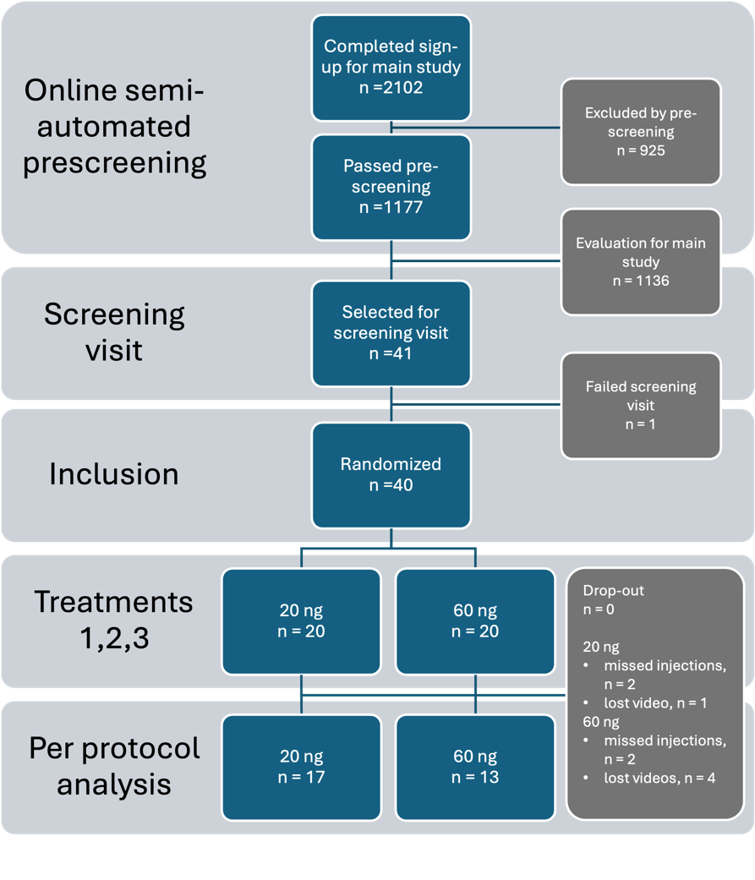
Figure 2: Consort statement.

 | Control, N = 20¹ | 20 ng, N = 20¹ | 60 ng, N = 20¹
Age | 27 (24, 40) | 29 (26, 34) | 29 (23, 34)
Female | 9 (45%) | 10 (50%) | 8 (40%)
Retrospective RTSS | 14.00 (13.00, 15.00) | 15.50 (13.00, 18.00) | 15.50 (14.00, 17.00)
Current smoker | 3 (15%) | 1 (5.0%) | 2 (10%)
FEV1 % predicted | 105 (101, 114) | 103 (96, 112) | 101 (94, 110)
FEV1/FVC ratio | 0.81 (0.80, 0.88) | 0.83 (0.79, 0.87) | 0.83 (0.78, 0.86)
Grass wheal size | 9.25 (8.06, 10.75) | 7.44 (5.13, 9.72) | 7.38 (6.53, 8.44)
¹Median (IQR); n (%)

Table 1: Demography of the two treatment groups and the control group.

Pollen season
The Danish pollen season of 2021 began on May 24 and lasted until August 1 (Figure 4). The peak pollen season began on June 14 and lasted until July 1.

Injection outcome
Across 120 injections, only five (4.2%) videos documented injection failure. However, six (5%) videos were lost or too low quality to confidently judge the injection outcome.
Consequently, in the 20 ng group, 17 received three documented and successful injections. One had two successful injections and one injection with an unknown outcome.
Two participants had two documented successful injections and one documented failure.
In the 60 ng group, 13 received three documented and successful injections. Four received two successful injections and one injection of unknown outcome. Two participants received two successful injections and one failed injection. One participant received one successful injection, one missed injection, and one of unknown outcome (see Figure 2).
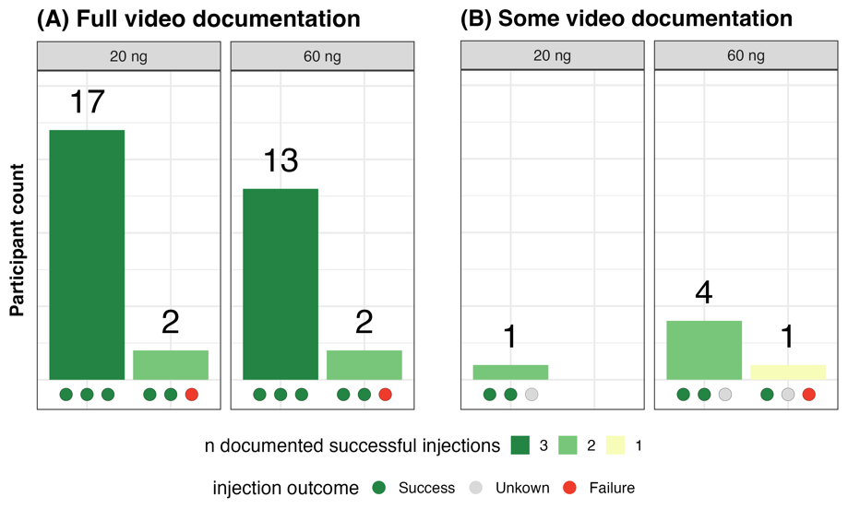
Figure 3: Illustration of how the 40 participants are distributed according to injection success and available video documentation.

CSMS
The group mean CSMS for the grass pollen season in 2021 was 2.01 (1.72 – 2.31) in the untreated control group. Treatment groups were significantly different from the untreated population but not from each other. In the 20 ng group, the mean CSMS was 1.12 (0.79 – 1.45), and in the 60 ng group, the median CSMS was 0.95 (0.61 – 1.29).
In the peak pollen season [24], the untreated control group had a mean CSMS of 2.62 (2.31 – 2.93), the 20 ng group had a mean CSMS of 1.83 (1.37 – 2.29), and the 60 ng group had a mean CSMS of 1.80 (1.20 – 2.39). Treatment groups were significantly lower, but again not from each other, both mean CSMS measures trended lower for the 60 ng group. (Figure 3, Table 2, and Table 3)

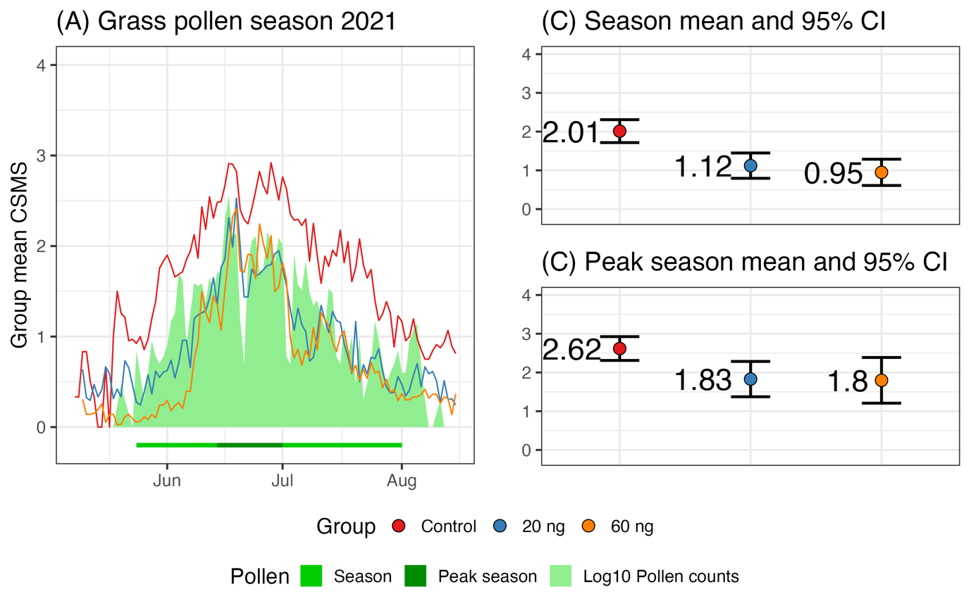
***
**
*
***
Figure 4: The group mean CSMS for the grass pollen season of 2021. A) The grass pollen season and the daily group mean CSMS. B) The group mean CSMS composed of each participant’s mean CSMS excluding data outside the grass pollen season and corresponding 95 % CI. C) The group mean CSMS for the peak pollen season composed of each participant’s mean CSMS excluding data outside the peak grass pollen season and corresponding 95 % CI.
*: p<0.05; **: p<0.01; ***: p<0.001.

Group mean CSMS | Control,  N = 20¹ | 20 ng,  N = 17¹ | 60 ng,  N = 13¹ | Absolute difference³ | p-value² | Relative reduction in % ³ | p-value
Grass pollen season | 2.01 (0.63) | 1.12 (0.64) | 0.95 (0.56)
 | 2.01 (0.63) | 1.12 (0.64) |  | 0.89  (0.47 – 1.3) | <0.001 | 44.27  (-13.14 – 72.55) | 0.11
 | 2.01 (0.63) |  | 0.95 (0.56) | 1.1  (0.63 – 1.5) | <0.001 | 52.87  (12.46 – 74.62) | 0.02
 |  | 1.12 (0.64) | 0.95 (0.56) | 0.17  (-0.28 – 0.62) | 0.4 | 15.43  (-229.02 – 78.26) | 0.86
Peak pollen season | 2.62 (0.66) | 1.83 (0.89) | 1.80 (0.98)
 | 2.62 (0.66) | 1.83 (0.89) |  | 0.79  (0.26 – 1.3) | 0.005 | 30.14  (-47.48 – 66.91) | 0.35
 | 2.62 (0.66) |  | 1.80 (0.98) | 0.82  (0.18 – 1.5) | 0.015 | 31.35  (-53.54 – 69.31) | 0.36
 |  | 1.83 (0.89) | 1.80 (0.98) | 0.03  (-0.68 – 0.74) | >0.9 | 1.74  (-299.3 – 75.82) | 0.86
¹ Mean (SD)
² Welch Two Sample t-test
³ Difference 95% CI(lower – upper)
Table 2: Group median CSMS for grass pollen season and peak pollen season of 2021.

RQLQ
The RQLQ trended lower for both total score and domain scores, but none were significant. RQLQ total was: 1.46 (0.79 – 1.79) for the control group; 0.64 (0.34 – 1.32) for the 20 ng group; and 0.67 (0.28 – 1.67) for the 60 ng group. In the peak season, no trend was discernable.

Safety
No severe adverse events occurred and no “severe side effects” were reported.

PEFR
PEFR before and after treatment had a median change of -2 % (-5 – 2). No individual had a clinically relevant drop in PEFR.

Treatment-emergent adverse events
Injection success was high, consequently, the number of documented missed injections was so low (n = 5), that no potential difference in side effects between successful and failed injections could be discerned.
No statistically significant differences were found in the number of side effects between the treatment groups or between treatments one to three.

Of the 120 treatments, the nurse reported the following after the 40-minute interview: seven mild cases (5.8 %) of local erythema or swelling and one moderate case (0.8%); three cases (2.5 %) of mild urticaria; three cases (2.5%) of and mild chest tightness. Additionally, three cases (2.5%) reported discomfort or tingling in the back of the throat. None of these had a relevant drop in PEFR but were treated with an additional 10 mg of cetirizine extended observation time to a maximum of 1.5 hours. No progression in symptoms was reported. A case of urticaria was also treated with an additional 10 mg of cetirizine, for a total of four (3.3%) additional antihistamine administrations. Side effects during the observation time were spread among 17 unique treatments (14.2%) and among 13 (32.5%) unique participants. Four participants experienced side effects in the waiting room twice.

Adverse-effects at home
An individual reported urticaria that lasted until the next day. None of the cases of chest tightness were reported at home later the same day. Four cases of erythema and swelling lasted for more than one day, two of which were still reported three days after injection.

At home, patients frequently reported fatigue and difficulty concentrating. A total of 56 times (49%) of the patients reported fatigue later, on the day of treatment. This number decreased to 50 (43%) the day after treatment. Two days later, 18 (15%) cases of fatigue were still reported. Difficulty concentrating was reported in 11 (9.6%) cases on the day of treatment, and nine (7.8%) were still present the day after.

Airway response
The median spirometry and AOS measurements: FEV₁ % predicted, FEV₁/FVC ratio, R₅ Hz, and R₅₋₂₀ Hz did not change significantly from baseline to summer within any of the three groups or between groups. The winter median measurements, only present for the two treatment groups, were not significantly different from the baseline or from the summer measurements. Some individuals showed larger increases and decreases between time points and were addressed according to anamnesis. The three known asthmatics were stable across all three measurements.

Skin prick test
Both treatment groups had a larger median grass wheal size at follow-up after treatment and pollen season, however, none of the changes were significant. The 20 ng group had a median wheal size of 7.5 mm (5.88 – 9.63) before and 8.6 mm (6.3 – 11.5) after with a median change of 1.38 mm (0.47 – 2.53). The 60 ng group had 7.25 mm (5.88 – 8.25) and 8.5 mm (7.3 – 10.6) after, with a median of changes of 2.25 mm (0.13 – 2.88).

Outcome | Result
Primary
CSMS | Signifcantly lower in treatment groups in both total season (20 ng,-0.9 and 60ng, -1,1) and in peak pollen season (20 ng, -0.8 and 60 ng, -0.8. No difference between doses
Secondary
RQLQ | No significant differences
Safety | Few mild AE’s (14.2 % of treatments) no SAE’s
SPT | No significant differences
Spirometry | No signficant differences
AOS | No significant differences
Table 2: Summary of primary and secondary outcomes

Discussion
This is the first published study to test two very low doses of ILIT treatment for grass pollen allergy. Both appear to be effective in reducing CSMS compared to an untreated group, but the higher 60 ng dose trended towards performing better.
The finding of a treatment effect on a combined symptom and medication score is consistent with other recent studies [10, 13, 25]. However, interpretation and comparison of the true effect size should be done with caution because of differences in the reporting of outcome parameters and trial designs.
Based on the currently available data it seems fair to assume that the optimal dose is within the ranges that have been tested. The upper limit has been established by Hellkvist et al[14]. In a dose escalation setup of; 200 ng – 600 ng – 2x1000 ng, the 1000 ng dose induced anaphylactic reactions at the first dose of 1000 ng in the first two patients treated with this dose and was interrupted. Instead, an alternate updosing of 200 ng – 600 ng – 600 ng was implemented. The 600 ng dose was mostly well tolerated but appeared ineffective at reducing CSMS compared to placebo. However, both the treatment and the placebo group experienced a reduction compared to their baseline year. This is in contrast to the well-tolerated and effective dose of 200 ng. The lower limit now also seems established. The two doses of this trial both appeared safe and effective, with the 60 ng dose trending towards a slight improvement over the 20 ng dose. At a 10-fold reduction compared to the 200 ng dose, and no evident improvement in the effect of treatment it seems unlikely that further reduction in doses would prove beneficial.
According to previously published papers, a low rate of adverse events was observed [10]. Only 14.2 % of treatments produced an adverse event in the waiting room. Consequently, only 1/ 3 participants experienced any side effects, and these were mostly local reactions. Adverse events tended not to repeat, as only four (10 %) reported symptoms at more than one treatment. Interestingly, all cases of adverse in the waiting room included only one side-effect. No obvious association between dose, treatment number, or injection outcome could be proven. None of the three mild cases of chest tightness or three mild cases of urticaria were however reported at treatment 3, two cases of discomfort in the throat were at treatment 2, and one at treatment 3.
Tiredness was very commonly reported after the treatments, most cases lasting at least until the day after the treatment. The level of adverse events did not differ much compared to the small placebo-controlled trial by Skaarup et al. [8] with 200 ng but lower than what was reported in a larger open-label trial with the same dose [9]. Consequently, the safety profile doesn’t clearly favor one dose over the other. In the context of the very low number of treatments, ILIT may be a remarkably improved recipient experience over conventional AIT.

The secondary effect parameters did not reveal any significant changes in the current study. Previously, SPTs have shown reduced allergen reactivity following ILIT treatment similar to those receiving SCIT[26]. However, a reduction in SPT was not found in a recent placebo-controlled study [8]. Both these studies although with different conclusions did use a similar measurement, i.e. titrated provocation response, whereas this study only employed a standard SPT at baseline and follow-up. Skaarup et al. [9] followed this method, and here a significant reduction in grass wheal size was found after treatment, compared to baseline. We observed a significant or near significant increase in grass wheal size from baseline to follow-up. This observation may best be explained by differences in administration of the SPT, or perhaps by the effect of a recent grass pollen season.

In our study, two important limitations must be acknowledged. First, the lack of a placebo group is the main limitation of this study. Second, the sample size was small. The study was, however, a part of a larger randomized, placebo-controlled trial, the ILIT.NU trial (EudraCT 2020-001060-28 currently being conducted. The results from this trial will address these limitations.

In perspective, results from this trial find that ultra-low dose ILIT is effective and may prove as a potent alternative administration route for AIT with the treatment duration and favorable safety profile being two major strengths. However, this must be confirmed in larger randomized placebo-controlled trials before clinical implementation. Data from this study does appear to narrow down potential doses for ILIT for grass pollen allergy to either 60 ng or 200 ng, for the frequently used allergen Alutard®. It is uncertain if these doses apply to other formulations.
.

Conclusion
The two very low doses of ILIT for grass pollen allergy significantly reduced CSMS compared to the untreated control group. No differences were found between treatment doses; however, the higher dose trended to perform better. Few adverse events were registered, those reported were mild and mostly self-limiting. Other secondary effect parameters (SPT, spirometry, and AOS) appeared to be unaffected by the ILIT treatment.

References

1. Wise, S.K., et al., International Consensus Statement on Allergy and Rhinology: Allergic Rhinitis. Int Forum Allergy Rhinol, 2018. 8(2): p. 108-352.
2. Bauchau, V. and S.R. Durham, Prevalence and rate of diagnosis of allergic rhinitis in Europe. Eur Respir J, 2004. 24(5): p. 758-64.
3. Roberts, G., et al., EAACI Guidelines on Allergen Immunotherapy: Allergic rhinoconjunctivitis. Allergy, 2018. 73(4): p. 765-798.
4. Cardell, L.O., et al., TOTALL: high cost of allergic rhinitis-a national Swedish population-based questionnaire study. NPJ Prim Care Respir Med, 2016. 26: p. 15082.
5. Linneberg, A., et al., Burden of allergic respiratory disease: a systematic review. Clin Mol Allergy, 2016. 14: p. 12.
6. Egert-Schmidt, A.M., et al., Patients' compliance with different administration routes for allergen immunotherapy in Germany. Patient Prefer Adherence, 2014. 8: p. 1475-81.
7. Pfaar, O., et al., Persistence in allergen immunotherapy: A longitudinal, prescription data-based real-world analysis. Clin Transl Allergy, 2023. 13(5): p. e12245.
8. Skaarup, S.H., et al., Intralymphatic immunotherapy improves grass pollen allergic rhinoconjunctivitis: A 3-year randomized placebo-controlled trial. J Allergy Clin Immunol, 2021. 147(3): p. 1011-1019.
9. Skaarup, S.H., et al., The number of successful injections associates with improved clinical effect in intralymphatic immunotherapy. Allergy, 2021. 76(6): p. 1859-1861.
10. Hoffmann, H.J. and B. Hviid-Vyff, Strengthening the case for intralymphatic immunotherapy. Curr Opin Allergy Clin Immunol, 2022. 22(6): p. 387-395.
11. Wang, K., et al., Clinical efficacy and safety of cervical intralymphatic immunotherapy for house dust mite allergic rhinitis: A pilot study. Am J Otolaryngol, 2019. 40(6): p. 102280.
12. Senti, G., et al., Intralymphatic Immunotherapy: Update and Unmet Needs. Int Arch Allergy Immunol, 2019. 178(2): p. 141-149.
13. Ahlbeck, L., et al., Intralymphatic immunotherapy with birch and grass pollen extracts. A randomized double-blind placebo-controlled clinical trial. Clin Exp Allergy, 2023. 53(8): p. 809-820.
14. Hellkvist, L., et al., High-dose pollen intralymphatic immunotherapy: Two RDBPC trials question the benefit of dose increase. Allergy, 2022. 77(3): p. 883-896.
15. Santos, A.F., O. Alpan, and H.J. Hoffmann, Basophil activation test: Mechanisms and considerations for use in clinical trials and clinical practice. Allergy, 2021. 76(8): p. 2420-2432.
16. Zimmer, J., et al., The History, Present and Future of Allergen Standardization in the United States and Europe. Front Immunol, 2021. 12: p. 725831.
17. Zimmer, J., et al., Standardisation of allergen products: 4. Validation of a candidate European Pharmacopoeia standard method for quantification of major grass pollen allergen Phl p 5. Allergy, 2022. 77(2): p. 633-642.
18. Harris, P.A., et al., The REDCap consortium: Building an international community of software platform partners. J Biomed Inform, 2019. 95: p. 103208.
19. Harris, P.A., et al., Research electronic data capture (REDCap)--a metadata-driven methodology and workflow process for providing translational research informatics support. J Biomed Inform, 2009. 42(2): p. 377-81.
20. Flory, S., et al., How to hit the allergy target: A critical appraisal of intralymphatic immunotherapy with practical recommendations on ultrasound-guided injections. Allergy, 2024.
21. Pfaar, O., et al., Recommendations for the standardization of clinical outcomes used in allergen immunotherapy trials for allergic rhinoconjunctivitis: an EAACI Position Paper. Allergy, 2014. 69(7): p. 854-67.
22. Juniper, E.F. and G.H. Guyatt, Development and testing of a new measure of health status for clinical trials in rhinoconjunctivitis. Clin Exp Allergy, 1991. 21(1): p. 77-83.
23. Juniper, E.F., et al., Validation of the standardized version of the Rhinoconjunctivitis Quality of Life Questionnaire. Journal of Allergy and Clinical Immunology, 1999. 104(2): p. 364-369.
24. Pfaar, O., et al., Defining pollen exposure times for clinical trials of allergen immunotherapy for pollen-induced rhinoconjunctivitis - an EAACI position paper. Allergy, 2017. 72(5): p. 713-722.
25. Wang, Q., et al., Intra-cervical lymphatic immunotherapy for dust mite-induced allergic rhinoconjunctivitis in children: a 3-year prospective randomized controlled trial. Front Immunol, 2023. 14: p. 1144813.
26. Senti, G., et al., Intralymphatic allergen administration renders specific immunotherapy faster and safer: A randomized controlled trial. Proceedings of the National Academy of Sciences, 2008. 105(46): p. 17908-17912.

